caIntegrator 2
Use-Case Specification: Deploy Study

Version 0.4
April 24, 2008

Document Approvals
The list contains the name and contact information for the core project team and any key stakeholders who have an interest in the success of the project. An “S” identifies persons responsible for approval from the stakeholder groups. Sign off of the document would be required when a decision is made not to take action for defined gaps.

S | Name | Role | S | Name | Role
S | Anand Basu | NCICB Engineering Manager | S | Subha Madhavan | Product Manager
 | Shine Jacobs | Project Manager

Revision History
Date | Version | Description | Author
3/26/2008 | 0.1 | Initial revision | Eric Tavela
3/31/2008 | 0.2 | Complete draft for Inception (subject to refinement) | Eric Tavela
4/9/2008 | 0.3 | Made changes for permissions, time points, indication of normal samples and validation | Eric Tavela
4/15/2008 | 0.4 | Made changes based on recent requirements reviews:  Questions about caBIO integration  Requirement of at least one type of data  Questions about sample annotation

Table of Contents
1. Brief Description 4
2. Basic Flow of Events 4
3. Alternative Flows 4
3.1 Import Clinical Data from Text File 4
3.2 Save Study Definition Prior to Deployment 5
4. Key Scenarios 5
4.1 NCIA/Vasari Study 5
4.2 TCGA Mutation Data 5
5. Preconditions 5
6. Postconditions 5
6.1 Study Data is Available for Access 5
7. Extension Points 5
8. Special Requirements 5
8.1 Study Configuration Data 5
8.2 Clinical Data Configuration 5
8.3 Genomic Data Configuration 6
8.4 Imaging Data Configuration 6
9. Additional Information 6
9.1 Open Issues 7
9.1.1 Sources of NCIA/Vasari Study Data 7

Use-Case Specification: Deploy Study

Brief Description
In this use case, a Study Manager defines the structure of a study which may consist of clinical data, imaging data and genomic data and deploys it for use. The items that are defined are the structure and source of data and the analysis tools to be associated with the study.
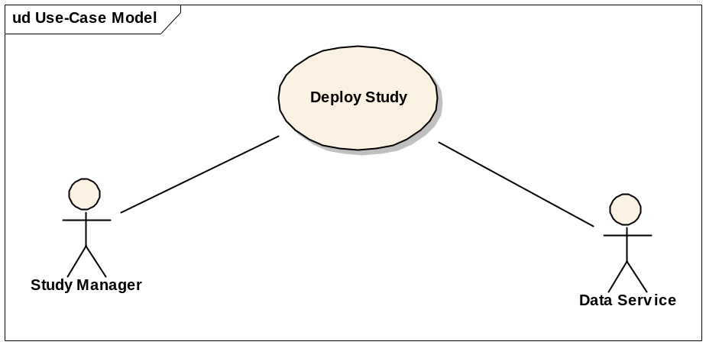

Basic Flow of Events
- The Study Manager indicates to the system that he will define a new study.
- The system provides an interface for defining the study configuration.
- The Study Manager specifies the high-level study configuration information. See Special Requirement: Study Configuration Data
- The Study Manager specifies the source of clinical data for the study and which data are to be imported to the study. See Special Requirement: Clinical Data Configuration.
- The Study Manager specifies the source and type of genomic data for the study and how the genomic data are mapped to the clinical data. See Special Requirement: Genomic Data Configuration.
- The Study Manager specifies the source of imaging data for the study (if any) and how the imaging data are mapped to the clinical data. See Special Requirement: Imaging Data Configuration.
- The Study Manager chooses to deploy the study.
- The system retrieves the selected data from the indicated Data Services and makes the study available for use.
- The Study Manager configures any shared queries and data lists that may be useful for all investigators who access the study. See the use cases Manage Queries and Manage Investigator Data Sets for details on how these are configured.

Alternative Flows

Import Clinical Data from Text File
If in step 4 of the Basic Flow the Study Manager indicates that the clinical data are defined in a delimited-text file, the system provides a special interface for specifying the attributes of the clinical data and for uploading the delimited text file.

Save Study Definition Prior to Deployment
A Study Manager may save the study at any point during the Basic Flow and resume the definition and deployment process later.

Key Scenarios

NCIA/Vasari Study
The initial study that TrWorkbench must be configured to support will integrate the Vasari image data from NCIA with clinical and genomic data.

TCGA Methylation Data

Preconditions
None

Postconditions

Study Data is Available for Access

Extension Points
None

Special Requirements

Study Configuration Data
Initial study configuration information consists of the following data:
- Study name (unique)
- Description
- Study globally visible (yes/no). If no, the Study Manager must approve requests from users to subscribe to the study.

Clinical Data Configuration
The following clinical data configuration information is collected:
- Clinical Data Source (choices CTODs or delimited text)
- For CTODs
  - CTODs grid URL
  - CTODs username
  - CTODs password
  - Protocol Id (of study to import)
- For delimited text (for each field)
  - Field type (patient identifier, category, free text, integer, float or Boolean)
  - Field description
- Which clinical fields are restricted access.
- Which clinical fields are to be included in the simple search interface and the results set for browsing clinical data.

Genomic Data Configuration
The following genomic data configuration information is collected:
- caArray server hostname
- caArray server JNDI port
- caArray username
- caArray password
- Mapping of data files to patient identifiers.

Imaging Data Configuration
The following imaging data configuration information is collected:
- NCIA server grid URL
- Protocol Id
- Mapping of NCIA Patients to patients imported from clinical data source.
- Image annotations are uploaded as a delimited text file.
- Which imaging features are to be included in the simple search interface and the results set for browsing image data.

Data Interpretation
It is important that the following data distinctions are discovered and captured at study definition time, either by automated examination of the data on import or (if necessary) by explicit definition by the Study Manager:
- Time points associated to study (and associations to individual samples or clinical data collections)

Study Data are Imported Asynchronously
When the Study Manager chooses to deploy the study, the study data are retrieved asynchronously. The system will provide information on the state of the import process (in progress or complete).

Genotyping Data Visibility
Low-level genotyping data (raw data and normalized) will always be restricted visibility.

Required Data
None of the study data types (clinical, imaging or genomic) are required though at least one must be included in order to create a study.

Study Validation Logging
When data is imported into the study, any data problems or inconsistencies (for example patients without associated samples) are noted in a log associated with the study.

Additional Information

Open Issues

Sources of NCIA/Vasari Study Data
We need to explicitly define the sources and formats of the imaging feature, clinical and genomic data to be imported for the NCIA/Vasari study.

Sample Annotation Source
Sample definition and annotation spans several sources (e.g. CTODs, caArray and caTissue) and it is currently unclear which is the definitive source of the study sample list. A definitive list of study samples is important as the Study Manager needs to define which are the normal samples for the study.
Note that caTissue integration is not in scope for TrWorkbench 1.0.

