caIntegrator 2
Use-Case Specification: Manage Investigator Data Lists

Version 0.1
April 24, 2008

Document Approvals
The list contains the name and contact information for the core project team and any key stakeholders who have an interest in the success of the project. An “S” identifies persons responsible for approval from the stakeholder groups. Sign off of the document would be required when a decision is made not to take action for defined gaps.

S | Name | Role | S | Name | Role
S | Anand Basu | NCICB Engineering Manager | S | Subha Madhavan | Product Manager
 | Shine Jacobs | Project Manager

Revision History
Date | Version | Description | Author
3/26/2008 | 0.1 | Initial revision | Eric Tavela
4/15/2008 | 0.2 | Incorporated requirements review feedback. | Eric Tavela

Table of Contents
1. Brief Description 4
2. Basic Flow of Events 4
3. Alternative Flows 4
3.1 Export Data List 4
3.2 Create a Copy of a Data List 4
3.3 Edit Data List 4
3.4 Delete Data List 4
3.5 Define List Manually 4
3.6 Share List 5
4. Key Scenarios 5
5. Preconditions 5
6. Postconditions 5
7. Extension Points 5
8. Special Requirements 5
8.1 Organization of Lists into Named Folders 5
8.2 List Types 5
8.3 Context of Saved List 5
8.4 Inform Research Investigator of List Element Removals 5
9. Additional Information 5

Use-Case Specification: Manage Investigator Data Lists

Brief Description
In this use case, a Research Investigator creates or edits a list of data intended for export or to be analyzed using an integrated analysis tool.
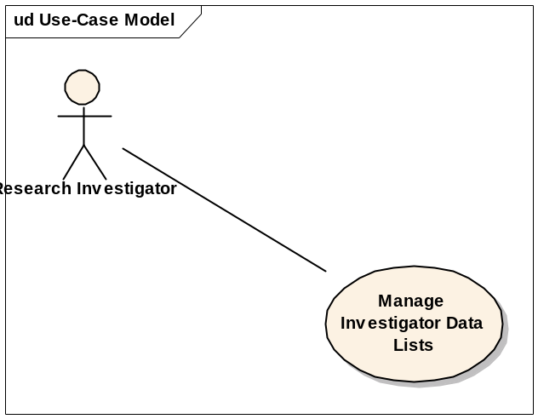

Basic Flow of Events
- The Research Investigator selects a list of entries from a query results set (see the use case Manage Queries) and saves the list, giving it a unique name and a description.
- The Research Investigator may view complete details for any entity in the list (see the use case Browse Study Data).

Alternative Flows

Export Data List
The Research Investigator may export any data list as a downloadable comma-separated value text export.

Create a Copy of a Data List
The Research Investigator may make a duplicate of any data list, providing it with a new name.

Edit Data List
The Research Investigator may delete selected entries from the list.

Delete Data List
The Research Investigator may delete a list.

Define List Manually
The Research Investigator may create a list by either manually entering the identifiers for the entities in a list or by uploading a text file containing a list of identifiers.

Share List
The Research Investigator may indicate that a particular list is shared. If a list is shared, it is visible to all Research Investigators that are subscribed to the study.

Key Scenarios

Preconditions
None

Postconditions
None

Extension Points
None

Special Requirements

Organization of Lists into Named Folders
To organize lists, Research Investigators may create named folders and subfolders to contain their lists (in a manner similar to directories in a file system).

List Types
The following list types are supported:
- Subject Lists
- Image Lists
- Sample Lists
- Array Data Lists
- Gene Lists
- Genomic Region Lists (chromosome, start and end)
- Reporter Lists

Context of Saved List
Generally, lists are specific to a given study and are only shown in the context of that study. Gene lists, genomic region lists and reporter lists are exceptions; these are associated with the user that defined the list and will be displayed in every study.

Inform Research Investigator of List Element Removals
If an update to a study made by the Study Manager results in the removal of an item that was included in a defined list, the system should inform the Research Investigator that the removal occurred.

Additional Information
None

