caIntegrator 2
Use-Case Specification: Perform Data Analysis

Version 0.3
April 24, 2008

Document Approvals
The list contains the name and contact information for the core project team and any key stakeholders who have an interest in the success of the project. An “S” identifies persons responsible for approval from the stakeholder groups. Sign off of the document would be required when a decision is made not to take action for defined gaps.

S | Name | Role | S | Name | Role
S | Anand Basu | NCICB Engineering Manager | S | Subha Madhavan | Product Manager
 | Shine Jacobs | Project Manager

Revision History
Date | Version | Description | Author
3/26/2008 | 0.1 | Initial revision | Eric Tavela
4/9/2008 | 0.2 | Completed draft for Inception | Eric Tavela
4/15/2008 | 0.3 | Incorporated feedback from requirements review | Eric Tavela

Table of Contents
1. Brief Description 4
2. Basic Flow of Events 4
3. Alternative Flows 4
3.1 Create New Query for Analysis Input 4
4. Key Scenarios 4
4.1 Kaplan-Meier Survival Plot 4
4.2 Cox Model Analysis 4
4.3 Methylation Data Analysis (see Special Requirements) 4
5. Preconditions 4
6. Postconditions 4
7. Extension Points 5
8. Special Requirements 5
8.1 Asynchronous Execution of Analysis Jobs 5
8.2 Support Analysis and Visualization Methods from caIntegrator 5
8.3 Support Methylation Data Visualization 5
8.4 List Creation from Visualized Data 5
8.5 Implicit Exclusion Set 5
9. Additional Information 5

Use-Case Specification: Perform Data Analysis

Brief Description
In this use case, a Research Investigator applies an analysis or visualization method to a new or previously defined data list (or lists).
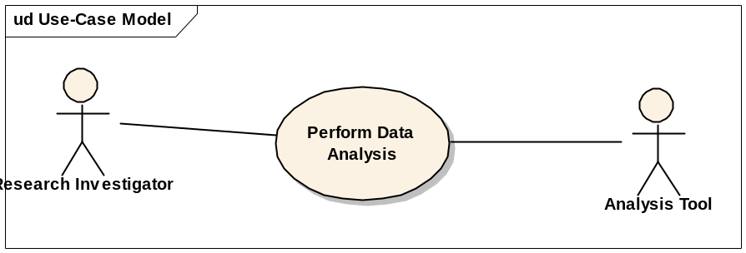

Basic Flow of Events
- The Research Investigator chooses an analysis method to perform on study data.
- The system presents the user with a form or wizard interface to name the analysis method configuration and to set the analysis method parameters.
- The Research Investigator supplies the necessary analysis method parameters.
- The system saves the supplied analysis method parameters and executes the analysis job.
- The system informs the user that the analysis method is complete.
- The user reviews the analysis results.

Alternative Flows

Create New Query for Analysis Input
As a shortcut, the Research Investigator may launch the functionality described in the use case Manage Queries at any point where the analysis parameter selection is requesting a data list. After defining or running the desired query to use to populate the data, the Research Investigator is returned to the analysis method definition with the selected query results used as the input data.

Key Scenarios

Kaplan-Meier Survival Plot

Cox Model Analysis

Methylation Data Analysis (see Special Requirements)

Preconditions
None

Postconditions
None

Extension Points
None

Special Requirements

Asynchronous Execution of Analysis Jobs
Any analysis method that is known to take more than five seconds to execute will be run asynchronously. The user interface must specify whether jobs are still executing or complete.

Required Analysis and Visualization Methods
TrWorkbench will support at least the analysis and visualization methods that are currently bundled in caIntegrator (specifically those in Rembrandt). These tools include the following:
- KM Plot
- Gene Expression Plot
- Class Comparison
- Principal Component Analysis
- Hierarchical Clustering Analysis
- Heat Map

Support Methylation Data Visualization
TrWorkbench will include the following visualization methods to support methylation data investigation.
- For a single sample and single gene, a bar-graph (and expression range) display of percent of probes methylated displayed side-by-side with expression values for these same probes. Both the selected sample and normal data are shown.
- For a single gene and all samples, a plot of percent of probes methylated (y axis) against mRNA expression ratio to normal (x axis). A user may then lasso selected data points (typically clusters) and see a list of the samples as rows and probes as columns indicating whether the probes were methylated or not.
- For all samples and one gene, display a bar graph showing the percent of samples methylated per probe.

List Creation from Visualized Data
Where possible, TrWorkbench should allow the Research Investigator to “lasso” visualized data to create new named data lists.

Implicit Exclusion Set
For analysis methods that require two lists of data (for example Class Comparison) the Research Investigator may specify a single data list and use the exclusion set of the data list as the data to compare against.

Set Intersection is Invalid for Some Analysis Methods
Some class / group comparison analyses require that the classes compared be mutually exclusive. If input for these methods includes intersecting input sets, the system should identify this as an error.

Integrated Analysis Tools
TrWorkbench will integrate with the following external applications for analysis and visualization:
- geWorkbench
- GenePattern

Additional Information
None

