caIntegrator 2
Use-Case Specification: Use Workspace

Version 0.1
April 24, 2008

Document Approvals
The list contains the name and contact information for the core project team and any key stakeholders who have an interest in the success of the project. An “S” identifies persons responsible for approval from the stakeholder groups. Sign off of the document would be required when a decision is made not to take action for defined gaps.

S | Name | Role | S | Name | Role
S | Anand Basu | NCICB Engineering Manager | S | Subha Madhavan | Product Manager
 | Shine Jacobs | Project Manager

Revision History
Date | Version | Description | Author
03/27/2008 | 0.1 | Initial revision | Eric Tavela
4/9/2008 | 0.2 | Completed draft for Inception | Eric Tavela

Table of Contents
1. Brief Description 4
2. Basic Flow of Events 4
3. Alternative Flows 4
3.1 Set Default Study 4
3.2 Subscribe to Study 4
4. Key Scenarios 5
5. Preconditions 5
6. Postconditions 5
7. Extension Points 5
8. Special Requirements 5
8.1 Shared vs. Investigator-Defined Data Lists and Queries 5
9. Additional Information 5
9.1 Workspace User Interface 5

Use-Case Specification: Use Workspace

Brief Description
In this use case, a Research Investigator views and updates the content of his workspace which consists of subscribed studies, data sets and analysis results.
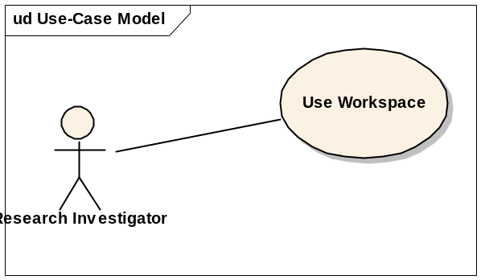

Basic Flow of Events
- As a result of logging in, the Research Investigator is presented with his workspace set to display his default study (see Alternative Flow: Set Default Study).
- The Research Investigator selects the study he wishes to use from a list of subscribed studies.
- The workspace displays the following items that may be opened in the workspace.
- Study contents (Use Case: Browse Study Data)
  - Subjects
  - Samples
  - Images
- Queries (Use Case: Manage Queries)
- Data Lists (Use Case: Manage Investigator Data Lists)
- Analysis Tools (Use Case: Perform Data Analysis)
- The user selects one of the study items listed above, invoking the associated use case functionality.

Alternative Flows

Set Default Study
If a Research Investigator is subscribed to multiple studies, he may choose to select any of these studies as the default that is opened at login. If the Research Investigator is only subscribed to a single study, it is automatically the default.

Subscribe to Study
A Research Investigator may subscribe himself to any publicly visible study. Similarly, a Research Investigator may request to be subscribed to restricted visibility studies, though these will not be accessible until the Study Author accepts the subscription request.

Key Scenarios
None

Preconditions
None

Postconditions
None

Extension Points
None

Special Requirements

Study, Shared and Private Data Lists and Queries
There are three levels of both lists and queries that should be displayed separately (e.g. in separately expandable tree nodes). The first category is lists or queries that are defined by the Study Manager. The second is lists or queries defined by the study investigator. The third is lists or queries defined by other investigators that have been marked as shared. These should be organized by user. An illustration of the organization is shown below:
- Queries
  - Study Queries
    - <global query 1>
  - Shared Queries
    - <user 1>
      - <user 1’s shared query 1>
  - My Queries
    - <my query 1>

Additional Information

Workspace User Interface
The suggested layout for the workspace is the standard tree-control and work area idiom. An example is shown below as a general illustration; this is not intended to define the actual contents of a study or the workspace.
Study: NCIA/VASARI

Study Elements
Patients
Images
Array Data

My Study Data
My Queries
Images w/ cortex involvement
+ My Groupings
+ My Data Sets
+ My Analysis Results

Analysis Tools
Generate KM Plot
Generate Heat Map
Query Results: Images w/ cortex involvement

Image NameSizeAction
MRI_112.34 MBDownload | View | etc.
MRI_112.34 MBDownload | View | etc.
MRI_112.34 MBDownload | View | etc.

Edit Query | Download Selected | Create Data Set | etc.

Study Tree Control
Work Area

Open Issues

Gene Profiles
The notion of a re-usable gene profile was introduced during requirements discussion. This would be reusable across studies and would select different data depending on platforms included in a study. This should be explored further and considered as a feature for a post-1.0 release.

