caIntegrator2 v.1.0
Title of Publication

Local Installation Guide






Center for Biomedical Informatics and Information Technology
Table of Contents

Introduction 1
caIntegrator2 Software and Technology Requirements 2
Java SDK Installation 3
Apache Ant Installation 3
Apache Ant Environment Variables 3
MySQL Installation and Configuration 6
Working with Properties Files 7
Downloading and Installing UPT (Optional) 8
Installing caIntegrator2 Application and Services 8
Downloading caIntegrator2 files 9
Installing a New caIntegrator2 9
GUI Installer Method of Installation 9
Command-Line Method of Installation 17
Configuring JBoss 19
Configuring JBoss Servers and MySQL Server to Run as Services 20
Post-Installation Tasks 21
Using UPT to Add caIntegrator2Users 21
Appendix I: Default Users 22
Contacting Application Support 22

Introduction
This caIntegrator2 v.1.0 Installation Guide provides you with the instructions to install and configure a fresh caIntegrator 2.0 v.1.0 application. The caIntegrator2installation installs and configures a JBoss application server and creates a caIntegrator2-specific schema within a pre-existing database on a preinstalled MySQL server.

Directions are given in this document for both Linux and Windows operating systems.

NOTE   | Published caIntegrator2 v.1.0 development documentation can be found on the caIntegrator2 page of the NCI wiki: https://wiki.nci.nih.gov/display/caIntegrator2/caIntegrator2+Wiki

Overview of caIntegrator2 Installation | The process for installing caIntegrator2 v1.0 includes the following tasks described in this document:  - Downloading and installing required software  - Setting environment variables  - Downloading caIntegrator2 v.1.0 distribution files  - Installing  - GUI Installer Method  - Command-Line Method  -- Editing install.properties file  - Configuring JBoss servers and MySQLserver to run as a service  - Post-Installation Tasks  - Using UPT to Add caIntegrator2Users

caIntegrator2 v.1.0 Software and Technology Requirements

Tested Environment | The caIntegrator2 v.1.0 installation has been tested on Linux Red Hat Enterprise Linux AS 4 64/32-bit (for AMD chipset) and the Windows XP/2003 environments. While the installation may work in other Linux and Windows environments, it has only been tested in these environments.

Required Software—Not Included in caIntegrator | Many of the servers and services that make up caIntegrator2 are automatically installed as part of this installation. However, certain tools that you must manually install and configure are listed in Table 1. The software name, version, description, and URL hyperlinks (for download) are indicated in the table.

Prior to the caIntegrator2 v.1.0 installation, you must download and install the following tools and recommended versions in the order they are listed in Table 1. Complete the directions for installing each, as directed on the corresponding website.

Required Software Name  Version | Description
Java 2 Platform Standard Edition 5.0 Update 10 (J2SE 5.0)  http://java.sun.com/products/archive/j2se/5.0_10/.  Be sure to download the correct Java SDK for your operating environment. For example, for Linux AMD 64, you would download jdk-1_5_0_10-linux-amd64-rpm.bin. For Windows, you might download jdk-1_5_0_10-windows-i586-p.exe. | The J2SE Development Kit (JDK) supports creating J2SE applications.
Apache Ant, 1.7.0  https://gforge.nci.nih.gov/svnroot/lsd/trunk/tools/apache-ant-1.7.0-bin.zip | Apache Ant is a Java-based build tool.
MySQL, 5.0.27  http://downloads.mysql.com/archives.php?p=mysql-5.0&v=5.0.27 | MySQL is an open-source database software application.
Table 1 Required Software

IMPORTANT | As you install each application, record the installation directory path, and the hostname of your MySQL DB server, and the DB admin username/password, if you are going to install UPT.

Java SDK Installation
When you install the Java SDK, you will be prompted to select the installation directory. Record the path, as this directory will be used when you set the environment variables.

Apache Ant Installation

- Unzip the Apache Ant distribution files using a command line unzip tool or a zip utility, such as WinZip.

- After extracting the zip, you must set the environment variables, described in the following section, so that Ant is available in the system PATH.

Apache Ant Environment Variables

NOTE | The purpose of setting operating system environment variables is so that the Java SDK and Ant build tool are available to run from anywhere in the system.

Linux
To set the environmental variables in Linux, follow these steps:

NOTE | The JAVA_HOME, ANT_HOME and PATH environment variables are set in /etc/profile. You may need to create the variables, or modify them if they already exist.

Step | Action
1 | As the root user, enter the following in the /etc/profile file. A PATH variable should already be created in this file, so be sure to define the JAVA_HOME and ANT_HOME export before the PATH export. Replace <some_path> with the correct path fragment for Java and Ant installations.  export JAVA_HOME=<some_path>/jdk1.5.0_10  export ANT_HOME=<some_path>/apache-ant-1.7.0  export PATH=$JAVA_HOME/bin:$ANT_HOME/bin:$PATH
2 | Log out and log back in so that the system recognizes your changes.

Verifying the Environment Variables in Linux
To verify that environment variables have been set correctly, follow these steps:

Step | Action
1 | From the command line, enter:  echo $JAVA_HOME  echo $ANT_HOME  Both of these commands should return the location where you installed these tools.
2 | To verify your Java SDK installation, enter java –version from a command prompt. You should see java version "1.5.0_10".
3 | To verify your Ant installation, enter: ant –version from a command prompt. You should see: Apache Ant version 1.7.0 compiled on December 13 2006.

Windows
To set the environmental variables in Windows, follow these steps:

NOTE | The JAVA_HOME, ANT_HOME and PATH environment variables are set in the Systems Properties.

Step | Action
1 | In Windows, select Control Panel, then select the Systems application. In the Systems window, select the Advanced tab.
2 | On the Advanced tab, click the Environment Variables button. To add a new system variable, select the New button.  - In the Variable name text box, enter JAVA_HOME.  - In the Variable value text box, enter the location of your Java installation.
3 | Click the New button again.  - In the Variable name text box, enter ANT_HOME.  - In the Variable value text box, enter the location of your Ant installation.
4 | Select the PATH system environment variable, and select the Edit button. This opens the Edit System Variable dialog box, displayed here as an example.  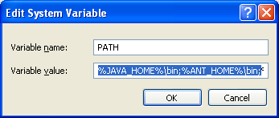
5 | In the Variable value text box, prepend the following text in front of the text that already exists in the Variable Value field.  %JAVA_HOME%\bin;%ANT_HOME%\bin;  Click OK.

Verifying the Environment Variables in Windows
To verify the environment variables have been set correctly, follow these steps:

Step | Action
1 | From the command line, enter:  echo %JAVA_HOME%  echo %ANT_HOME%  Both of these commands should return the location where you installed these tools.
2 | To verify your Java SDK installation, enter java –version from a command prompt. You should see java version "1.5.0_10".
3 | To verify your Ant installation, enter ant –version from a command prompt.  You should see: Apache Ant version 1.7.0 compiled on December 13 2006.

NOTE | Environment variables for caIntegrator2and, optionally, UPT are modified and set in those sections of this document: Installing a New on page 9 and Downloading and Installing UPT (Optional)  on page 7.

MySQL Installation and Configuration
A MySQL 5.0.27 server must be downloaded, installed and running in order for the caIntegrator2installation to work successfully.

To download and install MySQL, follow the steps outlined on the MySQL website: http://downloads.mysql.com/archives.php?p=mysql-5.0&v=5.0.27

TIP | You should consult the following three links to successfully set up secure and well-performing MySQL servers, in preparation for installing caIntegrator:  - MySQL Security Guide - http://dev.mysql.com/doc/refman/5.0/en/security-guidelines.html  - Performance –  - General performance tuning - http://dev.mysql.com/books/hpmysql-excerpts/ch06.html  - InnoDB engine performance tuning - http://dev.mysql.com/doc/refman/5.0/en/innodb-tuning.html

MORE TIPS | - Record the MySQL root username/password chosen during the MySQL installation process, as you will need to use this as your database.system.user/ database.system.password later in the UPT installation process, should you choose to install UPT.  - Note the MySQL port chosen during the MySQL installation process, as you will need to use this as your database.port later in both the caIntegrator2and UPT (if installing UPT) installation processes.

Working with Properties Files

About Properties
An important component of command-line installation of either caIntegrator2 or UPT, is configuring properties files.
Prior to initiating a command-line installation, property variables must be modified. Note the following points about changing or entering variables.

Paths in Properties Files
NOTE | The paths in the .properties files should use forward slashes. For example, you would use application.base.path=C:/apps/caIntegrator-app, not application.base.path=C:\apps\caIntegrator-app. If you use backslashes, you will experience undesirable results.

Spaces in Path Property Values
NOTE | You should not specify paths with spaces included as property values. In Windows, note that the C:\Documents and Settings\<username> path contains spaces and should not be used, or anything similar. If you are using Windows, use a path such as C:/apps/caIntegrator. Spaces are fine for property values which do not represent a path.

More About Property Values
NOTES | - In each *.properties file, any property value marked with uppercase REPLACE_* must be manually updated with the appropriate value.  - In each *.properties file, any property value marked with lowercase replace_* may be optionally updated with the appropriate value.  - If there is reference to a database.system.user for your MySQL server, you can determine which users have full privileges to create and manage other databases, by executing show grants from a MySQL prompt to determine the correct level of privileges.

Downloading and Installing UPT (Optional)
If you do not already have a User Provisioning Tool (UPT) installed, and you wish to manage user accounts for your caIntegrator2 application, you must install UPT.

Overview of UPT | UPT is used to provision users in the caIntegrator2 application. Each CBIIT application installs with its own Common Security Module (CSM) schema that has sample/default users and a role/permissions structure. To add additional users you must provision the caIntegrator2 application in the UPT. Then you can assign users to caIntegrator2.

You can download UPT 4.2 through the following link:

https://gforge.nci.nih.gov/frs/download.php/7244/CSM_UPT_42_Release.zip

For instructions on how to install UPT 4.2, refer to the chapter, UPT Installation and Deployment, in the following document:

https://gforge.nci.nih.gov/docman/view.php/12/18945/caCORE_CSM_v42_ProgrammersGuide.pdf

Installing caIntegrator2 v.1.0 Application and Services
To newly install the caIntegrator2 v.1.0 application and services, follow the steps in this section:
- Downloading caIntegrator2 v.1.0 files on page 9
- Installing a New on page 9
  - GUI Installer Method on page 9
  - Command-Line Method on page 17
- Configuring JBoss on page 28
  - Configuring JBoss Servers and MySQL Server to Run as Services on page 20
- Post-Installation Tasks on page 21
  - Using UPT to Add caIntegrator2 Users on page 21

BEFORE YOU BEGIN | - Important: There must already be a pre-existing MySQL DB and connection username/password for caIntegrator2 to install into; caIntegrator2 does not create its own DB.

Downloading caIntegrator2 v.1.0 files
To download the caIntegrator2 v.1.0 files, follow this step:

Step | Action
1 | The various installation files for caIntegrator2 v.1.0 are between 100-450MB in size. All of the files can be downloaded from the caIntegrator2 distribution folder here: https://gforge.nci.nih.gov/frs/?group_id=507.  - For a new command-line installer, download the caIntegrator2_install_1_0.zip file (around 285 MB).  - For a command-line upgrade installer, download the caIntegrator2_upgrade_1_0.zip file (about 285 MB).  - For a GUI installer that you can use to do a fresh caIntegrator 2.0 installation, download the caIntegrator2_gui_distribution_1_0.jar file (about 320 MB).  Remember the download location, as you will be using this file to run the installation in the steps that follow.

Server Components in caIntegrator2 v.1.0 | These server components are installed and configured as part of the caIntegrator2 v.1.0 installation. You do not need to do anything further to download or install these components.  - JBoss 4.0.5 (hosts the caIntegrator2 application)

Installing a New caIntegrator2 v.1.0

You can perform a new installation of caIntegrator2 v.1.0 using either of these two methods:
- A GUI Installation wizard. Instructions for this method begin on this page
- A command-line installation. For instructions, see page 17.

GUI Installer Method of Installation

For detailed information on all of the GUI installer fields, refer to the documentation at this location: https://wiki.nci.nih.gov/x/NAUuAQ.

For performing an installation using the GUI Installer, follow these steps:

Step | Action
1 | Open a command prompt in the directory where you downloaded the caIntegrator2_gui_distribution_1_0.jar. Enter this command to Invoke the GUI installer : java –jar caIntegrator2_gui_distribution_1_0.jar.
2 | The Installation Wizard opens to facilitate the installation process. Click Next to proceed through the pages of the wizard, beginning with progressing past the Welcome page.
3 | Review the release notes.
4 | You must accept the license agreement.
5 | Select Install installation type. For a new installation, select Install.  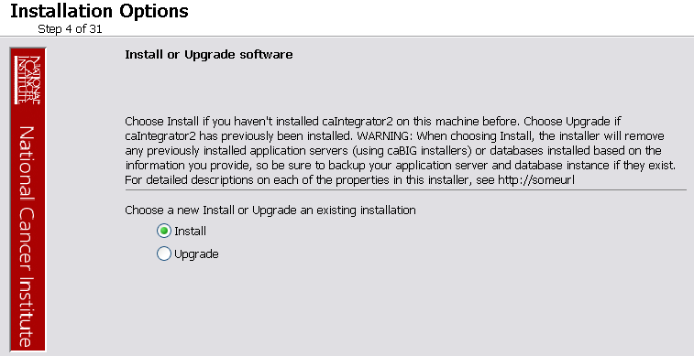
6 | Navigate to the directory where you would like to install caIntegrator2.  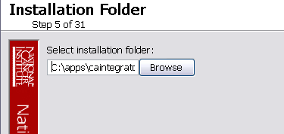  If the folder does not yet exist, click OK in the dialog box to indicate that you want the folder to be created.
7 | Select the type of installation you would like to do, you can install everything, or just specific components (JBoss or Database only). The remaining sections in this guide will assume you chose to install everything.  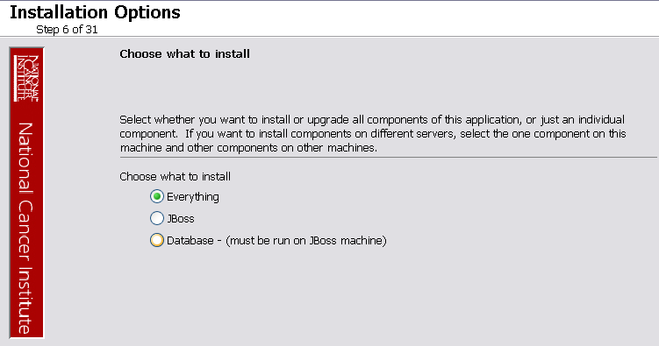
8 | Continue walking through the pages of the installer. Configure the caIntegrator2 JBoss server on the next two pages of the installation wizard. The screen shots show example values. The port values which are specified are the defaults and can be used unless you want to reconfigure the values because of values already in use.  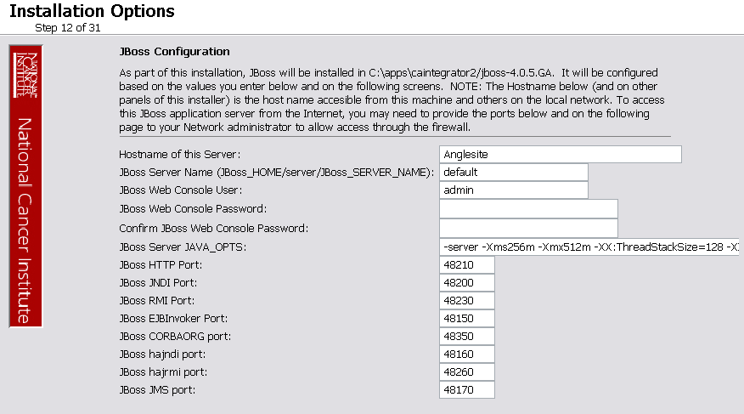
9 | 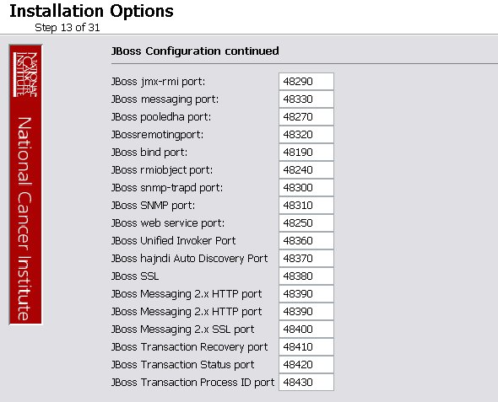
10 | JBoss SSL requires that you have requested and retrieved certificates already. If this doesn’t apply to your installation, leave the values as false and continue.  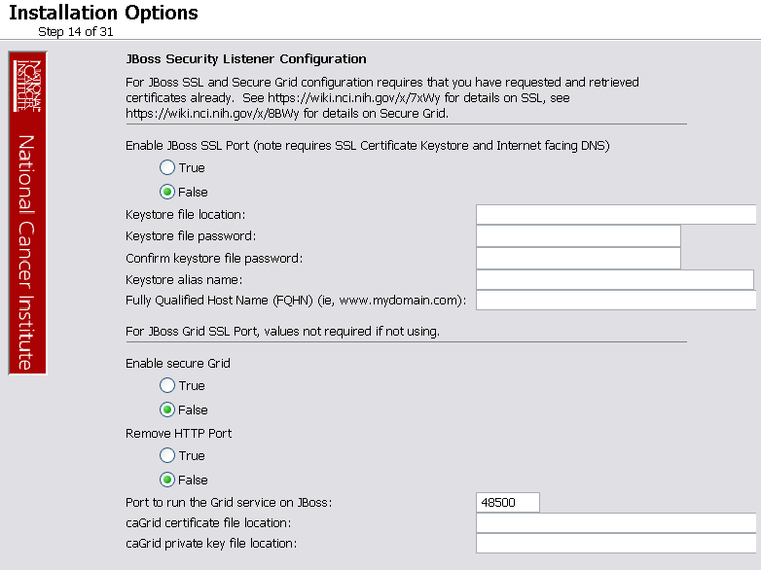
11 | If your JBoss is externally accessible then fill out this section, otherwise leave it blank and continue.  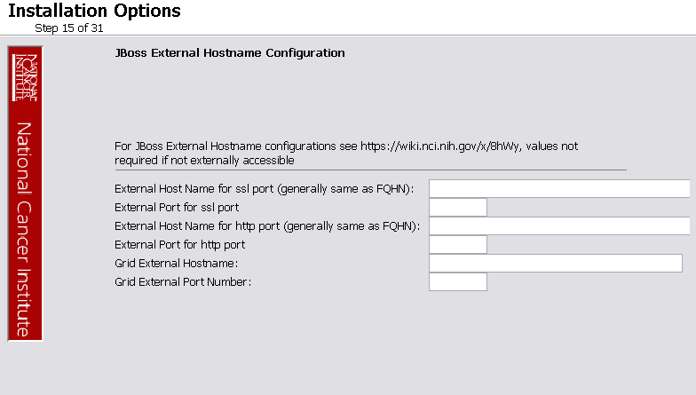
12 | Specify the authentication type that caIntegrator2 should use. Database is the most likely choice if you aren’t sure what to select here.  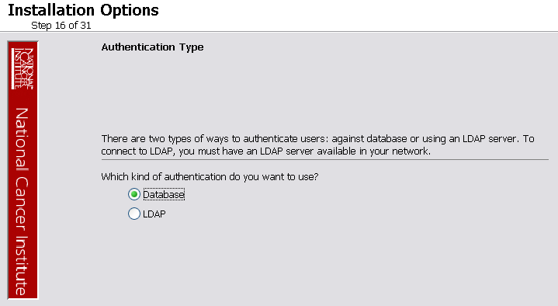
44  13 | If you selected LDAP in the previous step, enter the appropriate configuration information for LDAP.  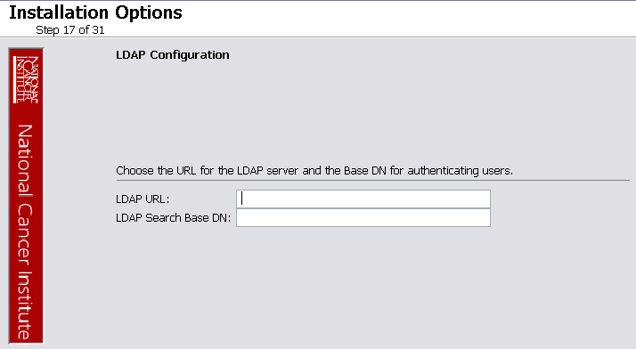
111141  14 | If the authentication type is database:  Specify the database connection information, including the name of the pre-existing database where the caIntegrator2 schema will be installed, and the pre-existing user which will be used by caIntegrator2 to connect to its database.  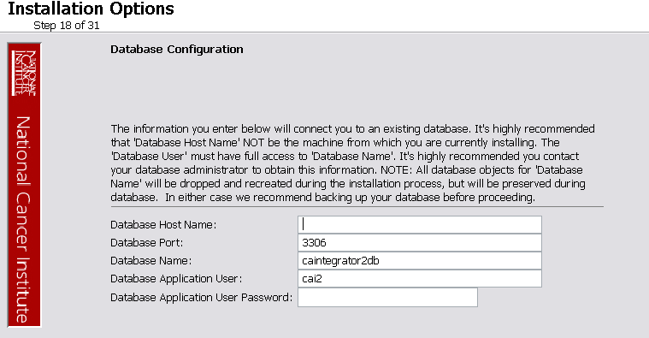  Error messages inform you if the following occurs:  - If the specified database host cannot be reached, or the field is blank.  - If the specified database does not already exist, or the caIntegrator2 DB user’s credentials are wrong.
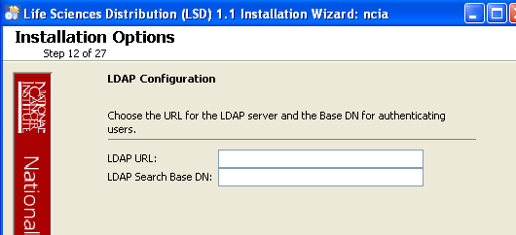  15 | Specify SMTP mail server connection information so that caIntegrator2 can send emails from users with new account requests.  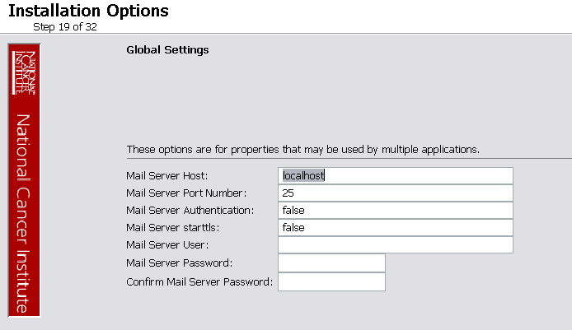
16  1615 | Specify email addresses for the administrator to approve user requests.  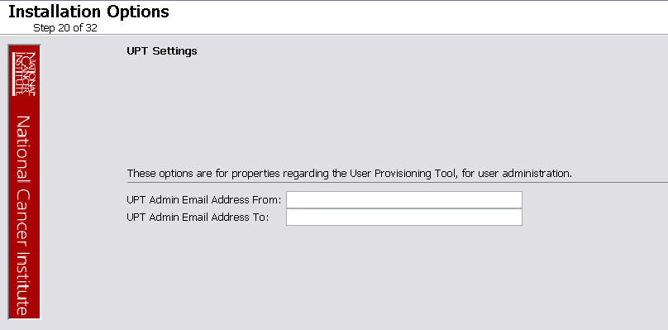
17 | If jar signing is necessary for the installation, then enable it on this page, however this is optional and can be skipped over.  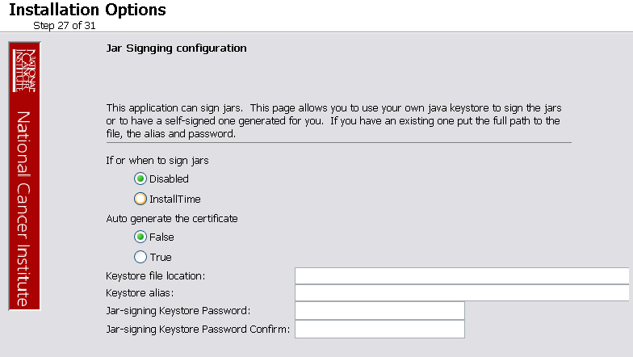
18 | Review the summary of the information you entered.  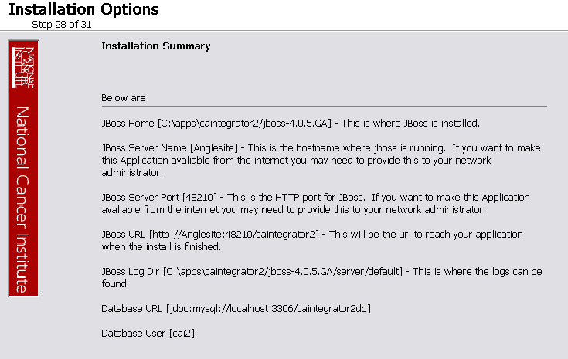
19 | Review the selected install type and the installation destination.  After you click Next from reviewing the installation destination, the installer runs. The installation wizard displays the installation progress and completion.
20 | When you are informed that the process is finished, click Done in the lower right corner of the wizard to close the installer.
21 | To verify caIntegrator2 installation:  - Open your web browser to http://<jboss.server.hostname>.<jboss.server.port>/caintegrator2 ;. Refer to the <user home>/.installer-caintegrator2/caintegrator2_installer/install.properties file for the correct values.  - Enter manager as the user and manager as the password.
22 | After successfully installing caIntegrator2, make a backup of the <user home>/.installer-caintegrator2/caintegrator2_installer/install.properties file in a different directory for future reference.

Command-Line Method of Installation

Overview of caIntegrator 2.0 Command-Line Installer Properties Files | When you do a command-line installation of caIntegrator2 for the first time, you will work with the properties file included in the caIntegrator2_distribution_1_0.zip. The file is: install.properties.  If you are command-line upgrading from a previous version of caIntegrator 2.X, you will work with the upgrade.properties file included in the caIntegrator2_upgrade_1_0.zip.

caIntegrator2 Port Usage
NOTE | Verify that default port values defined in install.properties files are not in use on your system by running netstat –a from the command line. If the ports are in use prior to installation, you will likely experience problems with your installation.

JBoss Errors During Installation
NOTE | You may receive an error such as Exception in thread "main" java.lang.NoClassDefFoundError: org/jboss/Shutdown. This should not be a problem, as the installer attempts to stop previously installed servers to prevent problems during the installation. If this is your first time installing caIntegrator2, you may receive and disregard this error message.

Command-line Installation Steps
To install a new instance of caIntegrator2 using the command-line, follow these steps:

Step | Action
 | Refer to the command-line installation instructions found here: https://wiki.nci.nih.gov/x/NgUuAQ.
1 | From the directory where you downloaded the caIntegrator2_distribution_1_0.zip from Downloading 2.0 files on page 9, unzip the files, using one of these two methods:  - Open a command prompt and use it to extract this file to a temporary location. For example, you may enter a command such as unzip -q caIntegrator2_distribution_1_0.zip (you must have a ZIP tool installed). This location will be referred to as the <installer_directory> henceforth.  - Use WinZip or a similar utility to unzip the files to a temporary location. This location will be referred to as the <installer_directory> henceforth.  Example: <installer directory> = C:\caIntegrator_20_installer
2 | Note: Setting the property values is an important step in the install process. Before you complete steps 2 & 3, review Working with Properties Files on page 7.  Open the <installer_directory>/install.properties file, modify the values for your environment and save the file. For the latest details about configuring the properties for your environment, refer to this wiki page: https://wiki.nci.nih.gov/x/NAUuAQ.
3 | Record the property values you have set.  Note: You shouldn’t need to modify the other default values as we have chosen unique ports to reduce the risk of other applications using the same values. However, be sure to verify that the ports in this file are not being used by other applications.
4 | From the command line, navigate to <installer_directory>/(Example:cd C:\caIntegrator_2_0_installer), and type ant. This initiates the installation process. The anticipated duration is anywhere from 1-15 minutes, depending on your system’s speed, power and memory.  The installer installs the caIntegrator2 schema in the specified pre-existing database on your MySQL server, and installs, configures, and starts the JBoss server for the caIntegrator2 application.
5 | To verify caIntegrator2 installation, open your web browser to http://<jboss.server.hostname>:<jboss.server.port>/caIntegrator Refer to the <installer_directory>/install.properties file for the correct values. Enter manager as the user and manager as the password.
6 | After successfully installing caIntegrator2, make a backup of the <installer_directory>/install.properties file in a different directory for future reference.

Configuring JBoss

NOTE | For optimal performance, you must modify your JBoss 4.0.5 configuration to increase the amount of available memory for the caIntegrator2 application. Directions for doing this in Windows are in the following step 1.

To configure JBoss in Windows, follow these steps:

Step | Action
1 | Add the following entry to the JBoss run.bat file which is located will be located at <application_root_directory>/jboss-4.0.5.GA/bin/run.bat. Add the text right after the line ”rem Add -server to the JVM options, if supported”.  -server -Xms2048m -Xmx2048m -XX:ThreadStackSize=128 -XX:SurvivorRatio=10 -XX:PermSize=128m -XX:MaxPermSize=128m -Dsun.rmi.dgc.client.gcInterval=3600000 -Dsun.rmi.dgc.server.gcInterval=3600000 -Djava.awt.headless=true  Warning: Be careful when copying and pasting from this document, whether PDF or MS Word. No spaces must come before and after the columns. A safe way to ensure that the text has no unwanted space and unwanted characters is to copy the text into a blank NotePad first. Then you can correct the spacing and copy-paste back into the run.bat file.
2 | Restart your JBoss 4.0.5 server for the changes to take effect. The method of doing this may depend on the start/stop/restart scripts you created after the installation. Most commonly, you can execute shutdown.bat and then run.bat under $JBOSS_HOME/bin. Refer to the publicly available JBoss user’s guide at www.jboss.org for more information.

Configuring JBoss Servers and MySQL Server to Run as Services

NOTE | MySQL and the JBoss server that make up caIntegrator2, and the JBoss server optionally installed for UPT, must run continually as services. The instructions in this section cover all of these scenarios. For a caIntegrator2 deployment, there are at least three servers, and if UPT is installed, four servers:  - JBoss 4.0.4 for UPT (optional)  - JBoss 4.0.5 (for caIntegrator2application)  - MySQL 5.0.27

Running JBoss as a Service

NOTE | The default caIntegrator2 installation runs JBoss as a command line process using the user currently logged on. Therefore, when you log out as this user, JBoss will no longer be available for caIntegrator2. For that reason, it is recommended that you configure your JBoss servers to run as a Linux or Windows service. The instructions are contained in this section.

To run JBoss as a service, follow these steps:

Step | Action
1 | Linux  See http://wiki.jboss.org/wiki/Wiki.jsp?page=StartJBossOnBootWithLinux.
2 | Windows  To run an existing JBoss command line installation as a service, follow the directions for creating a user-defined service at http://support.microsoft.com/kb/137890/EN-US/  Note: You need to have access to the Windows Resource Kit.

Running MySQL as a Service

NOTE | It is assumed that your MySQL server was installed as a service. If it was not, follow these recommendations for installing this server as a service.

To run MySQL as a service, follow these steps:

Step | Action
1 | Linux  See http://www.redhat.com/docs/manuals/enterprise/RHEL-AS-2.1-Manual/cluster-manager/s1-service-mysql.html.
2 | Windows  When installing MySQL server on Windows, choose the option to run MySQL as a Windows service.

Post-Installation Tasks

Using UPT to Add caIntegrator2 Users

To use the UPT, follow these steps (these assume that UPT is already installed and uses the database local to caIntegrator2):

Step | Action
1 | Login to UPT. Use the following login profile:  - Login ID=cai2admin  - Password= cai2@dmin  - Application Name=caintegrator2
2 | Add users to the caIntegrator2 application (see the UPT guide for more information).
3 | Click Logout.

Appendix I: Default Users
The following users are provided by default by the caIntegrator2 installer.

- manager / manager
- investigator / investigator
- cai2admin / cai2@dmin - This is the UPT user who will have access to provision caIntegrator2 users.

Contacting Application Support
NCICB Application Support | http://ncicb.nci.nih.gov/NCICB/support  Telephone: 301-451-4384  Toll free: 888-478-4423

