Bioconductor / caBIG v.1.0

Technical Guide

Document Change History
Version Number | Date | Contributor | Description
V1.0 | February 22, 2007 | Martin Morgan | Original content


Updated October 2, 2006
Copyright and License page

Copyright Notice. Copyright 2005 Fred Hutchinson Cancer Research Center (“caBIG™ Participant”). Bioconductor / caBIG was created with NCI funding and is part of the caBIG™ initiative. The software subject to this notice and license includes both human readable source code form and machine readable, binary, object code form (the “caBIG™ Software”).
This caBIG™ Software License (the “License”) is between caBIG™ Participant and You. “You (or “Your”) shall mean a person or an entity, and all other entities that control, are controlled by, or are under common control with the entity. “Control” for purposes of this definition means (i) the direct or indirect power to cause the direction or management of such entity, whether by contract or otherwise, or (ii) ownership of fifty percent (50%) or more of the outstanding shares, or (iii) beneficial ownership of such entity.
License. Provided that You agree to the conditions described below, caBIG™ Participant grants You a non-exclusive, worldwide, perpetual, fully-paid-up, no-charge, irrevocable, transferable and royalty-free right and license in its rights in the caBIG™ Software, including any copyright or patent rights therein that may be infringed by the making, using, selling, offering for sale, or importing of caBIG™ Software, to (i) use, install, access, operate, execute, reproduce, copy, modify, translate, market, publicly display, publicly perform, and prepare derivative works of the caBIG™ Software; (ii) make, have made, use, practice, sell, and offer for sale, and/or otherwise dispose of caBIG™ Software (or portions thereof); (iii) distribute and have distributed to and by third parties the caBIG™ Software and any modifications and derivative works thereof; and (iv) sublicense the foregoing rights set out in (i), (ii) and (iii) to third parties, including the right to license such rights to further third parties. For sake of clarity, and not by way of limitation, caBIG™ Participant shall have no right of accounting or right of payment from You or Your sublicensees for the rights granted under this License. This License is granted at no charge to You. Your downloading, copying, modifying, displaying, distributing or use of caBIG™ Software constitutes acceptance of all of the terms and conditions of this Agreement. If you do not agree to such terms and conditions, you have no right to download, copy, modify, display, distribute or use the caBIG™ Software.
- Your redistributions of the source code for the caBIG™ Software must retain the above copyright notice, this list of conditions and the disclaimer and limitation of liability of Article 6 below. Your redistributions in object code form must reproduce the above copyright notice, this list of conditions and the disclaimer of Article 6 in the documentation and/or other materials provided with the distribution, if any.
- Your end-user documentation included with the redistribution, if any, must include the following acknowledgment: “This product includes software developed by Fred Hutchinson Cancer Research Center” If You do not include such end-user documentation, You shall include this acknowledgment in the caBIG™ Software itself, wherever such third-party acknowledgments normally appear.
- You may not use the names “Fred Hutchinson Cancer Research Center”, “The National Cancer Institute”, “NCI”, “Cancer Bioinformatics Grid” or “caBIG™” to endorse or promote products derived from this caBIG™ Software. This License does not authorize You to use any trademarks, service marks, trade names, logos or product names of either caBIG™ Participant, NCI or caBIG™, except as required to comply with the terms of this License.
- For sake of clarity, and not by way of limitation, You may incorporate this caBIG™ Software into Your proprietary programs and into any third party proprietary programs. However, if You incorporate the caBIG™ Software into third party proprietary programs, You agree that You are solely responsible for obtaining any permission from such third parties required to incorporate the caBIG™ Software into such third party proprietary programs and for informing Your sublicensees, including without limitation Your end-users, of their obligation to secure any required permissions from such third parties before incorporating the caBIG™ Software into such third party proprietary software programs. In the event that You fail to obtain such permissions, You agree to indemnify caBIG™ Participant for any claims against caBIG™ Participant by such third parties, except to the extent prohibited by law, resulting from Your failure to obtain such permissions.
- For sake of clarity, and not by way of limitation, You may add Your own copyright statement to Your modifications and to the derivative works, and You may provide additional or different license terms and conditions in Your sublicenses of modifications of the caBIG™ Software, or any derivative works of the caBIG™ Software as a whole, provided Your use, reproduction, and distribution of the Work otherwise complies with the conditions stated in this License.
- THIS caBIG™ SOFTWARE IS PROVIDED "AS IS" AND ANY EXPRESSED OR IMPLIED WARRANTIES (INCLUDING, BUT NOT LIMITED TO, THE IMPLIED WARRANTIES OF MERCHANTABILITY, NON-INFRINGEMENT AND FITNESS FOR A PARTICULAR PURPOSE) ARE DISCLAIMED. IN NO EVENT SHALL THE Fred Hutchinson Cancer Research Center OR ITS AFFILIATES BE LIABLE FOR ANY DIRECT, INDIRECT, INCIDENTAL, SPECIAL, EXEMPLARY, OR CONSEQUENTIAL DAMAGES (INCLUDING, BUT NOT LIMITED TO, PROCUREMENT OF SUBSTITUTE GOODS OR SERVICES; LOSS OF USE, DATA, OR PROFITS; OR BUSINESS INTERRUPTION) HOWEVER CAUSED AND ON ANY THEORY OF LIABILITY, WHETHER IN CONTRACT, STRICT LIABILITY, OR TORT (INCLUDING NEGLIGENCE OR OTHERWISE) ARISING IN ANY WAY OUT OF THE USE OF THIS caBIG™ SOFTWARE, EVEN IF ADVISED OF THE POSSIBILITY OF SUCH DAMAGE.

.

Insert Names of Development Team(s) here
Development | Programmer’s guide | Program Management
Nianhua Li | Martin Morgan | Robert Gentleman
Martin Morgan |  | Seth Falcon

Contacts and Support
Robert Gentleman | rgentlem@fhcrc.org

LISTSERV Facilities Pertinent to software teams
LISTSERV | URL | Name
caBIO_Users | https://list.nih.gov/archives/cabio_users.html | caBIO Users Discussion Forum
caBIO_Developers | https://list.nih.gov/archives/cabio_developers.html | caBIO Developers Discussion Forum
caDSR_Users | https://list.nih.gov/archives/cadsr_users.html | Cancer Data Standards Repository
NCIEVS-L Listserv | https://list.nih.gov/archives/ncievs-l.html | NCI Vocabulary Services Information
Bioc | http://bioconductor.org/docs/mailList.html | Bioconductor Discussion Forum

Table of Contents

Chapter 1 Introduction to the Technical Guide 3
Overview of the Guide 3
Organization of the Technical Guide 3
Getting Started with this programmer’s guide 4
Document Text Conventions 4
Chapter 2 Overview of the Software 5
Software Overview 5
System Requirements 5
Design and Architecture 7
Chapter 3 Bioconductor / caBIG Requirements 9
User requirements 9
Security and security management 10
Design and architecture of deployed services 10
Design and architecture for service creation 11
Chapter 4 Bioconductor / caBIG APIs 15
Accessing exemplar APIs 15
ant APIs for service creation and deployment 15
ant APIs for local and web-services testing 17
Accessing R APIs 18
Chapter 5 Information Models 19
Overview 19
The MAGE data model 19
Additional data models 20
Service parameter data models 21
Chapter 6 Grid and Web Services 23
Accessing service descriptions 23
Configuring and using web and grid services 23
Additional integration with caGrid 23
Configuring the analytic back-end 24
Appendices 27
Bioconductor / R 27
Software dependencies 27
caBIG 27
.

Introduction to the Technical Guide
This document provides a technical guide to Bioconductor / caBIG software. This software enables the user to create web or grid services from existing Bioconductor packages, and includes three exemplars illustrating the process. Topics in the current chapter include:
- Overview of the Guide
- Organization of the Technical Guide
- Getting Started with this programmer’s guide
- Document Text Conventions

Overview of the Guide
This guide addresses the technical and administrative aspects of Bioconductor / caBIG. A separate guide, available at http://tinyurl.com/2jxml8, outlines software installation. Extensive documentation on Bioconductor is available online (http://bioconductor.org). Core functionality provided by this software is in the Bioconductor package RWebServices; the package contains extensive background, technical, and tutorial material, including manual pages. This material is available from within the R programming environment by loading the RWebServices package and issuing the openVignette() command.

Organization of the Technical Guide
Chapter in Bioconductor / caBIG Technical Guide | Chapter Contents
Table 1. 1 Organization of the technical guide
Introduction to the technical guide | This chapter
Overview of the software | Key software components required to deploy web- or grid-service enabled packages, or to web or grid-service enable existing packages.
Bioconductor / caBIG requirements | User requirements satisfied by this software; software design and architecture; security and security management.
Bioconductor / caBIG APIs | An introduction to the APIs of exemplar modules, and the script-based processes for creating new web or grid services from existing packages.
Information models | A summary of the information models used in the exemplar modules.
Web and grid services | Accessing and configuring web service deployment.

Getting Started with this programmer’s guide
- Review Chapter 2 to understand the overall software architecture required to deploy web- or grid-service enabled packages, and to web- or grid service enable existing Bioconductor packages.
- Review Chapter 3 to evaluate whether the software provided by Bioconductor / caBIG satisfies the needs of your users.
- Review the separate installation guide (at http://tinyurl.com/2jxml8) to install necessary software for service deployment or development.
- Review Error: Reference source not found to understand the limited security and security management capabilities available in Bioconductor / caBIG, and to identify alternative security management scenarios.
- Review Chapter 4 and Chapter 5 when writing client applications to use existing services, or when creating new services from existing packages.
- Review Chapter 6 when preparing to deploy packages as web or grid services.

Document Text Conventions
The following table shows various typefaces to differentiate between regular text and menu commands, keyboard keys, and text that you type. This illustrates how conventions are represented in this guide.
Convention | Description | Example
text in small caps | Keyboard key that you press | Press enter
Special typestyle | R- (when preceded by >) or command-line input | > library(RWebServices)  ant map-package
Italics | Used to reference other documents, sections, figures, and tables. | caCORE Software Development Kit 1.0 Programmer’s Guide
Note: | Highlights a concept of particular interest | Note: This concept is used throughout the installation manual.
Warning! | Highlights information of which you should be particularly aware. | Warning! Deleting an object will permanently delete it from the database.
<> | Angle brackets are used for replaceable items. | Replace <pkg> with its appropriate value  ant map-package –Dpkg=<pkg>
Table 1. 2 Document Conventions

Overview of the Software
This chapter provides an overview of the key software components required to deploy web- or grid-service enabled packages, or to web or grid-service enable existing packages.
Topics in this chapter include: (bullet list and cross reference to sections in chapter).
- System Requirements
- Design and Architecture
- Software Overview

Software Overview
Bioconductor / caBIG software extends the open-source Bioconductor project by providing tools to transform existing Bioconductor packages into web or grid services, and by providing three specific packages that illustrate the process. This document primarily addresses these extensions to Bioconductor, but the following paragraph provides additional background information on the overall Bioconductor project.
Bioconductor (http://bioconductor.org) is an open source software project emphasizing statistical genetic analysis of microarray and other high-throughput genomic data. Bioconductor is based on the R programming language (http://r-project.org). It consists of over 200 packages, written by over 100 domain experts and distributed under diverse licenses. Bioconductor has a strong international user community, with an active list-serve, regular workshops, and an annual conference.
Bioconductor / caBIG exposes functionality of three `exemplar’ packages as web and grid services. caAffy performs microarray pre-processing. caDNAcopy identifies chromosomal regions of constant copy number based on relative gene expression values. caPROcess emphasizes peak detection in SELDI-TOF mass spectroscopy data.
A primary component of Bioconductor / caBIG is the package RWebServices. This package provides infrastructure necessary for users (Bioconductor or web or grid service software developers) to transform existing R packages into web or grid services.
The web and grid services of the exemplar packages are caBIG silver (web) and gold (grid) compatible.

System Requirements
This software requires Linux-based 32- or 64 bit hardware.
Creating and deploying web services using RWebServices requires the following software:
Software Name | Version | Description | URL
R | 2.5.0 | R statistical programming language. Additional components required by R specified in R installation and administration manual | http://cran.fhcrc.org/  http://cran.fhcrc.org/doc/manuals/R-admin.html
Bioconductor | 2.0 | Bioconductor software packages, including SJava and TypeInfo | http://bioconductor.org
Java SDK | j2sdk1.5.0_09 or higher | The J2SE Software Development Kit (SDK) supports creating J2SE applications | http://java.sun.com/j2se/1.5.0/ download.html
Ant | 1.7.0Beta2 | Java build environment tool | http://ant.apache.org
Apache Axis | 1.4 | SOAP implementation (required for deployment as web service) | http://www.apache.org/dyn/closer.cgi/ws/axis/1_4/
Apache Tomcat | 5.0.28 | Servelet container | http://tomcat.apache.org/download-55.cgi#5.0.28
ActiveMQ | 4.0.2 | Java-based Message Bus | http://www.activemq.org

Creating and deploying grid services requires the following additional software:
Software Name | Version | Description | URL
caGrid | 1.0 | Infrastructure for caBIG on Globus (required for deployment as grid service) | http://gforge.nci.nih.gov/frs/download.php/1450/caGrid-1.0_Installer.jar
Globus Toolkit | 4.0.3 | Distributed computing infrastructure (required for deployment as grid service) | http://gforge.nci.nih.gov/frs/download.php/1334/ws-core-enum-4.0.3.zip

Design and Architecture
In outline, the design and architecture involved in service creation is as follows. The R software system loads specific packages, including RWebServices, SJava, and user packages. The functionality of the RWebServices is exposed as R commands, or as ant-based tasks. The R commands perform necessary steps in transforming an existing R package to a Java-based project capable of being deployed as a web service. The ant tasks provide an alternative interface to the R functions, and provide targets for transforming the Java-based project into a deployed web service.
Creating grid services requires development of a project using caGrid. This likely involves use of third-party software (see caGrid documentation) to appropriately model and register data types specific to the service. ant tasks available in RWebServices facilitate adding appropriate files to the caGrid project,, so that the R web service can be ‘wrapped’ as a caGrid service.
The architecture for service deployment is outlined in Figure 1. The service is encapsulated and exposed through tomcat or other servlet container. Incoming service requests are forwarded to activeMQ, and processed by persistent R instances embedded in Java programs. activeMQ and the R-Java programs can be on different machines from each other and from the server; communication occurs (by default) through tcp. Design and architecture details are provided in the next chapter.
Tomcat
caGrid
Bioconductor
service
activeMQ
Etc.
Bioconductor
worker 2
Bioconductor
worker 1
Figure 1 Architecture of deployed services

Bioconductor / caBIG Requirements
This chapter outlines user requirements of the Bioconductor / caBIG software, including the design and architecture used for deployed services or for service creation. Topics in this chapter include:
- User requirementsSecurity and security management
- Design and architecture of deployed services
- Design and architecture for service creation
- User requirements of the software

User requirements
Additional information relevant to this documentation can be found in the software requirements and specifications (http://tinyurl.com/yozmfo) and use case (http://tinyurl.com/23v5q5) documents.
The purpose of the Bioconductor / caBIG system and software is to provide exemplar packages that expose web-services enabled Bioconductor packages for discovery and invocation as caGrid analytic services. The exemplars represent diverse functionality; exemplar names have been created by following the convention of adding ‘ca’ to the start of the underlying Bioconductor package.
The caAffy package contains functions for exploratory oligonucleotide array analysis. Functionality includes background correction, normalization, and expression summaries. Inputs are typically collections of microarray expression values representing data collected from several samples in a single experiment. Outputs are typically transformed expression values or summary presentations. The MAGE-OMis used for I/O were possible. The caAffy package also implements methods for generating quality assurance reports, summarizing the statistical quality of the expression data.
caPROcess is a package for analysis of protein mass spectrometry data. Functionality includes baseline subtraction, peak identification, and quality control. Inputs are typically collections of SELDI-TOF mass spec scans representing data from a single experiment. Outputs are typically transformed scans, peak identification vectors, or summary presentations. The input and output data models for this domain are based on the MzAssays and PeakLocation types registered in the caDSR.
caDNAcopy segments DNA copy number data collected from array CGH experiments, using circular binary segmentation to detect regions with abnormal copy number. Functionality includes smoothing and segmenting copy number data. Typical inputs are vectors corresponding to marker location and relative marker expression levels. Outputs are vectors of sample identifiers, segment start and stop positions, and related statistics
In addition to exemplar software, a key component of this project is the RWebServices package. In broad terms, the software is a collaboration between three R packages (TypeInfo, RWebServices, and SJava) to allow R functions to be wrapped as Java classes. ant script and other caCORE and caGrid methodologies transform the Java classes to web- or caGrid-enabled components. Additional information is in Chapter 2.

Security and security management
Exemplars and RWebServices offers no security or security management facilities in addition to those provided by the web or caGrid services infrastructure.

Design and architecture of deployed services
A graphical depiction of the design and architecture of deployed systems is in Figure 1; the following is in reference to deployed caGrid services; web services are similar but without caGrid and Globus components.
The system architecture for service invocation consists of an established caGrid node, a queue of active service requests, and R/Java ‘workers’ performing evaluation.
The caGrid node includes the Tomcat java servlet container and deployed Globus web service resource framework. caGrid services are deployed to Globus and Tomcat. This software component has configurable security and service invocation facilities of a caGrid node, as outlined in caGrid documentation. In addition, the node contains one or more grid services representing functionality provided by Bioconductor / caBIG. XML-based service requests are received by Tomcat , forwarded and deserialized by the Axis / Globus / caGrid infrastructure, and presented to appropriate Java-based RWebServices methods with Java data beans representing incoming data. Invoking the RWebServices method places the service request and data into activeMQ.
activeMQ is a java-based messaging layer. RWebServices uses activeMQ to distribute service requests amongst one or several workers. This facilitates handling multiple service requests in a non-blocking way, while allows flexible deployment of workers (on one or several machines) to meet computational demands.
activeMQ is typically deployed on a machine separate from the caGrid node. This allows the server to retain specialized functionality. There is no need to deploy activeMQ (or R) to the server. Communication between the caGrid node and activeMQ is configurable (see the activeMQ documentation), but by default uses tcp. The recommended configuration of activeMQ disables persistence, so that ‘poison pill’ service requests (e.g., disabling R workers) are not propagated to the entire worker pool.
R worker nodes consist of Java programs with embedded R functionality. In addition to Java, worker machines require R to be installed as a shared library. R workers must have appropriate packages installed for the service requests they are designed to handle (e.g., an R worker configured to service caDNAcopy requests must have the caDNAcopy package installed).

Design and architecture for service creation
Service creation does not require the caGrid or activeMQ software components. The basic control and data flow starts with an existing Bioconductor package and a TypeInfo annotation file identifying functionality, argument, and return types to be exposed from the package as web services. TypeInfo provides help pages and a tutorial-style motivation and introduction to creating appropriate annotations. The package and TypeInfo annotation file are processed by TypeInfo and RWebServices to create a hierarchy of Java data class objects with data element accessor methods, and a Java class with Bioconductor functionality exposed as strongly typed Java functions. An additional Java class coordinates the requests for analytic services with the R evaluator.
The architecture of the system relies on RWebServices and the developer package to be installed in the same instance of R. The developer uses RWebServices to create a directory containing links back to RWebServices. Evaluating ant tasks in this directory reference scripts in the installed RWebServices package, and generates output (e.g., Java files) in the developer directory.
Packages processed in this way are available more-or-less immediately to be deployed as web services; additional guidance on package creation is available in the RWebServices vignettes available within R.
Web services enabled packages can be deployed as caGrid services by adding (with an ant target provided by RWebServices) the web services enabled package to caGrid projects. This normally requires use of third-party tools to create xsd descriptions of the RWebServices-generated Java data beans, registration of data types in the caDSR using the caCORE SDK, use of caGrid introduce to generate ‘wrapper’ grid projects, and coding the interface between the caGrid and web service interface (as outlined in caGrid documentation).

Bioconductor / caBIG APIs
This chapter outlines the APIs available to exemplar and RWebServices users, including pointers to complete API documentation (for exemplar APIs and R APIs available in RWebServices) and additional API documentation for key ant-based tasks important for service creation and deployment. Topics in this chapter include:
- Accessing exemplar APIs
- ant APIs for service creation and deployment
- ant APIs for local and web-services testing
- Accessing R APIs

Accessing exemplar APIs
Exemplar packages expose analytic methods for evaluation as web or grid services
Exposed services and their input and output values are documented in Javadocs associated with each service. These javadocs are auto-generated from documentation in the underlying Bioconductor package; the package can be consulted directly for additional detail.
Additional documentation on input and output values is available from the WSDL (accessible from the package, or through a deployed web service), and through semantically annotated data types registered in the caDSR (http://tinyurl.com/ynmvl6).
Vignettes are available in the original Bioconductor packages affy, DNAcopy, and PROcess. This documentation is provides a source of rich information on the structure and interpretation of input and output data, and the analytic methods performed. This documentation should be consulted by developers creating clients for exemplar functionality.
Exceptions returned during R method evaluation contain the R message in their body and returned to the service. Exceptions generated by other components of the software are returned to the service.
Each exemplar implements a simple client illustrating how the service is to be called. In the web services exemplars, the client is located at
<web-service-pkg>/test/src/org/bioconductor/rserviceJms/
services/<pkg>Test.java
The caGrid enabled client exemplars are located at
<grid-service-pkg>/src/org/bioconductor/cagrid/<pkg>/
client/<pkg>Client.java

ant APIs for service creation and deployment
The major workflow of enabling packages as RWebServices is most conveniently accessible as ant tasks. A typical workflow starts with constructing a new RWebServices project from within R (using the ‘unpackAntScript’ command) or from the command line:
echo “library(RWebServices);unpackAntScript(‘/path/to/project’)” | R --vanilla
Available commands are then documented from within ‘/path/to/project’ with the command
ant –p
- Purpose: query ant about available tasks
- Expected results: screen output of tasks, with synoptic descriptions
ant map-package –Dpkg=<pkg>
- Purpose: create a map between the R and Java representation of an existing Bioconductor package
- Input:: <pkg> is the name (or comma-separated list of names) of existing, installed R packages
- Expected results: A directory hierarchy of Java source files. The hierarchy contains representations of data objects, a service class to receive incoming service requests and forward to the activeMQ component, and a worker class to evaluate and return the results of the service request.
- A service created with –Dpkg=<pkg1,pkg2> exposes the functionality of both packages in a single web service, and R / Java workers are capable of responding to service requests addressed to either package.
- Overall project and service configurations are controlled by the RWebServicesEnv.properties and RWebServicesTuning.properties files.
ant unpack-package –Dpkg=<pkg>
- Purpose: overwrite auto-generated files with files present in the inst/rservices directory of enabled packages
- Inputs: is the name of an existing, installed R package; contents of multiple packages must be unpacked separately
- Expected results: A modified directory of Java source files, with files in the hierarchy in <pkg>/inst/rservices/src replacing corresponding file sin the src/ hierarchy.
ant precompile
- (Optional)
- Purpose: compile source produced by the map-package task
- Inputs: Java source files created from the map-package task
- Expected results: compiled Java classes.
ant ws
- Purpose: create the web service components of the RWebServices project
- Inputs: Java source files created from the map-package task
- Expected results: compiled Java classes; wsdl and all other text files required for web service deployment to tomcat.
ant deploy-serv
- Purpose: deploy service to tomcat container
- Inputs: compiled Java classes and web service configuration files produced by the ws task.
- Expected results: services deployed to the configured tomcat container.
- Note: manually confirm successful deployment, restarting the tomcat server if necessary
ant undeploy-serv
- Purpose: undeploy service from tomcat container
- Inputs: none
- Expected results: services associated with current project removed from the tomcat container.
ant start-worker
- Purpose: start an R worker capable of servicing requests
- Inputs: compiled Java classes created from the output of the map-package task
- Expected results: a [persistent R worker process attached to the activeMQ server and listening for messages as configured in the RWebServicesEnv.properties file.
ant mkdoc
- Purpose: generates Javadocs for the data objects and service methods
- Inputs: Java source from the map-package task
- Expected results: doc directory of Javadocs files.

ant APIs for local and web-services testing
ant rservices-test
- Purpose: evaluate basic functionality of R / SJava and RWebServices.
- Inputs: none (unit tests in the RWebServices package)
- Expected results: test logs in the test/output directory
ant local-test
- Purpose: evaluate data mapping and service invocation locally.
- Inputs: unit tests written by the package developer; templates available in test/src/org/bioconductor/rserviceJms/services/<pkg>/<pgk>Test.java (services) and test/src/org/bioconductor/rserviceJms/worker/RWorkerDataTest.java (data mapping)
- Expected results: test logs in the test/output directory
ant web-test
- Purpose: evaluate data mapping and service invocation through deployed web services.
- Inputs: as for local-test
- Expected results: test logs in the test/output directory

Accessing R APIs
The APIs covered in this section involve web or grid service creation or deployment. They include both R commands in the RWebServices package, and ant commands contained in scripts in the RWebServices package and accessible to the user.
R commands are documented In the RWebServices package, and are accessible through the R help system:
> library(RWebServices)
> help(package=“RWebServices”)
> help(“unpackAntScript”)
Typical workflows are documented in the RWebServices packages, and are accessible through R with the commands
> library(RWebServices)
> library(Biobase)
> openVignette()
Documentation relevant to specifying type information can also be found in the vignettes of the TypeInfo package, available with the commands
> library(TypeInfo)
> library(Biobase)
> openVignette()

Information Models
This chapter contains necessary information about the object models used to create Bioconductor / caBIG exemplars, with the following sections:
- This presents objects in a data model type view, as opposed to text descriptions that might be included in previous chapters.
- You could include links to the latest UML models: use case diagrams, class diagrams, sequence diagrams, etc.
For example, you might include a paragraph about how your application models biospecimens and their tracking attributes: “…with a total of 60 classes and 150 attributes. A detailed model can be found at {url for the model}.”

Overview
Our analytic services operate on diverse types of data. Two broad classes of objects are ‘data’ and ‘service parameters’. Data objects are typically large and with potentially complex structure; several different services are likely to operate on these objects, and they are likely to be persistent in data-based services. Service parameter objects encapsulate values (e.g., random number seeds) that influence how services are evaluated. They are typically small and not reusable between services (different services likely require different parameters).
Because the exemplars reflect development of existing software as web and grid services, the object models were generally developed in the underlying Bioconductor package. The objects then mapped to their corresponding Java representation, and the Java representation used as a basis for visualizing class structure and relationships with UML modeling tools. A Enterprise Architect based UML representation of the data models is available at http://tinyurl.com/eaj7d.

The MAGE data model
Microarray experiments are frequently summarized in the MAGE object model (http://tinyurl.com/2ott7d). Our caAffy services uses a subset of MAGE, accepting a collection of MeasuredBioAssay objects and returning a corresponding collection of DerivedBioAssay objects.
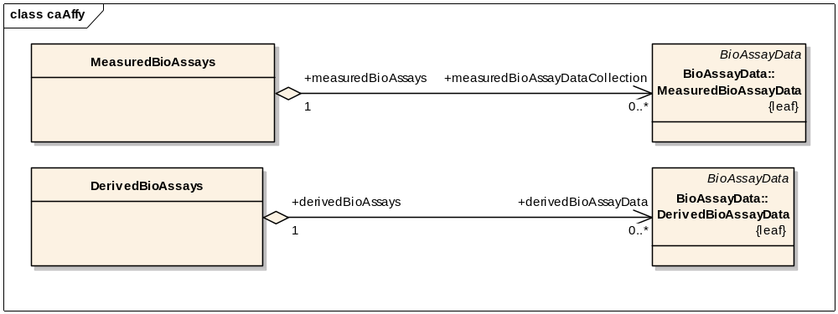Figure 2 MAGE entry point in caAffy

Additional data models
Our remaining analytic services define new data types to represent inputs and outputs.
The caDNAcooy service operates on vectors of relative expression values and chromosomal locations (ExpressionData) from several samples (DNAcopyAssays); results are line segments of common copy number (DerivedDNAcopySegment)
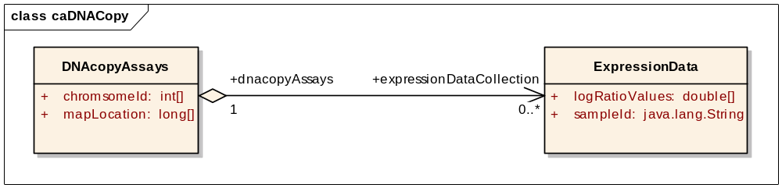
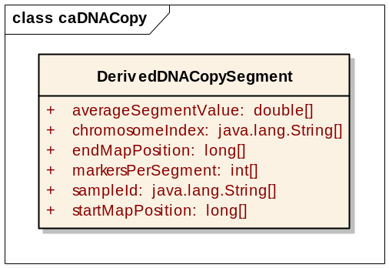
Figure 3 DNAcopyAssays (input) and DerivedDNACopySegment (output) to caDNAcopy
The caPROcess service operates on spectra (MzSpectrum) from several samples (MzAssays), identifying spectrum peak locations in the return value (PeakLocation):
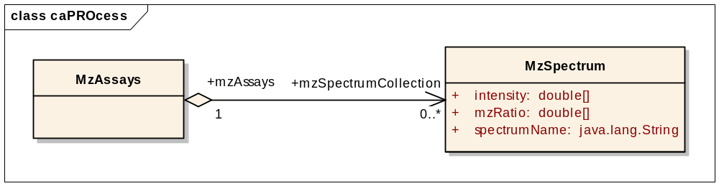
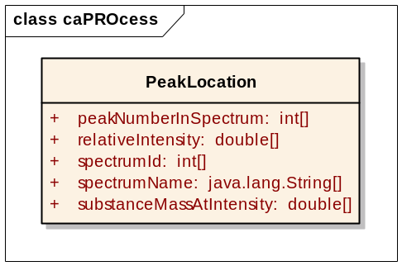
Figure 4 MzAssays (input) and PeakLocation (output) to caPROcess

Service parameter data models
The caAffy expresso service parameter data model is relatively complex, with parameters to several different normalization methods represented as classes derived from a common base. The model also makes use of value domains to enumerate possible values.
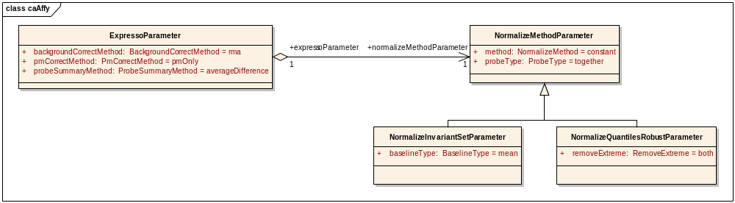
Figure 5 caAffy expresso service parameter models
Remaining parameter models are straight-forward, as detailed in the UML model.

Grid and Web Services
This chapter includes necessary information for accessing and using web and grid services, pointing to exemplar services for illustrative material, and to standard web and caGrid service documentation. Topics addressed include:
- Error: Reference source not found
- Configuring and using web and grid services
- Additional integration with caGrid
- Configuring the analytic back-end

Accessing service descriptions
Web service descriptions are generated by the ant ws task, and are present in the wsdl directory created by that task. Deployed Service descriptions are available through standard means. For instance, the WSDL description of a service on localhost is available as
http://localhost:8080/axis/services/<service-name>?wsdl
Grid service descriptions are available as documented by caGrid.

Configuring and using web and grid services
Correctly deployed web and grid services are accessible through standard ways (e.g., http://www.cagrid.org/). A simple client invoking each service is available in exemplar web and grid packages.
The location of the web client is
test/src/org/bioconductor/rserviceJms/services/<pkg>/<pkg>Test.java
Configuration for connecting to services is through the RWebServicesEnv.properties file. Important properties include the style and use of wsdl generated (wsdl.style, wsdl.use).
The grid client is at
src/org/bioconductor/cagrid/cadnacopy/client/<pkg>Client.java.
with configuration as described on the caGrid web site.

Additional integration with caGrid
Services deployed to caGrid can be configured for additional security, and to exploit other aspects of caGrid technology such as advertising availability. These aspects of caGrid integration are described in caGrid user documents available from the web site referenced above.

Configuring the analytic back-end
The analytic back-end consists of the activeMQ and R/Java worker software components. The web or grid service container, activeMQ, and the R/Java worker can be on the same or different machines. A typical installation places the service container outside a firewall on a dedicated server. activeMQ and the R/Java workers are inside the firewall. The server is configured to allow communication with activeMQ, and activeMQ and the workers configured to communicate with each other. Configuration is managed through the RWebServicesTuning.properties and RWebServicesEnv.properties files.
Properties available when the project is compiled are in the RWebServicesTuning.parameters file. The main options available for configuration are:
jms.timeout
- The timeout for service requests to be fulfilled.
- Default: 60 seconds
- Rationale: This provides a mechanism for limiting duration of service execution; the R / Java worker does NOT time-out, but the user receives notification that the request exceeds available time.
jms.gueue
- The queue name for messages to be posted to (by the service) and retrieved from (by the workerdefault BIOC).
- Default: BIOC
- Rationale: Deploying distinct services with separate queue names allows services and workers to specialize on particular tasks without requiring multiple activeMQ servers. For instance, a caDNAcopy service/worker pair might communicate on queue caDNAcopyQueue, whereas a caPROcess service and several caPROcess workers might communicate on queue caPROcessQueue.
Properties available for configuration at deployment include
jms.hostname
- The host name of the activeMQ server (jms.host) and port for establishing communication (jms.port, default 61616).
- Defualt: localhost
- Rationale: usually, a single activeMQ server instance will queue all service requests
jms.port
- The port on which activeMQ communicates.
- Defualt: 61616
- Rationale: This port must be available to the web or grid server, and to the workers. If two activeMQ instances are run simultaneously (e.g., by different users) then the ports used by each instance must be different
Additional activeMQ configuration is possible through the configuration files for the server, as documented at http://activemq.apache.org. An example of a configuration at this level is message persistence. The recommended configuration is to disable message persistence. This means that service requests that fail to execute (e.g., because of a severe system error in the R/Java worker) are not passed to additional workers; the user eventually receives a (configurable) service time-out error.

Appendices
- References

Bioconductor / R
- Bioconductor: http://bioconductor.org
- R: http://www.r-project.org

Software dependencies
- caGrid: http://www.cagrid.org
- Java: http://java.sun.com
- ant: http://ant.apache.org
- Apache tomcat: http://tomcat.apache.org
- Apache axis: http://ws.apache.org/axis
- Apache activeMQ: http://activemq.apache.org

caBIG
- caBIG: http://cabig.nci.nih.gov/
- caBIG Compatibility Guidelines: http://cabig.nci.nih.gov/guidelines_documentation
- caBIO: http://ncicb.nci.nih.gov/core/caBIO
- caDSR: http://ncicb.nci.nih.gov/core/caDSR
- EVS: http://ncicb.nci.nih.gov/core/EVS
- Glossary
Term | Definition
{jboss-home} | The base directory where JBoss is installed on the server
API | Application Programming Interface
caArray | cancer Array Informatics
caBIG | cancer Biomedical Informatics Grid
caBIO | Cancer Bioinformatics Infrastructure Objects
caCORE | cancer Common Ontologic Representation Environment
caDSR | Cancer Data Standards Repository
CDE | Common Data Element
EA | Enterprise Architect
EVS | Enterprise Vocabulary Services
JAR | Java Archive
Javadoc | Tool for generating API documentation in HTML format from doc comments in source code (http://java.sun.com/j2se/javadoc/)
JUnit | A simple framework to write repeatable tests (http://junit.sourceforge.net/)
MAGE | MicroArray and Gene Expression
MAGE-OM | MicroArray Gene Expression - Object Model
NCI | National Cancer Institute
NCICB | National Cancer Institute Center for Bioinformatics
SDK | Software Development Kit
URL | Uniform Resource Locators
WSDL | Web Services Description Language
XMI | XML Metadata Interchange (http://www.omg.org/technology/documents/formal/xmi.htm) - The main purpose of XMI is to enable easy interchange of metadata between modeling tools (based on the OMG-UML) and metadata repositories (OMG-MOF) in distributed heterogeneous environments
XML | Extensible Markup Language (http://www.w3.org/TR/REC-xml/) - XML is a subset of Standard Generalized Markup Language (SGML). Its goal is to enable generic SGML to be served, received, and processed on the Web in the way that is now possible with HTML. XML has been designed for ease of implementation and for interoperability with both SGML and HTML

http://www.mged.org/Workgroups/MAGE/mage-om.html

