GenePattern Grid Extensions v.1.0
Title of Publication

Technical Guide

Document Change History
Version Number | Date | Contributor | Description
V1.0 | 11/23/2006 | Ted Liefeld | initial revision
V1.1 | 1/17/2007 | Ted Liefeld | Updates per initial review of technical architecture section and additional detail in installation section
V1.3 | 2/5/07 | Jared Nedzel  Ted Liefeld | Updated installation chapter and replaced GenePattern default license with caBIG GenePattern license
V1.4 | 2/12/07 | Ted Liefeld | First draft of Administration guide chapter
V1.5 | 2/02/07 | Ted Liefeld | Final edits to admin, architecture and install guides for submission for review
V1.6 | 2/20/07 | Ted Liefeld | Updates per final review
V1.7 | 2/23/07 | Ted Liefeld | Changed font color in document change history


Updated February 20, 2007
Copyright and License page
Copyright 2005 The Broad Institute of MIT and Harvard ("The Broad Institute"). The software subject to this notice and license includes both human readable source code form and machine readable, binary, object code form ("the Software"). The Software was developed in conjunction with the National Cancer Institute ("NCI") by employees of The Broad Institute. To the extent government employees are authors, any rights in such works shall be subject to Title 17 of the United States Code, section 105.

This Software License (the "License") is between The Broad Institute (the “Licensor”) and You. "You (or "Your") shall mean a person or an entity, and all other entities that control, are controlled by, or are under common control with the entity. "Control" for purposes of this definition means (i) the direct or indirect power to cause the direction or management of such entity, whether by contract or otherwise, or (ii) ownership of fifty percent (50%) or more of the outstanding shares, or (iii) beneficial ownership of such entity.
This License is granted provided that You agree to the conditions described below. The Broad Institute grants You a non-exclusive, worldwide, perpetual, fully-paid-up, no-charge, irrevocable, transferable and royalty-free right and license in its rights in the Software to (i) use, install, access, operate, execute, copy, modify, translate, market, publicly display, publicly perform, and prepare derivative works of the Software; (ii) distribute and have distributed to and by third parties the Software and any modifications and derivative works thereof; and (iii) sublicense the foregoing rights set out in (i) and (ii) to third parties, including the right to license such rights to further third parties. For sake of clarity, and not by way of limitation, Licensor shall have no right of accounting or right of payment from You or Your sublicensees for the rights granted under this License. This License is granted at no charge to You.
1. Your redistributions of the source code for the Software must retain the above copyright notice, this list of conditions and the disclaimer and limitation of liability of Article 6, below. Your redistributions in object code form must reproduce the above copyright notice, this list of conditions and the disclaimer of Article 6 in the documentation and/or other materials provided with the distribution, if any.
2. Your end-user documentation included with the redistribution, if any, must include the following acknowledgment: "This product includes software developed by The Broad Institute of MIT and Harvard." If You do not include such end-user documentation, You shall include this acknowledgment in the Software itself, wherever such third-party acknowledgments normally appear.
3. You may not use the names "The Broad Institute", "MIT", "Harvard" and "The Broad Institute of MIT and Harvard" to endorse or promote products derived from this Software. This License does not authorize You to use any trademarks, service marks, trade names, logos or product names of The Broad Institute, MIT, or Harvard, except as required to comply with the terms of this License.
4. For sake of clarity, and not by way of limitation, You may incorporate this Software into Your proprietary programs and into any third party proprietary programs. However, if You incorporate the Software into third party proprietary programs, You agree that You are solely responsible for obtaining any permission from such third parties required to incorporate the Software into such third party proprietary programs and for informing Your sublicensees, including without limitation Your end-users, of their obligation to secure any required permissions from such third parties before incorporating the Software into such third party proprietary software programs. In the event that You fail to obtain such permissions, You agree to indemnify the Licensor for any claims against the Licensor by such third parties, except to the extent prohibited by law, resulting from Your failure to obtain such permissions.
5. For sake of clarity, and not by way of limitation, You may add Your own copyright statement to Your modifications and to the derivative works, and You may provide additional or different license terms and conditions in Your sublicenses of modifications of the Software, or any derivative works of the Software as a whole, provided Your use, reproduction, and distribution of the Work otherwise complies with the conditions stated in this License.
6. THIS SOFTWARE IS PROVIDED "AS IS," AND ANY EXPRESSED OR IMPLIED WARRANTIES, (INCLUDING, BUT NOT LIMITED TO, THE IMPLIED WARRANTIES OF MERCHANTABILITY, NON-INFRINGEMENT AND FITNESS FOR A PARTICULAR PURPOSE) ARE DISCLAIMED. IN NO EVENT SHALL THE BROAD INSTITUTE, HARVARD, MIT, OR THEIR AFFILIATES BE LIABLE FOR ANY DIRECT, INDIRECT, INCIDENTAL, SPECIAL, EXEMPLARY, OR CONSEQUENTIAL DAMAGES (INCLUDING, BUT NOT LIMITED TO, PROCUREMENT OF SUBSTITUTE GOODS OR SERVICES; LOSS OF USE, DATA, OR PROFITS; OR BUSINESS INTERRUPTION) HOWEVER CAUSED AND ON ANY THEORY OF LIABILITY, WHETHER IN CONTRACT, STRICT LIABILITY, OR TORT (INCLUDING NEGLIGENCE OR OTHERWISE) ARISING IN ANY WAY OUT OF THE USE OF THIS SOFTWARE, EVEN IF ADVISED OF THE POSSIBILITY OF SUCH DAMAGE.

Development Team(s)
Development | Programmer’s guide | Program Management
Jared Nedzel | Ted Liefeld | Ted Liefeld
Alan Su | Heidi Kuehn | Michael Reich
Ted Liefeld | Jared Nedzel | Jill P. Mesirov
Joshua Gould
The Broad Institute of MIT and Harvard

Contacts and Support
gp-help@broad.mit.edu | http://www.genepattern.org

LISTSERV Facilities Pertinent to software teams
LISTSERV | URL | Name
GenePattern User Forum | http://www.broad.mit.edu/cancer/software/genepattern/forum/ | GenePattern User Forum

Table of Contents
Chapter 1 Introduction to the GenePattern Grid Extensions Technical Guide 3
Overview of the Guide 3
Chapter 2 Overview of GenePattern and the GenePattern Grid Extensions Project 5
GenePattern Overview 5
Modules 6
Pipelines 6
Programming Interfaces 6
Availability 7
GenePattern System Requirements 7
GenePattern Grid Extensions Overview 7
Primary Components 7
Modules to be Published 8
GenePattern Grid Extensions System Requirements 8
Design and Architecture 8
Chapter 3 GenePattern Grid Extensions Installation 11
GenePattern Installation 11
GenePattern Grid Extensions Installation 11
Install Modules 11
Prerequisites 13
Configure Environment Variables 13
Deploy Globus to Tomcat 14
Install caGRID Application Proxy 14
Install Services 14
Testing the Installation 15
Chapter 4 GenePattern Grid Extensions Requirements 17
Chapter 5 GenePattern Grid Extensions Design and Architecture 19
System Architecture Overview 19
Deployment Architecture 20
Architectural Design 20
Chapter 6 Security and Security Management 23
Chapter 7 GenePattern Grid Extensions APIs 25
Preprocess Dataset 25
Input Parameters 25
Expected Outputs 26
Example Usage (Java) 27
Consensus Clustering 28
Input Parameters 28
Expected Outputs 29
Example Usage (Java) 29
Comparative Marker Selection 30
Input Parameters 30
Expected Outputs 31
Example Usage (Java) 32
Chapter 8 Information Models 35
Chapter 9 Administration 39
Administrating GenePattern 39
Administrating caGrid Services 39
Administrating GenePattern Grid Extensions 39
Configure Environment Variables 39
Configuring GenePattern Server 39
Adjusting Tomcat Memory 41
Appendix A References 43
Technical Manuals/Articles 43
Scientific Publications 43
caBIG Material 44
caCORE Material 44
Appendix B Glossary 45
Index 49

Introduction to the GenePattern Grid Extensions Technical Guide
The GenePattern Grid Extensions Technical Architecture Guide (henceforth the guide) is the primary technical documentation for the GenePattern grid extensions project in caBIG. The purpose of this project is to extend the GenePattern system and server to provide caGRID analytical services on caGRID. This guide aids bioinformaticists, computational biologists, and intermediate level java developers who are interested in connecting to and using GenePattern modules as caGRID analytical services.
Before continuing, note the following points about this GenePattern Grid Extensions Technical Architecture Guide:
- While some information in the installation and use of GenePattern itself is presented here, primary documentation for the installation and use of GenePattern outside of caBIG is covered in the installation instructions and tutorial available online at http://www.genepattern.org.
- This document contains no information on the topics of Java Programming or Object Oriented programming in the abstract.
- This document contains no information on the development or deployment of caGRID analytical services.
Users wanting more information about these topics are referred to the documentation noted above and the appendix.

Overview of the Guide
The GenePattern Grid Extensions Technical Architecture Guide contains the following chapters:
- Chapter 1, Introduction to the GenePattern Grid Extensions Technical Guide – this chapter provides information about using this guide.
- Chapter 2, Overview of GenePattern and the GenePattern Grid Extensions Project – this chapter provides an introductory overview of the GenePattern system, its capabilities, and the goals of the GenePattern Grid Extensions caBIG project.
- Chapter 3, GenePattern Grid Extensions Installation – This chapter describes briefly the process to install a GenePattern server and provides detail on the installation of GenePattern grid extensions into an existing GenePattern server.
- Chapter 4, GenePattern Grid Extensions Requirements – This chapter details the dependencies and requirements for using the GenePattern grid extensions tools.
- Chapter 5, GenePattern Grid Extensions Design and Architecture – This chapter details the design and architecture implemented to allow GenePattern modules to be exposed as caGRID analytic services.
- Chapter 6, Security and Security Management – This chapter details the interactions of the GenePattern grid extensions project with the caGRID security mechanisms.
- Chapter 7, GenePattern Grid Extensions API – This chapter details the APIs of the GenePattern modules exposed as caGRID analytical services during the first year implementation.
- Chapter 8, Information Models – This chapter describes the UML information models used for the GenePattern modules exposed as caGRID analytical services during the first year implementation.
- Chapter 9, Administration – This chapter covers the administration of the GenePattern Grid Extensions system.

Overview of GenePattern and the GenePattern Grid Extensions Project
Topics in this chapter include:
- GenePattern Overview
- GenePattern Grid Extensions Overview
- Design and Architecture

GenePattern Overview
GenePattern is a flexible analysis platform developed to support multidisciplinary biomedical research. GenePattern puts the power of sophisticated computational methods into the hands of non-programming users. It also provides an environment for rapid development and deployment of new analytic techniques.
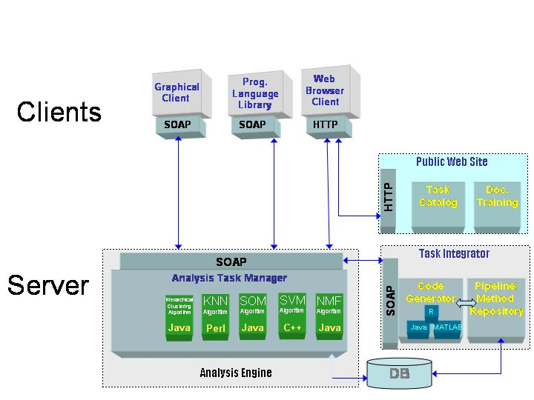

Figure 1 GenePattern system architecture.

Modules
GenePattern has a modular architecture that allows the inclusion of additional analytic or visualization modules. To be integrated into GenePattern, modules must provide a command-line interface allowing them to be called and have parameters passed to them from a normal command line. This facilitates the independent development and testing of Modules external to the GenePattern environment. As of November 2006, GenePattern includes approximately 70 analytic modules and visualizers.

Pipelines
GenePattern facilitates the creation of analysis workflows via pipelines. GenePattern pipelines allow you to capture, automate, and share the complex series of steps required to analyze genomic data. By providing a way to create and distribute an entire computational analysis methodology in a single executable script, pipelines enable a form of in silico reproducible research.
Pipelines capture computational analysis methods and their parameters. They allow you to “chain” methods by using the output of one as the input of another. You can use a simple form-based interface to build a pipeline from scratch, or have GenePattern work backward from an analysis results file to create a pipeline that contains the analysis methods used to generate that file. You can create a pipeline to reproduce an exact set of events, or parameterize the pipeline to run an analysis methodology against variable data.
Since pipelines are easily exported and imported from GenePattern, you can share them with colleagues who would like to reproduce your results or use them to document published research. By versioning every pipeline and each of its methods, GenePattern ensures that you can reproduce previous analysis results even if you modify the pipeline.

Programming Interfaces
GenePattern provides three user interface options:
- a simple application interface that gives users access to computational analysis methods and tools, regardless of their computational experience.
- a web service SOAP interface to make the analysis modules available to computational biologists and developers from any SOAP enabled programming language.
- a programmatic interface that wraps the SOAP interface that makes using analysis modules simpler from Java, MATLAB, and R.
If you are writing analysis modules to be added to GenePattern, you can use Java, MATLAB, R, or any other programming language. The GenePattern server provides links to GenePattern libraries, which provide access to GenePattern from the Java, MATLAB, and R programming environments. You can use the library functions to run analysis modules on the server, check the job status, and retrieve analysis result files. The analysis results files are then available for processing in the programming environment of your choice.
The GenePattern server also provides documentation of each analysis module and its parameters. Additionally, you can use the GenePattern application interface to generate the code (Java, MATLAB, or R) required to run the desired analysis.

Availability
GenePattern has been publicly available since January 2003. Development of the GenePattern Server and most of its modules has been supported by NIH grants outside of the caBIG system and development of the GenePattern server and modules remains external to caBIG. Currently (11/06) GenePattern is in use by over 3500 individuals in 500+ organizations throughout the world. While it is primarily used for micro array and proteomic analysis, GenePattern has also been adapted for use in computational chemistry, materials science and other application areas.

GenePattern System Requirements
OS compatibility:
- Windows: XP, 2000, 2003
- Mac: OS X 1.3.9 or later
- Unix: Linux, Solaris, Tru64
Hardware requirements:
- 256MB RAM
- 500MB disk space

GenePattern Grid Extensions Overview
The purpose of this project is to make several GenePattern analysis modules available as analytical services on caGRID. The design is intended to provide a tool set for GenePattern developers that is sufficient to allow additional GenePattern modules to be exported to caGRID easily provided that suitable CDEs exist to represent their data types and parameters.

Primary Components
The GenePattern Grid Extensions project consists of two primary components; the caGRID Module Publisher and the caGRID Proxy Application.
The caGRID Module Publisher is a software tool that will partially automate the process of creating the caGRID Proxy Application for the specified modules. It will provide the means to make the XML document used by the Introduce toolkit to create the grid service layer of the proxy application and also provide the necessary mapping between GenePattern SOAP calls and caGRID calls.
The caGRID Proxy Application is an application proxy layer that ‘speaks’ both caGRID protocols and the GenePattern web service protocol and makes the necessary translations between objects in the two protocols. This service will be deployed as a web application in a servlet container (like a GenePattern server), receive caGRID requests to the published GenePattern modules, reformulate the request as a GenePattern web service call, call the GenePattern module and reformat the GenePattern response as a caGRID response which will be returned to the caGRID caller.

Modules to be Published
The GenePattern Grid Extensions project will use these tools to publish three GenePattern modules as caGRID analytical services; PreprocessDataset, ComparativeMarkerSelection and ConsensusClustering.
The PreprocessDataset module performs a variety of pre-processing operations including thresholding/ceiling, variation filter, discretization and normalization.
The ComparativeMarkerSelection module includes several approaches to determine the features that are most closely correlated with a class template and the significance of that correlation. If the input class template has more than two classes, than a one-versus-all comparison is performed for each class. Note that the p-values obtained from the one-versus-all comparison are not fully corrected for multiple hypothesis testing.
The ConsensusClustering module is a resampling based clustering method that provides for a method to represent the consensus across multiple runs of a clustering algorithm and to assess the stability of the discovered clusters. To this end, perturbations of the original data are simulated by resampling techniques. The clustering algorithm of choice is applied to each of the perturbed data sets, and the agreement, or consensus, among the multiple runs is assessed and summarized in a consensus matrix.

GenePattern Grid Extensions System Requirements
The GenePattern Grid Extensions software requires the installation of a GenePattern server and has the same specific requirements as the GenePattern server.
OS compatibility:
- Windows: XP, 2000, 2003
- Mac: OS X 1.3.9 or later
- Unix: Linux, Solaris, Tru64
Hardware requirements:
- 256MB RAM
- 500MB disk space

Design and Architecture
For detailed information about the design of the GenePattern Grid Extensions project, please refer to the Software Requirements and Specifications document at http://cabigcvs.nci.nih.gov/viewcvs/viewcvs.cgi/genepattern/gridExtensions_y3/specifications/GenePatternCaGRIDAnalysisService_SRSS.doc
The architectural design is divided into two primary new components. The caGRID proxy application which provides the functionality of proxying GenePattern into caGRID, and the caGRID module publisher, which provides the function of mapping a GenePattern module into the XML file used by the caGRID Introduce toolkit which will then be used to create the analysis proxy.
The caGRID Proxy Application is an application proxy layer that ‘speaks’ both caGRID protocols and the GenePattern web service protocol and makes the necessary translations between objects in the two protocols. It will be deployed as a web application in a servlet container (normally the same servlet container used by the GenePattern server), receive caGRID requests to the published GenePattern modules, reformulate the request as a GenePattern web service call, call the GenePattern module and reformat the GenePattern response as a caGRID response which will be returned to the caGRID caller.
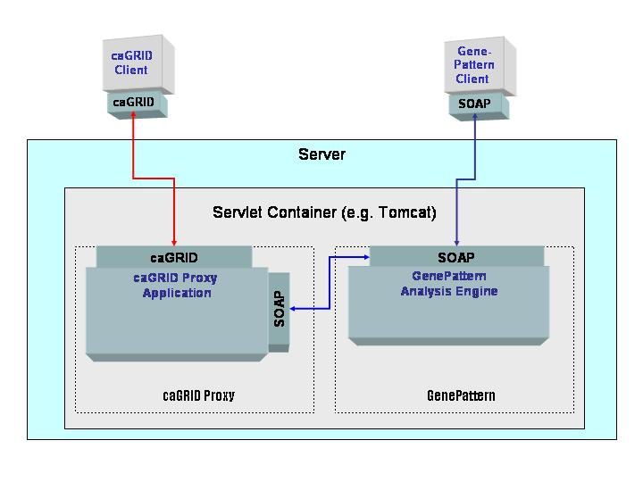
Figure 2 caGRID Proxy and GenePattern deployment architecture

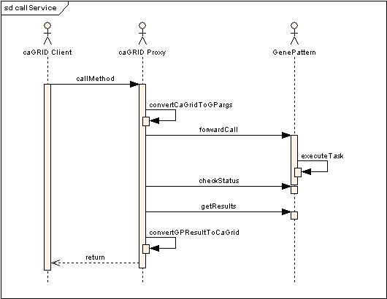
Figure 3 caGRID proxy and GenePattern call diagram

GenePattern Grid Extensions Installation
Topics in this chapter include:
- GenePattern Installation
- GenePattern Grid Extensions Installation

GenePattern Installation
This document provides only a brief overview of GenePattern installation. Refer to the online GenePattern installation guide at http://www.genepattern.org for complete detailed instructions on GenePattern server installation for windows, Macintosh, Linux and other platoforms.
The first installation step is to download the GenePattern installer by registering at www.genepattern.org. Start the installation program (e.g. GPServer.exe, .bin etc).
Proceed through the steps of the installation program to set the directory to install the GenePattern server, ports to run on, and so on. The last step of the installer is to open a web browser connected to the GenePatern server that describes the final installation steps. Ensure that these steps (particularly installing GenePattern modules) are performed.

GenePattern Grid Extensions Installation
To run the GenePattern Grid Extensions, the caGRID Proxy application needs to be installed into a servlet container. It is recommended that you use the same servlet container as the GenePattern installation itself though this is not strictly required. The following installation instructions assume that you will install into the same servlet container as GenePattern.

Install Modules
The first step is to ensure that the GenePattern server contains the three GenePattern analysis modules that are to be used on caGRID. The specific version of the modules to be used are to be exported on caGRID. The specific module versions that must be present on the GenePattern server are:
PreProcessDataset version 2
urn:lsid:broad.mit.edu:cancer.software.genepattern.module.analysis:00020:2
ComparativeMarkerSelection version 3
urn:lsid:broad.mit.edu:cancer.software.genepattern.module.analysis:00044:3
ConsensusClustering version 1
urn:lsid:broad.mit.edu:cancer.software.genepattern.module.analysis:00030:1
If these modules and versions are not yet present on the GenePattern server, install them by navigating your browser to the Install Modules and Pipelines page:
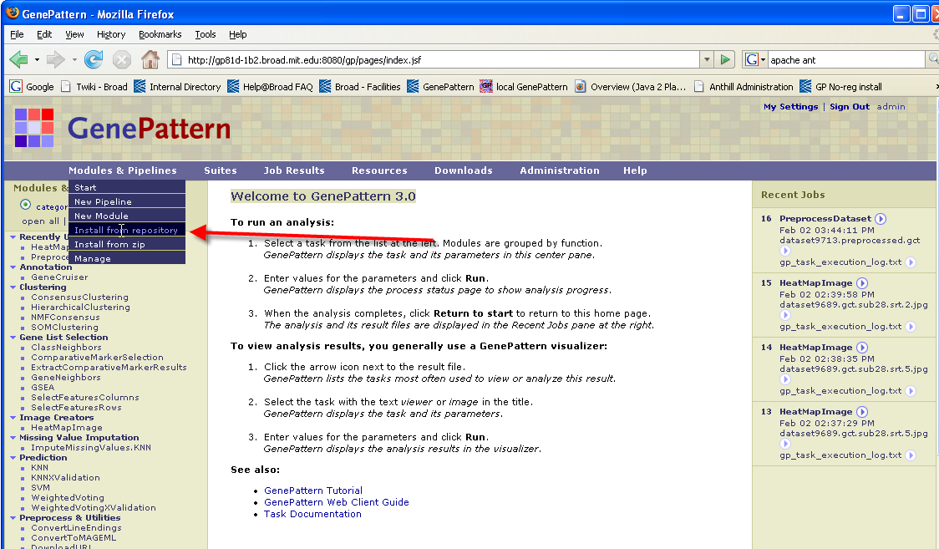
From the Install Modules and Pipelines page, set the filters to show tasks that are “up to date” and then scroll down to select the three modules individually (PreprocessDataset, ComparativeMarkerSelection, ConsensusClustering) click the checkbox next to the modules, select the appropriate versions and then finally click the “install checked” button to cause these modules to be loaded into the GenePattern server.
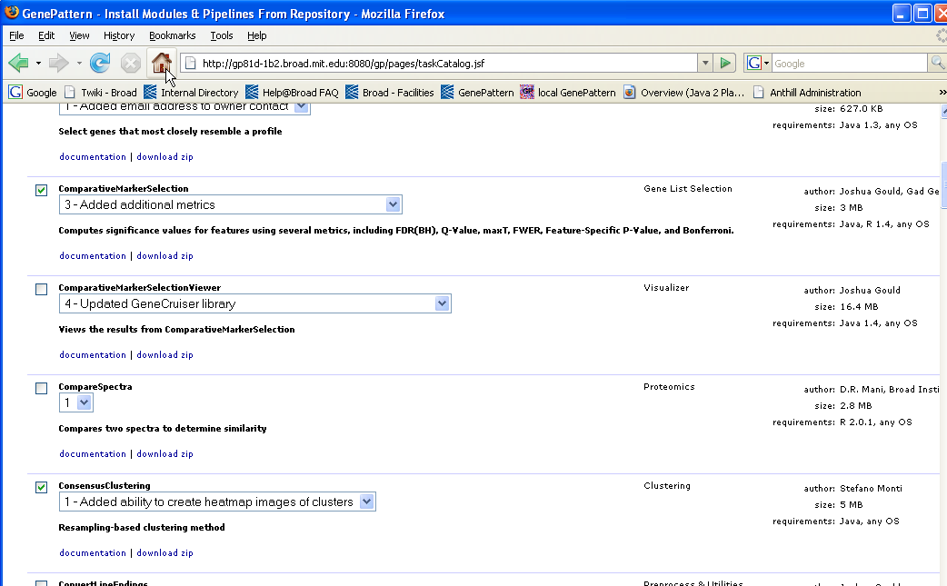

Prerequisites
In addition to GenePattern, you must install Apache Ant 1.6.5, caGrid, and a Java SDK 1.5.x:
- Apache Ant can be downloaded from the Apache site: http://ant.apache.org/
- The Java SDK can be downloaded from Sun’s site: http://java.sun.com

Configure Environment Variables
Four environment variables are required for proper installation of the GenePattern Grid Extensions, as shown in the table below. On a Linux machine, set these environment variables using a script. On a Windows machine, use Start -> Control Panel -> System. Choose the Advanced Tab, Environment Variables button, and then add a new System Variable.
Variable Name | Value
CATALINA_HOME | <GenePattern directory>/Tomcat
ANT_HOME | <Ant directory>
JAVA_HOME | <Java SDK 1.5.x directory>
GLOBUS_LOCATION | <Globus directory>

Deploy Globus to Tomcat
Once Globus is installed and the environment variables have been set, deploy Globus to the GenePattern Tomcat instance, using a command shell. On a Windows machine, open a command shell using Start -> run…, then enter “cmd”. Navigate to your Globus installation directory. Then type:
ant –f share\globus_wsrf_common\tomcat\tomcat.xml deployTomcat
–Dtomcat.dir=%CATALINA_HOME%
On a Linux machine, use:
ant –f share/globus_wsrf_common/tomcat/tomcat.xml deployTomcat
–Dtomcat.dir=$CATALINA_HOME

Install caGRID Application Proxy
The second and final step for installing the GenePattern Grid Extensions is to install the caGRID Application proxy into the GenePattern application server.
Download the caGridProxy from the caBIG CVS site under http://cabigcvs.nci.nih.gov/viewcvs/viewcvs.cgi/genepattern/gridExtensions_y3.
If your GenePattern installation is not running on port 8080, then you will need to edit the IntegrationServlet.java file in directory <caGridProxy home>/src/org/genepattern/integration. Change the line that reads:
public static final String GENEPATTERN_URL = "http://localhost:8080";
as needed to properly reflect the port that you are using.
Open up a command shell. Navigate to the directory where you placed the caGridProxy. Then type:
ant
This will compile the caGridProxy and deploy it to GenePattern.

Install Services
Download the code for the Preprocess Dataset, Comparative Marker Selection, and Consensus Clustering services from the caBIG CVS site:
http://cabigcvs.nci.nih.gov/viewcvs/viewcvs.cgi/genepattern/gridExtensions_y3.
If your GenePattern installation is not on port 8080, then you will need to edit a number of files, changing the “8080” entries to your chosen port. For Comparative Marker Selection, edit the following files:
./src/org/genepattern/cabig/service/compmarker/statml/service/GenePattern.properties
./build/schema/ComparativeMarkerSelSTATMLSvc/ComparativeMarkerSelSTATMLSvc_service.wsdl
./build/schema/wsrf/lifetime/WS-ResourceLifetime_service.wsdl
./build/schema/wsrf/notification/WS-BaseN_service.wsdl
./build/schema/wsrf/properties/WS-ResourceProperties_service.wsdl
./build/schema/wsrf/servicegroup/WS-ServiceGroup_service.wsdl
./build/stubs-ComparativeMarkerSelSTATMLSvc/classes/org/genepattern/cabig/service/compmarker/statml/stubs/service/ComparativeMarkerSelSTATMLSvcServiceLocator.class
./build/stubs-ComparativeMarkerSelSTATMLSvc/src/org/genepattern/cabig/service/compmarker/statml/stubs/service/ComparativeMarkerSelSTATMLSvcServiceLocator.java
./run-tools.xml
For ConsensusCluster, edit the following files:
./src/org/genepattern/cagrid/service/consensuscluster/statml/service/GenePattern.properties
./build/schema/ConsensusClusteringSTATMLService/ConsensusClusteringSTATMLService_service.wsdl
./build/schema/wsrf/lifetime/WS-ResourceLifetime_service.wsdl
./build/schema/wsrf/notification/WS-BaseN_service.wsdl
./build/schema/wsrf/properties/WS-ResourceProperties_service.wsdl
./build/schema/wsrf/servicegroup/WS-ServiceGroup_service.wsdl
./build/stubs-ConsensusClusteringSTATMLService/classes/org/genepattern/cagrid/service/consensuscluster/statml/stubs/service/ConsensusClusteringSTATMLServiceLocator.class
./build/stubs-ConsensusClusteringSTATMLService/src/org/genepattern/cagrid/service/consensuscluster/statml/stubs/service/ConsensusClusteringSTATMLServiceLocator.java
./run-tools.xml
For PreprocessDataset, edit the following files:
./src/org/genepattern/cagrid/service/preprocessdataset/statml/service/GenePattern.properties:submitTaskUrl=http://localhost:8080/gpintegration/submitTask
./build/schema/PreprocessDatasetSTATMLService/PreprocessDatasetSTATMLService_service.wsdl
./build/schema/wsrf/lifetime/WS-ResourceLifetime_service.wsdl
./build/schema/wsrf/notification/WS-BaseN_service.wsdl
./build/schema/wsrf/properties/WS-ResourceProperties_service.wsdl
./build/schema/wsrf/servicegroup/WS-ServiceGroup_service.wsdl
./build/stubs-PreprocessDatasetSTATMLService/classes/org/genepattern/cagrid/service/preprocessdataset/statml/stubs/service/PreprocessDatasetSTATMLServiceLocator.class
./build/stubs-PreprocessDatasetSTATMLService/src/org/genepattern/cagrid/service/preprocessdataset/statml/stubs/service/PreprocessDatasetSTATMLServiceLocator.java
./run-tools.xml
Now build and deploy each of these services. To do so, open a shell prompt, navigate to the service directory, and type:
ant all
ant deployTomcat
This must be done for each service.

Testing the Installation
To test the installation, first start GenePattern. In a command-shell, navigate to the Preprocess Dataset service directory and type:
ant runClient
The output should be:
$ ant runClient
Buildfile: build.xml

setGlobus:

checkGlobus:
[echo] Globus: C:\tools\caGrid-1.0-beta\ws-core-4.0.2

defineClasspaths:

runClient:
[echo] Connecting to service: http://localhost:8080/wsrf/services/cagrid/PreprocessDatasetSTATM
LService
[java] JVM args ignored when same JVM is used.
[java] Running the Grid Service Client
[java] i=[0] rowName=[gene 1] rowDescription=[gene 1 description]
[java] i=[1] rowName=[gene 2] rowDescription=[gene 2 description]
[java] index=[0] colName=[Sample 1]
[java] value=[<statml><scalar type="double">1.1</scalar><scalar type="double">1.2</scalar></sta
tml>]
[java] index=[1] colName=[Sample 2]
[java] value=[<statml><scalar type="double">2.1</scalar><scalar type="double">2.2</scalar></sta
tml>]
[java] index=[2] colName=[Sample 3]
[java] value=[<statml><scalar type="double">3.1</scalar><scalar type="double">3.2</scalar></sta
tml>]
[java] i=[0] row name=[gene 1] row description=[gene 1 description]
[java] i=[1] row name=[gene 2] row description=[gene 2 description]
[java] j=[0] column name=[Sample 1]
[java] j=[1] column name=[Sample 2]
[java] j=[2] column name=[Sample 3]
[java] i=[0] j=[0] value=[1.1]
[java] i=[0] j=[1] value=[2.1]
[java] i=[0] j=[2] value=[3.1]
[java] i=[1] j=[0] value=[1.2]
[java] i=[1] j=[1] value=[2.2]
[java] i=[1] j=[2] value=[3.2]

BUILD SUCCESSFUL
Total time: 15 seconds
Similar test clients can be run in the Comparative Marker Selection and Consensus Cluster directories.

GenePattern Grid Extensions Requirements
For detailed descriptions of the GenePattern Grid Extensions requirements, refer to the software requirements and specifications (SRSS) document GenePatterncaGRIDAnalysisService_SRSS.doc available for download from ttp://cabigcvs.nci.nih.gov/viewcvs/viewcvs.cgi/genepattern/gridExtensions_y3/specifications/.

Table 1: caGRID Proxy Application Requirements
Req ID | Requirement Type | Requirement Description | Qualification
2.4.1.1 | User | Publish Preprocess Dataset module to caGRID registry | Demonstration – visibility of Preprocess Dataset analysis service in caGRID registry
2.4.1.2 | User | Publish CMS module to caGRID registry | Demonstration – visibility of CMS analysis service in caGRID registry
2.4.1.3 | User | Publish GSEA module to caGRID registry | Demonstration – visibility of GSEA analysis service in caGRID registry
2.4.2.1 | User | call Preprocess dataset module as a grid service | Demonstration – call the module from a caGRID UI
2.4.2.2 | User | call CMS module as a grid service | Demonstration – call the module from a caGRID UI
2.4.2.3 | User | call GSEA module as a grid service | Demonstration – call the module from a caGRID UI

GenePattern Grid Extensions Design and Architecture
Topics in this chapter include:
- System Architecture Overview
- Deployment Architecture
- Architectural Design

System Architecture Overview
The existing GenePattern system architecture consists of a web application running in a servlet container that makes its analysis modules available via SOAP interfaces to many different client implementations (See figure 4.1)
Figure 4 GenePattern System Architecture
In the context of this development project, the caGRID Proxy Application will be simply another client to the existing GenePattern application interfaces. Essentially it will be a web application that presents one or more caGRID Analysis Service Interfaces to the caGRID and which consumes services from GenePattern via the GenePattern SOAP interfaces.

Deployment Architecture
The caGRID Proxy Application will be developed and deployed as a web application within a servlet container. The targeted deployment configuration will be to deploy the caGRID Proxy Application within the same servlet engine as the GenePattern system that it communicates with.
Figure 5 caGRID Proxy and GenePattern deployment architecture

Architectural Design
The architectural design is divided into two primary new components. The caGRID proxy application which provides the functionality of proxying GenePattern into caGRID, and the caGRID module publisher, which provides the function of mapping a GenePattern module into the XML file used by the caGRID Introduce toolkit which will then be used to create the analysis proxy.
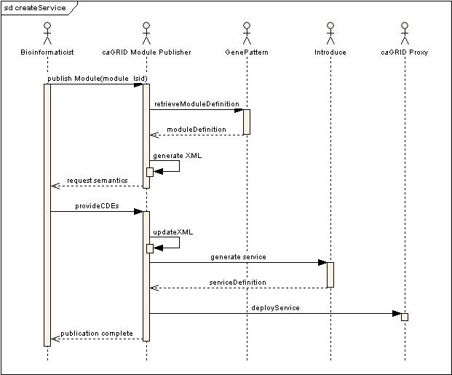
Figure 6 createService call diagram
Figure 7 executeTask call diagram

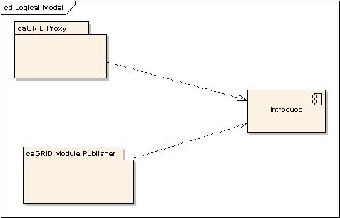
Figure 8 Logical Model

Security and Security Management
The GenePattern server (version 2) does not have any security mechanisms inherent to the System itself. The server was designed to permit users to layer their own security mechanisms over a GenePattern server. Since the GenePattern server itself does not require authentication, caGRID authentication credentials are not required to access the modules that GenePattern is publishing onto caGRID.

GenePattern Grid Extensions APIs
The GenePattern Grid Extensions project provides caGRID interfaces to three GenePattern analytic modules: Preprocess Dataset, Consensus Clustering and Comparative Marker Selection. Additional details of the parameters, inputs and outputs for these modules when run in from the GenePattern user interfaces (not through caGRID) are available on every GenePattern server that includes these modules. The caGRID APIs for each of these modules is similar but they differ in their input parameters and output types. This chapter describes each service:
- Preprocess Dataset
- Consensus Clustering
- Comparative Marker Selection

Preprocess Dataset
The PreprocessDataset module performs a variety of pre-processing operations including thresholding/ceiling, variation filter, discretization and normalization.
Thresholding:
Value = threshold if Value < threshold
Value = ceiling if Value > ceiling

Variation filter (exclude rows for which):
max / min < minchange
max – min < mindelta

Here, the max and min are computed over a row excluding the top (and bottom) “num.excl” experiments. This is to prevent one or more “spikes” that might make the gene pass the filter.
The module also includes the option to take the log base 2 of all values in the input dataset. Lastly, the module can remove rows in which the given number of columns does not contain a value greater or equal to a user defined threshold.
The order of the steps in the module is as follows:
- Thresholding
- Log Base 2
- Remove row if n columns not >= than given threshold
- Variation filter

Input Parameters
The PreprocessDataset algorithm accepts the following parameters:

Name | Description | Choices/type
ceiling | value to set a cell at if cellValue > ceiling | integer
columnThreshold | threshold for removing entire rows | float
filterFlag | perform filtering yes/no | Boolean
logBaseTwo | set value as log2 of the value | Boolean
maxSigmaBinning | maximum sigma value for binning | integer
minChange | minimum fold change for filter | float
minDelta | minimum delta for filter | float
numberOfColumnsAboveThreshold | remove row if n columns are not above the given threshold | integer
numExclude | number of experiments to exclude before applying variation filter | integer
preprocessingFlag | discretization and normalization flag | discretize, no disc or norm, row normalization
probabilityThreshold | value for uniform probability threshold filter | float
threshold | value to set a cell at if cellValue < Threshold | float
Input Data is provided to the analysis service in either of two forms corresponding to the two interfaces provided to this algorithm. Option one is to provide an array of MAGE-OM BioAssay objects. Option two is to provide a STATML Data object. The motivation for providing these two options is to provide a semanticly rich interface for microarray data (MAGE-OM) while also providing a more generic interface (STAT-ML) which reflects that this algorithm can operate on any data in matrix form, not just microarray data.

Expected Outputs
Output Data is returned from the analysis service in either of two forms corresponding to the two interfaces provided to this algorithm. Option one is to return an array of MAGE-OM BioAssay objects when input data was provided in this form. Option two is to return a STATML Data object when input data is provided in this form. The motivation for providing these two options is to provide a semanticly rich interface for microarray data (MAGE-OM) while also providing a more generic interface (STAT-ML) which reflects that this algorithm can operate on any data in matrix form, not just microarray data.

Example Usage (Java)
Full code to execute a client call to the PreprocessDataset module is available from the GenePattern Grid Extensions caBIG CVS repository. Client code examples exist for both MAGE and STAT-ML input data types. These can be found at
http://cabigcvs.nci.nih.gov/viewcvs/viewcvs.cgi/genepattern/gridExtensions_y3/code/
The code below is an abridged version of the client code reduced to show only the essential java calls.

String[] rowNames = {"gene 1", "gene 2"};
String[] rowDescriptions = {"gene 1 description", "gene 2 description"};
String[] columnNames = {"Sample 1", "Sample 2", "Sample 3"};
double[][] values = {{1.1, 2.1, 3.1},
{1.2, 2.2, 3.2}};
Data data = StatmlConverter.createStatmlData(rowNames, rowDescriptions, columnNames, values);

PreprocessDatasetParameterSet preprocessDatasetParameterSet = new PreprocessDatasetParameterSet();
preprocessDatasetParameterSet.setFilterFlag(0);
preprocessDatasetParameterSet.setPreprocessingFlag("0");
preprocessDatasetParameterSet.setMinChange(3f);
preprocessDatasetParameterSet.setMinDelta(100f);
preprocessDatasetParameterSet.setThreshold(20f);
preprocessDatasetParameterSet.setCeiling(2.1f);
preprocessDatasetParameterSet.setMaxSigmaBinning(1);
preprocessDatasetParameterSet.setProbThres(1f);
preprocessDatasetParameterSet.setNumExcl(0);
preprocessDatasetParameterSet.setLogBaseTwo(false);
preprocessDatasetParameterSet.setNumberOfColumnsAboveThreshold(1);

Data result = null;
synchronized(portTypeMutex){
configureStubSecurity((Stub)portType,"performAnalysis");
PerformAnalysisRequest params = new PerformAnalysisRequest();
PerformAnalysisRequestData dataContainer = new PerformAnalysisRequestData();
dataContainer.setData(data);
params.setData(dataContainer);
PerformAnalysisRequestPreprocessDatasetParameterSet preprocessDatasetParameterSetContainer = new PerformAnalysisRequestPreprocessDatasetParameterSet();

preprocessDatasetParameterSetContainer.setPreprocessDatasetParameterSet( preprocessDatasetParameterSet);
params.setPreprocessDatasetParameterSet(preprocessDatasetParameterSetContainer);
PerformAnalysisResponse boxedResult = portType.performAnalysis(params);
Result = boxedResult.getData();
}

// get the result STATML object back from the result
Array[] arrays = result.getArray();

Consensus Clustering
Given a set of items to be clustered (items can be either genes or chips/experiments), ConsensusClustering (CC) provides for a method to represent the consensus across multiple runs of a clustering algorithm and to assess the stability of the discovered clusters. To this end, perturbations of the original data are simulated by resampling techniques. The clustering algorithm of choice is applied to each of the perturbed data sets, and the agreement, or consensus, among the multiple runs is assessed and summarized in a consensus matrix. Each matrix entry is indexed by an item pair, and it measures the proportion of times the pair’s items are clustered together across the resampling iterations (ideally, always, or never). A distinct consensus matrix is generated for each of the number of clusters considered (e.g., if kmax=5, consensus matrices corresponding to 2, 3, 4, and 5 clusters will be generated). Visual inspection of the consensus matrices, and of the corresponding summary statistics can be used to determine the best number of clusters (see Monti et al for more details).

Input Parameters
Tuning parameters are provided to the algorithm as attributes of an instance of the class ConsensusClusteringParameterSet. The tuning parameters / attributes for this algorithm are:
Name | Description | Choices
num iterations | Number of resampling iterations | positive integer
kmax | Max number of clusters to test  (k = 1..kmax) | 1 < kmax < number of items
normalizeType | Type of normalization to perform on  data | rowNormalize, columnNormalize, both, none
normalizeIterations | Number of row/column normalization  iterations to perform. It supercedes  normalize.type. | positive integer
algorithm | Clustering algorithm to use | hierarchical, SOM, NMF
resample | resampling scheme to use
mergeType | How to update the distance measure  (ignored if algo is other than | “average”, “single”, “complete”.
descentIterations | Number of SOM/NMF iterations  (ignored when algo is hierarchical): | positive integer (default: 2000)

I Input Data is provided to the analysis service in either of two forms corresponding to the two interfaces provided to this algorithm. Option one is to provide an array of MAGE-OM BioAssay objects. Option two is to provide a STATML Data object. The motivation for providing these two options is to provide a semanticly rich interface for microarray data (MAGE-OM) while also providing a more generic interface (STAT-ML) which reflects that this algorithm can operate on any data in matrix form, not just microarray data.

Expected Outputs
The return from a Consensus Clustering run is an instance of the ConsensusClusteringResultCollection which includes an array of Cluster objects and also an array of ConsensusMatrix objects.
Cluster objects represent a single cluster found, and hold an array of the feature names for the features contained in the cluster, as well as a cluster name.
Each matrix entry is indexed by an item pair, and it measures the proportion of times the pair’s items are clustered together across the resampling iterations (ideally, always, or never). A distinct consensus matrix is generated for each of the number of clusters considered (e.g., if kmax=5, consensus matrices corresponding to 2, 3, 4, and 5 clusters will be generated)..

Example Usage (Java)
Full code to execute a client call to the ConsensusClustering module is available from the GenePattern Grid Extensions caBIG CVS repository. This can be found at
http://cabigcvs.nci.nih.gov/viewcvs/viewcvs.cgi/genepattern/gridExtensions_y3/code/
The code below is an abridged version of the client code reduced to show only the essential java calls.
// STATMLConverter is a utility class for creating a STATML data object
// from a GenePattern formatted gct file. It is available in the caBIG cvs site
final String TEST_GCT_FILENAME = "allfeatures_reduced.gct";
Data data = StatmlConverter.readGctFile(TEST_GCT_FILENAME);

// set the parameters for the analysis run
ConsensusClusteringParameterSet param = new ConsensusClusteringParameterSet();
param.setKmax(5);
param.setNiter(20);
param.setAlgorithm("hierarchical");
param.setResample("subsample");
param.setMergeType("average");
param.setDescentIter(2000);
param.setNormalizeType("-n1");
param.setNormIter(0);

ConsensusClusterResultCollection[] result= null;

// synchronize on the call
synchronized(portTypeMutex){

// configure the call
configureStubSecurity((Stub)portType,"performAnalysis");
PerformAnalysisRequest params = new PerformAnalysisRequest();

// set the data and parameters into the call
PerformAnalysisRequestData dataContainer = new PerformAnalysisRequestData();
dataContainer.setData(data);
params.setData(dataContainer);

PerformAnalysisRequestConsensusClusteringParameterSet consensusClusteringParameterSetContainer = new PerformAnalysisRequestConsensusClusteringParameterSet();

consensusClusteringParameterSetContainer.setConsensusClusteringParameterSet(
consensusClusteringParameterSet);
params.setConsensusClusteringParameterSet(
consensusClusteringParameterSetContainer);

// call the remote service
PerformAnalysisResponse boxedResult = portType.performAnalysis(params);

// acquire the results

result = boxedResult.getConsensusClusterResultCollection();
}
System.out.println("result collection size=" + result.length);

Comparative Marker Selection
The ComparativeMarkerSelection module includes several approaches to determine the features that are most closely correlated with a class template and the significance of that correlation. If the input class template has more than two classes, than a one-versus-all comparison is performed for each class. Note that the p-values obtained from the one-versus-all comparison are not fully corrected for multiple hypothesis testing.
Details of Comparative Marker Selection are available from Gould et al (2006).

Input Parameters
Name | Description | Choices
balanced | whether to perform balanced permutations | boolean
complete | whether to perform all possible permutations | boolean
minStd | the minimum standard deviation if test statistic includes the min std option | float
numberOfPermutations | the number of permutations to perform (use 0 to calculate asymptotic P values) | int
phenotypeTest | tests to perform when class membership has more than 2 classes. Note not fully corrected for multiple hypothesis testing | all-pairs  one-versus-all
randomSeed | the seed of the random number generator | int (default=779948241)
smoothPvalues | the seed of the random number generator | Boolean
testDirection | the test to perform (upregulated for class0, up regulated for class 1, two sided) | 2-sided, class 0, class 1
testStatistic | the statistic to use | SNR, SNR(Median), SNR(medianMinSTD), SNR(minStd),T-test, T-test(median),T-test(medianMinStd),T-test(minStd)
Input Data is provided to the analysis service in either of two forms corresponding to the two interfaces provided to this algorithm. Option one is to provide an array of MAGE-OM BioAssay objects. Option two is to provide a STATML Data object. The motivation for providing these two options is to provide a semanticly rich interface for microarray data (MAGE-OM) while also providing a more generic interface (STAT-ML) which reflects that this algorithm can operate on any data in matrix form, not just microarray data.

Expected Outputs
The return value from ComparativeMarkerSelection is an instance of ComparativeMarkerSelectionResultCollection which itself holds an array of MarkerResult objects. Each MarkerResult reflects a single feature (typically a feature would be a gene or probe set for microarray data) with the following attributes explaining the significance of that feature and its selection as a marker:
Name | Description
Bonferroni | The value of the Bonferroni correction applied to the feature specific pvalue.
class0Mean | The class zero mean.
class0Std | The class zero standard deviation
class1Mean | The class one mean.
class1Std | The class one standard deviation
description | the description of the feature
FDR | An estimate of the false discovery rate by the Benjamini and Hochberg procedure. The FDR is the expected proportion of erroneous rejections among all rejections.
feature | the feature name
featureP | The feature-specific p-value based on permutation testing.
featurePHigh
featurePLow | The estimated upper bound for the feature p-value.
foldChange | The class zero mean divided by the class one mean.
FWER | (Family Wise Error Rate) - the probability of at least one null hypothesis/feature having a score better than or equal to the observed one. This measure is not featurespecific.
k | If performing a two-sided test or a one-sided test for markers of class zero, the number of permuted scores greater than or equal to the observed score. If testing for markers of class one, then the number of permuted scores less than or equal to the other
maxT | The adjusted p-values for the maxT multiple testing procedure described in (5), which provides strong control of the FWER.
QValue | An estimate of the FDR using the procedure developed by Storey and Tibshirani
rank | The rank of the feature within the dataset based on the value of the test statistic. If a two-sided p-value is computed, the rank is with respect to the absolute value of the statistic.
score | The value of the test statistic

Example Usage (Java)
Full code to execute a client call to the ComparativeMarkerSelection module is available from the GenePattern Grid Extensions caBIG CVS repository. Client code examples exist for both MAGE and STAT-ML input data types. These can be found at
http://cabigcvs.nci.nih.gov/viewcvs/viewcvs.cgi/genepattern/gridExtensions_y3/code/
The code below is an abridged version of the client code reduced to show only the essential java calls.

// define the data the algorithm will operate on
String[] rowNames = {"gene 1", "gene 2"};
String[] rowDescriptions = {"gene 1 description", "gene 2 description"};
String[] columnNames = {"Sample 1", "Sample 2", "Sample 3"};
double[][] values = {{1.1, 2.1, 3.1},
{1.2, 2.2, 3.2}};
// the StatmlConverter is a utility class available in our CVS repository used
// to create STATML data objects
Data data = StatmlConverter.createStatmlData(rowNames, rowDescriptions, columnNames, values);

// set the analysis parameters
ComparativeMarkerSelectionParameterSet params = new
ComparativeMarkerSelectionParameterSet();
params.setTestDirection(2);
params.setTestStatistic(0);
params.setMinStd(1f);
params.setNumberOfPermutations(1000);
params.setComplete("false");
params.setBalanced("false");
params.setRandomSeed(779948241);
params.setSmoothPValues(false);
params.setPhenotypeTest("one versus all");

// create the class data which differentiates the 2 classes (e.g. tumor/normal)
ClassMembership cls = new ClassMembership();
String[] sampleNames = {"Sample 1", "Sample 2", "Sample 3"};
String[] classNames = {"tumor", "normal"};
int[] sampleClasses = {0, 0, 1};

cls.setNumSamples(3);
cls.setSampleNames(sampleNames);
cls.setClassNames(classNames);
cls.setSampleClasses(sampleClasses);

ComparativeMarkerSelectionResultCollection result = null;

// make the call
synchronized(portTypeMutex){

// set the data, class data and parameters up for the grid call
configureStubSecurity((Stub)portType,"performAnalysis");
PerformAnalysisRequest params = new PerformAnalysisRequest();
PerformAnalysisRequestData dataContainer = new PerformAnalysisRequestData();
dataContainer.setData(data);
params.setData(dataContainer);

PerformAnalysisRequestClassMembership classMembershipContainer = new PerformAnalysisRequestClassMembership();

classMembershipContainer.setClassMembership(cls);
params.setClassMembership(classMembershipContainer);

PerformAnalysisRequestComparativeMarkerSelectionParameterSet comparativeMarkerSelectionParameterSetContainer = new PerformAnalysisRequestComparativeMarkerSelectionParameterSet();

comparativeMarkerSelectionParameterSetContainer.setComparativeMarkerSelectionParameterSet(comparativeMarkerSelectionParameterSet);
params.setComparativeMarkerSelectionParameterSet( comparativeMarkerSelectionParamet erSetContainer);

// make the call to the service
PerformAnalysisResponse boxedResult = portType.performAnalysis(params);

// get the results
result = boxedResult.getComparativeMarkerSelectionResultCollection();
}

if (null != result) {
MarkerResult[] mr = result.getMarkerResult();
for (int i = 0; i < mr.length; i++) {
System.err.println("i=[" + i + "] + bonferroni=[" + mr[i].getBonferroni() +
"] maxT=[" + mr[i].getMaxT() + "]");
}
}

Information Models
The application information model for the GenePattern grid extensions project describes the objects used as inputs and outputs from the caGRID analysis services published from a GenePattern server. A detailed model can be found at http://cabigcvs.nci.nih.gov/viewcvs/viewcvs.cgi/genepattern/gridExtensions_y3/specifications/.

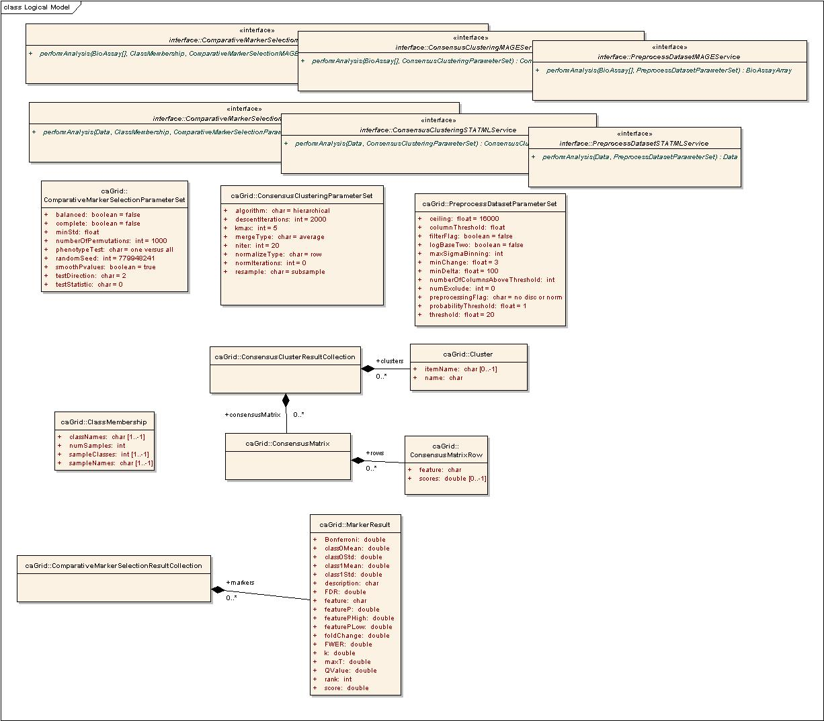
Figure 9 Parameters and Output Objects
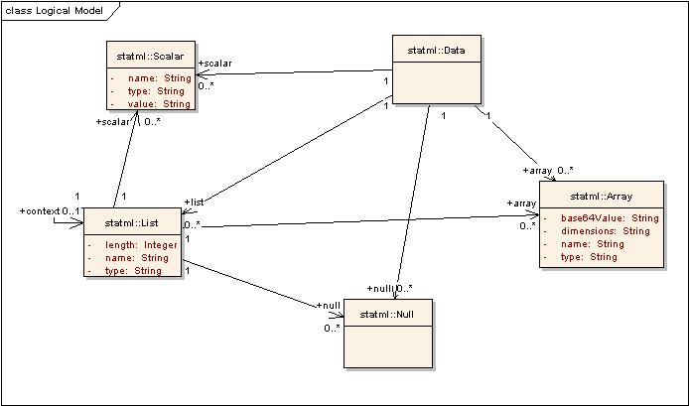
Figure 10 STAT-ML classes used as data inputs
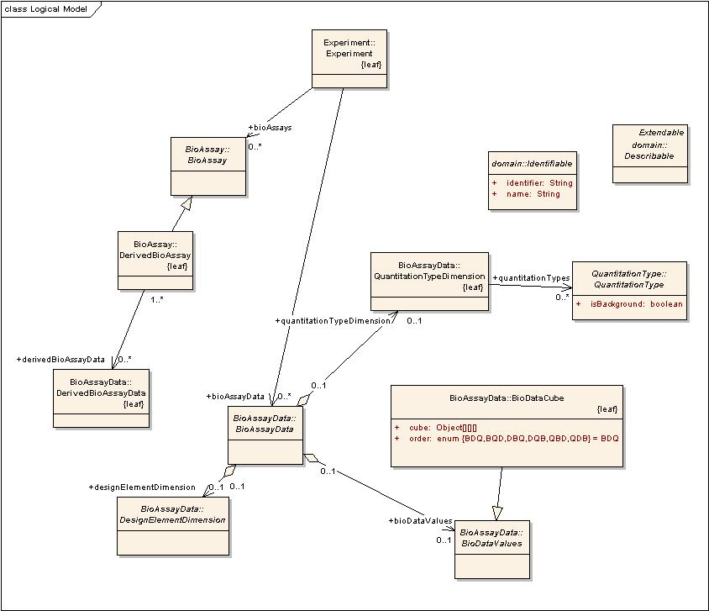
Figure 11 MAGE classes used as Inputs

Administration
Administration of the GenePattern Grid Extensions has three distinct administrative elements:
- Administrating GenePattern
- Administrating caGrid Services
- Administrating GenePattern Grid Extensions

Administrating GenePattern
Administration of a GenePattern server is covered in the GenePattern Web Client Guide which is available at http://www.broad.mit.edu/cancer/software/genepattern/tutorial/gp_web_client.html.

Administrating caGrid Services
Administration of caGrid and the Globus toolkit is covered in the caGrid documentation, which is available at http://www.cagrid.org/mwiki/index.php?title=CaGrid:Technical_Resources.

Administrating GenePattern Grid Extensions
The GenePattern grid extensions have a limited amount of administrative adjustments available, as described in this section.

Configure Environment Variables
Four environment variables are required for proper use of the GenePattern Grid Extensions, as shown in the table below. On a Linux machine, set these environment variables using a script. On a Windows machine, use Start -> Control Panel -> System. Choose the Advanced Tab, Environment Variables button, and then add a new System Variable.
Variable Name | Value
CATALINA_HOME | <GenePattern directory>/Tomcat
ANT_HOME | <Ant directory>
JAVA_HOME | <Java SDK 1.5.x directory>
GLOBUS_LOCATION | <Globus directory>

Configuring GenePattern Server
The code for the Preprocess Dataset, Comparative Marker Selection, and Consensus Clustering services is available from the caBIG CVS site:
http://cabigcvs.nci.nih.gov/viewcvs/viewcvs.cgi/genepattern/gridExtensions_y3

If your GenePattern Server installation is not on port 8080 and the same machine as the Globus installation, you will need to edit several files, changing the hostname and port entries to your chosen port. For Comparative Marker Selection, edit the following files:
./src/org/genepattern/cabig/service/compmarker/statml/service/GenePattern.properties
./build/schema/ComparativeMarkerSelSTATMLSvc/ComparativeMarkerSelSTATMLSvc_service.wsdl
./build/schema/wsrf/lifetime/WS-ResourceLifetime_service.wsdl
./build/schema/wsrf/notification/WS-BaseN_service.wsdl
./build/schema/wsrf/properties/WS-ResourceProperties_service.wsdl
./build/schema/wsrf/servicegroup/WS-ServiceGroup_service.wsdl
./build/stubs-ComparativeMarkerSelSTATMLSvc/classes/org/genepattern/cabig/service/compmarker/statml/stubs/service/ComparativeMarkerSelSTATMLSvcServiceLocator.class
./build/stubs-ComparativeMarkerSelSTATMLSvc/src/org/genepattern/cabig/service/compmarker/statml/stubs/service/ComparativeMarkerSelSTATMLSvcServiceLocator.java
./run-tools.xml

For ConsensusCluster, edit the following files:
./src/org/genepattern/cagrid/service/consensuscluster/statml/service/GenePattern.properties
./build/schema/ConsensusClusteringSTATMLService/ConsensusClusteringSTATMLService_service.wsdl
./build/schema/wsrf/lifetime/WS-ResourceLifetime_service.wsdl
./build/schema/wsrf/notification/WS-BaseN_service.wsdl
./build/schema/wsrf/properties/WS-ResourceProperties_service.wsdl
./build/schema/wsrf/servicegroup/WS-ServiceGroup_service.wsdl
./build/stubs-ConsensusClusteringSTATMLService/classes/org/genepattern/cagrid/service/consensuscluster/statml/stubs/service/ConsensusClusteringSTATMLServiceLocator.class
./build/stubs-ConsensusClusteringSTATMLService/src/org/genepattern/cagrid/service/consensuscluster/statml/stubs/service/ConsensusClusteringSTATMLServiceLocator.java
./run-tools.xml

For PreprocessDataset, edit the following files:
./src/org/genepattern/cagrid/service/preprocessdataset/statml/service/GenePattern.properties:submitTaskUrl=http://localhost:8080/gpintegration/submitTask
./build/schema/PreprocessDatasetSTATMLService/PreprocessDatasetSTATMLService_service.wsdl
./build/schema/wsrf/lifetime/WS-ResourceLifetime_service.wsdl
./build/schema/wsrf/notification/WS-BaseN_service.wsdl
./build/schema/wsrf/properties/WS-ResourceProperties_service.wsdl
./build/schema/wsrf/servicegroup/WS-ServiceGroup_service.wsdl
./build/stubs-PreprocessDatasetSTATMLService/classes/org/genepattern/cagrid/service/preprocessdataset/statml/stubs/service/PreprocessDatasetSTATMLServiceLocator.class
./build/stubs-PreprocessDatasetSTATMLService/src/org/genepattern/cagrid/service/preprocessdataset/statml/stubs/service/PreprocessDatasetSTATMLServiceLocator.java
./run-tools.xml

Adjusting Tomcat Memory
If large datasets are to be passed to the GenePattern grid extensions services, you may experience errors with the server running out of available memory. These are typically manifested as exceptions returned to grid clients along with “java.lang.OutOfMemory” errors recorded in the Tomcat log files. To try to minimize or eliminate these errors, the Tomcat web application hosting the services needs to have its available memory increased.
In the directory where GenePattern is installed (e.g. c:\Program Files\GenePatternServer on a windows computer), there is a file containing configuration settings for the Genepattern server launch called
StartGenePatternServer.lax

Edit this file, locating the section shown below
# LAX.NL.JAVA.OPTION.JAVA.HEAP.SIZE.INITIAL
# -----------------------------------------
# initial heap size

lax.nl.java.option.java.heap.size.initial=64m

# LAX.NL.JAVA.OPTION.JAVA.HEAP.SIZE.MAX
# -------------------------------------
# Max heap size

lax.nl.java.option.java.heap.size.max=256m

Increase the values for the initial and maximum java heap sizes to larger numbers, with the maximum permissible values for the “lax.nl.java.option.java.heap.size.max” being approximately 1500m on 32 bit operating systems and limited primarily by available physical ram on 64bit operating systems.
Following editing of this file, GenePattern (and Tomcat) will need to be stopped and restarted for the changes to take effect.
If the server is still running out of memory for a desired data set size using 1500m as the max setting for the java heap, you will need to move your installation to a server running a 64 bit operating system with sufficient physical memory to perform the desired analysis.
- References
This appendix includes the references for the following:
- Technical Manuals/Articles
- Scientific Publications
- caBIG Material
- caCORE Material

Technical Manuals/Articles
- National Cancer Institute. "caCORE 2.0 Technical Guide", ftp://ftp1.nci.nih.gov/pub/cacore/caCORE2.0_Tech_Guide.pdf
- Java Bean Specification: http://java.sun.com/products/javabeans/docs/spec.html
- Foundations of Object-Relational Mapping: http://www.chimu.com/publications/objectRelational/
- Object-Relational Mapping articles and products: http://www.service-architecture.com/object-relational-mapping/
- Hibernate Reference Documentation: http://www.hibernate.org/hib_docs/reference/en/html/
- Basic O/R Mapping: http://www.hibernate.org/hib_docs/reference/en/html/mapping.html
- Java Programming: http://java.sun.com/learning/new2java/index.html
- Javadoc tool: http://java.sun.com/j2se/javadoc/
- JUnit: http://junit.sourceforge.net/
- Extensible Markup Language: http://www.w3.org/TR/REC-xml/
- XML Metadata Interchange: http://www.omg.org/technology/documents/formal/xmi.htm

Scientific Publications
- Gould, J., Getz, G., Monti, S., Reich, M. Mesirov, J.P. (2006) Comparative Gene Marker Selection suite. Bioinformatics doi:10.1093/bioinformatics/btl196.
- Subramanian, A., Tamayo, P., Mootha, V. K., Mukherjee, S., Ebert, B. L., Gillette, M. A., Paulovich, A., Pomeroy, S. L., Golub, T. R., Lander, E. S. & Mesirov, J. P. (2005). Gene set enrichment analysis: A knowledge-based approach for interpreting genome-wide expression profiles. Proc. Natl. Acad. Sci. USA 102, 15545-15550.
- S. Monti, et al. “Consensus Clustering: A resampling-based method for class discovery and visualization of gene expression microarray data”, Machine Learning Journal, 52(1-2):91-118, 2003.

caBIG Material
- caBIG: http://cabig.nci.nih.gov/
- caBIG Compatibility Guidelines: http://cabig.nci.nih.gov/guidelines_documentation

caCORE Material
- caCORE: http://ncicb.nci.nih.gov/core
- caBIO: http://ncicb.nci.nih.gov/core/caBIO
- caDSR: http://ncicb.nci.nih.gov/core/caDSR
- EVS: http://ncicb.nci.nih.gov/core/EVS
- CSM: http://ncicb.nci.nih.gov/core/CSM
- Glossary
Term | Definition
API | Application Programming Interface
ANT | ANT, a java based build tool (http://ant.apache.org/)
caArray | cancer Array Informatics
caBIG | cancer Biomedical Informatics Grid
caCORE | cancer Common Ontologic Representation Environment
caDSR | Cancer Data Standards Repository
cardinality | Cardinality describes the minimum and maximum number of associated objects within a set
Catalina | code-name for Tomcat application server (see Tomcat)
CDE | Common Data Element
ComparativeMarkerSelection | GenePattern module that provides several methods of determining the features (genes) most closely correlated with a phenotype (class template).
ConsensusClustering | GenePattern module that provides a method to represent the consensus across multiple runs of a clustering algorithm.
CSM | Common Security Module
CVS | Concurrent Versions System
DAO | Data Access Objects
EA | Enterprise Architect
GenePattern | The GenePattern analysis system (http:://www.genepattern.org/ )
GLOBUS | The Globus grid system used by caGrid (http://www.globus.org)
HTTP | Hypertext Transfer Protocol
JAAS | Java Authentication and Authorization Service
JAR | Java Archive
Javadoc | Tool for generating API documentation in HTML format from doc comments in source code (http://java.sun.com/j2se/javadoc/)
MAGE | MicroArray and Gene Expression
MAGE-OM | MicroArray Gene Expression - Object Model
metadata | Definitional data that provides information about or documentation of other data.
MGED | Microarray Gene Expression Data
module | Code packaged to provide computational analyses or data visualization tools for GenePattern users.
multiplicity | Multiplicity of an association end indicates the number of objects of the class on that end may be associated with a single object of the class on the other end
NCI | National Cancer Institute
NCICB | National Cancer Institute Center for Bioinformatics
OMG | Object Management Group
ORM | Object Relational Mapping
pipeline | Analysis workflow in GenePattern, which executes one or more modules.
PreprocessDataset | GenePattern module that performs a variety of pre-processing operations, including thresholding, discretization and normalization.
SDK | Software Development Kit
STAT-ML | Statistics Markup Language – a XML based language defined by the RProteomics project (Duke) to represent statistical data forms sucha as matrices and arrays.
Tomcat | The Tomcat application server available from http://tomcat.apache.org/
UI | User Interface
UML | Unified Modeling Language
UMLS | Unified Medical Language System
URL | Uniform Resource Locators
WAR | Web Application Archive
WSDL | Web Services Description Language
XMI | XML Metadata Interchange (http://www.omg.org/technology/documents/formal/xmi.htm) - The main purpose of XMI is to enable easy interchange of metadata between modeling tools (based on the OMG-UML) and metadata repositories (OMG-MOF) in distributed heterogeneous environments
XML | Extensible Markup Language (http://www.w3.org/TR/REC-xml/) - XML is a subset of Standard Generalized Markup Language (SGML). Its goal is to enable generic SGML to be served, received, and processed on the Web in the way that is now possible with HTML. XML has been designed for ease of implementation and for interoperability with both SGML and HTML

Index

administration, 39
Ant, Apache, 13
ANT_HOME (environment variable), 13
APIs, GenePattern Grid Extensions, 25
application interface, GenePattern, 6
architecture. See system architecture
authentication, 23
caGRID Module Publisher, 20
caGRID Proxy Application
deployment architecture, 20
installing, 14
CATALINA_HOME (environment variable), 13
CC. See ConsensusClustering
clustering, 28
ComparativeMarkerSelection, 30
example code, 32
installing, 14
results, 31
ComparativeMarkerSelectionResultCollection, 31
ConsensusClustering, 28
example code, 29
installing, 14
ConsensusClusteringResultCollection, 29
ConsensusMatrix objects, 29
credentials, 23
data model, 35
discretization (PreprocessDataset), 25
environment variables, 13
example code
ComparativeMarkerSelection, 32
ConsensusClustering, 29
PreprocessDataset, 27
GenePattern
administration, 39
increasing memory, 41
installing, 11
modules, 6
overview, 5
pipelines, 6
programming interface, 6
security, 23
system architecture, 19
system requirements, 7
GenePattern Grid Extensions
administration, 39
APIs, 25
information model, 35
installing, 11
overview, 7
requirements, 17
requirements and specification, 8
system requirements, 8
Globus
administration, 39
installing, 14
GLOBUS_LOCATION (environment variable), 13
Grid extensions. See GenePattern Grid Extensions
increasing memory, 41
information model, 35
installation, testing, 15
installing
Apache Ant, 13
caGridProxy, 14
GenePattern, 11
GenePattern Grid Extensions, 11
Globus, 14
Java SDK, 13
Java SDK, 13
Java, access GenePattern from, 6
java.lang.OutOfMemory error, 41
JAVA_HOME (environment variable), 13
log base 2 values (PreprocessDataset), 25
MAGE-OM BioAssay object
in ComparativeMarkerSelection, 31
in ConsensusClustering, 28
in PreprocessDataset, 26
MarkerResult objects, 31
MATLAB, access GenePattern from, 6
memory, increasing, 41
modules
APIs, 25
ComparativeMarkerSelection, 30
ConsensusClustering, 28
installing, 14
overview, 6
PreprocessDataset, 25
normalization (PreprocessDataset), 25
OutOfMemory error, 41
pipelines, GenePattern, 6
PreprocessDataset, 25
example code, 27
installing, 14
programmatic interface, GenePattern, 6
Proxy application. See caGRID Proxy Application
R, access GenePattern from, 6
requirements for GenePattern Grid Extensions, 8
security, 23
services. See also modules
SOAP interface, GenePattern, 6
specifications for GenePattern Grid Extensions, 8
STATML Data object
in ComparativeMarkerSelection, 31
in ConsensusClustering, 28
in PreprocessDataset, 26
system architecture
caGRID module publisher, 20
caGRID proxy application, 20
GenePattern, 19
security, 23
testing the installation, 15
thresholding (PreprocessDataset), 25
variation filter (PreprocessDataset), 25

