caIntegrator 2
Requirements Management Plan

Version 1.0
June 8, 2008

Document Approvals
The list contains the name and contact information for the core project team and any key stakeholders who have an interest in the success of the project. An “S” identifies persons responsible for approval from the stakeholder groups. Sign off of the document would be required when a decision is made not to take action for defined gaps.

S | Name | Role | S | Name | Role
S | Anand Basu | NCICB Engineering Manager | S | Subha Madhavan | Product Manager
 | Shine Jacobs | Project Manager

Revision History
Date | Version | Description | Author
6/5/2008 | 1.0 | Initial revision | Eric Tavela

Table of Contents
1. Introduction 3
1.1 Purpose 3
1.2 Scope 4
1.3 Definitions, Acronyms, and Abbreviations 4
1.4 References 4
1.5 Overview 4
2. Requirements Management 4
2.1 Organization, Responsibilities, and Interfaces 4
2.2 Tools, Environment, and Infrastructure 4
3. The Requirements Management Program 4
3.1 Requirements Identification 4
3.2 Traceability 5
3.2.1 Criteria for Stakeholder Needs (NEED) 6
3.2.2 Criteria for Features (FEAT) 6
3.2.3 Criteria for Use-Case Requirements (UC) 7
3.2.4 Criteria for Supplementary Requirements (SUPP) 7
3.2.5 Criteria for Test Cases (TC) 7
3.3 Attributes 7
3.3.1 Attributes for Need (NEED) 7
3.3.2 Attributes for Feature (FEAT) 8
3.3.3 Attributes for Supplementary Requirement (SUPP) 9
3.3.4 Attributes for Use Case (UC) 10
3.3.5 Requirement Attributes for Test Case (TC) 11
3.4 Reports and Measures 12
3.4.1 Traceability Matrix 12
3.4.2 Project Baselines 12
3.5 Workflows and Activities 12
4. Milestones 12
5. Training and Resources 12

Introduction

Purpose
The Requirements Management Plan (RMP) provides a systematic approach to eliciting, organizing, and documenting the requirements of a system. The RMP supports maintenance of a common understanding of requirements between customers and the software development team. The RMP also assists in effectively controlling changes to requirements that can affect the scope of a project. In addition, the RMP prescribes traceability tags, which will be used throughout the software system lifecycle. The tags are used to track how design, development, testing, and user documentation artifacts satisfy documented requirements.

Scope
This Requirements Management Plan defines all aspects of requirements management as it applies to the caIntegrator 2 project.

Definitions, Acronyms, and Abbreviations
None

References
- caIntegrator 2 Development Case
- caIntegrator 2 Iteration Plans
- caIntegrator 2 Use-Case Model
- caIntegrator 2 Supplementary Specification

Overview
The Requirements Management Plan is divided into sections. Section 2 documents the management and environment. Section 3 documents the artifacts, requirements types, criteria and attributes that will be tracked in the project’s requirements database and, thus, provide for traceability through the requirements lifecycle. Section 4 establishes traceability criteria for the various requirement types for the project.

Requirements Management

Organization, Responsibilities, and Interfaces
This will be covered in the iteration plans.

Tools, Environment, and Infrastructure
The NCI’s GForge web application is the primary tool used to record and manage requirements. Located at: https://gforge.nci.nih.gov/projects/caintegrator2/ there are three main user types: project admin, developers and users. The development team – in concert with the Product and Project Management team – is the administrator of the tool.
At the completion of all iterations and as necessary, all requirements documents and reports should be made available as documents in the GForge project and baselined along with the general project artifact base in CM. The development process also uses the continuous integration tool Cruise Control to show the results of each build, including test cases.

The Requirements Management Program

Requirements Identification
Artifact | Traceability Item | Description
None (in GForge only) | Stakeholder Need (NEED) | Key stakeholder or user need. The business or operational problem (opportunity) that must be fulfilled in order to justify use. Also known as Goal or Objective.
None (in GForge only) | Feature (FEAT) | Conditions or capabilities of the system
Use-Case Model and Use-Case Specifications | Use-Case Requirement (UC) | Individual detailed requirements as specified in the use-case specification organized in a hierarchy. Each use case will contain a brief description, pre-conditions, basic and alternative flows, exception flows and post conditions.
Supplementary Specification | Supplementary Requirement (SUPP) | Requirements (often non-functional) that transcend or do not apply to a single use-case.
None (in GForge only) | Test Case (TC) | The specification (usually formal) of a set of test inputs, execution conditions, and expected results, identified for the purpose of making an evaluation of some particular aspect of a Target Test Item.

Each requirement will be recorded in a tracker specific to the requirement type and each name will be prefaced by its type abbreviation and a unique ascending number (e.g. FEAT1, UC2, etc.).

Traceability
The following traceability diagram is taken from the caArray Requirements Management Model and demonstrates the traceability that must be recorded between requirement types.
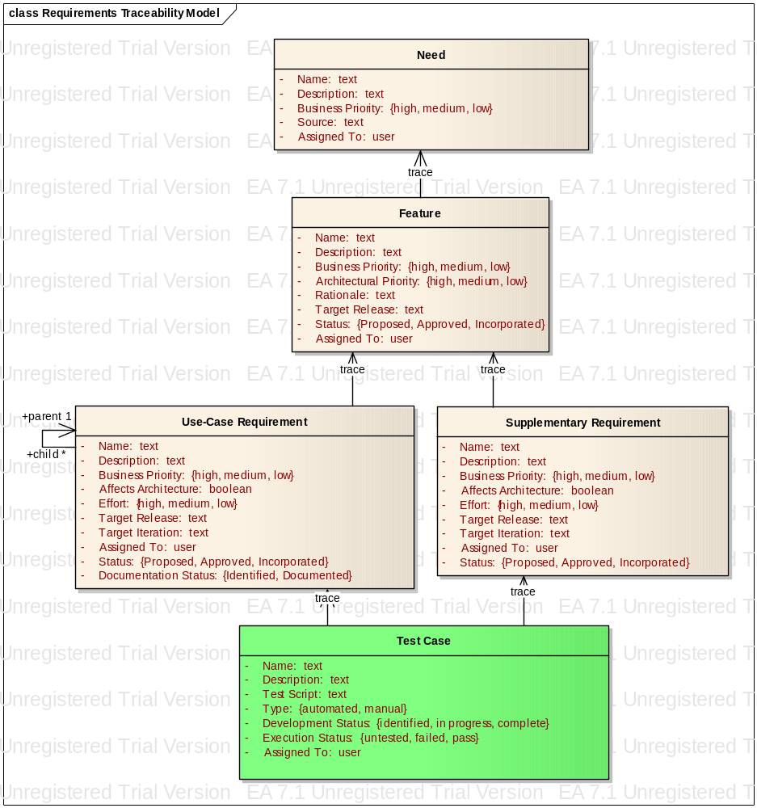
Figure 1 - Requirement Type Traceabilities

Criteria for Stakeholder Needs (NEED)
Stakeholder Needs (NEED) will be traced to Features (FEAT). Any NEED not traced to a FEAT will not be implemented.

Criteria for Features (FEAT)
Features (FEAT) will trace to Supplementary Requirements (SUPP) and/or Use-Case Requirements (UC).
A FEAT may trace directly to a UC. This allows the FEAT to be assigned to a UC before the use case sections have been written and enables impact analysis on the Use-Case Model at the Feature level and vice versa. A FEAT may trace to more than one UC in addition to the Supplementary Requirements in the Supplemental Specification [SS]. All Features that do not trace into the use case model must trace to at least one of the software requirements in the Supplementary Specification.
FEATs are distinct from Feature Requests. Once a request has been accepted as a Feature, it will follow the requirements management process detailed in this document.

Criteria for Use-Case Requirements (UC)
The top level Use-Case Requirement (UC) represents the use case in its entirety, whereas any child UC requirements represent requirements within the enclosing use case.
UCs will trace to the Test Cases (TC). This relationship allows us to see which requirements are to be tested and ensure coverage or to assess the impact of a failed test.

Criteria for Supplementary Requirements (SUPP)
Supplementary Requirements (SUPP) will trace to Test Cases (TC).
This relationship allows us to see which requirements are to be tested and ensure coverage or to assess the impact of a failed test.

Criteria for Test Cases (TC)
All Test Cases (TC) must trace from either a UC or a SUPP or a combination of the two, potentially tracing to multiple UCs or SUPPs when appropriate.

Attributes

Global Attributes
All requirement types have the following attributes.

Name
Identifies the requirement. Consists of the requirement identifiers followed by a brief, titular description (e.g. UC1: Access Data via API).

Description
Provides a more detailed description of the requirement. For use-case requirements this will be the text of the Brief Description in the use-case specification document.

Assigned To
Identifies the team member currently working on the requirement. At prioritization and approval time, this will be the product manager; at specification time the requirements analyst and during implementation the implementer.

Attributes for Need (NEED)

Business Priority
Used in managing scope and determining development priority.
High | Essential business needs that must be met by features of the system.
Medium | Important business needs that should be met by features of the system.
Low | Additional business needs that would be advantages to have incorporated into the system’s features, but are not crucial to a successful system.

Source
This text field describes how the need was first identified, which could be from a document, an external product or a stakeholder. The list will be generated from the stakeholder types detailed in the Vision document. If it is reference to a document, the need description should include a document name or a URL.

Attributes for Feature (FEAT)

Business Priority
All requirements are not created equal. Ranking requirements by their relative benefit to the stakeholders opens a dialogue with customers, analysts, and members of the development team. Used in managing scope and determining development priority.

High | Essential features. Failure to implement means the system will not meet customer needs. All critical features must be implemented in the release or the schedule will slip.
Medium | Features important to the effectiveness and efficiency of the system for most applications. The functionality cannot be easily provided in some other way. Lack of inclusion of a required feature may affect customer or user satisfaction, or even revenue, but release will not be delayed due to lack of any required feature.
Low | Features that are useful in less typical applications will be used less frequently, or for which reasonably efficient workarounds can be achieved. No significant revenue or customer satisfaction impact can be expected if such an item is not included in a release.

Rationale
This optional text field is used to track the source of the requested feature. Requirements exist for specific reasons. This field records an explanation or a reference to an explanation. For example, the reference might be to a page and line number of a product requirement specification, an important customer interview or an e.

Target Release
Records the intended product version in which the feature will first be implemented. This field can be used to allocate features from a Vision document into a particular baseline release. When scope management occurs, the Target Release Version Number can be increased so the item will remain in the Vision document but will be scheduled for a later release. Values: enumerates of pre-determined release names (e.g., 1.0, 2.0, 2.1, 3.0)

Status
Indicates the overall status of the feature.
Proposed | The feature has been identified but not yet approved by the Product Manager for inclusion into the project.
Approved | The feature will be targeted for inclusion in a specific release of the project.
Incorporated | The feature has been implemented.

Attributes for Supplementary Requirement (SUPP)

Type
Categorizes the requirement.
Functionality | Global functional requirements (i.e. not documented in a use case)
Usability | Requirements related to usability by end user
Reliability | Requirements related to system availability, MTBF, etc.
Performance | Requirements that specify acceptable performance characteristics
Supportability | Requirements that specify resources required to maintain the application in production.
Design Constraint | Requirements that dictate the use of specific technologies or design approaches.
Documentation | End-user documentation or help requirements.
Interface | Specifications of interfaces to be exposed by the application or communication paths with other applications.

Business Priority
High | Essential requirements. Failure to implement means the system will not meet customer needs. All critical features must be implemented in the release or the schedule will slip.
Medium | Requirements important to the effectiveness and efficiency of the system for most applications. The functionality cannot be easily provided in some other way. Lack of inclusion of this requirement may affect customer or user satisfaction, or even revenue, but release will not be delayed ..
Low | Requirements that are useful in less typical applications will be used less frequently, or for which reasonably efficient workarounds can be achieved. No significant revenue or customer satisfaction impact can be expected if such an item is not included in a release.

Affects Architecture
Set by the Software Architect, this indicates the requirement has an influence on the software architecture. Values: True or False.

Effort
Effort is assigned values that determine the level of effort required to implement the requirement. The values for effort are:
High | Unknown complexities or haven’t done it before. Estimated to be greater than 2 person-weeks.
Medium | Average complexity. Have done it before or know how to approach it. Estimated to be around 1 to 2 person-weeks.
Low | A few hours to a few man-days. Solution is well known. Confidence is high in the estimates. No expected complexities.

Target Release
Records the intended product version in which the requirement will first be implemented. Values: enumerates of pre-determined release names (e.g., 1.0, 2.0, 2.1, 3.0)

Target Iteration
Records the intended development iteration in which the requirement will first be implemented. Values: enumerates of pre-determined iteration identifiers (e.g., I1, E1, E2, etc.)

Status
Indicates the overall status of the requirement.
Proposed | The requirement has been identified but not yet approved by the Product Manager as accurately representing the actual need.
Approved | The requirement will be targeted for inclusion in a specific release of the project.
Incorporated | The requirement has been implemented.

Traces to
The feature(s) that the supplemental requirement can be traced to based on the current adoption of features into the current release.

Attributes for Use Case (UC)

Business Priority
High | Essential functionality. Failure to implement means the system will not meet customer needs. All critical functionality must be implemented in the release or the schedule will slip.
Medium | functionality important to the effectiveness and efficiency of the system for most applications. The functionality cannot be easily provided in some other way. Lack of inclusion of a required feature may affect customer or user satisfaction, or even revenue, but release will not be delayed due to lack of any required feature.
Low | Functionality that is useful in less typical applications will be used less frequently, or for which reasonably efficient workarounds can be achieved. No significant revenue or customer satisfaction impact can be expected if such an item is not included in a release.

Affects Architecture
Set by the Software Architect, this indicates that the Use-Case flow of events touches a delicate point in the architecture or exercises a significant portion of the architecture. Values: True or False.

Effort
Effort is assigned values that determine the level of effort required to implement the requirement. The values for effort are:

High | Unknown complexities or haven’t done it before. Estimated to be greater than 2 person-weeks.
Medium | Average complexity. Have done it before or know how to approach it. Estimated to be around 1 to 2 person-weeks.
Low | A few hours to a few man-days. Solution is well known. Confidence is high in the estimates. No expected complexities.

Target Release
Records the intended product version in which the use case will first be implemented. Values: enumerates of pre-determined release names (e.g., 1.0, 2.0, 2.1, 3.0)

Target Iteration
The iteration when this Use-Case is expected to be implemented in the current release cycle. While the product is expected to have many release cycles (2.0, 2.1, 2.2, 2.2.1, 3.0, etc.), the planned iteration always represents the release that is next in line.
Only features whose Target Release is set to the current release and whose Target Iteration is defined will be implemented. When scope management occurs, the Target Iteration can be changed so the item will remain but will be scheduled for a later iteration or the feature can be changed to a later release and removed from the current stream.

Status
Indicates the overall status of the requirement.
Proposed | The requirement has been identified but not yet approved by the Product Manager as accurately representing the actual need.
Approved | The requirement will be targeted for inclusion in a specific release of the project.
Incorporated | The requirement has been implemented.

Documentation Status
Indicates whether the use-case has been documented.
Identified | The use-case requirement has been noted and described with a brief textual description, but a complete use-case specification has not been developed.
Documented | The use-case specification has been completed for this requirement.

Traces to
The feature(s) that the use case can be traced to based on the current adoption of features into the current release.

Parent
This is used in use-case requirements that are identified separately from their owning use cases so that they may be tracked separately. Examples include items identified in the Special Requirements section of a use case that may be developed in a different iteration from the main use case. These are numbered hierarchically according to the parent use case (e.g. UC1.1: Grid API Access).

Requirement Attributes for Test Case (TC)
The Test Case Description is a list of steps to execute the Test Case. The steps must be unambiguous such that performance of a test case is repeatable and so that automated test scripts can be written reliably from the description.

Type
The type attribute indicates how the Test Case will be implemented as a Test Script.

Automated | This Test Case has an associated automated test script.
Manual | This Test Case is performed manually according to the steps given in the requirement Text.

Test Script
This is the class name of the test script (package name is unnecessary as it is based on convention) if automated.

Development Status
Set by the assigned test engineer. Tracks progress during test development.
Identified | The test case has been identified but not yet described.
In Progress | Test Case script, either manual or automated, that verifies the requirement is being written.
Written | Test Case has been written.

Execution Status
Set by the assigned test engineer. Tracks progress during test execution. For those test cases that are automated, the development team will use Cruise Control to show the results and at iteration completion points, update the associated GForge tracker. If there is no value in the Execution Status field, this indicates that the test hasn’t been performed.
Failed | Test Case failed
Passed | Test has been successfully completed

Target Release
Records the intended product version in which the test case will first be implemented. Values: enumerates of pre-determined release names (e.g., 1.0, 2.0, 2.1, 3.0)

Target Iteration
The iteration when the test case will be implemented and tested. The test case must be written before or during this iteration.

Traces to
The use case(s) or supplementary requirement(s) that the test case can be traced to based on the current adoption of features into the current release.

Reports and Measures

Traceability Matrix
Due to the current G-Forge implementation, there is no ability to create or automate this report. Currently, there is no ability to select one (much less multiple) items from one tracker to another. However, distinct “lists” will be created for Features (needs), for Use Cases and Supplemental Requirements (features and needs) and Test Cases (Use Cases and Supplemental Requirements) to allow for the selection of the primary parent element that impacts the requirement stated. The traceability matrix will be accumulated from downloads of existing trackers and represented as a spreadsheet.

Project Baselines
Baselines are created as specified in the Configuration Management Plan, including all requirements artifacts.

Workflows and Activities
The project employs the standard RUP workflows and activities for requirements management with any exceptions noted in the caIntegrator 2 Development Case.

Milestones
The sole notable milestones in the requirements process for caIntegrator 2 are the delivery of the requirements set to the program authority and the subsequent approval of the requirements set. This is expected to be complete by the close of Elaboration Phase during the 2.0 release cycle.

Training and Resources
No special formal training is required for internal or external users to use GForge, however, the tool doesn’t contain all the desired support for traceability and its user interface does take some effort to get used to. The NCICB’s system team will be the source of training and customizations when and if needed.

