Software Architecture Document
caIntegrator 2

Last Revised: | May 31, 2011
Produced By: | NCICB Development Team
Version: | 1.3

Revision History
When you make a change to a document, you must add an entry to this Revision History table and you must manually type the Last Revised Date on the front cover.

Date | Version | Description | Revised by
05/29/2008 | 1.0 | Original revision based on envisioned architecture | Michael Holck
1/23/2009 | 1.1 | Updated with current architecture and projected Grid interface. | Eric Tavela
10/8/2009 | 1.2 | Reformatted and revised to match current architecture for planned 1.0 release. | Eric Tavela
05/18/2011 | 1.3 | Updated prior to v 1.3 release. | JP Marple
Copyrights and Trademarks
© Copyright 2011 by CBIIT, caBIGTM. All rights reserved.
Table of Contents
1. Introduction 4
1.1. Purpose 4
1.2. Scope 4
1.3. Definitions, Acronyms, and Abbreviations 4
1.4. References 4
2. Architectural Representation 4
3. Architectural Goals and Constraints 5
3.1.1. Flexible Translational Study Hosting 5
3.1.2. Performance of Queries and Analysis 5
3.1.3. Use of caGrid Infrastructure 5
4. Use-Case View 5
4.1. Login 6
4.2. Deploy Study 6
4.3. Manage Queries 6
4.4. Review Images 7
4.5. Perform Data Analysis 7
5. Logical View 7
5.1. Overview 7
5.2. Architecturally Significant Design Elements 9
5.2.1. User Interface Layer 9
5.2.2. Domain Model 9
5.2.3. WorkspaceService 12
5.2.4. StudyManagementService 12
5.2.5. DeploymentService 13
5.2.6. ArrayDataService 14
5.2.7. QueryManagementService 14
5.2.8. AnalysisService 16
5.2.9. GenePatternClient 17
5.2.10. CaArrayFacade 17
5.2.11. CaDSRFacade 18
5.2.12. NCIAFacade 18
5.2.13. CaIntegrator2Dao 19
5.2.14. caIntegrator2 Database 21
5.2.15. caIntegrator 2 Grid Service (proposed) 21
6. Implementation View 22
6.1. Overview 22
7. Deployment View 22

Introduction

Purpose
This document provides a comprehensive architectural overview of caIntegrator 2 using a number of different architectural views to depict different aspects of the system. It is intended to capture and convey the significant architectural decisions that have been made in the design of caIntegrator 2.

Scope
This document describes the aspects of caIntegrator 2’s design that are considered to be architecturally significant; that is, those elements and behaviors that are most fundamental for guiding the construction of caIntegrator 2 and for understanding caIntegrator 2 as a whole. Stakeholders who require a technical understanding of caIntegrator 2 are encouraged to start by reading this document, then reviewing the caIntegrator 2 UML model and then by reviewing the source code. Please note that all diagrams represented in this document are taken from the caIntegrator 2 UML model; for more detail about the elements in these diagrams, please consult the source model.

Definitions, Acronyms, and Abbreviations
J2EE – Java 2 Enterprise Edition
Java SE – Java Standard Edition
JDK – Java Development Kit
JSP – JavaServer Pages
UML – Unified Modeling Language

References
caIntegrator 2 UML Model
https://gforge.nci.nih.gov/svnroot/caintegrator2/trunk/docs/analysis_and_design/models/caintegrator2_service_model.EAP
Philippe Kruchten 1995, "The 4+1 view model of architecture," IEEE Software. 12(6), November 1995.

Architectural Representation
The caIntegrator 2 architecture is represented in this document and in the UML design model as a set of views of the system from different but complementary perspectives. These views are:
The Use-Case View – Describes the functional requirements of the system.
The Logical View – Describes the organization of the system design into subsystems, interfaces, and classes and how these elements collaborate to provide the functionality described in the use-case view.
The Implementation View – Describes the software components that realize the elements from the logical view and the dependencies between these components.
The Deployment View – Describes how the processes are allocated to hardware and execution environments and the communication paths between hardware nodes.
This style of describing software architecture is the approach recommended by the Rational Unified Process and is based on Philippe Kruchten’s work, “The 4+1 view model of architecture”.

Architectural Goals and Constraints
The following factors are the key considerations in addition to the functional requirements that have guided the design of caIntegrator 2.

Flexible Translational Study Hosting
The principal rationale for developing caIntegrator 2 has been to expedite the time and effort required to host a new translational study. The predecessor suite, caIntegrator, provides reusable software components that could be used when designing and hosting a new study, but additional software development was required for each new study. The goal of caIntegrator 2 is to provide a study-hosting platform that requires no additional programming to host a new study allowing a new study to be deployed in a relatively short period by a non-developer.

Performance of Queries and Analysis
The distributed nature of data in the caBIG network provides the opportunity for client applications to access data at its source at runtime and in fact many applications are designed in this way. However, caIntegrator 2 is designed with performance in mind in order that queries and analysis may be performed for the user as quickly as possible. For that reason, most data is retrieved and then stored locally when a study is deployed.

Use of caGrid Infrastructure
In keeping with the caBIG vision, caIntegrator 2 has been implemented to leverage the caGrid architecture and to locate and use existing grid services for its dependencies where this is possible.

Use-Case View
The use cases represented in Figure 1 below contain the functionality that has the greatest impact on the application’s design. In brief, the use cases described below require implementation of mechanisms for security, data storage and retrieval and communication with various external systems. Brief descriptions of each of these use cases are provided below as extracted from the model.
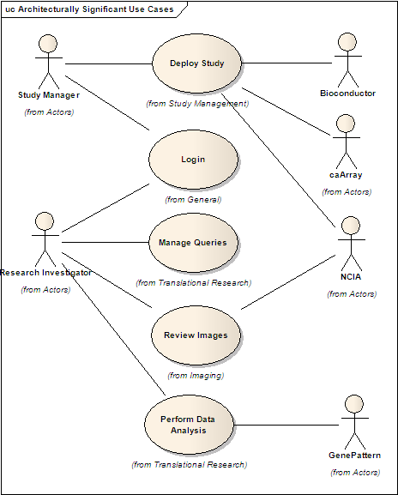
Figure 1 – Architecturally Significant Use Cases

Login
A caIntegrator 2 User authenticates his credentials in order to use the system.

Deploy Study
In this use case, a Study Manager defines the structure of a study that may consist of clinical data, imaging data and genomic data and deploys it for use. The items that are defined are the structure and sources of data and how they interrelate.

Manage Queries
In this use case, a Research Investigator defines, updates or executes a query (which may be saved) that can be used to locate a set of study data that meets specific criteria.

Review Images
In this use case, a Research Investigator views or downloads images associated with a study.

Perform Data Analysis
In this use case, a Research Investigator applies an analysis or visualization method to a new or previously defined data set.

Logical View

Overview
This section of the document first describes the structural hierarchy of the system in layers, packages, and subsystems and then goes on to describe how these elements collaborate to provide the most architecturally significant functionality. Figure 2 below shows the top-level structural organization of caIntegrator 2. The important subsystems and packages are shown as well as their interdependencies.
caIntegrator 2 is implemented as a Java web application that runs within JBoss 4.0.5 using Java SE 5 (JDK version 1.5.0_10). The application uses the following core technologies:
- JSP 2.0
- Servlet 2.4
- Struts 2.1.8.1
- Spring 2.0.3
- Hibernate 3.2.0
Spring is configured to handle the transactional behavior of the application in addition to its more general role of integrating the overall system via dependency injection.
The functionality of each of the subsystems shown in Figure 2 below is described in the sections that follow.
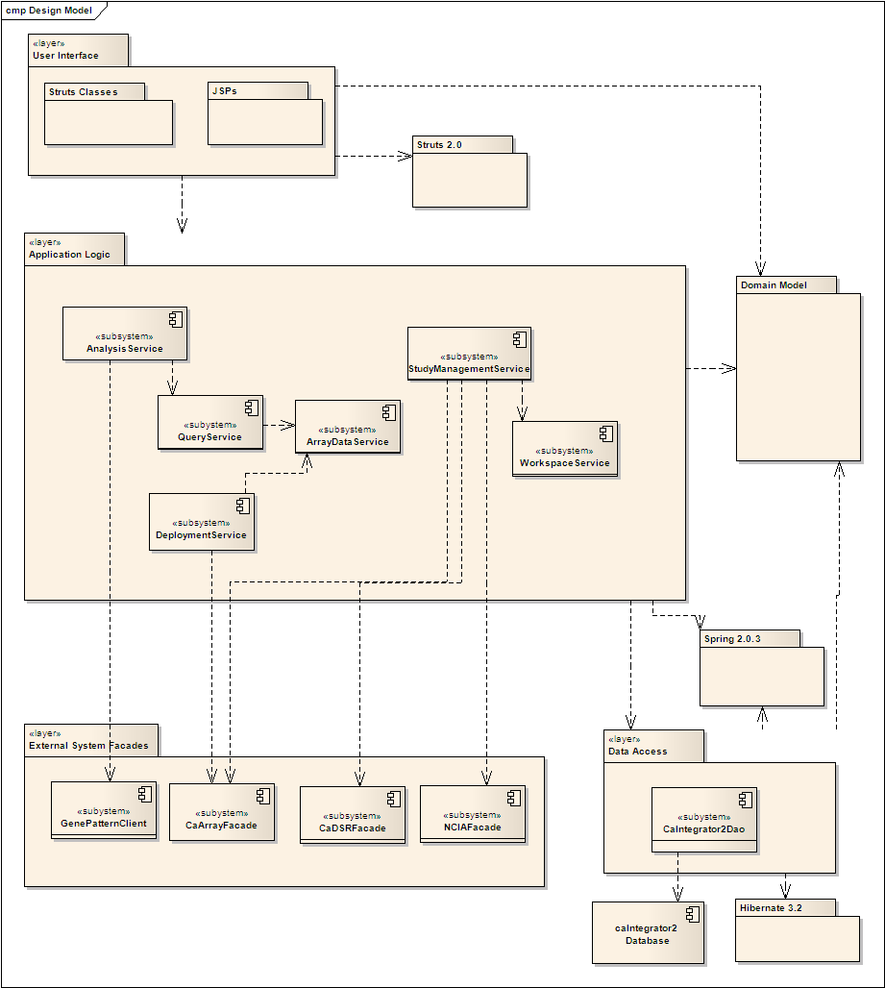

Figure 2 – Architecturally Significant Design Elements

Architecturally Significant Design Elements

User Interface Layer
The front-end of the application is a fairly standard Java web application in that it uses JSPs and Struts 2 for the view and controller/model functionality. The application also uses Tiles 2.0 for page template management and DWR 2.0 (as well as some additional front-end JavaScript libraries) for asynchronous updates to the GUI via AJAX.

Domain Model
Virtually all of the subsystems that will be described in the following sections operate on the abstractions of the translational research domain contained in the domain model. With few exceptions, these classes are persistent and represent the data and configuration of a particular translational study.
The core relationships are shown in Figure 3 below. Subjects participating in a Study are associated via a StudySubjectAssignment instance which also provides indirect associations to Samples and ImageSeriesAcquisitions associated with the Subject.
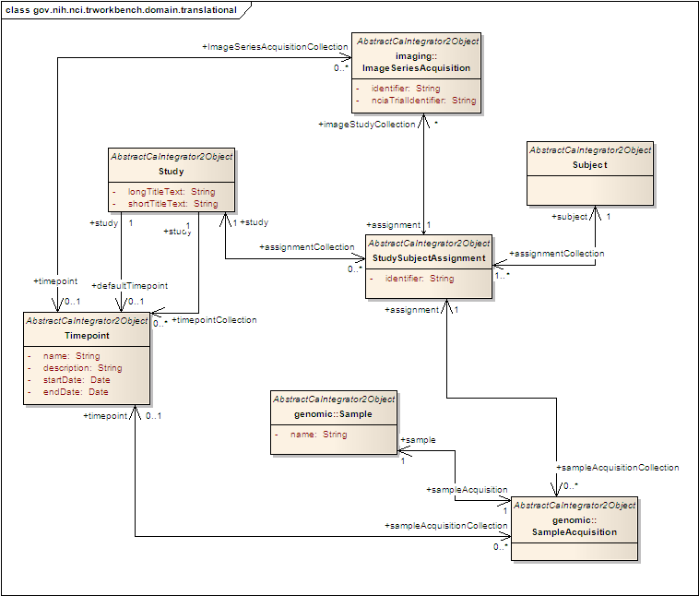
Figure 3 – Domain Model: Main translational entities
Clinical annotations may be assigned to Subjects (via StudySubjectAssignments) or to Images or ImageSeries as instances of the AbstractAnnotationValue hierarchy as shown in Figure 4.
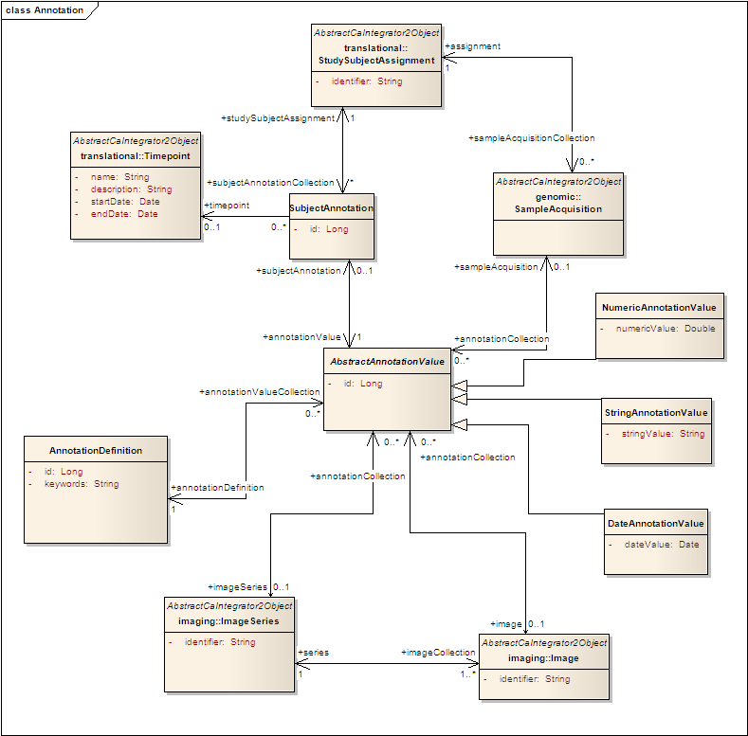
Figure 4 – Domain Model: Annotation value classes
The classes that represent genomic data entities are shown in Figure 5. To summarize the key classes: Samples may have associated ArrayData instances that come from a given Array. Each Array is associated to a Platform, which is made up of collections of AbstractReporter subclass instances.
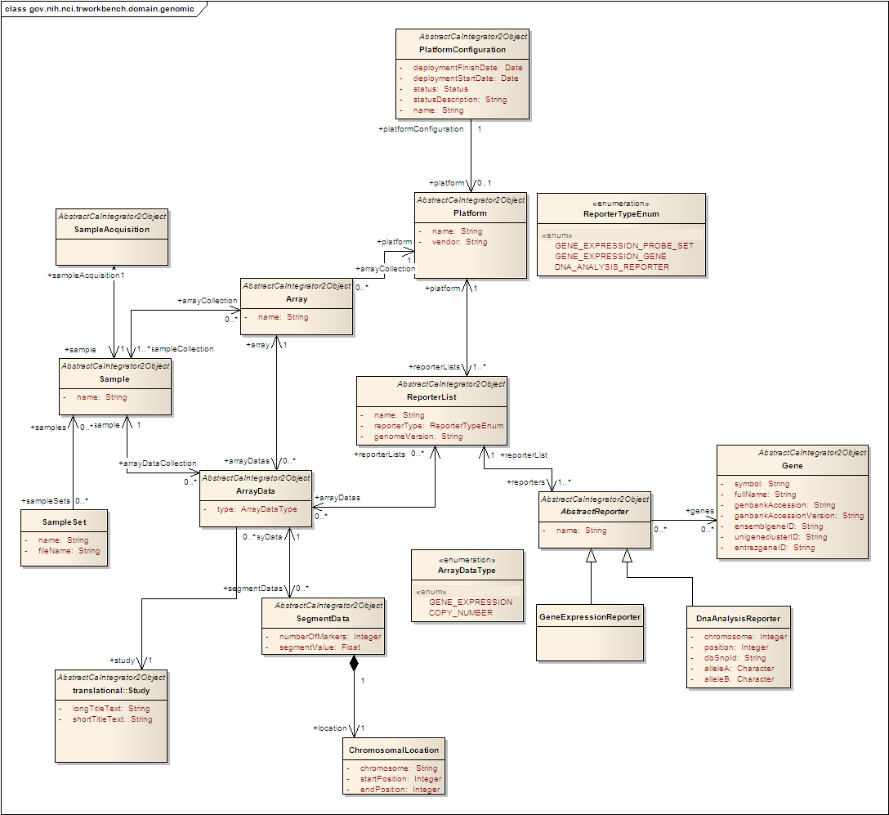
Figure 5 – Domain Model: Genomic data entities

WorkspaceService
The WorkspaceService subsystem provides methods for the front-end components to configure and retrieve information about the current user’s working environment, including retrieving the studies, analysis jobs and queries associated to a given user.

StudyManagementService
The StudyManagementService provides methods to configure new studies prior to deployment. Though most data retrieval is done at study deployment time via the DeploymentService subsystem, the StudyManagementService must interface with caArray and NCIA to retrieve metadata about associated microarray experiments and image studies respectively.

DeploymentService
As its name suggests, the DeploymentService handles the necessary data retrieval and configuration steps needed at study deployment time. A diagram of the important classes in this subsystem is shown below in Figure 6. The web-tier client components that invoke the deployment may register a listener object when invoking the methods of the subsystem and receive status updates as the deployment proceeds.
The key task at deployment time is to retrieve data from caArray and store it locally. Both expression and copy number data are supported. The GenomicDataHelper class manages the workflow of the retrieval activities using a number of supporting classes that ultimately call the CaArrayFacade subsystem to retrieve the data. The retrieved data are stored locally using the ArrayDataService subsystem.
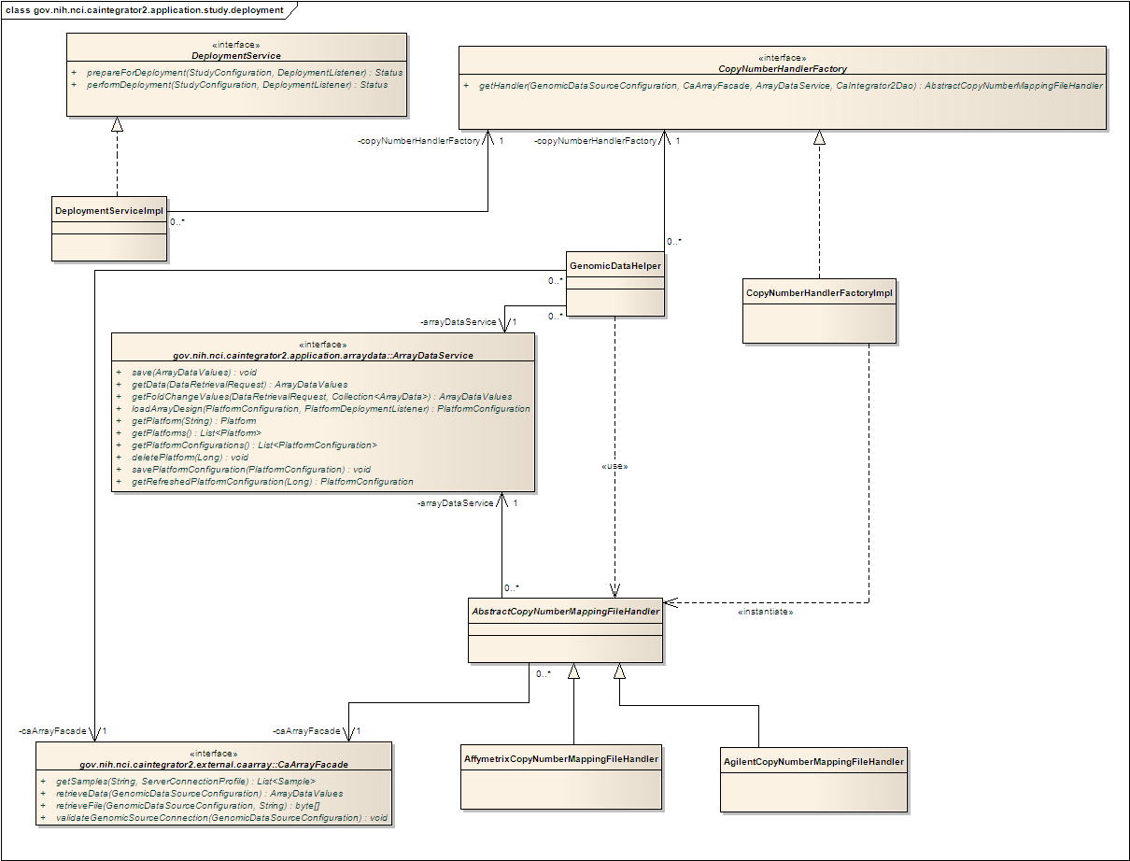
Figure 6 – DeploymentService implementation

ArrayDataService
The ArrayDataService implements efficient storage and retrieval of array data values using an underlying NetCDF storage mechanism. The subsystem also manages the parsing and retrieval of array platform annotations. The main collaborating classes in the subsystem are shown below in Figure 7. The classes NetCDFManager, NetCDFReader and NetCDFWriter are those responsible for array data storage and retrieval while the hierarchy of AbstractPlatformLoader classes is responsible for parsing and loading the various supported array platform annotations. Array data files used by the NetCDFReader and NetCDFWriter are managed by the FileManager subsystem. The FileManager subsystems stores and retrieves data files in a configurable location which defaults to the system’s configured temp directory.
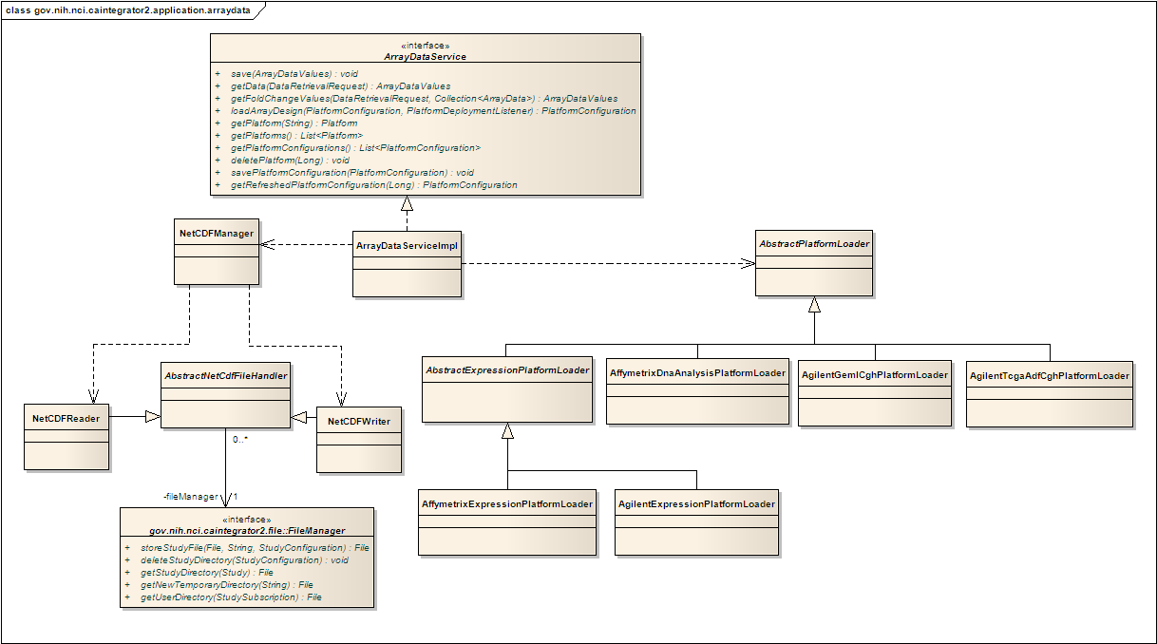
Figure 7 – ArrayDataService implementation

QueryManagementService
The QueryManagementService handles storage and more importantly execution of user-defined queries. The important classes internal to this subsystem are shown in Figure 8. Queries that return clinical and image annotations are delegated to a QueryTranslator and ResultHandler pair while queries that return genomic data values are delegated to a GenomicQueryHandler instance.
Both clinical annotation and genomic data queries require the use of a CompoundCriterionHandler. This class is the composite member in a Composite design pattern implemented by the members of the AbstractCriterionHandler hierarchy. Each handler subclass knows how to correctly interpret a specific criterion type defined in a query. The FoldChangeCriterionHandler and GeneNameCriterionHandler must interact with the ArrayDataService to locate matching data, while the AnnotationCriterionHandler looks for matching annotation via the CaIntegrator2Dao subsystem.
Genomic queries in caIntegrator 2 provide functionality to allow users to compare expression levels for a given gene against expression levels for a set of controls samples designated at study definition. The relative expression level is referred to as “fold change” and the numeric value for a given sample and reporter combination is the ratio of the expression value for that particular reporter for the given sample to a reference value calculated for that reporter across all control samples. The reference value is calculated by taking the mean of the log2 of the expression values for all control samples for the reporter in question. The log2 mean value (n) is then converted back to a comparable expression signal by returning 2 to the exponent n. In queries that include a fold change criterion and that are configured to return genomic data, the raw expression values are replaced with the calculated fold change value.

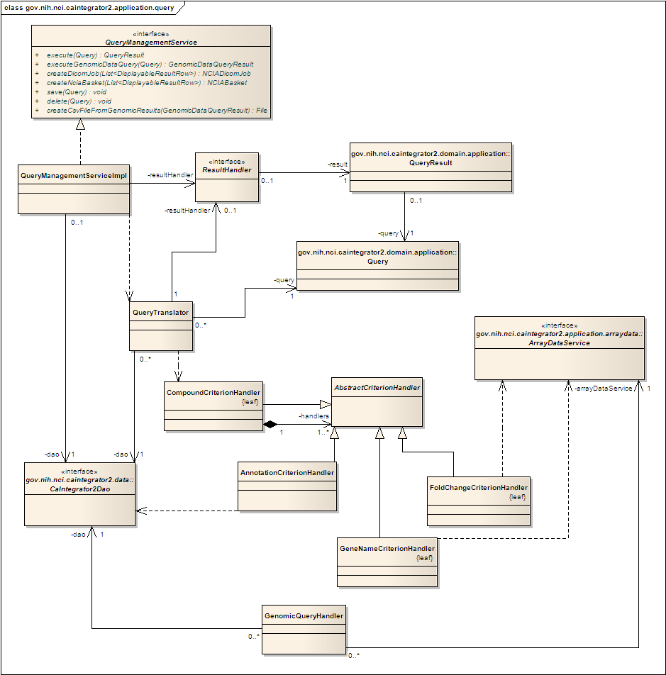
Figure 8 – QueryManagementService implementation

AnalysisService
The AnalysisService subsystem translates caIntegrator 2 data to the format required by a variety of analytic and visualization services, submits analysis jobs and provides the results. Currently the AnalysisService subsystem and its collaborating subsystems provide access to GenePattern via its web service interface and several exposed grid services as well as KM plot and gene expression plot visualization. The organization of the important classes and collaborating subsystems is shown below in Figure 9.
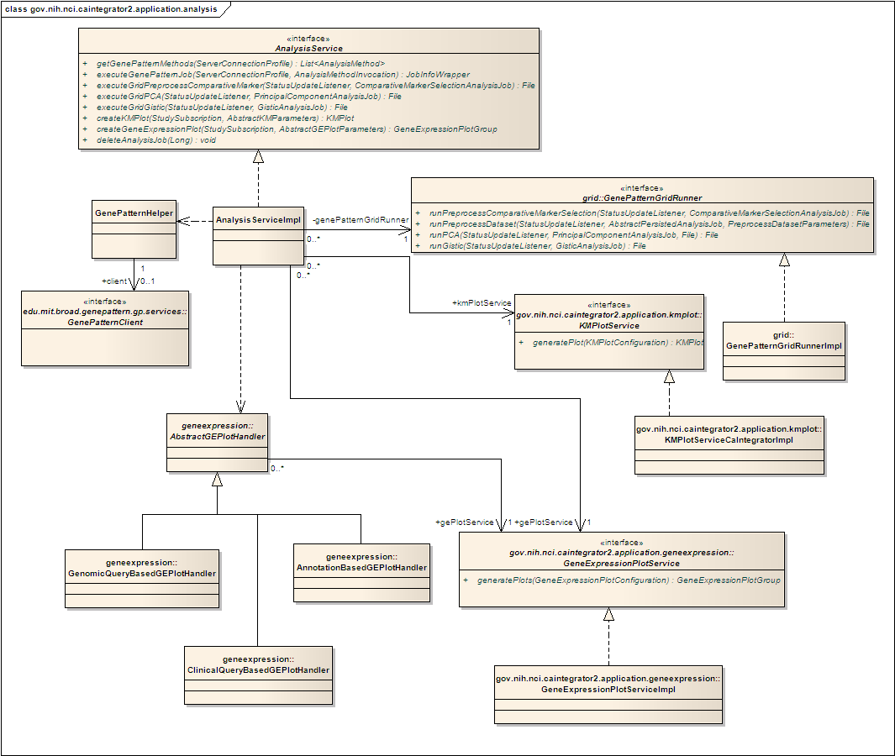
Figure 9 – AnalysisService implementation
All invocation of GenePattern web service based analysis jobs is handled through the GenePatternHelper class that communicates with an instance of GenePatternClient. Invocations of grid services are handled through an instance of the GenePatternGridRunner service. KM plots are generated using the KMPlotService subsystem, which is a façade wrapper around plot generation code from the original caIntegrator codebase. Finally, gene expression jobs are handled by instantiating one of the handler classes in the AbstractGEPlotHandler hierarchy, which will then delegate appropriately to the GeneExpressionPlotService.
A potential improvement for future development of the AnalysisService subsystem would be to provide a unified approach to calling any of the analysis services based on the analysis job abstraction classes used to invoke GenePattern web service based jobs.

GenePatternClient
The GenePatternClient subsystem provides a façade to invoking the analysis web service exposed by GenePattern. The Analysis and AnalysisService interfaces and their implementations were generated by Axis from GenePattern’s Analysis WSDL and the GenePatternClientImpl translates requests and responses to the web service for clients. The make up of this subsystem is shown in Figure 10.
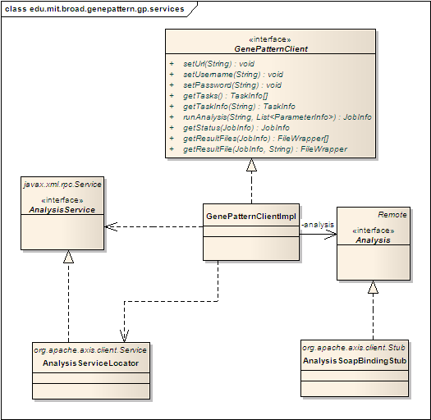
Figure 10 – GenePatternClient implementation

CaArrayFacade
The CaArrayFacade subsystem provides access to the functionality exposed by caArray’s external Java API that’s required by caIntegrator 2. The CaArrayFacadeImpl class handles some metadata lookup directly by invoking methods in caArray’s SearchService interface. Array data retrieval is handled by the AbstractDataRetrievalHelper class hierarchy, instances of which interact with caArray’s SearchService and DataService interfaces to retrieve the actual data values. The composition of the CaArrayFacade subsystem is shown in Figure 11.
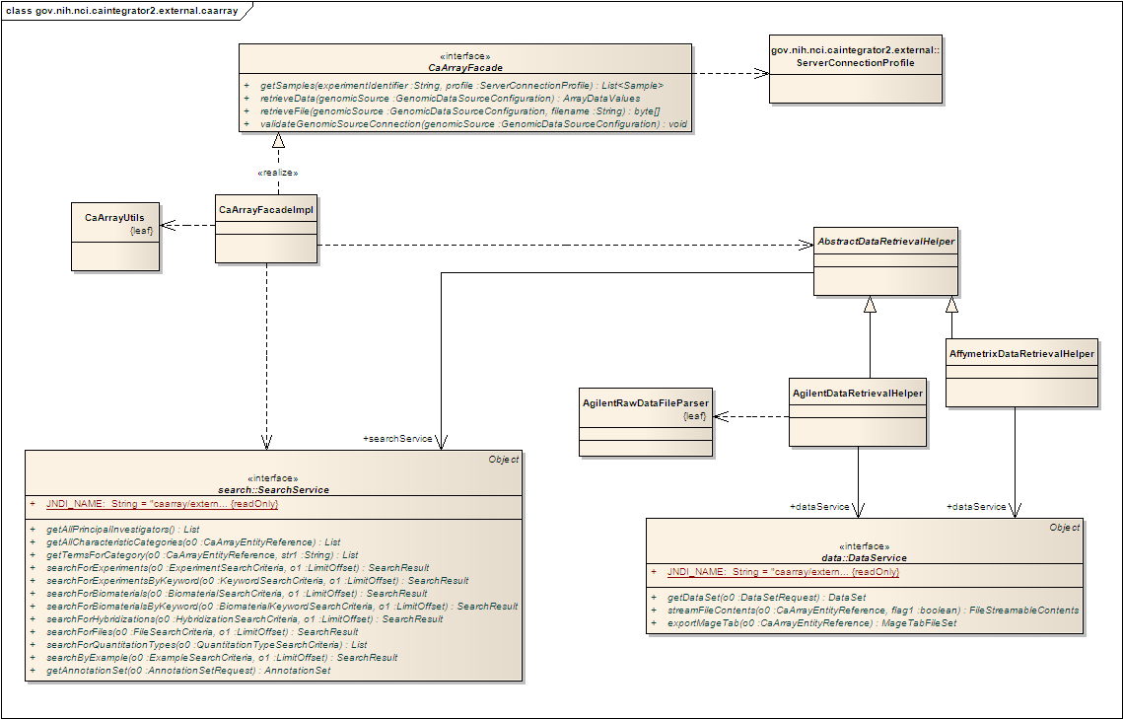
Figure 11 – CaArrayFacade implementation

CaDSRFacade
The CaDSRFacade is a very simple subsystem comprised of only an interface and implementation class (CaDSRFacadeImpl) used to look up DataElements in caDSR. The implementation class makes requests to caDSR via its exposed ApplicationService API.

NCIAFacade
The NCIAFacade subsystem provides access to the required functionality that NBIA exposes via its grid service interface. Simple image metadata retrieval is handled by the NCIAFacadeImpl delegating to an internal NCIASearchService subsystem that communicates with the NBIA grid service using the NCIACoreServiceClient provided by NBIA. An NCIAJobRunner that again delegates to the NCIACoreServiceClient and uses grid transfer to retrieve the DICOM images from NBIA handles retrieval of DICOM images. The subsystem contents are shown below in Figure 12.
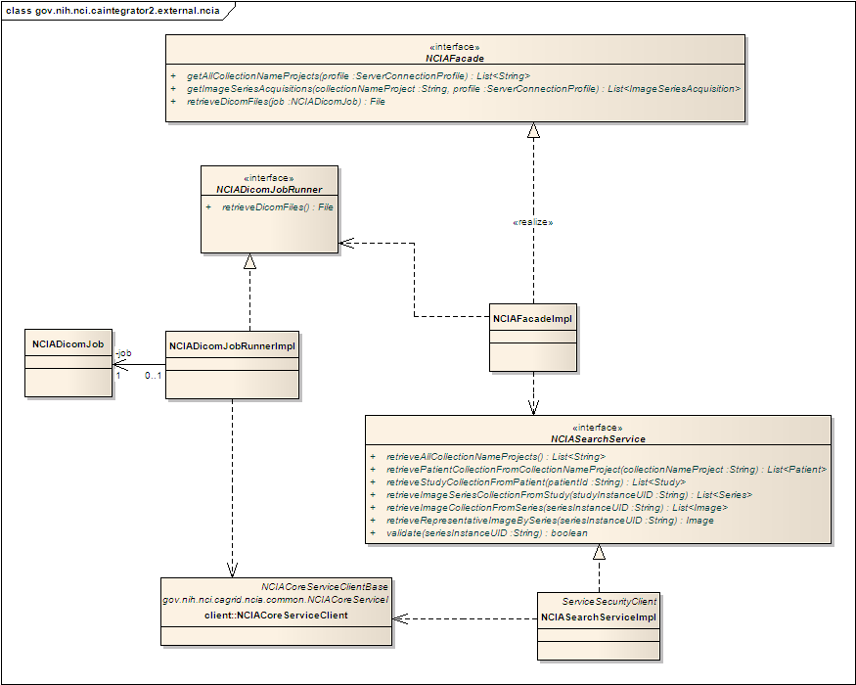
Figure 12 – NCIAFacade implementation

CaIntegrator2Dao
The CaIntegrator2Dao subsystem provides access to the domain model objects and other persistent class instances stored in the caIntegrator 2 database. The subsystem uses Hibernate to store and access persistent instances. Integration with Hibernate is provided by Spring through the HibernateDaoSupport class that CaIntegrator2DaoImpl inherits from. Annotation criteria based searches (used by the QueryManagementService described earlier) are handled using a hierarchy of handler classes that extend from AbstractAnnotationCriterionHandler. The subsystem contents are shown below in Figure 13.
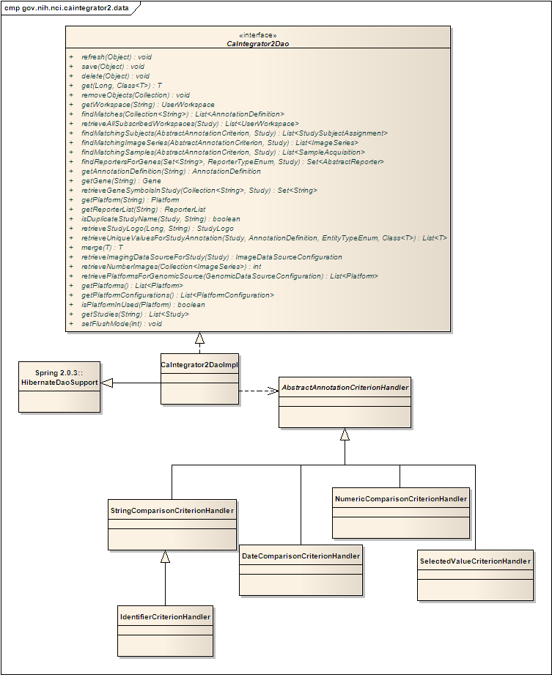
Figure 13 – CaIntegrator2Dao implementation

caIntegrator2 Database
The persistent data for the application (with the exception of array data values as described in ArrayDataService) are ultimately stored in the caIntegrator 2 database which is a relational schema store in MySQL 5.0. Approximately 80 tables in the schema are mapped to persistent classes using Hibernate XML mapping files. The schema also contains several tables required by CSM to record authentication and authorization information for the application.

caIntegrator 2 Grid Service (proposed)
caIntegrator 2 will expose a simple analysis grid service API. As an entry point, the service will allow clients to discover the publicly visible studies managed in a caIntegrator2 instance and the subjects associated with those studies. Clients may then use the service API to determine what array data from caArray is associated with a subject as well as imaging data from NCIA. The API has been designed to be as simple and straightforward as possible with the intention of building out further functionality as clients request it. It should be noted that it is expected that there will be very limited use of the service API and that clients will generally wish to use the web UI.
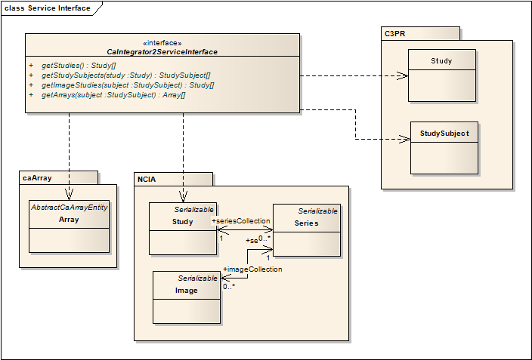
Figure 14 – Proposed grid service interface

Implementation View

Overview
Figure 15 below illustrates the major physical artifacts that comprise caIntegrator 2. caIntegrator 2 is packaged as a Java WAR. All of the classes and configuration files that directly define the application are found in the WEB-INF/classes path within the WAR. Dependent JARs are packaged in the WAR in WEB-INF/lib. The WAR (caintegrator2.war) and the most significant dependent JARs are pictured in Figure 14 below.
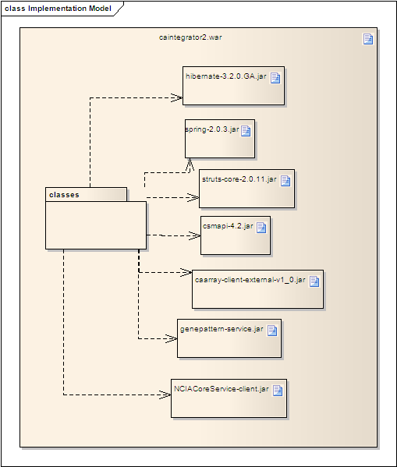
Figure 15 – Implementation Artifacts

Deployment View
The deployment architecture for caIntegrator 2 is shown in Figure 16. While this diagram shows the caintegrator2db database hosted on the same server as the web application these two components can certainly be hosted on different servers as this is also a very common deployment scenario. As the diagram shows, caIntegrator 2 depends on a number of external services to provide data or analysis services. Most inter-service communication is done using the caGrid infrastructure with a few notable exceptions. Access to caArray is currently implemented using the exposed Java API rather then the grid interface in order to support authenticated access to experiments with authorization restrictions. caIntegrator 2 should be updated to use the grid interface to caArray when authenticated access is incorporated in a future release. Also, caIntegrator 2 accesses GenePattern through both its exposed grid services and its web service interface. GenePattern’s web service interface exposes modules that aren’t accessible via the grid and provides significant performance benefits.
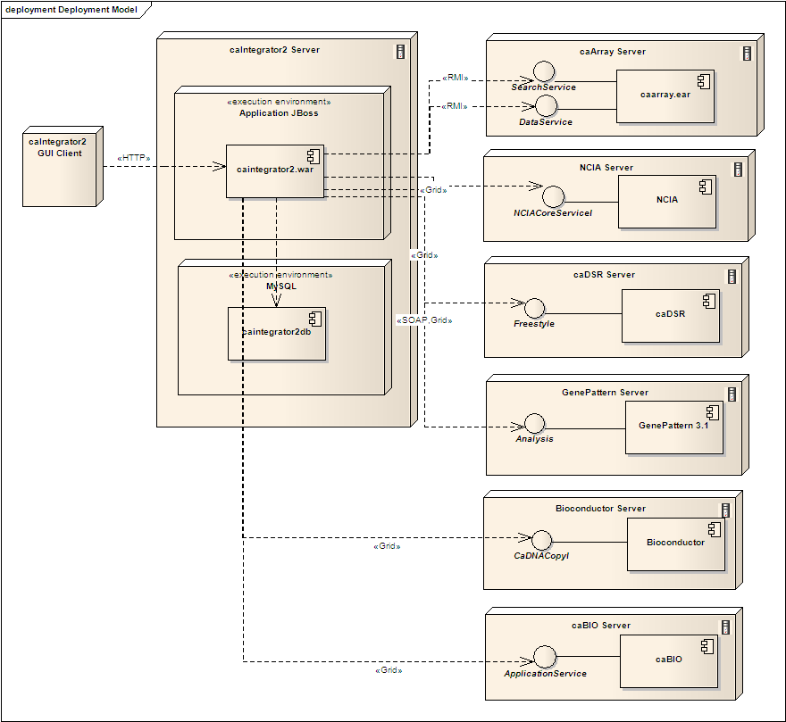
Figure 16 – Architecturally Significant Deployment Elements

