Iteration Plan
caIntegrator 2.0 - Elaboration 1Construction 1

Last Revised: | Oct 6, 2008
Produced By: | caIntegrator2 Development Team
Version: | 0.1

Document Approvals
The list contains the name and contact information for the core project team and any key stakeholders who have an interest in the success of the project. An “S” identifies persons responsible for approval from the Business and Development. Sign off of the document would be required when a decision is made not to take action for defined gaps.

S | Name | Role | S | Name | Role
S | Anand Basu | NCICB Engineering Manager | S |  | Product Manager
 | Shine Jacobs | Project Manager |  | JP Marple | Tech Lead
 | Eric Tavela | Lead Architect |  |  | NCICB Independent QA
Revision History
When you make a change to a document, you must add an entry to this Revision History table and you must manually type the Last Revised Date on the front cover.

Date | Version | Description | Revised by
10/6/08 | 0.1 | Initial Draft | Shine Jacob
Copyrights and Trademarks
© Copyright 2007 by NCICB, caBIGTM. All rights reserved.

Table of Contents
1. Introduction 5
1.1 Purpose 5
1.2 Scope 5
1.3 Definitions, Acronyms, and Abbreviations 5
1.4 References 5
2 Plan 5
3 Resources 6
4 Use Cases 7
4.1 Requirements Elaboration 7
4.2 Analysis 7
4.3 Implementation 7
4.4 Others 8
5 Evaluation Criteria 8

Iteration PlanE1>

Introduction
This iteration plan is for Construction Iteration 1 for caIntegrator2.0. Iteration duration is from Oct 1 2008 – Oct 30 2008.

Purpose
During the C1 iteration the caIntegrator2 application will complete implementation of all the existing bugs for deploy study, Complete Manage Queries, Complete simple interface to GenePattern. Use case definition of View Images will be also completed.

Scope
C2 iteration plan applies to caIntegrator2.0 – construction phase 2. This document will serve as the guide for the team during this iteration.

Definitions, Acronyms, and Abbreviations

References
- Project Management/ caintegrator2_schedule.mpp
- Project Management/ caintegrator2_risk_list.xls
- Requirements/caintegrator2_vision.doc
- Requirements/use cases

Plan

- Implementation plan is available at GFroge website - https://gforge.nci.nih.gov/tracker/?atid=2008&group_id=507&func=browse

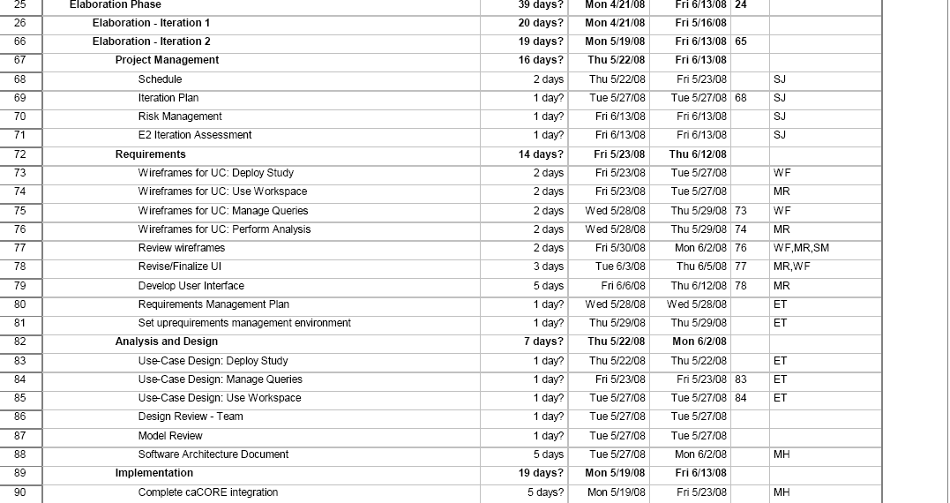
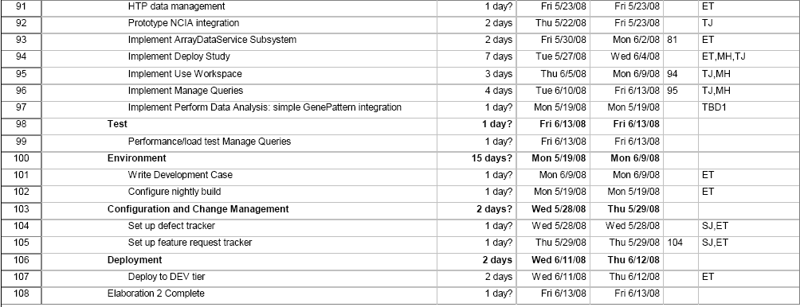

Resources

- Resources available for this iteration are given below.

Team Member | Role | Percentage on Project
Shine Jacob | Project Manager | 50%
Eric Tavela | Architect/Developer | 90%
JP Marple | Team Lead | 100
T.J Andrews | Developer | 100%
Will Fitzhugh | SME/ Requirement Analyst | 50%
Sangeetha Rajagopal | Developer | 100%
caIntegrator1.o team |  | As required/available

CaIntegrator1.0 Team members (Huaitian Liu and Mark Lewis) will be available based on priority for caIntegrator 1.0

Vacation plans

Use Cases
This section will describe at a high level what requirements, analysis and implementation will occur for E2 to be considered a success.

Requirements Elaboration
For this iteration we will create wire-frames and review, revise and finalize for the following use cases/usage scenarios.
- View Images

Analysis

Implementation

The following high priority items for Deploy Study will be completed.
- Complete the search for caDSR elements for Image Annotations
- Define Fold Changes
- Map Image AcquisitionId to PatientID

The following high priority items for Manage Queries will be completed.
- Add Image criterions when defining search criteria
- Add Genomic criterions when defining search criteria
- View Genomic Annotations in Search Results
- Provide Name and Description and Save Query
- Select the annotation columns that are to be included in the search results
- Define Query about Fold Change
The following high priority items for Perform Analysis will be completed.
- User can send the results to GenePattern and perform Analysis at GenePattern site.
Deployment to Development
- Development version of caIntegrator2 will be completed by end of this iteration.
Following lower priority tasks may be completed
- Link to NCIA for all images
- Pagination in search results
- User can select the sort order of search results
- User can select a study via MyStudy pulldown
- User can sort the search results by clicking on column header
- User view left menu and find all study related items together
- User can upload a logo for study
- User can configure the study using a tabbed display in which the configuration controls for each criterion appear on a separate tab

Others
- A requirement management plan with tracker and feature tracking requests.

Evaluation Criteria

The primary goal of this iteration is to wire frame the four selected use cases and implement at least three of them. The major goals to be reviewed for success criteria at the end of this iteration are described below. Due to resource shortage, some of these goals are identified as stretch goals.

Wireframes and UI Prototypes for Key Use Cases
Use Cases:
- Deploy Study
  - VASARI clinical, sample and NCIA data
- Manage Queries (create query and execute query)
- Use Workspace
- Perform Analysis

Complete caCORE End-to-End Generation
- Use of generated APIs in caIntegrator 2 code.
- Includes build functionality to deploy database DDL and generated application components.

Complete High-Throughput Data Handling
- NetCDF approach.

Implement Deploy Study
- Deploy all VASARI data (clinical, sample and NCIA)
- Clinical from text file
- Sample/array data from caArray
- VASARI annotation data (on ImageSeries) from text file

Implement Manage Queries
- Completely implement Manage Queries end-to-end. This will support all scenarios including:
- Retrieve ImageSeries by subject/patient clinical annotation
- Retrieve expression data by gene list and image annotation

Implement Use Workspace

Define Explicit Requirements Management Approach
- Create tracker
- Integrate work being done by CMA (Based on resource availability)
- Document explicit requirements management approach

Document Use Cases (Stretch Goal)
- Update Study
- Methylation data
- Security Requirements

Implement GenePattern Integration (Stretch Goal)

