MIGRATING EXISTING WEB APPLICATIONS

FROM CSM BASED AUTHENTICATION TO caGRID BASED AUTHENTICATION

Requirements

Business Requirements
To grid-enable an existing application which uses CSM based authentication
An existing application which is planning to move to grid needs to migrate its authentication from local CSM based and start using caGrid based authentication to authentication user.

To provide application users with a single set of credentials
Application users should not need separate credentials to access the application and the grid services

To migrate existing application users from local authentication mechanism to the new grid based authentication
Many sites might that have already adopted the application, and would be using local CSM for both authorization and authentication. There is requirement to provide a migration path to move these existing user accounts on to grid.

To help eliminate the need to provision user’s locally for the purpose of authorization
Once migrated to use caGrid Security, the application can leverage the Grip Grouper functionality. This would eliminate to provision new users locally at each application instance.

Policy Requirements
To use caBIG approved Identity Providers and thus allowing federation of identity
The web application should use a caBIG approved Identity Provider as your credential source. This way any user which is member of those Identity Providers can log onto the application (provided the user has appropriate access permission if any).

Assumptions
Institutional Identity Providers (IdP)
The solution provided is based on the assumption that most of the local users of the application are already provisioned in their local Institutional IdP. For some of the users who are provisioned on the Institutional IdP, they would be migrated and registered with the Dorian IdP. This solution would also work if the application wishes to utilize their local CSM as IdP.

Current Solution

Current Authentication Mechanism for an Application Using CSM Based Authentication

User is displayed the login screen of Web Application
User provides the Login Credentials
The Web Application invokes CSM API to authenticate user
Authn Credentials
username: johndoe
password: pwd
CSM API connects to the RDBMS database to validate user credentials
CSM Schema
Is user authenticated?
N
User is logged in and his login id is set for authorization
Y
Authz Id
username: johndoe

As show above, the application performs authentication locally using CSM to validate user’s credentials. This approach has the following drawbacks:

Users are provisioned locally for each application instances. This leads to:
- Users needing separate credentials for each applications instance they have access to.
- Users would need another set of credentials to access application’s Grid Services.

Proposed Solution #1: IdP/Dorian for Authentication and CSM for Authorization

Service - Components | Function | Deployment Location | Advantages | Disadvantages
Authentication – IdP | - Used to validate user’s credentials and issue authentication SAML token | NCICB Production Grid | - Eliminates need to provision user locally in the application.  - Leverages Federation features of caGrid
Authentication – Dorian | - Provides Grid Credentials for user authenticated by an IdP | NCICB Production Dorian | - Eliminates need to install and maintain local Dorian.  - Reduces administrative overhead.
Authorization – CSM | - Used for provisioning local authorization control for users | Local Web Application Instance | - Provides local control to restrict data access. | - Each application users needs to be provisioned locally for authorization
Account Migration  – CSM-Dorian Migration Plug-in | - Provides automated migration of users from local CSM database into Dorian for authentication. | Local Web Application Instance | - Removes administrative overhead of migrating manually and following up with users.  - More secured as user’s themselves register with Dorian

Proposed Authentication Solution

The following is work flow for the proposed solution

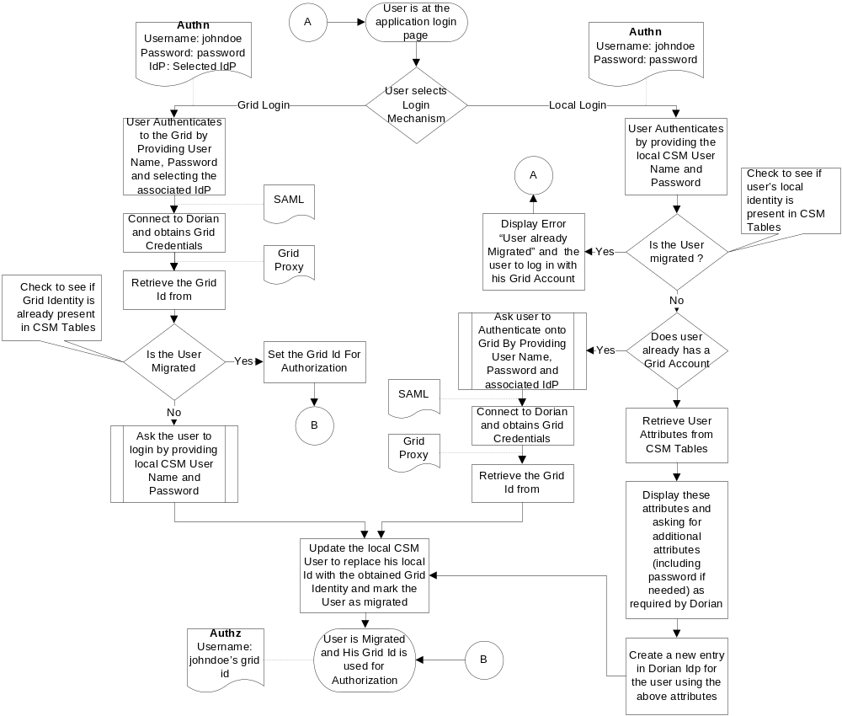

Components of Proposed Solution

Web Application

The web application would need refactoring to incorporate both Dorian-based authentication and the CSM-Dorian Migration Plug-in. It would also be able to route the user to appropriate path based on whether the user is migrated or not.

IdPs

The IdPs registered on NCICB Production Grid will be used as the Identity Provider to validate user’s credentials. They will authenticate the user and provide a SAML token.

Dorian

The NCICB Production Dorian as a Federation Service to generate user’s grid identity. This Dorian instance will also host all the users migrated from individual local web application instances which are not associated to any other IdPs.

CSM-Dorian Migration Plug-in

To assist in the migration of local CSM accounts to Dorian, a migration plug-in is provided which is invoked only the first time a non-migrated user logs into the application.
- This pluggable component would retrieve user information from the local CSM database, and allow the end user to complete any additional information needed by Dorian.
- It would then request a user account from Dorian and mark it as migrated in CSM.
- The application would be responsible at login for checking this flag and calling the plug-in if needed or authenticating the user against Dorian.

Application Data Service

Once migrated, users can use their grid credentials to access any grid service, including the Application Grid Service. Once authenticated, the user’s Grid Identity can be retrieved and used for authorization purposes in the same way as in the web application.

Deployment View of the Proposed Solution

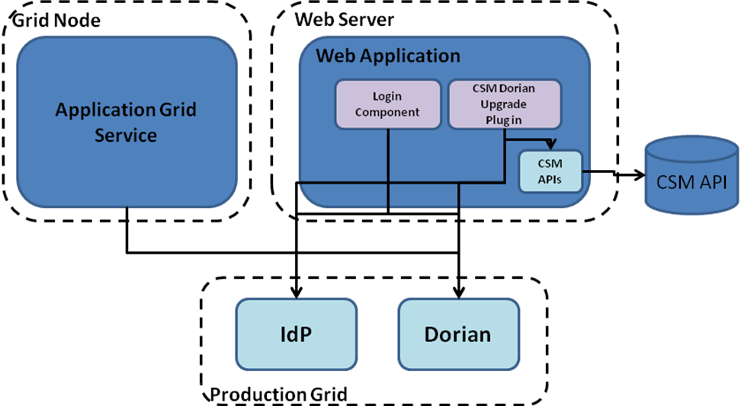

Impact of the Proposed Solution

Technical Impact
- Web application would need refactoring to incorporate the CSM-Dorian plug-in and to use Dorian for Authentication

End User Impact
- End users would endure a one-time migration process, after which grid credentials would be used for Authentication
- Users might need to provision a new password if their current password doesn’t meet the LOA1 password requirements set by Dorian.

Installation/Administration Impact
- New users would have to be provisioned both in Dorian for Authentication and in local CSM for Authorization
- New web application users would be provisioned using their grid identity into CSM for Authorization

Proposed Solution #2: Dorian for Authentication, CSM for Authorization, and Grid Grouper for Grouping

Service - Components | Function | Deployment Location | Advantages | Disadvantages
Authentication – IdP | - Used to validate user’s credentials and issue authentication SAML token | NCICB Production Grid | - Eliminates need to provision user locally in the application.  - Leverages Federation features of caGrid
Authentication – Dorian | - Provides Grid Credentials for user authenticated by an IdP | NCICB Production Dorian | - Eliminates need to install and maintain local Dorian.  - Reduces administrative overhead.
Grouping – Grid Grouper | - Used for assign grid user to group | NCICB Production Grid Grouper | - Removes the need to provision individual user at each web application instance
Authorization – CSM | - Used for provisioning local authorization control at group level | Local Web Application Instance | - Provides local control to restrict data access.
Account Migration  – CSM-Dorian Migration Plug-in | - Provides automated migration of users from local CSM database into Dorian for authentication. | Local Web Application Instance | - Removes administrative overhead of migrating manually and following up with users.  - More secured as user’s themselves register with Dorian

Proposed Authentication Solution

The following is work flow for the proposed solution. It follows the same workflow as proposed solution #1 and only the steps that are different are displayed here.

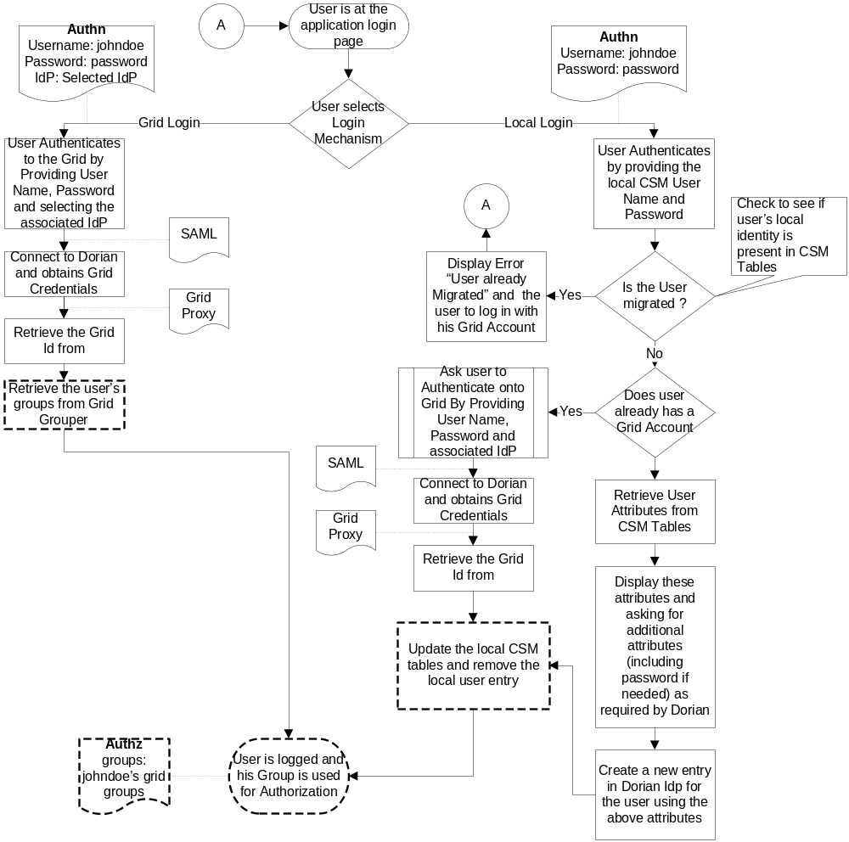

Components of Proposed Solution

Web Application

The web application would need refactoring to incorporate both Dorian-based authentication and the CSM-Dorian Migration Plug-in. It would also be able to route the user to appropriate path based on whether the user is migrated or not. Also the web application would be modified to use group based authorization. The groups returned for the logged in user would now be used to check access privileges. The local authorization policy would be published at group level in CSM.

IdPs

The IdPs registered on NCICB Production Grid will be used as the Identity Provider to validate user’s credentials. They will authenticate the user and provide a SAML token.

Dorian

The NCICB Production Dorian as a Federation Service to generate user’s grid identity. This Dorian instance will also host all the users migrated from individual local web application instances which are not associated to any other IdPs.

Grid Grouper

The NCICB Production Grid Grouper will be used to associate the grid user to various Groups provisioned for the web application. The application admin would be responsible for management of the required groups and its membership.

CSM-Dorian Migration Plug-in

To assist in the migration of local CSM accounts to Dorian, a migration plug-in is provided, which is invoked only the first time a non-migrated user logs into the application.
- This pluggable component would retrieve user information from the local CSM database, and allow the end user to complete any additional information needed by Dorian.
- It would then request a user account from Dorian and remove the user entry from the local CSM database.
- The application would be responsible at login for checking if the local user exists and calling the migration plug-in or routing the authenticating the user against Dorian.

Application Data Service

Once migrated, users can use their grid credentials to access any grid service, including the Application Grid Service. Once authenticated, the user’s groups can be retrieved and used for authorization purposes in the same way as in the web application.

Deployment View of the Proposed Solution

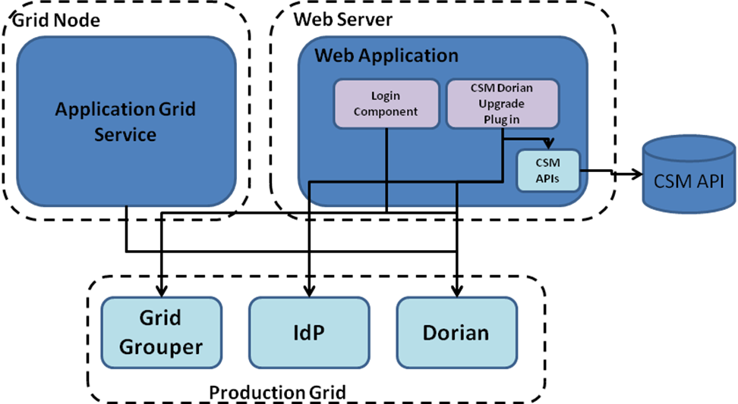

Impact of the Proposed Solution

Technical Impact
- The Application would need refactoring to incorporate the CSM-Dorian plug-in and to use Dorian for Authentication
- Application would need refactoring to use group based Authorization. (If required.)

End User Impact
- End users would endure a one-time migration process, after which grid credentials would be used for Authentication
- Users might need to provision a new password if their current password doesn’t meet the LOA1 password requirements set by Dorian.

Installation/Administration Impact
- New users would be now provisioned in Dorian only and would need to be associated to appropriate groups in the Grid Grouper.

