Iteration Plan
caIntegrator 2.0 - Elaboration 13

Last Revised: | Aug 13, 2008
Produced By: | caIntegrator2 Development Team
Version: | 0.1

Document Approvals
The list contains the name and contact information for the core project team and any key stakeholders who have an interest in the success of the project. An “S” identifies persons responsible for approval from the Business and Development. Sign off of the document would be required when a decision is made not to take action for defined gaps.

S | Name | Role | S | Name | Role
S | Anand Basu | NCICB Engineering Manager | S | Subha Madhavan | Product Manager
 | Shine Jacobs | Project Manager |  | JP Marple | Tech lead
 | Eric Tavela | Requirements Manager |  |  | NCICB Independent QA
Revision History
When you make a change to a document, you must add an entry to this Revision History table and you must manually type the Last Revised Date on the front cover.

Date | Version | Description | Revised by
8/13/08 | 0.1 | Initial Draft | Shine Jacob
Copyrights and Trademarks
© Copyright 2007 by NCICB, caBIGTM. All rights reserved.

Table of Contents
1. Introduction 5
1.1 Purpose 5
1.2 Scope 5
1.3 Definitions, Acronyms, and Abbreviations 5
1.4 References 5
2 Plan 5
3 Resources 6
4 Use Cases 7
4.1 Requirements Elaboration 7
4.2 Analysis 7
4.3 Implementation 8
4.4 Others 8
5 Evaluation Criteria 8

Iteration PlanE3>

Introduction
This iteration plan is for Elaboration Iteration 2 for caIntegrator2.0. Iteration duration is from July 7 2008 – Sep 15 2008.

Purpose
During the E2 iteration the “Perform Analysis” use case will be wire-framed and reviewed and finalized. The pending use-case from iteration 2 “Manage Queries” and “Perform Analysis” will be designed. Both these use cases and pending implementation from “Deploy Study” will be implemented. The Build Deploy Automation work for caIntegrator2 will be completed.

Scope
E3 iteration plan applies to caIntegrator2.0 – elaboration phase 3. This document will serve as the guide for the team during this iteration.

Definitions, Acronyms, and Abbreviations

References
- Project Management/ caintegrator2_schedule.mpp
- Project Management/ caintegrator2_risk_list.xls
- Requirements/caintegrator2_vision.doc
- Requirements/use cases

Plan

- Current schedule for Elaboration Iteration 3 is given below. Changes to schedule will be updated on the Microsoft Project and available thru GForge site - https://gforge.nci.nih.gov/docman/index.php?group_id=507&selected_doc_group_id=3377&language_id=1 .
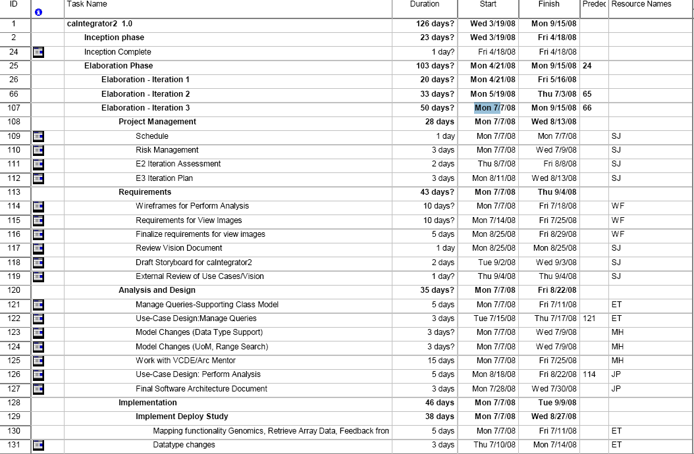
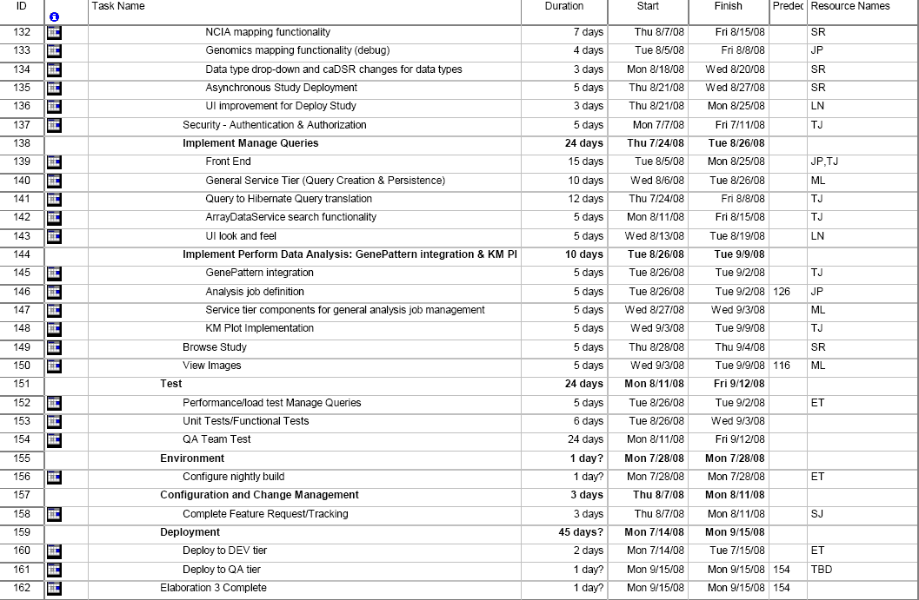

Resources

- Resources available for this iteration are given below.

Team Member | Role | Percentage on Project
Shine Jacob | Project Manager | 60%
Eric Tavela | Requirement Manager/Developer | 70% (Out for month of Aug)
JP Marple | Tech Lead | 100%
T.J Andrews | Developer | 100%
Will Fitzhugh | SME/ Requirement Analyst | 50%
Mark Lewis | Developer | 80%
Sangeetha Rajagopal | Developer | 100%

CaIntegrator1.0 Team members (Sangeetha Rajagopal and Mark Lewis) will be available from Aug 08.
Huaitian Liu will be available on as required basis.

Vacation plans
- Eric Tavela July 28th – Aug 26th
- Will Fitzhugh Aug 4th – 15th
- Mark Lewis Aug 11 – 15th
- Shine Jacob July 24 – 25

Use Cases
This section will describe at a high level what requirements, analysis and implementation will occur for E2 to be considered a success.

Requirements Elaboration
For this iteration we will create wire-frames and review, revise and finalize for the following use cases/usage scenarios.

- Perform Analysis
- View Images

Analysis
For this iteration, major milestones to be accomplished are
- Review of Object Model for data type changes
- Complete Use Case Design for Manage Queries and Perform Analysis
- A simple implementation of view images

Implementation
- Complete the Deploy Study – NCIA mappings and any other pending functionalities/defects
- Implement minimum security and CSM integration.
- Implement Manage Queries
- Implementation Perform Analysis – simple GenePattern Integration and KM Plot

Others
- BDA implementation for caIntegrator2

Evaluation Criteria

The primary goal of this iteration is to Design and implement Manage Queries and Perform Analysis. The major goals to be reviewed for success criteria at the end of this iteration are described below.

Wireframes and UI Prototypes for Use Cases
Use Cases:
- Perform Analysis
- View Images (Requirements)

Complete Implementation of Deploy Study
- VASARI annotation data (on ImageSeries) from text file
- Data-Types selections
- Genomic data load issues
- Asynchronous study load

Implement security – Authentication and Authorization
- Minimum role for this release using CSM

Implement Manage Queries
- Completely implement Manage Queries end-to-end. This will support all scenarios including:
- Retrieve ImageSeries by subject/patient clinical annotation
- Retrieve expression data by gene list and image annotation

Implement Perform Analysis and Gene-Pattern Integration
- Simple GenePattern Integration
- KM plot

Implement View Images (minimum functionality)

BDA implementation for caIntegrator2
- Work with BDA team for Build Deployment Automation of caIntegrator2.

