Iteration Plan
caArray 2.0 - Construction 1

Last Revised: | April 25, 2008
Produced By: | caIntegrator Development Team
Version: | 0.1

Document Approvals
The list contains the name and contact information for the core project team and any key stakeholders who have an interest in the success of the project. An “S” identifies persons responsible for approval from the Business and Development. Sign off of the document would be required when a decision is made not to take action for defined gaps.

S | Name | Role | S | Name | Role
S | Anand Basu | NCICB Engineering Manager | S | Subha Madhavan | Product Manager
 | Shine Jacobs | Project Manager |  | Michael Holck | Lead Architect
 | Eric Tavela | Requirements Manager |  |  | NCICB Independent QA
Revision History
When you make a change to a document, you must add an entry to this Revision History table and you must manually type the Last Revised Date on the front cover.

Date | Version | Description | Revised by
4/29/08 | 0.1 | Initial Draft | Shine Jacob
Copyrights and Trademarks
© Copyright 2007 by NCICB, caBIGTM. All rights reserved.

Table of Contents
1. Introduction 5
1.1 Purpose 5
1.2 Scope 5
1.3 Definitions, Acronyms, and Abbreviations 5
1.4 References 5
2 Plan 5
3 Resources 6
4 Use Cases 7
4.1 Requirements Elaboration 7
4.2 Analysis 7
4.3 Implementation 8
4.4 Others 8
5 Evaluation Criteria 8

Iteration PlanE1>

Introduction
This iteration plan is for Elaboration Iteration 1 for caIntegrator2.0. Iteration duration is from April 21 2008 – May 15 2008.

Purpose
During the E1 iteration the requirements will be further elaborated, analyzed and stabilized. The analysis and design of the selected use-cases will be completed. The architectural prototype will be developed to test the feasibility and performance of the architecture.

Scope

E1 iteration plan applies to caIntegrator2.0 – elaboration phase. This document will serve as the guide for the team during this iteration.

Definitions, Acronyms, and Abbreviations

References
- Project Management/ caintegrator2_schedule.mpp
- Project Management/ caintegrator2_risk_list.xls
- Requirements/caintegrator2_vision.doc
- Requirements/use cases

Plan

- Current schedule for Elaboration Iteration 1 is given below. Changes to schedule will be updated on the Microsoft Project maintained within Subversion.

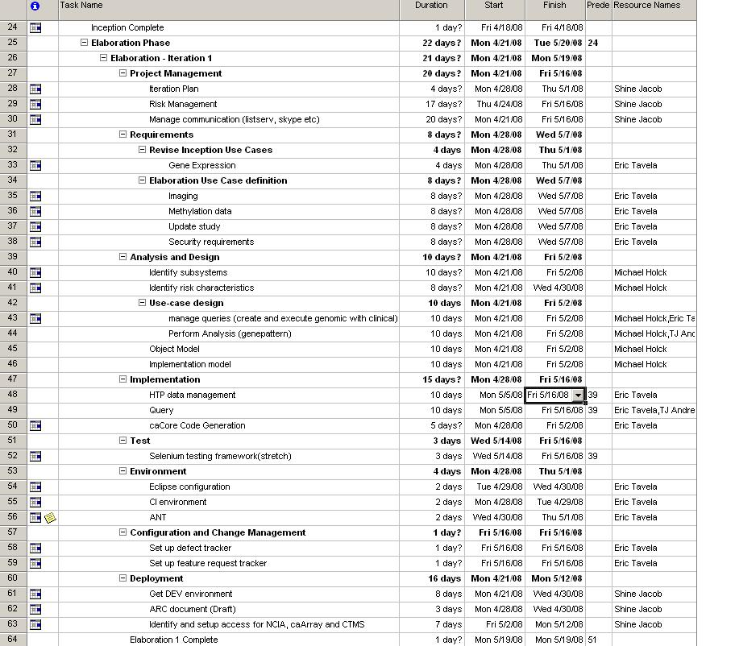

Resources

- Resources available for this iteration are given below.

Team Member | Role | Percentage on Project
Shine Jacob | Project Manager | 80%
Eric Tavela | Requirement Manager/Analyst | 80%
Michael Holck | Lead Architect | 100
T.J Andrews | Lead Developer | 100%
Will Fitzhugh | SME/ Sr. Analyst | 30%
caIntegrator1.o team |  | As required/available

Will Fitzhugh will be available only from May 5th 2007
CaIntegrator Team members (Michael Harris, Mark Lewis and Ryan Landy) will be available based on priority for caIntegrator 1.0

Vacation plans
  - Shine Jacob – May 16th – 20th
  - Eric Tavela - May 16th, May 23rd

Use Cases
This section will describe at a high level what requirements, analysis and implementation will occur for E1 to be considered a success.

Requirements Elaboration
For this iteration we will finalize and document the following use cases/usage scenarios.
- Gene Expression
- Imaging
- Methylation data
- Update Study
- Security

Analysis

For this iteration, major milestones to be accomplished are
- Identify all subsystems and risks.
- Completed Object Model and Data Model that can support translational research in a generic way.
- An implementation model

Implementation
- A viable solution for storage and retrieval of High Throughput Data
- A Query model to support the various genomics and clinical query use cases.
- Integration of one analysis method with GenePattern. This is a stretch goal for this iteration.

Others
- A complete end-to-end development environment (with defined Tech stack, IDE, Automatic build process etc).

Evaluation Criteria

The primary goal of this iteration is to document all use cases, provide a solution for High Throughput Data management and have a working query model. The major goals to be reviewed for success criteria at the end of this iteration are
- Specify the schedule for next iteration(s)
- Complete the documentation for all use cases
- High Throughput Data management solution
- Completed Query Framework
- Completed Data Model
- Complete end-to-end development environment
- Identify all sub-systems
- caCORE code generation

