Table of Contents

[To update the table of contents, select the message below and press F9]

**No table of contents entries found.**

1. Pages
   1. Page Tree

Home

New Study

Clinical Data Source

Clinical Data Field Definition

Clinical Data Access Control

Genomic Data Source

Genomic Data Patient Mapping

Imaging Data Source

Image Data Patient Mapping

Imaging Annotation Field Definition

Imaging Annotation Access Control

Study Manager

* 1. Home
  2. New Study
     1. User Interface

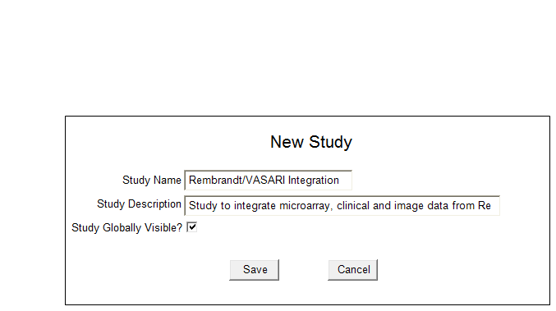

* 1. Clinical Data Source
     1. User Interface

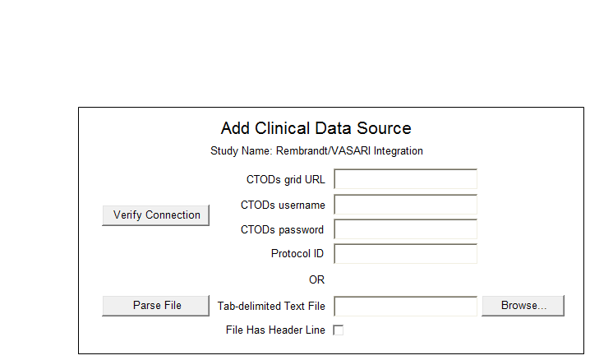

* 1. Clinical Data Field Definition
     1. User Interface

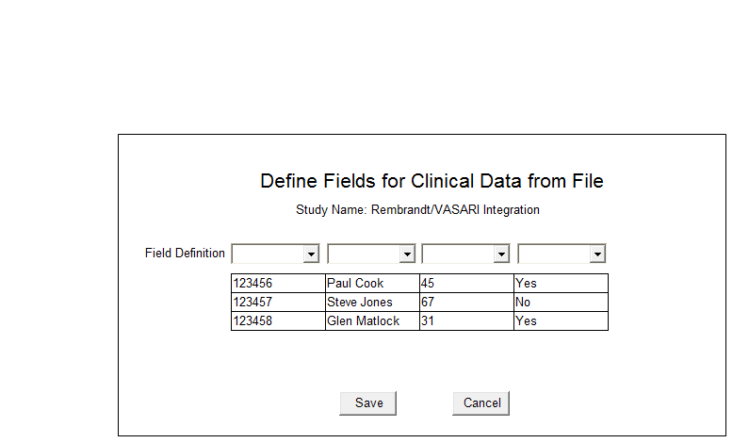

* 1. Clinical Data Access Control
     1. User Interface

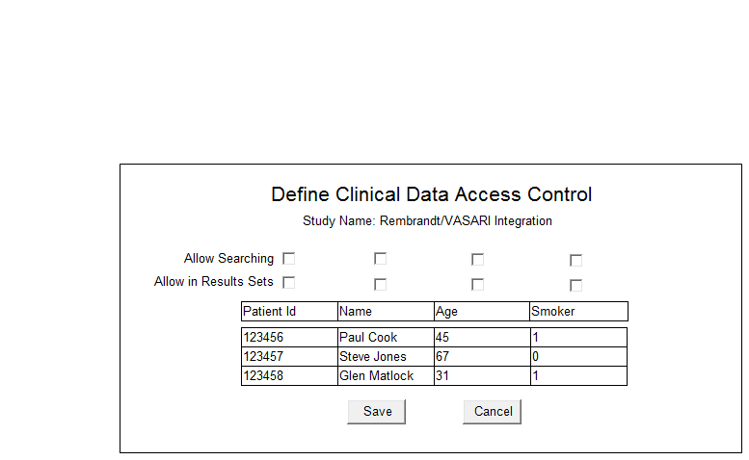

* 1. Genomic Data Source
     1. User Interface

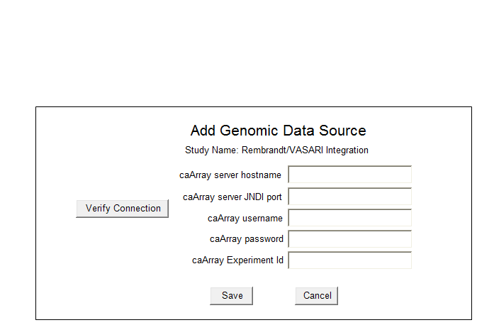

* 1. Genomic Data Patient Mapping
     1. User Interface

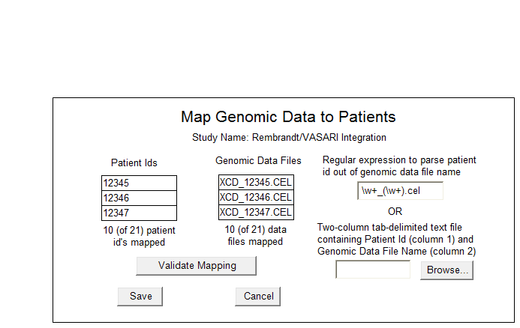

* 1. Imaging Data Source
     1. User Interface

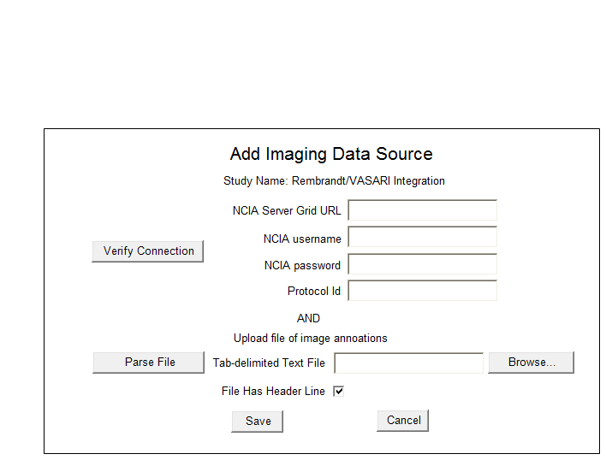

* 1. Image Data Patient Mapping
     1. User Interface

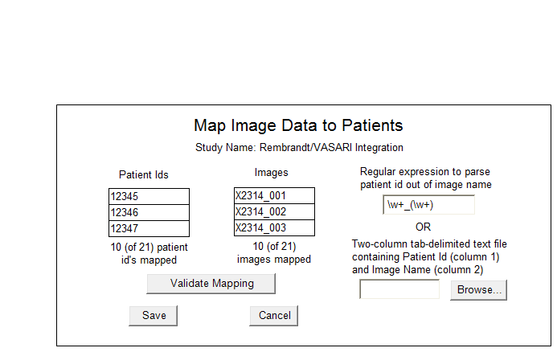

* 1. Imaging Annotation Field Definition
     1. User Interface

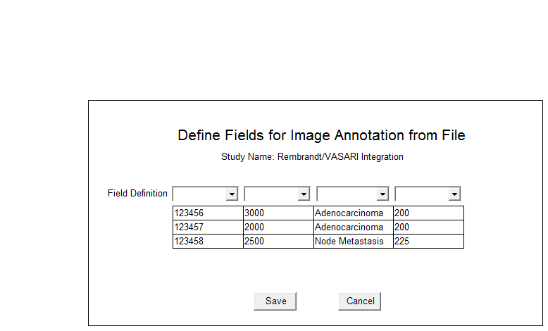

* 1. Imaging Annotation Access Control
     1. User Interface

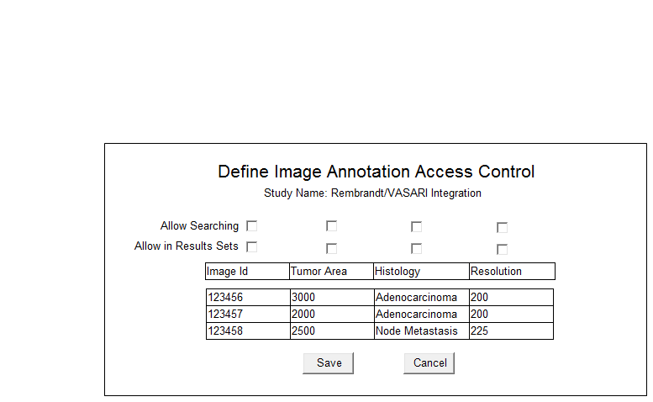

* 1. Study Manager
     1. User Interface

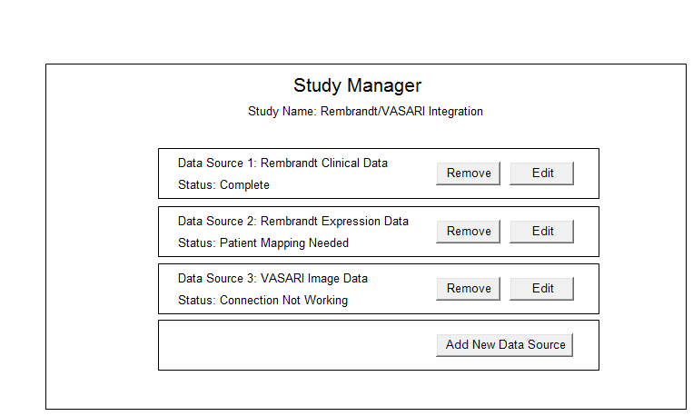

1. Masters
   1. Master List