caMOD Release 2.5

Software Design Description
Version 1.0

[Insert approval date of document]

Document Change Record
Version Number | Date | Description
1.0 | 5/8/2007 | Initial document
1.1 | 5/13/2008 | Added additional sections to document

TABLE OF CONTENTS
1. Introduction 7
1.1 Requirements Traceability 7
1.2 Background/Summary 7
2. System Overview 9
2.1.1 User Client Software 9
2.1.2 Back End 10
2.1.3 Hibernate 3 Data Access 10
2.1.4 JBoss Application Server 10
2.1.5 Database 10
2.1.6 Java 10
3. Submitting Microarray data that are stored in other applications other than caarry 11
3.1 user interface (VIEW) 11
3.1.1 submit microarrays screen 11
3.1.2 view microararys screen 12
3.1.3 Interface Classes to be Modified 12
3.2 middle tier (CONTROLLER) 13
3.2.1 Form and data classes 13
3.2.2 Manager Impl classes 13
3.2.3 Action classes 13
3.3 Persistence Layer 13
3.3.1 mapping files 13
3.4 database (MODEL) 13
3.5 configuration and utility classes 13
3.5.1 Configuration and Utility Files Changed 13
3.6 Database 14
4. Release Data selection not maintaining value 15
4.1 user interface (VIEW) 15
4.2 middle tier (CONTROLLER) 16
4.2.1 Action classes 16
4.2.2 ManagerImpl classes 16
5. Add link to pdf users guide to quick links menu 18
5.1 user interface (VIEW) 18
5.1.1 Interface Classes to be Modified 19
6. Fix searching – allow oracle result set > 1000 20
6.1 user interface (VIEW) 20
6.1.1 Interface Classes to be Modified 21
6.2 middle tier (CONTROLLER) 21
6.2.1 Form classes 21
6.2.2 Action classes 21
6.3 persistence layer 21
6.3.1 mapping files 21
6.4 database (MODEL) 21
6.5 configuration and utility classes 22
6.5.1 Configuration and Utility Files Changed 22
6.6 Database 22
7. Use Improved publication fetch script and fixes 23
7.1 user interface (VIEW) 23
7.1.1 Interface Classes to be Modified 23
7.2 middle tier (CONTROLLER) 23
7.2.1 123 23
7.3 persistence layer 24
7.3.1 123 24
7.4 database (MODEL) 24
7.4.1 123 24
7.5 configuration and utility classes 24
7.5.1 Configuration and Utility Files Changed 24
8. customize publication pages for rat to allow submission and display of rgd 25
8.1 user interface (VIEW) 25
8.1.1 Interface Classes to be Modified 25
8.2 middle tier (CONTROLLER) 26
8.2.1 Form and data classes 26
8.2.2 Action classes 26
8.2.3 ManagerImpl classes 26
8.3 persistence layer 26
8.3.1 hbm files 26
8.4 database (MODEL) 26
8.4.1 Database 26
8.5 configuration and utility classes 26
8.5.1 Configuration and Utility Files Changed 26
8.6 Database 27
9. place a url field on the image page 28
9.1 user interface (VIEW) 28
9.1.1 Interface Classes to be Modified 29
9.2 middle tier (CONTROLLER) 29
9.2.1 Form and data classes 29
9.2.2 Action classes 29
9.2.3 AnimalModelManagerImpl 29
9.3 persistence layer 30
9.3.1 mapping files 30
9.4 database (MODEL) 30
9.5 configuration and utility classes 30
9.5.1 Configuration and Utility Files Changed 30
9.6 Database 30
10. add search for pmid to advanced search page 31
10.1 user interface (VIEW) 31
10.1.1 Interface Classes to be Modified 33
10.2 middle tier (CONTROLLER) 33
10.2.1 Form and data classes 33
10.2.2 Action classes 33
10.2.3 AnimalModelManagerImpl 33
11. title field on publication submisson has size limit 34
11.1 user interface (VIEW) 34
11.1.1 Interface Classes to be Modified 35
11.2 middle tier (CONTROLLER) 35
11.2.1 Form classes 35
11.2.2 Action classes 35
11.2.3 AnimalModelManagerImpl 35
11.3 persistence layer 35
11.3.1 mapping files 35
11.4 database (MODEL) 36
11.5 configuration and utility classes 36
11.5.1 Configuration and Utility Files Changed 36
11.6 Database 36
12. fix - save query does not save 37
12.1 user interface (VIEW) 37
12.2 middle tier (CONTROLLER) 37
12.2.1 impl classes 37
13. create automated deployment for camod for each tier 38
13.1 user interface (VIEW) 38
13.1.1 Interface Classes to be Modified 39
13.2 middle tier (CONTROLLER) 39
13.2.1 Form classes 39
13.2.2 Action classes 39
13.2.3 AnimalModelManagerImpl 39
13.3 persistence layer 39
13.3.1 mapping files 39
13.4 database (MODEL) 40
13.5 configuration and utility classes 40
13.5.1 Configuration and Utility Files Changed 40
13.6 Database 40
14. take existing scripts and run them in selenium and cruisecontrol 41
14.1 user interface (VIEW) 41
14.1.1 Interface Classes to be Modified 42
14.2 middle tier (CONTROLLER) 42
14.2.1 Form classes 42
14.2.2 Action classes 42
14.2.3 AnimalModelManagerImpl 42
14.3 persistence layer 42
14.3.1 mapping files 42
14.4 database (MODEL) 43
14.5 configuration and utility classes 43
14.5.1 Configuration and Utility Files Changed 43
14.6 Database 43
15. duplication does not work for some fields 44
15.1 user interface (VIEW) 44
15.1.1 Interface Classes to be Modified 45
15.2 middle tier (CONTROLLER) 45
15.2.1 Form classes 45
15.2.2 Action classes 45
15.2.3 AnimalModelManagerImpl 45
15.3 persistence layer 45
15.3.1 mapping files 45
15.4 database (MODEL) 46
15.5 configuration and utility classes 46
15.5.1 Configuration and Utility Files Changed 46
15.6 Database 46
16. Give fields in “customize Results” feature meaningful names 47
16.1 user interface (VIEW) 47
16.1.1 Interface Classes to be Modified 48
16.2 configuration and utility classes 48
16.2.1 Dropdown lists 48
17. left side search menu disappears when user customizes search result list, save queries, etc 49
17.1 user interface (VIEW) 49
17.1.1 Interface Classes to be Modified 51
18. Automate nightly build using crusiecontrol 52
18.1 user interface (VIEW) 52
18.1.1 Interface Classes to be Modified 53
18.2 middle tier (CONTROLLER) 53
18.2.1 Form classes 53
18.2.2 Action classes 53
18.3 persistence layer 53
18.3.1 mapping files 53
18.4 database (MODEL) 53
18.5 configuration and utility classes 54
18.5.1 Configuration and Utility Files Changed 54
18.6 Database 54
19. lexbig prototype: investigate and demo connection to lexbig vocabulary system 55
19.1 user interface (VIEW) 55
19.1.1 Interface Classes to be Modified 56
19.2 middle tier (CONTROLLER) 56
19.2.1 Form classes 56
19.2.2 Action classes 56
19.3 persistence layer 56
19.3.1 mapping files 56
19.4 database (MODEL) 56
19.5 configuration and utility classes 57
19.5.1 Configuration and Utility Files Changed 57
19.6 Database 57
20. Change spelling of Equus Caballus - start Caballus with a lower case "c" 58
20.1 user interface (VIEW) 58
20.2 Database 58
21. Delete Sequnce ID field from genetic description search page, targeted modification table 59
21.1 user interface (VIEW) 59
22. Induced mutation entries need to be flagged and searches for induced mutation and carcinogenic interventions need to be fixed 60
22.1 user interface (VIEW) 60
22.2 middle tier (CONTROLLER) 60
22.2.1 EnvironmentalFactorForm 60
22.2.2 InducedMutationManagerImpl 61
22.2.3 CarcinogenExposureManagerImpl 61
22.2.4 QueryManagerImpl 61
22.3 persistence layer 62
22.3.1 EnvironmentalFactor 62
22.4 database (MODEL) 62
22.4.1 EnvironmentalFactor 62
22.5 Database 62
23. Add urlAlternEntry to image object 63
23.1 user interface (VIEW) 63
23.1.1 Interface Classes to be Modified 64
23.2 middle tier (CONTROLLER) 64
23.2.1 Form classes 64
23.2.2 Action classes 64
23.2.3 EngineeredTransgeneManagerImpl 65
23.2.4 GenomicSegmentManagerImpl 65
23.2.5 TargetedModificationManagerImpl 65
23.3 persistence layer 65
23.3.1 mapping files 65
23.4 database (MODEL) 66
23.5 Database 66
24. rename OtherLocationURL in microarray object to url 67
24.1 user interface (VIEW) 67
24.2 middle tier (CONTROLLER) 67
24.2.1 MicroArrayDataForm 67
24.3 persistence layer 68
24.3.1 MicroArrayData 68
24.4 database (MODEL) 68
24.4.1 MicroArrayData 68
24.5 Database 68
[Appendix A – acronym List] 69
[APPENDIX B – DATABASE changes] 70

Introduction
The purpose of this document is to describe the design for the enhancements that are being developed for caMOD release 2.4. The primary enhancement includes: import caELMIR study data for the therapeutic approaches search results screen. In addition we will modify the object model as a result of the recent VCDE silver level review recommendations.

Requirements Traceability
Req # | Requirement Description
6812 | Change spelling of Equus Caballus - start Caballus with a lower case "c"
12824 | Delete Sequence ID field from genetic description search page, targeted modification table
12825 | Induced mutation entries need to be flagged (requires OM change) and searches for induced mutation and carcinogenic interventions need to be fixed
13897 | Add urlAlternEntry to image object
13898 | Renamed OtherLocationURL in microarray object to url

Background/Summary
The cancer models database (caMOD) is a web-based resource that provides information about animal models for human cancer to the public research community.
caMOD provides the following key capabilities to its users:

Data Submission--Data in caMOD are extracted from the public scientific literature by curators and verified by the scientists who generated or worked with the models, or they are directly submitted by scientists.

Cancer Model Search--Users can retrieve information about the making of models, their genetic descriptions, histopathology, derived cell lines, associated images, carcinogenic interventions, microarray data, and therapeutic trials in which the models were used. caMOD provides links to PubMed for associated publications and other resources such as mouse repositories, detailed information about altered gene, pathway affected, and information about human clinical trials that utilize the same compounds as the pre-clinical trials in the animal models.

System Function Administration--The Admin function provides services for user registration, review of submitted models and database management.

System Overview
The purpose of this section is to give an overview of the caMOD API. The following diagrams show the overall architecture and of the caMOD application.
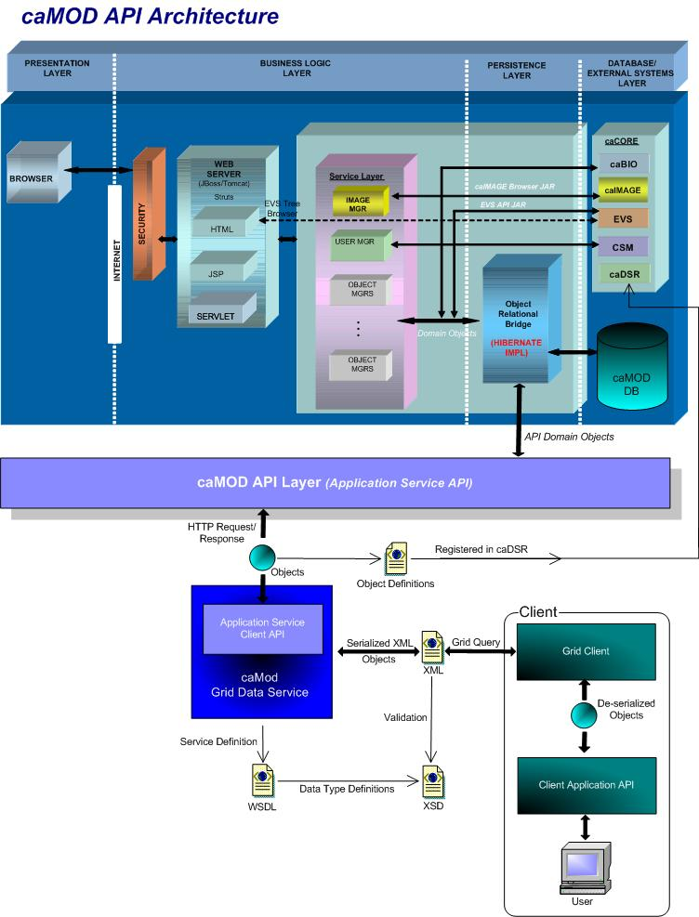

User Client Software
caMOD is a web based user interface implemented as HTML, JSP, JavaScript, and AJAX. The use of JavaScript is limited to improving usability only.
Java Server Pages (JSPs) are used to generate dynamic HTML based on user actions. JSPs are combinations of HTML, Java Code, and custom JSP and JSTL tags that get compiled into servlet classes.

Back End
The caMOD back end components provide access to persistence services for retrieving and storing data in the database. Hibernate, an open source tool, is used as the Object Relational Mapping (ORM) software.

Hibernate 3 Data Access
The caMOD uses Hibernate version 3. Hibernate is used for read, write access. It provides the insert, update and delete capability to the caMOD application thru the domain classes.

JBoss Application Server
The user interface, middle tier, and backend components are run with in JBoss Java2 Enterprise Edition (J2EE) application server. JBoss is an open source application server that provides a servlet container, an EJB container, the full range of J2EE 1.4 features as well as extended enterprise services including clustering, caching and persistence. JBoss 4.0.5 conforms to the newest technology stack. It will be consistent with many other applications.

Database
Oracle Relation Database Management System (RDBMS) software is used as the persistent store for caMOD and caIMAGE application data. Java classes access the database using the Java Database Connectivity (JDBC) API.

Java
The new version of Java1.5 (Java tool kit version jdk1.5.0_10) is used for compilation. Therefore all the code in caMOD has been compiled using the JDK 1.5 version. This will conform to the latest technology stack currently used by NCI.

Submitting Microarray data that are stored in other applications other than caarry

user interface (VIEW)

submit microarrays screen
Allow the submitter a choice to enter the data directly, provide a brief description and a link to data stored in other places like university servers, lab servers or NCBI.
Current caMOD submit microarrays screen:
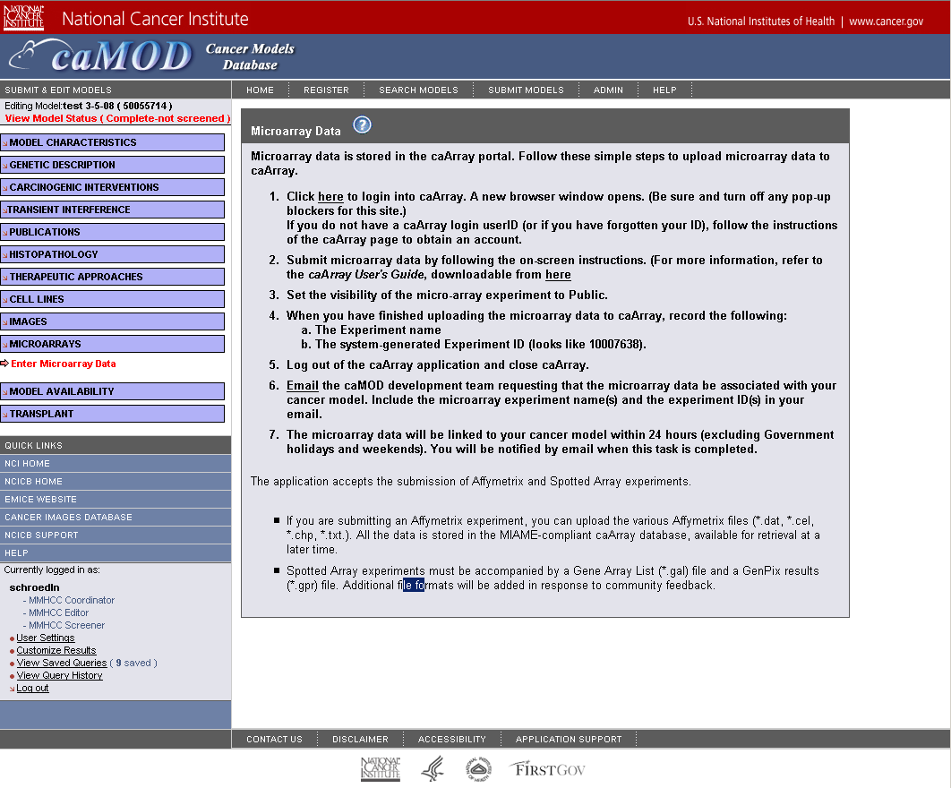
New URL and DESCRIPTION fields added to current screen:
[ IMAGE! ]

view microararys screen
Current view caMOD microarrays screen
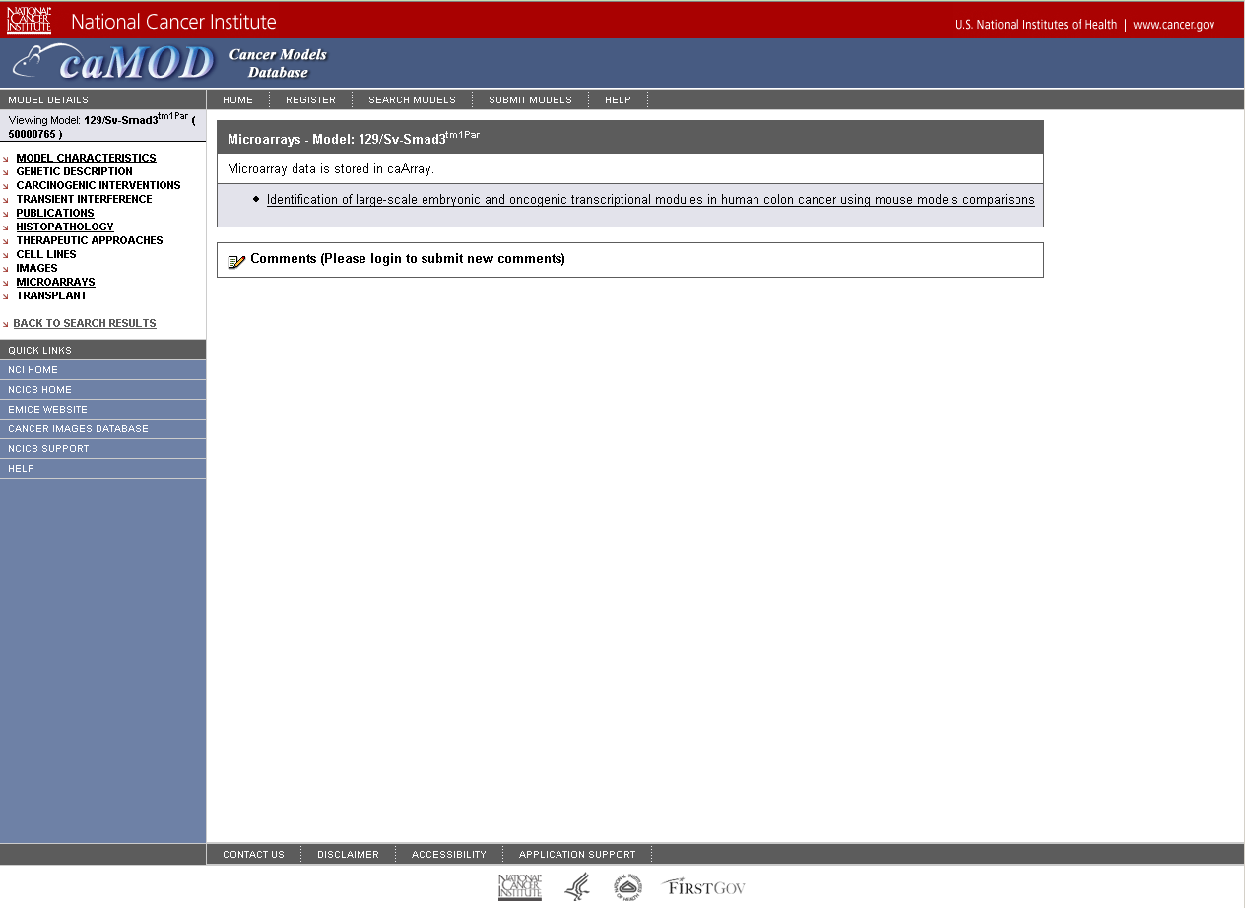:
New view caMOD microarrays screen:

Interface Classes to be Modified
The following is a list of interface classes (GUI and interface java classes) that need to be modified.
Interface Class Name | Description
viewMicroarrays.jsp
submitMicroarrayData.jsp
searchResults.jsp

middle tier (CONTROLLER)

Form and data classes
Method Name | Description
MicroArraryData.java | .
MicroArrayDataForm.java

Manager Impl classes
Method Name | Description
MicroArrayDataManagerImpl.java | .

Action classes
Method Name | Description
MicroArrayDataAction.java | .
MicroArrayPopulateAction.java

Persistence Layer
    - mapping files
File Name | Function
MicroArrayData.hbm.xml | .

database (MODEL)
The following attributes will be added to the following objects in the object model.
Class Name | Description
MicroArrayData.java

configuration and utility classes
    - Configuration and Utility Files Changed
File Name | Function
SeachResultsColumns.txt
Hibernate.cfg.xml
Validation.xml

Database
The database table change is defined in Appendix B.

Release Data selection not maintaining value

user interface (VIEW)
When creating a model the default choice is "release immediately". When the user returns to the page the selection has automatically jumped to "release after" and today's date has been entered.
In order for a model to be displayed on the search side the model needs to be in the "edited-approved" state and the release date has to be passed. Since the radio button on the model char submission page jumps to "release after" models are not immediately displayed.
Will correct this by setting the date check to greater than or equal to the release date.
Current create new Model screen:
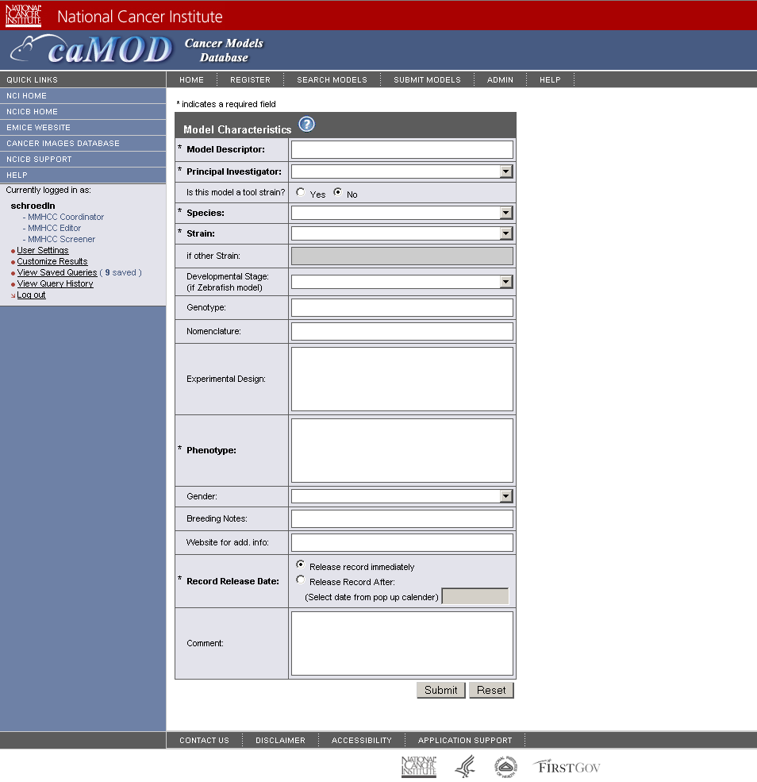

middle tier (CONTROLLER)

Action classes
Class Name | Description
AnimalModelPopulateAction.java

ManagerImpl classes
Method Name | Description
AnimalModelManagerImpl.java

Add link to pdf users guide to quick links menu

user interface (VIEW)
Add a link to the pdf users guide to quick links menu
Current quick links GUI:
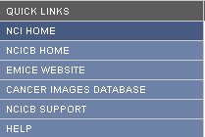
New GUI:

Interface Classes to be Modified
The following is a list of interface classes (GUI and interface java classes) that need to be modified.
Interface Class Name | Description
sidebar.jsp

Fix searching – allow oracle result set > 1000

user interface (VIEW)

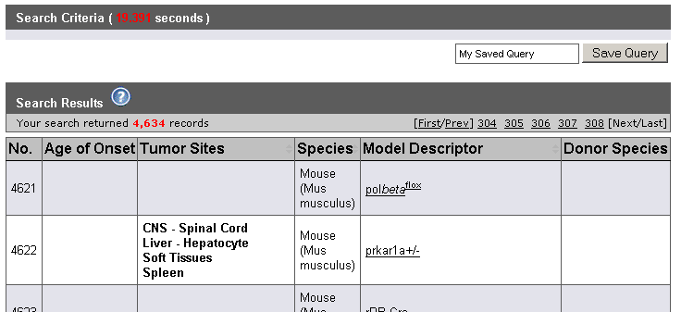y
Example of comments field on search screen:

Interface Classes to be Modified
The following is a list of interface classes (GUI and interface java classes) that need to be modified.
Interface Class Name | Description

middle tier (CONTROLLER)
    - Form classes
The following Form.java classes will be modified to add comments.
Class Name | Description

Action classes
The following Action.java classes will be modified to add comments.
Class Name | Description

persistence layer

mapping files
The following hibernate mapping files will be modified to add comments.
Class Name | Description

database (MODEL)
The comments attribute will be added to the following objects in the object model.
Class Name | Description

configuration and utility classes
    - Configuration and Utility Files Changed
File Name | Function
SeachResultsColumns.txt
Hibernate.cfg.xml
Validation.xml

Database
The database table change is defined in Appendix B.

Use Improved publication fetch script and fixes

user interface (VIEW)

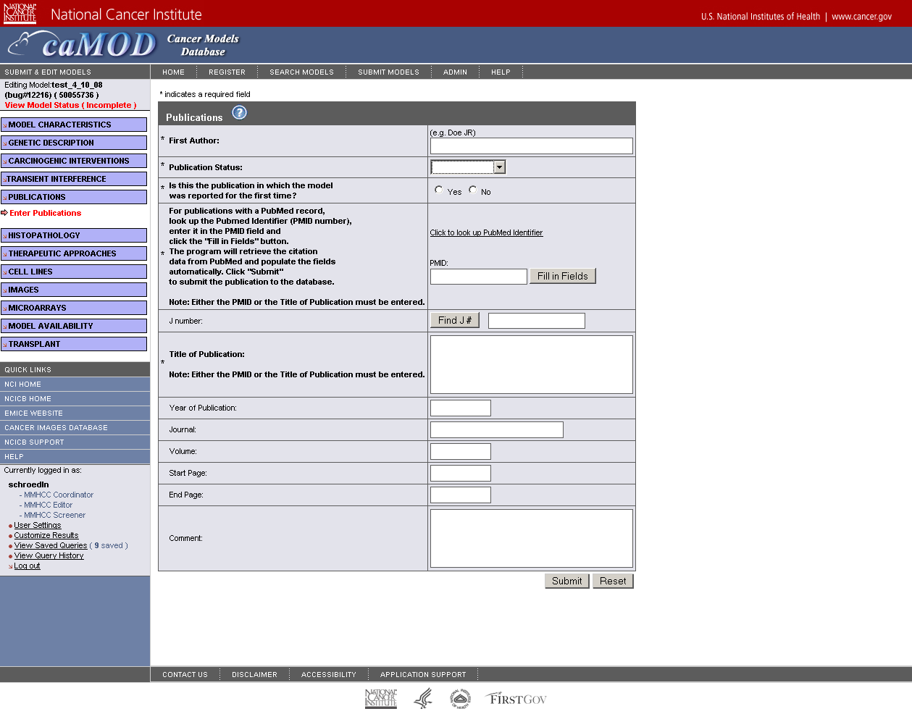

Interface Classes to be Modified
The following is a list of interface classes (GUI and interface java classes) that need to be modified.
Interface Class Name | Description

middle tier (CONTROLLER)
    - 123

persistence layer

123
Attribute Name | Description

database (MODEL)

123
Attribute Name | Description

configuration and utility classes
    - Configuration and Utility Files Changed
File Name | Function
SeachResultsColumns.txt
Hibernate.cfg.xml
Validation.xml

customize publication pages for rat to allow submission and display of rgd

user interface (VIEW)

Interface Classes to be Modified
The following is a list of interface classes (GUI and interface java classes) that need to be modified. .
Interface Class Name | Description
submitPublications.jsp
searchResults.jsp

middle tier (CONTROLLER)
    - Form and data classes
Method Name | Description
PublicationForm.java
PublicationData.java

Action classes
Method Name | Description
PublicationAction.java
PublicationPopulateAction.java

ManagerImpl classes
Method Name | Description
PublicationManagerImpl.java

persistence layer

hbm files
Attribute Name | Description
Publication.hbm.xml

database (MODEL)

Database
Attribute Name | Description
Publication.java

configuration and utility classes
    - Configuration and Utility Files Changed
File Name | Function
Hibernate.cfg.xml
Validation.xml

Database
The database table change is defined in Appendix B.

place a url field on the image page

user interface (VIEW)
Allow for linking of external images not to be saved to caImage. Create a new database field called URL_Altern_Entry
Current submit Images page
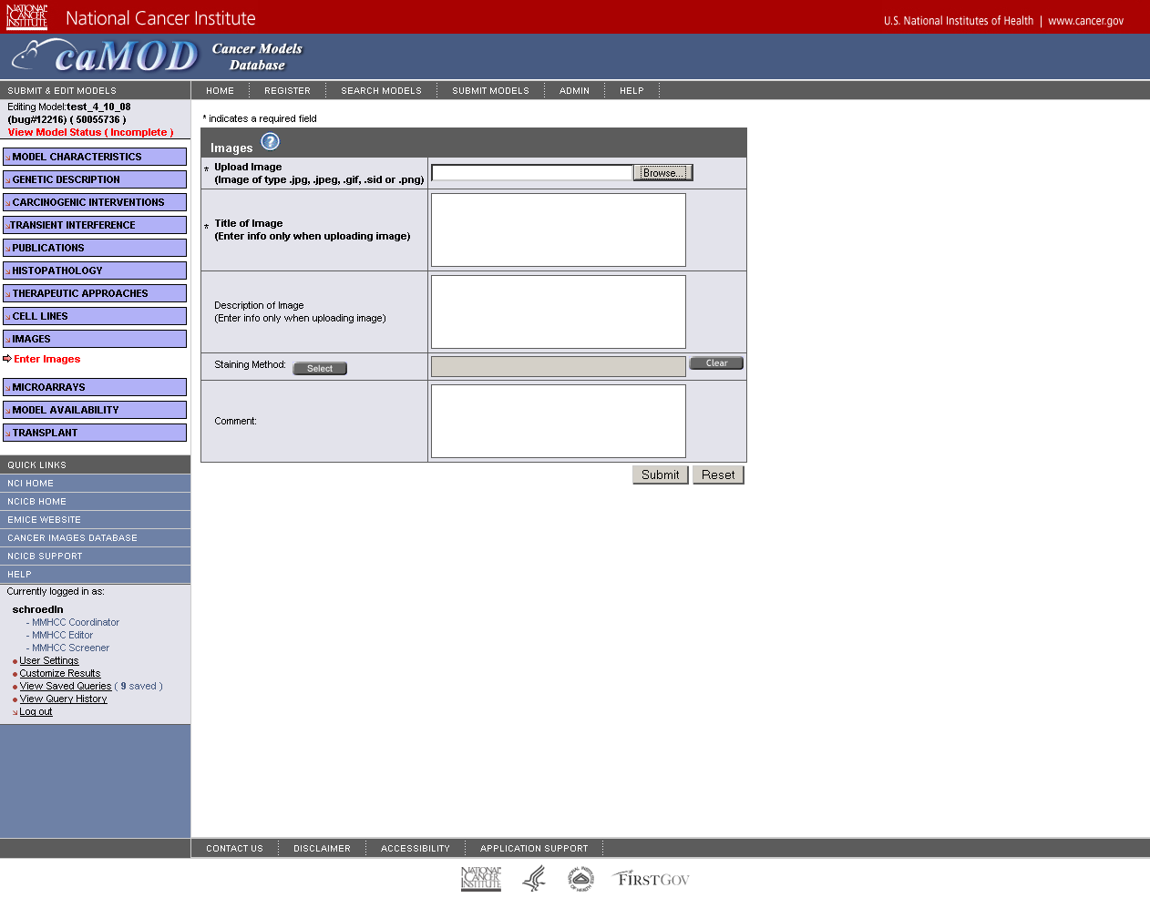
New submit Images page

Interface Classes to be Modified
The following is a list of interface classes (GUI and interface java classes) that need to be modified.
Interface Class Name | Description
viewImages.jsp
submitImages.jsp
searchResults.jsp

middle tier (CONTROLLER)
    - Form and data classes
The following Form.java classes will be modified to add comments.
Class Name | Description
ImageForm.java
ImageData.java

Action classes
The following Action.java classes will be modified to add comments.
Class Name | Description
ImagePopulateAction.java

AnimalModelManagerImpl
AnimalModelManagerImpl.java is an existing class that manages persistence for animal model objects. The method that will be modified is listed below.
Method Name | Description
addImage()
populateAnimalModel()

persistence layer

mapping files
The following hibernate mapping files will be modified to add comments.
Class Name | Description
Image.hbm.xml | Added URL_Altern_Entry

database (MODEL)
The following attributes will be added to the following objects in the object model.
Class Name | Description
Image.java

configuration and utility classes
    - Configuration and Utility Files Changed
File Name | Function
SeachResultsColumns.txt
Hibernate.cfg.xml
Validation.xml

Database
The database table change is defined in Appendix B.

add search for pmid to advanced search page

user interface (VIEW)

Current advanced search page
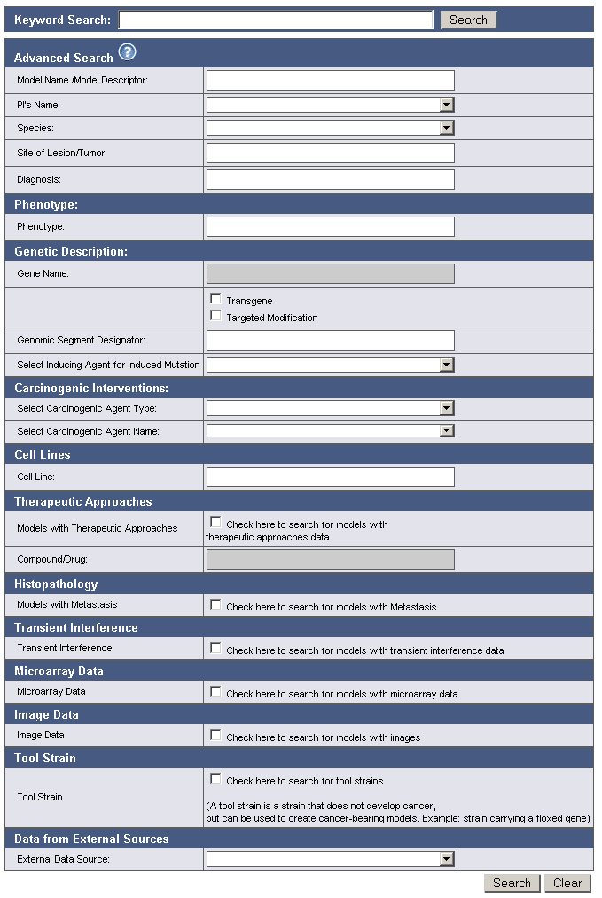
Example of comments field on search screen:

Interface Classes to be Modified
The following is a list of interface classes (GUI and interface java classes) that need to be modified.
Interface Class Name | Description
searchAdvanced.jsp

middle tier (CONTROLLER)
    - Form and data classes
The following Form.java classes will be modified to add comments.
Class Name | Description
searchData.java
searchForm.java

Action classes
The following Action.java classes will be modified to add comments.
Class Name | Description

AnimalModelManagerImpl
AnimalModelManagerImpl.java is an existing class that manages persistence for animal model objects. The method that will be modified is listed below.
Method Name | Description

title field on publication submisson has size limit

user interface (VIEW)

Example of comments field on search screen:

Interface Classes to be Modified
The following is a list of interface classes (GUI and interface java classes) that need to be modified.
Interface Class Name | Description

middle tier (CONTROLLER)
    - Form classes
The following Form.java classes will be modified to add comments.
Class Name | Description

Action classes
The following Action.java classes will be modified to add comments.
Class Name | Description

AnimalModelManagerImpl
AnimalModelManagerImpl.java is an existing class that manages persistence for animal model objects. The method that will be modified is listed below.
Method Name | Description
populateAnimalModel | Added code to retrieve comments field.

persistence layer

mapping files
The following hibernate mapping files will be modified to add comments.
Class Name | Description

database (MODEL)
The comments attribute will be added to the following objects in the object model.
Class Name | Description

configuration and utility classes
    - Configuration and Utility Files Changed
File Name | Function
Hibernate.cfg.xml
Validation.xml

Database
The database table change is defined in Appendix B.

fix - save query does not save

user interface (VIEW)
Current side bar:
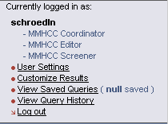
Fixed side bar:
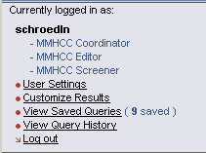

middle tier (CONTROLLER)

impl classes
The following Action.java classes will be modified to add comments.
Class Name | Description
QueryManagerImpl.java | getSavedQueriesByParty(String..) fixed

create automated deployment for camod for each tier

user interface (VIEW)

Example of comments field on search screen:

Interface Classes to be Modified
The following is a list of interface classes (GUI and interface java classes) that need to be modified.
Interface Class Name | Description

middle tier (CONTROLLER)
    - Form classes
The following Form.java classes will be modified to add comments.
Class Name | Description

Action classes
The following Action.java classes will be modified to add comments.
Class Name | Description

AnimalModelManagerImpl
AnimalModelManagerImpl.java is an existing class that manages persistence for animal model objects. The method that will be modified is listed below.
Method Name | Description
populateAnimalModel | Added code to retrieve comments field.

persistence layer

mapping files
The following hibernate mapping files will be modified to add comments.
Class Name | Description

database (MODEL)
The comments attribute will be added to the following objects in the object model.
Class Name | Description

configuration and utility classes
    - Configuration and Utility Files Changed
File Name | Function
Hibernate.cfg.xml
Validation.xml

Database
The database table change is defined in Appendix B.

take existing scripts and run them in selenium and cruisecontrol

user interface (VIEW)

Example of comments field on search screen:

Interface Classes to be Modified
The following is a list of interface classes (GUI and interface java classes) that need to be modified.
Interface Class Name | Description

middle tier (CONTROLLER)
    - Form classes
The following Form.java classes will be modified to add comments.
Class Name | Description

Action classes
The following Action.java classes will be modified to add comments.
Class Name | Description

AnimalModelManagerImpl
AnimalModelManagerImpl.java is an existing class that manages persistence for animal model objects. The method that will be modified is listed below.
Method Name | Description

persistence layer

mapping files
The following hibernate mapping files will be modified to add comments.
Class Name | Description

database (MODEL)
The comments attribute will be added to the following objects in the object model.
Class Name | Description

configuration and utility classes
    - Configuration and Utility Files Changed
File Name | Function
Hibernate.cfg.xml
Validation.xml

Database
The database table change is defined in Appendix B.

duplication does not work for some fields

user interface (VIEW)

Example of comments field on search screen:

Interface Classes to be Modified
The following is a list of interface classes (GUI and interface java classes) that need to be modified.
Interface Class Name | Description

middle tier (CONTROLLER)
    - Form classes
The following Form.java classes will be modified to add comments.
Class Name | Description

Action classes
The following Action.java classes will be modified to add comments.
Class Name | Description

AnimalModelManagerImpl
AnimalModelManagerImpl.java is an existing class that manages persistence for animal model objects. The method that will be modified is listed below.
Method Name | Description

persistence layer

mapping files
The following hibernate mapping files will be modified to add comments.
Class Name | Description

database (MODEL)
The comments attribute will be added to the following objects in the object model.
Class Name | Description

configuration and utility classes
    - Configuration and Utility Files Changed
File Name | Function
Hibernate.cfg.xml
Validation.xml

Database
The database table change is defined in Appendix B.

Give fields in “customize Results” feature meaningful names

user interface (VIEW)
Current view of Customize Search Results page, review and change the naming to be more clear.
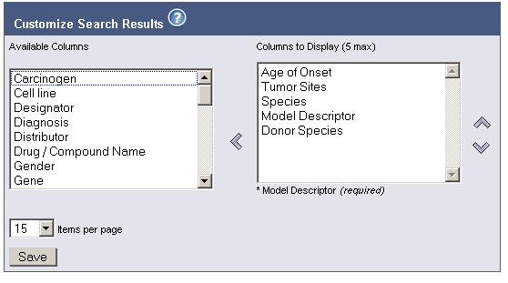
New Customize Search Results page

Interface Classes to be Modified
The following is a list of interface classes (GUI and interface java classes) that need to be modified.
Interface Class Name | Description
searchResults.jsp | Edit to match new searchResultsColumns.txt field names

configuration and utility classes
    - Dropdown lists
The following Form.java classes will be modified to add comments.
File Name | Description
SearchResultsColumns.txt | List containing available column names to customize search results

left side search menu disappears when user customizes search result list, save queries, etc

user interface (VIEW)

Current customize search results page:
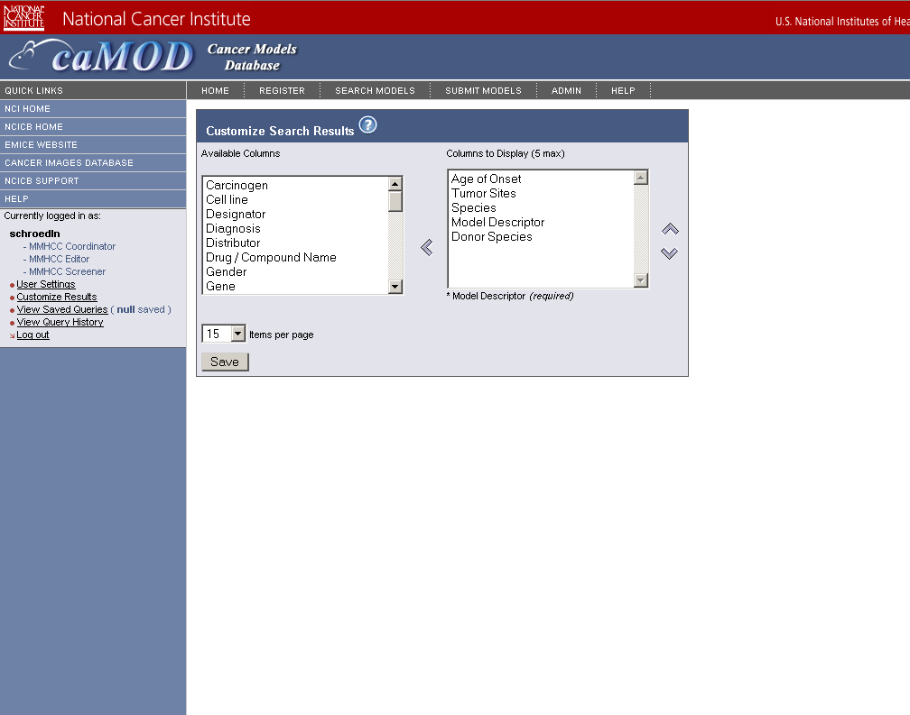
New customize search results page:
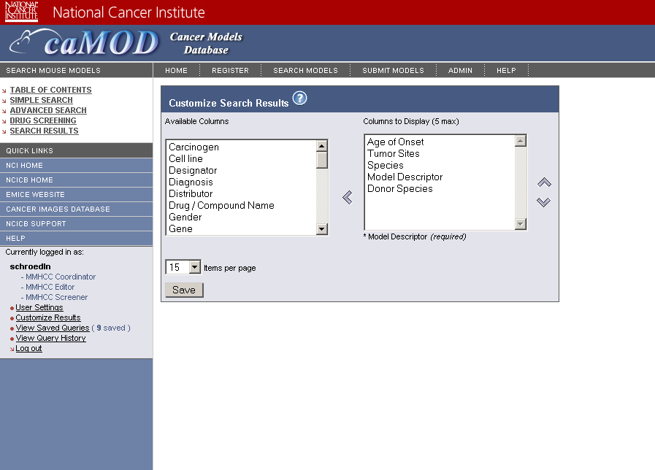
Example of comments field on search screen:

Interface Classes to be Modified
The following is a list of interface classes (GUI and interface java classes) that need to be added.
Interface Class Name | Description
subSearchMenu.jsp | Added subSearchMenu.jsp to /protected directory

Automate nightly build using crusiecontrol

user interface (VIEW)

Example of comments field on search screen:

Interface Classes to be Modified
The following is a list of interface classes (GUI and interface java classes) that need to be modified.
Interface Class Name | Description

middle tier (CONTROLLER)
    - Form classes
The following Form.java classes will be modified to add comments.
Class Name | Description

Action classes
The following Action.java classes will be modified to add comments.
Class Name | Description

persistence layer

mapping files
The following hibernate mapping files will be modified to add comments.
Class Name | Description

database (MODEL)
The comments attribute will be added to the following objects in the object model.
Class Name | Description

configuration and utility classes
    - Configuration and Utility Files Changed
File Name | Function
SeachResultsColumns.txt
Hibernate.cfg.xml
Validation.xml

Database
The database table change is defined in Appendix B.

lexbig prototype: investigate and demo connection to lexbig vocabulary system

user interface (VIEW)
Example of comments field on search screen:

Interface Classes to be Modified
The following is a list of interface classes (GUI and interface java classes) that need to be modified.
Interface Class Name | Description

middle tier (CONTROLLER)
    - Form classes
The following Form.java classes will be modified to add comments.
Class Name | Description

Action classes
The following Action.java classes will be modified to add comments.
Class Name | Description

persistence layer

mapping files
The following hibernate mapping files will be modified to add comments.
Class Name | Description

database (MODEL)
The comments attribute will be added to the following objects in the object model.
Class Name | Description

configuration and utility classes
    - Configuration and Utility Files Changed
File Name | Function
Hibernate.cfg.xml
Validation.xml

Database
The database table change is defined in Appendix B.

Change spelling of Equus Caballus - start Caballus with a lower case "c"

user interface (VIEW)
The Graft object will be renamed to Transplantation as a result of the VCDE silver level review comments.
Current GUI:
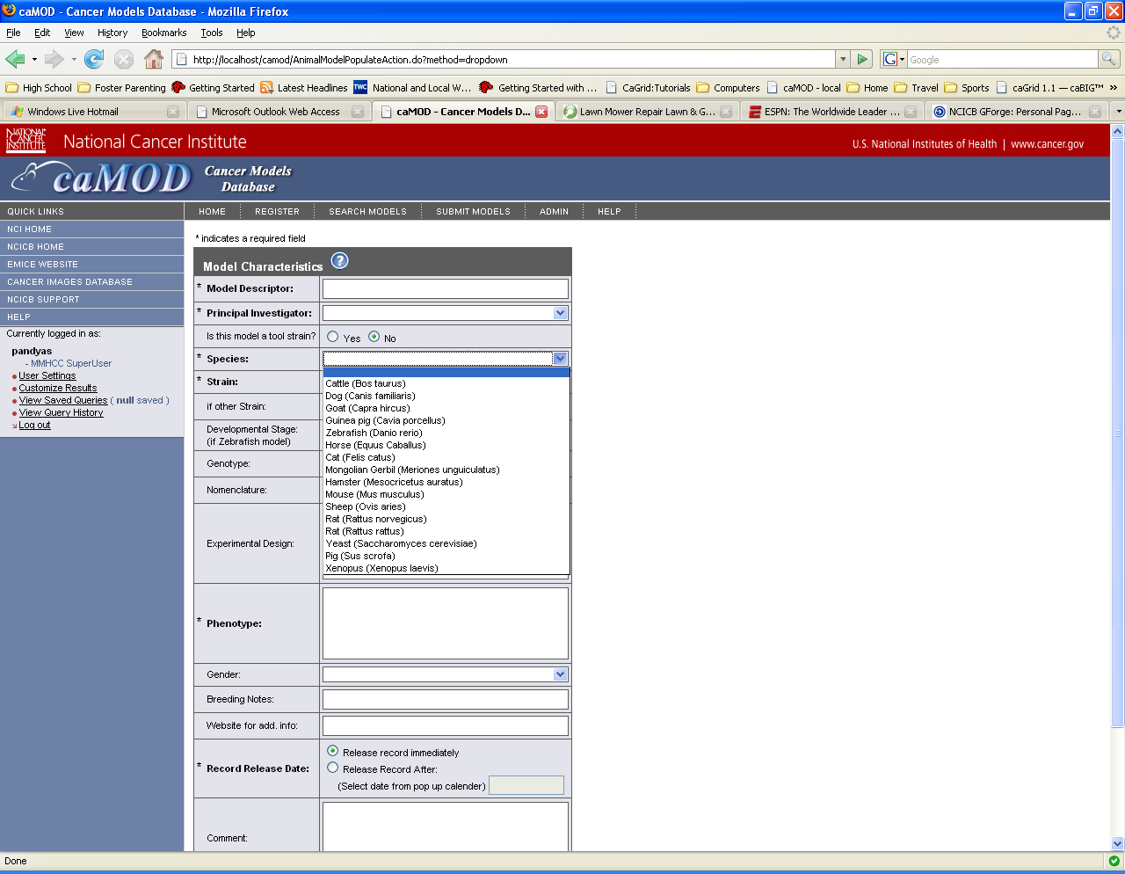

Database
The database table change is defined in Appendix B.

Delete Sequnce ID field from genetic description search page, targeted modification table

user interface (VIEW)
The Sequence ID data label will be removed from the GUI since it was never populated from caBIO.
Current GUI:
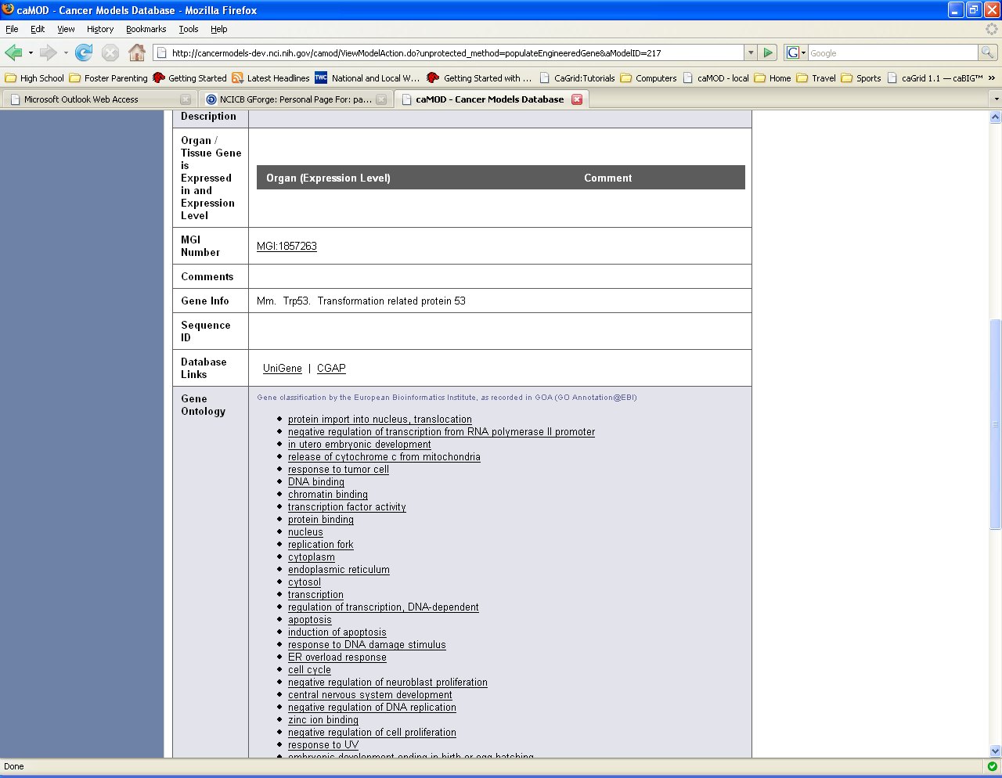
The following interface class will be modified to remove the sequence id field.
Class Name | Description
viewGeneticDescription.jsp | The sequence ID filed will be removed from the Targeted Modification table.

Induced mutation entries need to be flagged and searches for induced mutation and carcinogenic interventions need to be fixed

user interface (VIEW)
A boolean flag called isInducedMutationTrigger will be used to differentiate between data submitted from the Induced Mutation and Carcinogenic Intervention submission screens. The Carcinogenic Intervention Agent Type query will use this attribute in order to filter out data that was submitted by a user on the Induced Mutations submission screen for either a Chemical / Drug or Radiation. Currently the query displays all Environmental Factor names regardless of which screen the data was submitted from.
Current GUI:
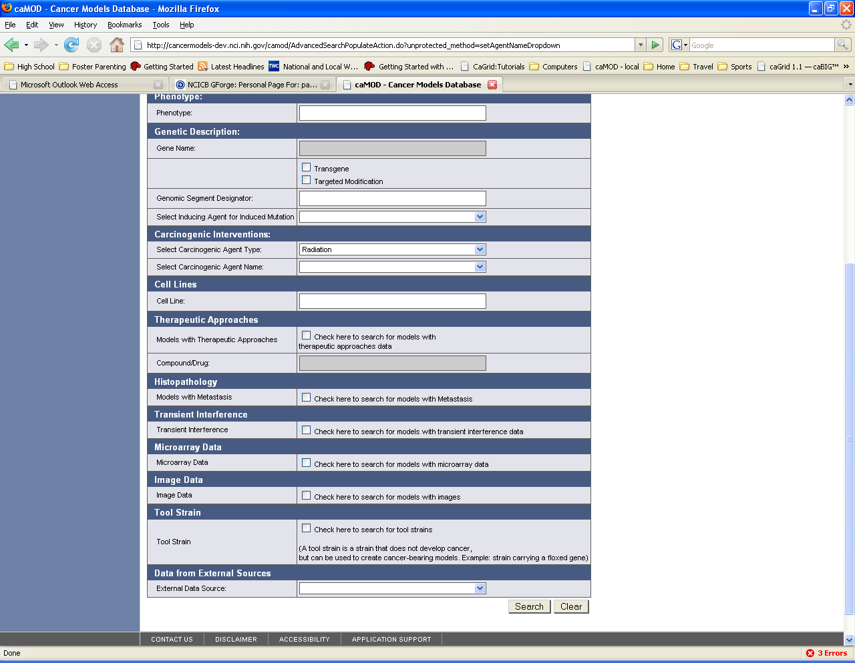

middle tier (CONTROLLER)
    - EnvironmentalFactorForm
EnvironmentalFactorForm.java is an existing struts Form classes that is able to transfer data between the Model and View layers. Struts ActionForm beans are controller components. The attributes defined will remain the same with the addition of one modification.
Method Name | Description
isInducedMutationTrigger | Add Renamed to isInducedMutationTrigger.

InducedMutationManagerImpl
InducedMutationManagerImpl.java is an existing class that manages persistence for Induced Mutation objects. The method that will be modified is listed below.
Method Name | Description
populateInducedMutation | Modify the populateInducedMutation method in order to populate the isInducedMutationTrigger field for each Induced Mutation submitted from the GUI.

CarcinogenExposureManagerImpl
CarcinogenExposureManagerImpl.java is an existing class that manages persistence for Carcinogen Exposure objects. The method that will be modified is listed below.
Method Name | Description
populateName | Modify the populateName method in order to populate the isInducedMutationTrigger field for each Carcinogen Exposure submitted from the GUI.

QueryManagerImpl
QueryManagerImpl.java is an existing class that defines each query used in all sections of the caMOD application. The method that will be modified is listed below.
Method Name | Description
getQueryOnlyEnvironmentalFactors | Modify the getQueryOnlyEnvironmentalFactors method in order to filter out any data submitted from the Induced Mutation submission screen (isInducedMutationTrigger is true).

persistence layer

EnvironmentalFactor
EnvironmentalFactor.hbm.xml is an existing hibernate mapping file used to provide Hibernate with information to persist mutation identifier objects to the caMOD database. The attribute isInducedMutationTrigger will be added to the mapping class.

database (MODEL)

EnvironmentalFactor
EnvironmentalFactor.java is an existing domain object class used to hold data for EnvironmentalFactor objects. One new attribute called isInducedMutationTrigger will be added. Accessor and mutator methods for the attributes will be added.
Attribute Name | Description
isInducedMutationTrigger | The isInducedMutationTrigger will be used to differentiate between data submitted from the Induced Mutation and Carcinogenic Intervention submission screens. The Carcinogenic Intervention Agent Type query will include this attribute in order to filter out data that should not show up in the results for carcinogenic agent Name when a user selects Chemical / Drug or Radiation (which are also Induced Mutation options).

Database
The database table change is defined in Appendix B.

Add urlAlternEntry to image object

user interface (VIEW)

Current submission GUI:
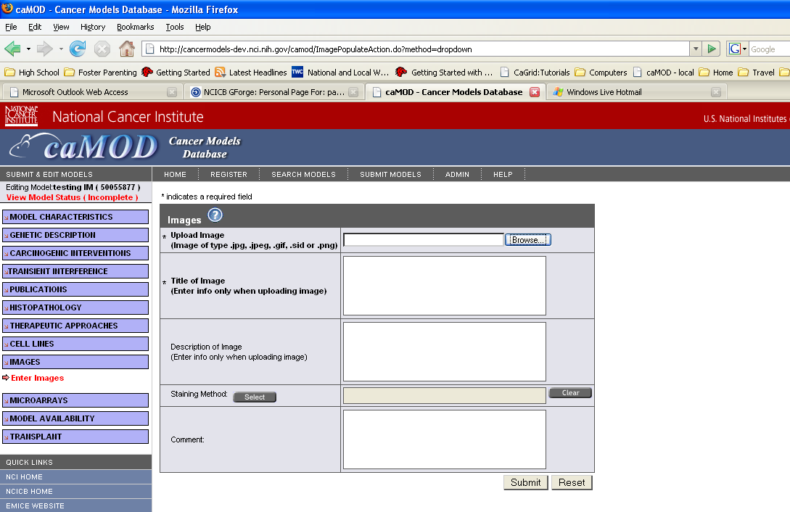
Current search results GUI:
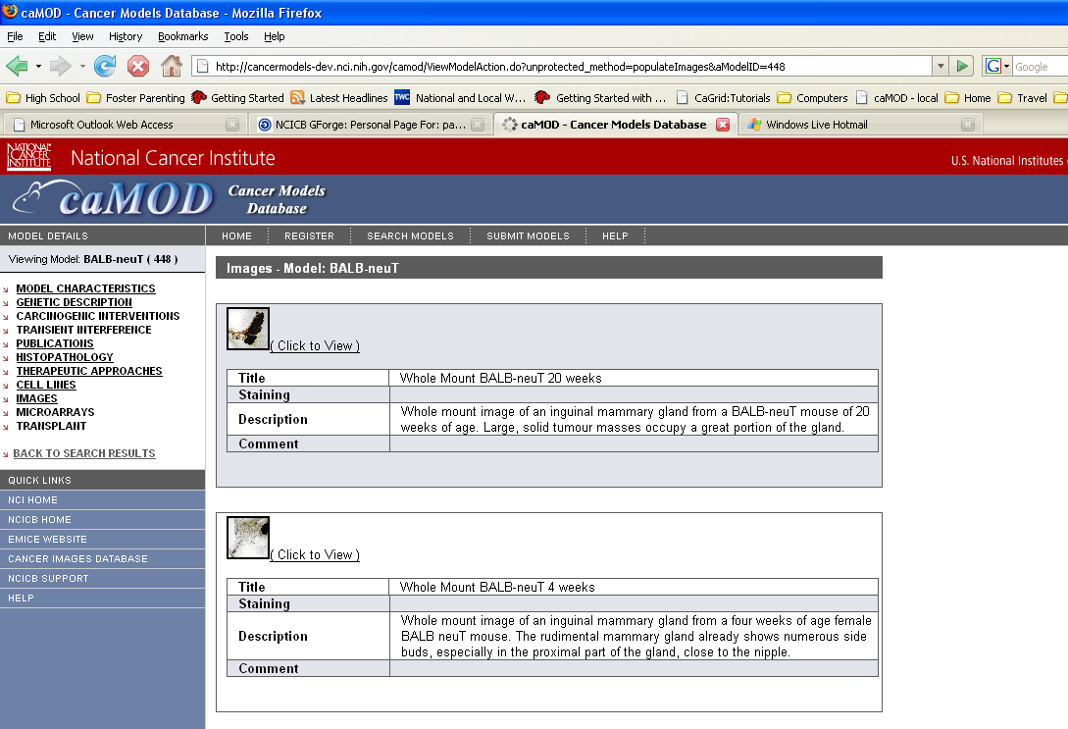

Interface Classes to be Modified
The following is a list of interface classes (GUI and interface java classes) that need to be modified.
Interface Class Name | Description
viewImages.jsp | Add new field to screen
viewGeneticDescription.jsp | Add new field to screen
submitEngineeredTransgene.jsp | Add new field to screen
submitGenomicSegment.jsp | Add new field to screen
submitImages.jsp | Add new field to screen
submitTargetedModification.jsp | Add new field to screen
ImageData.java | Added otherUrl attribute and methods
EngineeredTransgeneData.java | Added otherUrl attribute and methods
GenomicSegmentData.java | Added otherUrl attribute and methods
TargetedModificationData.java | Added otherUrl attribute and methods

middle tier (CONTROLLER)
    - Form classes
The following Form.java classes will be modified to add otherUrl.
Class Name | Description
ImageForm.java | Added otherUrl attribute and methods
EngineeredTransgeneForm.java | Added otherUrl attribute and methods
GenomicSegmentForm.java | Added otherUrl attribute and methods
TargetedModificationForm.java | Added otherUrl attribute and methods

Action classes
The following Action.java classes will be modified to add otherUrl.
Class Name | Description
EngineeredTransgenePopulateAction.java | Added code to retrieve otherUrl in the populate method
GenomicSegmentPopulateAction.java | Added code to retrieve otherUrl in the populate method
ImagePopulateAction.java | Added code to retrieve otherUrl in the populate method
TargetedModificationPopulateAction.java | Added code to retrieve otherUrl in the populate method

EngineeredTransgeneManagerImpl
EngineeredTransgeneManagerImpl.java is an existing class that manages persistence for Engineered Gene objects. The method that will be modified is listed below.
Method Name | Description
populateEngineeredTransgene | Added code to save new field.

GenomicSegmentManagerImpl
GenomicSegmentManagerImpl.java is an existing class that manages persistence for Genomic Segment objects. The method that will be modified is listed below.
Method Name | Description
populateGenomicSegment | Added code to save new field.

TargetedModificationManagerImpl
TargetedModificationManagerImpl.java is an existing class that manages persistence for Targeted Modification objects. The method that will be modified is listed below.
Method Name | Description
populateTargetedModification | Added code to save new field.

persistence layer

mapping files
The following hibernate mapping files will be modified to add comments.
Class Name | Description
Image.hbm.xml | Added UrlAlternEntry mapping

database (MODEL)
The comments attribute will be added to the following objects in the object model.
Class Name | Description
Image.java | Added UrlAlternEntry attribute and methods

Database
The database table change is defined in Appendix B.

rename OtherLocationURL in microarray object to url

user interface (VIEW)
Currently the URL attribute is not displayed on the GUI. This will be implemented in this build.
Current GUI:
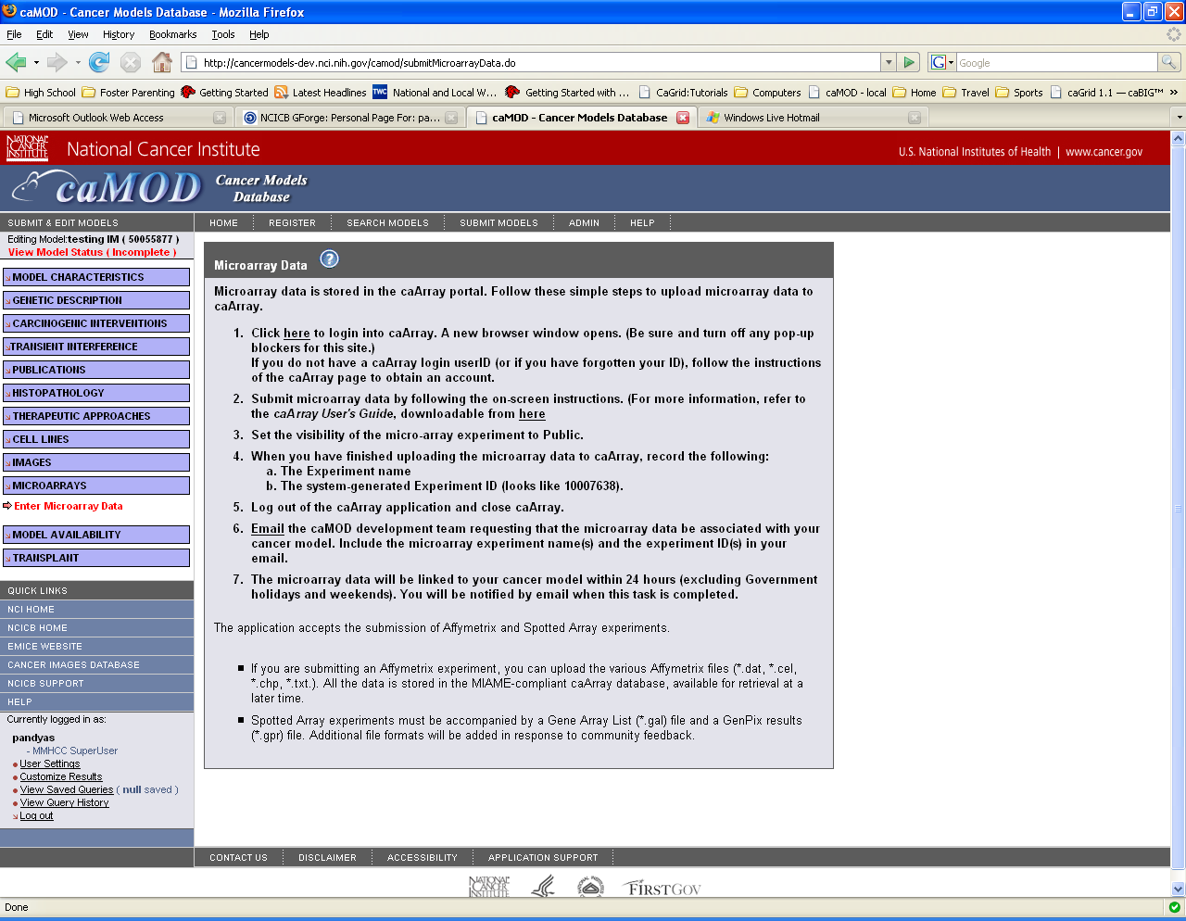

middle tier (CONTROLLER)
    - MicroArrayDataForm
MicroArrayDataForm.java is an existing struts Form class that is able to transfer data between the Model and View layers. Struts ActionForm beans are controller components. The attribute otherLocationURL will be renamed to URL.

persistence layer

MicroArrayData
MicroArrayData.hbm.xml is an existing hibernate mapping file used to provide Hibernate with information to persist MicroArrayData objects to the caMOD database. The attribute otherLocationURL will be renamed to URL.

database (MODEL)

MicroArrayData
MicroArrayData.java is an existing domain object class used to hold data for MicroArrayData objects. The otherLocationURL attribute will be renamed to URL. The accessor and mutator methods for the attribute will be renamed.
Attribute Name | Description
URL | The otherLocationURL attribute will be renamed to URL.

Database
The database table change is defined in Appendix B.

[Appendix A – acronym List]
Acronym | Description
caMOD | Cancer Models Database
JSP | Java Server Pages
Morpholino | Morpholino phosphorodiamidate oligonucleotides
PubMed | PubMed is a service of the U.S. National Library of Medicine that includes over 16 million citations from MEDLINE and other life science journals for biomedical articles back to the 1950s.
RNA | Ribonucleic acid
siRNA | short interfering RNA

[APPENDIX B – DATABASE changes]
This section describes all changes made to the object model and database/back end. The entity changes will be updated in the caMOD_release_2_5.EAP file in Enterprise Architect. The database changes will be updated in PVCS at the time of implementation.
Examples

This table summarizes the object and attribute changes being made in caMOD 2.5
Object Name | Previous Attribute Name | New/Modified Attribute Name | Description (Add, Delete, Rename, ect)
IMAGE | None | URL_ALTERN_ENTRY | Add
MICRO_ARRAY_DATA | OTHER_LOCATION_URL | URL | Rename
ENVIRONMENTAL_FACTOR | None | isInducedMutationTrigger | Add

SPECIES
Modification
Purpose: Change spelling of Equus Caballus - start Caballus with a lower case "c". The SQL is listed below.
Schema: caMOD
Modification Scripts:
-- Change spelling of Equus Caballus in species table
update species sp
set sp.SCIENTIFIC_NAME = 'Equus caballus'
where sp.SPECIES_ID = 11;
Procedure to Modify: Run update scripts.
Data Modifications: No further action is needed.
Location of script: The script is stored in PVS under the camod\docs\deployment\camod 2.5 project folder.

ENVIRONMENTAL_FACTOR
Addition
Purpose: Add isInducedMutationTrigger to the ENVIRONMENTAL_FACTOR object.
Schema: caMOD
Modification Scripts:
-- Add flag named is_Induced_Mutation_Trigger to ENVIRONMENTAL_FACTOR
alter table ENVIRONMENTAL_FACTOR
ADD is_Induced_Mutation_Trigger NUMBER(1);
Procedure to Modify: Run update scripts.
Data Modifications: No further action is needed.
Location of script: The script is stored in PVS under the camod\docs\deployment\camod 2.5 project folder.

IMAGE
Addition
Purpose: Add the urlAlternEntry attribute to all submission screens displaying images. The SQL is listed below.
Schema: caMOD
Modification Scripts:
-- Add urlAlternEntry to image object
alter table IMAGE
ADD URL_ALTERN_ENTRY VARCHAR2(255);
Procedure to Modify: Run update scripts.
Data Modifications: No further action is needed.
Location of script: The script is stored in PVS under the camod\docs\deployment\camod 2.5 project folder.

MICRO_ARRAY_DATA
Modification
Purpose: Rename OtherLocationURL to URL in the Micro_Array_Data table. The SQL is listed below.
Schema: caMOD
Modification Scripts:
-- Rename OtherLocationURL in micro array data object to url
ALTER TABLE MICRO_ARRAY_DATA
RENAME COLUMN OTHER_LOCATION_URL to URL;
Procedure to Modify: Run update scripts.
Data Modifications: No further action is needed.
Location of script: The script is stored in PVS under the camod\docs\deployment\camod 2.5 project folder.

