caMOD 2.1 Clinical Trials Data

Software Design Description

Document Change Record
Version Number | Date | Description
1.0 | 02/24/06 | Initial document
1.1
1.2
1.3
1.4
1.5
1.6
1.7
1.8
1.9

TABLE OF CONTENTS
1. Introduction 4
1.1 The Mouse Genome Informatics (MGI) Database Error! Bookmark not defined.
1.2 The Mouse Tumor Biology (MTB) Database Error! Bookmark not defined.
1.3 PROJECT BACKGROUND Error! Bookmark not defined.
1.4 Back End Error! Bookmark not defined.
1.4.1 caBio data source Error! Bookmark not defined.
2. Use case and design specifications 5
2.1 add a link on the therapeutic approaches search results screen to additional data for clinical trials data in cabio 5
2.1.1 Use case 5
2.1.2 design specification 6
3. Appendix a 7

Introduction
The cancer models database (caMOD) is a web-based resource that provides information about rodent models for human cancer to the public research community.

caMOD provides the following key capabilities to its users:

- Data Submission--Data in caMOD are extracted from the public scientific literature by curators and verified by the scientists who generated or worked with the models, or they are directly submitted by scientists.

- Cancer Model Search--Users can retrieve information about the making of models, their genetic descriptions, histopathology, derived cell lines, associated images, carcinogenic interventions, microarray data, and therapeutic trials in which the models were used. caMOD provides links to PubMed for associated publications and other resources such as mouse repositories, detailed information about altered gene, pathway affected, and information about human clinical trials that utilize the same compounds as the pre-clinical trials in the animal models.

- System Function Administration--The Admin function provides services for user registration, review of submitted models and database management.

  - PROJECT BACKGROUND
During user acceptance testing some enhancement requests were made by the users. One of the requests included adding links to additional Clinical Trials data from the Therapeutic Approaches models results screen under the Search Models sections.

Use case and design specifications

add a link on the therapeutic approaches search results screen to additional data for clinical trials data in cabio

Use case
Use Case Name | Add a Link on the Therapeutic Approaches Search Results Screen to Additional Data for Clinical Trials Data in caBio.
Test Track Ref | Defect #301
Primary Actor | All users
Brief Description | When a user is searching for a model, the user is presented with data associated with the Therapeutic Approaches of the model. Data can be from one of the following areas of research: General Agent Details, Pre-clinical Trials, Clinical Trials, Yeast Data, or in-vivo Data. Enhance the Clinical Trials section to include a link to additional Clinical Trials data in cMAP linked by the protocol number from caBio.
Trigger | Actor navigates to the Search Models screen and searches for an Animal model where a Therapeutic Approach is present.
Pre-conditions | User Successfully navigates to the search models section of the application.  Successfully searches for a model with a Therapeutic Approach.  Available to all registered users of the system.
Flow of Events | 1. The actor is presented with the home page for the caMod application.
Flow of Events | 2. The user
Flow of Events | a. Selects the link to search for models.
Flow of Events | b. Selects the link for Advanced Search.
Flow of Events | c. Select the check box next to “Models with Therapeutic Approaches” and submits the form.
Flow of Events | 3. The system
Flow of Events | a. Returns a list of models that contain data about Therapeutic Approaches.
Flow of Events | 4. The user
Flow of Events | a. Selects a model from the list and navigates to the Therapeutic Approaches section from the left menu bar.
Flow of Events | 5. The system
Flow of Events | - Returns the data associated with the Therapeutic Approaches for the model. This section includes: general Agent information, pre-clinical data, Clinical data, and publications for the selected model.
Flow of Events | 6. The user
Flow of Events | - Navigates to the section titled “Current Clinical Trials for <compound name>” and selects a link for one of the protocols listed.
Flow of Events | 7. The system
Flow of Events | a. Pops up a window linked to the “Therapeutic Trials Info Page” of the cMAP application.
Post Conditions | Success Condition: User finds an Animal model matching the selection criteria submitted on the Advanced Search screen or the system displays “No models found!” to the user.  Error Condition:
Related Use Cases

design specification
- The Clinical Trails section of Therapeutic Approaches include protid (Protocol_id).
- The Protocol_id will link to cMAP for additional information.
- Modify includeClinicalTrials.jsp to include:\
- Modify viewModelAction.java to
- Add link for Clinical Trials in cMAP. The link would be http://cmap.nci.nih.gov/Trials/ProtocolInfo?protid=103848; Where 103848 is the protid.
- Modify the viewModelAction.java class to capture the protocol numbers for each compound defined in the animal model from caBio.
- Display the Protocol number(s) for each of the compound’s nscNumber on the Therapeutic Approaches results screen.
- Link the protocol number to the cMAP “Therapeutic Trials Info Page” by dynamically capturing the protocol number in the link.
- Test the back button functionality.

Appendix a
caMod screen shot of Clinical Trails section of Therapeutic Approaches search results.
Add list of protocols and link them to cMAP by Protocol#

The link would be http://cmap.nci.nih.gov/Trials/ProtocolInfo?protid=103848
Where 103848 is the protid
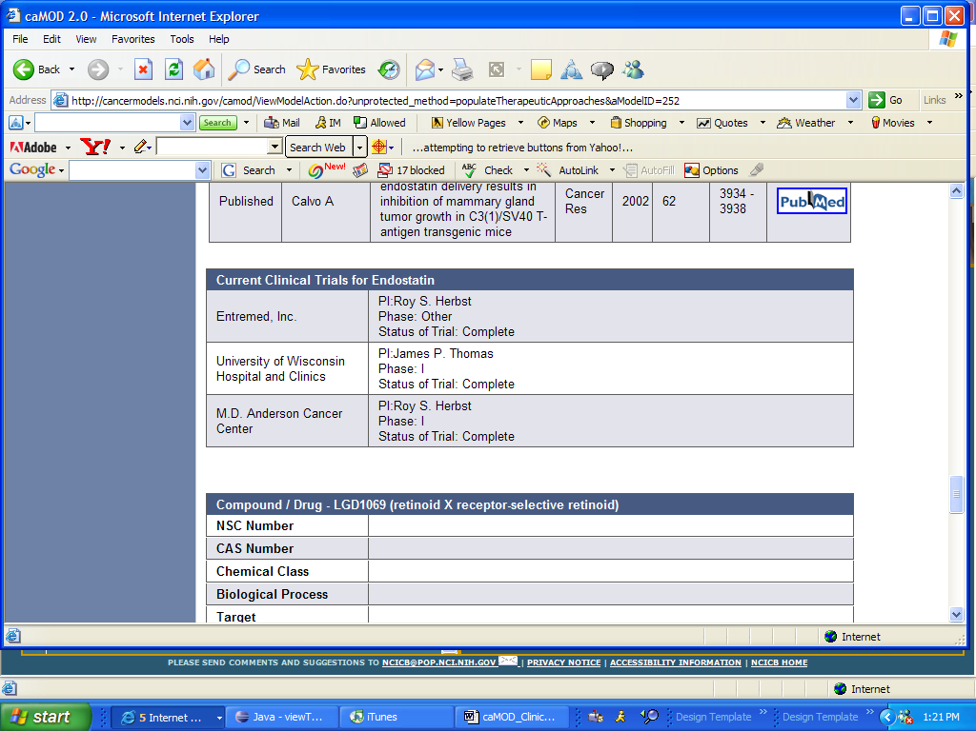

http://cmap.nci.nih.gov/Trials/ProtocolInfo?protid=103848 is forwarded to:
http://remoteapps.nci.nih.gov/newdefault.htm?Server=ts.nci.nih.gov&FS=3&AutoConnect=1




