caMOD Release 2.5.1

Software Design Description
Version 1.0

[Insert approval date of document]

Document Change Record
Version Number | Date | Description
1.0 | 3/30/2009 | Initial document

TABLE OF CONTENTS
1. Introduction 4
1.1 Requirements Traceability 4
1.2 Background/Summary 4
2. System Overview 5
2.1.1 User Client Software 5
2.1.2 Back End 6
2.1.3 Hibernate 3 Data Access 6
2.1.4 JBoss Application Server 6
2.1.5 Database 6
2.1.6 Java 6
3. Upgrade caMOD to use caBIO 4.0 to get additional data 7
3.1 user interface (VIEW) 7
3.1.1 therapeutic approaches search results screen (partial screen): 7
3.1.2 genetic description search results screen (current): 8
3.2 middle tier (CONTROLLER) 8
3.2.1 viewmodelAction 8
3.2.2 AgentManagerImpl class 9
3.3 configuration and utility classes 9
3.3.1 Configuration and Utility Files Changed 9
4. Upgrade caMOD to use EVS 4.2 to get current data 10
4.1 user interface (VIEW) 10
[Appendix A – acronym List] 13
[APPENDIX B – DATABASE changes] 14

Introduction
The purpose of this document is to describe the design for the integration of caBIO 4.x and EVS 4.x upgrades in caMOD. caMOD currently uses caCORE 3.2 to aquire remote services to caBIO and EVS. After caCORE 3.2, EVS and caBIO were split into separate parts and the current version of caCORE is being depreciated in Q2 2009. Both upgrades include new jars, new configuration files, and new code and their integrations must work together inside caMOD. In addition, the EVStree application will be upgraded to use EVS 4.2 technology.

Requirements Traceability
Req # | Requirement Description
 | caMOD - Cancer Models Database - Feature Requests
17325 | Upgrade caMOD to use caBIO 4.0 to get additional data
 | EVSTree - Feature Requests
10957 | re-code the connection to EVS 4.x (Lexbig Vocabuarly System / Architecture)

Background/Summary
The cancer models database (caMOD) is a web-based resource that provides information about animal models for human cancer to the public research community.
caMOD provides the following key capabilities to its users:

Data Submission--Data in caMOD are extracted from the public scientific literature by curators and verified by the scientists who generated or worked with the models, or they are directly submitted by scientists.

Cancer Model Search--Users can retrieve information about the making of models, their genetic descriptions, carcinogenic interventions, transient interference, histopathology, derived cell lines, associated images, microarray data, transplantations, and therapeutic trials in which the models were used. caMOD provides links to PubMed for associated publications and other resources such as mouse repositories, detailed information about altered gene, pathway affected, and information about human clinical trials that utilize the same compounds as the pre-clinical trials in the animal models.

System Function Administration--The Admin function provides services for user registration, review of submitted models and database management.

System Overview
The purpose of this section is to give an overview of the caMOD API. The following diagrams show the overall architecture and of the caMOD application.
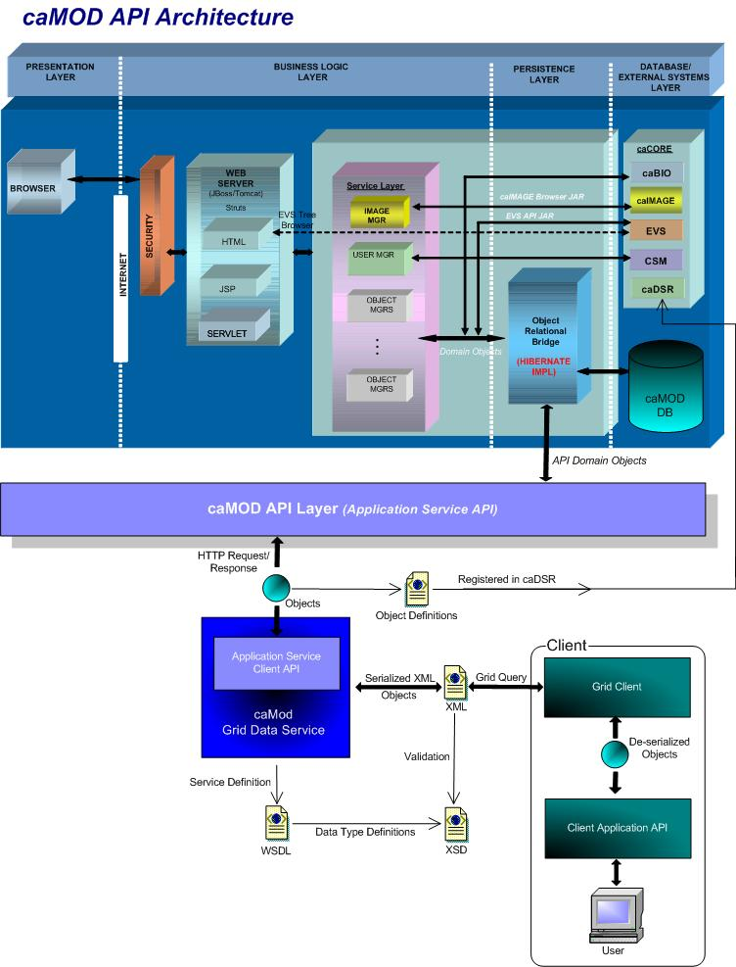

User Client Software
caMOD is a web based user interface implemented as HTML, JSP, JavaScript, and AJAX. The use of JavaScript is limited to improving usability only.
Java Server Pages (JSPs) are used to generate dynamic HTML based on user actions. JSPs are combinations of HTML, Java Code, and custom JSP and JSTL tags that get compiled into servlet classes.

Back End
The caMOD back end components provide access to persistence services for retrieving and storing data in the database. Hibernate, an open source tool, is used as the Object Relational Mapping (ORM) software.

Hibernate 3 Data Access
The ORM mapping is implemented using Hibernate version 3.x. Hibernate is a high performance object/relational persistence and query service for Java. Hibernate provides the ability to develop persistent classes following common object-oriented (OO) design methodologies such as association, inheritance, polymorphism, and composition.
The Hibernate Query Language (HQL), deigned as a “minimal” object-oriented extension of SQL, provides a bridge between the object and relational databases. Hibernate allows for real world modeling of biological entities without creating complete SQL-based queries to represent them.

JBoss Application Server
The user interface, middle tier, and backend components are run with in JBoss Java2 Enterprise Edition (J2EE) application server. JBoss is an open source application server that provides a servlet container, an EJB container, the full range of J2EE 1.4 features as well as extended enterprise services including clustering, caching and persistence. JBoss 4.0.5 conforms to the newest technology stack. It will be consistent with many other applications.

Database
Oracle Relation Database Management System (RDBMS) software is used as the persistent store for caMOD and caIMAGE application data. Java classes access the database using the Java Database Connectivity (JDBC) API.

Java
The new version of Java1.5 (Java tool kit version jdk1.5.0_10) is used for compilation. Therefore all the code in caMOD has been compiled using the JDK 1.5 version. This will conform to the latest technology stack currently used by NCI.

Upgrade caMOD to use caBIO 4.0 to get additional data

user interface (VIEW)
The caMOD application connects to caBIO to retrieve additional data for the Therapeutic Approaches and Genetic Description search results screens. On the Therapeutic Approaches search results screen caMOD displays clinical trials data from caBIO. On the Genetic Description search results screen caMOD displays additional data within the Targeted Modification section for “Gene Info” (official nomenclature of the gene), Database Links to UniGene and CGAP, “Gene Ontology” (controlled vocabulary to describe gene and gene product attributes), and “BioCarta Pathways”.
Currently caMOD is using caCORE 3.2 to retrieve additional data from caBIO and EVS. In Q2 of 2009, caCORE 3.x (all versions) will be deprecated and no longer available for use in applications. In the new version of the caCORE technology the caBIO and EVS application services were separated into individual services.
We will upgrade caMOD to use caBIO version 4.2 to correspond to the upgrade we will perform on the EVSTree application (upgrade to EVS 4.2).
There should be no difference in the display of data for any of the search results screens.

therapeutic approaches search results screen (partial screen):
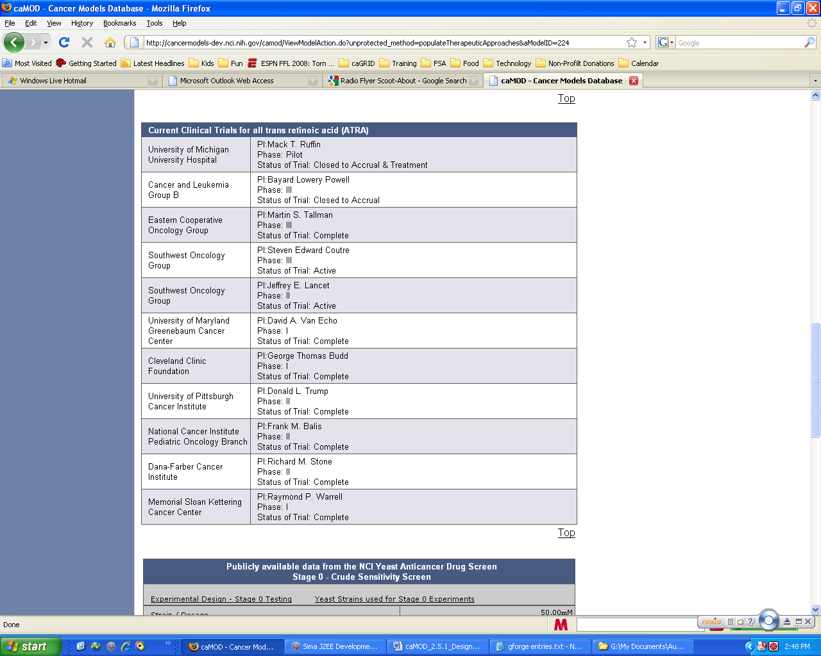

genetic description search results screen (current):
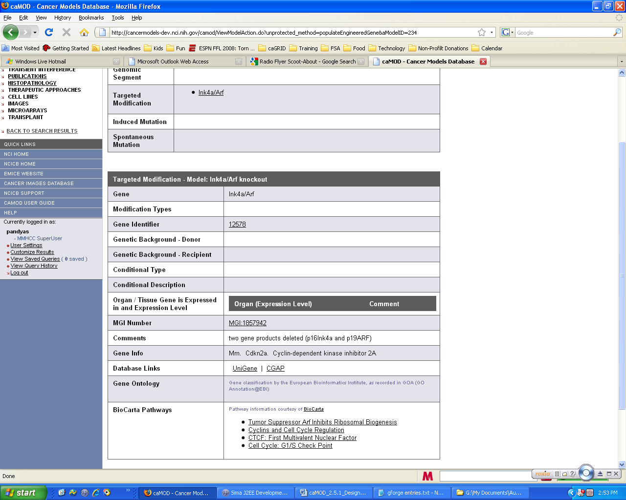

middle tier (CONTROLLER)

viewmodelAction
ViewModelAction.java is an existing struts Action classes that manage requests by the application to populate the struts Form during submission of a new object and to repopulate the struts form with values from the existing object. The following modification will be made:
Method Name | Description
populateTherapeuticApproaches.java | Modify code to retrieve data from new caBIO 4.2 instance.

AgentManagerImpl class
AgentManagerImpl.java is an existing class that manages persistence for the Agent object. The method that will be modified this class is listed below.
Method Name | Description
getClinicalProtocols.java | Modified code to save get new connection to caBIO 4.2 in the new caCORE architecture structure.

configuration and utility classes
    - Configuration and Utility Files Changed
File Name | Function
Constants. java | Configuration files to hold global constants for the application. Add constant for the connection to caBIO 4.x which was separated from the connection to EVS 4.x in the new caCORE.
EVSTreeUtil.java | The EVSTreeUtil.java class was created to handle the code to fetch/cache EVS data. This class also contains the code to call the application server. The application server call will be modified to connect to caBIO 4.2.

Upgrade caMOD to use EVS 4.2 to get current data

user interface (VIEW)
The caMOD application connects to caBIO to retrieve additional data for the Therapeutic Approaches and Genetic Description search results screens. On the Therapeutic Approaches search results screen caMOD displays clinical trials data from caBIO. On the Genetic Description search results screen caMOD displays additional data within the Targeted Modification section for “Gene Info” (official nomenclature of the gene), Database Links to UniGene and CGAP, “Gene Ontology” (controlled vocabulary to describe gene and gene product attributes), and “BioCarta Pathways”.
Currently caMOD is using caCORE 3.2 to retrieve additional data from caBIO and EVS. In Q2 of 2009, caCORE 3.x (all versions) will be deprecated and no longer available for use in applications. In the new version of the caCORE technology the caBIO and EVS application services were separated into individual services.
We will upgrade caMOD to use caBIO version 4.2 to correspond to the upgrade we will perform on the EVSTree application (upgrade to EVS 4.2).
There should be no difference in the display of data for any of the search results screens.

Steps 2:
Background:
The caBIO

caBIO Version | SDK Version Used | EVS Version | SDK Version Used
caBIO 4.0 | SDK 4.0 | EVS 4.2 | SDK 4.0
caBIO 4.1 | SDK 4.0.1
caBIO 4.2 | SDK 4.0.1
caBIO 4.3 | SDK 4.1 | EVS 4.3 | SDK 4.1

caBIO jars include:
acegi-security-1.0.4.jar
caBIO lib and conf files | EVS lib and conf files | caMOD
 | acegi-security-1.0.4.jar
antlr-2.7.6.jar | antlr-2.7.6.jar | antlr-2.7.6rc1.jar
asm.jar | asm.jar | asm.jar
cabio40-beans.jar
cabio40-client-framework.jar
castor-1.0.2.jar | castor-1.0.2.jar
 | castor-1.2-xml.jar
cglib-2.1.3.jar | cglib-2.1.3.jar | cglib-2.1.3.jar
commons-codec-1.3.jar | commons-codec-1.3.jar | commons-codec.jar
commons-collections-3.2.jar | commons-collections-3.2.jar | commons-collections-2.1.1.jar
commons-logging-1.1.jar | commons-logging-1.1.jar | commons-logging-1.0.4.jar
 | commons-pool-1.3.jar
 | dlbadapter.jar
ejb3-persistence.jar
handle.jar
handlerservice.jar
hibernate3.jar (version 3.2.1) | hibernate3.jar (version 3.2.0) | hibernate3.jar (version 3.1.3)
hibernate-annotations.jar
hibernate-commons-annotations.jar
hibernate-search.jar
 | lexbig.jar
 | lexevsapi42-beans.jar
 | lexevsapi42-framework.jar
log4j-1.2.14.jar | log4j-1.2.14.jar
lucene-core-2.2.0.jar | lucene-core-2.3.2.jar
 | lucene-regex-2.3.2.jar
 | lucene-snowball-2.3.2.jar
sdk-client-framework.jar | sdk-client-framework.jar | Must use EVS version
spring.jar (version 2.0.3) | spring.jar (version 2.0.3) | spring.jar (version ?) – File compare shows caMOD spring.jar is more recent  BUT I used the version 2.0.3 after finding an error
 | umlslicense.jar
xercesImpl.jar | xercesImpl.jar
CONF
application-config-client.xml | application-config-client.xml | Merged
gov.nih.nci.cabio.domain.xsd |  | Added
 | gov.nih.nci.evs.domain.xsd | Added
 | gov.nih.nci.evs.security.xsd | Added
gov.nih.nci.common.domain.xsd |  | Added
gov.nih.nci.common.provenance.domain.xsd |  | Added
log4j.properties | log4j.properties | Both same
mapping.dtd | mapping.dtd | Both same
unmarshaller-xml-mapping.xml | unmarshaller-xml-mapping.xml | Merged
xml-mapping.xml | xml-mapping.xml | Merged

1) The configurations files will need to be merged manually. In the case of the Spring configuration files, the beans inside each file will need to be renamed so they don't conflict.

2) As far as libraries go, there are a few conflicts, but it should be possible to just choose the newer version in each case. For example, EVS uses Hibernate 3.2.0, while caBIO used 3.2.1, so you would take the jar from caBIO. The one tricky case is sdk-client-framework.jar, where you must use the EVS version, because EVS adds its own classes to the SDK jar.

Step 1: Modify camod.properties file on local instance
Added jars according to rules and most current version
Added conf from caBIO only
Start JBoss – no glaring errors (log4j error – look at later)
Go to localhost/camod
Error:
12:56:26,933 ERROR [HibernateUtil] Building SessionFactory failed.
java.lang.IllegalAccessError: tried to access method net.sf.ehcache.CacheManager.<init>()V from class org.hibernate.cache.EhCacheProvider
at org.hibernate.cache.EhCacheProvider.start(EhCacheProvider.java:124)
at org.hibernate.impl.SessionFactoryImpl.<init>(SessionFactoryImpl.java:183)
at org.hibernate.cfg.Configuration.buildSessionFactory(Configuration.java:1218)
at gov.nih.nci.common.persistence.hibernate.HibernateUtil.<clinit>(HibernateUtil.java:43)
at gov.nih.nci.common.persistence.hibernate.HibernateFilter.doFilter(HibernateFilter.java:47)
at org.apache.catalina.core.ApplicationFilterChain.internalDoFilter(ApplicationFilterChain.java:202)
at org.apache.catalina.core.ApplicationFilterChain.doFilter(ApplicationFilterChain.java:173)
at org.jboss.web.tomcat.filters.ReplyHeaderFilter.doFilter(ReplyHeaderFilter.java:81)
at org.apache.catalina.core.ApplicationFilterChain.internalDoFilter(ApplicationFilterChain.java:202)
at org.apache.catalina.core.ApplicationFilterChain.doFilter(ApplicationFilterChain.java:173)
at org.apache.catalina.core.StandardWrapperValve.invoke(StandardWrapperValve.java:213)
at org.apache.catalina.core.StandardContextValve.invoke(StandardContextValve.java:178)
at org.jboss.web.tomcat.security.CustomPrincipalValve.invoke(CustomPrincipalValve.java:39)
at org.jboss.web.tomcat.security.SecurityAssociationValve.invoke(SecurityAssociationValve.java:153)
at org.jboss.web.tomcat.security.JaccContextValve.invoke(JaccContextValve.java:59)
at org.apache.catalina.core.StandardHostValve.invoke(StandardHostValve.java:126)
at org.apache.catalina.valves.ErrorReportValve.invoke(ErrorReportValve.java:105)
at org.apache.catalina.core.StandardEngineValve.invoke(StandardEngineValve.java:107)
at org.apache.catalina.connector.CoyoteAdapter.service(CoyoteAdapter.java:148)
at org.apache.coyote.http11.Http11Processor.process(Http11Processor.java:856)
at org.apache.coyote.http11.Http11Protocol$Http11ConnectionHandler.processConnection(Http11Protocol.java:744)
at org.apache.tomcat.util.net.PoolTcpEndpoint.processSocket(PoolTcpEndpoint.java:527)
at org.apache.tomcat.util.net.MasterSlaveWorkerThread.run(MasterSlaveWorkerThread.java:112)
at java.lang.Thread.run(Thread.java:595)
12:56:26,933 ERROR [[action]] Servlet.service() for servlet action threw exception
java.lang.NoClassDefFoundError
at gov.nih.nci.common.persistence.hibernate.HibernateFilter.doFilter(HibernateFilter.java:56)
at org.apache.catalina.core.ApplicationFilterChain.internalDoFilter(ApplicationFilterChain.java:202)
at org.apache.catalina.core.ApplicationFilterChain.doFilter(ApplicationFilterChain.java:173)
at org.jboss.web.tomcat.filters.ReplyHeaderFilter.doFilter(ReplyHeaderFilter.java:81)
at org.apache.catalina.core.ApplicationFilterChain.internalDoFilter(ApplicationFilterChain.java:202)
at org.apache.catalina.core.ApplicationFilterChain.doFilter(ApplicationFilterChain.java:173)
at org.apache.catalina.core.StandardWrapperValve.invoke(StandardWrapperValve.java:213)
at org.apache.catalina.core.StandardContextValve.invoke(StandardContextValve.java:178)
at org.jboss.web.tomcat.security.CustomPrincipalValve.invoke(CustomPrincipalValve.java:39)
at org.jboss.web.tomcat.security.SecurityAssociationValve.invoke(SecurityAssociationValve.java:153)
at org.jboss.web.tomcat.security.JaccContextValve.invoke(JaccContextValve.java:59)
at org.apache.catalina.core.StandardHostValve.invoke(StandardHostValve.java:126)
at org.apache.catalina.valves.ErrorReportValve.invoke(ErrorReportValve.java:105)
at org.apache.catalina.core.StandardEngineValve.invoke(StandardEngineValve.java:107)
at org.apache.catalina.connector.CoyoteAdapter.service(CoyoteAdapter.java:148)
at org.apache.coyote.http11.Http11Processor.process(Http11Processor.java:856)
at org.apache.coyote.http11.Http11Protocol$Http11ConnectionHandler.processConnection(Http11Protocol.java:744)
at org.apache.tomcat.util.net.PoolTcpEndpoint.processSocket(PoolTcpEndpoint.java:527)
at org.apache.tomcat.util.net.MasterSlaveWorkerThread.run(MasterSlaveWorkerThread.java:112)
at java.lang.Thread.run(Thread.java:595)
Added ehcache-1.6.0-beta3.jar to lib folder – started again
Internet says:
If you are using Hibernate 3.2 make sure you use the proper EhCache version (which is 1.2 at least I think)
Deleted ehcache-1.1.jar from project and added ehcache-1.2.4.jar
Upgraded to log4j-1.2.15.jar
Modified EVStreeUtil.java
Changed methods to return specific ApplicationService for caBIO and EVS:
public static CaBioApplicationService getCabioApplicationService()
public static EVSApplicationService getApplicationService()
Note: EVS getPreferredName() code now works but is depreciated and should be investigated later
application-config-client.xml Error for EVS – must add code for that file from conf folder
OPTION from application-config-client.xml (files from EVS conf folder were merged with files from caBIO conf folder)

http://lexevsapi.nci.nih.gov:80/lexevsapi42/http/applicationService
OPTIONS from TestEVS.java:
String genUrl = "http://cbvapp-d1007.nci.nih.gov:19080/evsapi41";
String _service = "EvsServiceInfo";

try
{
EVSApplicationService appService = (EVSApplicationService) ApplicationServiceProvider.getApplicationServiceFromUrl(genUrl, _service);

OPTION from TestClient.java
String _service = "EvsServiceInfo";
public void testSearch() throws Exception
{
EVSApplicationService appService = (EVSApplicationService)ApplicationServiceProvider.getApplicationService(_service);
try
{
DescLogicConcept dlc = new DescLogicConcept();
dlc.setName("ear*");
Collection results = appService.search("gov.nih.nci.evs.domain.DescLogicConcept", dlc);
Found new error:

Found new error:
16:02:20,546 INFO [XmlBeanDefinitionReader] Loading XML bean definitions from class path resource [application-config-client.xml]
16:02:20,687 ERROR [[jsp]] Servlet.service() for servlet jsp threw exception
java.lang.ExceptionInInitializerError
at gov.nih.nci.camod.util.EvsTreeUtil.getApplicationService(EvsTreeUtil.java:226)
at gov.nih.nci.camod.util.EvsTreeUtil.getEVSPreferedDescription(EvsTreeUtil.java:125)
at gov.nih.nci.camod.domain.Organ.getEVSPreferredDescription(Organ.java:77)
at sun.reflect.NativeMethodAccessorImpl.invoke0(Native Method)
at sun.reflect.NativeMethodAccessorImpl.invoke(NativeMethodAccessorImpl.java:39)
at sun.reflect.DelegatingMethodAccessorImpl.invoke(DelegatingMethodAccessorImpl.java:25)
at java.lang.reflect.Method.invoke(Method.java:585)
at org.hibernate.proxy.pojo.cglib.CGLIBLazyInitializer.invoke(CGLIBLazyInitializer.java:185)
at gov.nih.nci.camod.domain.Organ$$EnhancerByCGLIB$$be6a4e2b.getEVSPreferredDescription(<generated>)
at gov.nih.nci.camod.domain.AnimalModelSearchResult.getTumorSites(AnimalModelSearchResult.java:1316)
at sun.reflect.NativeMethodAccessorImpl.invoke0(Native Method)
at sun.reflect.NativeMethodAccessorImpl.invoke(NativeMethodAccessorImpl.java:39)
at sun.reflect.DelegatingMethodAccessorImpl.invoke(DelegatingMethodAccessorImpl.java:25)
at java.lang.reflect.Method.invoke(Method.java:585)
at org.apache.taglibs.standard.lang.jstl.ArraySuffix.evaluate(ArraySuffix.java:278)
at org.apache.taglibs.standard.lang.jstl.ComplexValue.evaluate(ComplexValue.java:107)
at org.apache.taglibs.standard.lang.jstl.ELEvaluator.evaluate(ELEvaluator.java:204)
at org.apache.taglibs.standard.lang.jstl.ELEvaluator.evaluate(ELEvaluator.java:163)
at org.apache.taglibs.standard.lang.jstl.Evaluator.evaluate(Evaluator.java:101)
at org.apache.taglibs.standard.lang.jstl.Evaluator.evaluate(Evaluator.java:129)
at org.apache.taglibs.standard.lang.support.ExpressionEvaluatorManager.evaluate(ExpressionEvaluatorManager.java:75)
at org.apache.taglibs.standard.tag.el.core.ExpressionUtil.evalNotNull(ExpressionUtil.java:48)

Caused by: org.springframework.beans.factory.BeanDefinitionStoreException: Error registering bean with name
'AppService' defined in class
path resource [application-config-client.xml]: Validation of bean definition with name failed; nested exception is
org.springframework.beans.factory.support.BeanDefinitionValidationException: FactoryBean must be defined as
singleton - FactoryBeans themselves are not allowed to be prototypes
at org.springframework.beans.factory.support.DefaultListableBeanFactory.registerBeanDefinition(DefaultListableBeanFactory.java:312)
at org.springframework.beans.factory.support.BeanDefinitionReaderUtils.registerBeanDefinition(BeanDefinitionReaderUtils.java:123)
at org.springframework.beans.factory.xml.DefaultXmlBeanDefinitionParser.parseBeanDefinitions(DefaultXmlBeanDefinitionParser.java:236)
at org.springframework.beans.factory.xml.DefaultXmlBeanDefinitionParser.registerBeanDefinitions
(DefaultXmlBeanDefinitionParser.java:184)
at org.springframework.beans.factory.xml.XmlBeanDefinitionReader.registerBeanDefinitions(XmlBeanDefinitionReader.java:188)
at org.springframework.beans.factory.xml.XmlBeanDefinitionReader.loadBeanDefinitions(XmlBeanDefinitionReader.java:146)
at org.springframework.beans.factory.support.AbstractBeanDefinitionReader.loadBeanDefinitions(AbstractBeanDefinitionReader.java:99)
at org.springframework.context.support.AbstractXmlApplicationContext.loadBeanDefinitions(AbstractXmlApplicationContext.java:102)
at org.springframework.context.support.AbstractXmlApplicationContext.loadBeanDefinitions(AbstractXmlApplicationContext.java:70)
at org.springframework.context.support.AbstractRefreshableApplicationContext.refreshBeanFactory
(AbstractRefreshableApplicationContext.java:87)
at org.springframework.context.support.AbstractApplicationContext.refresh(AbstractApplicationContext.java:264)
at org.springframework.context.support.ClassPathXmlApplicationContext.<init>(ClassPathXmlApplicationContext.java:80)
at org.springframework.context.support.ClassPathXmlApplicationContext.<init>(ClassPathXmlApplicationContext.java:65)
at org.springframework.context.support.ClassPathXmlApplicationContext.<init>(ClassPathXmlApplicationContext.java:56)
at gov.nih.nci.system.client.ApplicationServiceProvider.<clinit>(ApplicationServiceProvider.java:25)
... 75 more
Caused by: org.springframework.beans.factory.support.BeanDefinitionValidationException: FactoryBean must be defined as singleton -
FactoryBeans themselves are not allowed to be prototypes
at org.springframework.beans.factory.support.RootBeanDefinition.validate(RootBeanDefinition.java:151)
at org.springframework.beans.factory.support.DefaultListableBeanFactory.registerBeanDefinition(DefaultListableBeanFactory.java:309)
... 89 more
SOLUTION:
SOLUTION:
The error seems to refer to this line in the EVS config:
<bean id="AppService" class="org.springframework.remoting.httpinvoker.HttpInvokerProxyFactoryBean" singleton="false">
The error is saying that you should change “singleton” to “true”, but presumably the EVS client was tested with the
“false” value, so I would not change it unless Kim says it’s necessary for some reason.
Are you using the version of Spring that comes with either EVS or caBIO? They both use Spring 2.0.3.
Thanks,
Konrad
First, tried upgrading the spring.jar to use the EVS version 2.0.3 jar.
Second, set singleton="true”
Error Fixed
Error using
String EVS_URL ="http://evsapi.nci.nih.gov/evsapi42/http/remoteService";

Error: …“ No bean named ‘http://evsapi.nci.nih.gov/evsapi42/http/remoteService’ is defined ....
Solution:
- Changed URL to match one defined in the application-config-client.xml:
String EVS_URL ="http://lexevsapi.nci.nih.gov:80/lexevsapi42/http/applicationService";
Result: new error:
12:49:39,960 INFO [EvsTreeUtil] Exiting getEVSPreferedDescription
12:49:39,960 INFO [EvsTreeUtil] Entering getEVSPreferedDescription
12:49:39,960 INFO [EvsTreeUtil] inConceptCode: C22730
12:49:39,960 INFO [EvsTreeUtil] NOT Zebrafish modelSpecies
12:49:39,960 INFO [EvsTreeUtil] EVSTreeNameSpace: NCI_Thesaurus
12:49:39,960 INFO [EvsTreeUtil] EVSApplicationService.getApplicationService Enter :
12:49:39,960 ERROR [EvsTreeUtil] Caught exception finding file for properties:
org.springframework.beans.factory.NoSuchBeanDefinitionException: No bean named
'http://lexevsapi.nci.nih.gov:80/lexevsapi42/http/applicationService' is defined
at org.springframework.beans.factory.support.DefaultListableBeanFactory.getBeanDefinition
(DefaultListableBeanFactory.java:350)
at org.springframework.beans.factory.support.AbstractBeanFactory.getMergedBeanDefinition
(AbstractBeanFactory.java:920)
at org.springframework.beans.factory.support.AbstractBeanFactory.getBean(AbstractBeanFactory.java:246)
at org.springframework.beans.factory.support.AbstractBeanFactory.getBean(AbstractBeanFactory.java:163)
at org.springframework.context.support.AbstractApplicationContext.getBean(AbstractApplicationContext.java:683)
at gov.nih.nci.system.client.ApplicationServiceProvider.getApplicationContext(ApplicationServiceProvider.java:147)
at gov.nih.nci.system.client.ApplicationServiceProvider.getApplicationService(ApplicationServiceProvider.java:81)
at gov.nih.nci.system.client.ApplicationServiceProvider.getApplicationService(ApplicationServiceProvider.java:43)
at gov.nih.nci.camod.util.EvsTreeUtil.getApplicationService(EvsTreeUtil.java:227)
at gov.nih.nci.camod.util.EvsTreeUtil.getEVSPreferedDescription(EvsTreeUtil.java:125)
at gov.nih.nci.camod.domain.Organ.getEVSPreferredDescription(Organ.java:77)
- Changed URL to:
String EVS_URL ="http://lexevsapi.nci.nih.gov:80/lexevsapi42/http/remoteService";

Separated the application-config-client.xml:
- Application-config-client.xml contains calls to import an application-config-local.xml and application-config-remote.xml files
- application-config-local.xml contains the caBIO contents
- application-config-remote.xml contains the EVS contents

Modified the call in EVSTreeUtil.java:
appService = (EVSApplicationService) ApplicationServiceProvider.getApplicationServiceFromUrl(serverURL, "EvsServiceInfo");
Error: Cannot access HTTP invoker remote service
at [http://evsapi.nci.nih.gov/evsapi42/http/remoteService/http/applicationService]; nested exception is java.io.StreamCorruptedException: invalid stream header

Output:
12:48:53,014 INFO [EvsTreeUtil] Entering getEVSPreferedDescription
12:48:53,014 INFO [EvsTreeUtil] inConceptCode: C22590
12:48:53,014 INFO [EvsTreeUtil] NOT Zebrafish modelSpecies
12:48:53,014 INFO [EvsTreeUtil] EVSTreeNameSpace: NCI_Thesaurus
12:48:53,014 INFO [EvsTreeUtil] EVSApplicationService.getApplicationService Enter :
12:48:53,014 INFO [EvsTreeUtil] serverURL : http://evsapi.nci.nih.gov/evsapi42/http/remoteService
12:48:53,076 INFO [ClassPathXmlApplicationContext] Refreshing org.springframework.context.support.ClassPathXmlApplicationContext@ca7186: display name [org.springframework.context.support.ClassPathXmlApplicationContext@ca7186]; startup date [Wed Apr 08 12:48:53 EDT 2009]; root of context hierarchy
12:48:53,076 INFO [XmlBeanDefinitionReader] Loading XML bean definitions from class path resource [application-config-client.xml]
12:48:53,092 INFO [XmlBeanDefinitionReader] Loading XML bean definitions from class path resource [application-config-client-local.xml]
12:48:53,139 INFO [XmlBeanDefinitionReader] Loading XML bean definitions from class path resource [application-config-client-remote.xml]
12:48:53,170 INFO [ClassPathXmlApplicationContext] Bean factory for application context [org.springframework.context.support.
ClassPathXmlApplicationContext@ca7186]: org.springframework.beans.factory.support.DefaultListableBeanFactory@1b9950e
12:48:53,249 INFO [DefaultListableBeanFactory] Pre-instantiating singletons in org.springframework.beans.factory.support.
DefaultListableBeanFactory@1b9950e: defining beans [ServiceInfo,interceptor,applicationService,authenticationProvider,applicationServiceConfig,EvsServiceInfo,EvsInterceptor,EvsApplicationService,
AppService,EvsAuthenticationProvider,EvsApplicationServiceConfig]; root of factory hierarchy
12:48:54,251 INFO [XmlBeanDefinitionReader] Loading XML bean definitions from resource loaded through InputStream
12:48:54,282 INFO [GenericApplicationContext] Refreshing org.springframework.context.support.GenericApplicationContext@1b80053:
display name [org.springframework.context.support.GenericApplicationContext@1b80053]; startup date [Wed Apr 08 12:48:54 EDT 2009]; root of context hierarchy
12:48:54,282 INFO [GenericApplicationContext] Bean factory for application context [org.springframework.context.support.
GenericApplicationContext@1b80053]: org.springframework.beans.factory.support.DefaultListableBeanFactory@6d5bb4
12:48:54,314 INFO [DefaultListableBeanFactory] Pre-instantiating singletons in org.springframework.beans.factory.support.
DefaultListableBeanFactory@6d5bb4: defining beans [interceptor,applicationService,authenticationProvider]; root of factory hierarchy
12:48:54,721 ERROR [EvsTreeUtil] Caught exception finding file for properties:
org.springframework.remoting.RemoteAccessException: Cannot access HTTP invoker remote service
at [http://evsapi.nci.nih.gov/evsapi42/http/remoteService/http/applicationService]; nested exception is java.io.StreamCorruptedException: invalid stream header
Caused by:
java.io.StreamCorruptedException: invalid stream header
at java.io.ObjectInputStream.readStreamHeader(ObjectInputStream.java:764)
at java.io.ObjectInputStream.<init>(ObjectInputStream.java:277)
at org.springframework.remoting.rmi.CodebaseAwareObjectInputStream.<init>(CodebaseAwareObjectInputStream.java:85)
at org.springframework.remoting.httpinvoker.AbstractHttpInvokerRequestExecutor.createObjectInputStream
(AbstractHttpInvokerRequestExecutor.java:274)
at org.springframework.remoting.httpinvoker.AbstractHttpInvokerRequestExecutor.readRemoteInvocationResult
(AbstractHttpInvokerRequestExecutor.java:238)
at org.springframework.remoting.httpinvoker.SimpleHttpInvokerRequestExecutor.doExecuteRequest(SimpleHttpInvokerRequestExecutor
.java:65)
at org.springframework.remoting.httpinvoker.AbstractHttpInvokerRequestExecutor.executeRequest(AbstractHttpInvokerRequestExecutor
.java:134)
at org.springframework.remoting.httpinvoker.HttpInvokerClientInterceptor.executeRequest
(HttpInvokerClientInterceptor.java:177)
at org.springframework.remoting.httpinvoker.HttpInvokerClientInterceptor.invoke(HttpInvokerClientInterceptor.java:154)
at org.springframework.aop.framework.ReflectiveMethodInvocation.proceed(ReflectiveMethodInvocation.java:161)
at org.springframework.aop.framework.JdkDynamicAopProxy.invoke(JdkDynamicAopProxy.java:202)
at $Proxy53.executeSecurely(Unknown Source)

Modified camod.properties file:
evs.uri=http://evsapi.nci.nih.gov/evsapi42

CHANGES FOUND IN WEB-INF\classes folder (unjar and expanded into temp)
- evsconfig.properties
#serverURL = http://cabio.nci.nih.gov/cacore32/http/remoteService
serverURL = http://evsapi.nci.nih.gov/evsapi42/http/remoteService
- EvsWebTreeImpl.java
Public EvsWebTreeImpl() changed
getResults() changed

[Appendix A – acronym List]
Acronym | Description
caMOD | Cancer Models Database
JSP | Java Server Pages
Morpholino | Morpholino phosphorodiamidate oligonucleotides
PubMed | PubMed is a service of the U.S. National Library of Medicine that includes over 16 million citations from MEDLINE and other life science journals for biomedical articles back to the 1950s.
RNA | Ribonucleic acid
siRNA | short interfering RNA

[APPENDIX B – DATABASE changes]
This section describes all changes made to the object model and database/back end. The entity changes will be updated in the caMOD_release_2_5.1.EAP file in Enterprise Architect. The database changes will be updated in CVS at the time of implementation.
Examples

