EVSTree Release 1.2

Software Design Description
Version 1.0

[Insert approval date of document]

Document Change Record
Version Number | Date | Description
1.0 | 10/11/2007 | Initial document
1.1 | 10/15/2007 | Updated details for design
1.2 | 11/6/2007 | Accepted track changes from review
1.3 | 11/16/2007 | Updated various sections
1.4
1.5

TABLE OF CONTENTS
1. Introduction 4
1.1 Requirements Traceability 4
1.2 Background/Summary 4
2. System Overview 6
2.1.1 User Client Software 7
2.1.2 Back End 7
2.1.3 Hibernate 3 Data Access 7
2.1.4 JBoss Application Server 7
2.1.5 Java 8
3. Alternate search terms are only shown when matches in the existing trees are found 9
3.1 user interface (VIEW) 9
3.1.1 Vocabulary Trees 9
3.1.2 Interface Classes to be Modified 9
3.2 configuration and utility classes 10
3.2.1 Configuration and Utility Files Changed 10
4. tree doesn't jump to the highlighted term after performing search 11
4.1 user interface (VIEW) 11
4.1.1 Interface Classes to be Modified 12
4.2 configuration and utility classes 12
5. Search does not work for rat anatomy 13
5.1 user interface (VIEW) 13
5.1.1 Values for semanticType for rat organ and disease 13
5.2 configuration and utility classes 14
6. Cancelling selection gives error messages in Mozilla and no response in IEodifications to histopathology submission to allow for text entry of diagnosis 15
6.1 user interface (VIEW) 15
6.1.1 Interface Classes to be Modified 15
6.2 middle tier (CONTROLLER) 16
6.3 configuration and utility classes 16
7. search does not work for zebrafish vocabularies 17
7.1 user interface (VIEW) 17
7.1.1 Values for semanticType for Zebrafish organ 17
7.2 configuration and utility classes 18
8. when trying to select search results the page crashes 19
8.1 user interface (VIEW) 19
8.1.1 Interface Classes to be Modified 20
8.2 utility classes 20
[Appendix A – acronym List] 21
[APPENDIX B – STatus of various vocabulary trees] 22

Introduction
The purpose of this document is to describe the design for the various enhancements that are being developed for caMOD release 2.4. These enhancements include enhancements and bugs that deal with the search features for the vocabularies This document identifies and defines the design for these user requests for the EVSTree application.

Requirements Traceability
Req # | Requirement Description
9277 | Alternate search terms are only shown when matches in the existing trees are found, consider removing alternate search terms
9274 | tree doesn't jump to the highlighted term after performing search
7790 | Search does not work for rat anatomy
7451 | Cancelling selection gives error messages in Mozilla and no response in IE
7387 | search does not work for zebrafish vocabularies
6389 | EVS tree - crash - when trying to select search result page crashes

Background/Summary
caMOD utilizes vocabularies provided via read-only access by the NCI Thesaurus and Zebrafish Vocabulary. NCI Thesaurus and the Zebrafish vocabulary are products of the NCI’s Enterprise Vocabulary System (EVS). The objects returned by the EVS API’s are used to display vocabularies in tree-like structures in the caMOD application. Currently, the following vocabularies are used:
- Mouse Anatomy
- Mouse Disease
- Rat Anatomy
- Rat Diseases
- Zebrafish Anatomy
- Zebrafish Developmental Stages
- Human Anatomy
- Staining Methods
The caMOD application is queried based upon the returned concept id from the tree. This minimizes display or entry errors. The vocabulary trees are cached locally using the caBIO API’s.

System Overview
The purpose of this section is to give an overview of the caMOD/caIMAGE, EVS, caBIO API. The following diagrams show the overall architecture and sequence of events of the use of EVS system.
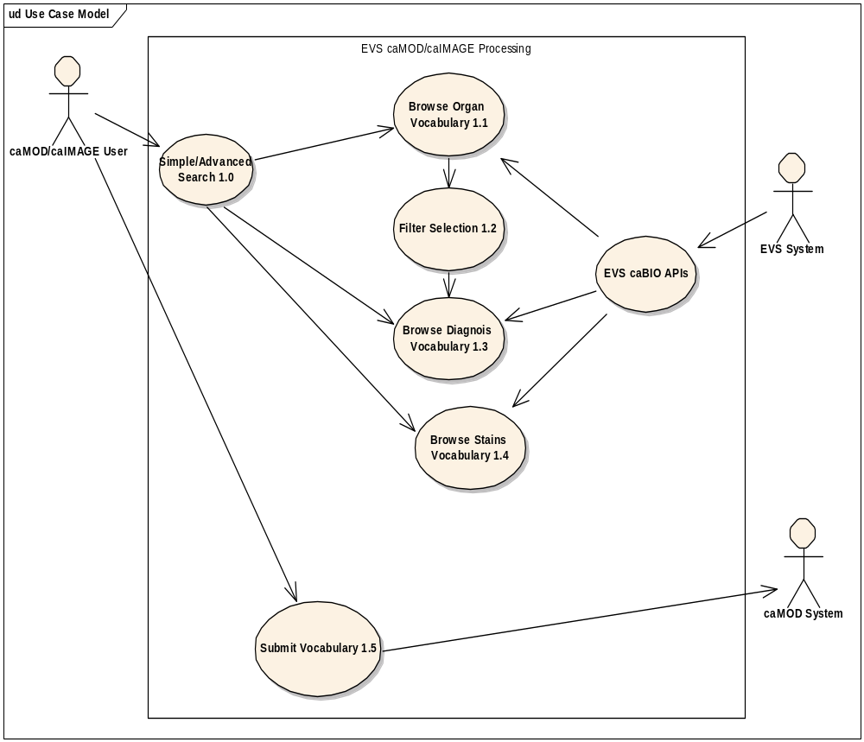

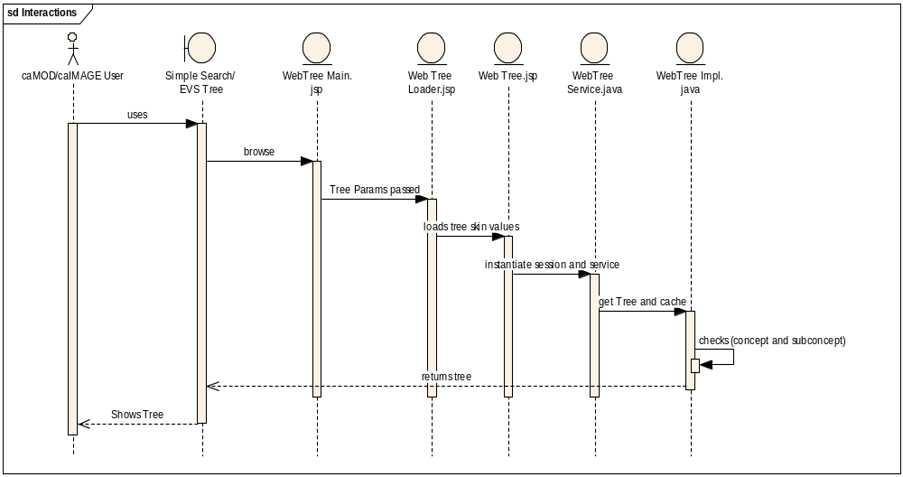

User Client Software
EVS, caMOD and caIMAGE is web based user interface is implemented as HTML, JSP and JavaScript. The use of JavaScript is limited to improving usability only.
Java Server Pages (JSPs) are used to generate dynamic HTML based on user actions. JSPs are combinations of HTML, Java Code, and custom JSP tags that get compiled into servlet classes.

Back End
The caMOD back end components provide access to persistence services for retrieving and storing data in the database. Hibernate, an open source tool, is used as the Object Relational Mapping (ORM) software.

Hibernate 3 Data Access
The caMOD uses Hibernate version 3. Hibernate is used for read, write access. It provides the insert, update and delete capability to the caMOD application thru the domain classes.

JBoss Application Server
The user interface, middle tier, and backend components are run with in JBoss Java2 Enterprise Edition (J2EE) application server. JBoss is an open source application server that provides a servlet container, an EJB container, the full range of J2EE 1.4 features as well as extended enterprise services including clustering, caching and persistence. caIMAGE application will be migrated to run on JBoss 4.0.5 instead of Tomcat 4.1.18. JBoss 4.0.5 conforms to the latest technology stack. It will be consistent with most other applications.

Java
The new version of Java1.5 (Java tool kit version jdk1.5.0_10) is used for compilation. Since EVSTree, which has the dependency on the client.jar file has been up upgraded to Java 1.5. in the latest caBIO version (cacoretoolkit 3.2). Therefore all the code in caMOD and caIMAGE had been compiled using the JDK 1.5 version. This will conform to the latest technology stack currently used by NCI.

Alternate search terms are only shown when matches in the existing trees are found

user interface (VIEW)

Vocabulary Trees
The EVSTree application provides the user a way of searching the data tree by keyword in addition to traversing the tree manually. The results of the search feature are displayed on the left hand side of the data tree screen and the list of the alternative terms that were used to produce the list of search terms is displayed to the user for their information. This list of alternative search terms used by the application has not been useful and therefore will be removed from the display.
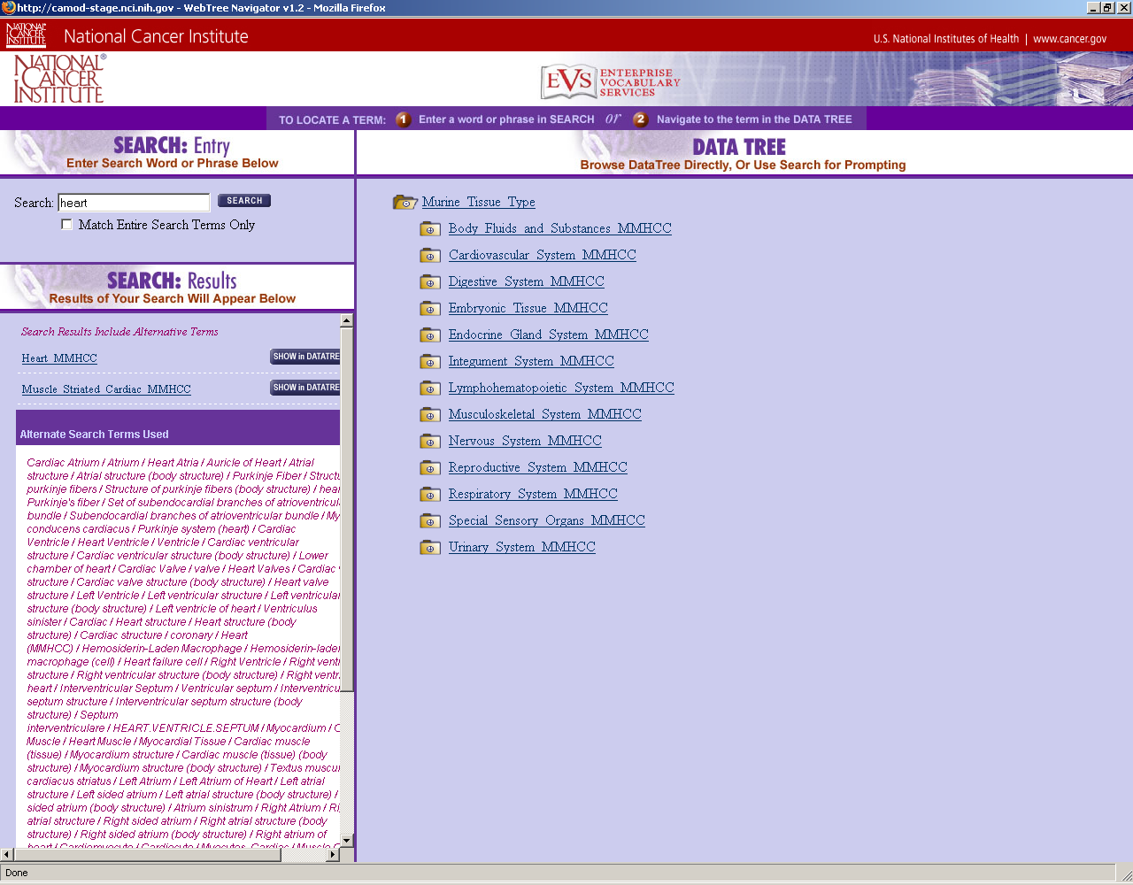

Interface Classes to be Modified
The following is a list of interface classes (GUI and interface java classes) that need to be modified.
Interface Class Name | Description
searchResults.jsp | Remove the alternated search term code block from the jsp page.

configuration and utility classes
    - Configuration and Utility Files Changed
File Name | Function
evsconfig.properties | Defines the properties for each vocabulary tree. Verify the symanticType values for each tree.

tree doesn't jump to the highlighted term after performing search

user interface (VIEW)
If the user chooses to search the data tree via the search text feature, the EVSTree application returns a list of terms present in the data tree that match the search term or are synonyms to the word entered in the search text box. The list of vocabulary terms present in the data tree is presented in two ways: 1) the term is hyperlinked and 2) the application displays a “show in datatree” button. The hyperlink allows the user to skip the steps of selecting the vocabulary from the tree and moves directly to the caMOD submission or search screen with the vocabulary term inserted in the text field. The “show in datatree” button expands the selected tree node in the datatree and highlights the vocabulary term for the user within the EVSTree application pop up screen. Neither of these functions works correctly for all trees and various fixes will be implemented.
First the searchResults screen will be expanded so that more of the data tree shows up in the pop up screen. This will solve some of the issues with seeing the highlighted value immediately in the user’s window.
Second, the application will be modified so that it scrolls down to the highlighted vocabulary.
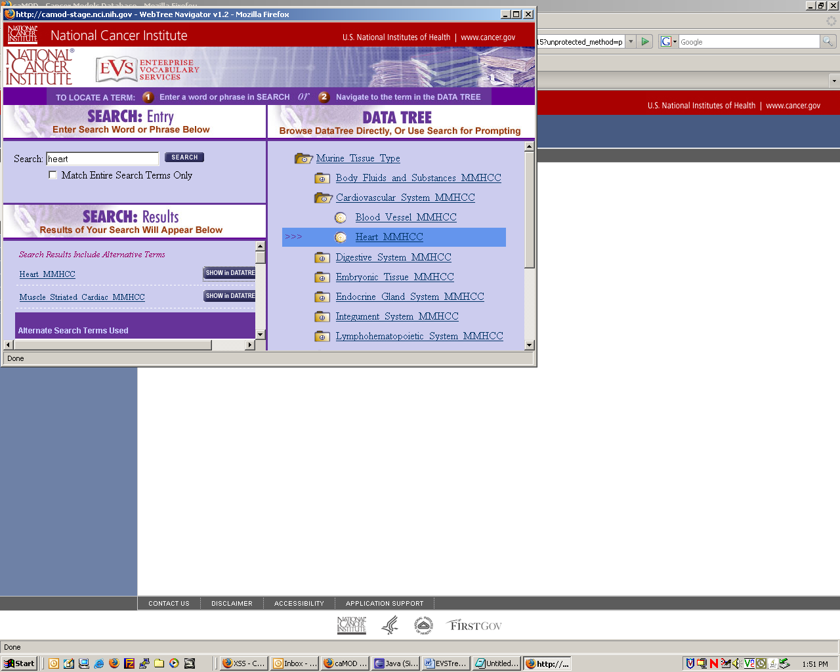

Interface Classes to be Modified
The following is a list of interface classes (GUI and interface java classes) that need to be modified.
Interface Class Name | Description

configuration and utility classes
Configuration and Utility Files Changed
File Name | Function
EVSTreescript.js | Modify showTree method to increase the windowOpen size parameters for height and width.

Search does not work for rat anatomy

user interface (VIEW)
The EVSTree application provides the user a way of searching the data tree by keyword in addition to traversing the tree manually. The results of the search feature are displayed on the left hand side of the data tree screen and application allows the user to simply select one of the options listed or see the vocabulary in the tree to the right. These search features are not currently working for rat anatomy, human, anatomy, rat diseases, mouse diseases, zebrafish anatomy, zebrafish developmental stages, and staining methods..

Values for semanticType for rat organ and disease
The semanticType values were reviewed and these values were decided upon.
Property Name | Property Value(s)

configuration and utility classes
Configuration and Utility Files Changed
File Name | Function
evsconfig.properties | Modify file to fix typo in “semanticType” variable which prevents the application from reading the values currently.

Cancelling selection gives error messages in Mozilla and no response in IEodifications to histopathology submission to allow for text entry of diagnosis

user interface (VIEW)
The caMOD application renders code from the EVSTree application on many submission and search screens. In each of these screens a user can open the data tree specified for a species, search the datatree, select a vocabulary from the tree, and verify the selection. The EVSTree application then transfers the values selected and control back to the caMOD application. If the user wishes to cancel this functionality and start over there is a cancel button provided on all caMOD submission and search screens. This cancel button throws a HTTP 404 error to the user. 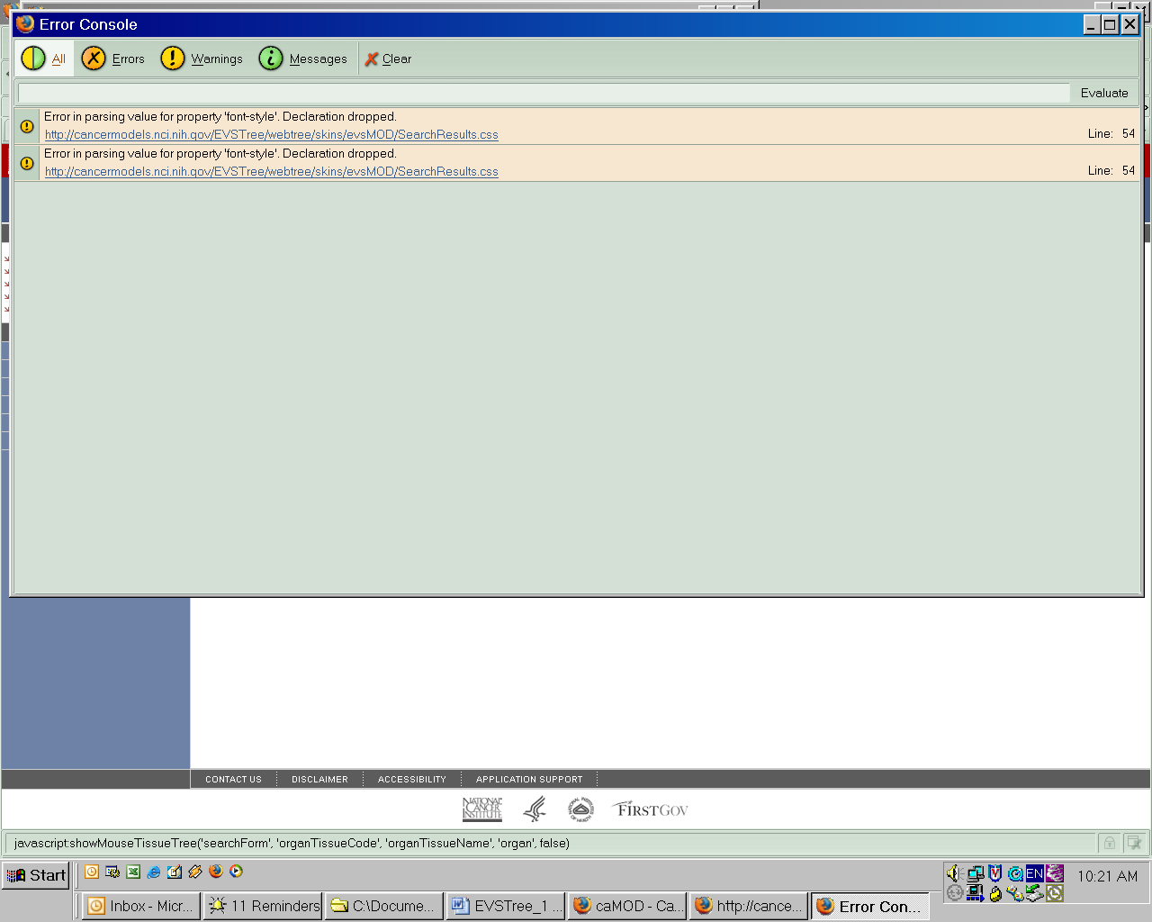

Interface Classes to be Modified
The following is a list of interface classes (GUI and interface java classes) that need to be modified.
Interface Class Name | Description

middle tier (CONTROLLER)

configuration and utility classes
Configuration and Utility Files Changed
File Name | Function

search does not work for zebrafish vocabularies

user interface (VIEW)
The EVSTree application provides the user a way of searching the data tree by keyword in addition to traversing the tree manually. The results of the search feature are displayed on the left hand side of the data tree screen and application allows the user to simply select one of the options listed or see the vocabulary in the tree to the right. These search features currently work using the symanticType values to limit the search. The Zebrafish vocabulary does not have symanticTypes and therefore the search feature needs to be modified to work for the added vocabularies outside NCI_Thesaursus.

Values for semanticType for Zebrafish organ
The semanticType values were evaluated and these are the current values.
Property Name | Property Value(s)

configuration and utility classes
Configuration and Utility Files Changed
File Name | Function
evsconfig.properties | Modify file to fix typo in “semanticType” variable which prevents the application from reading the values currently.

when trying to select search results the page crashes

user interface (VIEW)
If the user chooses to search the data tree via the search text feature, the EVSTree application returns a list of terms present in the data tree that are synonyms to the word entered in the search text box. The list of vocabulary terms present in the data tree is presented in two ways: 1) the term is hyperlinked and 2) the application displays a “show in datatree” button. The hyperlink allows the user to skip the steps of selecting accepting the vocabulary from the tree and moves directly to the caMOD submission or search screen with the vocabulary inserted in the text field. The show in datatree button expands the selected tree node in the datatree and highlights the vocabulary for the user within the EVSTree application pop up screen. Neither of these functions work correctly for all trees and various fixes will be implemented. In one case a HTTP 404 error is thrown by the application. In another case a HTTP 505 error is thrown.
Each tree will be tested and fixed according to the steps needed for the specific functionality.

Interface Classes to be Modified
The following is a list of interface classes (GUI and interface java classes) that need to be modified.
Interface Class Name | Description

utility classes
Configuration and Utility Files Changed
File Name | Function

[Appendix A – acronym List]
Acronym | Description
caMOD | Cancer Models Database
JSP | Java Server Pages

[APPENDIX B – STatus of various vocabulary trees]
 | Mouse Anatomy | Mouse Disease | Rat Anatomy | Rat Disease | Human Anatomy | Zebrafish anatomy | zebrafish dev stages | staining methods
Does search return results for terms that are in the vocabulary? | yes | no, get no matches found when querying for neoplasm or neoplasm | no, get no matches found message when querying for eye or lung | no matches found message when querying for adenoma | no matches found message when querying for antigen | no, get no matches found when querying for cell | no, get no matches found when querying for blastula | no, get no matches found when querying for beta
Does search for synonyms return results? Throat = pharynx | yes | not tested | not tested | not tested | not tested | not tested | not tested | not tested
For disease vocabularies: When search does not return, is the submit new term button shown? | n/a | yes | n/a | no, get only no matches found message, see above | n/a | n/a | n/a | n/a yet
Does submit new term button work? | n/a | yes | n/a | could not be tested, because button not shown | n/a | n/a | n/a | n/a yet

[APPENDIX C –]

