Software Requirements Specification
EVSTree 1.2
NCICB

DOCUMENT REVISION HISTORY
Version Number | Date | Description
1.0 | Sep 27, 2007 | - Initial Draft
1.1 | Oct 11, 2007 | - Updated document with more details
1.2 | Oct 15, 2007 | - Added additional requirements
1.3
1.4

Background/Summary
caMOD utilizes vocabularies provided via read-only access by the NCI Thesaurus and Zebrafish. NCI Thesaurus and Zebrafish are a product of the NCI’s Enterprise Vocabulary System (EVS). The objects returned by the EVS API’s are used to display vocabularies in tree-like structures in the caMOD application. Currently, vocabularies for mouse anatomy and diseases, rat anatomy and diseases, Human anatomy, Zebrafish anatomy and developmental stages, and staining methods are used. The caMOD application is queried based upon the returned concept id from the tree. This minimizes display or entry errors. The vocabulary trees are cached locally using the caBIO API’s.
The EVS Tree code is extendable and generic in nature, so that new vocabularies are easily implemented and configured.
Table of Content
1 Introduction 3
1.1 Overview for additional EVSTree features 3
2 Actors and Authorization 3
3 Use Cases 4
3.1 Alternate search terms only shown when matches in existing trees are found 5
3.1.1 Use Case Model 5
3.1.2 Supplemental Requirements 6
3.2 Tree doesn't jump to the highlighted term after performing search 6
3.2.1 Use Case Model 6
3.2.2 Supplemental Requirements 7
3.3 Search does not work for rat anatomy 7
3.3.1 Use Case Model 7
3.3.2 Supplemental Requirements 8
3.4 Canceling selection gives error messages in Mozilla and no response in IE 8
3.4.1 Use Case Model 8
3.4.2 Supplemental Requirements 9
3.5 Search does not work for Zebrafish vocabularies 9
3.5.1 Use Case Model 9
3.5.2 Supplemental Requirements 10
3.6 EVS tree - crash - when trying to select search result page crashes 10
3.6.1 Use Case Model 10
3.6.2 Supplemental Requirements 11
3.7 Selecting search results in tree causes HTTP 404 Error 12
3.7.1 Use Case Model 12
3.7.2 Supplemental Requirements 13
4 General Requirements 13
4.1 Requirements Prioritization 13
5 Data Definitions 13
6 Sign Off 15
6.1 Approval 15

Introduction

Overview for additional EVSTree features

The EVSTree 1.2 version will address a series of bugs and feature requests that were either dropped from the second rewrite of EVSTree (cache implementation) or which have not fit into the two recent releases.

Actors and Authorization

An actor is a person, organization or external system that plays a role in one or more interactions with the caMOD EVS application. The following is a list of actors that interact with the system:
Researcher or caMOD User: This is the end user that will be using the caMOD portal to search and submit mouse models.
EVS: The Enterprise Vocabulary Service is an API which allows access to NCI’s controlled vocabularies.

Use Cases

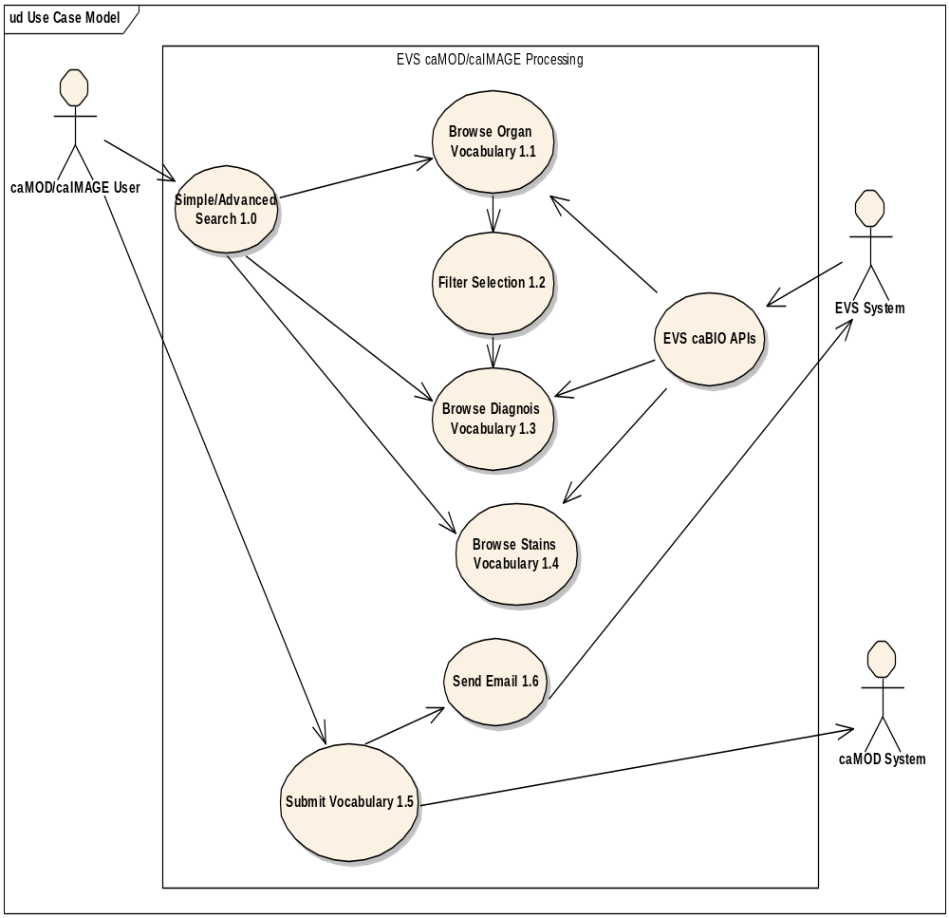
Figure 1. EVSTree Use Case Diagram

Alternate search terms only shown when matches in existing trees are found

Use Case Model

Use Case Name | Alternate search terms only shown when matches in existing trees are found
Use Case ID | 1
Primary Actor | All registered (caMOD submission) and no-registered (caMOD search) users
Brief Description | The submission section allows a user to submit data with an associated organ or diagnosis. When the EVSTree application is rendered it allows a user to further drill down into the existing tree to find any term related to the one entered by the user.  Remove the alternate search terms since they are not useful to the users.
Trigger | Actor navigates to the caMOD URL
Pre-conditions | Successful navigation to the caMod URL  Successful login to caMOD, if submitting a model
Flow of Events | 1. The system presents search and submit models hyperlinks.
Flow of Events | 2. The actor
Flow of Events | - Navigates to the new model submission section  - Successfully enters the data to create an animal model
Flow of Events | 3. The system
Flow of Events | - Returns the data-type categories for submitting data
Flow of Events | 4. The actor
Flow of Events | - Navigates to the Histopathology submission section  - Begins to enters data for the organ or disease
Flow of Events | - Instead of traversing the tree displayed on the right side the user enters a term in the Search entry box on the left hand side and hits the search button
Flow of Events | 5. The system
Flow of Events | - Returns a list of terms contained in the organ or disease tree and displays links for the application to highlight each term in the datatree (“show in datatree” button).
Flow of Events | - A list of the alternate search terms that were used is displayed on the left hand side below the matching terms.
Post Conditions | Success Condition: User creates new model and submits data for appropriate section.  Error Condition: Fails to find search terms  Error Condition: Validation fails  Error Condition: System Error
Alternative Courses of Action | If a validation error occurs, the system throws an exception, displays an error message and re-displays page for data entry.  a. Fails to find search terms  -Re Submit a new search term, if previous term is invalid  -Contact system administrator  b. Validation fails  - Re-enter required data for model Return to step 2a)  c. System Error.  -Contact system administrator
Issues

Supplemental Requirements
None

Tree doesn't jump to the highlighted term after performing search

Use Case Model

Use Case Name | Tree doesn't jump to the highlighted term after performing search
Use Case ID | 2
Primary Actor | All registered (caMOD submission) and no-registered (caMOD search) users
Brief Description | The submission section allows a user to submit data with an associated organ or diagnosis. When the EVSTree application is rendered it allows a user to further drill down into the existing tree to find any term related to the one entered by the user. Fix the following annoyance in EVSTree:  - Tree does not jump to selected search term after user clicks “Show in data tree.”
Trigger | Actor navigates to the caMOD URL
Pre-conditions | Successful navigation to the caMod URL  Successful login to caMOD, if submitting a model
Flow of Events | 1. The system presents search and submit models hyperlinks.
Flow of Events | 2. The actor
Flow of Events | - Navigates to the new model submission section  - Successfully enters the data to create an animal model
Flow of Events | 3. The system
Flow of Events | - Returns the data-type categories for submitting data
Flow of Events | 4. The actor
Flow of Events | - Navigates to the Histopathology submission section  - Begins to enters data for the organ or disease
Flow of Events | - Instead of traversing the tree displayed on the right side the user enters a term in the Search entry box on the left hand side and hits the search button
Flow of Events | 5. The system
Flow of Events | - Returns a list of terms contained in the organ or disease tree and displays links for the application to highlight each term in the datatree (“show in datatree” button).
Flow of Events | - When the user selects one of the terms the EVSTree application jumps to the term and expands the selected tree node.
Post Conditions | Success Condition: User creates new model and submits data for appropriate section.  Error Condition: Fails to find search terms  Error Condition: Validation fails  Error Condition: System Error
Alternative Courses of Action | If a validation error occurs, the system throws an exception, displays an error message and re-displays page for data entry.  a. Fails to find search terms  -Re Submit a new search term, if previous term is invalid  -Contact system administrator  b. Validation fails  - Re-enter required data for model Return to step 2a)  c. System Error.  -Contact system administrator
Issues

Supplemental Requirements
None

Search does not work for rat anatomy

Use Case Model

Use Case Name | Search does not work for rat anatomy
Use Case ID | 3
Primary Actor | All registered (caMOD submission) and no-registered (caMOD search) users
Brief Description | The submission section allows a user to submit data with an associated organ or diagnosis. When the EVSTree application is rendered it allows a user to further drill down into the existing tree to find any term related to the one entered by the user. Fix the following bug in EVSTree:  - Search does not work for rat anatomy
Trigger | Actor navigates to the caMOD URL
Pre-conditions | Successful navigation to the caMod URL  Successful login to caMOD, if submitting a model
Flow of Events | 1. The system presents search and submit models hyperlinks.
Flow of Events | 2. The actor
Flow of Events | - Navigates to the new model submission section  - Successfully enters the data to create a rat animal model
Flow of Events | 3. The system
Flow of Events | - Returns the data-type categories for submitting data
Flow of Events | 4. The actor
Flow of Events | - Navigates to the Histopathology submission section  - Begins to enters data for the organ
Flow of Events | - Instead of traversing the tree displayed on the right side the user enters a term in the Search entry box on the left hand side and hits the search button
Flow of Events | 5. The system
Flow of Events | - Returns a list of terms contained in the organ tree and displays links for the application to highlight each term in the datatree (“show in datatree” button).
Post Conditions | Success Condition: User creates new model and submits data for appropriate section.  Error Condition: Fails to find search terms  Error Condition: Validation fails  Error Condition: System Error
Alternative Courses of Action | If a validation error occurs, the system throws an exception, displays an error message and re-displays page for data entry.  a. Fails to find search terms  -Re Submit a new search term, if previous term is invalid  -Contact system administrator  b. Validation fails  - Re-enter required data for model Return to step 2a)  c. System Error.  -Contact system administrator
Issues

Supplemental Requirements
None

Canceling selection gives error messages in Mozilla and no response in IE

Use Case Model

Use Case Name | Canceling selection gives error messages in Mozilla and no response in IE
Use Case ID | 4
Primary Actor | All registered (caMOD submission) and no-registered (caMOD search) users
Brief Description | The submission section allows a user to submit data with an associated organ or diagnosis. When the EVSTree application is rendered it allows a user to further drill down into the existing tree to find any term related to the one entered by the user. Fix the following annoyances in EVSTree:  - Selecting the cancel button throws and error in firefox and no response in IE
Trigger | Actor navigates to the caMOD URL
Pre-conditions | Successful navigation to the caMod URL  Successful login to caMOD, if submitting a model
Flow of Events | 1. The system presents search and submit models hyperlinks.
Flow of Events | 2. The actor
Flow of Events | - Navigates to the new model submission section  - Successfully enters the data to create an animal model
Flow of Events | 3. The system
Flow of Events | - Returns the data-type categories for submitting data
Flow of Events | 4. The actor
Flow of Events | - Navigates to the Histopathology submission section  - Begins to enters data for the organ or disease
Flow of Events | - Instead of traversing the tree displayed on the right side the user enters a term in the Search entry box on the left hand side and hits the search button
Flow of Events | 5. The system
Flow of Events | - Returns a list of terms contained in the organ or disease tree and displays links for the application to highlight each term in the datatree (“show in datatree” button).
Flow of Events | 6. The actor
Flow of Events | - Decides to cancel the selection.
Flow of Events | 7. The system
Flow of Events | - Returns the user back to the previous screen
Post Conditions | Success Condition: User creates new model and submits data for appropriate section.  Error Condition: Fails to find search terms  Error Condition: Validation fails  Error Condition: System Error
Alternative Courses of Action | If a validation error occurs, the system throws an exception, displays an error message and re-displays page for data entry.  a. Fails to find search terms  -Re Submit a new search term, if previous term is invalid  -Contact system administrator  b. Validation fails  - Re-enter required data for model Return to step 2a)  c. System Error.  -Contact system administrator
Issues

Supplemental Requirements
None

Search does not work for Zebrafish vocabularies

Use Case Model

Use Case Name | Search does not work for Zebrafish vocabularies
Use Case ID | 5
Primary Actor | All registered (caMOD submission) and no-registered (caMOD search) users
Brief Description | The submission section allows a user to submit data with an associated organ or diagnosis. When the EVSTree application is rendered it allows a user to further drill down into the existing tree to find any term related to the one entered by the user. Fix the following annoyances in EVSTree:  - Search does not work for Zebrafish vocabulary  Note: Zebrafish vocabulary does not use the symenticType variable so the search must work without this parameter, if possible.
Trigger | Actor navigates to the caMOD URL
Pre-conditions | Successful navigation to the caMod URL  Successful login to caMOD, if submitting a model
Flow of Events | 1. The system presents search and submit models hyperlinks.
Flow of Events | 2. The actor
Flow of Events | - Navigates to the new model submission section  - Successfully enters the data to create a Zebrafish animal model
Flow of Events | 3. The system
Flow of Events | - Returns the data-type categories for submitting data
Flow of Events | 4. The actor
Flow of Events | - Navigates to the Histopathology submission section  - Begins to enters data for the organ
Flow of Events | - Instead of traversing the tree displayed on the right side the user enters a term in the Search entry box on the left hand side and hits the search button
Flow of Events | 5. The system
Flow of Events | - Returns a list of terms contained in the organ tree and displays links for the application to highlight each term in the datatree (“show in datatree” button).
Post Conditions | Success Condition: User creates new model and submits data for appropriate section.  Error Condition: Fails to find search terms  Error Condition: Validation fails  Error Condition: System Error
Alternative Courses of Action | If a validation error occurs, the system throws an exception, displays an error message and re-displays page for data entry.  a. Fails to find search terms  -Re Submit a new search term, if previous term is invalid  -Contact system administrator  b. Validation fails  - Re-enter required data for model Return to step 2a)  c. System Error.  -Contact system administrator
Issues

Supplemental Requirements
None

EVS tree - crash - when trying to select search result page crashes

Use Case Model

Use Case Name | EVS tree - crash - when trying to select search result page crashes
Use Case ID | 6
Primary Actor | All registered (caMOD submission) and no-registered (caMOD search) users
Brief Description | The submission section allows a user to submit data with an associated organ or diagnosis. When the EVSTree application is rendered it allows a user to further drill down into the existing tree to find any term related to the one entered by the user. Fix the following annoyances in EVSTree:  - The application throws a 404 error when selecting the hyperlinked search result from the returned list of search values.
Trigger | Actor navigates to the caMOD URL
Pre-conditions | Successful navigation to the caMod URL  Successful login to caMOD, if submitting a model
Flow of Events | 1. The system presents search and submit models hyperlinks.
Flow of Events | 2. The actor
Flow of Events | - Navigates to the new model submission section  - Successfully enters the data to create an animal model
Flow of Events | 3. The system
Flow of Events | - Returns the data-type categories for submitting data
Flow of Events | 4. The actor
Flow of Events | - Navigates to the Histopathology submission section  - Begins to enters data for the organ or disease
Flow of Events | - Instead of traversing the tree displayed on the right side the user enters a term in the Search entry box on the left hand side and hits the search button
Flow of Events | 5. The system
Flow of Events | - Returns a list of terms contained in the organ or disease tree and displays links for the application to highlight each term in the datatree (“show in datatree” button).
Flow of Events | - When the user selects one of the hyperlinked terms the EVSTree application jumps to the term and expands the selected tree node.
Post Conditions | Success Condition: User creates new model and submits data for appropriate section.  Error Condition: Fails to find search terms  Error Condition: Validation fails  Error Condition: System Error
Alternative Courses of Action | If a validation error occurs, the system throws an exception, displays an error message and re-displays page for data entry.  a. Fails to find search terms  -Re Submit a new search term, if previous term is invalid  -Contact system administrator  b. Validation fails  - Re-enter required data for model Return to step 2a)  c. System Error.  -Contact system administrator
Issues

Supplemental Requirements
None

Selecting search results in tree causes HTTP 404 Error

Use Case Model

Use Case Name | Selecting search results in tree causes HTTP 404 Error
Use Case ID | 7
Primary Actor | All registered (caMOD submission) and no-registered (caMOD search) users
Brief Description | The submission section allows a user to submit data with an associated organ or diagnosis. When the EVSTree application is rendered it allows a user to further drill down into the existing tree to find any term related to the one entered by the user. Fix the following annoyances in EVSTree:  - Selecting the hyperlink value from the search results throws a HTTP 404 error.
Trigger | Actor navigates to the caMOD URL
Pre-conditions | Successful navigation to the caMod URL  Successful login to caMOD, if submitting a model
Flow of Events | 1. The system presents search and submit models hyperlinks.
Flow of Events | 2. The actor
Flow of Events | - Navigates to the new model submission section  - Successfully enters the data to create an animal model
Flow of Events | 3. The system
Flow of Events | - Returns the data-type categories for submitting data
Flow of Events | 4. The actor
Flow of Events | - Navigates to the Histopathology submission section  - Begins to enters data for the organ or disease
Flow of Events | - Instead of traversing the tree displayed on the right side the user enters a term in the Search entry box on the left hand side and hits the search button
Flow of Events | 5. The system
Flow of Events | - Returns a list of terms contained in the organ or disease tree and displays links for the application to highlight each term in the datatree (“show in datatree” button).
Flow of Events | - When the user selects one of the hyperlinked terms returned from the search the EVSTree application jumps to the term and expands the selected tree node.
Post Conditions | Success Condition: User creates new model and submits data for appropriate section.  Error Condition: Fails to find search terms  Error Condition: Validation fails  Error Condition: System Error
Alternative Courses of Action | If a validation error occurs, the system throws an exception, displays an error message and re-displays page for data entry.  a. Fails to find search terms  -Re Submit a new search term, if previous term is invalid  -Contact system administrator  b. Validation fails  - Re-enter required data for model Return to step 2a)  c. System Error.  -Contact system administrator
Issues

Supplemental Requirements
None

General Requirements

Requirements Prioritization

Req # | Use Case Name | Priority
9277 | Alternate search terms are only shown when matches in the existing trees are found | High
9274 | Tree doesn't jump to the highlighted term after performing search | High
7790 | Search does not work for rat anatomy or disease | High
7451 | Cancelling selection gives error messages in Mozilla and no response in IE | High
7387 | Search does not work for zebrafish vocabularies | High
6389 | EVS tree - crash - when trying to select search result page crashes | High
6388 | Selecting search results in tree causes HTTP 404 Error | High

Data Definitions

CDE # | Data Element | Description | Use Case Name

Sign Off

Approval

Workspace General Contractor Rep Print Name Date
Architecture Workspace Rep Print Name Date
VCDE Workspace Rep Print Name Date
Workspace Working Group Rep Print Name Date
NCICB Rep Print Name Date

