caMOD 2.1 MGI/MTB Data Integration

Software Design Description

Document Change Record
Version Number | Date | Description
1.0 | 02/22/06 | Initial document
1.1
1.2
1.3
1.4
1.5
1.6
1.7
1.8
1.9

TABLE OF CONTENTS
1. Introduction 4
1.1 The Mouse Genome Informatics (MGI) Database 4
1.2 The Mouse Tumor Biology (MTB) Database 5
1.3 PROJECT BACKGROUND 5
1.4 Back End 5
1.4.1 MGI Data source 5
1.4.2 MTB Data source 5
2. USE CasE overview 6
3. Use case and design specifications 7
3.1 upgrade the Genetic description screen when the mgi number is present in the animal model 7
3.1.1 Use case 7
3.1.2 design specification 8
3.2 upgrade the publication Screen when a j numer is present in the animal model 10
3.2.1 Use case 10
3.2.2 design specification 11
Appendix a 14

Introduction
The Jackson Laboratory, established in 1929, has been developed into a world center for the study of mammalian genetics. No other facility exists of its kind. The original goal of laboratory, first envisioned by C.C. Little, still remains today: to understand cancer. He created the first in-bred mouse strain and noticed that different strains of mice develop different tumors at different rates. Mice proved to be a surprisingly accurate model of human biology and allow researchers to study up to 30 generations during one human generation.

Today, the Jackson Laboratory supports a staff for its 35 Principal Investigators leading research groups in six major areas; Bioinformatics, Cancers, Development and Age-Related Defects, Immune System and Blood Disorders, Metabolic Diseases, Neurological and Sensory Disorders. To support bioinformatics research, the Jackson Lab created two databases that are important to the caMod application: the Mouse genome informatics database (MGI) which holds everything collected about mice and The Mouse Tumor Biology (MTB) Database which supports the use of the mouse as a model system of hereditary cancer.

The Mouse Genome Informatics (MGI) Database
The Mouse Genome Informatics (MGI) Database provides integrated access to data on the genetics, genomics, and biology of the laboratory mouse. The MGI database provides tools to search by the following data types:
- Genes and Markers
- Sequence
- Phenotypes and Alleles
- Strains and Polymorphisms
- Gene Expression
- Comparative Maps and Data
- Maps and Mapping Data
- Molecular Reagents (Probes/Clones)
- Accession IDs
- References
- Provides cross-reference to MTB data

The Mouse Tumor Biology (MTB) Database
The Mouse Tumor Biology (MTB) Database supports the use of the mouse as a model system of hereditary cancer by providing electronic access to:
Information on endogenous spontaneous and induced tumors in mice, including tumor frequency & latency data,
Information on genetically defined mice (inbred, hybrid, mutant, and genetically engineered strains of mice) in which tumors arise,
Information on genetic factors associated with tumor susceptibility in mice and somatic genetic-mutations observed in the tumors,
Tumor pathology reports and images,
References, supporting MTB data
Links to other online resources for cancer

Excerpts taken from http://www.jax.org/.

PROJECT BACKGROUND

Back End

MGI Data source

MTB Data source
Version 1.0 of the new Mouse Tumor Biology database is now publicly available. With this release MTB has been ported to Sybase as the database platform. This major infrastructure change provides a scalable foundation for future growth of the database and will enable us to develop new dynamic web-based user interfaces and provide programmatic accessible web services.

USE CasE overview
During many team discussions it was decided that there are three use cases to develop more integration to JAX data sources. The first use case involves linking the MGI number and J Number to additional data provided by JAX MGI and MTB databases.

Upgrade the Genetic Description screen if the MGI Number is present in the Animal model.
Upgrade the Publication screen if a J Number(s) is present in the Animal model.
Upgrade the Publication screen with Images if we can import them from JAX.
Upgrade additional sections of caMod (TBD) with data from JAX if we import all of MGI database into an intermediate caMod data source.
Upgrade additional sections of caMod (TBD) with data from JAX if we import all of MTB database into an intermediate caMod data source.

Use case and design specifications

upgrade the Genetic description screen when the mgi number is present in the animal model

Use case
Use Case Name | Upgrade the Genetic Description Screen When the MGI Number is present in the Animal Model
Test Track Ref | Defect #
Primary Actor | All users
Brief Description | When a use is searching for a model, the user is presented with data associated with the Genetic Description of the model. Data can be from one of the following areas of research: Engineered Transgenes, Genomic Segments, Targeted Modifications, Induced Mutations, and Spontaneous Mutations.  Enhance the Genetic Description screen to include data presented on the MGI Phenotypic Allele Detail page of the MGI Jax website according to the Allele Type (spontaneous, targeted modification, transgene, ect) present.
Trigger | Actor navigates to the Search Models screen and searches for an Animal model where MGI Number in the Mutation Identifier table is not null.
Pre-conditions | User Successfully navigates to the search models section of the application.  Successfully searches for a model with a MGI Number present.  Available to all registered users of the system.
Flow of Events | 1. The actor is presented with the home page for the caMod application.
Flow of Events | 2. The user
Flow of Events | a. Selects the link to search for models.
Flow of Events | 3. The system
Flow of Events | a. Returns the Simple Search screen
Flow of Events | 4. The user
Flow of Events | a. Selects/inputs text for the defined selection criteria to search for an existing Animal model and submits the screen.
Flow of Events | 5. The system
Flow of Events | a. Returns a list of Animal models that match the selection criteria or the message “No models found!”
Post Conditions | Success Condition: User finds an Animal model matching the selection criteria submitted on the Simple Search screen or the system displays “No models found!” to the user.  Error Condition:
Related Use Cases

design specification
The following data will be added to the Genetic Description screen. The data from MGI will be loaded into a secondary caMod data source and a query by MGI Number will produce an additional data table.

JAX data displayed in caMod 2.1 – example for targeted modification
Phenotypic Allele Detail | Top of Form  Bottom of Form

Allele | Symbol: Mlh1^{tm1Rak}  Name: targeted mutation 1, Raju Kucherlapati  ID: MGI:1858054
Synonyms | mlh1-, Mlh1⁻
Allele details | Allele Type: Targeted (knock-out)  Strain of Origin: 129P2/OlaHsd  ES Cell Line: E14.1  ES Cell Line Strain: 129P2/OlaHsd  Mutation: Disruption caused by insertion of vector  Replacement of exon 2 and flanking intronic sequence with a neomycin cassette. (J:33878)
Gene  information | Symbol: Mlh1  Name: mutL homolog 1 (E. coli)  Chromosome: 9  Genetic Position: 62.0 cM  Genome Coordinates: 111269553-111312860 bp, - strand (From NCBI annotation of NCBI Build 34)  Human Ortholog: MLH1

JAX data displayed in caMod 2.1 – example for engineered transgene
Transgene Detail | Top of Form  Bottom of Form

Transgene | Symbol: Tg(S100b-v-erbB)4496Waw  Name: transgene insertion 4496, William A Weiss  ID: MGI:3033302
Transgene  details | Transgene Type: Transgenic (random, expressed)  Strain of Origin: (C57BL/6J x DBA/2J)F1/J  Mutation: Insertion  This transgene expresses viral erbB under the control of the mouse S100b promoter. (J:82649)
Transgene  information | Symbol: Tg(S100b-v-erbB)4496Waw  Name: transgene insertion 4496, Michael Weis  Chromosome: UN

upgrade the publication Screen when a j numer is present in the animal model

Use case
Use Case Name | Upgrade the Publication Screen When a J Number is present in the Animal Model
Test Track Ref | Defect #
Primary Actor | All users
Brief Description | When a use is searching for a model, the user is presented with data for Publications associated with the model.  Enhance the Publication screen to include data presented on the MGI Phenotypic Allele Detail page of the MGI Jax website according to the Allele Type (spontaneous, targeted modification, transgene, ect) present.
Trigger | Actor navigates to the Search Models screen and searches for an Animal model where MGI Number in the Mutation Identifier table is not null.
Pre-conditions | User Successfully navigates to the search models section of the application.  Successfully searches for a model with a MGI Number present.  Available to all registered users of the system.
Flow of Events | 1. The actor is presented with the home page for the caMod application.
Flow of Events | 2. The user
Flow of Events | a. Selects the link to search for models.
Flow of Events | 3. The system
Flow of Events | a. Returns the Simple Search screen
Flow of Events | 4. The user
Flow of Events | a. Selects/inputs text for the defined selection criteria to search for an existing Animal model and submits the screen.
Flow of Events | 5. The system
Flow of Events | a. Returns a list of Animal models that match the selection criteria or the message “No models found!”
Post Conditions | Success Condition: User finds an Animal model matching the selection criteria submitted on the Simple Search screen or the system displays “No models found!” to the user.  Error Condition:
Related Use Cases

design specification
- The Publication screen will include J Number

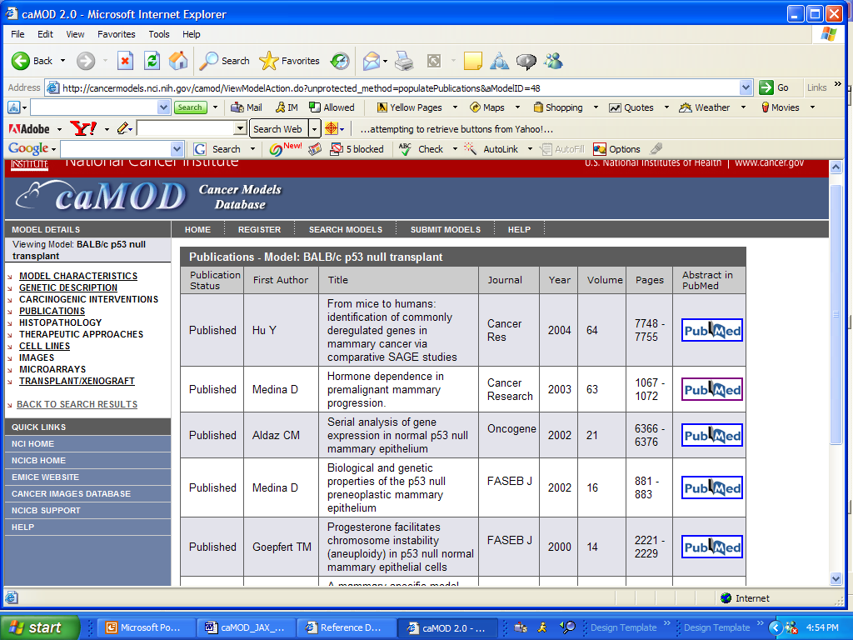

2a. The J Number will link to EITHER the References page on the MGI database

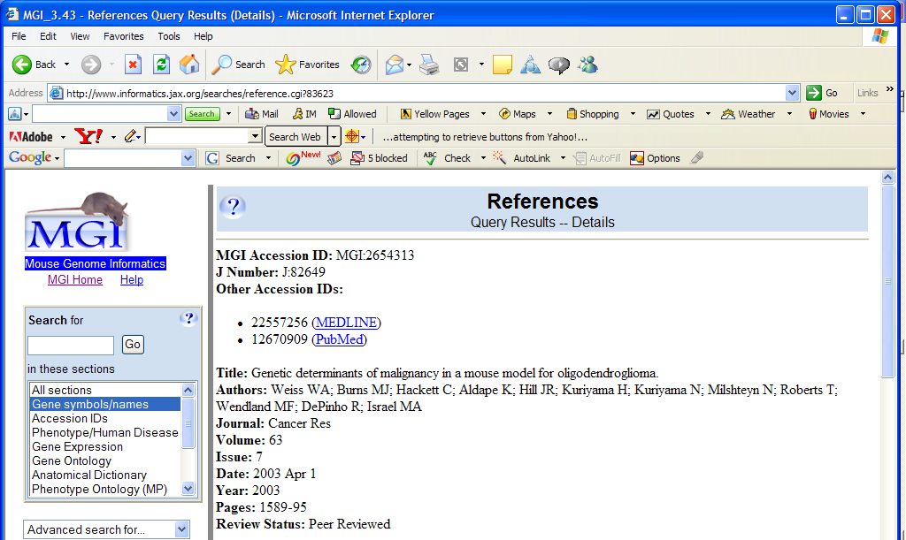
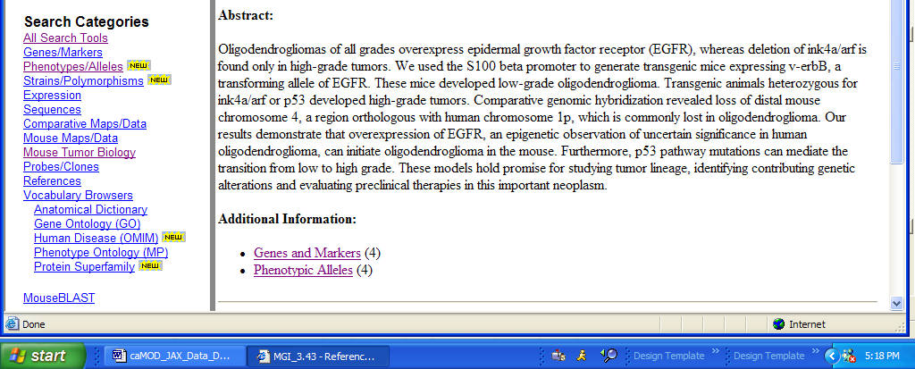

**Note: users can navigate to additional links in MGI

2b. OR the Reference Detail page from MTB 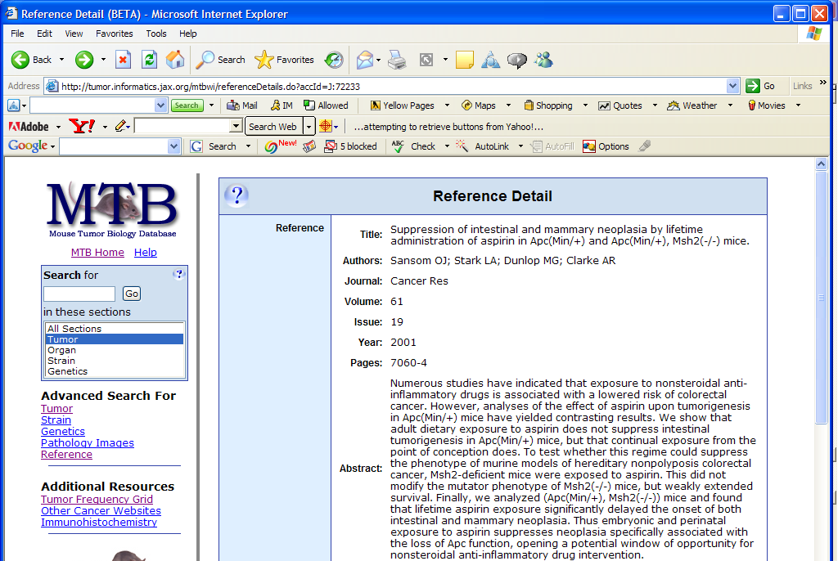
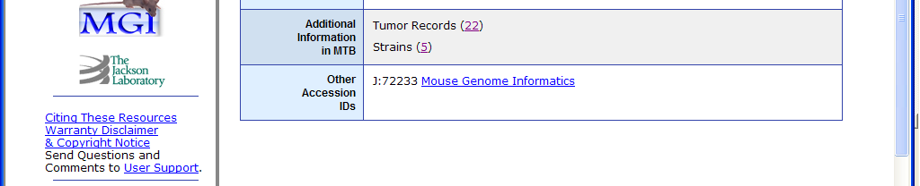

Note: Users can navigate through the “Additional Information in MTB” section.

Appendix a
DATA MAPPING TO MGI DATABASE

Phenotypic Allele Detail Section
SECTION | FIELD | DATABASE | TABLE | ATTRIBUTE
Allele | Symbol
Allele | Name
Allele | Type
Allele | PI
Allele | ID | Used to link from | caMod | MGIAccession ID
Synonyms | Synonyms
Allele details | Allele Type
Allele details | Strain of Origin
Allele details | ES Cell Line
Allele details | ES Cell Line Strain
Allele details | Mutation
Allele details | ??
Gene information | Symbol
Gene information | Name
Gene information
Gene information | Chromosome
Gene information | Genetic Position
Gene information | Genetic Coordinates
Gene information | Human Ortholog

Presentation format:
Phenotypic Allele Detail | Top of Form  Bottom of Form

Allele | Symbol: Mlh1^{tm1Rak}  Name: targeted mutation 1, Raju Kucherlapati  ID: MGI:1858054
Synonyms | mlh1-, Mlh1⁻
Allele details | Allele Type: Targeted (knock-out)  Strain of Origin: 129P2/OlaHsd  ES Cell Line: E14.1  ES Cell Line Strain: 129P2/OlaHsd  Mutation: Disruption caused by insertion of vector  Replacement of exon 2 and flanking intronic sequence with a neomycin cassette. (J:33878)
Gene  information | Symbol: Mlh1  Name: mutL homolog 1 (E. coli)  Chromosome: 9  Genetic Position: 62.0 cM  Genome Coordinates: 111269553-111312860 bp, - strand (From NCBI annotation of NCBI Build 34)  Human Ortholog: MLH1

Transgene Detail Section
SECTION | FIELD | DATABASE | TABLE | ATTRIBUTE
Transgene | Symbol
Transgene | Name
Transgene | ID |  |  | MGIAccession ID
Transgene details | Transgene Type
Transgene details | Strain of Origin
Transgene details | Mutation
Transgene information | Symbol
Transgene information | Name
Transgene information | Chromosome

Presentation format
Transgene Detail | Top of Form  Bottom of Form

Transgene | Symbol: Tg(S100b-v-erbB)4496Waw  Name: transgene insertion 4496, William A Weiss  ID: MGI:3033302
Transgene  details | Transgene Type: Transgenic (random, expressed)  Strain of Origin: (C57BL/6J x DBA/2J)F1/J  Mutation: Insertion  This transgene expresses viral erbB under the control of the mouse S100b promoter. (J:82649)
Transgene  information | Symbol: Tg(S100b-v-erbB)4496Waw  Name: transgene insertion 4496, Michael Weis  Chromosome: UN

appendix b
The Genetic Description screen needs to be reworked so the JAX data can be displayed.

Show on the sections that have data on the Summary Table. Model this more like Carcinogenic Interventions which does not show empty sections when an Environmental Factor (Type) is not present in the model.
Present the JAX data in a separate table with the appropriate acknowledgements.
If the page gets too long then discuss ways to break this section into smaller units.

Appendix C
How to get to the reference page in MGI

Presentation format in MTB: step 1 – Look up by Organ (mammary gland)

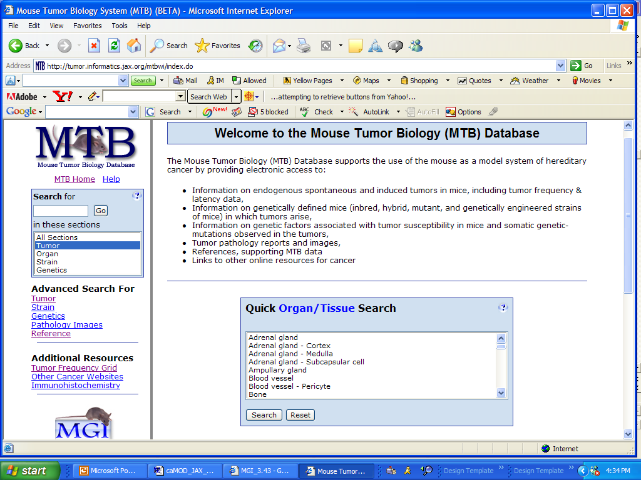

step 2- Select Tumor Summary link
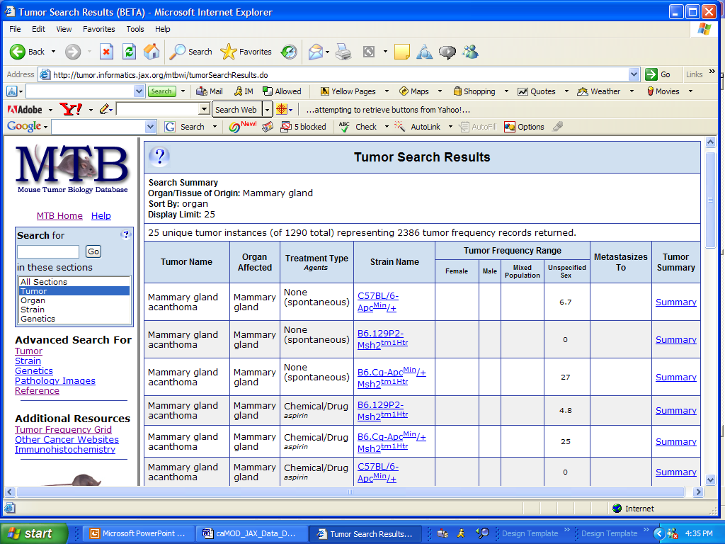

step 2 – Select J Number

