Recommended method to connect to our public MGI Sybase schema:

This how-to deals with how to perform simple queries against the mgi-sybase database. It is not meant be the data integration solution to ingest JAX data elements to caMOD, for which another prototype exists.

The caMOD team has licenses for MyEclipse, so let us use the MyEclipse database explorer plugin.
To access this tool within eclipse, you must:

- Launch MyEclipse 4.0
- Open the DBBrowser view from Window->Show View or Open the MyEclipse Database Perspective.
Connecting the Database Explorer to a database is a 3 step process:
- Configure the Database Explorer JDBC driver for your database
- Create a database connection profile
- Open a database connection
You must obtain a JDBC Driver for Sybase. I recommend using the Sybase JConnect 6.0 driver available in T:\Srini\ folder. Unzip the folder to your dev directory (some place safe) where you will configure eclipse to point to the jconn3.jar (or jconn3d.jar for debug)
- Open the Database Driver Manager. From the MyEclipse menubar select Window > Preferences > MyEclipse > Database Explorer > Drivers

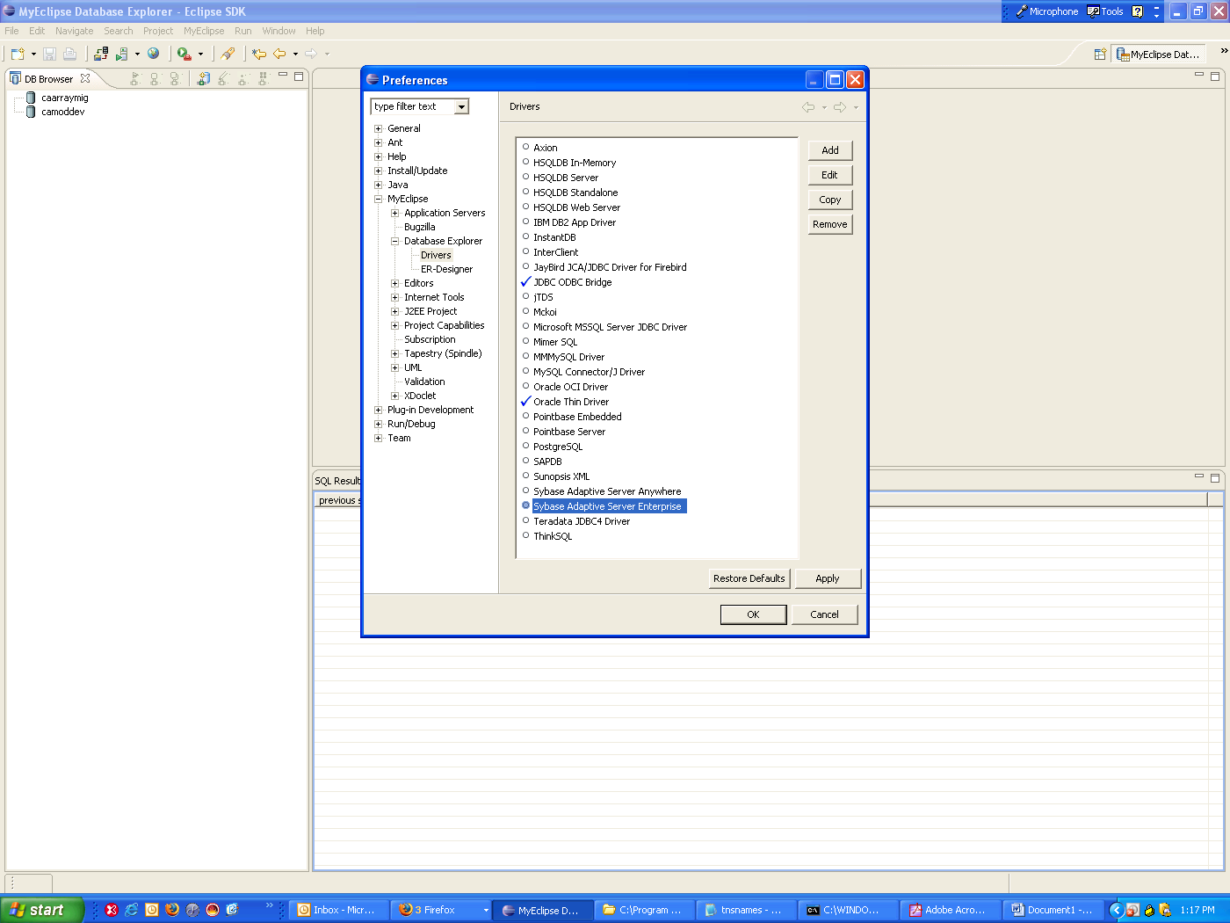

- Select the Sybase Adaptive Sever Enterprise followed by the Edit action
This will open the Driver properties as shown below. Click on the Driver Libraries tab, then click on the new button, and choose the path to jconn3.jar (or 3d if you want debug). Click OK to exit out of this dialog box.
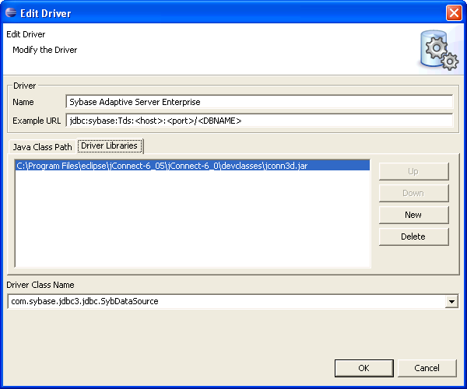

- From the Database Browser view select the New Connection Profile. This will open a New Connection Profile dialog. Enter the appropriate information as shown in the dialog box below (note: As the time of writing this how-to, our ncicb account to Jax did not work. I have a ticket to mgi-support to deal with this issue, until then I have taken Jose’s offer to use his account).

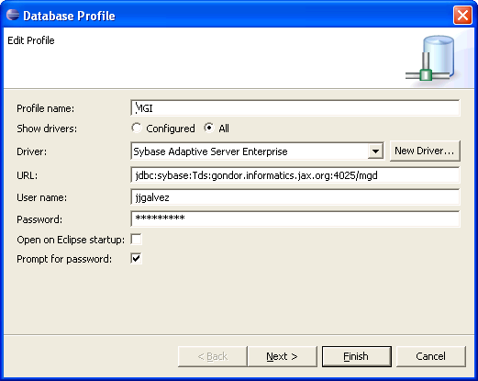

4. You can do Selects against the schema, like the following and view the results.

