Software Requirements Specification
caMOD 2.6.1
NCICB

DOCUMENT REVISION HISTORY
Version Number | Date | Description
1.0 | 4/6/2010 | - Initial Draft
1.1 | 4/7/2010 | - Removed item #18684 - no time to add any more extra items to release
1.2
1.3
1.4

Background/Summary

The cancer models database (caMOD) is a web-based resource that provides information about animal models for human cancer to the public research community.

caMOD provides the following key capabilities to its users:

- Data Submission--Data in caMOD are extracted from the public scientific literature by curators and verified by the scientists who generated or worked with the models, or they are directly submitted by scientists.

- Cancer Model Search--Users can retrieve information about the making of models, their genetic descriptions, carcinogenic interventions, transient interference, histopathology, derived cell lines, associated images, transplantation, microarray data, and therapeutic trials in which the models were used. caMOD provides links to PubMed for associated publications and other resources such as mouse repositories, detailed information about altered gene, pathway affected, and information about human clinical trials that utilize the same compounds as the pre-clinical trials in the animal models.

- System Function Administration--The Admin function provides services for user registration, review of submitted models and database management.
Table of Content
1 Introduction 4
1.1 Overview for 2.6.1 4
2 Actors and Authorization 4
3 Use Cases 6
3.1 Change label from MMHCC Repository to NCI Mouse Repository 7
3.1.1 Use Case Model 7
3.1.2 Supplemental Requirements 7
3.2 Entered date changes every single time the model characteristics page is changed 8
3.2.1 Use Case Model 8
3.2.2 Supplemental Requirements 9
3.3 Can’t enter "Other" for site of administration on Transplant page 9
3.3.1 Use Case Model 9
3.3.2 Supplemental Requirements 10
3.4 Make sorting meaningful for humans and not for computers 10
3.4.1 Use Case Model 10
3.4.2 Supplemental Requirements 11
3.5 Separation between keyword search and simple/advanced search is not obvious to user 11
3.5.1 Use Case Model 11
3.5.2 Supplemental Requirements 11
3.6 Display PMID number on search results detail page 12
3.6.1 Use Case Model 12
3.6.2 Supplemental Requirements 12
3.7 Wrap First Author field for MTB pages 13
3.7.1 Use Case Model 13
3.7.2 Supplemental Requirements 13
3.8 Links to sid, gif, jpeg, jpg, tif images needs to be modified for caIMAGE upgrade 14
3.8.1 Use Case Model 14
3.8.2 Supplemental Requirements 15
3.9 BDA - automate changes to external properties for caIMAGE upgrade 15
3.9.1 Use Case Model 15
3.9.2 Supplemental Requirements 16
3.10 Change zebrafish concept codes to accommodate new NCI Thesaurus release with improved zebrafish vocabularies 16
3.10.1 Use Case Model 16
3.10.2 Supplemental Requirements 17
4 General Requirements 18
4.1 Requirements Prioritization 18
5 Data Definitions 18
6 Sign Off 19
6.1 Approval 19

Introduction

Overview for 2.6.1
caMOD 2.6.1 is a maintenance build. This build will include an upgrade to the code that submits and retrieves images for storage in caIMAGE. A small variety of bug fixes and small feature requests will also be included.

Actors and Authorization

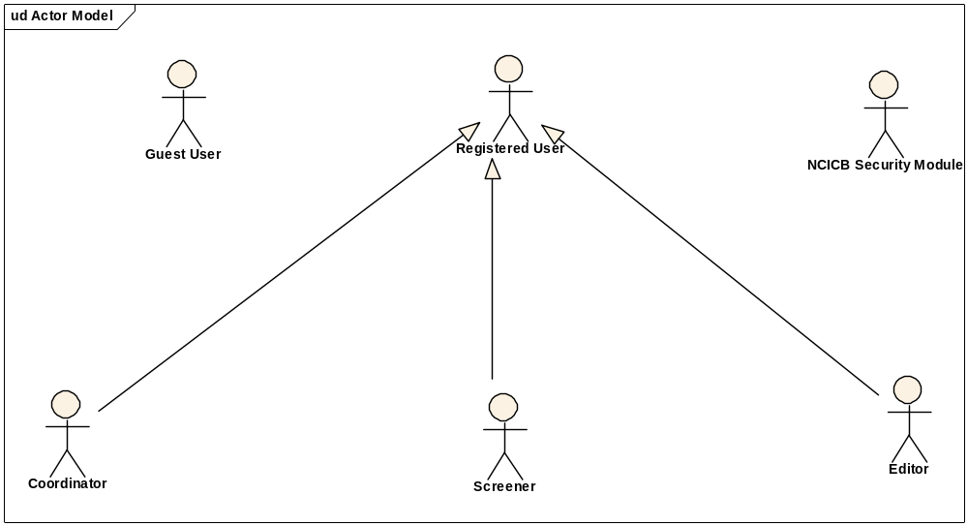
Guest User: Includes every user without an account. These users can query the database without restrictions, but they cannot submit models or comment on models.
Registered User: Can submit models to the database and can comment on models submitted by other researchers.
Super User (not shown): Has access to all model entries to update them. This is to facilitate minor text corrections in an entry without having to bother the submitter.
Coordinator: The coordinator is a registered user who appoints screener and editors. The coordinator also grants access privileges and manages the review process. After a model has been entered the coordinator assigns a screener who will check that all required fields have been specified and that the model does not contain junk or grossly inappropriate material. The coordinator will be informed about the decision of the screener by email. If the screener accepted the model the coordinator then assigns the model to an editor, who is a content expert.
Screener: The Screener is a registered user who performs the initial review of submitted models. This review is a quick check that all required fields have been specified and that the model does not contain junk or grossly inappropriate material. The screener also makes a preliminary assessment for clarity, typographic errors and other issues that would make the model less than fully comprehensible. The screening process should be complete within 24 hours. The screener does not contact the submitter about the submission. Any deficiencies found are described in the email to the coordinator. Each email deals with only one submission, so that the emails can be independently routed for vetting.
Editor: The Editor is a registered user who examines a model to see if it satisfies criteria to be made available to the public. The editor also considers any comments, made by the screener, that are passed along in the email from the coordinator. The editor may determine that the model cannot be made acceptable for publication in the database because it requires additional data. If the model has correctable defects, it may be necessary to communicate by email with the submitter to make the model acceptable. Correspondence and telephone contact with the submitters may be conducted through the coordinator. Editors are responsible for maintaining a paper trail or log of email exchanges regarding the models they review. The editor may elect to review a model without assistance. He or she can also request assistance from other subject matter experts. Only the editor has the authority to release the model to the intended audience.

Use Cases

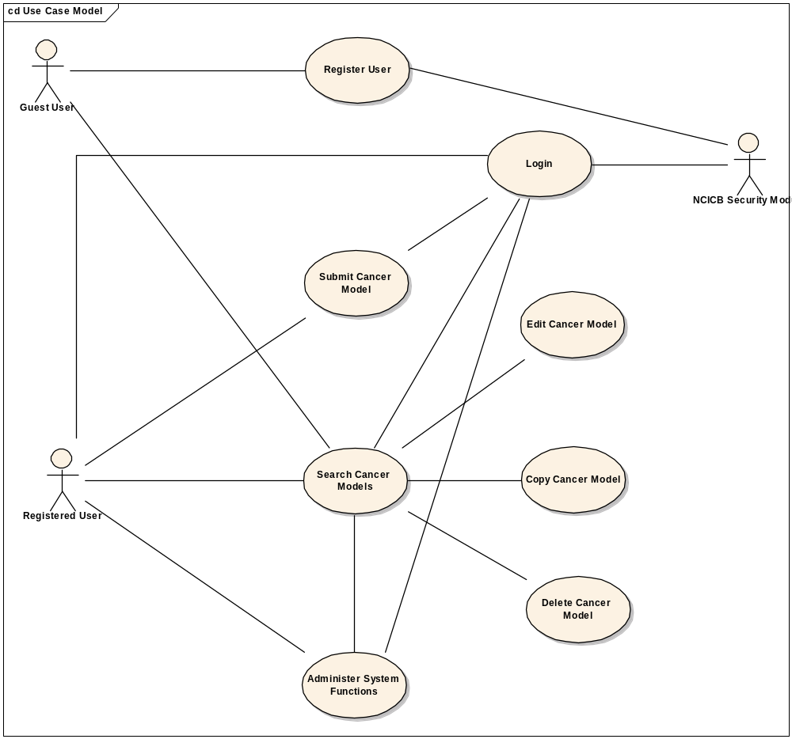
Figure 1. caMOD Use Case Diagram

Change label from MMHCC Repository to NCI Mouse Repository

Use Case Model

Use Case Name | Change label from MMHCC Repository to NCI Mouse Repository
Use Case ID | 18438
Primary Actor | All registered users
Brief Description | The MMHCC Repository is now referred to as NCI Mouse Repository. Change the Animal Availability submission page and all the references to MMHCC Repository in caMOD.
Trigger | Actor navigates to the caMOD URL
Pre-conditions | Successful navigation to the caMOD URL  Successful login to caMOD
Flow of Events | 1. The system presents search and submit models hyperlinks.
Flow of Events | 2. The actor
Flow of Events | - Navigates to the new model submission section  - Successfully enters the data to create an animal model
Flow of Events | 3. The system
Flow of Events | - Returns the data-type categories for submitting data
Flow of Events | 4. The actor
Flow of Events | - Navigates to the Animal Availability submission section  - Enters data for the NCI Mouse Repository and submits the form
Flow of Events | 5. The system
Flow of Events | - Saves the data for the submitted model
Post Conditions | Success Condition: User creates new model and submits data for appropriate section.  Error Condition: Fails to create new model  Error Condition: Validation fails  Error Condition: System Error
Alternative Courses of Action | If a validation error occurs, the system throws an exception, displays an error message and re-displays page for data entry.  a. Fails to create new model  -Re Submit new model data (Return to step 2a)  -Contact system administrator  b. Validation fails  - Re-enter required data for model Return to step 2a)  c. System Error.  -Contact system administrator
Issues

Supplemental Requirements
None

Entered date changes every single time the model characteristics page is changed

Use Case Model

Use Case Name | Entered date changes every single time the model characteristics page is changed
Use Case ID | 20593
Primary Actor | All registered users
Brief Description | The entered date is recorded in the Availability table and referenced in the Abs_Cancer_Model table by Availability id. This date should be entered once when the model is created and should not be modified through out the life of the model.
Trigger | Actor navigates to the caMOD URL
Pre-conditions | Successful navigation to the caMOD URL  Successful login to caMOD
Flow of Events | 1. The system presents search and submit models hyperlinks.
Flow of Events | 2. The actor
Flow of Events | - Navigates to the new model submission section  - Successfully enters the data to create an animal model
Flow of Events | 3. The system
Flow of Events | - Returns the data-type categories for submitting data
Flow of Events | 4. The actor
Flow of Events | - Checks the value of the entered date in the Availability table in the database  - Navigates to the Model Characteristics submission section  - Modifies any data on the page and submits form
Flow of Events | 5. The system
Flow of Events | - Saves the data for the submitted model
Flow of Events | 4. The actor
Flow of Events | - Verifies that the entered date did not change in the database
Post Conditions | Success Condition: User creates new model and submits data for appropriate section.  Error Condition: Fails to create new model  Error Condition: Validation fails  Error Condition: System Error
Alternative Courses of Action | If a validation error occurs, the system throws an exception, displays an error message and re-displays page for data entry.  a. Fails to create new model  -Re Submit new model data (Return to step 2a)  -Contact system administrator  b. Validation fails  - Re-enter required data for model Return to step 2a)  c. System Error.  -Contact system administrator
Issues

Supplemental Requirements
None

Can’t enter "Other" for site of administration on Transplant page

Use Case Model

Use Case Name | Can't enter "Other" for site of administration on Transplant page
Use Case ID | 27700
Primary Actor | All users, all registered users
Brief Description | The submission and search page for Transplantation first checks for a value in the admin site field then the other admin site field to determine what value is displayed on the GUI. The user selected a value from the drop down list, but then modified the admin site value to “other” and entered text for other admin site. The original value of the admin site was never deleted in the database so the change was not displayed correctly. Null the value for admin site when other is selected to guard against this issue when a user edits a models.
Trigger | Actor navigates to the caMOD URL
Pre-conditions | Successful navigation to the caMOD URL
Flow of Events | 1. The system presents search and submit models hyperlinks.
Flow of Events | 2. The actor
Flow of Events | - Navigates to the new model submission section  - Successfully enters the data to create an animal model
Flow of Events | 3. The system
Flow of Events | - Returns the data-type categories for submitting data
Flow of Events | 4. The actor
Flow of Events | - Navigates to the Transplantation submission section  - Enters a value for admin site from the drop down list and submits form
Flow of Events | 5. The system
Flow of Events | - Saves the data for the submitted model
Flow of Events | 4. The actor
Flow of Events | - Checks that the entry is listed correctly in the edit mode of the submission section
Flow of Events | - Moves the model to edited approved and checks that the value displays in the search results page for Transplantation
Flow of Events | - Returns to the submission page for Transplantation and selects “other” as the value for admin site and enters data in the other admin site field.
Flow of Events | - submits form
Flow of Events | - Checks that the entry is listed correctly in the edit mode of the submission section
Flow of Events | - Then returns to check that the new value displays in the search results page for Transplantation
Post Conditions | Success Condition: User creates new model and submits data for appropriate section.  Error Condition: Fails to create new model  Error Condition: Validation fails  Error Condition: System Error
Alternative Courses of Action | If a validation error occurs, the system throws an exception, displays an error message and re-displays page for data entry.  a. Fails to create new model  -Re Submit new model data (Return to step 2a)  -Contact system administrator  b. Validation fails  - Re-enter required data for model Return to step 2a)  c. System Error.  -Contact system administrator
Issues

Supplemental Requirements
None

Make sorting meaningful for humans and not for computers

Use Case Model

Use Case Name | Make sorting meaningful for humans and not for computers
Use Case ID | 14379
Primary Actor | All registered users, all public users
Brief Description | There are drop down list generated dynamically and saved statically all over the caMOD application. The oracle sorting algorithm does not consider initial caps vs lower caps and instead lists lower caps after the initial caps regardless of spelling. Add a smarter sorting algorithm to the queries to sort in a more meaningful way for human reading.
Trigger | Actor navigates to the caMOD URL
Pre-conditions | Successful navigation to the caMOD URL  Successful login to caMOD
Flow of Events | 1. The system presents search and submit models hyperlinks.
Flow of Events | 2. The actor
Flow of Events | - Opens the attached spreadsheet from the gforge entry that lists which drops downs were sorted  - Navigates to the submission and search sections comparing the lists to production (or verifying that he list is sorted alphabetically regardless of capitalization)
Post Conditions | Success Condition: User navigates through both the search and submission sections.  Error Condition: System Error
Alternative Courses of Action | If the system throws an exception or displays an error message.  a. System Error.  -Contact system administrator
Issues

Supplemental Requirements
None

Separation between keyword search and simple/advanced search is not obvious to user

Use Case Model

Use Case Name | Separation between keyword search and simple/advanced search is not obvious to user
Use Case ID | 14560
Primary Actor | All users
Brief Description | The caMOD application offers a keyword, simple and advanced search functionality. Add more space between the keyword and simple search, change the button name for the keyword search, and add a button at the top of the advanced search that works the same as the button at the bottom of the page. All these changes will make searching more clear for the users of the application.
Trigger | Actor navigates to the caMOD URL
Pre-conditions | Successful navigation to the caMOD URL
Flow of Events | 1. The system presents search and submit models hyperlinks.
Flow of Events | 2. The actor
Flow of Events | - Navigates to the various search criteria pages  - Verify that the changes listed above have been made
Post Conditions | Success Condition: User navigates to keyword, simple and adv search sections.  Error Condition: System Error
Alternative Courses of Action | If the system throws an exception or displays an error message.  a. System Error.  -Contact system administrator
Issues

Supplemental Requirements
None

Display PMID number on search results detail page

Use Case Model

Use Case Name | Display PMID number on search results detail page
Use Case ID | 19879
Primary Actor | All users
Brief Description | The advances search allows a user to search for animal models by PMID. Then the PMID number is used to link to Pub Med using the PubMed icon. The users want to know the PMID without having to read the link. Use the PMID number instead of the PubMed icon to link to Pub Med so it is obvious to users.
Trigger | Actor navigates to the caMOD URL
Pre-conditions | Successful navigation to the caMOD URL
Flow of Events | 1. The system presents search and submit models hyperlinks.
Flow of Events | 2. The actor
Flow of Events | - Navigates to the advanced search section  - Searches for a model by PMID (find one in the database)
Flow of Events | 3. The system
Flow of Events | - Returns the list of animal models matching the PMID entered
Flow of Events | 4. The actor
Flow of Events | - Navigates to the publication search results page and verifies the link to PMID is working
Post Conditions | Success Condition: User searches for animal models by the criteria entered  Error Condition: Fails to return a list of models or no model found  Error Condition: Validation fails  Error Condition: System Error
Alternative Courses of Action | If a validation error occurs, the system throws an exception, displays an error message and re-displays page for data entry.  a. Fails to return a list of models (or no models found)  -Re Submit the search criteria page (Return to step 2a)  -Contact system administrator  b. Validation fails  - Re-enter required data for model Return to step 2a)  c. System Error.  -Contact system administrator
Issues

Supplemental Requirements
None

Wrap First Author field for MTB pages

Use Case Model

Use Case Name | Wrap First Author field for MTB pages
Use Case ID | 23452
Primary Actor | All users
Brief Description | When a user enters data for a publication, he/she enters one name for the first author field. But in the MTB records the complete list of authors is saved in the first author field in the database. Therefore, the display of the first author field in MTB models causes formatting issues and extends the field beyond the width normally given to that value (looks ugly). Wrap the first author field so the formatting is fixed and the list of authors displays with temporary breaks and spaces. The data in the database is not modified.
Trigger | Actor navigates to the caMOD URL
Pre-conditions | Successful navigation to the caMOD URL
Flow of Events | 1. The system presents search and submit models hyperlinks.
Flow of Events | 2. The actor
Flow of Events | - Navigates to the advanced search section  - Searches for a model by PMID
Flow of Events | 3. The system
Flow of Events | - Returns the list of animal models matching the PMID entered
Flow of Events | 4. The actor
Flow of Events | - Navigates to the publication search results page and verifies the author field is formatted with break points and spans multiple lines of text
Post Conditions | Success Condition: User searches for animal models by the criteria entered  Error Condition: Fails to return a list of models or no model found  Error Condition: Validation fails  Error Condition: System Error
Alternative Courses of Action | If a validation error occurs, the system throws an exception, displays an error message and re-displays page for data entry.  a. Fails to return a list of models (or no models found)  -Re Submit the search criteria page (Return to step 2a)  -Contact system administrator  b. Validation fails  - Re-enter required data for model Return to step 2a)  c. System Error.  -Contact system administrator
Issues

Supplemental Requirements
None

Links to sid, gif, jpeg, jpg, tif images needs to be modified for caIMAGE upgrade

Use Case Model

Use Case Name | Links to sid, gif, jpeg, jpg, tif images needs to be modified for caIMAGE upgrade
Use Case ID | 23750
Primary Actor | All users, all registered users
Brief Description | The caMOD application allows images submission in the genetic description section and in an individual images submission section. The caMOD application FTPs the images to caIMAGE for storage on the submission side and retrieves the thumbnails and images from caIMAGE on the search side. The caIMAGE application is being upgraded and new servers are being built for each tier. Change the submission code to send the images to the new server on all tiers. Change the search code to retrieve images from the new server on each tier. Remove the ability to upload .sid images from caMOD. All existing .sid images were converted to .tif images during the caIMAGE upgrade.
Trigger | Actor navigates to the caMOD URL
Pre-conditions | Successful navigation to the caMOD URL  Successful login to caMOD for submission testing
Flow of Events | 1. The system presents search and submit models hyperlinks.
Flow of Events | 2. The actor
Flow of Events | - Navigates to the new model submission section  - Successfully enters the data to create an animal model
Flow of Events | 3. The system
Flow of Events | - Returns the data-type categories for submitting image and genetic description data
Flow of Events | 4. The actor
Flow of Events | - Navigates to each of the sub-sections that allow image submission (Image) or construct submission (Transgene, Genomic Segment, and Targeted Modification) and enter data for the pages by attaching an image or construct.  - Repeats the testing until all four types of images (Image of type .jpg, .jpeg, .gif or .png) are tested for all pages in caMOD and submit the page each time.
Flow of Events | 5. The system
Flow of Events | - Saves the data for the submitted model
Flow of Events | 4. The actor
Flow of Events | - Moves the model to edited approved and checks that the data submitted is displayed on each of the search results pages
Flow of Events | - Also tests all the models that have existing images by searching by image in the advanced search section. The actor must test all the models with images but not MTB. The MTB images are not stored so these models do not need testing.
Post Conditions | Success Condition: User creates new model and submits data for appropriate section.  Error Condition: Fails to create new model  Error Condition: Validation fails  Error Condition: System Error
Alternative Courses of Action | If a validation error occurs, the system throws an exception, displays an error message and re-displays page for data entry.  a. Fails to create new model  -Re Submit new model data (Return to step 2a)  -Contact system administrator  b. Validation fails  - Re-enter required data for model Return to step 2a)  c. System Error.  -Contact system administrator
Issues

Supplemental Requirements
None

BDA - automate changes to external properties for caIMAGE upgrade

Use Case Model

Use Case Name | BDA - automate changes to external properties for caIMAGE upgrade
Use Case ID | 25294
Primary Actor | Development team only
Brief Description | BDA automates the build and deployment of caMOD. It also has the capability to change the externalized properties for the application from script calls within the BDA xml files. Add code to modify three properties for the caIMAGE upgrade (caIMAGE.host, caIMAGE.modelview.uri, and caIMAGE.genconview.uri)
Trigger | Actor navigates to the camod.properties file on the server
Pre-conditions | Successful navigation to the camod.properties file on the server
Flow of Events
Flow of Events | 2. The actor
Flow of Events | - Navigates to the camod.properties file on the server following a deployment to the tier  - Successfully verifies that the properties are modified to the defined value from the upgrade-[tier].properties file saved in gforge at the BDA-defined location (see developer for properties file).
Post Conditions | Success Condition: Properties were modified correctly.  Error Condition: BDA fails to modify properties  Error Condition: BDA deployment Error
Alternative Courses of Action | If a validation error occurs, the system throws an exception, displays an error message and re-displays page for data entry.  a. Fails to modify properties  -Contact developer  b. BDA deployment Error.  -Contact developer
Issues

Supplemental Requirements
None

Change zebrafish concept codes to accommodate new NCI Thesaurus release with improved zebrafish vocabularies

Use Case Model

Use Case Name | Change zebrafish concept codes to accommodate new NCI Thesaurus release with improved zebrafish vocabularies
Use Case ID | 27533
Primary Actor | All users, all registered users
Brief Description | The caMOD application retrieves two Zebrafish vocabularies from EVS (Zebrafish organ and developmental stages). Change the underscore to a colon for all Zebrafish records in the database to match the new EVS data load. This will allow caMOD to retrieve the updated vocabulary.
Trigger | Successful navigation to the caMOD URL
Pre-conditions | Successful navigation to the caMOD URL for search testing  Successful login to caMOD for submission testing
Flow of Events | 1. The system presents search and submit models hyperlinks.
Flow of Events | 2. The actor
Flow of Events | - Navigates to the simple search section  - Searches for a model with Zebrafish species  - Selects the organ button
Flow of Events | 3. The system
Flow of Events | - Successfully displays the organ tree
Flow of Events | 4. The actor
Flow of Events | - Navigates to the new model submission section  - Successfully enters the data to create an animal model for a Zebrafish model
Flow of Events | 5. The system
Flow of Events | - Returns the data-type categories for submitting data
Flow of Events | 6. The actor
Flow of Events | - Navigates to the Therapy submission section and selects the developmental stage vocabulary button
Flow of Events | 7. The system
Flow of Events | - Successfully displays the organ tree
 | 8. The actor
 | - Finds all the existing models with Zebrafish organ or developmental stage data and searches for each model to verify that the organ is retrieved from EVS using the new concept_code format (colon instead of underscore).
Post Conditions | Success Condition: User creates new model and submits data for appropriate section.  Error Condition: Fails to create new model  Error Condition: Validation fails  Error Condition: System Error  Error Condition: Vocabulary not generated or displayed
Alternative Courses of Action | If a validation error occurs, the system throws an exception, displays an error message and re-displays page for data entry.  a. Fails to create new model  -Re Submit new model data (Return to step 2a)  -Contact system administrator  b. Validation fails  - Re-enter required data for model Return to step 2a)  c. System Error.  -Contact system administrator  d. Vocabulary not generated.  -Delete local file and regenerate tree from GUI
Issues

Supplemental Requirements
None

General Requirements

Requirements Prioritization

Req # | Use Case Name
 | caMOD - Cancer Models Database – Bugs
18438 | Change label from MMHCC Repository to NCI Mouse Repository
20593 | Entered date changes every single time the model characteristics page is changed
27167 | delete image record for image_id=1058 (database change only – no use case)
27700 | Can't enter "Other" for site of administration on Transplant page
 | caMOD - Cancer Models Database – Feature Requests
14379 | Make sorting meaningful for humans and not for computers
14560 | Separation between keyword seach and simple/advanced search is not obvious to user
18685 | Assign various records to curator - data cleanup (database change only – no use case)
19879 | Display PMID number on search results detail page
23452 | Wrap First Author field for MTB pages
23750 | Links to sid, gif, jpeg, jpg, tif images needs to be modified for caIMAGE upgrade
25294 | BDA - automate changes to external properties for caIMAGE upgrade
27533 | Change zebrafish concept codes to accommodate new NCI Thesaurus release with improved zebrafish vocabularies
27836 | Retrieve developmental stage from DB when EVS does not return value (can not test – no use case)

Data Definitions

CDE # | Data Element | Description | Use Case Name

Sign Off

Approval

Workspace General Contractor Rep Print Name Date
Architecture Workspace Rep Print Name Date
VCDE Workspace Rep Print Name Date
Workspace Working Group Rep Print Name Date
NCICB Rep Print Name Date

