Software Requirements Specification
caMOD 2.5
NCICB

DOCUMENT REVISION HISTORY
Version Number | Date | Description
1.0 | April 17, 2008 | - Initial Draft
1.1 | Jan 15, 2009 | - Updated to reflect work completed in build
1.2
1.3
1.4

Background/Summary

The cancer models database (caMOD) is a web-based resource that provides information about animal models for human cancer to the public research community.

caMOD provides the following key capabilities to its users:

- Data Submission--Data in caMOD are extracted from the public scientific literature by curators and verified by the scientists who generated or worked with the models, or they are directly submitted by scientists.

- Cancer Model Search--Users can retrieve information about the making of models, their genetic descriptions, histopathology, derived cell lines, associated images, carcinogenic interventions, microarray data, and therapeutic trials in which the models were used. caMOD provides links to PubMed for associated publications and other resources such as mouse repositories, detailed information about altered gene, pathway affected, and information about human clinical trials that utilize the same compounds as the pre-clinical trials in the animal models.

- System Function Administration--The Admin function provides services for user registration, review of submitted models and database management.
Table of Content
1 Introduction 5
1.1 Overview for automation efforts in 2.5 5
2 Actors and Authorization 5
3 Use Cases 7
3.1 Take existing test scripts and run them in Selenium and CruiseControl 8
3.1.1 Use Case Model 8
3.1.2 Supplemental Requirements 9
3.2 LexBig Prototype: Investigate and demo connection to LexBig Vocabulary System / Architecture 9
3.2.1 Use Case Model 9
3.2.2 Supplemental Requirements 10
3.3 Submitting Micro array data that are stored in other applications than caArray 10
3.3.1 Use Case Model 10
3.3.2 Supplemental Requirements 11
3.4 Do not delete Environmental Factor objects – instead reuse and leave in DB 11
3.4.1 Use Case Model 11
3.4.2 Supplemental Requirements 12
3.5 Use improved PubMed fetch script on publication submission page 12
3.5.1 Use Case Model 12
3.5.2 Supplemental Requirements 13
3.6 Duplicate Model – Status of duplicated model should default to “Incomplete” 13
3.6.1 Use Case Model 13
3.6.2 Supplemental Requirements 14
3.7 Duplication does not work for some fields 14
3.7.1 Use Case Model 14
3.7.2 Supplemental Requirements 15
3.8 Add search for PMID to advanced search page 15
3.8.1 Use Case Model 15
3.8.2 Supplemental Requirements 16
3.9 Save query function broken - Fix 16
3.9.1 Use Case Model 16
3.9.2 Supplemental Requirements 17
3.10 Customize publication pages for rat to allow submission and display of RGD references 17
3.10.1 Use Case Model 17
3.10.2 Supplemental Requirements 18
3.11 Release date selection not maintaining value 18
3.11.1 Use Case Model 18
3.11.2 Supplemental Requirements 19
3.12 Add link to PDF users guide to quick links menu 19
3.12.1 Use Case Model 19
3.12.2 Supplemental Requirements 20
3.13 Give fields in “Customize Results” feature meaningful names 20
3.13.1 Use Case Model 20
3.13.2 Supplemental Requirements 20
3.14 Place a URL field on the image page 20
3.14.1 Use Case Model 20
3.14.2 Supplemental Requirements 21
3.15 Change spelling of Equus Caballus - start Caballus with a lower case "c" 21
3.15.1 Use Case Model 21
3.15.2 Supplemental Requirements 22
3.16 Delete Sequnce ID field from genetic description search page, targeted modification table 22
3.16.1 Use Case Model 22
3.16.2 Supplemental Requirements 23
3.17 Induced mutation entries need to be flagged 23
3.17.1 Use Case Model 23
3.17.2 Supplemental Requirements 24
3.18 Rename OtherLocationURL in microarray object to url 25
3.18.1 Use Case Model 25
3.18.2 Supplemental Requirements 25
3.19 *** EMPTY 26
3.19.1 Use Case Model 26
3.19.2 Supplemental Requirements 26
3.20 *** EMPTY 27
3.20.1 Use Case Model 27
3.20.2 Supplemental Requirements 27
3.21 *** EMPTY 28
3.21.1 Use Case Model 28
3.21.2 Supplemental Requirements 28
4 General Requirements 29
4.1 Requirements Prioritization 29
5 Data Definitions 29
6 Sign Off 30
6.1 Approval 30

Introduction

Overview for caMOD 2.5
caMOD 2.5 will include the following enhancements:
Rewrite the QueryManagerImpl to work around the Oracle restriction on returning more than 1000 rows inside an IN CLAUSE. The code will be rewritten to use an architecture that allows us to eliminate the use of the IN CLAUSE where we currently have the restriction.
Users will be able to submit microarray data and images from outside caArray and caImage. To do this the user will provide a url to the location where the image or microarry is being stored. The application will be able to link to the external location and display the image or microarray in the search results section of caMOD.

Actors and Authorization

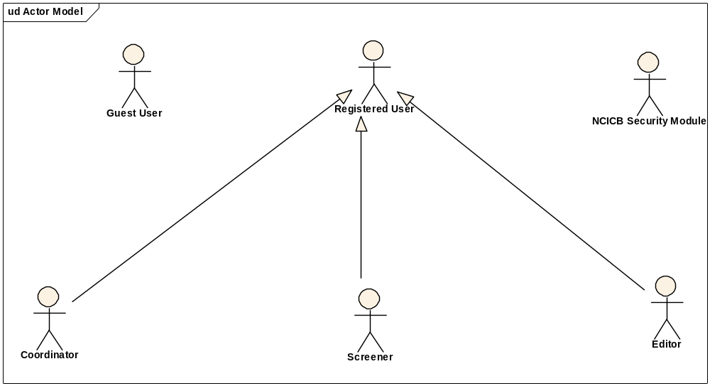
Guest User: Includes every user without an account. These users can query the database without restrictions, but they cannot submit models or comment on models.
Registered User: Can submit models to the database and can comment on models submitted by other researchers.
Super User (not shown): Has access to all model entries to update them. This is to facilitate minor text corrections in an entry without having to bother the submitter.
Coordinator: The coordinator is a registered user who appoints screener and editors. The coordinator also grants access privileges and manages the review process. After a model has been entered the coordinator assigns a screener who will check that all required fields have been specified and that the model does not contain junk or grossly inappropriate material. The coordinator will be informed about the decision of the screener by email. If the screener accepted the model the coordinator then assigns the model to an editor, who is a content expert.
Screener: The Screener is a registered user who performs the initial review of submitted models. This review is a quick check that all required fields have been specified and that the model does not contain junk or grossly inappropriate material. The screener also makes a preliminary assessment for clarity, typographic errors and other issues that would make the model less than fully comprehensible. The screening process should be complete within 24 hours. The screener does not contact the submitter about the submission. Any deficiencies found are described in the email to the coordinator. Each email deals with only one submission, so that the emails can be independently routed for vetting.
Editor: The Editor is a registered user who examines a model to see if it satisfies criteria to be made available to the public. The editor also considers any comments, made by the screener, that are passed along in the email from the coordinator. The editor may determine that the model cannot be made acceptable for publication in the database because it requires additional data. If the model has correctable defects, it may be necessary to communicate by email with the submitter to make the model acceptable. Correspondence and telephone contact with the submitters may be conducted through the coordinator. Editors are responsible for maintaining a paper trail or log of email exchanges regarding the models they review. The editor may elect to review a model without assistance. He or she can also request assistance from other subject matter experts. Only the editor has the authority to release the model to the intended audience.

Use Cases

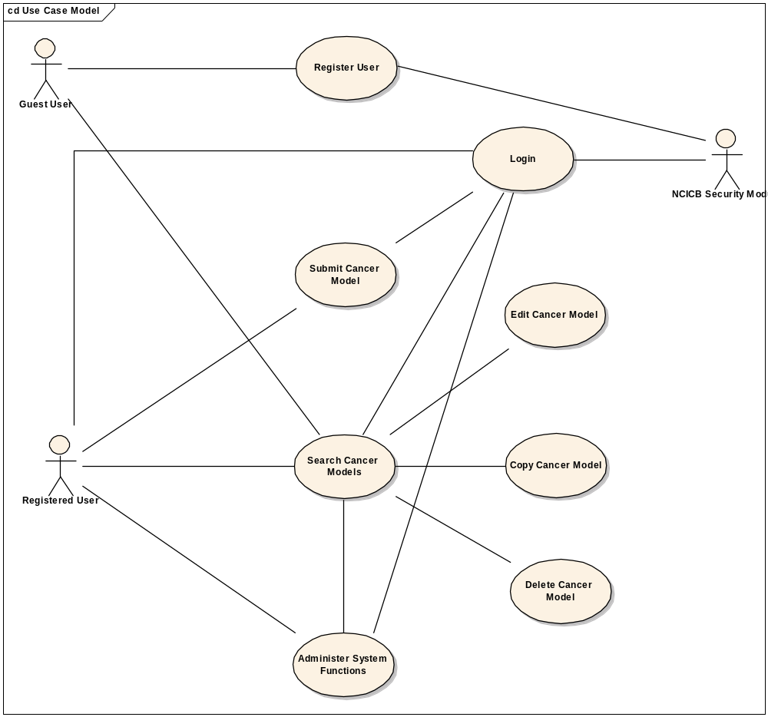
Figure 1. caMOD Use Case Diagram

Submitting Micro array data that are stored in other applications than caArray

Use Case Model

Use Case Name | Submitting Micro array data that are stored in other applications than caArray
Use Case ID | 3
Primary Actor | All users for search section, registered users for submission section
Brief Description | Allow the submitter a choice to enter the data directly, provide a brief description and a link to data stored in other places like university servers, lab servers or NCBI.
Trigger | Actor navigates to the caMOD URL
Pre-conditions | Successful navigation to the caMOD URL and successful login for submission section
Flow of Events | 1. To submit an animal model, the user
Flow of Events | - Navigates to the new model submission section  - Successfully enters the data to create an animal model
Flow of Events | 8. The system
Flow of Events | - Returns the data-type categories for submitting data
Flow of Events | 9. The actor
Flow of Events | - Navigates to the Microarrays section  - Selects “Enter Microarray Data”  - Inputs a URL as the value in “External URL” field  - Inputs a brief description of the data in “Description” field
Flow of Events | 10. The system
Flow of Events | - Saves the data for the submitted model
Post Conditions | Success Condition (Submission): User creates new model and submits data for appropriate section.  Error Condition: Fails to create new model  Error Condition: Validation fails  Error Condition: System Error
Alternative Courses of Action | If a validation error occurs, the system throws an exception, displays an error message and re-displays page for data entry.  a. Fails to create new model  -Re Submit new model data (Return to step 2a)  -Contact system administrator  b. System Error.  -Contact system administrator
Issues

Supplemental Requirements
None

Release date selection not maintaining value

Use Case Model

Use Case Name | Release date selection not maintaining value
Use Case ID | 11
Primary Actor | All users for search section, registered users for submission section
Brief Description | When creating a model the default choice is "release immediately". When the user returns to the page the selection has automatically jumped to "release after" and today's date has been entered.  In order for a model to be displayed on the search side the model needs to be in the "edited-approved" state and the release date has to be passed. Since the radiobutton on the model char submission page jumps to "release after" models are not immediately displayed.
Trigger | Actor navigates to the caMOD URL
Pre-conditions | Successful navigation to the caMOD URL and successful login for submission section
Flow of Events | 1. The system presents both search and submit models hyperlinks.
Flow of Events | 2. To submit an animal model, the user
Flow of Events | - Navigates to the new model submission section  - Successfully enters the data to create an animal model  3. The System  - Creates the model and sets the appropriate release date
Flow of Events | 4. To search a model, the actor  - Navigates to the search models section  - Enters selection criteria and submits search form  5. The system  - Returns models matching any selection criteria entered by the user
Post Conditions | Success Condition (Submission): User creates new model and submits data for appropriate section.  Error Condition: Fails to create new model  Error Condition: Validation fails  Error Condition: System Error
Alternative Courses of Action | If a validation error occurs, the system throws an exception, displays an error message and re-displays page for data entry.  a. Fails to create new model  -Re Submit new model data (Return to step 2a)  -Contact system administrator  b. System Error.  -Contact system administrator
Issues

Supplemental Requirements
None

Add link to PDF users guide to quick links menu

Use Case Model

Use Case Name | Add link to PDF users guide to quick links menu
Use Case ID | 12
Primary Actor | Add link to pdf users guide to quick links menu
Brief Description | The application provides the ability to customize the search fields returned for each Add a link to the sidebar
Trigger | Actor navigates to the caMOD URL
Pre-conditions | Successful navigation to the caMOD URL
Flow of Events | 1. The actor
Flow of Events | - Clicks the link on sidebar
Post Conditions | Success Condition (Customized Search): System loads the pdf file.  Error Condition: Link does not exist  Error Condition: System Error
Alternative Courses of Action | If a validation error occurs, the system throws an exception, displays an error message and re-displays page for data entry.  a. System Error.  -Contact system administrator
Issues

Supplemental Requirements
None

Use improved PubMed fetch script on publication submission page

Use Case Model

Use Case Name | Use improved PubMed fetch script on publication submission page
Use Case ID | 5
Primary Actor | All users for search section, registered users for submission section
Brief Description | Improve the fetch script on publication submission page to fix various bugs.
Trigger | Actor navigates to the caMOD URL
Pre-conditions | Successful navigation to the caMOD URL and successful login for submission section
Flow of Events | 1. To submit an animal model, the user
Flow of Events | - Navigates to the new model submission section  - Successfully enters the data to create an animal model
Flow of Events | 2. The system
Flow of Events | - Returns the data-type categories for submitting data
Flow of Events | 3. The actor
Flow of Events | - Navigates to the Publications section  - Selects “Enter Publication”  - Inputs data relating to a publication
Flow of Events | 4. The system
Flow of Events | - Saves the data for the submitted model
Post Conditions | Success Condition (Submission): User creates new model and submits data for appropriate section.  Error Condition: Fails to create new model  Error Condition: Validation fails  Error Condition: System Error
Alternative Courses of Action | If a validation error occurs, the system throws an exception, displays an error message and re-displays page for data entry.  a. Fails to create new model  -Re Submit new model data (Return to step 2a)  -Contact system administrator  b. System Error.  -Contact system administrator
Issues

Supplemental Requirements
None

Customize publication pages for rat to allow submission and display of RGD references

Use Case Model

Use Case Name | Customize publication pages for rat to allow submission and display of RGD references
Use Case ID | 10
Primary Actor | All users for search section, registered users for submission section
Brief Description
Trigger | Actor navigates to the caMOD URL
Pre-conditions | Successful navigation to the caMOD URL and successful login for submission section
Flow of Events | 1. The system presents both search and submit models hyperlinks.
Flow of Events | 2. To search a model, the actor
Flow of Events | - Navigates to the search models section
Flow of Events | 3. To submit an animal model, the user
Flow of Events | - Navigates to the new model submission section  - Successfully enters the data to create an animal model
Post Conditions | Success Condition (Search): System returns models matching selection criteria.  Error Condition: No models found  Error Condition: Validation fails  Error Condition: System Error
Alternative Courses of Action

Issues

Supplemental Requirements
None

Add search for PMID to advanced search page

Use Case Model

Use Case Name | Add search for PMID to advanced search page
Use Case ID | 8
Primary Actor | All users for search section, registered users for submission section
Brief Description | Want to add PMID to advanced search page
Trigger | Actor navigates to the caMOD URL
Pre-conditions | Successful navigation to the caMOD URL and successful login for submission section
Flow of Events | 1. The system presents both search and submit models hyperlinks.
Flow of Events | 2. To search a model, the actor
Flow of Events | - Navigates to the search models section
Flow of Events | 3. The system
Flow of Events | - Returns the search criteria screen
Flow of Events | 4. The actor
Flow of Events | - Navigates to the advanced search section  - Enters selection criteria and submits search form, including PMID
Flow of Events | 5. The system
Flow of Events | - Returns models matching any selection criteria entered by the user
Post Conditions | Success Condition (Search): System returns models matching selection criteria.  Error Condition: No models found  Error Condition: Validation fails  Error Condition: System Error
Alternative Courses of Action | If a validation error occurs, the system throws an exception, displays an error message and re-displays page for data entry.  a. No Models Found  -Re Submit modified search criteria (Return to step 4a)  b. Fails to create new model  -Re Submit new model data (Return to step 2a)  -Contact system administrator  c. System Error.  -Contact system administrator
Issues

Supplemental Requirements
None

Fix - Save query function does not save

Use Case Model

Use Case Name | Fix - Save query function does not save
Use Case ID | 9
Primary Actor | All users for search section, registered users for submission section
Brief Description | Save query functionality is not functioning. The saved queries page isn’t saving any searches.
Trigger | Actor navigates to the caMOD URL
Pre-conditions | Successful navigation to the caMOD URL and successful login for submission section
Flow of Events | 1. The system presents both search and submit models hyperlinks.
Flow of Events | 2. To search a model, the actor
Flow of Events | - Navigates to the search models section
Flow of Events | 3. The system
Flow of Events | - Returns the search criteria screen
Flow of Events | 4. The actor
Flow of Events | - Enters selection criteria and submits search form  - Enters a name for “My Saved Query”  - Clicks the Save Query button  5. The system  - Saves the query
Success Condition (Search): System returns models matching selection criteria.
Error Condition: No models found
Error Condition: Validation fails
Error Condition: System Error
Success Condition (Submission): User saves the query.
Error Condition: Fails to save query
Error Condition: Validation fails
Error Condition: System Error
Alternative Courses of Action | If a validation error occurs, the system throws an exception, displays an error message and re-displays page for data entry.  a. No Models Found  -Re Submit modified search criteria (Return to step 4a)  b. Fails to save query  -Re Submit save query (Return to step 4c)  -Contact system administrator  c. System Error.  -Contact system administrator
Issues

Supplemental Requirements
None

Give fields in “Customize Results” feature meaningful names

Use Case Model

Use Case Name | Give fields in “Customize Results” feature meaningful names
Use Case ID | 13
Primary Actor | All users for search section
Brief Description | Current available columns in customize search results need to be clearer
Trigger | Actor navigates to the caMOD URL
Pre-conditions | Successful navigation to the caMOD URL and successful login for submission section
 | 1. To customize search results, the actor
 | - Navigates to the customize results
 | 3. The system
 | - Returns the customize results search screen
Post Conditions | Success Condition (Search): System returns the customize results page  Error Condition: System Error
Alternative Courses of Action | If a validation error occurs, the system throws an exception, displays an error message and re-displays page for data entry.  b. System Error.  -Contact system administrator
Issues

Supplemental Requirements
None

Change spelling of Equus Caballus - start Caballus with a lower case "c"

Use Case Model

Use Case Name | Change spelling of Equus Caballus – start Caballus with a lower case “c”
Use Case ID | 15
Primary Actor | All registered users for submission section
Brief Description | The application provides users with drop down selections for species on the submission and search sections of the GUI. The spelling of Equus Caballus will be modified. Only the submission section displays the horse species as an option currently.
Trigger | Actor navigates to the caMOD URL
Pre-conditions | Successful navigation to the caMOD URL
 | 1. To submit an animal model, the user
- Navigates to the new model submission section
- Successfully enters the data to create an animal model with species data equal to Horse
 | 2. The system
 | - Saves the data for the submitted model
 | - Returns the data-type categories for submitting data
Post Conditions | Success Condition (Submission): User creates new model and submits data for appropriate section.  Error Condition: Fails to create new model  Error Condition: Validation fails  Error Condition: System Error
Alternative Courses of Action | If a validation error occurs, the system throws an exception, displays an error message and re-displays page for data entry.  a. Fails to create new model  -Re Submit new model data (Return to step 2a)  -Contact system administrator  b. System Error.  -Contact system administrator
Issues

Supplemental Requirements
None

Delete Sequence ID field from genetic description search page, targeted modification table

Use Case Model

Use Case Name | Delete Sequnce ID field from genetic description search page, targeted modification table
Use Case ID | 16
Primary Actor | All users for search section
Brief Description | The sequence id field was supposed to be populated by caBIO. The data was not made available at the time of implementation. Remove the empty row label heading so it does not display on the GUI.
Trigger | Actor navigates to the caMOD URL
Pre-conditions | Successful navigation to the caMOD URL
 | 1. To search a model, the actor
 | - Navigates to the advanced search models section
 | 3. The system
 | - Returns the search criteria screen
 | 4. The actor
 | - Enters selection criteria for models with Genetic Description and submits search form
 | 5. The system
 | - Returns models matching any selection criteria entered by the user
 | 6. The actor
 | - Navigates to the Genetic Description screen and is presented with the available data excluding the empty section for sequence id.
Post Conditions | Success Condition (Search): System returns models matching selection criteria.  Error Condition: No models found  Error Condition: Validation fails  Error Condition: System Error
Alternative Courses of Action | If a validation error occurs, the system throws an exception, displays an error message and re-displays page for data entry.  a. No Models Found  -Re Submit modified search criteria (Return to step 4a)  b. System Error.  -Contact system administrator
Issues

Supplemental Requirements
None

Induced mutation entries need to be flagged

Use Case Model

Use Case Name | Induced mutation entries need to be flagged and searches for induced mutation and carcinogenic interventions need to be fixed
Use Case ID | 17
Primary Actor | All users for search section
Brief Description | The application allows users to search for models with carcinogenic intervention data. This query pulls data from the Environmental Factors table. The Carcinogenic Intervention screens input data into the Environmental Factor type and type_altern_entry and the name and name_altern_entry fields in the database. The Induce Mutation data is stored in the Environmental Factor type (chemical / Drug and Radiation) and Environmental Factor name or name_altern_entry fields. The MTB data is also stored in the type_altern_entry and name_altern_entry fields. As a result of these insertions the induced mutation data to show up in query for Carcinogenic Interventions. The Induced Mutation data and Carcinogenic Intervention (including MTB) data is not distinguishable from each other when dealing with Chemical / Drug or Radiation agent types.  Add a flag to the Environmental Factor table to distinguish between data submitted form the Carcinogenic Intervention and Induced Mutation screens. Fix the code so each section populates this flag and the search criteria for Carcinogenic Intervention separates the data by this flag.
Trigger | Actor navigates to the caMOD URL
Pre-conditions | Successful navigation to the caMOD URL
 | 1. To search a model, the actor
 | - Navigates to the search models section
 | 3. The system
 | - Returns the search criteria screen
 | 4. The actor
 | - Enters selection criteria for Carcinogenic Intervention data and submits search form
 | 5. The system
 | - Returns models matching any selection criteria entered by the user
 | 6. The actor
 | - Navigates to the Genetic Description screen and is presented with the available data excluding the section for sequence id that did not include data.
Post Conditions | Success Condition (Search): System returns models matching selection criteria.  Error Condition: No models found  Error Condition: Validation fails  Error Condition: System Error
Alternative Courses of Action | If a validation error occurs, the system throws an exception, displays an error message and re-displays page for data entry.  a. No Models Found  -Re Submit modified search criteria (Return to step 4a)  b. System Error.  -Contact system administrator
Issues

Supplemental Requirements
None

Add URLALTERNENTRY to image object

Use Case Model

Use Case Name | Add URLALTERNENTRY to image object
Use Case ID | 14
Primary Actor | All users for search section
Brief Description | Allow for linking of external images not to be saved to caImage. Create a new database field called URL_Altern_Entry
Trigger | Adds a new Image to an existing model
Pre-conditions | Successful login for submission section
 | 1. To submit an animal model, the user
- Navigates to the new model submission section
- Successfully enters the data to create an animal model
 | 2. The system
 | - Saves the data for the submitted model
 | 3. The actor
- Navigates to the Images data for the newly submitted model from the left menu bar
- Adds a new Image with an external URL
 | 4. The system
 | - Saves the current data for the submitted model
Post Conditions | Success Condition (Submission): User creates new model and submits data for appropriate section.  Error Condition: Fails to create new model  Error Condition: Validation fails  Error Condition: System Error
Alternative Courses of Action | If a validation error occurs, the system throws an exception, displays an error message and re-displays page for data entry.  b. Fails to create new model  -Re Submit new model data (Return to step 2a)  -Contact system administrator  c. System Error.  -Contact system administrator
Issues

Supplemental Requirements
None

Rename OtherLocationURL in microarray object to url

Use Case Model

Use Case Name | Rename OtherLocationURL in microarray object to url
Use Case ID | 18
Primary Actor | All users for search section
Brief Description | The application provides an advanced search to allow users to search for animal models with micro array data.
Trigger | Actor navigates to the caMOD URL
Pre-conditions | Successful navigation to the caMOD URL
 | 1. To search a model, the actor
 | - Navigates to the search models section
 | 3. The system
 | - Returns the search criteria screen
 | 4. The actor
 | - Enters selection criteria including micro array data and submits search form
 | 5. The system
 | - Returns models matching any selection criteria entered by the user
 | 6. The actor
 | - Navigates to the Microarrays section and is presented with the data for the associated micro array stored a location indicated in the URL field.
Post Conditions | Success Condition (Search): System returns models matching selection criteria.  Error Condition: No models found  Error Condition: Validation fails  Error Condition: System Error
Alternative Courses of Action | If a validation error occurs, the system throws an exception, displays an error message and re-displays page for data entry.  a. No Models Found  -Re Submit modified search criteria (Return to step 4a)  b. System Error.  -Contact system administrator
Issues

Supplemental Requirements
None

General Requirements

Requirements Prioritization
Req # | Requirement Description
5097 | Submitting microarray data that are stored in other applications than caArray
12216 | Release date selection not maintaining value
7028 | Add link to pdf users guide to Quick Links menu
5249 | Fix searches - allow oracle result set > 1000
11013 | Use improved PubMed fetch script on publication submission page
9127 | Customize publication pages for rat to allow submission & display of RGD references
11007 | Add search for PMID to advanced search page
12064 | Title field on publication submission field has size limit OR PubMed fetch script does not retrieve complete publication title
12042 | Fix - Save query does not save
7474 | Give fields in "Customize Search" feature meaningful names
5204 | Left side search menu disappears when user customizes search
6812 | Change spelling of Equus Caballus - start Caballus with a lower case "c"
12824 | Delete Sequence ID field from genetic description search page, targeted modification table
12825 | Induced mutation entries need to be flagged and searches for induced mutation and carcinogenic interventions need to be fixed
13897 | Add urlAlternEntry to image object
13898 | Rename OtherLocationURL in microarray object to url
 | Additional bugs added to build (not detailed)
5173 | Publication issues - various bugs
5205 | Cannot delete/enter radiation for old model - page does not
11013 | Use improved PubMed fetch script on publication submission page
5249 | Fix searches - allow oracle result set > 1000
12064 | Title field on publication submission field has size limit OR PubMed fetch script does not retrieve complete publication title
5204 | Left side search menu disappears when user customizes search

Data Definitions

CDE # | Data Element | Description | Use Case Name

Sign Off

Approval

Workspace General Contractor Rep Print Name Date
Architecture Workspace Rep Print Name Date
VCDE Workspace Rep Print Name Date
Workspace Working Group Rep Print Name Date
NCICB Rep Print Name Date

