Software Requirements Specification

caMOD 2.2 Iteration 2
NCICB

DOCUMENT REVISION HISTORY
Version Number | Date | Description
1.0 | July 11, 2006 | - Initial Draft
1.1
1.2

Background/Summary
The cancer models database (caMOD) is a web-based resource that provides information about animal models for human cancer to the public research community.

caMOD provides the following key capabilities to its users:

- Data Submission--Data in caMOD are extracted from the public scientific literature by curators and verified by the scientists who generated or worked with the models, or they are directly submitted by scientists.

- Cancer Model Search--Users can retrieve information about the making of models, their genetic descriptions, histopathology, derived cell lines, associated images, carcinogenic interventions, microarray data, and therapeutic trials in which the models were used. caMOD provides links to PubMed for associated publications and other resources such as mouse repositories, detailed information about altered gene, pathway affected, and information about human clinical trials that utilize the same compounds as the pre-clinical trials in the animal models.

- System Function Administration--The Admin function provides services for user registration, review of submitted models and database management.

Table of Content
Requirements Specification 1
caMOD 2.2 Iteration 2 1
Background/Summary 1
1 Introduction 3
1.1 Overview for searching for Jackson Lab’s Mouse Tumor Biology (MTB) data 3
1.2 Overview retrieving and displaying Mouse Genome Informatics (MGI) data 3
1.3 Related Documents 3
2 Actors and Authorization 4
3 Use Cases 6
3.1 Search for Mouse Tumor Biology data (MTB) 6
3.1.1 Use Case Model 6
3.1.2 Supplemental Requirements 7
3.2 Retrieving and displaying Mouse Genome Informatics (MGI) data 8
3.2.1 Use Case Model 8
3.2.2 Supplemental Requirements 9
4 General Requirements 9
4.1 Requirements Prioritization 9
5 Data Definitions 9
6 Sign Off 10
6.1 Approval 10

Introduction

Overview for searching for Jackson Lab’s Mouse Tumor Biology (MTB) data
The number of models provided to the user through caMOD will be expanded by integrating data from the Mouse Tumor Biology database generated at the Jackson Laboratory (http://tumor.informatics.jax.org). Importing the data will also allow to make these data available via caGrid in the future. The MTB data will be shown on the caMOD search detail pages for model characteristics, genetic description, publication and histopathology since there is a substantial overlap of data categories between MTB and caMOD.

Overview retrieving and displaying Mouse Genome Informatics (MGI) data
The pages of the genetic description part gather and display information about genetic alterations introduced or found in animal models. The search detail pages for the genetic description part will be expanded by using the Mouse Genome Informatics identifier (MGI number) to retrieve data from the Mouse Genome Informatics application provided by the Jackson Laboratory.

Related Documents

Document Name | Version | Location
caMODRequirementsDocument-02282005.doc | Fixed | CVS project in the C:\dev\workspace\camod_dev\docs\artifacts\requirements folder

Actors and Authorization

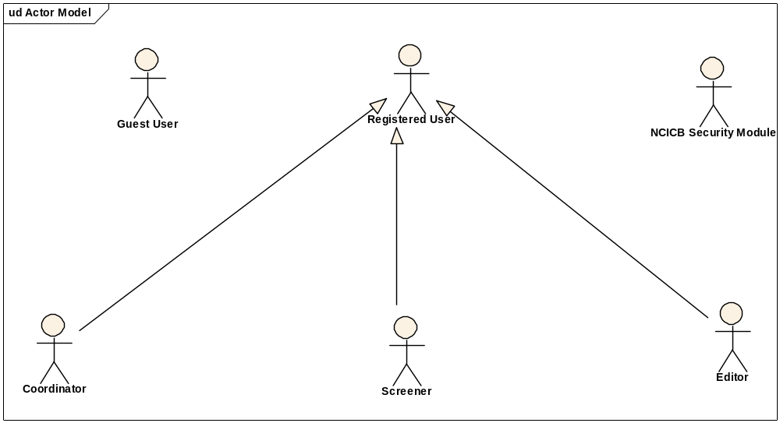
Guest User: Includes every user without an account. These users can query the database without restrictions, but they cannot submit models or comment on models.
Registered User: Can submit models to the database and can comment on models submitted by other researchers.
Super User (not shown): Has access to all model entries to update them. This is to facilitate minor text corrections in an entry without having to bother the submitter.
Coordinator: The coordinator is a registered user who appoints screener and editors. The coordinator also grants access privileges and manages the review process. After a model has been entered the coordinator assigns a screener who will check that all required fields have been specified and that the model does not contain junk or grossly inappropriate material. The coordinator will be informed about the decision of the screener by email. If the screener accepted the model the coordinator then assigns the model to an editor, who is a content expert.
Screener: The Screener is a registered user who performs the initial review of submitted models. This review is a quick check that all required fields have been specified and that the model does not contain junk or grossly inappropriate material. The screener also makes a preliminary assessment for clarity, typographic errors and other issues that would make the model less than fully comprehensible. The screening process should be complete within 24 hours. The screener does not contact the submitter about the submission. Any deficiencies found are described in the email to the coordinator. Each email deals with only one submission, so that the emails can be independently routed for vetting.
Editor: The Editor is a registered user who examines a model to see if it satisfies criteria to be made available to the public. The editor also considers any comments, made by the screener, that are passed along in the email from the coordinator. The editor may determine that the model cannot be made acceptable for publication in the database because it requires additional data. If the model has correctable defects, it may be necessary to communicate by email with the submitter to make the model acceptable. Correspondence and telephone contact with the submitters may be conducted through the coordinator. Editors are responsible for maintaining a paper trail or log of email exchanges regarding the models they review. The editor may elect to review a model without assistance. He or she can also request assistance from other subject matter experts. Only the editor has the authority to release the model to the intended audience.

Use Cases
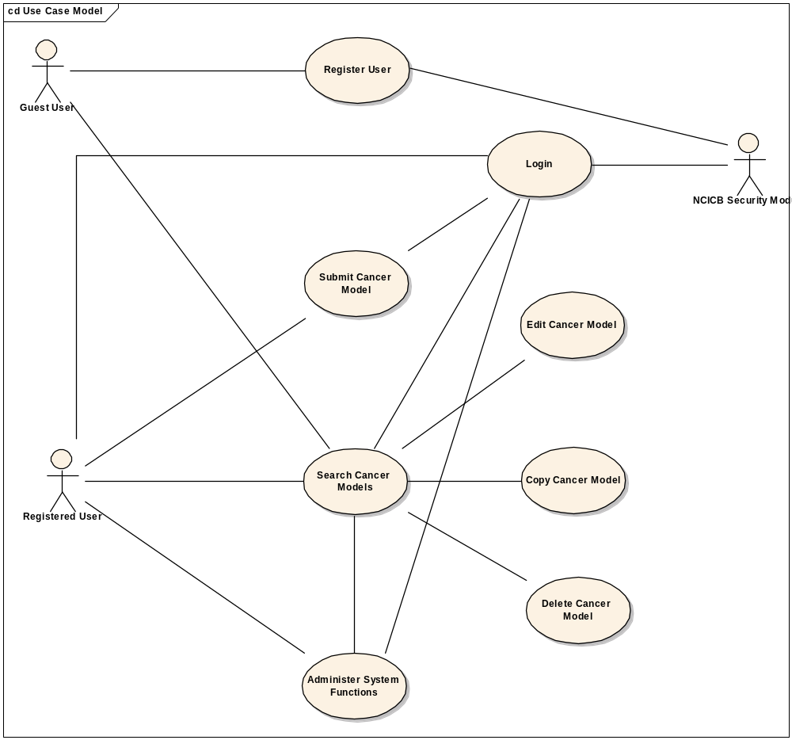
Figure 1. caMOD Use Case Diagram

Search for Mouse Tumor Biology Data (MTB)

Use Case Model

Use Case Name | Search for Mouse Tumor Biology Data (MTB)
Use Case ID | 1
Primary Actor | All users
Brief Description | Users can query caMOD for data provide by the Mouse Tumor Biology (MTB) database using either the simple or advanced search pages. Data will be shown on the model characteristics, genetic description, publication and histopathology search detail pages.
Trigger | Actor navigates to the caMOD URL
Pre-conditions | Successful navigation to the caMOD URL
Flow of Events | 1. The system presents search and submit models hyperlinks.
Flow of Events | 2. The actor
Flow of Events | a. Navigates to the search models section
Flow of Events | 3. The system
Flow of Events | - Returns the search criteria screen
Flow of Events | 4. The actor
Flow of Events | a. Enters selection criteria and submits search form
Flow of Events | 5. The system
Flow of Events | a. Returns models matching any selection criteria entered by the user. MTB models are specifically marked.
Post Conditions | Success Condition: System returns models matching selection criteria. MTB data are displayed on the model characteristics, genetic description, publication and histopathology search detail pages.  Error Condition: No models found  Error Condition: Validation fails  Error Condition: System Error
Alternative Courses of Action | If a validation error occurs, the system throws an exception, displays an error message and re-displays page for data entry.  a. No Models Found  -Re Submit modified search criteria (Return to step 4a)  b. System Error.  -Contact system administrator
Issues

Supplemental Requirements
- New attributes need to be added to the object model to accommodate all MTB fields
- Data needs to be mapped to existing caMOD vocabularies
- Vocabulary items that cannot be mapped to existing caMOD vocabularies need to be accommodated e.g. organs that are not found in the EVS mouse tissue vocabulary

Retrieving and Displaying Mouse Genome Informatics (MGI) Data

Use Case Model

Use Case Name | Retrieving and Displaying Mouse Genome Informatics (MGI) Data
Use Case ID | 2
Primary Actor | All users
Brief Description | Genetic description search result detail pages describe genetic modifications found or introduced in animal models. Submitted information will be supplemented by MGI information
Trigger | Actor navigates to the caMod URL
Pre-conditions | Successful navigation to the caMod URL
Flow of Events | 1. The system presents search and submit models hyperlinks.
Flow of Events | 2. The actor
Flow of Events | a. Navigates to the search models section
Flow of Events | 3. The system
Flow of Events | - Returns the search criteria screen
Flow of Events | 4. The actor
Flow of Events | a. Enters selection criteria and submits search form
Flow of Events | 5. The system
Flow of Events | a. Returns models matching any selection criteria entered by the user
Flow of Events | 6. The actor
Flow of Events | a. navigates to genetic description pages
Flow of Events | 7. The system
Flow of Events | a. returns MGI data in addition to data entered by the user
Post Conditions | Success Condition: System returns MGI data on genetic description pages.  Error Condition: No models found  Error Condition: Validation fails  Error Condition: MGI number missing  Error Condition: System Error
Alternative Courses of Action | If a validation error occurs, the system throws an exception, displays an error message and re-displays page for data entry.  a. No Models Found  -Re Submit modified search criteria (Return to step 4a)  b. MGI number missing.  - record is shown without additional MGI data  c. System Error.  -Contact system administrator
Issues

Supplemental Requirements

MGI numbers need to be submitted for existing records

General Requirements

Requirements Prioritization

Req # | Supp Req Ref # | Use Case Name | Priority
416 |  | Search for Mouse Tumor Biology data (MTB) | High
322 |  | Retrieving and displaying Mouse Genome Informatics (MGI) data | High

Data Definitions

CDE # | Data Element | Description | Use Case Name

Sign Off

Approval

Workspace General Contractor Rep Print Name Date
Architecture Workspace Rep Print Name Date
VCDE Workspace Rep Print Name Date
Workspace Working Group Rep Print Name Date
NCICB Rep Print Name Date

