caMOD Release 2.2 Iteration 2 - MTB

Software Design Description

Version 1.0

[Insert approval date of document]

Document Change Record
Version Number | Date | Description
1.0 | October 11, 2006 | Initial document to upload to cvs

TABLE OF CONTENTS
caMOD Release 2.2 Iteration 2 i
1. Introduction 5
1.1 Requirements Traceability 5
1.2 Background/Summary 5
2. System Overview 7
2.1.1 User Client Software 8
2.1.2 Back End 8
2.1.3 Hibernate 3 Data Access 8
2.1.4 JBoss Application Server 8
2.1.5 Database 8
2.1.6 Java 8
3. IMPORTING MOUSE TUMOR BIOLOGY DATASET 9
3.1 user interface (VIEW) 9
3.2 Interface Classes to be Modified 9
3.3 middle tier (CONTROLLER) 9
3.3.1 SearchForm 9
3.3.2 QueryManagerImpl 9
3.3.3 SavedQueryManagerImpl 10
3.3.4 AdvancedSearchPopulateAction 10
3.4 persistence layer 10
3.4.1 AnimalModel 10
3.5 database (MODEL) 11
3.5.1 AnimalModel 11
3.6 configuration and utility classes 11
3.6.1 Configuration and Utility Files Changed 11
4. Incorporating MGI data in genetic description search pages 13
4.1 user interface (VIEW) 13
4.1.1 Targeted modification Search page 13
4.1.2 Transgene Search Page 14
4.1.3 spontaneous mutation search page 15
15
4.1.4 induced mutation search page 16
4.1.5 Interface Classes to be Modified 16
4.2 middle tier (CONTROLLER) 17
4.2.1 TransientInterferenceManagerImpl 17
4.2.2 TransInterferenceMethodManagerImpl 18
4.2.3 TransInterferenceMethodManager 18
4.2.4 TransientInterferenceManagerSingleton 18
4.2.5 TransIntMethodManagerSingleton 18
4.2.6 AnimalModelManagerImpl 18
4.2.7 AnimalModelManager 19
4.2.8 QueryManagerImpl 19
4.2.9 TransientInterferenceAction 19
4.2.10 MorpholinoPopulateAction 19
4.2.11 SirnaPopulateAction 20
4.2.12 AnimalModelTreePopulateAction 20
4.2.13 TransientInterferenceForm 20
4.3 persistence layer 21
4.3.1 TransientInterference 21
4.3.2 TransientInterferenceMethod 21
4.3.3 AnimalModel 21
4.4 database (MODEL) 21
4.4.1 TransientInterference 21
4.4.2 TransientInterferenceMethod 22
4.4.3 AnimalModel 22
4.5 configuration and utility classes 22
4.5.1 Configuration and Utility Files Changed 22
Appendix A – acronym List 24
[APPENDIX B – STEPS to import MTB data in camod] 25

Introduction
The purpose of this document is to describe the design for the various enhancements that are being developed for caMOD release 2.2 iteration 2. These enhancements include: importing and displaying the Mouse Tumor Biology (MTB) dataset provided by the Jackson Laboratory, Bar Harbor, Maine, and extending the genetic description search detail pages with allele-specific data retrieved from the Mouse Genome Informatics (MGI) resources at the Jackson Laboratory. This document identifies and defines the design for these user requests for the caMOD application.

Requirements Traceability
Req # | Requirement Description
322 | Provide additional data from MGI
416 | Integration with Jax Mouse Tumor Biology data
440 | Link to Jackson lab in availability search page needs to be updated
442 | experiment field on the experimental therapeutics page not interpreting html code correctly
443 | comment field in the metastasis table on the histopath search page not interpreting html code correctly

Background/Summary
The cancer models database (caMOD) is a web-based resource that provides information about animal models for human cancer to the public research community.
caMOD provides the following key capabilities to its users:

- Data Submission--Data in caMOD are extracted from the public scientific literature by curators and verified by the scientists who generated or worked with the models, or they are directly submitted by scientists.

- Cancer Model Search--Users can retrieve information about the making of models, their genetic descriptions, histopathology, derived cell lines, associated images, carcinogenic interventions, microarray data, and therapeutic trials in which the models were used. caMOD provides links to PubMed for associated publications and other resources such as mouse repositories, detailed information about altered gene, pathway affected, and information about human clinical trials that utilize the same compounds as the pre-clinical trials in the animal models.

- System Function Administration--The Admin function provides services for user registration, review of submitted models and database management.

caMOD 2.2 alterations will greatly increase the amount and value of information provided to caMOD users. Importing the MTB dataset will increase the number of model entries by about 4,000. Adding the MGI data to the genetic description search pages will supplement the information entered by the scientists or retrieved from literature by NCICB curators.

System Overview
The purpose of this section is to give an overview of the caMOD API. The following diagrams show the overall architecture and of the caMOD application.
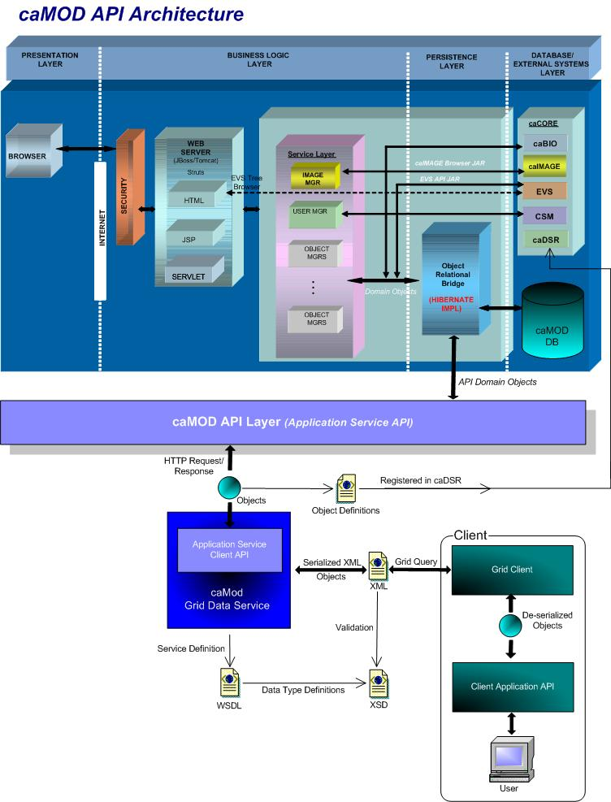

User Client Software
caMOD is a web based user interface implemented as HTML, JSP, JavaScript, and AJAX. The use of JavaScript is limited to improving usability only.
Java Server Pages (JSPs) are used to generate dynamic HTML based on user actions. JSPs are combinations of HTML, Java Code, and custom JSP and JSTL tags that get compiled into servlet classes.

Back End
The caMOD back end components provide access to persistence services for retrieving and storing data in the database. Hibernate, an open source tool, is used as the Object Relational Mapping (ORM) software.

Hibernate 3 Data Access
The caMOD uses Hibernate version 3. Hibernate is used for read, write access. It provides the insert, update and delete capability to the caMOD application thru the domain classes.

JBoss Application Server
The user interface, middle tier, and backend components are run with in JBoss Java2 Enterprise Edition (J2EE) application server. JBoss is an open source application server that provides a servlet container, an EJB container, the full range of J2EE 1.4 features as well as extended enterprise services including clustering, caching and persistence. JBoss 4.0.2 conforms to the latest technology stack. It will be consistent with most other applications.

Database
Oracle Relation Database Management System (RDBMS) software is used as the persistent store for caMOD and caIMAGE application data. Java classes access the database using the Java Database Connectivity (JDBC) API.

Java
The new version of Java1.5 (Java tool kit version jdk1.5.0_04) is used for compilation. Therefore all the code in caMOD has been compiled using the JDK 1.5 version. This will conform to the latest technology stack currently used by NCI.

IMPORTING MOUSE TUMOR BIOLOGY DATASET

user interface (VIEW)
The data imported from the Mouse Tumor Biology Database will be displayed in the existing search pages for model characteristics, carcinogenic interventions, histopathology, and publications.

Interface Classes to be Modified
The following is a list of interface classes (JSP and interface java classes) that need to be modified.
Interface Class Name | Description
searchAdvanced.jsp | Advanced search query submission screen – Add check-box and drop-down box for new queries.
SearchData.java | Interface class for SearchForm.java class – Add variables to hold the new tool mouse (searchToolStrain ) and external source (externalSource) attributes for the advanced search screen

middle tier (CONTROLLER)
    - SearchForm
SearchForm.java is an existing struts Form class that is able to transfer data between the Model and View layers. Struts ActionForm beans are controller components. The attributes defined will remain the same with the exception for two additions.
Method Name | Description
externalSource | Add attribute to hold the value for the external_source attribute in the abs_cancer_model table. Add getter and setter methods for new attribute.
searchToolStrain | Add variable to support the new query for models with tool strains. Add getter and setter methods for new attribute.
    - QueryManagerImpl
QueryManagerImpl.java is an existing class that defines each query used in all sections of the caMOD application. One new method needs to be added for the search for tool strains.
Method Name | Description
getModelIdsForToolStrain | Add new method to retrieves models indicated as tool strains from the abs_cancer_model table.
getModelIdsForTransientInterference | Modify query to retrieve data from the TransientInterference table instead of the Morpholino table (name change).

The new sql will be defined as:
String theSQLString = "SELECT distinct abs_cancer_model_id FROM abs_cancer_model " + "WHERE is_tool_mouse = 1 " + " AND state = 'Edited-approved' ";
    - SavedQueryManagerImpl
SavedQueryManagerImpl.java is an existing class that defines each saved query attribute name used to save user queries and display on the search criteria section of the saved query list screen.
Method Name | Description
buildSearchData | Add definition isSearchToolStrain and ExternalSource to define saved query attributes for new queries.
Set buildCriteriaList | Add isSearchToolStrain and ExternalSource to the list of criteria used to display user selections on the search results screen.
    - AdvancedSearchPopulateAction
AdvancedSearchPopulateAction.java is an existing struts Action class that manages requests by the application to populate the advanced search screen. The dropdown method of this class was modified in order to populate the drop-down menu used to search for models from external sources query.

persistence layer
    - AnimalModel
AnimalModel.hbm.xml is an existing hibernate mapping file used to provide Hibernate with information to persist objects to the caMOD database. The mapping file will remain the same except for two additions.
Attribute Name | Description
externalSource | Mapping for the externalSource attribute for the object
externalSourceIdentifier | Mapping for the externalSourceIdentifier attribute for the object

database (MODEL)
    - AnimalModel
AnimalModel.java is an existing domain object used to hold data for AnimalModel objects. The domain object will remain the same except for two additions.
Attribute Name | Description
externalSource | Name of data source from which data were imported
externalSourceIdentifier | Identifier for data record from external source

configuration and utility classes
    - Configuration and Utility Files Changed
File Name | Function
CriteriaTableUtil.java | Creates a HTML table with all criteria formatted within. Add definition for isSearchToolStrain and getExternalSource
ApplicationResources_en.properties | Properties file to hold the global messages for validation, errors, and global variable definitions for attributes used for queries. Add definition for Criteria.ExternalSource and Criteria.isSearchToolStrain values.
Constants. java | Configuration files to hold global constants for the application. Add EXTERNALSOURCEQUERYDROP constant to hold the drop-down options for models from external sources.
NewDropdownUtil.java | Add getExternalSourceList method to return externalSource values from AnimalModel object.
insert into abs_cancer_model (abs_cancer_model_id, abs_cancer_model_type, external_source)
values (hibernate_sequence.NEXTVAL, 'AM', 'JAX MTB');

select * from abs_cancer_model
where external_source IS NOT NULL;
Tested with abs_cancer_model_id = 10008490

Incorporating MGI data in genetic description search pages

user interface (VIEW)

Targeted modification Search page
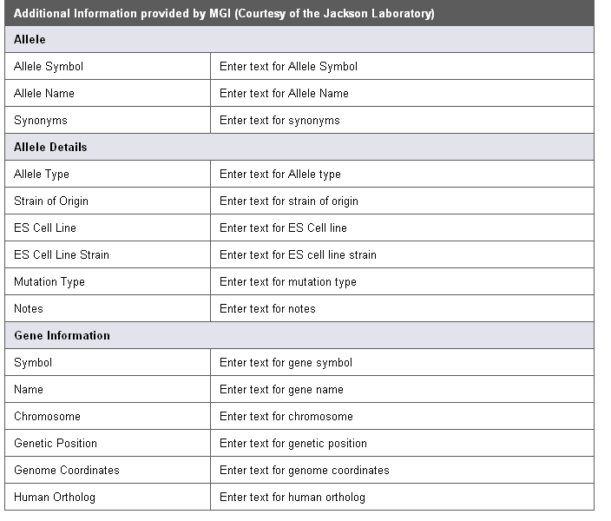
If the existing record contains a MGI identifier entry the application will retrieve data for this particular allele from MGI and display them as shown above.

Transgene Search Page
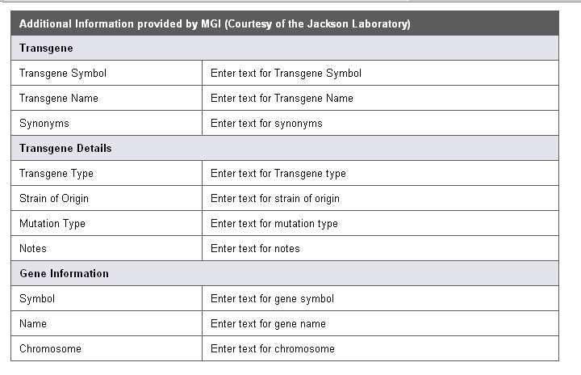
If the existing record contains a MGI identifier entry the application will retrieve data for this particular allele from MGI and display them as shown above.

spontaneous mutation search page

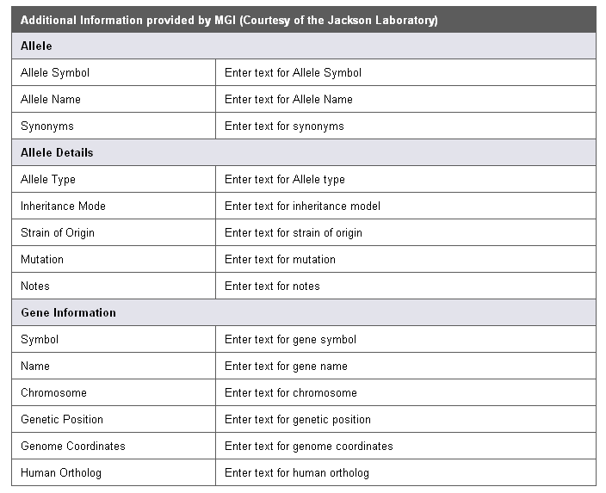
If the existing record contains a MGI identifier entry the application will retrieve data for this particular allele from MGI and display them as shown above.

induced mutation search page
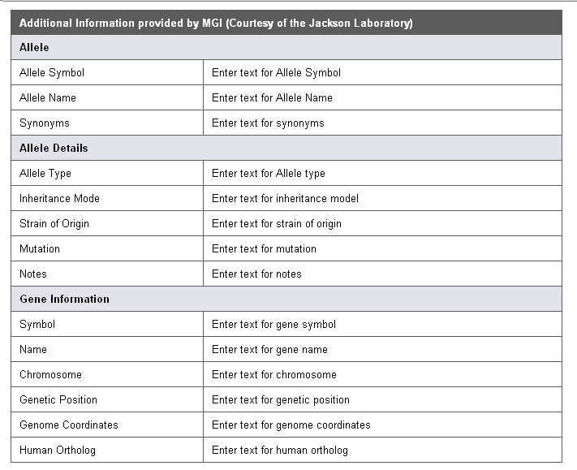
If the existing record contains a MGI identifier entry the application will retrieve data for this particular allele from MGI and display them as shown above.

Interface Classes to be Modified
The following is a list of interface classes (GUI and interface java classes) that need to be modified.
Interface Class Name | Description
subSubmitMenu.jsp | Left menu bar – add link to enter siRNA models
submitSirna.jsp | siRNA model submission screen - new
submitMorpholino.jsp | Morpholino model submission screen – modified for object name change and added comment field
subViewModelMenu.jsp | Modified for object name change
viewTransientInterference.jsp | Added section for siRNA models
SideBarUtil.java | Controls which side bar is displayed with each JSP page. Added submitSirna.jsp
TransientInterferenceData.java (formerly named MorpholinoData.java) | Interface class for TransientInterferenceForm class (formerly named MorpholinoForm.java) - Modified for object name change
Configuration files to be added for new dropdowns menus for the new siRNA interface | sirnaDeliveryMethods.txt, sirnaSources.txt, sirnaTypes.txt, sirnaVisualLigands.txt

middle tier (CONTROLLER)

TransientInterferenceManagerImpl
TransientInterferenceManagerImpl.java (formerly named MorpholinoManagerImpl.java) is an existing class that manages persistence for Transient Interference objects (Morpholino and siRNA). The methods will remain the same except for the class name change.
Method Name | Description
getAll | Retrieves all the transient interference objects by id
get | Retrieves a single transient interference object by id
save | Saves a transient interference object
remove | Removes a single transient interference object and association to its animal model by id
create | Creates a transient interference object
update | Updates/ Modifies a single transient interference object by id

TransInterferenceMethodManagerImpl
TransInterferenceMethodManagerImpl.java is a new class that manages persistence for Transient Interference Method objects. This object servers as a lookup for the transient interference methods. This implementation will allow the application to be easily extended to additional transient interference method types in the future. The methods for this class will be:
Method Name | Description
getAll | Retrieves all the transient interference method objects by id
getByConceptCode | Retrieves a single transient interference method object by its concept code

TransInterferenceMethodManager
TransInterferenceMethodManager.java is a new class that is an interface class to the TransInterferenceMethodManagerImpl.java class. The methods will be:
Method Name | Description
getAll | Retrieves all the transient interference method objects by id
getByConceptCode | Retrieves a single transient interference method object by its concept code

TransientInterferenceManagerSingleton
TransientInterferenceManagerSingleton.java (formerly named MorpholinoManagerSingleton.java) is an existing class that controls object creation for transient interference objects, limiting the number to one but allowing the flexibility to create more transient interference objects if the situation changes. Since there is only one Singleton instance, any instance fields of a Singleton will occur only once per class, just like static fields). There are no methods in this class.

TransIntMethodManagerSingleton
TransIntMethodManagerSingleton.java is a new class that controls object creation for transient interference method objects, limiting the number to one but allowing the flexibility to create more transient interference method objects if the situation changes. Since there is only one Singleton instance, any instance fields of a Singleton will occur only once per class, just like static fields). There are no methods in this class.

AnimalModelManagerImpl
AnimalModelManagerImpl.java is an existing class that manages persistence for Animal Model objects. One method will need to be modified.
Method Name | Description
addTransientInterference  (formerly named addMorpholino) | Adds a Transient Interference object to the Animal Model

AnimalModelManager
AnimalModelManager.java is an existing class that serves as an interface to the AnimalModelManagerImpl.java class. One method will need to be modified
Method Name | Description
addTransientInterference  (formerly named addMorpholino) | Adds a Transient Interference object to the Animal Model
    - QueryManagerImpl
QueryManagerImpl.java is an existing class that defines each query used to return data for all sections of the application. One method will need to be modified
Method Name | Description
getModelIdsForTransientInterference | Modified for object name change
    - TransientInterferenceAction
TransientInterferenceAction.java (formerly named MorpholinoAction.java) is an existing struts Action class that manages requests and creates form beans for transient interference objects, validates the form, and calls the action methods defined in the class. This class was renamed so it can support both Morpholino and siRNA models The methods will remain the same.
Method Name | Description
edit | Edits a single transient interference object by id
save | Saves a single transient interference object by id
    - MorpholinoPopulateAction
MorpholinoPopulateAction.java is an existing struts Action class that manages requests by the application to populate the struts Form during submission of a new transient interference (morpholino) and to repopulate the struts form with values from existing transient interference objects. The methods will remain the same.
Method Name | Description
populate | Populates data for an existing transient interference object by id
dropdown | Populates the drop-down menus for a transient interference object
    - SirnaPopulateAction
SirnaPopulateAction.java is a new struts Action class that manages requests by the application to populate the struts Form during submission of a new transient interference (siRNA) and to repopulate the struts form with values from existing transient interference objects. The methods will be the same as those in MorpholinoPopulateAction.java class.
Method Name | Description
populate | Populates data for an existing transient interference object by id
dropdown | Populates the drop-down menus for a transient interference object

AnimalModelTreePopulateAction
AnimalModelTreePopulateAction.java is an existing struts Action class that manages requests by the application to populate the left menu bar with hyperlinks for existing data types in an animal model. This class loops through all animal models submitted by a user and populates each data category with existing data. This class was modified in order to discriminate between Morpholino and siRNA transient interference objects. This class has only the default struts execute method.

TransientInterferenceForm
TransientInterferenceForm.java (formerly named MorpholinoForm.java) is an existing struts Form class that is able to transfer data between the Model and View layers. While ActionForm beans often have properties that correspond to properties in your Model beans, the form beans themselves should be considered a Controller component. The attributes defined will remain the same with the exception of two.
Method Name | Description
conceptCode | Added to support the addition of transient interface method object
comments | Added to interface

persistence layer
    - TransientInterference
TransientInterference.hbm.xml (formerly named Morpholino.hbm.xml) is an existing hibernate mapping file used to provide Hibernate with information to persist objects to the caMOD database. The mapping file will remain the same except for two additions.
Attribute Name | Description
comments | Mapping for the comments attribute for the object
transientInterferenceMethod | Mapping for the association to the transient interference method object
    - TransientInterferenceMethod
TransientInterferencemethod.hbm.xml is a new hibernate mapping file used to provide Hibernate with information to persist the transient interference object to the caMOD database. The mapping file will define three attributes (id, name, conceptCode).
    - AnimalModel
AnimalModel.hbm.xml is an existing hibernate mapping file used to provide Hibernate with information to persist the animal model object to the caMOD database. The mapping file will be modified to reference a transientInterferenceCollection rather than a morpholinoCollection (object name change).

database (MODEL)
    - TransientInterference
TransientInterference.java (formerly named Morpholino.java) is an existing domain object used to hold data for TransientInterference objects. The domain object will remain the same for two additions.
Attribute Name | Description
comments | Attribute for comments
transientInterferenceMethod | Attribute for the association to the transient interference method object
    - TransientInterferenceMethod
TransientInterferencemethod.java is a new domain object used to hold data for TransientInterferenceMethod objects. The domain object will have three attributes.
Attribute Name | Description
id | The object identifier.
name | The name of the transient interference method.
conceptCode | Concept unique identifier for the transient interference method
    - AnimalModel
AnimalModel.hbm.xml is an existing domain object used to hold data for Animal Model objects. The domain object will remain the same except for the reference to the transientInterferenceCollection instead of a morpholinoCollection (object name change).

configuration and utility classes
    - Configuration and Utility Files Changed
File Name | Function
applicationContext-service.xml | Registers manager classes in struts architecture.
struts-config.xml | Used by struts to define all form beans, global exceptions, global forwards, actions, plug-ins, and various resources used by the application.
Validation.xml | Configuration file that defines which validation routines are being applied to validate each Form Bean in the application.
Hibernate.cfg.xml | Used to hold definitions for database connection properties and hibernate mapping files.
ApplicationResources_en.properties | Properties file to hold the error messages for the application.
Constants.java | Defines all constants used in the application

Appendix A – acronym List
Acronym | Description
caMOD | Cancer Models Database
caIMAGE | Cancer Models Database
JSP | Java Server Pages
MGI | Mouse Genome Informatics (http://informatics.jax.org)
MTB | Mouse Tumor Biology Database (http://tumor.informatics.jax.org)
PubMed | PubMed is a service of the U.S. National Library of Medicine that includes over 16 million citations from MEDLINE and other life science journals for biomedical articles back to the 1950s.

[APPENDIX B – STEPS to import MTB data in camod]
This section describes the steps that will be necessary to map and import the MTB data in the caMOD database.

Create 2 entries in party table
(one will be displayed in submitter printout on the model characteristics search page and one will be displayed in the PI printout on the model characteristics page). The final prinout should read

"This record was retrieved from the Mouse Tumor Biology Database (MTB), Mouse Genome Informatics, The Jackson Laboratory, Bar Harbor, Maine. World Wide Web (URL: http://www.informatics.jax.org/). (July 2006)"

Insert (submitter record) in party table
Insert 'PE' in party_type
Insert 'Mouse Genome Informatics, The Jackson Laboratory, Bar Harbor, Maine.' in first_name
Insert 'This record was retrieved from the Mouse Tumor Biology Database (MTB)' in last_name
Insert 0 in is_principal_investigator
Insert 'JacksonLab'in username

Insert (PI record) in party table
Insert 'PE' in party_type
Insert '(July 2006)' in first_name
Insert 'World Wide Web (URL: http://www.informatics.jax.org/)' in last_name
Insert 1 in is_principal_investigator
Insert 'JacksonLab2'in username

Create entry in strain table
Insert ‘Please refer to official nomenclature name’ in name_unctrl_vocab
Insert 1 in species_id

Selection to find models

SELECT DISTINCT STRAINKEY, STRAINNAME, STRAINTYPES, STRAINGENERALNOTE, TREATMENTTYPE, TREATMENTAGENTS
FROM [Jax_tmp];

Insert found models in abs_cancer_model table

Insert STRAINNAME in model_descriptor
Insert 'AM' in abs_cancer_model_type
Insert STRAINTYPES in experiment_design (while inserting replace ‘|’ with ‘ & ’ [space&space])
Insert STRAINGENERALNOTE in experiment_design
Insert 'Edited-approved' in state
Insert party_id for submitter in submitter_id
Insert party_id for PI in principal_investigator_id
Insert 'http://tumor.informatics.jax.org' in URL
Insert 0 in is_tool_strain
Insert phenotype_id from phenotype table (see instructions below)
Insert availability_id from availability table (see instructions below)
Insert strain_id for entry generated in strain table in strain_id
Insert ‘Jax MTB’ in external_source
Insert running number in external_source_identfier (alternatively this field could be left empty)

Create entries in phenotype table
These entries will be identical for all models.
Insert ‘For a detailed description refer to the histopathology section of this record’ in phenotype

Create entries in availability table
These entries will be identical for all models.
Insert [today’s date] in entered_date
Insert ‘PUBLIC’ in visible_to
Insert [today’s date] in release_date

Nomenclature
SELECT DISTINCT STRAINKEY, STRAINNAME FROM [jax_tmp];

Insert records in nomenclature table
Insert strainname in name

Genotype
Insert nomenclature.nomenclature_id in genotype.nomenclature_id and abs_cancer_model.abs_cancer_model_id in genotype.abs_cancer_model_id where abs_cancer_model.model_descriptor = nomenclature.name

Histopathology
Every single record from the Jax_tmp table needs to be inserted in the histopathology table (25,860 records)

Insert tumorname in disease_id
Insert tumor_synonyms in comments (add the following text in front of the entry: ‘Disease Name Synonyms:’; while inserting replace ‘|’ with ‘ & ’ [space&space])
Insert organaffected in organ_id
Insert AGEOFONSET in age_of_onset
Insert AGEOFDETECTION in age_of_detection
Insert TUMORFREQUENCY in tumor_incidence_rate
Insert REPRODUCTIVESTATUS in comments (add the following text in front of the entry: ‘Reproductive Status:’)
Insert Sex in comments (add the following text in front of the entry: ‘Gender:’)
Insert organ_id from organ table (see instructions below)
Insert disease_id from disease table (see instructions below)
Insert abs_cancer_model_ID

Select distinct organ records from jax_tmp
SELECT DISTINCT organkey, ORGANAFFECTED
FROM [jax_tmp];

(304 unique records, there are multiple “unspecified organ” records, keep them)

Insert in organ table
Insert distinct organs from jax_tmp in organ table using the mapping file

Select distinct tumor name records from jax_tmp
SELECT DISTINCT TUMORNAME FROM [jax_tmp];
(There are 1.399 unique tumor name records)

Insert in disease table
Insert TUMORNAME in name
Insert ‘000000’ in concept_code
_______________________________________________________________________

Insert Metastases in Histopathology
375 MTB records list one or more metastases
SELECT MTBID, MTBIDSOFMETs FROM jax_tmp WHERE MTBIDSOFMETs Is Not Null

All metastasis records are included in the table. We need to build the connection between the metastasis and the primary tumor record.
Jax stores the metastasis ID in the primary tumor record while caMOD stores the ID of the primary tumor in the metastasis record.
Example: In jax_tmp MTB_ID = 21 lists MTB_ID=700 as metastasis.
The caMOD histopathology entry for MTB_ID=700 needs to list the caMOD histopathology entry for MTB_ID = 21 as parent_histopathology_id.

Complicating factor: There are 106 records that contain more than one MTB_IDs for metastases. The MTB_IDs are as usual separated by ‘|’.

Carcinogenic interventions (Environmental_Factor table)
Workaround that will require writing code to display the data correctly on the carcinogenic interventions search page; the advantage is that we don’t need to map to existing categories/types and existing entries. This will speed up the importing of the data set. Problems: how can users query for these records; how to distinguish between “other” induced mutation records

Insert TREATMENTTYPE in type_unctrl_vocab
Insert TREATMENTAGENTS in name_unctrl_vocab (while inserting replace ‘|’ with ‘ & ’ [space&space])
DO NOT INSERT RECORDS WHERE THE TREATMENTTYPE=’None (Spontaneous)’

Insert in Carcinogen_Exposure
Insert environmental_factor_id (see instructions above)
Insert abs_cancer_model_id (see instructions above)

Insert in Publications
Problem: the jax_tmp table contains only J: numbers, no PMIDs.
Solution: download the latest version of this report
ftp://ftp.informatics.jax.org/pub/reports/BIB_PubMed.rpt
It contains the J: number linked to the PMID number
Out of 25860 records there are only matches for 22581 records.
One part of the problem is that there are 32 records which list more than one reference for a single MTB_ID; the other part of the problem is that some of the publications predate PubMED. I emailed Matt Vincent on 07/18/06 and 08/16/06 asking him to provide us with citation information for these old articles.

For the records that have matches in the BIB_PubMed.rpt
Insert PMID in PMID
Insert 1 in Publication_status_id
Insert REFERENCES in J_number
Use script to fetch information for these columns from PubMED
Volume
End_page
Year
Title
Start_page
Journal
Authors (potential problem – truncating the text if there
are multiple authors )

Insert in Abs_can_mod_publication

Insert Abs_cancer_model_id (see instructions above)
Insert Publication_id (see instructions above)

Take care of duplications (included in instructions above)
Replace ‘|’ with ‘ & ’ [space & space]

X Tumor Synonyms: 5134 records
X Strain types: 6198 records
X Treatment Agents: 939 records
X Metastasizes to: 106 records
X MTBIDs of metastases: 106 records
X References: 32 records

