

Use Cases Document

caMOD/caIMAGE EVS

December29, 2005

Software Requirements Specification

CaMOD/caIMAGE EVS use cases
NCICB

DOCUMENT REVISION HISTORY
Version Number | Date | Contributor | Description
1.0 | 12/29/2005 | Ajay Gupta | Draft

Background/Summary

caMOD utilizes vocabularies provided via read-only access by the NCI Thesaurus. NCI Thesaurus is a product of the NCI’s Enterprise Vocabulary System (EVS). The objects returned by the EVS API’s are used to display vocabularies in tree-like structures in the caMOD application. Currently, vocabularies for mouse anatomy and diseases in mice are used. The caMOD application is queried based upon the returned concept id from the tree. This minimizes display or entry errors. The vocabulary trees can be cached locally or accessed at runtime using the caBIO API’s of the caMOD application.
caIMAGE which is part of the caMOD application uses the mouse and human anatomy vocabularies as well as disease vocabularies provided by the CTRM vocabulary browser. In the near future, the CTRM vocabulary will no longer be supported. Therefore, caIMAGE needs to move from the CTRM code to NCI Thesaurus code.

Table of Content
caMOD/caIMAGE EVS 1
Requirements Specification 2
CaMOD/caIMAGE EVS use cases 2
Background/Summary 2
1 Introduction 5
1.1 Overview 5
2 Actors and Goals 6
3 Release 1.1 Requirements Summary 6
4 Use Cases 12
4.1 Search Data – High Level Use Case 12
4.2 Search – Detailed Use Case (requirement 1,5,9,12) 13
4.2.1 Perform Simple/Advanced Search Workflow 13
4.2.1.1 Perform Simple/Advanced Search Use Case (Organ only) 14
4.2.1.2 Perform Simple/Advanced Search Use Case (Organ and Diagnosis) 16
4.2.1.3 Perform Simple/Advanced Search Use Case (Diagnosis only) 17
4.3 Submit Use Case (Requirement 4, 11) 19
4.3.1.1 Submit Use Case 19
Sign Off 21
4.4 Approval 21

Introduction

Overview
caMOD utilizes vocabularies provided via read-only access by the NCI Thesaurus NCI Thesaurus is a product of the NCI’s Enterprise Vocabulary System (EVS). The objects returned by the EVS API’s are used to display vocabularies in tree-like structures in the caMOD application. CaMOD uses the EVS Tree to graphically display data retrieved from EVS service as a browse able tree structure. An HTML form is passed into the EVSTree application during a JavaScript invocation of the EVSTree JSP. Parameters on the form are set when a selection from the tree is made. Currently, the displayed tree can be for either the Mouse or Human vocabularies. Mouse and Human vocabularies have tow parts: organ and diagnosis. One of the data values returned from the EVSTree is the “concept code”. This is an immutable id which identifies the concept. This concept code is use both in submission and searches and eliminates problem with the user data entry. The EVSTree application can be configured to cache certain tree configurations upon startup for performance reasons.
caIMAGE which is part of the caMOD application uses the mouse and human anatomy vocabularies as well as disease vocabularies provided by the CTRM vocabulary browser. In the near future, the CTRM vocabulary will not be supported. Therefore, caIMAGE needs to be moved to the new NCI Thesaurus code.
The EVS Tree code has to be extendable and generic in nature, so that new vocabularies can be easily implemented and configured.
Related Documents

Document Name | Version | Location

Actors and Goals
An actor is a person, organization or external system that plays a role in one or more interactions with the caMOD/caIMAGE EVS application. The following is a list of actors that interact with the system:
Researcher or caMOD User: This is the end user that will be using the caMOD/caIMAGE portal to search and submit mouse models.
EVS: The Enterprise Vocabulary Service is an API which allows access to NCI’s controlled vocabularies.

Release 1.1 Requirements Summary
The following table summarizes requirements that will be implemented in Release 1.1 of caMOD/caIMAGE EVS implementation.
Replace the current EVS CTRM code with the new NCI Thesaurus codes in the database, and change the application to use the new EVSTree.
This change would be transparent to caMOD and caIMAGE client and would not result in any change in the user experience.
Table 2.1-1: EVS NCI Thesaurus Requirements
Req ID | Requirement Type | Requirement Description | CCR # | Trace from User Requirement/  Trace to System Requirement
1 | Feature Request | EVS Tree - restore the association between organ and diagnosis  The vocabulary tree prior to caMOD 2.0 supported the association between organ and diagnosis. The user selected an organ and the diagnosis tree opens only the diagnoses that could occur in the selected organ. This functionality no longer exist in the new tree. NCI Thesaurus still provides the association between organ and diagnosis (EO_Disease_Has_Associated_EO _Anatomy), but the software does not utilize this information. User shall be able to select sub tree or entire tree or both using the role name.  For search side organ and diagnosis shall be independent of each other i.e. user shall be able to use the diagnosis tree without selecting the organ tree first.  For submission side the user has to first select the organ tree and then the associated diagnosis tree.  The use of associations is also required for building a human anatomy vocabulary as well as connecting the human anatomy to the disease vocabulary.  The actor needs to be able to access all diagnoses for all organs. This feature was provided via a link on the right side of the tree window on the EVS pop upwindow. | Bug Track Number 274
2 | Feature Request | (EVS Tree - the search for synonyms returns all kinds of results)  The vocabulary tree supports a search for synonyms. The search returns results not matching results. The search for "throat" in the mouse anatomy vocabulary should return "pharynx". This function works correctly, but the search also suggests "alternate search terms" and the list of these terms includes diagnoses. This is not correct. If querying for an anatomical structure the alternate search terms should be limited to anatomical terms. The same is true when querying for a diagnostic term.  Example shows "alternate search terms" returned for "throat"  Pharyngeal Hemorrhage / Pharyngeal haemorrhage / Hemorrhage from throat / [D]Throat hemorrhage / Bleeding of pharynx / [D]Throat hemorrhage / [D]Throat hemorrhage (context-dependent category) / Bleeding of pharynx (finding) / Pharyngeal hemorrhage (disorder) / Hemorrhage from throat (disorder) / Observation of bleeding of pharynx / Hemorrhage from pharynx / Hemorrhage from pharynx / PHARYNGEAL BLEED / hemorrhage; throat / Pharynx / Head and Neck, Pharynx / Pharynxes / Pharyngeal structure / Pharyngeal structure (body structure) / THRT / Head, Ears, Eyes, Nose and Throat / HEENT / Acute Pharyngitis / Acute pharyngitis NOS (disorder) / Acute pharyngitis, unspecified / Acute sore throat NOS / Pharyngitis / Throat infection / Pharyngeal pain / Pharyngitis (disorder) / Pharyngeal pain (finding) / Irritation of the throat / Sore throat / Throat soreness / inflammation; throat / inflammation; pharynx / Throat Cancer / Throat Carcinoma.  This functionality was not supported in previous caBIO release. We shall check and test the new functionality in the new release 3.0.1. Implement this functionality if caBIO API has been modified (official release in March). | Test Track Number 275
3 | Feature Request | EVS Tree - use display name instead of concept name  The vocabulary tree used to support the use of the display name instead of concept name. The concept name contains underscore(s) and the letters MMHCC.  Example: concept name: Esophagus_MMHCC  Display name: Esophagus  This functionality was not supported in previous caBIO release. We shall check and test the new functionality in the new release 3.0.1. We shall try to get the concept name and concept id and make sure that display name is not shown. Implement this functionality after caBIO API has been modified (official release in March). | Test Track number 276
4 | Feature Request | EVS Tree - develop procedure to inform/email EVS team about newly entered diagnostic terms  The 2-tier app sends an email to the EVS team when a user manually entered a diagnostic term, which doesn't exist in the vocabulary. The EVS team could then consider the term for permanent inclusion in the NCI Thesaurus.  We need to develop a procedure how to handle the manual submissions (free text entry) for organ, diagnosis stain etc. After the entry the EVS team shall be automatically informed about this new entry or entries.  These questions need to be addressed:  1. How do we inform the EVS team? We will inform the EVS team with the email about the new entry.  2. How does the EVS team respond to the request? (Options: synonym of term exists, term was included in the vocabulary, term was not included in the vocabulary)  3. How does the caMOD team learn about the response of the EVS team?  4. How does the caMOD team prevent misuse of this feature? (User enters the term "tumor" instead of selecting a more specific diagnosis from the vocabulary)  Options: Which needs to be considered:  - Instead of using the Tree we can use the drop down selection for the organ and stain system.  - Pre populate the drop downs from EVSTree vocabularies. | Test Track Number 277
5 | Feature Request | EVS Tree - change skin to match caMOD application  The vocabulary tree should match the layout and color schema of current caMOD application. Look at he options including style sheet in caMOD. | Test Track Number 278
6 | Feature Request | EVS Tree - remove the word "Done" from the tree  After performing a search the word "done" appears at the lower left corner of the tree browser window. This looks like a programming artifact. | Test Track 279
7 | Feature Request | EVS Tree - show species specific anatomy vocabularies  The xenograft submission page contains a field where the users indicate from what species and strain the graft was taken. Only the mouse anatomy is available at this point and users who selected another species than mouse are not prevented from selecting an organ from the mouse anatomy tree.  We need to  - Research if anatomy vocabularies are available from EVS.  - Add anatomy vocabularies.  - Show anatomy vocabulary depending on what species was selected  - If no anatomy vocabulary is available offer text input fields.  There are few case like histopathology, cell lines, associated expressions where user default to mouse model but has to be referenced to whatever the species user can pick from species selection (like zebra, fish etc.) . | Test Track 280
8 | Feature Request | EVS Tree - utilize the staining vocabulary  The image submission page should utilize the staining method vocabulary provided by NCI Thesaurus.  Path: Clinical or Research Activity → Procedure→ Laboratory Procedure → Histological Technique → Staining Method  Drop down to populated by using the EVS vocabulary. | Test Track 280
9 | Feature Request | caIMAGE still uses the vocabularies stored on the CTRM browser. The EVS team would like to retire this service. We need to take the following steps to make this possible:  1. Identify in NCI Thesaurus what vocabulary should be used as human anatomical vocabulary  2. Identify in NCI Thesaurus what vocabulary should be used as human disease vocabulary  3. Get these vocabularies to work (structure is more complicated than for mouse)  4. Map the existing CTRM concept codes in caIMAGE to NCI Thesaurus concept codes; use existing spreadsheet; if terms cannot be found ask Sherri DeCoronado or somebody else from the EVS team for help  5. Replace the CTRM concept codes in caIMAGE with NCI Thesaurus concept codes | Test Track 285
10 | Design Request | Organ-diagnosis one to many relationship  In some models (such as Model ID 2059), one organ could have multiple diagnoses. We need to change the current EVS one to one relationship to one to many relationships.  Result page shall show multiple diagnoses after search only but user still will be limited to one diagnosis for one organ for submission. | Test Track 306
11 | Feature Request | Find ways to speed up the entry of organs and diagnoses  Add the ability to populate a dropdown list  Add a synonym search if they enter something that does not match the known values (do auto completion)  Also match on concept name.  If we decide to use the drop downs for the search page then this will not be applicable. Using dropdown lists will allow us to include the free text diagnostic terms. The drop down lists for organs and diagnoses shall only include terms that return results. The dropdown lists will be provided in addition to the vocabulary trees. The user may choose to use either one. Providing the tree will allow users to query for models with lesions in specific organ systems. | Test Track 320
12 | Feature Request /Design Request | Make the EVSTree generic- Currently the EVS tree GUI is designed around organ and disease. It expects certain fields on the form being passed in, and when an organ is selected it blanks out the disease fields. What we really need is an interface, which allows this behavior to be configurable. We need to be able to configure the following behavior:  - Which fields to be set. Do not hard code the names.  - What fields need to be already populated before a selection can be made.  - What fields need to be blanked out when a selection is made.  - What tree to display  - What relationship to use to display the tree. I.e. if an organ is selected we want to use an EVS relationship to restrict the displayed tree. We should be able to use any tree and any relationship. | TBD

Use Cases

Search Data – High Level Use Case

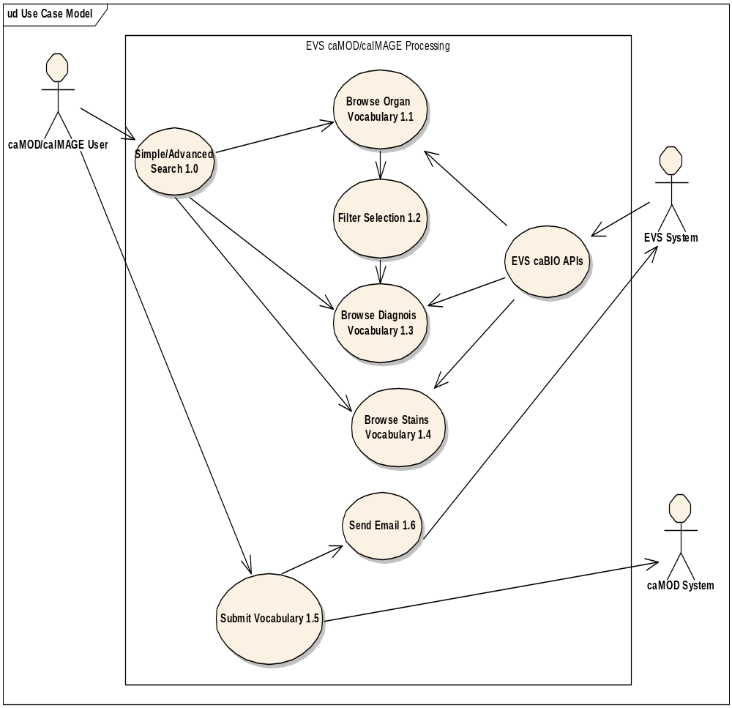

Search – Detailed Use Case (requirement 1,5,9,12)

Perform Simple/Advanced Search Workflow
The search workflow for the use cases can be implemented in three ways.
1. | Organ Selected | --------------
2. | Organ Selected | Diagnosis Selected
3. | ------------------- | Diagnosis Selected
The user will have 3 choices to select from the organ and diagnosis tree.
- Organ Only Selected
- Organ is selected first then diagnosis is selected for the particular organ
- Diagnosis is selected without first selecting the organ.

Perform Simple/Advanced Search Use Case (Organ only)
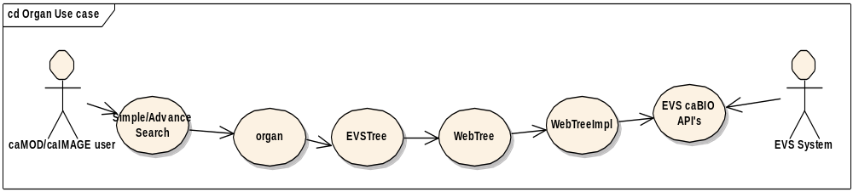

Use Case Name | Perform Simple/Advanced Search Use Case (Organ only)
Use Case ID | 2.1
Primary Actor | Researcher, caMOD User
Trigger | Researcher has clicked on the Simple or Advanced Search links after selecting the search models from the search models page
Pre-conditions | 1. User select the species type either human or mouse which is currently available thru NCI Thesaurus (Zebra, fish etc are not available currently.
Flow of Events | - Researcher clicks on the Simple or Advanced Search link from the after selecting the search models page.  - Researcher is presented with a list of search fields to fill out. The list of search fields displayed for Simple search is a subset of the search fields displayed for the Advanced Search. All fields entered by the actor are logically connected by “AND” statements to creating the query. In the available choices, the system will display the Site of Lesion/Tumor search criteria fields along with a “Select” button.  - Researcher first selects the species then researcher clicks the “Select” button and researcher is presented with organ system (human) or murine tissue type (mouse) root node tree. Researcher cannot choose the organ without selecting the species first other wise error message will be thrown.  - The system gets the variables form name, concept name (root node) and role name and pass to JavaScript to bring the appropriate tree. Those variables are not be hard coded in the JSP pages or classes.  - The researcher can selects vocabulary from the tree. Alternatively, the user can enter a term to be searched in the “search” text filed and search the vocabulary/condition for matching terms and/or synonyms (if any).  - Researcher clicks on the term he is interested in. After the selection is made the researcher confirms the selection. He can either click “OK” or “cancel”.  - The system then uses the selected concept name to fill the concept name in the form field and closes the tree view window.  - The system then uses the selected concept name to fill the concept name in the form field and closes the tree view window.
Post-Conditions | Success Condition: Researcher is presented with the search results screen to view the results.  Error Condition: Root node not found or EVS server is down.  Error Condition: System error while processing the search query
Alternative Flow | - If the EVS server is down, availability or the root node or role name is not known the system displays an error in the tree view pane. If it is an EVS problem the actor can attempt the EVS tree selection again. Problems in role name/root node names cannot be worked around.  - If system error is thrown, the researcher is asked to contact the system administrator to report the circumstances under which the error occurred.
Related Use Case

Perform Simple/Advanced Search Use Case (Organ and Diagnosis)
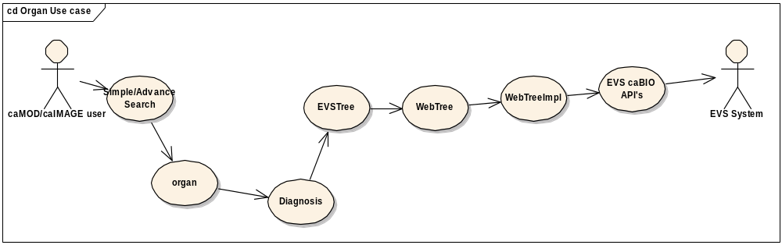

Use Case Name | Perform Simple/Advanced Search Use Case (Organ and Diagnosis)
Use Case ID | 2.2
Primary Actor | Researcher
Trigger | Researcher has clicked on the Advanced Search links after selecting the search models from the search models page
Pre-conditions | 1. User select the species type either human or mouse which is currently available thru NCI Thesaurus (Zebra, fish etc are not available currently.
Flow of Events | - Researcher clicks on the Simple or Advanced Search link from the after selecting the search models page.  - Researcher is presented with a list of search fields to fill out. The list of search fields displayed for Simple search is a subset of the search fields displayed for the Advanced Search. All fields entered by the actor are logically connected by “AND” statements to creating the query. In the available choices, the system will display the Site of Lesion/Tumor search criteria fields along with a “Select” button.  - Researcher first selects the species then researcher clicks the “Select” button and researcher is presented with organ system (human) or murine tissue type (mouse) root node tree. Researcher cannot choose the organ without selecting the species first other wise error message will be thrown.  - The system gets the variables form name, concept name (root node) and role name and pass to JavaScript to bring the appropriate tree. Those variables are not be hard coded in the JSP pages or classes.  - The researcher can selects vocabulary from the tree. Alternatively, the user can enter a term to be searched in the “search” text filed and search the vocabulary/condition for matching terms and/or synonyms (if any).  - Researcher clicks on the term he is interested in. After the selection is made the researcher confirms the selection. He can either click “OK” or “cancel”.  - The system then uses the selected concept name to fill the concept name in the form field and closes the tree view window. The user has now selected an Organ, and the “Select” Button next to the diagnosis should now be active.  - The user clicks on the “Select” Button next to Diagnosis and follows the same steps as are outlined in 4-7  - The system then uses the selected concept name to fill the concept name in the form field and closes the tree view window.  - The research hits the “Search” button to retrieve all matching records.
Post-Conditions | Success Condition: Researcher is presented with the search results screen to view the results.  Error Condition: Root node not found or EVS server is down.  Error Condition: System error while processing the search query
Alternative Flow | - If the EVS server is down, availability or the root node or role name is not known the system displays an error in the tree view pane. If it is an EVS problem the actor can attempt the EVS tree selection again. Problems in role name/root node names cannot be worked around.  - If system error is thrown, the researcher is asked to contact the system administrator to report the circumstances under which the error occurred.
Related Use Case

Perform Simple/Advanced Search Use Case (Diagnosis only)
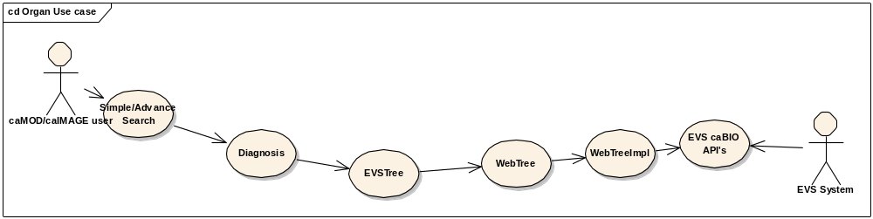

Use Case Name | Perform Simple/Advanced Search Use Case (Diagnosis only)
Use Case ID | 2.3
Primary Actor | Researcher
Trigger | Researcher clicked on the Advanced Search links after selecting the search models from the search models page
Pre-conditions | 1. User select the species type either human or mouse which is currently available thru NCI Thesaurus (Zebra, fish etc are not available currently.
Flow of Events | - Researcher clicks on the Simple or Advanced Search link from the after selecting the search models page.  - Researcher is presented with a list of search fields to fill out. The list of search fields displayed for Simple search is a subset of the search fields displayed for the Advanced Search. All fields entered by the actor are logically connected by “AND” statements to creating the query. In the available choices, the system will display the Site of Lesion/Tumor search criteria fields along with a “Select” button.  - Researcher first selects the species then researcher clicks the “Select” button and researcher is presented with organ system (human) or murine tissue type (mouse) root node tree. Researcher cannot choose the organ without selecting the species first other wise error message will be thrown.  - The system gets the variables form name, concept name (root node) and role name and pass to JavaScript to bring the appropriate tree. Those variables are not be hard coded in the JSP pages or classes.  - The researcher can selects vocabulary from the tree. Alternatively, the user can enter a term to be searched in the “search” text filed and search the vocabulary/condition for matching terms and/or synonyms (if any).  - Researcher clicks on the term he is interested in. After the selection is made the researcher confirms the selection. He can either click “OK” or “cancel”.  - The system then uses the selected concept name to fill the concept name in the form field and closes the tree view window. The user has now selected an Diagnosis.  - The system then uses the selected concept name to fill the concept name in the form field and closes the tree view window.  - The research hits the “Search” button to retrieve all matching records.
Post-Conditions | Success Condition: Researcher is presented with the search results screen to view the results.  Error Condition: Root node not found or EVS server is down.  Error Condition: System error while processing the search query
Alternative Flow | - If the EVS server is down, availability or the root node or role name is not known the system displays an error in the tree view pane. If it is an EVS problem the actor can attempt the EVS tree selection again. Problems in role name/root node names cannot be worked around.  - If system error is thrown, the researcher is asked to contact the system administrator to report the circumstances under which the error occurred.
Related Use Case

Submit Use Case (Requirement 4, 11)
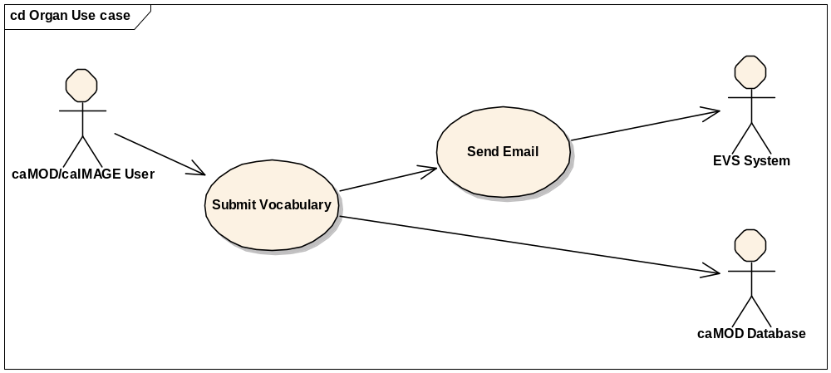

Submit Use Case

Use Case Name | Submit Concept Code Use Case
Use Case ID | 3.1
Primary Actor | Researcher (via Simple/Advanced Search)
Secondary Actor | Image data store  Annotation Database
Trigger | System has successfully retrieved the EVS Tree data for display
Pre-conditions | 1. User clicks the button to display either organ or diagnosis tree is executed without any system errors
Flow of Events | - The system has successfully retrieved the data requested by the user through the EVS API’s. User is presented with either organ or diagnosis tree.  - The user searches for the diagnosis in the tree, but could not locate the desired terms by navigating the tree or using the search feature.  - After performing a search the user is informed that he has the option to add a term to the vocabulary if he does not find the term he is looking for.  - The user accepts the choice and opens a text input box.  - The user enters the new vocabulary term.  - New element is added in the caMOD database.  - The system generates an email to notify the EVS team about the term. The EVS team decides if this term is going to be added to the vocabulary.
Post-Conditions | Success Condition: User successfully enters the new term code in caMOD or caIMAGE database and an email is send to the EVS team.
Alternative Flow | - If no data is submitted or no email is send, an appropriate message is returned to the user.
Related Use Case

Sign Off

Approval
PROJECT ACCEPTANCE: By signing this use case document, you are accepting the use cases of the caMOD/caIMAGE EVS implementation.

________________________________________________ DATE: ___/___/___
Dr. Ken Buetow, NCICB, Director Center for Bioinformatics
________________________________________________ DATE: ___/___/___
Sue Dubman, NCICB, Director of Application
________________________________________________ DATE: ___/___/___

