Software Requirements Specification

caMOD 2.2 Iteration 2
NCICB

DOCUMENT REVISION HISTORY
Version Number | Date | Description
1.0 | July 11, 2006 | - Initial Draft
1.1 | November 30, 2006 | - Additional items added throughout project
1.2

Background/Summary
The cancer models database (caMOD) is a web-based resource that provides information about animal models for human cancer to the public research community.

caMOD provides the following key capabilities to its users:

- Data Submission--Data in caMOD are extracted from the public scientific literature by curators and verified by the scientists who generated or worked with the models, or they are directly submitted by scientists.

- Cancer Model Search--Users can retrieve information about the making of models, their genetic descriptions, histopathology, derived cell lines, associated images, carcinogenic interventions, microarray data, and therapeutic trials in which the models were used. caMOD provides links to PubMed for associated publications and other resources such as mouse repositories, detailed information about altered gene, pathway affected, and information about human clinical trials that utilize the same compounds as the pre-clinical trials in the animal models.

- System Function Administration--The Admin function provides services for user registration, review of submitted models and database management.

Table of Content
Requirements Specification 1
caMOD 2.2 Iteration 2 1
Background/Summary 1
1 Introduction 4
1.1 Overview for searching for Jackson Lab’s Mouse Tumor Biology (MTB) data 4
1.2 Related Documents 4
2 Actors and Authorization 5
3 Use Cases 7
3.1 Search for Mouse Tumor Biology Data (MTB) 7
3.1.1 Use Case Model 7
3.1.2 Supplemental Requirements 8
3.2 Add Age of Detection to Histopathology Submission Screen 9
3.2.1 Use Case Model 9
3.2.2 Supplemental Requirements 10
3.3 Add Age of Detection to Histopathology Search Screen 10
3.3.1 Use Case Model 10
3.3.2 Supplemental Requirements 11
3.4 Modify viewCarcinogenicInterventions to display data from MTB (JAX) 11
3.4.1 Use Case Model 11
3.4.2 Supplemental Requirements 12
3.5 Modify Organ object to display data for organ to allow for conceptCodes = '0000000' 12
3.5.1 Use Case Model 12
3.5.2 Supplemental Requirements 13
3.6 Mark histopathology records with 0% tumor incidence rate 13
3.6.1 Use Case Model 13
3.6.2 Supplemental Requirements 14
3.7 Indicate if a record has associated microarray data and/or images. 14
3.7.1 Use Case Model 14
3.7.2 Supplemental Requirements 15
3.8 Mark MTB records on search results list either with icon or with text 15
3.8.1 Use Case Model 15
3.8.2 Supplemental Requirements 16
4 General Requirements 16
4.1 Requirements Prioritization 16
5 Data Definitions 16
6 Sign Off 18
6.1 Approval 18

Introduction

Overview for searching for Jackson Lab’s Mouse Tumor Biology (MTB) data
The number of models provided to the user through caMOD will be expanded by integrating data from the Mouse Tumor Biology database generated at the Jackson Laboratory (http://tumor.informatics.jax.org). Importing the data will also allow to make these data available via caGrid in the future. The MTB data will be shown on the caMOD search detail pages for model characteristics, genetic description, publication and histopathology since there is a substantial overlap of data categories between MTB and caMOD.

Related Documents

Document Name | Version | Location
caMODRequirementsDocument-02282005.doc | Fixed | CVS project in the C:\dev\workspace\camod_dev\docs\artifacts\requirements folder

Actors and Authorization

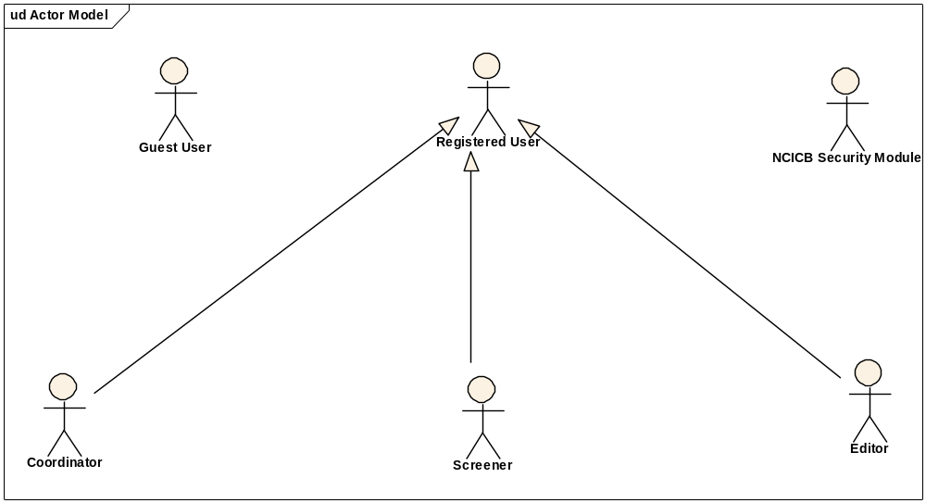
Guest User: Includes every user without an account. These users can query the database without restrictions, but they cannot submit models or comment on models.
Registered User: Can submit models to the database and can comment on models submitted by other researchers.
Super User (not shown): Has access to all model entries to update them. This is to facilitate minor text corrections in an entry without having to bother the submitter.
Coordinator: The coordinator is a registered user who appoints screener and editors. The coordinator also grants access privileges and manages the review process. After a model has been entered the coordinator assigns a screener who will check that all required fields have been specified and that the model does not contain junk or grossly inappropriate material. The coordinator will be informed about the decision of the screener by email. If the screener accepted the model the coordinator then assigns the model to an editor, who is a content expert.
Screener: The Screener is a registered user who performs the initial review of submitted models. This review is a quick check that all required fields have been specified and that the model does not contain junk or grossly inappropriate material. The screener also makes a preliminary assessment for clarity, typographic errors and other issues that would make the model less than fully comprehensible. The screening process should be complete within 24 hours. The screener does not contact the submitter about the submission. Any deficiencies found are described in the email to the coordinator. Each email deals with only one submission, so that the emails can be independently routed for vetting.
Editor: The Editor is a registered user who examines a model to see if it satisfies criteria to be made available to the public. The editor also considers any comments, made by the screener, that are passed along in the email from the coordinator. The editor may determine that the model cannot be made acceptable for publication in the database because it requires additional data. If the model has correctable defects, it may be necessary to communicate by email with the submitter to make the model acceptable. Correspondence and telephone contact with the submitters may be conducted through the coordinator. Editors are responsible for maintaining a paper trail or log of email exchanges regarding the models they review. The editor may elect to review a model without assistance. He or she can also request assistance from other subject matter experts. Only the editor has the authority to release the model to the intended audience.

Use Cases
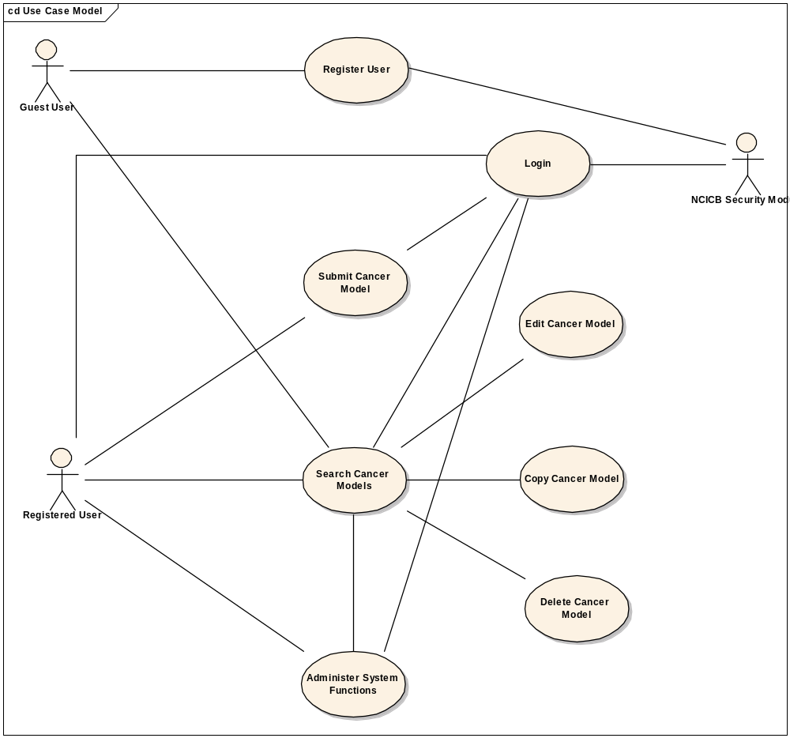
Figure 1. caMOD Use Case Diagram

Search for Mouse Tumor Biology Data (MTB)

Use Case Model

Use Case Name | Search for Mouse Tumor Biology Data (MTB)
Use Case ID | 1
Primary Actor | All users
Brief Description | Users can query caMOD for data provide by the Mouse Tumor Biology (MTB) database using either the simple or advanced search pages. Data will be shown on the model characteristics, genetic description, publication and histopathology search detail pages.
Trigger | Actor navigates to the caMOD URL
Pre-conditions | Successful navigation to the caMOD URL
Flow of Events | 1. The system presents search and submit models hyperlinks.
Flow of Events | 2. The actor
Flow of Events | a. Navigates to the search models section
Flow of Events | 3. The system
Flow of Events | - Returns the search criteria screen
Flow of Events | 4. The actor
Flow of Events | a. Enters selection criteria and submits search form
Flow of Events | 5. The system
Flow of Events | a. Returns models matching any selection criteria entered by the user. MTB models are specifically marked.
Post Conditions | Success Condition: System returns models matching selection criteria. MTB data are displayed on the model characteristics, genetic description, publication and histopathology search detail pages.  Error Condition: No models found  Error Condition: Validation fails  Error Condition: System Error
Alternative Courses of Action | If a validation error occurs, the system throws an exception, displays an error message and re-displays page for data entry.  a. No Models Found  -Re Submit modified search criteria (Return to step 4a)  b. System Error.  -Contact system administrator
Issues

Supplemental Requirements
- New attributes need to be added to the object model to accommodate all MTB fields
- Data needs to be mapped to existing caMOD vocabularies
- Vocabulary items that cannot be mapped to existing caMOD vocabularies need to be accommodated e.g. organs that are not found in the EVS mouse tissue vocabulary

Add Age of Detection to Histopathology Submission Screen

Use Case Model

Use Case Name | Add age of detection to histopathology submission screen
Use Case ID | 2
Primary Actor | All registered users
Brief Description | Camod provides interfaces for users to submit various types of data for animal models. Modify the interface for Histopathology to allow for the submission of age of detection data.
Trigger | Actor navigates to the caMod URL
Pre-conditions | Successful navigation to the caMod URL  Successful login to camod
Flow of Events | 1. The system presents search and submit models hyperlinks.
Flow of Events | 2. The actor
Flow of Events | - Navigates to the new model submission section  - Successfully enters the data to create a new model
Flow of Events | 3. The system
Flow of Events | - Returns the data-type categories for submitting data
Flow of Events | 4. The actor
Flow of Events | - Navigates to the Histopathology submission section  - Enters data for the age of detection and unit data and submits form
Flow of Events | 3. The system
Flow of Events | a. Saves the data for the submitted model
Post Conditions | Success Condition: User creates new model and submits data for appropriate section.  Error Condition: Fails to create new model  Error Condition: Validation fails  Error Condition: System Error
Alternative Courses of Action | If a validation error occurs, the system throws an exception, displays an error message and re-displays page for data entry.  a. Fails to create new model  -Re Submit new model data (Return to step 2a)  -Contact system administrator  b. Validation fails  - Re-enter required data for model Return to step 2a)  c. System Error.  -Contact system administrator
Issues

Supplemental Requirements
1. Change the Histopathology object name to include ageOfDetection and ageOfDetectionUnit..
    - Modify all code that refers to the Histopathology object (data, form, action, populateAction, managers, impls) to populate, edit and save the new data type.

Add Age of Detection to Histopathology Search Screen

Use Case Model

Use Case Name | Add age of detection to histopathology search screen
Use Case ID | 3
Primary Actor | All users
Brief Description | Advanced search features allow users to search by a range of variables. Add the ability to see the age of detection data on the Histopathology screen.
Trigger | Actor navigates to the caMod URL
Pre-conditions | Successful navigation to the caMod URL
Flow of Events | 1. The system presents search and submit models hyperlinks.
Flow of Events | 2. The actor
Flow of Events | a. Navigates to the search models section
Flow of Events | 3. The system
Flow of Events | - Returns the search criteria screen
Flow of Events | 4. The actor
Flow of Events | a. Enters selection criteria for Histopathology and submits search form
Flow of Events | 3. The system
Flow of Events | a. Returns models matching any selection criteria entered by the user
Post Conditions | Success Condition: System returns models matching selection criteria.  Error Condition: No models found  Error Condition: Validation fails  Error Condition: System Error
Alternative Courses of Action | If a validation error occurs, the system throws an exception, displays an error message and re-displays page for data entry.  a. No Models Found  -Modify search criteria and submit again (Return to step 4a)  b. Validation fails  - Retype required data (Return to step 2a)  c. System Error.  -Contact system administrator
Issues

Supplemental Requirements
1. Search for models with Histopathology data (specifically the age of detection data type).

Modify viewCarcinogenicInterventions to display data from MTB (JAX)

Use Case Model

Use Case Name | Modify viewCarcinogenicInterventions to display data from MTB (JAX)
Use Case ID | 4
Primary Actor | All users
Brief Description | The search unit allows a user to view all the various data for a single model. Modify the carcinogenic intervention display screen to include data from Jackson Lab.
Trigger | Actor navigates to the caMod URL
Pre-conditions | Successful navigation to the caMod URL
Flow of Events | 1. The system presents search and submit models hyperlinks.
Flow of Events | 2. The actor
Flow of Events | a. Navigates to the search models section
Flow of Events | 3. The system
Flow of Events | - Returns the search criteria screen
Flow of Events | 4. The actor
Flow of Events | a. Enters selection to search for external sources (Jax MTB) and submits search form
Flow of Events | 3. The system
Flow of Events | a. Returns models matching any selection criteria entered by the user
Flow of Events | 4. The user
Flow of Events | a. Navigates to the CARCINOGENIC INTERVENTIONS sub menu of a model with the data and views the available data.
Post Conditions | Success Condition: System returns models matching selection criteria.  Error Condition: No models found  Error Condition: Validation fails  Error Condition: System Error
Alternative Courses of Action | If a validation error occurs, the system throws an exception, displays an error message and re-displays page for data entry.  a. No Models Found  -Modify search criteria and submit again (Return to step 4a)  b. Validation fails  - Retype required data (Return to step 2a)  c. System Error.  -Contact system administrator
Issues

Supplemental Requirements
1. Search for models with Jackson Lab and CARCINOGENIC INTERVENTIONS data.

Modify Organ object to display data for organ to allow for conceptCodes = '0000000'

Use Case Model

Use Case Name | Modify Organ object to display data for organ to allows for conceptCodes = '0000000'
Use Case ID | 5
Primary Actor | All users
Brief Description | The search unit allows a user to view all the various data for a single model. Modify the Histopathology display screen to include data from Jackson Lab.
Trigger | Actor navigates to the caMod URL
Pre-conditions | Successful navigation to the caMod URL
Flow of Events | 1. The system presents search and submit models hyperlinks.
Flow of Events | 2. The actor
Flow of Events | a. Navigates to the search models section
Flow of Events | 3. The system
Flow of Events | - Returns the search criteria screen
Flow of Events | 4. The actor
Flow of Events | a. Enters selection to search for external sources (Jax MTB) and submits search form
Flow of Events | 3. The system
Flow of Events | a. Returns models matching any selection criteria entered by the user
Flow of Events | 4. The user
Flow of Events | a. Navigates to the Histopathology sub menu of a model with the data and views the available data for organ.
Post Conditions | Success Condition: System returns models matching selection criteria.  Error Condition: No models found  Error Condition: Validation fails  Error Condition: System Error
Alternative Courses of Action | If a validation error occurs, the system throws an exception, displays an error message and re-displays page for data entry.  a. No Models Found  -Modify search criteria and submit again (Return to step 4a)  b. Validation fails  - Retype required data (Return to step 2a)  c. System Error.  -Contact system administrator
Issues

Supplemental Requirements
1. Search for models with Jackson Lab and Histopathology (Organ) data.

Mark histopathology records with 0% tumor incidence rate

Use Case Model

Use Case Name | Mark histopathology records with 0% tumor incidence rate
Use Case ID | 6
Primary Actor | All users
Brief Description | The search unit allows a user to view all the various data for a single model. Modify the Histopathology display screen to include data from Jackson Lab. The Jackson Lab indicates data for no tumor incidence rate (as 0%) unlike caMOD. Simply mark the data with a red highlight.
Trigger | Actor navigates to the caMod URL
Pre-conditions | Successful navigation to the caMod URL
Flow of Events | 1. The system presents search and submit models hyperlinks.
Flow of Events | 2. The actor
Flow of Events | a. Navigates to the search models section
Flow of Events | 3. The system
Flow of Events | - Returns the search criteria screen
Flow of Events | 4. The actor
Flow of Events | a. Enters selection to search for external sources (Jax MTB) and submits search form
Flow of Events | 3. The system
Flow of Events | a. Returns models matching any selection criteria entered by the user
Flow of Events | 4. The user
Flow of Events | a. Navigates to the Histopathology sub menu of a model with the data and views the available data for tumor incidence rate = 0%.
Post Conditions | Success Condition: System returns models matching selection criteria.  Error Condition: No models found  Error Condition: Validation fails  Error Condition: System Error
Alternative Courses of Action | If a validation error occurs, the system throws an exception, displays an error message and re-displays page for data entry.  a. No Models Found  -Modify search criteria and submit again (Return to step 4a)  b. Validation fails  - Retype required data (Return to step 2a)  c. System Error.  -Contact system administrator
Issues

Supplemental Requirements
1. Search for models with Jackson Lab and Histopathology (tumor incidence rate = 0%) data.

Indicate if a record has associated microarray data and/or images.

Use Case Model

Use Case Name | Indicate if a record has associated microarray data and/or images.
Use Case ID | 7
Primary Actor | All users
Brief Description | The search unit allows a user to view all the various data for a single model. Modify the search results screen to include an icon to indication that a model includes either microarray or image data (in front of he model descriptor).
Trigger | Actor navigates to the caMod URL
Pre-conditions | Successful navigation to the caMod URL
Flow of Events | 1. The system presents search and submit models hyperlinks.
Flow of Events | 2. The actor
Flow of Events | a. Navigates to the search models section
Flow of Events | 3. The system
Flow of Events | - Returns the search criteria screen
Flow of Events | 4. The actor
Flow of Events | a. Enters selection to search for either microarray data or images and submits search form
Flow of Events | 3. The system
Flow of Events | a. Returns models matching any selection criteria entered by the user displaying the icon to indicate microarray or image data.
Post Conditions | Success Condition: System returns models matching selection criteria.  Error Condition: No models found  Error Condition: Validation fails  Error Condition: System Error
Alternative Courses of Action | If a validation error occurs, the system throws an exception, displays an error message and re-displays page for data entry.  a. No Models Found  -Modify search criteria and submit again (Return to step 4a)  b. Validation fails  - Retype required data (Return to step 2a)  c. System Error.  -Contact system administrator
Issues

Supplemental Requirements
1. Search for models with Microarray or Image data .

Mark MTB records on search results list either with icon or with text

Use Case Model

Use Case Name | Mark MTB records on search results list either with icon or with text
Use Case ID | 8
Primary Actor | All users
Brief Description | The search unit allows a user to view all the various data for a single model. Modify the search results screen to include an icon to indication that a model is from Jackson lab (behind the model descriptor).
Trigger | Actor navigates to the caMod URL
Pre-conditions | Successful navigation to the caMod URL
Flow of Events | 1. The system presents search and submit models hyperlinks.
Flow of Events | 2. The actor
Flow of Events | a. Navigates to the search models section
Flow of Events | 3. The system
Flow of Events | - Returns the search criteria screen
Flow of Events | 4. The actor
Flow of Events | a. Enters selection to search for external source data (Jax MTB) and submits search form
Flow of Events | 3. The system
Flow of Events | a. Returns models matching any selection criteria entered by the user displaying the icon to indicate that the model is from Jackson Lab.
Post Conditions | Success Condition: System returns models matching selection criteria.  Error Condition: No models found  Error Condition: Validation fails  Error Condition: System Error
Alternative Courses of Action | If a validation error occurs, the system throws an exception, displays an error message and re-displays page for data entry.  a. No Models Found  -Modify search criteria and submit again (Return to step 4a)  b. Validation fails  - Retype required data (Return to step 2a)  c. System Error.  -Contact system administrator
Issues

Supplemental Requirements
1. Search for models from external sources (Jax MTB).

General Requirements

Requirements Prioritization

Req # | Supp Req Ref # | Use Case Name
416 |  | Search for Mouse Tumor Biology data (MTB)
455 |  | Add ageOfDetection (and unit) to submission and search screens
453 |  | Modify viewCarcinogenicInterventions to display data from MTB (JAX)
451 |  | Modify Organ object to display data for organ allows for conceptCodes = '000000'
448 |  | mark histopathology records with 0% tumor incidence rate
396 |  | Indicate if a record has associated microarray data and/or images
458 |  | Mark MTB records on search results list either with icon or with text

Data Definitions

CDE # | Data Element | Description | Use Case Name

Sign Off

Approval

Workspace General Contractor Rep Print Name Date
Architecture Workspace Rep Print Name Date
VCDE Workspace Rep Print Name Date
Workspace Working Group Rep Print Name Date
NCICB Rep Print Name Date

