caMOD Release 2.2 Iteration 1

Software Design Description

Version 1.0

[Insert approval date of document]

Document Change Record
Version Number | Date | Description
1.0 | June 29, 2006 | Initial document to upload to cvs
1.1 | July 17, 2006 | Updated

TABLE OF CONTENTS
caMOD Release 2.2 Iteration 1 i
1. Introduction 1
1.1 Requirements Traceability 1
1.2 Background/Summary 1
2. System Overview 3
2.1.1 User Client Software 4
2.1.2 Back End 4
2.1.3 Hibernate 3 Data Access 4
2.1.4 JBoss Application Server 4
2.1.5 Database 4
2.1.6 Java 4
3. components for additional advanced search queries 5
3.1 user interface (VIEW) 5
3.1.1 Advanced Search Screens 5
3.1.2 Interface Classes to be Modified 5
3.2 middle tier (CONTROLLER) 6
3.2.1 SearchForm 6
3.2.2 QueryManagerImpl 6
3.2.3 SavedQueryManagerImpl 6
3.2.4 AdvancedSearchPopulateAction 7
3.3 persistence layer 7
3.3.1 AbstractCancerModel 7
3.4 database (MODEL) 7
3.4.1 AbstractCancerModel 7
3.5 configuration and utility classes 7
3.5.1 Configuration and Utility Files Changed 7
4. components for submission and search of sirna knock down experiments 9
4.1 user interface (VIEW) 9
4.1.1 Navigation Bar 9
4.1.2 Submission Screen for siRNA 10
4.1.3 Search Screen for siRNA 12
4.1.4 Interface Classes to be Modified 13
4.2 middle tier (CONTROLLER) 13
4.2.1 TransientInterferenceManagerImpl 13
4.2.2 TransInterferenceMethodManagerImpl 14
4.2.3 TransInterferenceMethodManager 14
4.2.4 TransientInterferenceManagerSingleton 14
4.2.5 TransIntMethodManagerSingleton 15
4.2.6 AnimalModelManagerImpl 15
4.2.7 AnimalModelManager 15
4.2.8 QueryManagerImpl 15
4.2.9 TransientInterferenceAction 15
4.2.10 MorpholinoPopulateAction 16
4.2.11 SirnaPopulateAction 16
4.2.12 AnimalModelTreePopulateAction 16
4.2.13 TransientInterferenceForm 17
4.3 persistence layer 17
4.3.1 TransientInterference 17
4.3.2 TransientInterferenceMethod 17
4.3.3 AnimalModel 17
4.4 database (MODEL) 18
4.4.1 TransientInterference 18
4.4.2 TransientInterferenceMethod 18
4.4.3 AnimalModel 18
4.5 configuration and utility classes 18
4.5.1 Configuration and Utility Files Changed 18
5. components for additional administration features 20
5.1 user interface (VIEW) 20
5.1.1 Search Screen 20
5.1.2 Model Status Screen 21
5.1.3 Interface Classes to be Modified 22
5.2 middle tier (CONTROLLER) 22
5.2.1 ChangeAnimalModelStateAction 22
5.2.2 AnimalModelManagerImpl 22
5.3 configuration and utility classes 23
5.3.1 Configuration and Utility Files Changed 23
6. components for submission of nomenclature and genotype information 24
6.1 user interface (VIEW) 24
6.1.1 Interface Classes to be Modified 24
6.2 middle tier (CONTROLLER) 25
6.2.1 SearchAction 25
6.2.2 ModelCharacteristicsForm 25
6.2.3 AnimalModelAction 25
6.2.4 AnimalModelPopulateAction 25
6.2.5 AnimalModelManagerImpl 26
6.3 persistence layer 26
6.3.1 EngineeredGene 26
6.3.2 AnimalModel 26
6.4 database (MODEL) 27
6.4.1 EngineeredGene 27
6.4.2 AnimalModel 27
6.5 configuration and utility classes 27
6.5.1 Configuration and Utility Files Changed 27
7. components for indicating if model has associated image or microarry 29
7.1 user interface (VIEW) 29
7.1.1 Search Screen 29
7.1.2 Interface Classes to be Modified 29
7.2 middle tier (CONTROLLER) 30
7.2.1 SearchAction 30
Appendix A – acronym List 31
[APPENDIX B – DATABASE] 32
[Appendix C – Other Appendix] 38

Introduction
The purpose of this document is to describe the design for the various enhancements that are being developed for caMOD release 2.2 iteration 1. These enhancements include: allow for the submission of genotype and nomenclature information, search for models from Jackson labs (external source), add submission and search of models with siRNA knock down experiments, allows super users to change the state of models, duplicate models and delete (inactivate) models, add search for models defined as tool mouse models, and indicate if a model as associated image or micro array data. This document identifies and defines the design for these user requests for the caMOD application.

Requirements Traceability
Req # | Requirement Description
356 | Find a solution for entering the nomenclature and genotype information
380 | Add search option for models from the Jackson Laboratory MTB database (external source)
385 | caMOD should be able to handle the submission and search of siRNA knock down experiments
389 | Super user should be allowed to change the state (incomplete, complete etc) and assignments of every model
390 | Super users should be allowed to delete (inactivate) and duplicate models
395 | Add search option for tool mouse strains
396 | Indicate if a record has associated image or micro array data

Background/Summary
The cancer models database (caMOD) is a web-based resource that provides information about animal models for human cancer to the public research community.
caMOD provides the following key capabilities to its users:

- Data Submission--Data in caMOD are extracted from the public scientific literature by curators and verified by the scientists who generated or worked with the models, or they are directly submitted by scientists.

- Cancer Model Search--Users can retrieve information about the making of models, their genetic descriptions, histopathology, derived cell lines, associated images, carcinogenic interventions, microarray data, and therapeutic trials in which the models were used. caMOD provides links to PubMed for associated publications and other resources such as mouse repositories, detailed information about altered gene, pathway affected, and information about human clinical trials that utilize the same compounds as the pre-clinical trials in the animal models.

- System Function Administration--The Admin function provides services for user registration, review of submitted models and database management.

System Overview
The purpose of this section is to give an overview of the caMOD API. The following diagrams show the overall architecture and of the caMOD application.
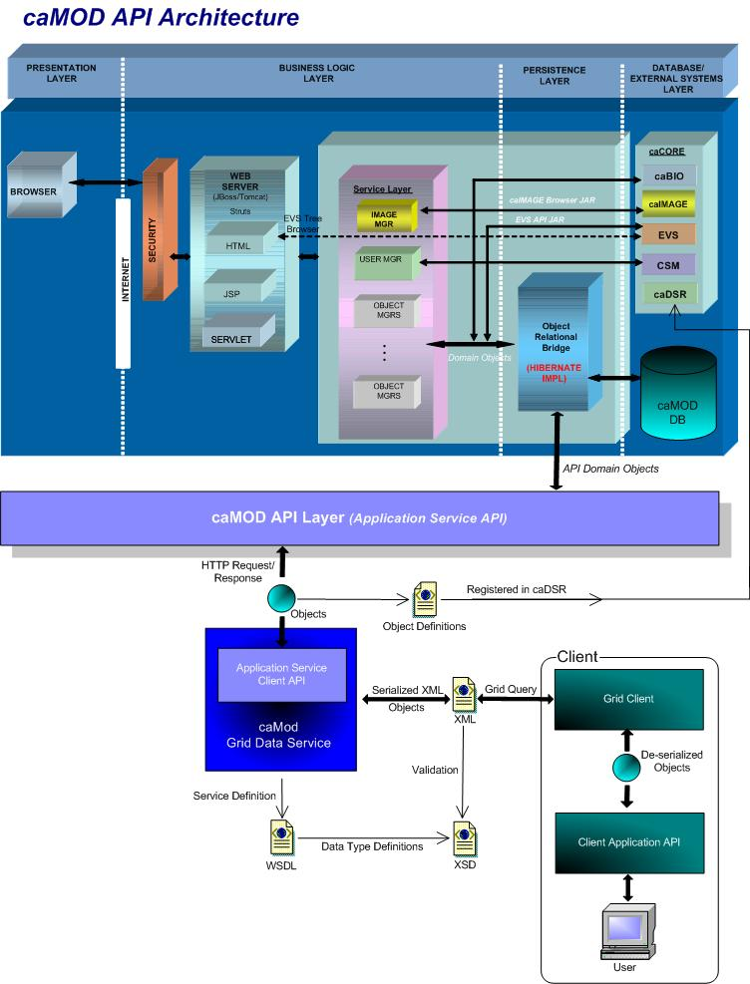

User Client Software
caMOD is a web based user interface implemented as HTML, JSP, JavaScript, and AJAX. The use of JavaScript is limited to improving usability only.
Java Server Pages (JSPs) are used to generate dynamic HTML based on user actions. JSPs are combinations of HTML, Java Code, and custom JSP and JSTL tags that get compiled into servlet classes.

Back End
The caMOD back end components provide access to persistence services for retrieving and storing data in the database. Hibernate, an open source tool, is used as the Object Relational Mapping (ORM) software.

Hibernate 3 Data Access
The caMOD uses Hibernate version 3. Hibernate is used for read, write access. It provides the insert, update and delete capability to the caMOD application thru the domain classes.

JBoss Application Server
The user interface, middle tier, and backend components are run with in JBoss Java2 Enterprise Edition (J2EE) application server. JBoss is an open source application server that provides a servlet container, an EJB container, the full range of J2EE 1.4 features as well as extended enterprise services including clustering, caching and persistence. JBoss 4.0.2 conforms to the latest technology stack. It will be consistent with most other applications.

Database
Oracle Relation Database Management System (RDBMS) software is used as the persistent store for caMOD and caIMAGE application data. Java classes access the database using the Java Database Connectivity (JDBC) API.

Java
The new version of Java1.5 (Java tool kit version jdk1.5.0_04) is used for compilation. Therefore all the code in caMOD has been compiled using the JDK 1.5 version. This will conform to the latest technology stack currently used by NCI.

components for additional advanced search queries

user interface (VIEW)

Advanced Search Screens
The new query for tool strains will be implemented as a check-box (similar to models with Histopathology, models with Transient Interference, or models with Microarray data).
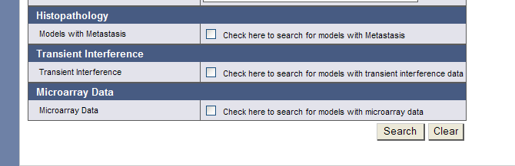
The new query for models from the Jackson Laboratory will be implemented as a drop-down box (similar to models by Species). The drop-down list will be populated with the value saved in the external_source field in the abs_cancer_model table. The user will select the external source and submit the form.
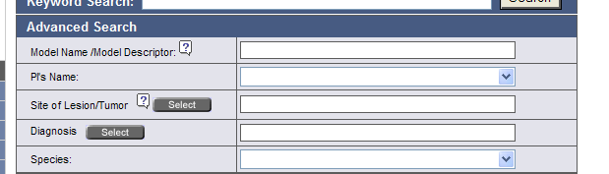

Interface Classes to be Modified
The following is a list of interface classes (JSP and interface java classes) that need to be modified.
Interface Class Name | Description
searchAdvanced.jsp | Advanced search query submission screen – Add check-box and drop-down box for new queries.
SearchData.java | Interface class for SearchForm.java class – Add variables to hold the new tool mouse (searchToolStrain ) and external source (externalSource) attributes for the advanced search screen

middle tier (CONTROLLER)
    - SearchForm
SearchForm.java is an existing struts Form class that is able to transfer data between the Model and View layers. Struts ActionForm beans are controller components. The attributes defined will remain the same with the exception for two additions.
Method Name | Description
externalSource | Add attribute to hold the value for the external_source attribute in the abs_cancer_model table. Add getter and setter methods for new attribute.
searchToolStrain | Add variable to support the new query for models with tool strains. Add getter and setter methods for new attribute.

    - QueryManagerImpl
QueryManagerImpl.java is an existing class that defines each query used in all sections of the caMOD application. One new method needs to be added for the search for tool strains.
Method Name | Description
getModelIdsForToolStrain | Add new method to retrieves models indicated as tool strains from the abs_cancer_model table.
getModelIdsForTransientInterference | Modify query to retrieve data from the TransientInterference table instead of the Morpholino table (name change).

The new sql will be defined as:
String theSQLString = "SELECT distinct abs_cancer_model_id FROM abs_cancer_model " + "WHERE is_tool_mouse = 1 " + " AND state = 'Edited-approved' ";
    - SavedQueryManagerImpl
SavedQueryManagerImpl.java is an existing class that defines each saved query attribute name used to save user queries and display on the search criteria section of the saved query list screen.
Method Name | Description
buildSearchData | Add definition isSearchToolStrain and ExternalSource to define saved query attributes for new queryies.
Set buildCriteriaList | Add isSearchToolStrain and ExternalSource to the list of criteria used to display user selections on the search results screen.

    - AdvancedSearchPopulateAction
AdvancedSearchPopulateAction.java is an existing struts Action class that manages requests by the application to populate the advanced search screen. The dropdown method of this class was modified in order to populate the drop-down menu used to search for models from external sources query.

persistence layer
    - AnimalModel
AnimalModel.hbm.xml is an existing hibernate mapping file used to provide Hibernate with information to persist objects to the caMOD database. The mapping file will remain the same except for two additions.
Attribute Name | Description
externalSource | Mapping for the externalSource attribute for the object
externalSourceIdentifier | Mapping for the externalSourceIdentifier attribute for the object

database (MODEL)
    - AnimalModel
AnimalModel.java is an existing domain object used to hold data for AnimalModel objects. The domain object will remain the same except for two additions.
Attribute Name | Description
externalSource | Name of data source from which data were imported
externalSourceIdentifier | Identifier for data record from external source

configuration and utility classes
    - Configuration and Utility Files Changed
File Name | Function
CriteriaTableUtil.java | Creates a HTML table with all criteria formatted within. Add definition for isSearchToolStrain and getExternalSource
ApplicationResources_en.properties | Properties file to hold the global messages for validation, errors, and global variable definitions for attributes used for queries. Add definition for Criteria.ExteranalSource and Criteria.isSearchToolStrain values.
Constants.java | Configuration files to hold global constants for the application. Add EXTERNALSOURCEQUERYDROP constant to hold the drop-down options for models from external sources.
NewDropdownUtil.java | Add getExternalSourceList method to return externalSource values from AnimalModel obeject.
insert into abs_cancer_model (abs_cancer_model_id, abs_cancer_model_type, external_source)
values (hibernate_sequence.NEXTVAL, 'AM', 'JAX MTB');

select * from abs_cancer_model
where external_source IS NOT NULL;
Tested with abs_cancer_model_id = 10008490

components for submission and search of sirna knock down experiments

user interface (VIEW)

Navigation Bar
Submission and search for siRNA models will be located under the Transient Interference sections already available in the submission and search sections of caMOD 2.1. The siRNA submissions will have its own hyperlink, while data results for both Morpholino and siRNA models will be displayed under the Transient Interference section in the search section of the application. There will be an extra heading to indicate the transient interference method of the model (Morpholino or siRNA).
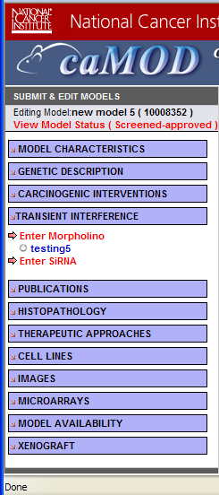
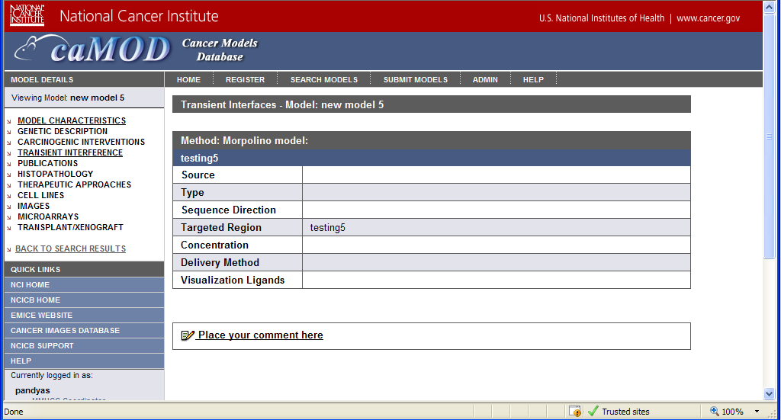

Submission Screen for siRNA
The submission screen for siRNA will contain the following fields and value options:
Field Label | Field Value Options
Type | Chemically synthesized  Enzymatically synthesized  Vector-mediated (Pol-III promoter)  Vector-mediated (Pol-II promoter)  Virus-vector-mediated (lentivirus)  Virus-vector-mediated (oncoretrovirus)  Transgene-mediated  Other
Source | Amaxa  Ambion  BioLynx  Cenix BioScience  Invitrogen  Qiagen  SystemBio  Other
Sequence | 5'-3' (sense)  3'-5' (antisense)
Gene/Locus | insert  gene ID
Concentration | text input field
Concentration Units | Molar  Millimolar  Micromolar  Nanomolar
Delivery method | siRNA transfection kit  CaPO4  DMRIEC  Effectene  FuGene6  GM00637  GenePorter 2  GeneSilencer  HVJ-E vector  JetSi  LipofectAMINE Plus  Lipofectamine2000  NC388  Oligofectamine  PolyFect  RNAi Starter  RNAiFect  SiPortAmine  SilencerTM siRNA Construction Kit  SuperFect  TransFast  TransGene II  TransITTKO  TransMessenger  Electroporation  Pegylated immunoliposome (PIL)  siPORTLipid  Other
Visualization ligands | GFP  Other
Comment | text input field

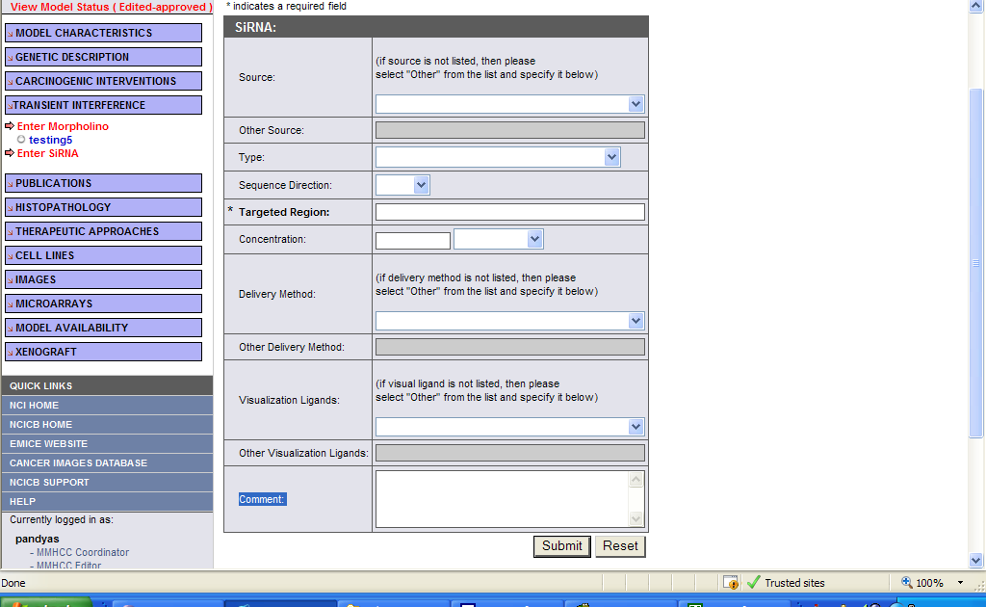

Submission Screen for Morpholino
The submission screen for morpholino will remain the same except for the addition of the comments input field.
Field Label | Field Value Options
Comment | text input field (added)

Search Screen for siRNA
The search results screen for siRNA will look similar to the search results screen for Morpholino except for the additional heading for method (Morpholino or siRNA).
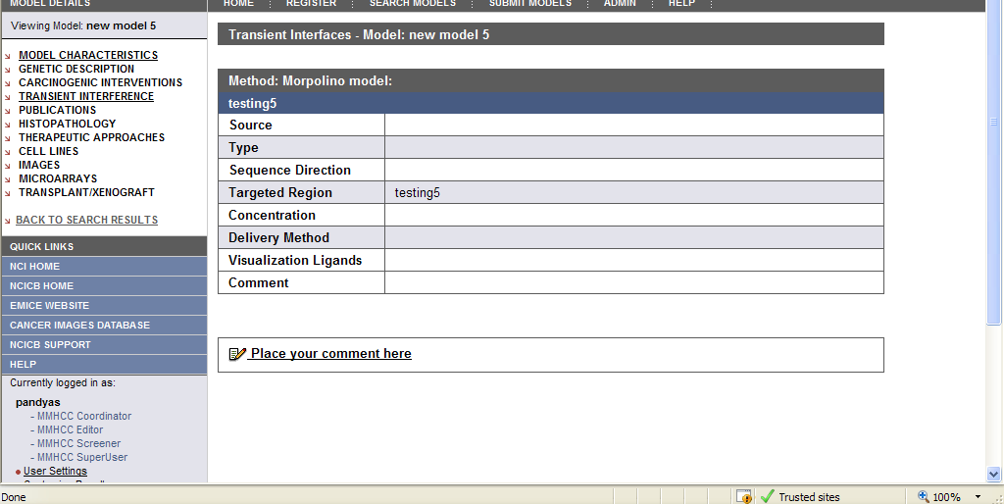

Interface Classes to be Modified
The following is a list of interface classes (GUI and interface java classes) that need to be modified.
Interface Class Name | Description
subSubmitMenu.jsp | Left menu bar – add link to enter siRNA models
submitSirna.jsp | siRNA model submission screen - new
submitMorpholino.jsp | Morpholino model submission screen – modified for object name change and added comment field
subViewModelMenu.jsp | Modified for object name change
viewTransientInterference.jsp | Added section for siRNA models
SideBarUtil.java | Controls which side bar is displayed with each JSP page. Added submitSirna.jsp
TransientInterferenceData.java (formerly named MorpholinoData.java) | Interface class for TransientInterferenceForm class (formerly named MorpholinoForm.java) - Modified for object name change
Configuration files to be added for new dropdowns menus for the new siRNA interface | sirnaDeliveryMethods.txt, sirnaSources.txt, sirnaTypes.txt, sirnaVisualLigands.txt

middle tier (CONTROLLER)

TransientInterferenceManagerImpl
TransientInterferenceManagerImpl.java (formerly named MorpholinoManagerImpl.java) is an existing class that manages persistence for Transient Interference objects (Morpholino and siRNA). The methods will remain the same except for the class name change.
Method Name | Description
getAll | Retrieves all the transient interference objects by id
get | Retrieves a single transient interference object by id
save | Saves a transient interference object
remove | Removes a single transient interference object and association to its animal model by id
create | Creates a transient interference object
update | Updates/ Modifies a single transient interference object by id

TransInterferenceMethodManagerImpl
TransInterferenceMethodManagerImpl.java is a new class that manages persistence for Transient Interference Method objects. This object servers as a lookup for the transient interference method. This implementation will allow the application to be easily extended to additional transient interference method types in the future. The methods for this class will be:
Method Name | Description
getAll | Retrieves all the transient interference method objects by id
getByConceptCode | Retrieves a single transient interference method object by its concept code

TransInterferenceMethodManager
TransInterferenceMethodManager.java is a new class that is an interface class to the TransInterferenceMethodManagerImpl.java class. The methods will be:
Method Name | Description
getAll | Retrieves all the transient interference method objects by id
getByConceptCode | Retrieves a single transient interference method object by its concept code

TransientInterferenceManagerSingleton
TransientInterferenceManagerSingleton.java (formerly named MorpholinoManagerSingleton.java) is an existing class that controls object creation for transient interference objects, limiting the number to one but allowing the flexibility to create more transient interference objects if the situation changes. Since there is only one Singleton instance, any instance fields of a Singleton will occur only once per class, just like static fields). There are no methods in this class.

TransIntMethodManagerSingleton
TransIntMethodManagerSingleton.java is a new class that controls object creation for transient interference method objects, limiting the number to one but allowing the flexibility to create more transient interference method objects if the situation changes. Since there is only one Singleton instance, any instance fields of a Singleton will occur only once per class, just like static fields). There are no methods in this class.

AnimalModelManagerImpl
AnimalModelManagerImpl.java is an existing class that manages persistence for Animal Model objects. One method will need to be modified.
Method Name | Description
addTransientInterference  (formerly named addMorpholino) | Adds a Transient Interference object to the Animal Model

AnimalModelManager
AnimalModelManager.java is an existing class that serves as an interface to the AnimalModelManagerImpl.java class. One method will need to be modified
Method Name | Description
addTransientInterference  (formerly named addMorpholino) | Adds a Transient Interference object to the Animal Model
    - QueryManagerImpl
QueryManagerImpl.java is an existing class that defines each query used to return data for all sections of the application. One method will need to be modified
Method Name | Description
getModelIdsForTransientInterference | Modified for object name change
    - TransientInterferenceAction
TransientInterferenceAction.java (formerly named MorpholinoAction.java) is an existing struts Action class that manages requests and creates form beans for transient interference objects, validates the form, and calls the action methods defined in the class. This class was renamed so it can support both Morpholino and siRNA models The methods will remain the same.
Method Name | Description
edit | Edits a single transient interference object by id
save | Saves a single transient interference object by id
    - MorpholinoPopulateAction
MorpholinoPopulateAction.java is an existing struts Action class that manages requests by the application to populate the struts Form during submission of a new transient interference (morpholino) and to repopulate the struts form with values from existing transient interference objects. The methods will remain the same.
Method Name | Description
populate | Populates data for an existing transient interference object by id
dropdown | Populates the drop-down menus for a transient interference object
    - SirnaPopulateAction
SirnaPopulateAction.java is a new struts Action class that manages requests by the application to populate the struts Form during submission of a new transient interference (siRNA) and to repopulate the struts form with values from existing transient interference objects. The methods will be the same as those in MorpholinoPopulateAction.java class.
Method Name | Description
populate | Populates data for an existing transient interference object by id
dropdown | Populates the drop-down menus for a transient interference object

AnimalModelTreePopulateAction
AnimalModelTreePopulateAction.java is an existing struts Action class that manages requests by the application to populate the left menu bar with hyperlinks for existing data types in an animal model. This class loops through all animal models submitted by a user and populates each data category with existing data. This class was modified in order to discriminate between Morpholino and siRNA transient interference objects. This class has only the default struts execute method.

TransientInterferenceForm
TransientInterferenceForm.java (formerly named MorpholinoForm.java) is an existing struts Form class that is able to transfer data between the Model and View layers. While ActionForm beans often have properties that correspond to properties in your Model beans, the form beans themselves should be considered a Controller component. The attributes defined will remain the same with the exception of two.
Method Name | Description
conceptCode | Added to support the addition of transient interface method object
comments | Added to interface

persistence layer
    - TransientInterference
TransientInterference.hbm.xml (formerly named Morpholino.hbm.xml) is an existing hibernate mapping file used to provide Hibernate with information to persist objects to the caMOD database. The mapping file will remain the same except for two additions.
Attribute Name | Description
comments | Mapping for the comments attribute for the object
transientInterferenceMethod | Mapping for the association to the transient interference method object

    - TransientInterferenceMethod
TransientInterferencemethod.hbm.xml is a new hibernate mapping file used to provide Hibernate with information to persist the transient interference object to the caMOD database. The mapping file will define three attributes (id, name, conceptCode).
    - AnimalModel
AnimalModel.hbm.xml is an existing hibernate mapping file used to provide Hibernate with information to persist the animal model object to the caMOD database. The mapping file will be modified to reference a transientInterferenceCollection rather than a morpholinoCollection (object name change).

database (MODEL)
    - TransientInterference
TransientInterference.java (formerly named Morpholino.java) is an existing domain object used to hold data for TransientInterference objects. The domain object will remain the same for two additions.
Attribute Name | Description
comments | Attribute for comments
transientInterferenceMethod | Attribute for the association to the transient interference method object
    - TransientInterferenceMethod
TransientInterferencemethod.java is a new domain object used to hold data for TransientInterferenceMethod objects. The domain object will have three attributes.
Attribute Name | Description
id | The object identifier.
name | The name of the transient interference method.
conceptCode | Concept unique identifier for the transient interference method

    - AnimalModel
AnimalModel.hbm.xml is an existing domain object used to hold data for Animal Model objects. The domain object will remain the same except for the reference to the transientInterferenceCollection instead of a morpholinoCollection (object name change).

configuration and utility classes
    - Configuration and Utility Files Changed
File Name | Function
applicationContext-service.xml | Registers manager classes in struts architecture.
struts-config.xml | Used by struts to define all form beans, global exceptions, global forwards, actions, plug-ins, and various resources used by the application.
Validation.xml | Configuration file that defines which validation routines are being applied to validate each Form Bean in the application.
Hibernate.cfg.xml | Used to hold definitions for database connection properties and hibernate mapping files.
ApplicationResources_en.properties | Properties file to hold the error messages for the application.
Constants.java | Defines all constants used in the application

components for additional administration features

user interface (VIEW)

Search Screen
The search results screen for the admin section under edit models will be modified to include an icon for duplicate and delete (inactivate) models. This will look similar to the submitModels.jsp screen.
Current Screen:
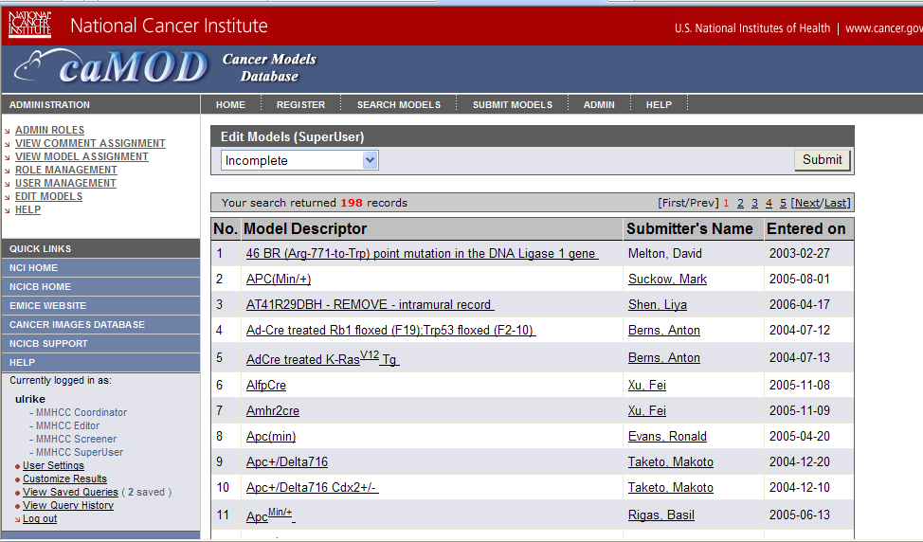
New Screen will look like this with the duplicate record, model descriptor, submitter’s name, entered on, and remove (inactivate) columns.
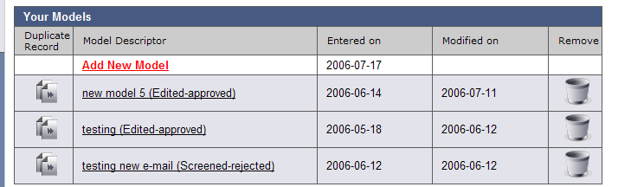

Model Status Screen
The model status screen in the admin section will be modified to include a drop-down list displaying the available states for a model. This will look similar to the adminEditModels.jsp screen.
Current Screen when a model is in the incomplete status (complete action appears):
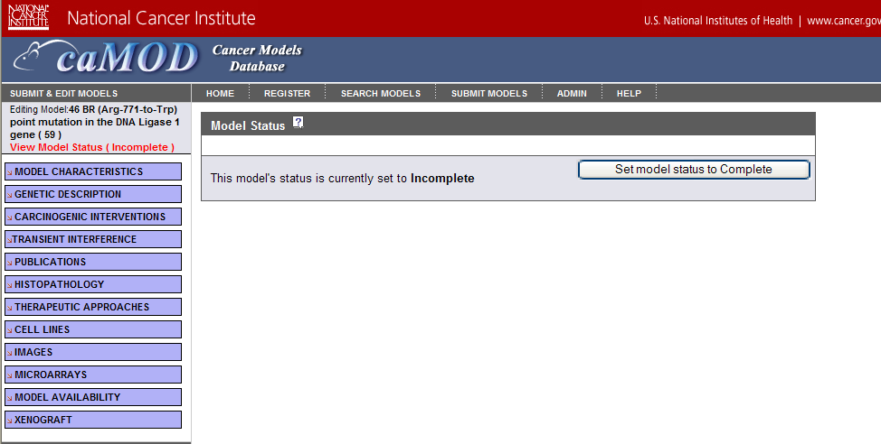
Current Screen when a model is in any status except incomplete:
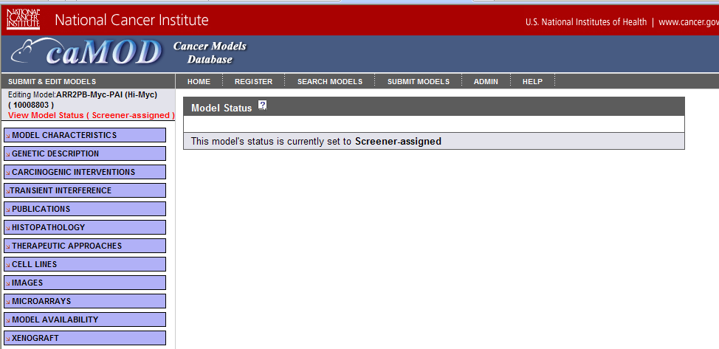
Drop-down menu to change state:
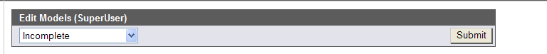

Interface Classes to be Modified
The following is a list of interface classes (GUI and interface java classes) that need to be modified.
Interface Class Name | Description
adminEditModels.jsp | Displays results for admin edit models sections – add icons for delete and remove (inactivate)
submitOverview.jsp | Displays model status – change to allow super user to changed state of model

middle tier (CONTROLLER)
    - ChangeAnimalModelStateAction
ChangeAnimalModelStateAction.java is an existing struts Action class that changes the model state from incomplete to complete on the submitOverview.jsp screen. This class will be modified to control all model state changes for super users. When a model is in any state, the drop-down box will appear (replace the completion action). This will allow the super user to change the model status to any of the existing model states.
    - AnimalModelManagerImpl
AnimalModelManagerImpl.java is an existing class that manages persistence for Animal Model objects. Change the way the duplicate method creates the model descriptor for the duplicated model from:
String theNewModelDescriptor = "Copy of " + theDuplicatedModel.getModelDescriptor();
to a indicate the “ModelDescriptor (Copy) “ so the models are listed consecutively.
Method Name | Description
duplicate | Duplicates model – change the way the ModelDescriptor is formated. Make the duplicated model name as “ModelDecriptor (Copy)” instead of “Copy of ModelDescriptor.”

configuration and utility classes
    - Configuration and Utility Files Changed
File Name | Function
Struts-config.xml | Add action definition(s) needed to change state of model. Add duplicate and remove action definitions, if not reused.
ApplicationResources_en.properties | Properties file to hold the global messages for application – add messages for state change, duplication, and removal (delete) of model.

components for submission of nomenclature and genotype information

user interface (VIEW)
The model characteristics submission screen will be modified to include input text boxes for genotype and nomenclature. The viewModelCharacteristics.jsp screen already displays genotype and nomenclature data for a model.
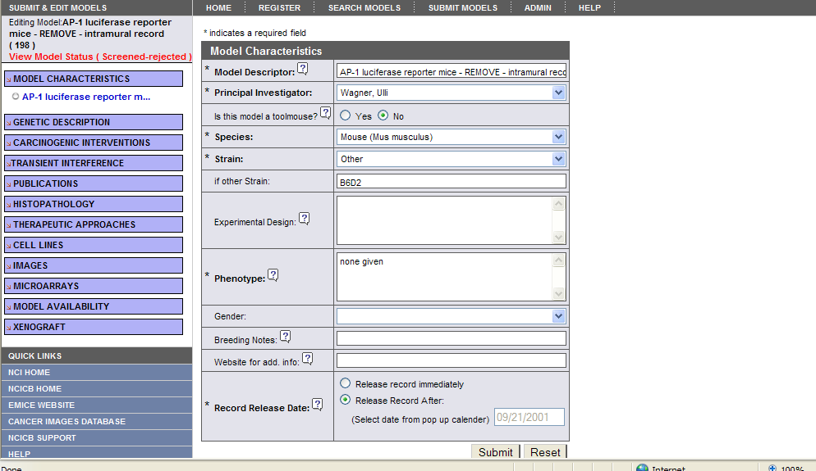

Interface Classes to be Modified
The following is a list of interface classes (GUI and interface java classes) that need to be modified.
Interface Class Name | Description
submitModelCharacteristics.jsp | Screen to edit model characteristics data for an existing model – Add input boxes for genotype and nomenclature.
submitNewModel.jsp | Submission screen for model characteristics data for a new model – Add input boxes for genotype and nomenclature.
viewModelCharacteristics.jsp | Displays model characteristics data for model – modify where the data originates (moved genotype and nomenclature object association from the EngineeredGene object to the Animal Model object)
ModelCharacteristicsData.java | Interface class for ModelCharacteristicsData class – Added variables to hold the new tool mouse (searchToolStrain ) and external source (externalSource) variables for the advanced search screen

middle tier (CONTROLLER)
    - SearchAction
SearchAction.java is an existing struts Action class that manages requests by the application to find models matching user search criteria. The execute method will be modified to retrieve image and microarray data for each model.
    - ModelCharacteristicsForm
ModelCharacteristicsForm.java is an existing struts Form class that is able to transfer data between the Model and View layers. While ActionForm beans often have properties that correspond to properties in your Model beans, the form beans themselves should be considered a Controller component. The attributes defined will remain the same with the exception of two additions.
Attribute Name | Description
genotype | Added to hold value for the genotype in the animal model table
nomenclature | Added to hold value for the nomenclature in the animal model table
    - AnimalModelAction
AnimalmodelAction.java is an existing struts Action class that manages requests and creates form beans for animal model objects, validates the form, and calls the action methods defined in the class. The methods will remain the same. Only the print / debug statement will be changed to include the two new attributes.
    - AnimalModelPopulateAction
AnimalmodelPopulateAction.java is an existing struts Action class that manages requests by the application to populate the struts Form during submission of a new Animal model and to repopulate the struts form with values from existing transient interference objects. The populate method will be modified to include code to repopulate the new genotype and nomenclature input bexes with data for the model.
Method Name | Description
populate | Populates data for an existing transient interference object by id
dropdown | Populates the drop-down menus for a transient interference object

AnimalModelManagerImpl
AnimalModelManagerImpl.java is an existing class that manages persistence for Animal Model objects. The methods that will be modified.
Method Name | Description
populateAnimalModel | Adds code to save the genotype and nomenclature input from the user.

persistence layer
    - EngineeredGene
EngineeredGene.hbm.xml is an existing hibernate mapping file used to provide Hibernate with information to persist engineered gene objects to the caMOD database. The association from EngineeredGene to GenotypeSummary object will be removed from the mapping file.
Attribute Name | Description
genotypeSummary | Mapping for the association to GenotypeSummary object (removed)

    - AnimalModel
AnimalModel.hbm.xml is an existing hibernate mapping file used to provide Hibernate with information to persist animal model objects to the caMOD database. The association from EngineeredGene to GenotypeSummary object will be removed from the mapping file. This association will be a one to one unidirectional association from the AnimalModel object to the GenotypeSummary object.
Attribute Name | Description
genotypeSummary | Mapping for the association to GenotypeSummary object (Added)

database (MODEL)
    - EngineeredGene
EngineeredGene.java is an existing domain object used to hold data for EngineeredGene objects. The GenotypeSummary attribute will be removed.
Attribute Name | Description
genotypeSummary | Mapping for the association to GenotypeSummary object

    - AnimalModel
AnimalModel.java is an existing domain object used to hold data for AnimalModel objects. The GenotypeSummary attribute and will be added. The getDistinctNomenclatureFromEngineeredGeneCollection method will be removed.
Attribute / Method Name | Description
genotypeSummary | Mapping for the association to GenotypeSummary object
getDistinctNomenclatureFromEngineeredGeneCollection | Used to get nomenclature information from the EngineeredGene object for the search screen for model characteristics (delete)

configuration and utility classes
    - Configuration and Utility Files Changed
File Name | Function
Validation.xml | Configuration file that defines which validation routines are being applied to validate each Form Bean in the application.  – add definitions for new attributes for ModelCharacteristicsForm (nomenclature and genotype)
ApplicationResources_en.properties | Properties file to hold the global messages for application – add definitions for new attributes for ModelCharacteristicsForm (nomenclature and genotype)

components for indicating if model has associated image or microarry

user interface (VIEW)

Search Screen
The search results screen for the simple and advanced search will be modified to include an icon next to the model descriptor to indicate if the model has associated image or microarray data. The user will be able to select the model and navigate to the image or microarray section to view the associated data.
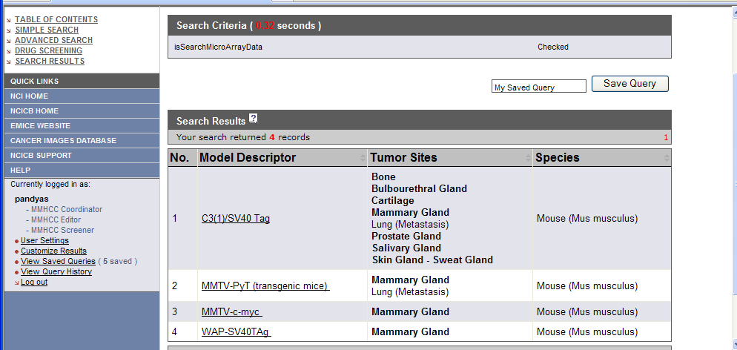

Interface Classes to be Modified
The following is a list of interface classes (GUI and interface java classes) that need to be modified.
Interface Class Name | Description
searchResults.jsp | Displays results for simple and advanced search – add icon for associated image or microarray data next to model descriptor

middle tier (CONTROLLER)
    - SearchAction
SearchAction.java is an existing struts Action class that manages requests by the application to find models matching user search criteria. The execute method will be modified to retrieve image and microarray data for each model.

Appendix A – acronym List
Acronym | Description
caMOD | Cancer Models Database
caIMAGE | Cancer Models Database
JSP | Java Server Pages
Morpholino | Morpholino phosphorodiamidate oligonucleotides
PubMed | PubMed is a service of the U.S. National Library of Medicine that includes over 16 million citations from MEDLINE and other life science journals for biomedical articles back to the 1950s.
RNA | Ribonucleic acid
siRNA | short interfering RNA

[APPENDIX B – DATABASE]
This section describes all changes made to the database/back end. The entity changes will be updated in the caMOD_release_2_2.EAP file in Enterprise Architect. The database changes will be updated in PVCS at the time of implementation.
- Abs_Cancer_Model
  - Modification
    - Purpose: In order to keep track of models loaded from external sources, two columns need to be add to this table: external_source and external_source_identifier
    - Schema: caMOD
    - Modification Script:
create table abs_cancer_model (
abs_cancer_model_id number(19,0) not null,
abs_cancer_model_type varchar2(255) not null,
experiment_design clob,
model_descriptor varchar2(255),
state varchar2(255),
availability_id number(19,0) unique,
strain_id number(19,0),
submitter_id number(19,0),
principal_investigator_id number(19,0),
url varchar2(255),
is_tool_mouse number(1,0),
repository_info_id number(19,0),
phenotype_id number(19,0),
administrative_site varchar2(255),
admin_site_unctrl_vocab varchar2(255),
external_source varchar2(255),
external_source_identifier varchar2(255),
genetic_manipulation varchar2(255),
modification_description varchar2(255),
parental_cell_line_name varchar2(255),
xenograft_name varchar2(255),
atcc_number varchar2(255),
cell_amount varchar2(255),
growth_period varchar2(255),
graft_type varchar2(255),
graft_type_unctrl_vocab varchar2(255),
tumor_code_id number(19,0),
donor_species_id number(19,0),
organ_id number(19,0),
par_abs_can_model_id number(19,0),
primary key (abs_cancer_model_id)
);
    - Procedure to Modify: Drop Abs_Cancer_Model and Create the new table. All new or changed database objects are included in the create-tables.sql script for camod_dev project.
OR
alter table abs_cancer_model
ADD external_source varchar2(255);
alter table abs_cancer_model
ADD external_source_identifier varchar2(255);
    - Data Modifications: All previous data for the table must be re-loaded into this table. The new coumns (external_source and external_source_identifier) will be populated directly from Jackson Lab data files.
    - Location of script: The create-tables.sql script is stored in PVS under the camod_dev project.

- Transient_Interference Table
  - Modification to Morpholino Table
    - Purpose: Changing the object name from Morpholino to Transient_Interference will allow the table to store both morpholino and siRNA data. Associating this table with the transient_interference_method table allows for easier extension to additional type os transient_interference models. The addition of a comments fields allows users to add comments about the submitted model.
    - Schema: caMOD
    - Modification Script: (change included in the camod create-tables.sql script)
create table transient_interference (
transient_interference_id number(19,0) not null,
source varchar2(255),
source_unctr_vocab varchar2(255),
type varchar2(255),
sequence_direction varchar2(255),
targeted_region varchar2(255),
concentration varchar2(255),
concentration_unit varchar2(255),
delivery_method varchar2(255),
delivery_method_unctrl_vocab varchar2(255),
visual_ligand varchar2(255),
visual_ligand_unctrl_vocab varchar2(255),
comments clob,
trans_interference_method_id number(19,0) unique,
abs_cancer_model_id number(19,0) not null,
primary key (transient_interference_id)
);
    - Procedure to Modify: Drop Morpholino and Create the new Transient_Interference table. All new or changed database objects are included in the create-tables.sql script for camod_dev project.
    - Data Modifications: All previous data for Mopholino must be re-loaded into this table with the transient_interference_method_id cooresponding to Morpholino phosphorodiamidate oligonucleotides ( id=1).
    - Location of script: The create-tables.sql script is stored in PVS under the camod_dev project.
- Transient_Interference_Method Table
  - New Table
    - Purpose: Serve as a lookup table for the transient interference method attribute stored in the transient_interface table
    - Schema: caMOD
    - Modification Script: (change included in the camod create-tables.sql script)
create table transient_interference_method (
trans_interference_method_id number(19,0) not null,
name varchar2(255),
concept_code varchar2(255),
primary key (trans_interference_method_id)
);
    - Data Modifications:
INSERT INTO transient_interference_method VALUES (1, ‘Morpholino phosphorodiamidate oligonucleotides’, ‘C60700’);

INSERT INTO transient_interference_method VALUES (2, ‘siRNA’,’C2191’);

    - Location of script: The create-tables.sql script is stored in PVS under the camod_dev project. The insert into scripts will be stored by the DBA in the repository for camod..
- Genotype_Summary Table
  - Modification
    - Purpose: Drop the Genotype column since it is unused and a duplicate of data already stored in the Summay column. This column has not been implemented in the application.
    - Schema: caMOD
    - Modification Script: (change included in the camod create-tables.sql script)
create table genotype_summary (
genotype_summary_id number(19,0) not null,
summary varchar2(255),
nomenclature_id number(19,0),
primary key (genotype_summary_id)
);
OR
ALTER TABLE genotype_summary
DROP COLUMN genotype;

    - Procedure to Modify: Run alter table script or drop Genotype_Summary table and re-create using the caMOD create-tables.sql script.
    - Data Modifications: All previous data for Genotype_Summary must be re-loaded into this table if table was dropped and re-created.
    - Location of script: The create-tables.sql script is stored in PVS under the camod_dev project.

- Engineered_Gene and Abs_Cancer_Model (from the Animal_Model) Tables
  - Modification
    - Purpose: Remove the association between genotype_summery and Engineered_gene and replace it with an association between genotype_summary and animal_model object. Make it a one to one relationship.
    - Schema: caMOD
    - Modification Script: (changes included in the camod create-tables.sql script)
create table engineered_gene (
engineered_gene_id number(19,0) not null,
engineered_gene_type varchar2(255) not null,
name varchar2(255),
comments varchar2(2000),
conditionality_id number(19,0) unique,
image_id number(19,0) unique,
mutation_identifier_id number(19,0) unique,
location_of_integration varchar2(255),
is_random number(1,0),
segment_size varchar2(255),
clone_designator varchar2(255),
construct_sequence clob,
segment_type_id number(19,0),
gene_id varchar2(255),
description varchar2(255),
genetic_alteration_id number(19,0) unique,
environmental_factor_id number(19,0),
es_cell_line_name varchar2(255),
blastocyst_name varchar2(255),
species_id number(19,0) unique,
abs_cancer_model_id number(19,0) not null,
primary key (engineered_gene_id)
);
create table abs_cancer_model (
abs_cancer_model_id number(19,0) not null,
abs_cancer_model_type varchar2(255) not null,
experiment_design clob,
model_descriptor varchar2(255),
state varchar2(255),
availability_id number(19,0) unique,
strain_id number(19,0),
submitter_id number(19,0),
principal_investigator_id number(19,0),
url varchar2(255),
is_tool_mouse number(1,0),
repository_info_id number(19,0),
phenotype_id number(19,0),
genotype_summary_id number(19,0) unique,
administrative_site varchar2(255),
admin_site_unctrl_vocab varchar2(255),
genetic_manipulation varchar2(255),
modification_description varchar2(255),
parental_cell_line_name varchar2(255),
xenograft_name varchar2(255),
atcc_number varchar2(255),
cell_amount varchar2(255),
growth_period varchar2(255),
graft_type varchar2(255),
graft_type_unctrl_vocab varchar2(255),
tumor_code_id number(19,0),
donor_species_id number(19,0),
organ_id number(19,0),
par_abs_can_model_id number(19,0),
primary key (abs_cancer_model_id)
);
    - Procedure to Modify: Run create-tables.sql script.
    - Data Modifications: All previous data for Genotype_Summary must be re-mapped into the abs_cancer_model table.
    - Location of script: The create-tables.sql script is stored in PVS under the camod_dev project.

[Appendix C – Other Appendix]
[Appendixes may be used to provide information published separately for convenience in document maintenance (e.g., charts, classified data). As applicable, each appendix shall be referenced in the main body of the document where the data would normally have been provided. Appendixes may be bound as separate documents for ease in handling. Appendixes shall be lettered alphabetically (A, B, etc.).]

