caMOD Release 2.7

Software Design Description
Version 1.0

[Insert approval date of document]

Document Change Record
Version Number | Date | Description
1.0 | 5/25/2010 | Initial document
1.1
1.2

TABLE OF CONTENTS
1. Introduction 4
1.1 Requirements Traceability 4
1.2 Background/Summary 4
2. System Overview 5
2.1.1 User Client Software 5
2.1.2 Back End 6
2.1.3 Hibernate 3 Data Access 6
2.1.4 JBoss Application Server 6
2.1.5 Database 6
2.1.6 Java 6
3. Upgrade caMOD to use caBIO 4.x and EVS 5.x to get data 7
3.1 user interface (VIEW) 7
3.1.1 therapeutic approaches search results screen (partial screen): 8
3.1.2 genetic description search results screen (current): 9
3.2 middle tier (CONTROLLER) 9
3.2.1 viewmodelAction 9
3.2.2 AgentManagerImpl class 9
3.3 configuration and utility classes 10
3.3.1 Configuration and Utility Files Changed 10
4. Upgrade caMOD to use EVS 5.1 to get current data 11
4.1 user interface (VIEW) 11
CHANGES FOUND IN WEB-INF\classes folder (unjar and expanded into temp) 16
[Appendix A – acronym List] 17
[APPENDIX B – DATABASE changes] 18

Introduction
The purpose of this document is to describe the design for the integration of caBIO 4.x and EVS 4.x upgrades in caMOD. caMOD currently uses caCORE 3.2 to aquire remote services to caBIO and EVS. After caCORE 3.2, EVS and caBIO were split into separate parts and the current version of caCORE is being depreciated in Q2 2009. Both upgrades include new jars, new configuration files, and new code and their integrations must work together inside caMOD. In addition, the EVStree application will be upgraded to use EVS 4.2 technology.

Requirements Traceability
Req # | Requirement Description
 | caMOD - Cancer Models Database - Feature Requests
 | Upgrade caMOD to use caBIO 4.x and EVS 5.x to get data

Background/Summary
The cancer models database (caMOD) is a web-based resource that provides information about animal models for human cancer to the public research community.
caMOD provides the following key capabilities to its users:

Data Submission--Data in caMOD are extracted from the public scientific literature by curators and verified by the scientists who generated or worked with the models, or they are directly submitted by scientists.

Cancer Model Search--Users can retrieve information about the making of models, their genetic descriptions, carcinogenic interventions, transient interference, histopathology, derived cell lines, associated images, microarray data, transplantations, and therapeutic trials in which the models were used. caMOD provides links to PubMed for associated publications and other resources such as mouse repositories, detailed information about altered gene, pathway affected, and information about human clinical trials that utilize the same compounds as the pre-clinical trials in the animal models.

System Function Administration--The Admin function provides services for user registration, review of submitted models and database management.

System Overview
The purpose of this section is to give an overview of the caMOD API. The following diagrams show the overall architecture and of the caMOD application.
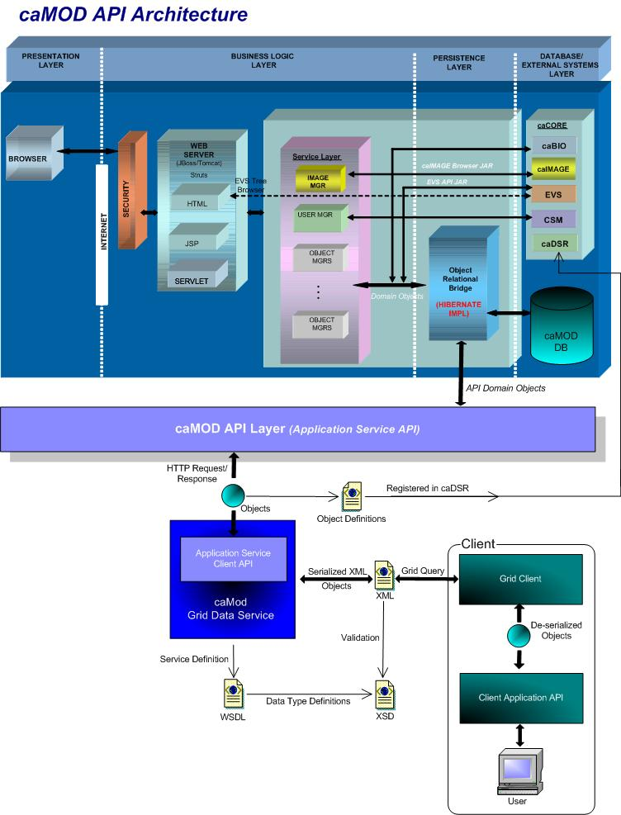

User Client Software
caMOD is a web based user interface implemented as HTML, JSP, JavaScript, and AJAX. The use of JavaScript is limited to improving usability only.
Java Server Pages (JSPs) are used to generate dynamic HTML based on user actions. JSPs are combinations of HTML, Java Code, and custom JSP and JSTL tags that get compiled into servlet classes.

Back End
The caMOD back end components provide access to persistence services for retrieving and storing data in the database. Hibernate, an open source tool, is used as the Object Relational Mapping (ORM) software.

Hibernate 3 Data Access
The ORM mapping is implemented using Hibernate version 3.x. Hibernate is a high performance object/relational persistence and query service for Java. Hibernate provides the ability to develop persistent classes following common object-oriented (OO) design methodologies such as association, inheritance, polymorphism, and composition.
The Hibernate Query Language (HQL), deigned as a “minimal” object-oriented extension of SQL, provides a bridge between the object and relational databases. Hibernate allows for real world modeling of biological entities without creating complete SQL-based queries to represent them.

JBoss Application Server
The user interface, middle tier, and backend components are run with in JBoss Java2 Enterprise Edition (J2EE) application server. JBoss is an open source application server that provides a servlet container, an EJB container, the full range of J2EE 1.4 features as well as extended enterprise services including clustering, caching and persistence. JBoss 4.0.5 conforms to the newest technology stack. It will be consistent with many other applications.

Database
Oracle Relation Database Management System (RDBMS) software is used as the persistent store for caMOD and caIMAGE application data. Java classes access the database using the Java Database Connectivity (JDBC) API.

Java
The new version of Java1.5 (Java tool kit version jdk1.5.0_10) is used for compilation. Therefore all the code in caMOD has been compiled using the JDK 1.5 version. This will conform to the latest technology stack currently used by NCI.

Upgrade caMOD to use caBIO 4.x and EVS 5.x to get data

user interface (VIEW)
The caMOD application connects to caBIO to retrieve additional data for the Therapeutic Approaches and Genetic Description search results screens. On the Therapeutic Approaches search results screen caMOD displays clinical trials data from caBIO. On the Genetic Description search results screen caMOD displays additional data within the Targeted Modification section for “Gene Info” (official nomenclature of the gene), Database Links to UniGene and CGAP, “Gene Ontology” (controlled vocabulary to describe gene and gene product attributes), and “BioCarta Pathways”. I
In addition, all the vocabulary is being server by a connection to EVS API.
Currently caMOD is using caCORE 3.2 to retrieve all its data from caBIO and EVS. In Q2 of 2009, caCORE 3.x (all versions) will be deprecated and no longer available for use in applications. In the new version of the caCORE technology the caBIO and EVS application services were separated into individual services.
We will upgrade caMOD to use EVS 4.2 and caBIO 4.0. This will correspond to the upgrade we will perform on the EVSTree application (upgrade to EVS 4.2).
There should be no difference in the display of data for any of the submission or search results screens. We anticipate a small change in some of the vocabulary trees, but the change will not be detrimental to the user.

therapeutic approaches search results screen (partial screen):
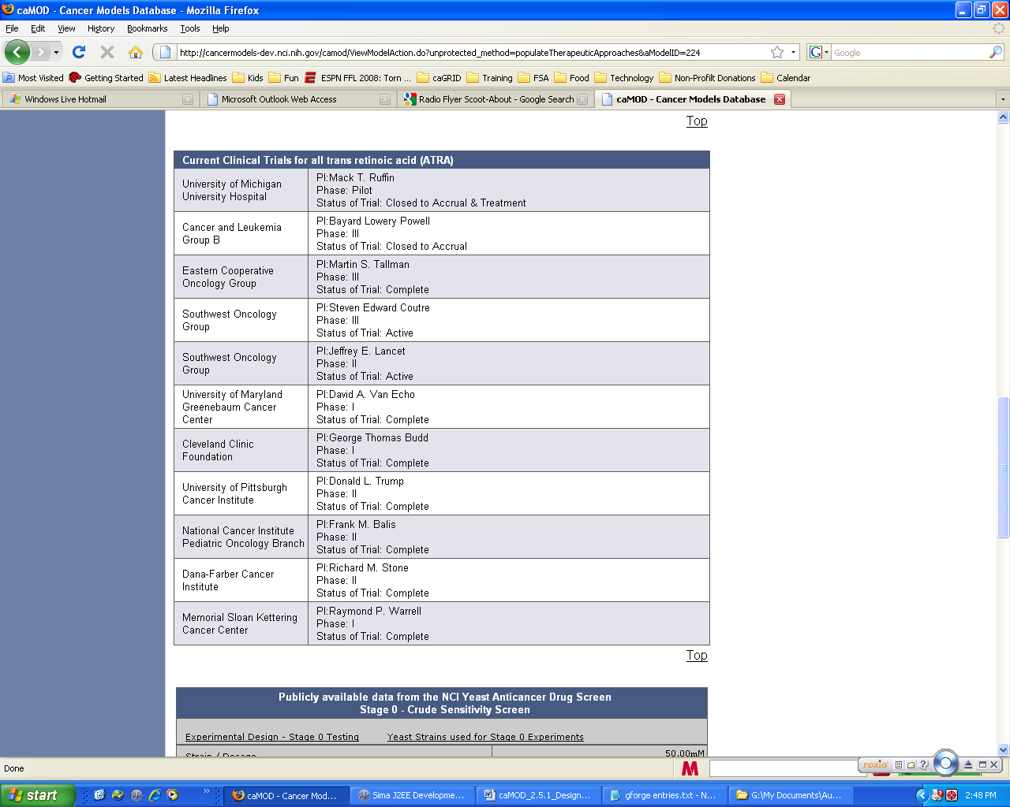

genetic description search results screen (current):
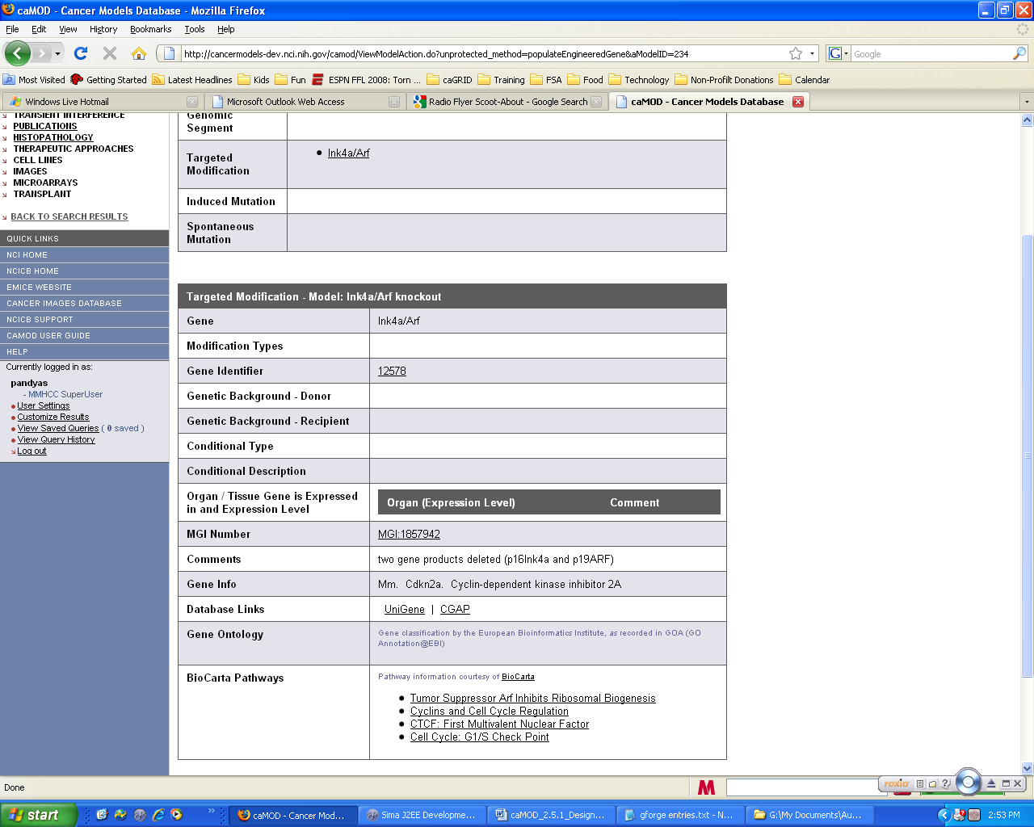

middle tier (CONTROLLER)

viewmodelAction
ViewModelAction.java is an existing struts Action classes that manage requests by the application to populate the struts Form during submission of a new object and to repopulate the struts form with values from the existing object. The following modification will be made:
Method Name | Description
populateTherapeuticApproaches.java | Modify code to retrieve data from new caBIO 4.2 instance.

AgentManagerImpl class
AgentManagerImpl.java is an existing class that manages persistence for the Agent object. The method that will be modified this class is listed below.
Method Name | Description
getClinicalProtocols.java | Modified code to save get new connection to caBIO 4.2 in the new caCORE architecture structure.

configuration and utility classes
    - Configuration and Utility Files Changed
File Name | Function
Constants. java | Configuration files to hold global constants for the application. Add constant for the connection to caBIO 4.x which was separated from the connection to EVS 4.x in the new caCORE.
EVSTreeUtil.java | The EVSTreeUtil.java class was created to handle the code to fetch/cache EVS data. This class also contains the code to call the application server. The application server call will be modified to connect to caBIO 4.2.

Upgrade caMOD to use EVS 5.1 to get current data

user interface (VIEW)
The caMOD application connects to caBIO to retrieve additional data for the Therapeutic Approaches and Genetic Description search results screens. On the Therapeutic Approaches search results screen caMOD displays clinical trials data from caBIO. On the Genetic Description search results screen caMOD displays additional data within the Targeted Modification section for “Gene Info” (official nomenclature of the gene), Database Links to UniGene and CGAP, “Gene Ontology” (controlled vocabulary to describe gene and gene product attributes), and “BioCarta Pathways”.
Currently caMOD is using caBIO 4.0 to retrieve additional data from caBIO because it integrates with EVS 4.2. There was no option to use a higher version of caBIO since EVS API was using a older version of SDK to generate its code base. This was discussed with both teams and resolved for the current caMOD upgrade.
We will upgrade caMOD to use caBIO version 4.3.1 and LexEVS 5.1. The LexEVS 5.1 version will also be used to in the EVSTree application upgrade.
There should be no difference in the display of data for any of the search results screens.
Steps 2: Background:
caBIO Version | SDK Version Used | SDK Version Used | EVS Version
caBIO 4.3.1 | SDK 4.1.1  caCORE_SDK_411-src.zip | SDK 4.1.1  the official release tag of 4.1.1 | EVS 5.1
caBIO 4.3 | SDK 4.1.1  caCORE_SDK_411-src.zip | SDK 4.1.1  the official release tag of 4.1.1 | EVS 5.0
caBIO 4.2 | SDK 4.0.1  CACORE_SDK_401_RC1_04152008
caBIO 4.1 | SDK 4.0.1  CACORE_SDK_401_RC1_04152008
caBIO 4.0 | SDK 4.0  CACORE_SDK_40_RC2_11022007 | SDK 4.0  CACORE_SDK_40_RC2_11022007 | EVS 4.2

The previous upgrade consisted of caBIO 4.0 and EVS 4.2 (caMOD 2.5.1)
The current upgrade consists of caBIO 4.3.1 and EVS 5.1 (caMOD 2.7)

Jar name | caBIO 4.3.1 | LexEVS 5.1 | EVSTree51/ caIMAGE | caMOD 2.6.1 | Action
acegi-security-1.0.4.jar | Y | y | Y / y | y | None
antlr-2.7.6.jar | Y | y | y | y | None
activation.jar (origin?) | n | n | Y | n | Later
antlr-2.7.6rc1.jar | n | n | N / n | y | Test, if needed
asm.jar | y | y | Y | y | None
axis.jar | y | Y | y | y | None
cabio40-beans.jar | N | n/a | n/a | y | remove
cabio43-beans.jar | Y | n/a |  | n | add
cabio40-client-framework.jar (removed) | N | n/a | n/a | y | remove
cabio43-client-framework.jar | Y | n/a | n/a | n | add
caGrid-CQL-cql.1.0-1.2.jar | Y | Y | y | y
castor-1.0.2.jar | Y | Y | y | y | Remove older version
castor-1-2.jar | n/a | Y | y | y | Leave newer version
castor-bean-serializer.jar | n/a | Y | y | n | Add new file
cglib-2.1.3.jar | Y | Y | y | y | None
cog-jglobus.jar | Y | Y | y | n | Add new file
commons-cli-1.0.jar | n/a | Y | y | n | Add new file
commons-codec.jar | n | n | n | y | Remove older version (added 2005)
commons-codec-1.3.jar | Y | Y | Y / y | y | none
commons-collections-2.1.1.jar | N | N | N / n | y | Remove older version
commons-collections-3.2.jar | Y | Y | y | y | none
commons-discovery-0.2.jar | Y | Y | y | n | Add new file
commons-lang-2.0.jar | N | Y | y | y | Removed older version
commons-lang-2.2.jar | N | Y | y | N | Add newer version (added 2005)
commons-logging-1.1.jar | Y | Y | N / y | n | Removed to avoid logging error in JBoss
commons-pool-1.3.jar | n | Y | Y | y | None
dlbadapter.jar | n/a | N | Remove / n | y | remove
dom4j-1.4.jar | Y | n/a | N | n | Older version
dom4j-1.6.1.jar | N | n/a | N | y | Leave newer version in project, test
ejb3-persistence.jar | N | n/a | n/a | y | None, not sure if for caELMIR
handle.jar | N | n/a | n/a | y | None, not sure what this is for
handlerservice.jar (removed) | N | n/a | n/a | y | None, not sure what this is for
hibernate3.jar (previous version 3.2.1) | hibernate3.jar (version 3.2.0) | Y | Y / y | hibernate3.jar (version 3.1.3) | Leave current version for now, test
hibernate-annotations.jar (removed) | N | n/a | n/a | y | Remove??
hibernate-commons-annotations.jar (removed) | N | n/a | n/a | y | Remove??
hibernate-search.jar | Y | n/a | n/a | y | Remove??
jakarta-regexp-1.4.jar * | n/a | Y | Y | n | add
Jakarta-oro.jar | n | n |  | y | ??
jaxrpc.jar | y | Y | Y | n | Add new file
Jsr107cache.jar | n/a | n | Y / n |  | Removed from EVSTree
lexbig.jar | n/a | Y | Y | y | Add new version
Lexevsapi51-beans.jar | n/a | Y | Y |  | Add new file
lexevsapi51-client.jar | n/a | Y | Y |  | Add new file
Lexevsapi51-framework.jar | n/a | Y | Y |  | Add new file
LexEVSSecurity.jar | n/a | Y | Y |  | Add new file
log4j-1.2.14.jar | Y | Y | Y | n | Not needed in lib folder of project
lucene-core-2.3.2.jar | n/a | N | N | y | Remove old version
lucene-core-2.4.0.jar | n/a | Y | Y | n | Add new version
lucene-regex-2.3.2.jar | N | Y | Y | y | Remove old version
lucene-regex-2.4.0.jar | N | Y | Y | n | Add new version
lucene-snowball-2.3.2.jar | n/a | N | N | y | Remove old version
lucene-snowball-2.4.0.jar * | n/a | Y | Y | n | Add new version
org.eclipse.emf.ecore.xmi_2.2.1.  v200609210005.jar | n/a | Y | Y | n | Add new file
org.eclipse.emf.ecore_2.2.1.  v200609210005.jar | n/a | Y | Y | n | Add new file
sdk-client-framework.jar | Y | Y | Y | y | Must use newest EVS version  Add new version from LexEVS
sdk-grid-remoting.jar | Y | Y | Y | n | Add new file from LexEVS
sdk-security.jar | Y | Y | Y | n | Add new file from LexEVS
spring.jar | Y | 2.0.3 | Y | 2.0.3 | None, test
umlslicense.jar | N | N | Y | y | Remove??
xercesImpl.jar | Y | Y | y | y | None, test
xml-apis.jar | n | n | y | y | None
xml-mappning.xml  (caCORE reference) | n | n | Y / n | n | None  Removed from EVSTree
xml.properties  (supports xml-mapping.xml) | n | n | Y / n | n | None  Removed from EVSTree

Note: CONF FOLDER
application-config-client-local.xml (renamed for caBIO)
application-config-client-remote.xml (renamed for LexEVS)
application-config-client.xml (References both above files)
caBIO (4.3.1) | LexEVS 5.1
application-config-client.xml |  |  | Rename to application-config-client-local.xml  Add new version
 | application-config-client.xml |  | Rename to application-config-client-remote.xml  Add new version
application-config-client-info.xml | application-config-client-info.xml |  | Add new file, merge LexEVS beans into caBIO file
gov.nih.nci.cabio.domain.xsd |  |  | Add new version
gov.nih.nci.cabio.pathways.xsd |  |  | Add new file
gov.nih.nci.common.domain.xsd |  |  | Add new version
gov.nih.nci.common.provenance.  domain.xsd |  |  | Add new version
mapping.dtd | mapping.dtd |  | Both same contents, Added caBIO copy of new file
unmarshaller-xml-mapping.xml |  |  | Add new version
xml-mapping.xml |  |  | Add new version

1) The configurations files will need to be merged manually. In the case of the Spring configuration files, the beans inside each file will need to be renamed so they don't conflict.

2) As far as libraries go, there are a few conflicts, but it should be possible to just choose the newer version in each case. For example, EVS uses Hibernate 3.2.0, while caBIO used 3.2.1, so you would take the jar from caBIO. The one tricky case is sdk-client-framework.jar, where you must use the EVS version, because EVS adds its own classes to the SDK jar.

Step 1: Modify camod.properties file on local instance
Added jars according to rules and most current version
Added conf from caBIO only
Start JBoss – no glaring errors (log4j error – look at later)
Go to localhost/camod
Upgraded to log4j-1.2.15.jar
Modified EVStreeUtil.java
Changed methods to return specific ApplicationService for caBIO and EVS:
public static CaBioApplicationService getCabioApplicationService()
public static EVSApplicationService getApplicationService()
Note: EVS getPreferredName() code now works but is depreciated and should be investigated later
application-config-client.xml Error for EVS – must add code for that file from conf folder
OPTION from application-config-client.xml (files from EVS conf folder were merged with files from caBIO conf folder)

http://lexevsapi.nci.nih.gov:80/lexevsapi42/http/applicationService
OPTIONS from TestEVS.java:
String genUrl = "http://cbvapp-d1007.nci.nih.gov:19080/evsapi41";
String _service = "EvsServiceInfo";

try
{
EVSApplicationService appService = (EVSApplicationService) ApplicationServiceProvider.getApplicationServiceFromUrl(genUrl, _service);

OPTION from TestClient.java
String _service = "EvsServiceInfo";
public void testSearch() throws Exception
{
EVSApplicationService appService = (EVSApplicationService)ApplicationServiceProvider.getApplicationService(_service);
try
{
DescLogicConcept dlc = new DescLogicConcept();
dlc.setName("ear*");
Collection results = appService.search("gov.nih.nci.evs.domain.DescLogicConcept", dlc);
Separated the application-config-client.xml:
Application-config-client.xml contains calls to import an application-config-local.xml and application-config-remote.xml files
application-config-local.xml contains the caBIO contents
application-config-remote.xml contains the EVS contents

Modified the call in EVSTreeUtil.java:
appService = (EVSApplicationService) ApplicationServiceProvider.getApplicationServiceFromUrl(serverURL, "EvsServiceInfo");

CHANGES FOUND IN WEB-INF\classes folder (unjar and expanded into temp)
evsconfig.properties
#serverURL = http://cabio.nci.nih.gov/cacore32/http/remoteService
serverURL = http://evsapi.nci.nih.gov/evsapi42/http/remoteService
EvsWebTreeImpl.java
Public EvsWebTreeImpl() changed
getResults() changed

[Appendix A – acronym List]
Acronym | Description
caMOD | Cancer Models Database
JSP | Java Server Pages
Morpholino | Morpholino phosphorodiamidate oligonucleotides
PubMed | PubMed is a service of the U.S. National Library of Medicine that includes over 16 million citations from MEDLINE and other life science journals for biomedical articles back to the 1950s.
RNA | Ribonucleic acid
siRNA | short interfering RNA

[APPENDIX B – DATABASE changes]
This section describes all changes made to the object model and database/back end. The entity changes will be updated in the caMOD_release_2_5.1.EAP file in Enterprise Architect. The database changes will be updated in CVS at the time of implementation.
Examples

