Software Requirements Specification
caMOD 2.5.1
NCICB

DOCUMENT REVISION HISTORY
Version Number | Date | Description
1.0 | February 6, 2008 | - Initial Draft
1.1
1.2
1.3
1.4

Background/Summary

The cancer models database (caMOD) is a web-based resource that provides information about animal models for human cancer to the public research community.

caMOD provides the following key capabilities to its users:

- Data Submission--Data in caMOD are extracted from the public scientific literature by curators and verified by the scientists who generated or worked with the models, or they are directly submitted by scientists.

- Cancer Model Search--Users can retrieve information about the making of models, their genetic descriptions, carcinogenic interventions, transient interference, histopathology, derived cell lines, associated images, transplantation, microarray data, and therapeutic trials in which the models were used. caMOD provides links to PubMed for associated publications and other resources such as mouse repositories, detailed information about altered gene, pathway affected, and information about human clinical trials that utilize the same compounds as the pre-clinical trials in the animal models.

- System Function Administration--The Admin function provides services for user registration, review of submitted models and database management.
Table of Content
1 Introduction 5
1.1 Overview for 2.5.1 5
2 Actors and Authorization 5
3 Use Cases 7
3.1 Take existing test scripts and run them in Selenium and CruiseControl 8
3.1.1 Use Case Model 8
3.1.2 Supplemental Requirements 9
3.2 LexBig Prototype: Investigate and demo connection to LexBig Vocabulary System / Architecture 9
3.2.1 Use Case Model 9
3.2.2 Supplemental Requirements 10
3.3 Submitting Micro array data that are stored in other applications than caArray 10
3.3.1 Use Case Model 10
3.3.2 Supplemental Requirements 11
3.4 Do not delete Environmental Factor objects – instead reuse and leave in DB 11
3.4.1 Use Case Model 11
3.4.2 Supplemental Requirements 12
3.5 Use improved PubMed fetch script on publication submission page 12
3.5.1 Use Case Model 12
3.5.2 Supplemental Requirements 13
3.6 Duplicate Model – Status of duplicated model should default to “Incomplete” 13
3.6.1 Use Case Model 13
3.6.2 Supplemental Requirements 14
3.7 Duplication does not work for some fields 14
3.7.1 Use Case Model 14
3.7.2 Supplemental Requirements 15
3.8 Add search for PMID to advanced search page 15
3.8.1 Use Case Model 15
3.8.2 Supplemental Requirements 16
3.9 Save query function broken - Fix 16
3.9.1 Use Case Model 16
3.9.2 Supplemental Requirements 17
3.10 Customize publication pages for rat to allow submission and display of RGD references 17
3.10.1 Use Case Model 17
3.10.2 Supplemental Requirements 18
3.11 Release date selection not maintaining value 18
3.11.1 Use Case Model 18
3.11.2 Supplemental Requirements 19
3.12 Add link to PDF users guide to quick links menu 19
3.12.1 Use Case Model 19
3.12.2 Supplemental Requirements 20
3.13 Give fields in “Customize Results” feature meaningful names 20
3.13.1 Use Case Model 20
3.13.2 Supplemental Requirements 20
3.14 Place a URL field on the image page 20
3.14.1 Use Case Model 20
3.14.2 Supplemental Requirements 21
3.15 Change spelling of Equus Caballus - start Caballus with a lower case "c" 21
3.15.1 Use Case Model 21
3.15.2 Supplemental Requirements 22
3.16 Delete Sequnce ID field from genetic description search page, targeted modification table 22
3.16.1 Use Case Model 22
3.16.2 Supplemental Requirements 23
3.17 Induced mutation entries need to be flagged 23
3.17.1 Use Case Model 23
3.17.2 Supplemental Requirements 24
3.18 Rename OtherLocationURL in microarray object to url 25
3.18.1 Use Case Model 25
3.18.2 Supplemental Requirements 25
3.19 *** EMPTY 26
3.19.1 Use Case Model 26
3.19.2 Supplemental Requirements 26
3.20 *** EMPTY 27
3.20.1 Use Case Model 27
3.20.2 Supplemental Requirements 27
3.21 *** EMPTY 28
3.21.1 Use Case Model 28
3.21.2 Supplemental Requirements 28
4 General Requirements 29
4.1 Requirements Prioritization 29
5 Data Definitions 29
6 Sign Off 30
6.1 Approval 30

Introduction

Overview for 2.5.1
caMOD 2.5.1 is a maintenance build. This build will include a variety of bug fixes and small feature requests. The build also includes required technical upgrades to the connections to caBIO and EVS applications.

Actors and Authorization

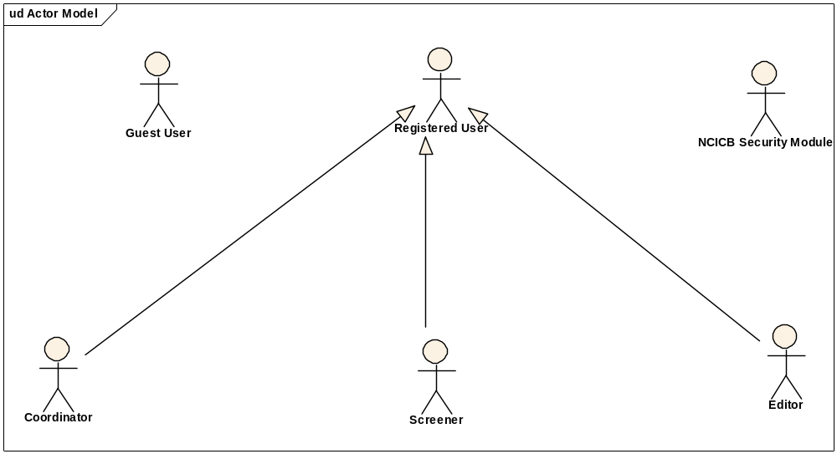
Guest User: Includes every user without an account. These users can query the database without restrictions, but they cannot submit models or comment on models.
Registered User: Can submit models to the database and can comment on models submitted by other researchers.
Super User (not shown): Has access to all model entries to update them. This is to facilitate minor text corrections in an entry without having to bother the submitter.
Coordinator: The coordinator is a registered user who appoints screener and editors. The coordinator also grants access privileges and manages the review process. After a model has been entered the coordinator assigns a screener who will check that all required fields have been specified and that the model does not contain junk or grossly inappropriate material. The coordinator will be informed about the decision of the screener by email. If the screener accepted the model the coordinator then assigns the model to an editor, who is a content expert.
Screener: The Screener is a registered user who performs the initial review of submitted models. This review is a quick check that all required fields have been specified and that the model does not contain junk or grossly inappropriate material. The screener also makes a preliminary assessment for clarity, typographic errors and other issues that would make the model less than fully comprehensible. The screening process should be complete within 24 hours. The screener does not contact the submitter about the submission. Any deficiencies found are described in the email to the coordinator. Each email deals with only one submission, so that the emails can be independently routed for vetting.
Editor: The Editor is a registered user who examines a model to see if it satisfies criteria to be made available to the public. The editor also considers any comments, made by the screener, that are passed along in the email from the coordinator. The editor may determine that the model cannot be made acceptable for publication in the database because it requires additional data. If the model has correctable defects, it may be necessary to communicate by email with the submitter to make the model acceptable. Correspondence and telephone contact with the submitters may be conducted through the coordinator. Editors are responsible for maintaining a paper trail or log of email exchanges regarding the models they review. The editor may elect to review a model without assistance. He or she can also request assistance from other subject matter experts. Only the editor has the authority to release the model to the intended audience.

Use Cases

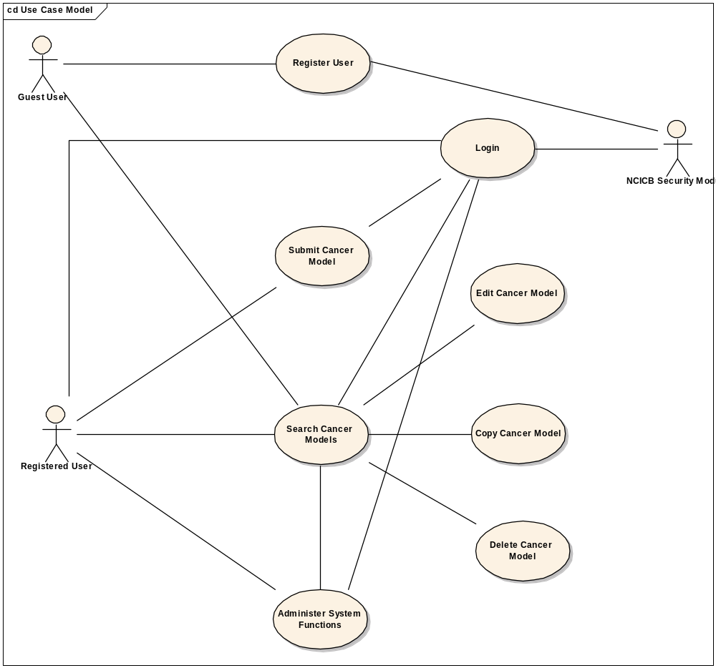
Figure 1. caMOD Use Case Diagram

Amount of cells on Transplantation needs to accept 10^6 instead of a number (validation)l

Use Case Model

Use Case Name | Amount of cells on Transplantation needs to accept 10^6 instead of a number (validation)
Use Case ID | 5235
Primary Actor | All registered users
Brief Description
Trigger | Actor navigates to the caMOD URL
Pre-conditions | Successful navigation to the caMOD URL  Successful login to caMOD
Flow of Events | 1. The system presents search and submit models hyperlinks.
Flow of Events | 2. The actor
Flow of Events | - Navigates to the new model submission section  - Successfully enters the data to create an animal model
Flow of Events | 3. The system
Flow of Events | - Returns the data-type categories for submitting data
Flow of Events | 4. The actor
Flow of Events | - Navigates to the Transplantation submission section  - Enters data for the amount of cells including 10<sub>6</sub> and submits form
Flow of Events | 5. The system
Flow of Events | - Saves the data for the submitted model
Post Conditions | Success Condition: User creates new model and submits data for appropriate section.  Error Condition: Fails to create new model  Error Condition: Validation fails  Error Condition: System Error
Alternative Courses of Action | If a validation error occurs, the system throws an exception, displays an error message and re-displays page for data entry.  a. Fails to create new model  -Re Submit new model data (Return to step 2a)  -Contact system administrator  b. Validation fails  - Re-enter required data for model Return to step 2a)  c. System Error.  -Contact system administrator
Issues

Supplemental Requirements
None

Construct sequence field on genetic description pages is independent of image submission

Use Case Model

Use Case Name | Construct sequence field on genetic description pages is independent of image submission
Use Case ID | 11623
Primary Actor | All registered users
Brief Description
Trigger | Actor navigates to the caMOD URL
Pre-conditions | Successful navigation to the caMOD URL  Successful login to caMOD
Flow of Events | 1. The system presents search and submit models hyperlinks.
Flow of Events | 2. The actor
Flow of Events | - Navigates to the new model submission section  - Successfully enters the data to create an animal model
Flow of Events | 3. The system
Flow of Events | - Returns the data-type categories for submitting data
Flow of Events | 4. The actor
Flow of Events | - Navigates to the Genetic Description submission section  - Navigates to the various  - Enters data for the siRNA or Morpholino and submits form
Flow of Events | - Navigates to the Histopathology submission section  - Enters data specific to zebrafish anatomy vocabulary and submits form
Flow of Events | 5. The system
Flow of Events | - Saves the data for the submitted model
Post Conditions | Success Condition: User creates new model and submits data for appropriate section.  Error Condition: Fails to create new model  Error Condition: Validation fails  Error Condition: System Error
Alternative Courses of Action | If a validation error occurs, the system throws an exception, displays an error message and re-displays page for data entry.  a. Fails to create new model  -Re Submit new model data (Return to step 2a)  -Contact system administrator  b. Validation fails  - Re-enter required data for model Return to step 2a)  c. System Error.  -Contact system administrator
Issues

Supplemental Requirements
None

General Requirements

Requirements Prioritization

Req # | Use Case Name
 | caMOD - Cancer Models Database - Bugs
5235 | Amount of cells on Transplantation needs to accept 10^6 instead of a number (validation)
11623 | Construct sequence field on genetic description pages is independent of image submission
12483 | Why does unpublished entry not show up on publication search page
17320 | Make sure all field sizes in database are validated correctly in validation.xml
17993 | The autocomplete Servlet.service() throws java.lang.OutOfMemoryErro: Java heap space
18267 | No other zebrafish diagnosis shown on search page
18694 | Correct the spelling of Motility on Therapy/Biological Process page
 | caMOD - Cancer Models Database - Feature Requests
17040 | Make PMID field on advanced search page userfriendlier by adding a link to PubMed and trim functions
17321 | Configure caMOD to run in JBoss 4.0.4 and JBoss 4.0.5
17325 | Upgrade caMOD to use caBIO 4.0 to get data
19107 | Clean up unused tables in database - backup and tmp tables
19205 | Sort therapies in the order they are entered

Data Definitions

CDE # | Data Element | Description | Use Case Name

Sign Off

Approval

Workspace General Contractor Rep Print Name Date
Architecture Workspace Rep Print Name Date
VCDE Workspace Rep Print Name Date
Workspace Working Group Rep Print Name Date
NCICB Rep Print Name Date

