caMOD Release 2.4

Software Design Description
Version 1.0

[Insert approval date of document]

Document Change Record
Version Number | Date | Description
1.0 | 10/13/2007 | Initial document
1.1 | 10/15/2007 | Added details and screen shots
1.2
1.3
1.4
1.5

TABLE OF CONTENTS
1. Introduction 4
1.1 Requirements Traceability 4
1.2 Background/Summary 4
2. System Overview 5
2.1.1 User Client Software 5
2.1.2 Back End 6
2.1.3 Hibernate 3 Data Access 6
2.1.4 JBoss Application Server 6
2.1.5 Database 6
2.1.6 Java 6
3. import caELMIR study data for camod therapy screen 7
3.1 user interface (VIEW) 7
3.1.1 view therapeutic approaches screen 7
3.1.2 Additional data from caELMIR 9
3.1.3 Interface Classes to be Modified 10
3.2 middle tier (CONTROLLER) 10
3.2.1 Form classes 10
3.2.2 Action classes 10
3.2.3 viewmodelAction 10
3.3 configuration and utility classes 10
3.3.1 Configuration and Utility Files Changed 10
3.3.2 Data Source for new caMOD therapy data 11
[Appendix A – acronym List] 13
[APPENDIX B – caelmir screen shots] 14
[APPENDIX C – TBD] 17

Introduction
The purpose of this document is to describe the design for the enhancements that are being developed for caMOD release 2.4. The one enhancement includes: import caELMIR study data for the therapeutic approaches search results screen.

Requirements Traceability
Req # | Requirement Description
8816 | Connection to caELMIR - retrieve data for therapy search page

Background/Summary
The cancer models database (caMOD) is a web-based resource that provides information about animal models for human cancer to the public research community.
caMOD provides the following key capabilities to its users:

Data Submission--Data in caMOD are extracted from the public scientific literature by curators and verified by the scientists who generated or worked with the models, or they are directly submitted by scientists.

Cancer Model Search--Users can retrieve information about the making of models, their genetic descriptions, histopathology, derived cell lines, associated images, carcinogenic interventions, microarray data, and therapeutic trials in which the models were used. caMOD provides links to PubMed for associated publications and other resources such as mouse repositories, detailed information about altered gene, pathway affected, and information about human clinical trials that utilize the same compounds as the pre-clinical trials in the animal models.

System Function Administration--The Admin function provides services for user registration, review of submitted models and database management.

System Overview
The purpose of this section is to give an overview of the caMOD API. The following diagrams show the overall architecture and of the caMOD application.
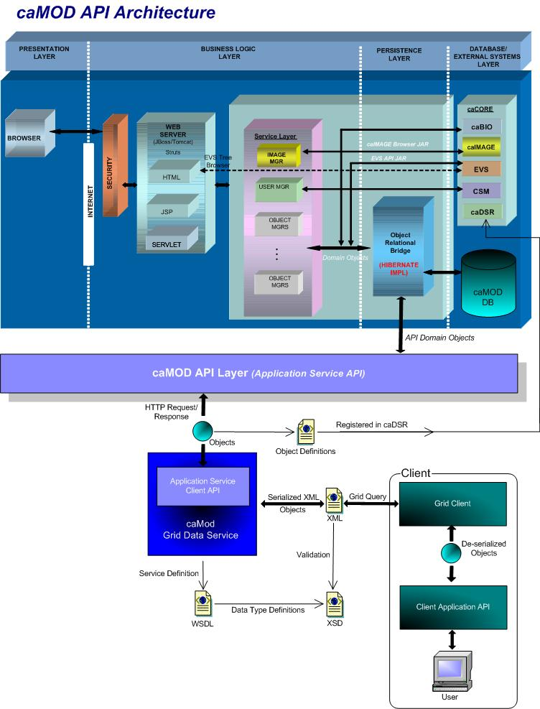

User Client Software
caMOD is a web based user interface implemented as HTML, JSP, JavaScript, and AJAX. The use of JavaScript is limited to improving usability only.
Java Server Pages (JSPs) are used to generate dynamic HTML based on user actions. JSPs are combinations of HTML, Java Code, and custom JSP and JSTL tags that get compiled into servlet classes.

Back End
The caMOD back end components provide access to persistence services for retrieving and storing data in the database. Hibernate, an open source tool, is used as the Object Relational Mapping (ORM) software.

Hibernate 3 Data Access
The caMOD uses Hibernate version 3. Hibernate is used for read, write access. It provides the insert, update and delete capability to the caMOD application thru the domain classes.

JBoss Application Server
The user interface, middle tier, and backend components are run with in JBoss Java2 Enterprise Edition (J2EE) application server. JBoss is an open source application server that provides a servlet container, an EJB container, the full range of J2EE 1.4 features as well as extended enterprise services including clustering, caching and persistence. JBoss 4.0.4 conforms to the latest technology stack. It will be consistent with most other applications.

Database
Oracle Relation Database Management System (RDBMS) software is used as the persistent store for caMOD and caIMAGE application data. Java classes access the database using the Java Database Connectivity (JDBC) API.

Java
The new version of Java1.5 (Java tool kit version jdk1.5.0_04) is used for compilation. Therefore all the code in caMOD has been compiled using the JDK 1.5 version. This will conform to the latest technology stack currently used by NCI.

import caELMIR study data for camod therapy screen

user interface (VIEW)

view therapeutic approaches screen
The therapeutic approaches search results screen will be updated to include information about the results of the study experiments conducted with a specific animal model from caELMIR.

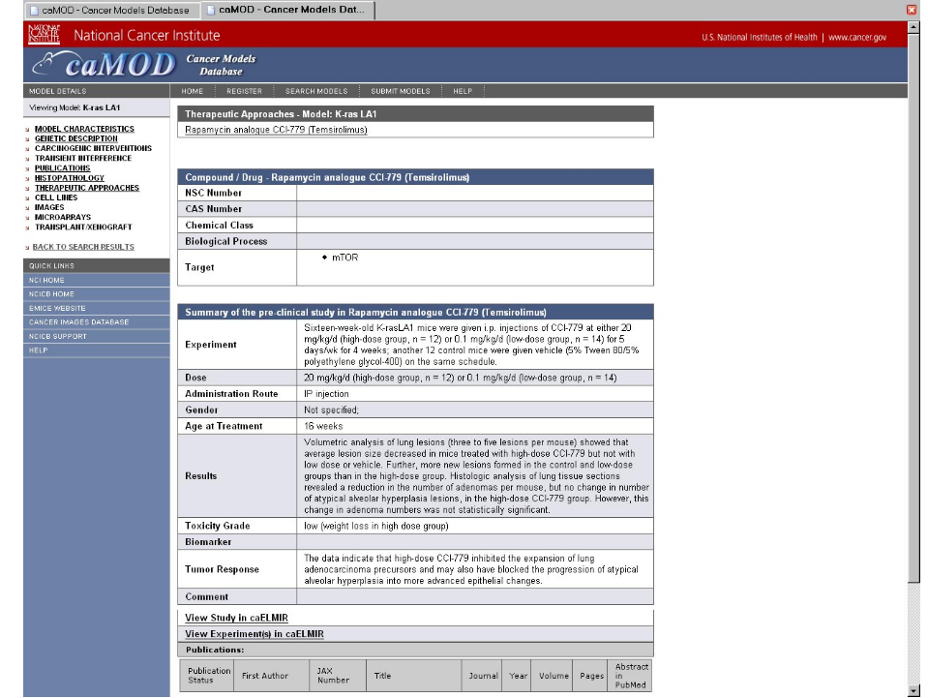

The screen will be modified to include a list of study data available in caELMIR. There will be a link from the study data back to caELMIR to allow the user to drill down into caELMIR for further details.
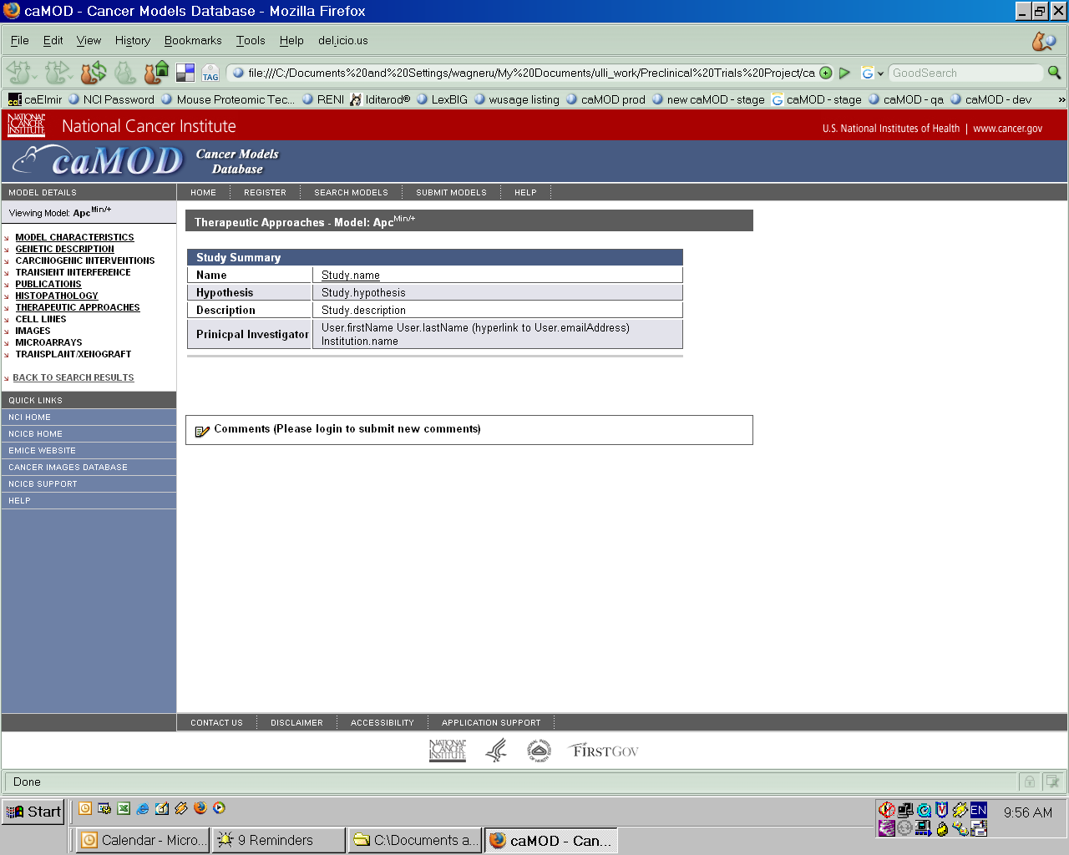
The study name will be linked to caELMIR as shown below.
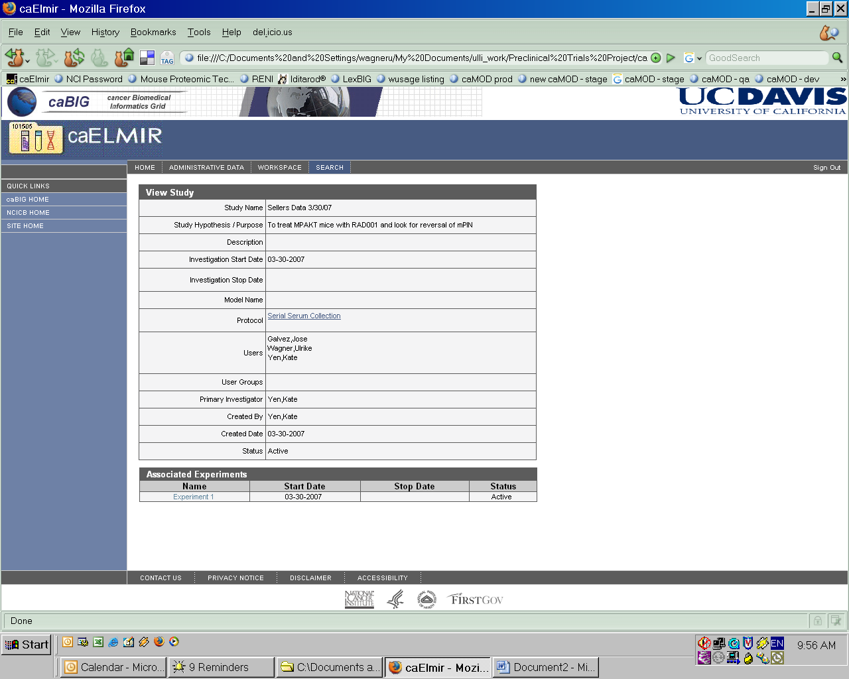

Additional data from caELMIR
Data Type |  | Note:
Study name
Study hypothesis / purpose
Study description
Institution |  | Principal investigator and institution need to be displayed since it can not be assumed that the lab that submitted the model to caMOD also conducted the pre-clinical study described in caELMIR.
Link to caELMIR

Interface Classes to be Modified
The following is a list of interface classes (GUI and interface java classes) that need to be modified.
Interface Class Name | Description
viewTherapeuticApproaches.jsp | Displays caELMIR study list data, if available for model.

middle tier (CONTROLLER)
    - Form classes

Action classes
    - viewmodelAction
ViewModelAction.java is an existing struts Action class that retrieves and stores the data for a model in order for it to be displayed in each hyperlink. The populateTherapeuticApproaches method will be modified to retrieve study data from caELMIR, if available, and store it in a constant for the selected model.
Method Name | Description
populateTherapeuticApproaches | Populates data for an existing object by id. Add code to populate study data from caELMIR.

configuration and utility classes
    - Configuration and Utility Files Changed
File Name | Function
Constants. java | Configuration files to hold global constants for the application. Add constant for the retrieved study data from caELMIR.

Data Source for new caMOD therapy data
The populateEngineeredGene and populateTherapeuticApproaches methods already connect to caBIO to retrieve data for gene info, sequence_id, database links, gene ontology, biocarta pathway data, and clinical protocols. This implementation will be repeated in order to connect to caELMIR and retieve the defined study data for a specific model.
public ActionForward populateEngineeredGene(ActionMapping mapping, ActionForm form, HttpServletRequest request, HttpServletResponse response) throws Exception {
String modelID = request.getParameter("aModelID");

AnimalModelManager animalModelManager = (AnimalModelManager) getBean("animalModelManager");
AnimalModel am = animalModelManager.get(modelID);

…..
log.debug("Connecting to caBIO to look up gene " + geneId);
// the geneId is available
try
{
ApplicationService appService = EvsTreeUtil.getApplicationService();
DatabaseCrossReference dcr = new DatabaseCrossReferenceImpl();
dcr.setCrossReferenceId(geneId);

dcr.setType("gov.nih.nci.cabio.domain.Gene");
dcr.setDataSourceName("LOCUS_LINK_ID");
List<DatabaseCrossReference> cfcoll = new ArrayList<DatabaseCrossReference>();
cfcoll.add(dcr);

Gene myGene = new GeneImpl();
myGene.setDatabaseCrossReferenceCollection(cfcoll);
List resultList = appService.search(Gene.class, myGene);

final int geneCount = (resultList != null) ? resultList.size() : 0;
log.debug("Got " + geneCount + " Gene Objects");
if (geneCount > 0)
{
myGene = (Gene) resultList.get(0);
log.debug("Gene:" + geneId + " ==>" + myGene);
tmGeneMap.put(tm.getId(), myGene);
}
}
catch (Exception e)
{
log.error("Unable to get information from caBIO", e);
}
}
}
else if (eg instanceof InducedMutation)
{
imc.add(eg);
imCnt++;
}
}

log.debug("<populateEngineeredGene> " + "egcCnt=" + egcCnt + "tgc=" + tgCnt + "gsc=" + gsCnt + "tmc=" + tmCnt + "imc=" + imCnt);
request.getSession().setAttribute(Constants.ANIMALMODEL, am);
…
System.out.println("<populateEngineeredGene> set attributes done.");

setComments(request, Constants.Pages.GENETIC_DESCRIPTION);
return mapping.findForward("viewGeneticDescription");
}

[Appendix A – acronym List]
Acronym | Description
caMOD | Cancer Models Database
caIMAGE | Cancer Models Database
JSP | Java Server Pages
Morpholino | Morpholino phosphorodiamidate oligonucleotides
PubMed | PubMed is a service of the U.S. National Library of Medicine that includes over 16 million citations from MEDLINE and other life science journals for biomedical articles back to the 1950s.
RNA | Ribonucleic acid
siRNA | short interfering RNA

[APPENDIX B – caelmir screen shots]
This section displays the current functionality in caELMIR.
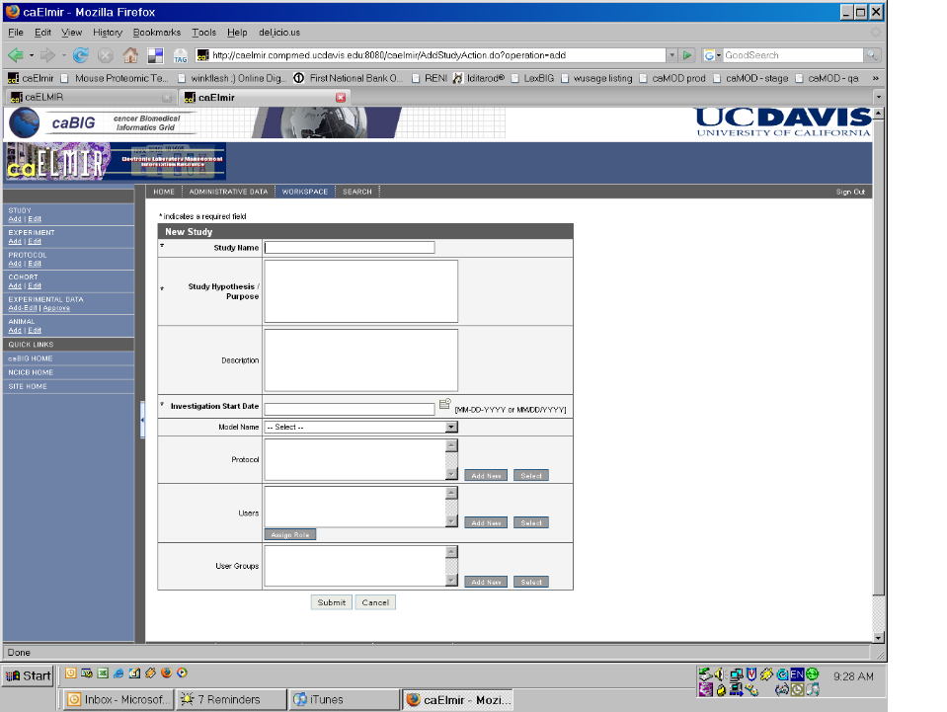
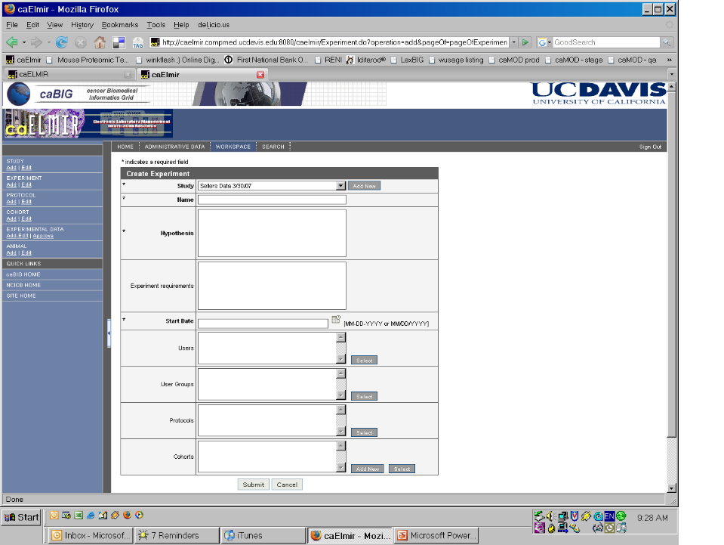

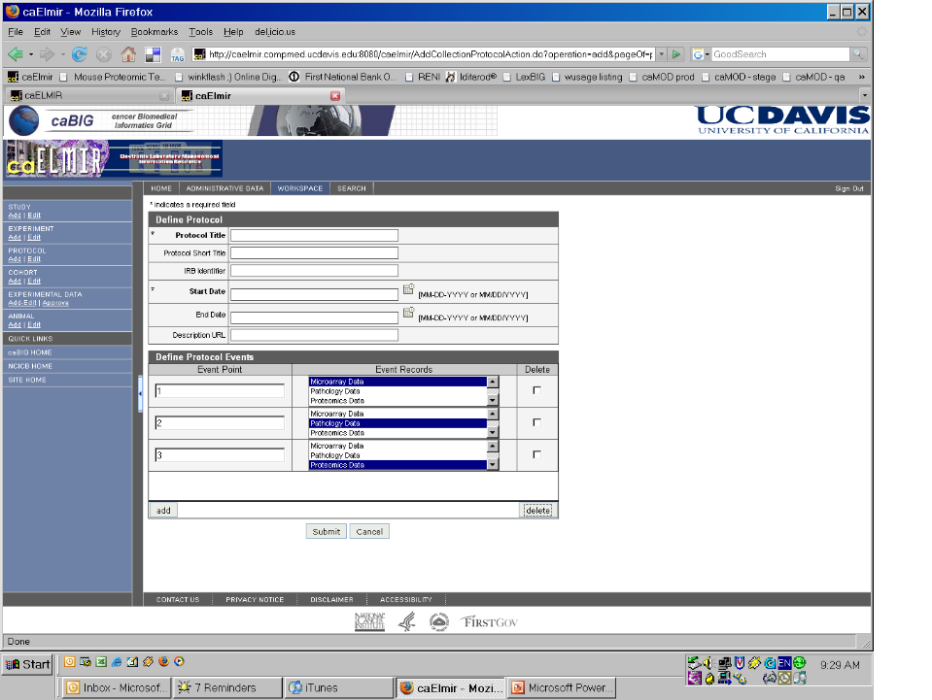

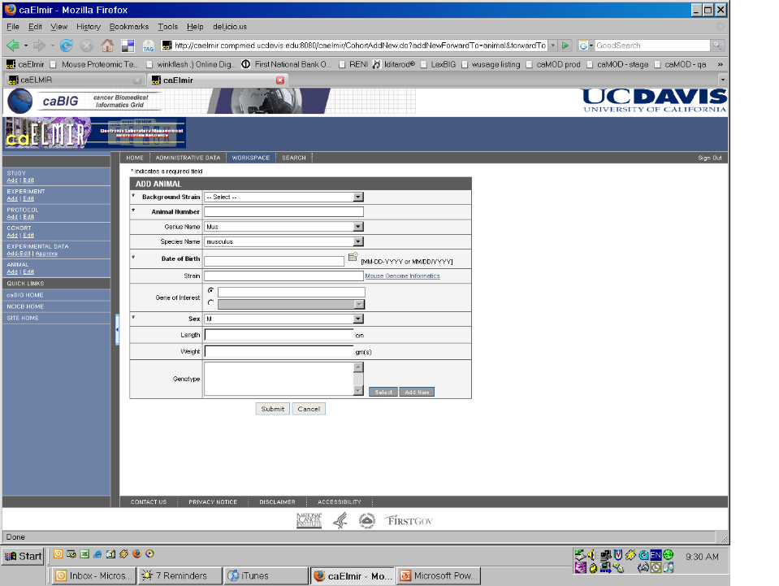

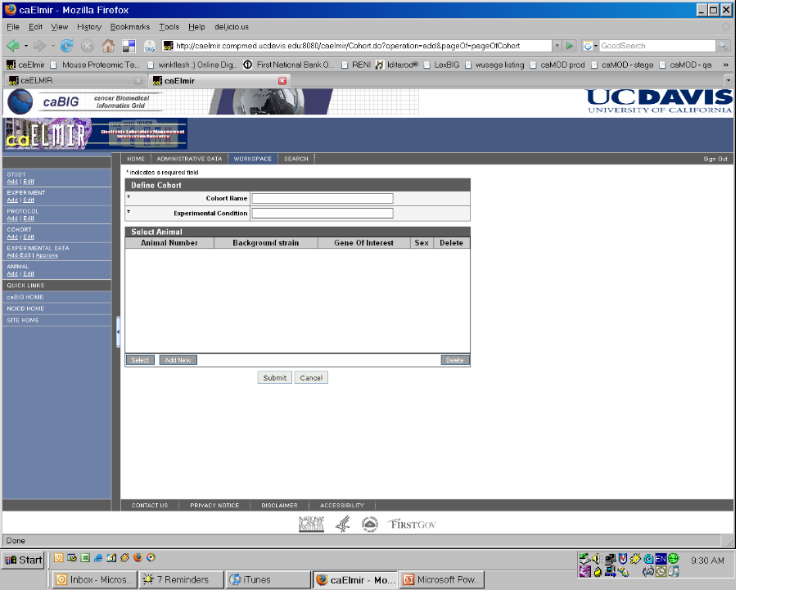

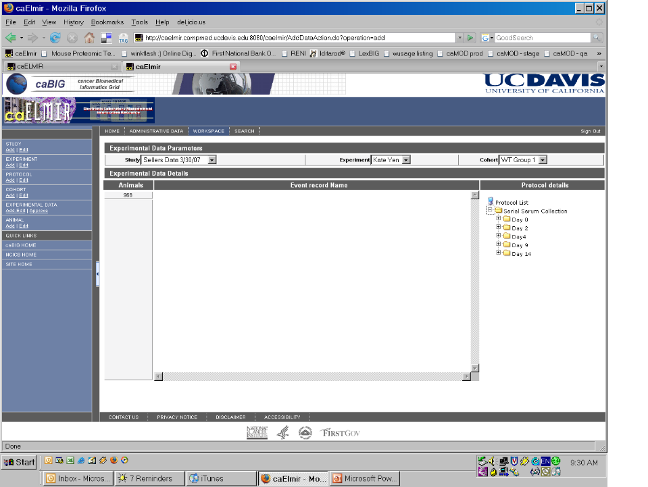

[APPENDIX C – TBD]

