Cancer Models Database
System Design Document
Version 0.1

Table of Contents
Table of Contents
1.Introduction 3
1.1 Definitions, Acronyms, and Abbreviations……………………………………………………………….4
2.Background 5
3.Architectural Goals and Constraints 6
3.1 Architectural Goals………………………………………………………………………………………..6
3.2 Architectural Constraints………………………………………………………………………………..6
4.Architectural Representation 7
4.1 Application Layers………………………………………………………………………………………….7
4.2 Design Patterns Applied to Application Layers………………………………………………………….8
5.Use-Case View 13
5.1 Introduction………………………………………………………………………………………………13
5.2 Pilot Release Use Cases…………………………………………………………………………………..13
6.Logical View 15
6.1 Subsystems…………………………………………………………………………………………………15
7.Deployment View 20
7.1 Deployment Diagram………………………………………………………………………………………20
7.2 Deployment Products and Framework Versions………………………………………………………..20
8.Data View 22

Figures

Figure 1. DESIGN_DOCUMENT_TEMPLATE Architecture Layers 7
Figure 2. General MVC System Flow 8
Figure 3. Presentation Layer Framework Sequence 10
Figure 4. DESIGN_DOCUMENT_TEMPLATE Pilot Use Cases 13
Figure 5. Case Management Subsystem Value Objects 15
Figure 6. Workflow Subsystem class model 16
Figure 7. Routing Sequence 17
Figure 8. DESIGN_DOCUMENT_TEMPLATE Conceptual Authorization Model 19
Figure 9. DESIGN_DOCUMENT_TEMPLATE Deployment View 20
Figure 10. Primary DESIGN_DOCUMENT_TEMPLATE database entities 22

Document History

Change Record
Date | Author(s) | Document  Version | Change Reference (Major Changes)

Reviewers
Name | Position | Document  Version | Date  Reviewed

Introduction
This Cancer Models Database (caMOD) is provided as a public service by the National Cancer Institute (NCI) to foster the rapid dissemination of information to the scientific community and the public. Historically, the cancer models application evolved from being a prototype application that demonstrated basic requirements/use cases to a sophisticated 2-tier search and submission web portal. The cancer models application allows researchers to submit animal models of cancer, retrieve animal based cancer models (primarily mouse and rat), and retrieve anti-cancer drug screening yeast and invivo models.

Purpose of this Document
This document provides an overview of the Cancer Models (caMOD) Database system design. It is intended to describe and capture the caMOD design decisions and is written as a reference for both the NCI customer and the NCI contractors/developers involved with the evolution of caMOD. This is a living document and will be updated to reflect the evolution of development, as well as future enhancements and upgrades.

Document Overview
The main sections of this document are listed and described below.

- Section 1 provides a purpose statement, a document overview, identifies the scope and provides a list of related documents. In addition, this section identifies (at a very high level), the methodologies, tool and techniques employed for the caMOD design activities, addresses any NCICB directives impacting the design decisions, and identifies the key stakeholders and points of contact.

- Section 2 is the design overview. It outlines any background information that is relevant to the proposed design, identifies the step-by-step procedure to migrate the existing system to a more efficient implementation. In addition, this section identifies the emerging technologies that are expected to available in a given timeframe and how they make effect the future development of the system/system architecture. Risks, issues, assumptions and dependencies are also addressed.

- Section 3 captures the system architecture design. The architectural goals and constraints are identified and an architecture diagram is provided. Additionally, we discuss the architectural layers and describe any design patterns applied within them.

- Section 4 addresses the software design. We discuss the software packages and the associated object models that capture specific functional areas. We will show samples of how these objects address the requirements/use cases captured in the Requirements Document. The objects are described at a high-level in this section. The detailed description of the classes and there associated attributes will be detailed in the Section 5 Data Design.

- Section 5 addresses the data design. We discuss the data design with respect to object model. We describe the relationships between the data objects (tables) and the attributes that comprise each. The object-to-relational mappings will be addressed as well.

- Section 6 addresses the system deployment. We describe the build process, the resulting products and how those products will be deployed. This section also address the technology stack being deployed by caMOD.

Scope
The scope of this document is to provide a detailed design specification for the implementation of a multi-tiered, caBIG silver compliant, cancer models application. The system architecture design, software component design, user interface design, design constraints and design guidelines are presented.

This document does not address the caMOD project timeline/schedule, use cases/requirements, or any testing activities. These items are captured as part of separate documents. (Refer to 1.4 for a list of related documents.)

Related Documents
- Cancer Models Database Project Plan
- Cancer Models Database Requirements Document
- Cancer Models Database Test Plan
- National Cancer Institute Center for Bioinformatics (NCICB) caBIG Compatibility Guidelines
- NCICB Common Security Module Technical Reference

Methodologies, Tools and Techniques
The caMOD design will be based on object oriented (OO) principles. Enterprise Architect (EA) will be the tool used to build several of the key design artifacts. The Rational Unified Process will be the base technique used for object modeling and other detailed design exercises.

Policies, Directives, Procedures
The NCICB requires that the development of a multi-tiered cancer models application portal be caBIG compatible.

Key Stakeholders
[Ulli to identify]

Points of Contact
- Project Oversight/Management
Name: Srini Guruswami
Title: SAIC Project Manager/Contractor
Email: guruswas@mail.nih.gov
Phone: 301.451.2211
Srini Guruswami
- NCICB Application Support
Email: appsupport@mail.nih.gov

DESIGN OVERVIEW
The caMOD application portal will be re-engineered to instantiate a more scaleable and robust infrastructure that will allow for seamless integration of data with other caGRID compatible systems as well as, inter-operability at the application level. The cancer models database portal will continue to allow researchers to submit and retrieve animal cancer models as well as, anti-cancer drug screening yeast and invivo models.

Background Information
The cancer models database application was originally established as a prototype to demonstrate the ability capture and search animal cancer models via a user friendly, web-based application. The application has since evolved into a feature rich data submission and retrieval tool. The existing cancer models application portal is one means a researcher has to access cancer model data. The other is available for those researchers who are programmatically inclined and exists in the form of an Application Programming Interface (API). This API is currently bundled and available for download as part of the cancer Bioinformatics Infrastructure Objects (caBIO). The data retrievable through the caMOD API is a snapshot of the data submitted via the cancer models application portal and migrated to a common/shared caBIO schema. The design of the re-engineered, multi-tiered cancer models application portal, will involve decoupling the caMOD API from caBIO and re-establishing the read-only API as part of the caGRID (hence the NCICB directive to be caGRID Compatible via a well-defined API). This same API will essentially comprise the middle tier of the caMOD application portal.

System Evolution Description
The evolution of the existing 2-tiered application portal will involve the following steps.

- Decoupling the caMOD API from caBIO and exposing the API through the caGRID.
- Establishing a design strategy for providing read-only access though a single caGRID-exposed API while the Common Security Module (CSM) is evolving.
- Establishing an N-Tier architecture.
- Updating the existing 2-tier database schema to the multi-tiered schema. This includes the establishment of an automated mechanism for importing “manually” staged data (i.e. anti-cancer drug screening yeast and invivo data).

Technology Forecast
The caMOD application will rely on the NCICB Common Security Module to fully evolve to handle API-based security. The initial caMOD multi-tiered release will employ the caCORE 3.0 version of the CSM and any bugs that have been identified in that release my impact the application functionality.

Risks
Risks | Low | Med | High | Contingency

Issues
Ref | Issue | Action

Assumptions
Ref | Assumption | Impact

Dependencies
Ref | Dependency | Action

SYSTEM ARCHITECTURE

Architectural Goals and Constraints
The following are goals and constraints of the caMOD system architecture.

- To ensure the platform addresses enterprise level of service requirements: Performance, Scalability, Reliability, Availability, Extendibility, Maintainability, Manageability, and Security.
- The caMOD N-Tier model of computing enables the overall performance and maintainability of the systems to be substantially improved. This layered environment also simplifies code distribution, since most of the business logic has been moved from the client to the server.
- The caMOD code base will address the performance, reliability, extendibility and maintainability. J2EE design patterns and best practices will be utilized throughout the application.
- Define clear application layers delineating architectural role and functionality
- The caMOD N-Tier architecture provides clear separation of user-interface-control and data presentation from application-logic. Through this separation more clients are able to have access to a wide variety of server applications. The two main advantages for client-centered applications are like caMOD are: quicker development through the reuse of pre-built business-logic components and a shorter test phase, because the server-components have already been tested.

- Integrate well with NCICB’s caCORE applications
- The caMOD application will integrate with the Extended Vocabulary System (EVS) to assist users in ascertaining common vocabulary for Organ and Disease references.
- The caMOD application will integrate with the caBIO API to offer the user extended relationships to Gene and Agent/Drug references.
- The caMOD application will integrate with the Common Security Model (CSM) to handle user authentication and system authorization.
- Provide an expandable applications platform and a complete framework to which DESK applications can migrate to

- Utilize industry supported specifications and open source technologies whenever possible
- The caMOD web application framework is implemented using an open source Model View Controller (MVC) framework.
- The caMOD persistence model will be implemented using Container Managed Persistence (CMP).
- The caMOD architecture will rely on common industry-based standards such as HTTP to interface with other applications and application services.

Architectural Constraints
TBD.

Architectural Layers
The caMOD architecture is based on an n-tier computing environment that assigns responsibilities to separate application layers. This fosters a loosely coupled and tightly cohesive architecture in which objects in each layer are focused on specific architectural responsibilities yet, cleanly integrate with the other layers.

The diagram below illustrates the following horizontally across the diagram.

- Presentation Layer - responsible for the presentation of data, receiving user events and controlling the user interface.
- Business Logic Layer – Business-objects that implement the business rules "live" here, and are available to the client-tier. This level now forms the central key to solving 2-tier problems. This tier protects the data from direct access by the clients.
- Persistence Layer – a transparent data management layer that receives requests for and with reqard to system data.
- Database/External Systems Layer – houses the physical database instantiation and is the access point to any external system accessed by caMOD to access related foreign data elements.
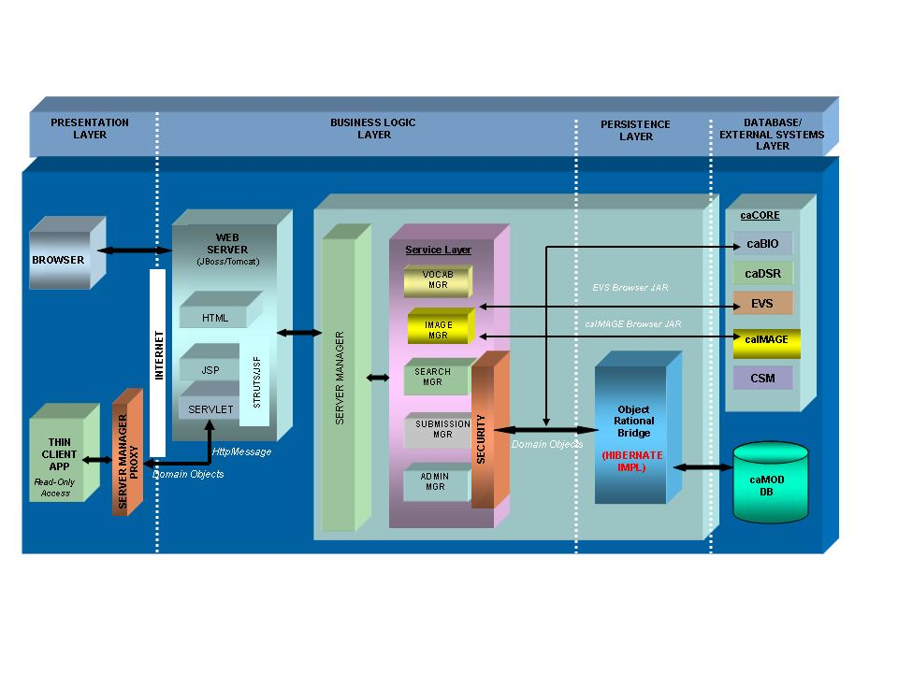Figure 3.1. caMOD Architecture Layers

Design Patterns Applied to Application Layers
This section of the document describes the architecture and the implementation within each application layer. The major products, frameworks and patterns used in the implementation are described. In addition, to review additional detail on the patterns and mechanisms, please review the Developer Guidelines document.

    - Client Layer

The caMOD client layer will be implemented as a HTML web application. caMOD will support the browser and user interface standards put forward by the NCICB User Interface working group and will incorporate NCICB’s 508 compliance guidelines. The application client layer will utilize HTML and style sheets.

    - Presentation Layer
The presentation layer will be developed on a J2EE 1.4 implementation using Java Server Pages (JSPs), JSP custom tags and servlet technologies. The JBoss 4.0.x application server bundles the Apache Tomcat 4.1.x web container in its implementation. In the default configuration, Tomcat and JBoss share the same JVM and Tomcat delegates J2EE authentication / authorization to JBoss services.

Web Application Framework Approach
caMOD is using the Model View Controller (MVC) design pattern implemented in the Apache Struts (http://jakarta.apache.org/struts/) and the Java Server Faces (JSF) web application frameworks. The Struts framework is more mature however, JSF offers similar functionality to Struts and additionally offers for array of presentation centric features. The frameworks are NOT mutually exclusive. They can be used together. caMOD will initially rely on STRUTS with the mindset that industry is encouraging full migration to the JSF Framework.

Model 2 is a term used to indicate that the web-adapted version of the classic MVC pattern is being implemented.

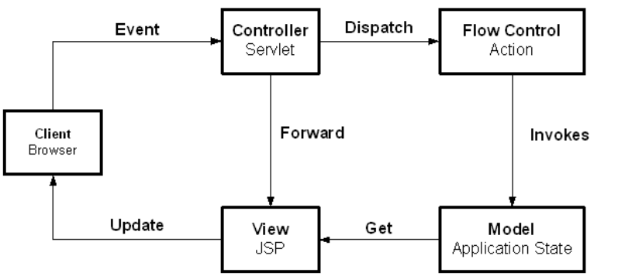
Figure 3.2. General MVC System Flow

The MVC pattern separates presentation-oriented responsibilities from application specific processing / controller responsibilities and business domain specific model. As a result, application maintainability is improved. In a MVC-based J2EE web application, JSPs are the “view” (web page presentation); a Java servlet is the “controller” and processes and delegates requests to Java components; and the “model” or business logic is implemented using business delegate Java objects.

In addition to the MVC implementation, caMOD will implement the J2EE Composite View Pattern (http://developer.java.sun.com/developer/restricted/patterns/CompositeView.html) using the Tiles framework distributed with Struts.

The Composite View pattern is used to combine modular, atomic portions of a web page view into a single, composite web page view. The component portions of the web page are maintained separately and combined to display the complete view to the user. Use of this pattern aids because a small set of common templates can be established that are utilized or extended for many web pages. At runtime, the template applies the atomic page components, such as headers or footers, to create the viewed page. With this approach, different and dynamic atomic view components can be combined into one complete page.

Additional Presentation Layer Design Pattern Usage
In addition to the MVC-based Struts framework used for View and Controller components of MVC, caMOD will employ several other design patterns in the presentation layer. In a Struts application, the Struts controller calls Struts Action classes to perform processing in response to a screen display, link or form submission to the controller. Some applications code the business logic directly in the Action class. However, because caMOD is using a layered architecture, the Struts Action class will only focus on the workflow of the application and will make business requests to classes associated with the business layer of the application.

Business Delegate Pattern
The business delegate pattern (http://java.sun.com/blueprints/corej2eepatterns/Patterns/BusinessDelegate.html) is used to reduce coupling between the presentation layer and the business (also known as model or domain) layer. The business delegate hides the underlying implementation and details for accessing business services. In a J2EE application, the delegate is somewhat like a proxy object in that it provides an interface accessed by its clients but it normally delegates its implementation to other classes.

For caMOD, the presentation layer executes in a J2EE web container and the business, model or domain layer is implemented using custom Java manager classes and Plain Old Java Objects (POJOs). The business delegate allows classes running in the web application to execute the business services in a simpler approach. The delegate handles communication details such as JNDI lookup. The delegate can also encapsulate business layer decisions such as when to cache or retrieve data locally instead of going to business classes. The presentation client does not need to be aware of these details.

Session Data Manager Pattern
A web application’s ‘javax.servlet.http.HTTPSession’ object can be used to set and get objects specific to a user session. The session is convenient to access since it is accessible in each request. As a result, it is very easy to add or remove items to the session. This ease of use results in a lack of control over how the session is being used by developers. In addition, adding attributes to the session requires retrieving the key for the object. Instead of adding objects directly to the session, a Session Data Manager object is introduced that contains the logic to get and set objects from the session.

This lightweight object provides the application team with additional visibility as to how the session is being utilized because session objects are saved and retrieved from a central point. In addition, adding the wrapper provides a central way to change how session data is stored. For example, an application may wish to persist highly critical session data to a database or cache large session objects in an external cache and only store the session key in the session itself. This functionality is possible behind a Session Data Manager object.

Presentation Layer Sequence Diagram
The diagram below illustrates an example interaction between the major classes in the presentation framework. Please note that the sequence is drawn from a specification perspective to provide an overview of the normal sequence between these important classes.

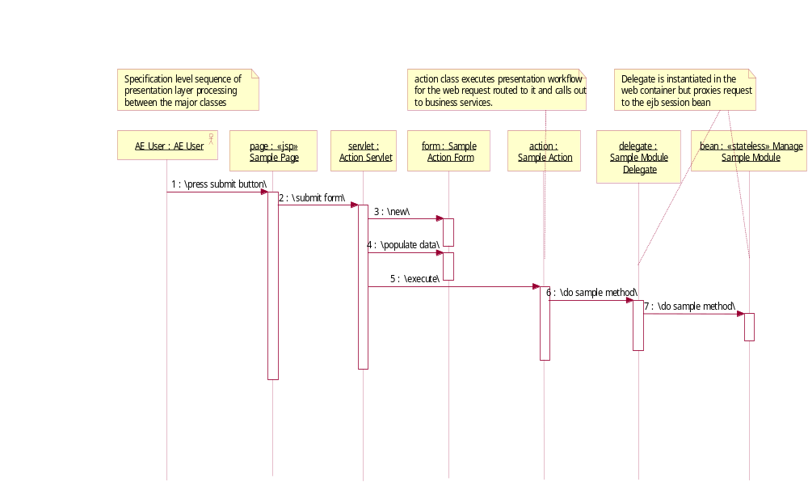
Figure 3.3. Presentation Layer Framework Sequence

    - Business Logic Layer
The business logic layer executes the business logic of the application. The business layer is presentation independent because presentation-specific workflow is not built into these classes. As a result, it is possible to provide several separate presentations for the same application.

In the typical scenario, the business delegate will call a system/function manager acting in the Session Façade (described below) role. The façade will then delegate to the appropriate business classes that process the request and retrieve or store the data.

Session Façade Pattern
The session façade design pattern (http://java.sun.com/blueprints/corej2eepatterns/Patterns/SessionFacade.html) is used to encapsulate the complexity of interactions between business objects in a workflow. The façade or boundary class, hides these interactions and provides a simpler, course-grained access to clients. As a result, coupling between business and presentation layers is reduced, transaction control is centralized, and fewer interfaces are exposed to the client.

The implementation of the session façade pattern often includes a java manager class and one or more business objects that execute the actual business processing. In this case, the façade is lightweight, performs security and other transaction services but delegates implementation of the method to a business object that interacts with other business objects.

In caMOD, course-grained domain modules expose their functionality via session façade custom java classes. The presentation layer will have a business delegate boundary counterpart that interacts with the session façade.

Data Transfer Object (DTO) Pattern
The J2EE Data Transfer Objects design pattern (http://java.sun.com/blueprints/corej2eepatterns/Patterns/DataTransferObject.html) is used to encapsulate business data. It is frequently used when passing data from one application layer to another in order to provide generic and consolidated access to data from layer to layer. DTOs are generally lightweight, serializable and contain private data with public assessors.

    - Persistence Layer
The data access layer’s responsibility is to provide a transparent and lightweight mechanism for retrieve and submitting information from an external data store and return that information in a generic way. In caMOD, the primary approach for this is via Data Access Objects and a customized implementation of the open-source object-to-relational mapping tool, Hibernate version 3.0.

Data Access Objects Pattern
The data access object pattern (http://java.sun.com/blueprints/corej2eepatterns/Patterns/DataAccessObject.html) is used to encapsulate all access to a data source. While the object contains data source technology-specific logic in the object to interact with the external data source, clients are shielded from these details. Instead, clients typically provide and receive technology independent value objects containing the data.

In caMOD, our Data Access Objects are realized via the Hibernate DAO implementation.

Software Design
Modeling is the process of software design prior to the generation of code. The model is therefore the core of the software design process. Using a model, those responsible for a software development project's success can assure themselves that business functionality is complete and correct, end-user needs are met, and program design supports requirements for scalability, robustness, security, extendibility, and other characteristics, before implementation in code renders changes difficult and expensive to make.

Modeling can be performed using a number of different methodologies. In caMOD, we will be using the OMG's Unified Modeling Language™ (UML®). UML helps you specify, visualize, and document models of software systems, including their structure and design, in a way that meets all of these requirements. We will be using the UML implementation found in the UML Case Tool, Enterprise Architect (EA).

    - Domain Objects
At the core of the caMOD application are the business or domain objects and the relationships they share. Cancer models can be of a variety of types and, caMOD will be designed to be extendable, allowing for the capturing of Animal Model cancer data, anti-cancer Yeast and Invivo screening data, as well as other types of cancer models in the future. Each model may share several common business objects that in the context of a specific model type but, may have different associations. For this reason, we will capture the known cancer model designs in separate UML diagrams with a diagram to render their high-level associations. These domain/business objects will be implemented as Plain Old Java Objects (POJOs). The identified domain objects and their relationships are captured in the following sections. In each section, there is a catalog list of the objects defined in the gov.nih.nci.caMOD.domain package. The items in each of the listings below should be interpreted as follows:

- Related MMHCC domain objects: A second MMHCC domain object is “related” to the first domain object if that second object occurs anywhere in the signature of a method for the first object.
- Other related domain objects: The same as above, but in this case the second domain object is defined outside the gov.nih.nci.caMOD.bean package.
- Extends: This field reflects direct inheritance; i.e., the current class is a direct subclass of that which it extends.
- Implements: This field lists all interfaces implemented by the object.

In cases where no relations, extensions, or interface implementations apply, the above fields are omitted.

Cancer Model Domain Object Descriptions
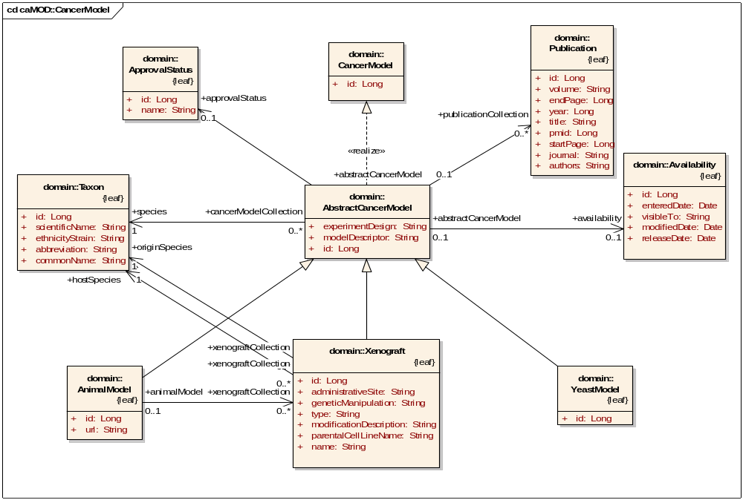

Figure 4.1 High-Level Cancer Model Domain Objects

AbstractCancerModel
An abstract implementation of the CancerModel interface. All concrete CancerModel implementations will extend the AbstractCancerModel.

Implements:.CancerModel

ApprovalStatus
The approval status identifies a particular state of approval (during the curation process) that the cancer model currently resides. (i.e. Incomplete, ScreenerAssigned, Screened, ReviewerAssigned, Reviewed, Complete).

Implements:.java.io.Serializable

Availability
The availability status of a developed strain from the MMHCC Repository, the Jackson Laboratory, or directly from the principal investigator.

Implements: java.io.Serializable

CancerModel
The interface defined the basic implementation for all concrete CancerModels.

Implements: java.io.Serializable

Publication
Publications describing the animal model itself or experiments in which the animal model was used.

Related caMOD domain objects: PublicationStatus

Implements: java.io.Serializable

Taxon
A Taxon captures the particular species and ethnicity strain associated with a particular cancer model.

Implements: java.io.Serializable

Xenograft
A surgical graft of tissue from one species onto or into individuals of unlike species, genus or
family.

Other related domain objects: gov.nih.nci.common.domain.EVSOntology

Extends: AbstractCancerModel

Implements: java.io.Serializable

YeastModel
A yeast model captures the yeast strains altered in the NCI Yeast Anticancer Drug Screen.

Related caMOD domain objects: ScreeningResult, TargetedModification

Implements: java.io.Serializable

Animal Model Domain Object Descriptions
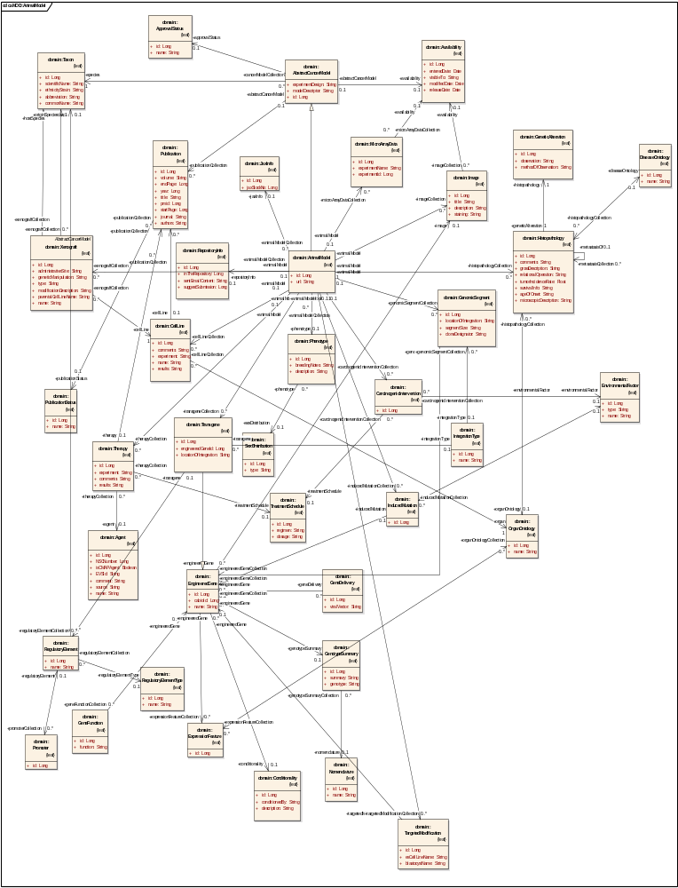
Figure 4.2 Animal Model Domain Objects

Agent
A therapeutic agent (drug, intervention therapy) used in a clinical trial protocol.

Implements: java.io.Serializable

AnimalModel
A strain of animals used to study the various types of cancer.

Related caMOD domain objects:
Availability, CarcinogenicIntervention, CellLine, GenomicSegment, Histopathology, Image, InducedMutation, JaxInfo, MicroArrayData, PartyRole, Phenotype, Publication, RepositoryInfo, TargetedModification, Taxon, Therapy, Transgene, Xenograft

Implements: java.io.Serializable

CarcinogenicIntervention
A treatment (chemical or drug administration, radiation, etc) applied to an animal model to
induce a disease state.

Related caMOD domain objects:
EnvironmentalFactor, GeneDelivery, TreatmentSchedule

Implements: java.io.Serializable

CellLine
A cell line generated from a particular strain of animal model.

Related caMOD domain objects: Publication

Other related objects: gov.nih.nci.common.domain.EVSOntology

Implements: java.io.Serializable

Conditionality
Indicates if a transgene or targeted modification is time- or tissue-specific.

Implements: java.io.Serializable

EngineeredGene
A gene sequence that has been genetically modified to induce a desired state in an animal model.

Related caMOD domain objects: Conditionality, ExpressionFeature, GeneFunction, GenomicSegment,
GenotypeSummary, Image

Implements: java.io.Serializable

EnvironmentalFactor
A chemical, radiation, or hormone treatment, or other environmental factor that initiates or
supports development of neoplasis in the animal model.

Implements: java.io.Serializable

ExpressionFeature
The expression feature associated with an EngineeredGene.
Related domain objects: EngineeredGene.
Implements: java.io.Serializable

ExpressionLevelDesc
Used to capture descriptive, unquantifiable annotations of the observed expression levels.

Implements: java.io.Serializable

GeneDelivery
The method of introducing a modified gene to the recipient animal.

Related caMOD domain objects: EngineeredGene

Other related objects: gov.nih.nci.common.domain.EVSOntology

Implements: java.io.Serializable

GeneFunction
The known or hypothesized function of a gene.

Implements: java.io.Serializable

GeneticAlteration
Genetic alterations found in the diseased tissue other than the engineered genetic changes.

Implements: java.io.Serializable

GenomicSegment
A region or set of regions of a genome including chromosome, gene, breakpoint etc. The size of
a genomic segment varies from a fraction of a gene to a region containing many genes
surrounded by non-coding sequences, and can be as large as a chromosome.

Related caMOD domain objects: EngineeredGene, IntegrationType, SegmentType

Implements: java.io.Serializable

GenotypeSummary
Summary of genotype information for a particular model.

Related caMOD domain objects: Nomenclature

Implements: java.io.Serializable

Histopathology
An object representing anatomical changes in a diseased tissue sample associated with an
expression experiment; captures the relationship between organ and disease.

Related caMOD domain objects: Organ, Disease

Implements: java.io.Serializable

Image
Images and image annotations associated with animal models.

Related caMOD domain objects: Availability

Implements: java.io.Serializable

InducedMutation
A mutation in a gene caused by exposure to chemicals, radiation or other types of mutagens. By
definition, an induced mutation is inherited by the next generation.

Related caMOD domain objects: EnvironmentalFactor, EngineeredGene

Implements: java.io.Serializable

IntegrationType
Location of the integration of the engineered gene, e.g. “random” or “targeted”.

Related caMOD domain objects: GenomicSegment, Transgene

Implements: java.io.Serializable

JaxInfo
Information associated with an animal model in The Jackson Laboratory; for example: stock
number, strain name, etc.

Implements: java.io.Serializable

MicroArrayData
Gene expression data from microarray experiments using cells or tissues from an animal model.

Related caMOD domain objects: Availability

Implements: java.io.Serializable

ModificationType
The type of gene modification in the target gene, such as the Null modification, amino acid
substitution, deletion, insertion, misense, nonsense, point mutation, etc.

Related caMOD domain objects: TargetedModification

Implements: java.io.Serializable

Nomenclature
Official nomenclature name of the animal model, following the recommendations of the
International Committee on Standardized Genetic Nomenclature for Mice; nomenclature is also
applicable to rats starting in 2001.

Implements: java.io.Serializable

Phenotype
The physical appearance or otherwise observable characteristics of a model animal.

Related caMOD domain objects: SexDistribution

Implements: java.io.Serializable

Promoter
A region of DNA sequence upstream of the coding region to which RNA polymerase will bind
and initiate replication.

Related caMOD domain objects: Taxon

Extends: RegulatoryElement

Implements: java.io.Serializable

PublicationStatus
Status regarding a scientific paper, e.g., “unpublished”, “submitted”, “published”.

Implements: java.io.Serializable

RegulatoryElement
A region of DNA sequence controlling the transcription/expression of a gene.

Related caMOD domain objects: Promoter, RegulatoryElementType, Taxon

Implements: java.io.Serializable

RegulatoryElementType
The type of regulation imposed by the element, e.g., suppressor, promoter, etc.

Implements: java.io.Serializable

RepositoryInfo
A RepositoryInfo object contains information about the availability of a particular model from
the MMHCC repository. Data submitters to the cancer models database can indicate that their
model should be submitted to the repository for acceptance for acceptance.

Implements: java.io.Serializable

SegmentType
Genetic segment type such as chromosome, contig, CpG islands, repetitive DNA (e.g. Alu,
LINE, SINE etc.), gene, breakpoint etc. (see GenomicSegment).

Implements: java.io.Serializable

SexDistribution
The observerable distribution of phenotypes between sexes.

Implements: java.io.Serializable

TargetedModification
Modification of a specific gene (versus one randomly selected) by a genetic engineering
technology called gene targeting through homologous recombination; usually achieved using
gene targeting vectors.

Related caMOD domain objects: EngineeredGene

Implements: java.io.Serializable

Therapy
A defined treatment protocol for testing the efficacy of the treatment on an engineered animal
model.

Related caMOD domain objects: Agent, TreatmentSchedule,

Implements: java.io.Serializable

Transgene
A foreign gene that has been integrated into the genome of an animal.

Related caMOD domain objects: IntegrationType, RegulatoryElement, Taxon

Extends: EngineeredGene

Implements: java.io.Serializable

TreatmentSchedule
The dosage and regimen for treating cancer in an animal model.

Implements: java.io.Serializable

Yeast Model Domain Object Descriptions
The NCI Yeast Anticancer Drug Screen has screened tens of thousands of compounds for the ability to inhibit the growth of selected yeast strains altered in DNA damage repair or cell cycle control. Compounds are initially screened against a panel of 6 yeast strains at a single concentration (Stage0). Compounds with activity in Stage0 are re-screened against the same panel at 2 concentrations (Stage1). Selected compounds with activity in Stage1 that also show selectivity are re-screened against a panel of 13 yeast strains at 5 concentrations (Stage2).

Figure 4.3 captures the Yeast UML Model. Most of the classes that comprise the Yeast Model were described in Section 4.1.1.2. There is one object, unique to the Yeast Model that captures the anti-cancer drug screening results and it is described below
.
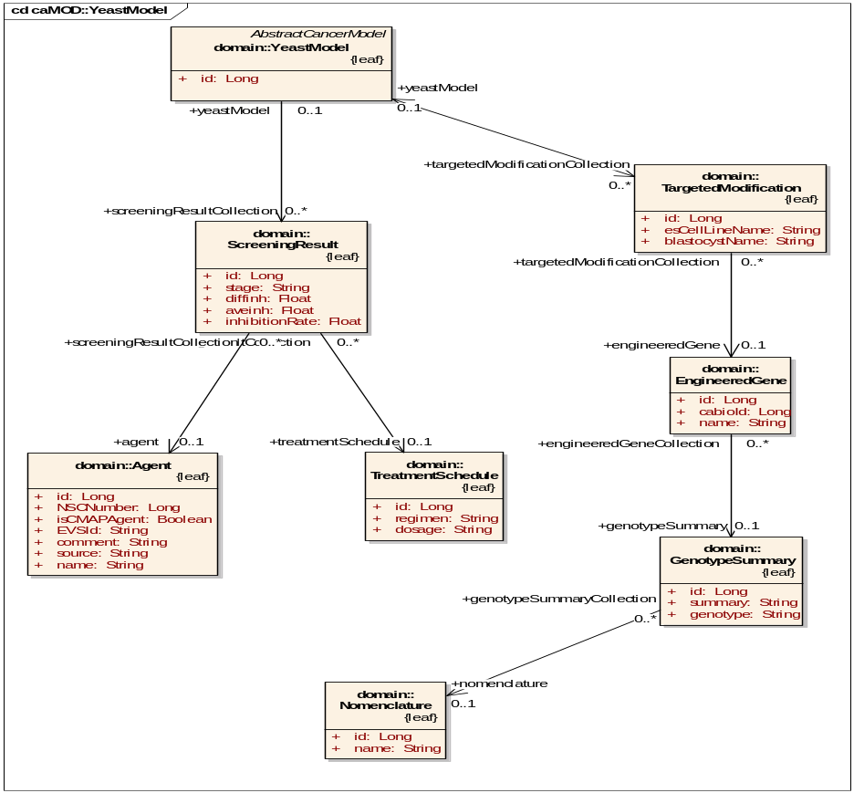
Figure 4.3 Yeast Model Domain Objects

ScreeningResult
A Screening Result captures the results of the tens of thousands of compounds screened for their ability to inhibit the growth of selected yeast strains altered in DNA damage repair or cell cycle control.

Related caMOD domain objects: Agent, TreatmentSchedule, YeastModel

Implements: java.io.Serializable

Invivo Model Domain Object Descriptions
Advancement of potential anti-cancer agents from identification in the invitro screen to preclinical development is enhanced with demonstration of invivo efficacy in one or more animal models of neoplastic disease. Most such models require considerable materials in terms of laboratory animals and test compound as well as substantial amounts of time and cost to determine whether a given experimental agent or series of agents have even minimal anti-tumor activity.

There only a few classes unique to the Xenograft or Invivo model. These classes are described below.

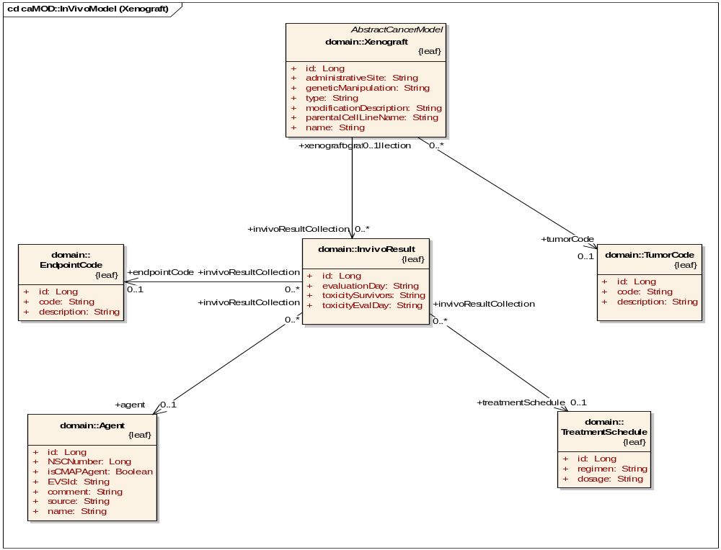
Figure 4.4 Invivo Model Domain Objects

EndpointCode
An EndpointCode captures the parameter for measuring success of anti-drug screen test; mean tumor weight, median survival time, etc.

Implements: java.io.Serializable

InvivoResult
An Invivo Result captures the results of anti-tumor drug screening.

Implements: java.io.Serializable

TumorCode
A tumor code captures the tumor type and origin species used for a drug screen test.

Implements: java.io.Serializable

    - Course-Grained Domain Objects
Course-grained domain objects represent a logical grouping of the fine-grained domain objects presented in sections 4.1.1.1 – 4.1.1.4. In the case of caMOD these course-grained objects are specific to the web application context and correspond to the categories of data our domain experts/system users relate to when dealing with the Animal Model submissions. The fine-grained model lends itself to the API user whose goals may be to make use of the cancer model data in a way other than that imposed by the application context.

The course-grained domain model is shown in Figure 4.x.

Course-Grained Domain Object Descriptions

General Information
Provides an overview of the experimental design, phenotype and availability of the model; elements on this page include: model descriptor (name), official nomenclature, genotype, principal investigator’s laboratory, location where the model is available, species, genetic background, experimental design, phenotype, sex distribution of phenotype, breeding notes, and record release date.

Genetic Description
Information about transgenes, targeted mutations, and targeted transgenes.

Carcinogenic Interventions
Information about chemicals/drugs used, relevant growth factors, hormones, radiation treatments, viral agents, and surgical procedures. This page also contains information on
xenografts and allografts.

Publications
Used to specify any citations associated with the generation of the model, phenotype, therapeutic experiments, or cell lines and experiments conducted on those cell lines.

Histopathology
Used to capture information about the organ where the tumor/lesion arises, the diagnosis, and other tumor-related data like time of onset, tumor incidence, and any genetic aberrations observed in the lesion.

Therapeutic Approaches
Cites any therapeutic trials associated with the model.

Cell Lines
Used to capture the name of the cell line, the organ of origin, and experiments conducted with the cell line that was generated from the model.

Images
Provides links to any image data associated with the model.

Microarray
Provides links to any microarray data associated with the model.

    - Common Persistence Module
The Common Persistence Module is a lightweight Hibernate wrapper which exposes transparent retrieval and submission services for a specific application context. The persistence mechanism is transparent in that the java objects that are used to access data and that carry the retrieved data have no knowledge of the persistence implementation.

Common Persistence Architecture
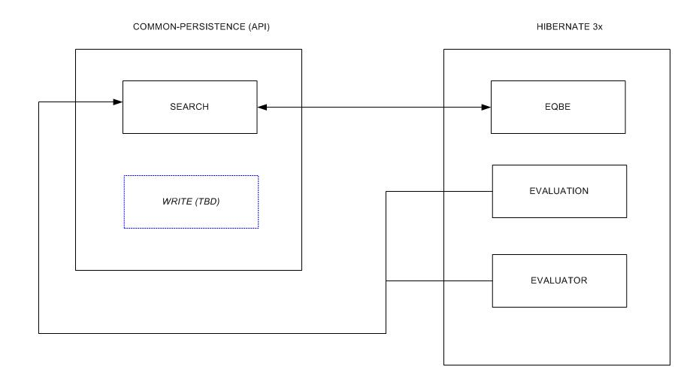
Figure 4.5 Common Persistence Architecture

As shown in the Figure 4.5, the common persistence API exposes the search, save, and delete services provided for by the Hibernate 3.x Object-Relational Mapping Tool.

Query-By-Example is a concept which Hibernate has implemented allowing for the querying of a database through the instantiation of “example" objects populated with search data.
Enhanced Query-By-Example is the mechanism in the COMMON-PERSISTENCE package that implements “enhanced” QBE functionality. Examples of this include:

- Object Graph Traversal
  - Dynamically builds Query Criteria thru traversing the “entire” object graph and member object properties (unlike basic QBE which only queries direct properties of the target search object).
- Evaluation/Evaluators
  - Provides mechanisms for applying “Evaluators” to specific properties in the object graph allowing for fine-grained querying of properties (unlike Basic QBE which simply queries for pure “equal” of property values.

Common Persistence Model
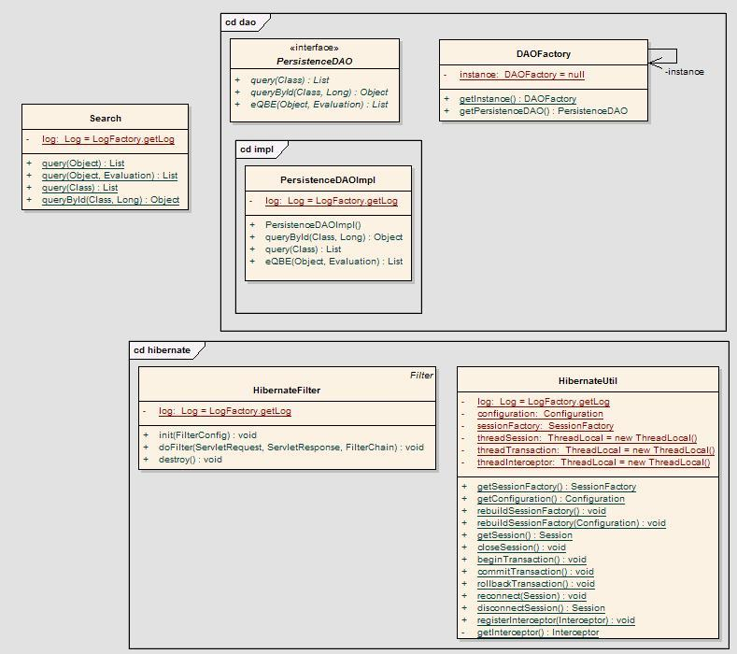
Figure 4.6 Common Persistence Model

Enhanced QBE (Hibernate 3.x) Model
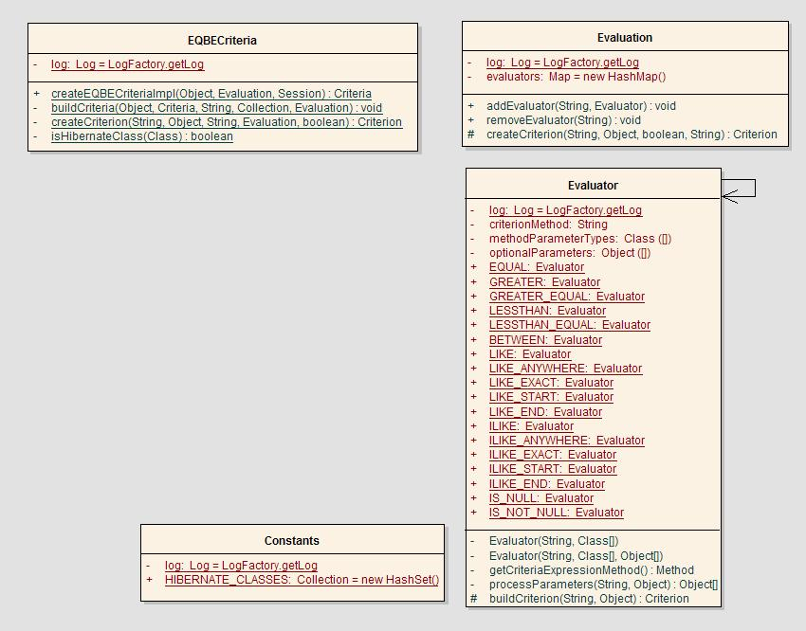Figure 4.7 Enhanced QBE (Hibernate 3.x) Model

    - Common Security Module (CSM)
The caMOD will be a secure application that integrates with the NCICB authentication infrastructure. While the existing Oracle-based DESK application authentication and authorization services have a relational Database Management System (RDBMS) implementation, caMOD will rely on the approach that leverages the institute-wide LDAP directory service. Use of NCI’s LDAP infrastructure will support internal and external users across Java and non-Java applications supporting the use of a single username and password for ALL applications leveraging the LDAP directory service for authentication and authorization services.

The CSM is currently under development and is only capable of providing web-based security at the time of the writing of this document. API security is not available and will be integrated following the next major caCORE release.

Application authorization is a caMOD requirement that will also be based on the CSM. The CSM will address the following caMOD needs:
1. Security service is comprised of both a runtime authorization component and a user-provisioning module for adding users to the system.
2. Module allows user to be associated to multiple applications.
3. Each application may be configured to support one single role or multiple roles.
4. Each role assigned to a user can be filtered by other data (e.g.: administrator role assigned to user Joe for Rockville office 1234 only).
5. Role and privilege information is retrieved by an application using the data filter.
6. Multiple application roles can share privileges.
7. Application clients can choose to store role-only information or role/privilege information in the module.
8. Support Web container and client application access to the security module.
9. Applications must log into the security service. Applications can only access user information specific to their application. They cannot access user information for other applications.
Using the authorization security service application, caMOD will provide an application security client that addresses caMOD application requirements. caMOD will likely log into the common security application on startup and retrieve the application’s role and privilege, which will be stored application-wide. User-specific information will be retrieved on each user’s login. Programmatic security will be completed locally using the retrieved objects.
1. User roles and authorizations are protocol-based.
2. Declarative security will be used for access. When caMOD only require role-based checks, declarative security can be used.
3. For protocol-specific security checks, programmatic security will be executed. User id, role and privilege information will be checked by protocol to determine access.
4. JSP custom tags will be used to check for roles and/or privileges in the web application. Tags should include or exclude content based on result of security checks.

    - Object Communication

TO DO: Show sequence diagrams per selected use cases

Deployment View

Deployment Diagram
Figure 5. caMOD Deployment View
caMOD will deploy using …. When moving to production …..:
- caMOD.jar – All general CAIMAGE application logic non-specific to an application layer is contained in the app jar.
- caMOD.war – Contains the CAIMAGE web application-specific classes and web server document classes.
- third party jars – All third-party jars used by the application are also loaded in the EAR file. No third party jar files are contained in the ejb jar or war files. Instead, the manifest files of each component references the dependent jars, which are contained directly in the EAR file.

Deployment Products and Framework Versions
CAIMAGE implements the following APIs and versions. As new versions are released or are supported by NCICB, the products will be updated after a determination that the versions do not cause problems in the application.
Name | Version | Provider | Description
Java SDK | 1.4.1_X | Sun Microsystems | JDK that the application runs. Deployed version dependent on NCICB standard at time of deployment. (java.sun.com/j2se/1.4.1/index.html)
Java J2EE Specification | 1.3 | Sun Microsystems | J2EE specification version supported in JBoss 3.2.1. Note: This is a specification included in JBoss
JBoss | 3.2.1 | JBoss Group open source | J2EE application server. (www.jboss.org)
Tomcat | 4.1.24 | Apache open source | J2EE web container that ships integrated with JBoss. (jakarta.apache.org/tomcat)
Struts | 1.1 | Apache open source | Web application framework (jakarta.apache.org/struts)
Commons | various | Apache open source | Common utilities required by Struts and utilized by caMOD. Includes: beanutils, collections, digester, logging
JSTL | 1.0.3 | Apache open source | Apache implementation of Sun JSTL specification
JDBC | 9i | Oracle | All Java driver for Oracle database
LDAP | TBD | Novell | NCICB authentication (to be used in later release)
Log4J | 1.2.7 | Apache open source | Logging API. Also used by JBoss
Velocity | 1.3 | Apache open source | Development use for generating Java classes

