caMOD API
Design Document
Version 1.0

Table of Contents
Table of Contents ii
Document History 3
Change Record 3
1 Introduction 4
1.1 Purpose of this Document 4
1.2 References 4
2 API Architecture 5
2.1 Overview 5
2.2 caMOD API Layer 6
3 caBIG and caGrid Integration 7
3.1 Overview 7
3.2 caMOD Grid Data Service 7
3.3 caBIG Registration 7

Figures

Figure 1 - caMOD API Architecture 5

Document History

Change Record
Date | Author(s) | Document  Version | Change Reference (Major Changes)
27 Jan 2007 | Marc Piparo | 1.0 | Initial Release

Introduction
The caMOD API architecture provides the ability for accessing and retrieving caMOD data via several mechanisms. The design provides functionality enabling remote applications to query and retrieve caMOD domain data using caCore and caGrid based methodologies, in addition to providing the necessary infrastructure for the integration of caMOD into the caBIG Index Service.

Purpose of this Document
This document provides a detailed view of the design and architecture of the API of the caMOD application. It will define the remote data access mechanisms and caGrid services integration into the caMOD application.

References
- caGrid 0.5 Technical Guide
- caMod System Design Document
- Hibernate in Action (Christian Bauer, Gavin King)

API Architecture

Overview
The caMOD API architecture integrates the caCore Application Service API design and caGrid Data Service infrastructure into the caMOD application design.

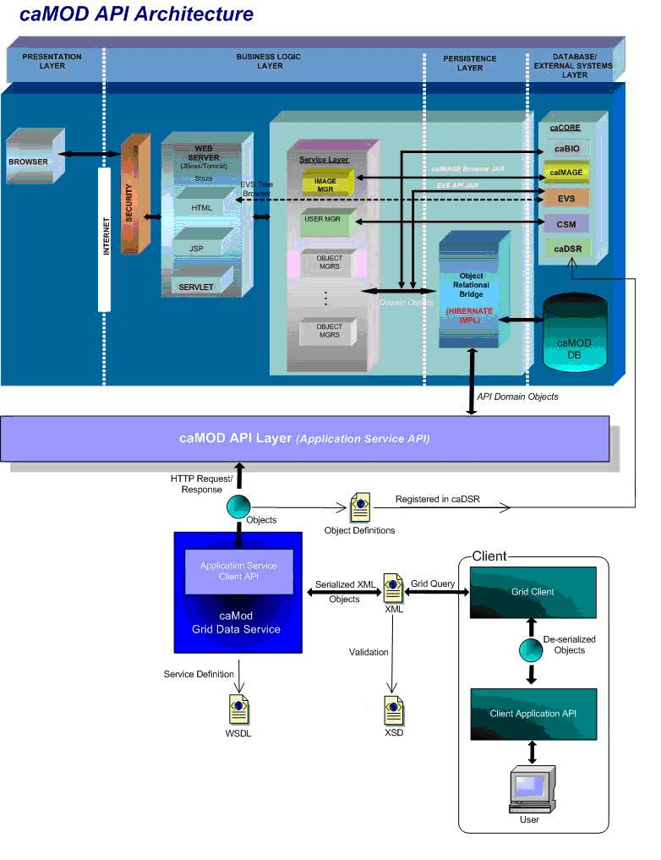
Figure 1 - caMOD API Architecture

caMOD API Layer
Using the caCore SDK Toolkit, the caMOD API Layer is built upon the generated framework and domain objects (API Domain Objects) along with the caCore Application Service remote interface infrastructure.

The caMOD API Layer integrates with the caMOD application thru the Object Relational Bridge which is built upon the Hibernate v3 ORM. The caMOD API, through the caCore Application Service framework, integrates with the Hibernate ORM using the caMOD application’s Hibernate mapping metadata. The Application Service query mechanism is responsible for communications to the Hibernate ORM layer via its ORM-DAO implementation.

API Domain Object based query requests are sent to the caMOD API Layer via HTTP Requests from an application (such as a caGrid Data Service) implementing the Application Service Client API. The caMOD API receives the HTTP Request queries and builds the supporting Hibernate query criteria from the API Domain Object based query embedded in the request. After Hibernate executes the criteria query, an HTTP Response containing query results, based upon API Domain Objects, are sent back to the Application Service based client application via an HTTP Response.

This caMOD API Layer communication protocol enables remote applications to request and retrieve data from the caMOD database via HTTP using domain object based queries and results. A primary client of this mechanism is the caMOD Grid Data Service discussed in the next section.

caBIG and caGrid Integration

Overview
Integration of the caMOD application into the caGrid infrastructure to meet caBIG sliver level compliancy guidelines involves the deployment of the caMOD Grid Data Service node and registration to the caBIG Index Service.

caMOD Grid Data Service
The caMOD Grid Data Service node is generated using the caGrid Toolkit. The process for the generation of this Grid Data Service involves the importing of the registered caMOD v2 model from the caDSR. The model is parsed and used to build the necessary Data Type Definitions metadata supporting the caGrid Web Service configuration. The caGrid services architecture is based upon the Open Grid Services Architecture (OGSA) using the Globus Toolkit v3. A Web Service Description Language (WSDL) is used to describe the supporting operations of the Grid Data Service. The Data Type Definitions extracted from the caDSR registered caMOD model are used to build an XML schema or XSD that is used to define the input and output data types of the Grid services. This XSD is registered in the Global Model Exchange (GME) and used to describe the contract of the grid service and to validate the XML serialization of the API Domain Objects during data requests.

The Grid Data Service framework provides core support of the caCore Application Service communication protocol as implemented by the caMOD API Layer. Communication to the caMOD API Layer involves the mechanisms discussed in the caMOD API Layer section in this document.

Applications communicate with the caMOD Grid Data Service node following the caGrid services protocol. The caMOD API domain objects are serialized by the caMOD Grid Data Service to and from XML adhering to the XML Schema (XSD) that is registered in the Global Model Exchange (GME). XML based queries are received by the caMOD Grid Data Service via an HTTP Request from a client application implementing the caGrid Client API. The XML query is processed and de-serialized into a caMOD API domain object based query following the caCore Service Application API protocol. The object based query is then sent via HTTP Request to the caMOD API Layer at which point it is processed as described in the caMOD API Architecture section of this document.

Query results are received from the caMOD API Layer, in the form of an API domain object based HTTP Response. The caMOD Grid Data Service serializes the resulting domain objects within the response to XML while validating against the registered XSD. The client application receives the XML query results via an HTTP Response and de-serializes the XML into caMOD API domain objects for processing via the caGrid Client API.

caBIG Registration
The caMOD Grid Data Service will use the core caGrid Toolkit generated framework for registering its availability and service metadata to the caBIG Index Service. The Data Service metadata is generated by the caGrid Toolkit thru referencing the caMOD v2 domain model registered in the caDSR, and contains details of the caMOD API domain object definitions, attributes, and associations. This defines the input parameters and output of operations supported by the caMOD Grid Data Service, as discussed in the previous section.

Registry of the caMOD Grid Data Service to the caBIG Index Service will provide researchers the ability to lookup caMOD services and the ability for client applications to retrieve data from the caMOD database via the caMOD Grid Data Service. In addition, users can access the on-line web based caGrid Browser and communicate XML based queries directly to the caMOD Grid Data Service and retrieve XML based query results.

