Software Requirements Specification
caMOD 2.8.1
NCICB

DOCUMENT REVISION HISTORY
Version Number | Date | Description
1.0 | 12/20/2010 | - Initial Draft
1.1
1.2
1.3
1.4

Background/Summary

The cancer models database (caMOD) is a web-based resource that provides information about animal models for human cancer to the public research community.

caMOD provides the following key capabilities to its users:

- Data Submission--Data in caMOD are extracted from the public scientific literature by curators and verified by the scientists who generated or worked with the models, or they are directly submitted by scientists.

- Cancer Model Search--Users can retrieve information about the making of models, their genetic descriptions, carcinogenic interventions, transient interference, histopathology, derived cell lines, associated images, transplantation, microarray data, and therapeutic trials in which the models were used. caMOD provides links to PubMed for associated publications and other resources such as mouse repositories, detailed information about altered gene, pathway affected, and information about human clinical trials that utilize the same compounds as the pre-clinical trials in the animal models.

- System Function Administration--The Admin function provides services for user registration, review of submitted models and database management.
Table of Content
1 Introduction 4
1.1 Overview for 2.8.1 4
2 Actors and Authorization 4
3 Use Cases 6
3.1 html tag syntax appears in Adv Search / Compound/Drug dropdown menu for agent name 7
3.1.1 Use Case Model 7
3.1.2 Supplemental Requirements 7
3.2 Transplantation page for old models does not open in Edit Mode 8
3.2.1 Use Case Model 8
3.2.2 Supplemental Requirements 9
3.3 Publication table on cell line and therapy search detail pages do not show RGD Reference Links 9
3.3.1 Use Case Model 9
3.3.2 Supplemental Requirements 10
3.4 Provide additional data from MGI - Parsing MGI data 10
3.4.1 Use Case Model 10
3.4.2 Supplemental Requirements 11
3.5 Re-engineer genetic description page to retrieve data from MGI 11
3.5.1 Use Case Model 11
3.5.2 Supplemental Requirements 12
3.6 Improve labeling and sorting of promoter poly A and intro entries on search page 12
3.6.1 Use Case Model 12
3.6.2 Supplemental Requirements 13
3.7 Add search for model id to simple and advanced search page 13
3.7.1 Use Case Model 13
3.7.2 Supplemental Requirements 14
3.8 Rewrite and data clean up for induced mutation data 14
3.8.1 Use Case Model 14
3.8.2 Supplemental Requirements 15
3.9 Therapy search results page is getting too long 15
3.9.1 Use Case Model 15
3.9.2 Supplemental Requirements 16
3.10 Bring search for induced mutations back 16
3.10.1 Use Case Model 16
3.10.2 Supplemental Requirements 17
3.11 Java upgrade 17
3.11.1 Use Case Model 17
3.11.2 Supplemental Requirements 18
3.12 Link styles for NSC and CAS numbers should be consistent between different pages 18
3.12.1 Use Case Model 18
3.12.2 Supplemental Requirements 19
3.13 Different sorting order for species in Search Models vs Submit Models 19
3.13.1 Use Case Model 19
3.13.2 Supplemental Requirements 20
3.14 Targeted Modification gene search term shows up in the customize search summary table if checkbox is deselected manually 20
3.14.1 Use Case Model 20
3.14.2 Supplemental Requirements 21
3.15 Transgene search term shows up in the customize search summary table if checkbox is deselected manually 21
3.15.1 Use Case Model 21
3.15.2 Supplemental Requirements 23
General Requirements 24
3.16 Requirements Prioritization 24
4 Data Definitions 24
5 Sign Off 25
5.1 Approval 25

Introduction

Overview for 2.8.1
caMOD 2.8.1 is a new feature build. This build will include additional data from the Jackson Lab Mouse Genome Informatics (MGI) database and an upgrade to Java JDK version. A few bug fixes and a variety of feature requests will also be included in this release.

Actors and Authorization

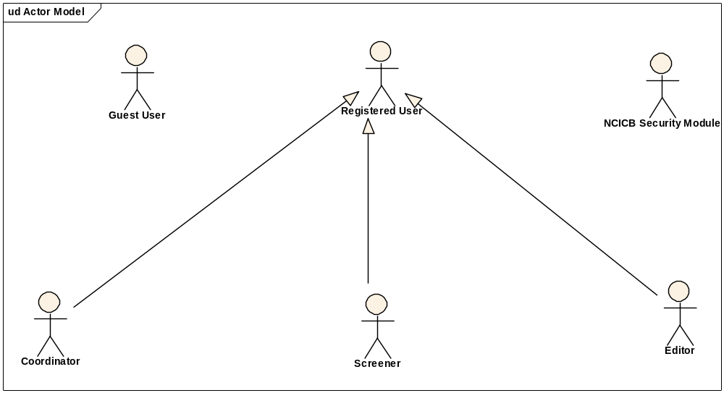
Guest User: Includes every user without an account. These users can query the database without restrictions, but they cannot submit models or comment on models.
Registered User: Can submit models to the database and can comment on models submitted by other researchers.
Super User (not shown): Has access to all model entries to update them. This is to facilitate minor text corrections in an entry without having to bother the submitter.
Coordinator: The coordinator is a registered user who appoints screener and editors. The coordinator also grants access privileges and manages the review process. After a model has been entered the coordinator assigns a screener who will check that all required fields have been specified and that the model does not contain junk or grossly inappropriate material. The coordinator will be informed about the decision of the screener by email. If the screener accepted the model the coordinator then assigns the model to an editor, who is a content expert.
Screener: The Screener is a registered user who performs the initial review of submitted models. This review is a quick check that all required fields have been specified and that the model does not contain junk or grossly inappropriate material. The screener also makes a preliminary assessment for clarity, typographic errors and other issues that would make the model less than fully comprehensible. The screening process should be complete within 24 hours. The screener does not contact the submitter about the submission. Any deficiencies found are described in the email to the coordinator. Each email deals with only one submission, so that the emails can be independently routed for vetting.
Editor: The Editor is a registered user who examines a model to see if it satisfies criteria to be made available to the public. The editor also considers any comments, made by the screener, that are passed along in the email from the coordinator. The editor may determine that the model cannot be made acceptable for publication in the database because it requires additional data. If the model has correctable defects, it may be necessary to communicate by email with the submitter to make the model acceptable. Correspondence and telephone contact with the submitters may be conducted through the coordinator. Editors are responsible for maintaining a paper trail or log of email exchanges regarding the models they review. The editor may elect to review a model without assistance. He or she can also request assistance from other subject matter experts. Only the editor has the authority to release the model to the intended audience.

Use Cases

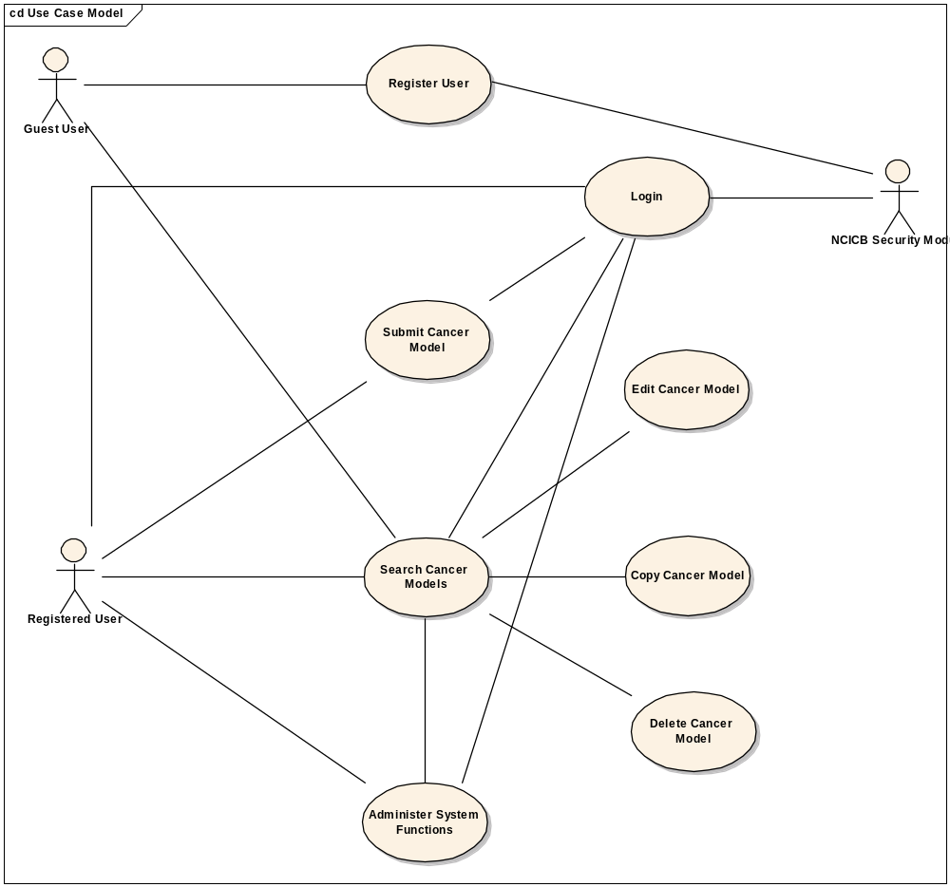
Figure 1. caMOD Use Case Diagram

html tag syntax appears in Adv Search / Compound/Drug dropdown menu for agent name

Use Case Model

Use Case Name | html tag syntax appears in Adv Search / Compound/Drug dropdown menu for agent name
Use Case ID | CAMOD-684
Primary Actor | All registered users
Brief Description | The advanced search allows users to select criteria to submit to the caMOD database in the form of a query. The application returns a list of models that match the selection criteria submitted by the user. If possible, re-format the entries in the Carcinogenic Agent Name drop-down menu displayed to the user (use filter=true in the jsp).
Trigger | Actor navigates to the caMOD URL
Pre-conditions | Successful navigation to the caMOD URL
Flow of Events | 1. The system presents search and submit models hyperlinks.
Flow of Events | 2. The actor
Flow of Events | - Navigates to the advanced search screen  - Selects Chemical / Drug from the Carcinogenic Agent Type drop down  - Verifies that the Carcinogenic Agent Name drop down is properly displayed
Post Conditions | Success Condition (Selection Criteria): User searches for animal models by the criteria entered  Error Condition: Fails to return a list of models or no model found  Error Condition: Validation fails  Error Condition: System Error
Alternative Courses of Action | If a validation error occurs (search), the system throws an exception, displays an error message and re-displays page for criteria search.  a. Fails to return a list of models (or no models found)  - Navigate to the search criteria page (simple or advanced)  - Re Submit the search criteria page (Return to step 2a)  - Contact system administrator  b. Validation fails (if implemented)  - Enter valid search criteria (Return to step 2a)  c. System Error.  -Contact system administrator
Issues

Supplemental Requirements
None

Transplantation page for old models does not open in Edit Mode

Use Case Model

Use Case Name | Transplantation page for old models does not open in Edit Mode
Use Case ID | CAMOD-685
Primary Actor | Model Submitter, Model PI and administrators of caMOD
Brief Description | The submission section of the application allows user to submit animal model information for many categories. One of these sections is titled Transplantation. After a user submits the data to the caMOD database the application will display the data in an edit mode for verification or modification by the submitter. Figure out why older models are not displayed correctly and resolve the issue.
Trigger | Actor navigates to the caMOD URL
Pre-conditions | Successful navigation to the caMOD URL  Successful login to caMOD
Flow of Events | 1. The system presents search and submit models hyperlinks. The admin link is only displayed for administrators of the system.
Flow of Events | 2. The actor
Flow of Events | - Navigates to the new admin section  - Successfully searches for the model by model id
Flow of Events | 3. The system
Flow of Events | - Returns the model
Flow of Events | 4. The actor
Flow of Events | - Selects the returned model and move to the Model Characteristics page
Flow of Events | - Verify that the data is displayed correctly
Post Conditions | Success Condition (Submit models): User creates new model and submits data for appropriate section.  Error Condition: Fails to create new model  Error Condition: Validation fails  Error Condition: System Error
Alternative Courses of Action | If a validation error occurs (submit), the system throws an exception, displays an error message and re-displays page for data entry.  a. Fails to create new model  -Re Submit new model data (Return to step 2a)  -Contact system administrator  b. Validation fails  - Re-enter required data for model (Return to step 2a)  c. System Error.  -Contact system administrator
Issues | select ac.ABS_CANCER_MODEL_ID, ac.ABS_CANCER_MODEL_TYPE, ac.STRAIN_ID, ac.DONOR_SPECIES_ID  from abs_cancer_model ac  where ac.ABS_CANCER_MODEL_ID = '1055';  select * from strain st  where st.STRAIN_ID = '293';

Supplemental Requirements
None

Publication table on cell line and therapy search detail pages do not show RGD Reference Links

Use Case Model

Use Case Name | Publication table on cell line and therapy search detail pages do not show RGD Reference Links
Use Case ID | CAMOD-692
Primary Actor | All users
Brief Description | Publication data for a model can be displayed on the main publication page and can be associated to either a cell line and therapy object. The publication data for the cell line and therapy data is not displaying correctly.
Trigger | Actor navigates to the caMOD URL
Pre-conditions | Successful navigation to the caMOD URL
Flow of Events | 1. The system presents search and submit models hyperlinks.
Flow of Events | 2. The actor
Flow of Events | - Navigates to the advanced search screen  - Successfully searches for an animal model with cell line or therapy data including publication entry
Flow of Events | 3. The system
Flow of Events | - Returns the model matching the selection criteria
Flow of Events | 4. The actor
Flow of Events | - Navigates to the cell line or therapy view page  - Verifies that the publication data is displayed correctly
Post Conditions | Success Condition (Search): System returns models matching selection criteria.  Error Condition: No models found  Error Condition: Validation fails  Error Condition: System Error
Alternative Courses of Action | If a validation error occurs (search), the system throws an exception, displays an error message and re-displays page for criteria search.  a. Fails to return a list of models (or no models found)  - Navigate to the search criteria page (simple or advanced)  - Re Submit the search criteria page (Return to step 2a)  - Contact system administrator  b. Validation fails (if implemented)  - Enter valid search criteria (Return to step 2a)  c. System Error.  -Contact system administrator
Issues

Supplemental Requirements
None

Provide additional data from MGI - Parsing MGI data

Use Case Model

Use Case Name | Provide additional data from MGI - Parsing MGI data
Use Case ID | CAMOD-842
Primary Actor | All public users
Brief Description | The Mouse Genome Informatics (MGI) database is hosted by Jackson Laboratory. The MGI database includes data related to genes, phenotypes, expression, pathway, strains, and tumor data. Additional data will be added to the targeted medication and transgene data pages from MGI. The data will either be displayed dynamically from MGI or imported into the caMOD database for display.
Trigger | Actor navigates to the caMOD URL
Pre-conditions | Successful navigation to the caMOD URL
Flow of Events | 1. The system presents search and submit models hyperlinks.
Flow of Events | 2. The actor
Flow of Events | - Navigates to the advanced search screen  - Successfully searches for an animal model with targeted modification or transgene data including additional data from MGI
Flow of Events | 3. The system  - Returns the model matching the selection criteria
Flow of Events | 4. The actor  - Navigates to the targeted modification or transgene view page  - Verifies that the additional MGI data is displayed correctly
Post Conditions | Success Condition (Search): System returns models matching selection criteria.  Error Condition: No models found  Error Condition: Validation fails  Error Condition: System Error
Alternative Courses of Action | If a validation error occurs (search), the system throws an exception, displays an error message and re-displays page for criteria search.  a. Fails to return a list of models (or no models found)  - Navigate to the search criteria page (simple or advanced)  - Re Submit the search criteria page (Return to step 2a)  - Contact system administrator  b. Validation fails (if implemented)  - Enter valid search criteria (Return to step 2a)  c. System Error.  -Contact system administrator
Issues

Supplemental Requirements
None

Re-engineer genetic description page to retrieve data from MGI

Use Case Model

Use Case Name | Re-engineer genetic description page to retrieve data from MGI
Use Case ID | CAMOD-851
Primary Actor | All registered users
Brief Description | The Mouse Genome Informatics (MGI) database is hosted by Jackson Laboratory. The MGI database includes data related to genes, phenotypes, expression, pathway, strains, and tumor data. If the MGI data is not stored in the caMOD database modify the targeted modification and/or transgene submission page to allow the user to simply input the MGI number instead of filling in all the fields. If the user does not have the MGI number, he/she will still have to fill in the data field.
Trigger | Actor navigates to the caMOD URL
Pre-conditions | Successful navigation to the caMOD URL  Successful login to caMOD
Flow of Events | 1. The system presents search and submit models hyperlinks.
Flow of Events | 2. The actor
Flow of Events | - Navigates to the new model submission section  - Successfully enters the data to create an animal model
Flow of Events | 3. The system
Flow of Events | - Returns the data-type categories for submitting data
Flow of Events | 4. The actor
Flow of Events | - Selects the submit targeted modification and submit transgene screens  - Verify that the user can either submit the MGI number or fill in all the data fields for each screen  - Submit the page
Flow of Events | 5. The system
Flow of Events | - Saves the data for the submitted model
Flow of Events | 4. The actor
Flow of Events | - Verify that the entered data is saved in the database
Post Conditions | Success Condition (Submit models): User creates new model and submits data for appropriate section.  Error Condition: Fails to create new model  Error Condition: Validation fails  Error Condition: System Error
Alternative Courses of Action | If a validation error occurs (submit), the system throws an exception, displays an error message and re-displays page for data entry.  a. Fails to create new model  -Re Submit new model data (Return to step 2a)  -Contact system administrator  b. Validation fails  - Re-enter required data for model (Return to step 2a)  c. System Error.  -Contact system administrator
Issues

Supplemental Requirements
None

Improve labeling and sorting of promoter poly A and intro entries on search page

Use Case Model

Use Case Name | Improve labeling and sorting of promoter poly A and intro entries on search page
Use Case ID | CAMOD-869
Primary Actor | All users
Brief Description | The transgene search results page displays data for promoter elements poly A. The data needs to be labeled clearly and the page needs to be organized in the same order as the submission screen.
Trigger | Actor navigates to the caMOD URL
Pre-conditions | Successful navigation to the caMOD URL
Flow of Events | 1. The system presents search and submit models hyperlinks.
Flow of Events | 2. The actor
Flow of Events | - Navigates to the advanced search section  - Searches for a model with transgene data
Flow of Events | 3. The system
Flow of Events | - Returns the list of animal models matching the PMID entered
Flow of Events | 4. The actor
Flow of Events | - Verifies that the poly A data and transgene pages is ordered better
Post Conditions | Success Condition (Search): System returns models matching selection criteria.  Error Condition: No models found  Error Condition: Validation fails  Error Condition: System Error
Alternative Courses of Action | If a validation error occurs (search), the system throws an exception, displays an error message and re-displays page for criteria search.  a. Fails to return a list of models (or no models found)  - Navigate to the search criteria page (simple or advanced)  - Re Submit the search criteria page (Return to step 2a)  - Contact system administrator  b. Validation fails (if implemented)  - Enter valid search criteria (Return to step 2a)  c. System Error.  -Contact system administrator
Issues

Supplemental Requirements
None

Add search for model id to simple and advanced search page

Use Case Model

Use Case Name | Add search for model id to simple and advanced search page
Use Case ID | CAMOD-882
Primary Actor | All users for search section, registered users for submission section
Brief Description | Want to add model id to advanced search page
Trigger | Actor navigates to the caMOD URL
Pre-conditions | Successful navigation to the caMOD URL and successful login for submission section
Flow of Events | 1. The system presents both search and submit models hyperlinks.
Flow of Events | 2. To search a model, the actor
Flow of Events | - Navigates to the search models section
Flow of Events | 3. The system
Flow of Events | - Returns the search criteria screen
Flow of Events | 4. The actor
Flow of Events | - Navigates to the advanced search section  - Enters selection criteria and submits search form, including model id
Flow of Events | 5. The system  - Returns models matching any selection criteria entered by the user
Post Conditions | Success Condition (Selection Criteria): User searches for animal models by the criteria entered  Error Condition: Fails to return a list of models or no model found  Error Condition: Validation fails  Error Condition: System Error
Alternative Courses of Action | If a validation error occurs (search), the system throws an exception, displays an error message and re-displays page for criteria search.  a. Fails to return a list of models (or no models found)  - Navigate to the search criteria page (simple or advanced)  - Re Submit the search criteria page (Return to step 2a)  - Contact system administrator  b. Validation fails (if implemented)  - Enter valid search criteria (Return to step 2a)  c. System Error.  -Contact system administrator
Issues

Supplemental Requirements
None

Rewrite and data clean up for induced mutation data

Use Case Model

Use Case Name | Rewrite and data clean up for induced mutation data
Use Case ID | CAMOD-886
Primary Actor | All users
Brief Description | The caMOD application displays induced mutation data on the genetic description results page. The induced mutation data is stored in the environmental factor database table along with the environmental factor data. Modify the search query to take advantage of the induced mutation flag (column) that was added in a recent release.
Trigger | Actor navigates to the caMOD URL
Pre-conditions | Successful navigation to the caMOD URL and successful login for submission section
Flow of Events | 1. The system presents both search and submit models hyperlinks.
Flow of Events | 2. To search a model, the actor
Flow of Events | - Navigates to the search models section
Flow of Events | 3. The system
Flow of Events | - Returns the search criteria screen
Flow of Events | 4. The actor
Flow of Events | - Navigates to the advanced search section  - Enters selection criteria and submits search form, including a model with induced mutation data
Flow of Events | 5. The system
Flow of Events | - Returns models matching any selection criteria entered by the user
Post Conditions | Success Condition (Selection Criteria): User searches for animal models by the criteria entered  Error Condition: Fails to return a list of models or no model found  Error Condition: Validation fails  Error Condition: System Error
Alternative Courses of Action | If a validation error occurs (search), the system throws an exception, displays an error message and re-displays page for criteria search.  a. Fails to return a list of models (or no models found)  - Navigate to the search criteria page (simple or advanced)  - Re Submit the search criteria page (Return to step 2a)  - Contact system administrator  b. Validation fails (if implemented)  - Enter valid search criteria (Return to step 2a)  c. System Error.  -Contact system administrator
Issues

Supplemental Requirements
None

Therapy search results page is getting too long

Use Case Model

Use Case Name | Therapy search results page is getting too long
Use Case ID | CAMOD-892
Primary Actor | All users
Brief Description | The caMOD application displays therapy data. Some models have so much therapy data that the page is getting too long. Engineer a way to make the results page easier to read.
Trigger | Actor navigates to the caMOD URL
Pre-conditions | Successful navigation to the caMOD URL and successful login for submission section
Flow of Events | 1. The system presents both search and submit models hyperlinks.
Flow of Events | 2. To search a model, the actor
Flow of Events | - Navigates to the search models section
Flow of Events | 3. The system
Flow of Events | - Returns the search criteria screen
Flow of Events | 4. The actor
Flow of Events | - Navigates to the advanced search section  - Enters selection criteria and submits search form, including a model with therapy data
Flow of Events | 5. The system  - Returns models matching any selection criteria entered by the user
Post Conditions | Success Condition (Search): System returns models matching selection criteria.  Error Condition: No models found  Error Condition: Validation fails  Error Condition: System Error
Alternative Courses of Action | If a validation error occurs (search), the system throws an exception, displays an error message and re-displays page for criteria search.  a. Fails to return a list of models (or no models found)  - Navigate to the search criteria page (simple or advanced)  - Re Submit the search criteria page (Return to step 2a)  - Contact system administrator  b. Validation fails (if implemented)  - Enter valid search criteria (Return to step 2a)  c. System Error.  -Contact system administrator
Issues

Supplemental Requirements
None

Bring search for induced mutations back

Use Case Model

Use Case Name | Bring search for induced mutations back
Use Case ID | CAMOD-900
Primary Actor | All users
Brief Description | The caMOD application displays induced mutation data on the genetic description results page. The induced mutation data is stored in the environmental factor database table along with the environmental factor data separated by an induced mutation flag (column) that was added in a recent release. At that time the application provided the users with a search for models with induced mutations. Fix this search and restore this on the advanced search screen.
Trigger | Actor navigates to the caMOD URL
Pre-conditions | Successful navigation to the caMOD URL and successful login for submission section
Flow of Events | 1. The system presents both search and submit models hyperlinks.
Flow of Events | 2. To search a model, the actor
Flow of Events | - Navigates to the search models section
Flow of Events | 3. The system
Flow of Events | - Returns the search criteria screen
Flow of Events | 4. The actor
Flow of Events | - Navigates to the advanced search section  - Enters selection criteria and submits search form, including induced mutation criteria
Flow of Events | 5. The system
Flow of Events | - Returns models matching any selection criteria entered by the user
Post Conditions | Success Condition (Selection Criteria): User searches for animal models by the criteria entered  Error Condition: Fails to return a list of models or no model found  Error Condition: Validation fails  Error Condition: System Error
Alternative Courses of Action | If a validation error occurs (search), the system throws an exception, displays an error message and re-displays page for criteria search.  a. Fails to return a list of models (or no models found)  - Navigate to the search criteria page (simple or advanced)  - Re Submit the search criteria page (Return to step 2a)  - Contact system administrator  b. Validation fails (if implemented)  - Enter valid search criteria (Return to step 2a)  c. System Error.  -Contact system administrator
Issues

Supplemental Requirements
None

Java upgrade

Use Case Model

Use Case Name | Java upgrade
Use Case ID | CAMOD-918
Primary Actor | All users
Brief Description | The caMOD application currently runs against Java JDK version 1.5. Upgrade the JDK version to the current version as defined by the NCICB tech stack. Test all code running against this version including the grid service.
Trigger | Actor navigates to the caMOD URL
Pre-conditions | Successful navigation to the caMOD URL and successful login for submission section and successful search functionality
Flow of Events | 1. Test the entire system
Post Conditions
Alternative Courses of Action

Issues

Supplemental Requirements
None

Link styles for NSC and CAS numbers should be consistent between different pages

Use Case Model

Use Case Name | Link styles for NSC and CAS numbers should be consistent between different pages
Use Case ID | CAMOD-965
Primary Actor | All registered users
Brief Description | The caMOD application allows users to input NSC and CAS numbers on various pages within the animal model submission section. The display and functionality of each of these buttons need to be consistent.
Trigger | Actor navigates to the caMOD URL
Pre-conditions | Successful navigation to the caMOD URL  Successful login to caMOD
Flow of Events | 1. The system presents search and submit models hyperlinks.
Flow of Events | 2. The actor
Flow of Events | - Navigates to the new model submission section  - Successfully enters the data to create an animal model
Flow of Events | 3. The system
Flow of Events | - Returns the data-type categories for submitting data
Flow of Events | 4. The actor
Flow of Events | - Navigates to the various submission pages that include NSC and CAS number.  - Verify that the format and function of the buttons are consistent between pages.
Post Conditions | Success Condition (Submit models): User creates new model and submits data for appropriate section.  Error Condition: Fails to create new model  Error Condition: Validation fails  Error Condition: System Error
Alternative Courses of Action | If a validation error occurs (submit), the system throws an exception, displays an error message and re-displays page for data entry.  a. Fails to create new model  -Re Submit new model data (Return to step 2a)  -Contact system administrator  b. Validation fails  - Re-enter required data for model (Return to step 2a)  c. System Error.  -Contact system administrator
Issues

Supplemental Requirements
None

Different sorting order for species in Search Models vs Submit Models

Use Case Model

Use Case Name | Different sorting order for species in Search Models vs Submit Models
Use Case ID | CAMOD-966
Primary Actor | All registered users
Brief Description | The caMOD application allows users to select data for species on various pages within the animal model submission section. The caMOD application also displays a species drop down on the simple and advanced search criteria screens. The display (sorting order) of the species drop down should be consistent between sections.
Trigger | Actor navigates to the caMOD URL
Pre-conditions | Successful navigation to the caMOD URL  Successful login to caMOD
Flow of Events | 1. The system presents search and submit models hyperlinks.
Flow of Events | 2. The actor
Flow of Events | - Navigates to the new model submission section  - Successfully enters the data to create an animal model
Flow of Events | 3. The system
Flow of Events | - Returns the data-type categories for submitting data with a species drop down
Flow of Events | 4. The actor
Flow of Events | - Navigates to the simple and advanced search criteria screens.  - Verify that the sorting order of each drop down menu is consistent between sections.
Post Conditions | Success Condition (Submit models): User creates new model and submits data for appropriate section.  Error Condition: Fails to create new model  Error Condition: Validation fails  Error Condition: System Error  Success Condition (Selection Criteria): User searches for animal models by the criteria entered  Error Condition: Fails to return a list of models or no model found  Error Condition: Validation fails  Error Condition: System Error
Alternative Courses of Action | If a validation error occurs (submit), the system throws an exception, displays an error message and re-displays page for data entry.  a. Fails to create new model  -Re Submit new model data (Return to step 2a)  -Contact system administrator  b. Validation fails  - Re-enter required data for model (Return to step 2a)  c. System Error.  -Contact system administrator  If a validation error occurs (search), the system throws an exception, displays an error message and re-displays page for criteria search.  a. Fails to return a list of models (or no models found)  - Navigate to the search criteria page (simple or advanced)  - Re Submit the search criteria page (Return to step 2a)  - Contact system administrator  b. Validation fails (if implemented)  - Enter valid search criteria (Return to step 2a)  c. System Error.  -Contact system administrator
Issues

Supplemental Requirements
None

Targeted Modification gene search term shows up in the customize search summary table if checkbox is deselected manually

Use Case Model

Use Case Name | Targeted Modification gene search term shows up in the customize search summary table if checkbox is deselected manually
Use Case ID | CAMOD-970
Primary Actor | All users
Brief Description | The caMOD application displays the criteria selected by the user in a summary table used by the customized search functionality. The user can save searches for later use. The application provides a button to clear all the criteria so a user can start a new search or saves the last criteria so the user can modify that criteria search. If the user manually deselects the checkbox for targeted modification without clearing the gene name field, the application incorrectly retains the gene name and displays it in the customize search summary table. The search to the database works correctly since it checks for the checkbox value first before setting the criteria and sending the query to the database. Fix the customized search code so it reads the checkbox first and nulls out or ignores the gene name in to prevent an inaccurate display.
Trigger | Actor navigates to the caMOD URL
Pre-conditions | Successful navigation to the caMOD URL and successful login for submission section
Flow of Events | 1. The system presents both search and submit models hyperlinks.
Flow of Events | 2. To search a model, the actor
Flow of Events | - Navigates to the search models section
Flow of Events | 3. The system
Flow of Events | - Returns the search criteria screen
Flow of Events | 4. The actor
Flow of Events | - Navigates to the advanced search section  - Enters selection criteria and submits search form, including targeted modification criteria
Flow of Events | 5. The system
Flow of Events | - Returns models matching any selection criteria entered by the user
Flow of Events | 6. The actor
Flow of Events | - Deselects just the checkbox for targeted modification  - Verifies that the customized search summary table displays the criteria correctly
Post Conditions | Success Condition (Selection Criteria): User searches for animal models by the criteria entered  Error Condition: Fails to return a list of models or no model found  Error Condition: Validation fails  Error Condition: System Error
Alternative Courses of Action | If a validation error occurs (search), the system throws an exception, displays an error message and re-displays page for criteria search.  a. Fails to return a list of models (or no models found)  - Navigate to the search criteria page (simple or advanced)  - Re Submit the search criteria page (Return to step 2a)  - Contact system administrator  b. Validation fails (if implemented)  - Enter valid search criteria (Return to step 2a)  c. System Error.  -Contact system administrator
Issues

Supplemental Requirements
None

Transgene search term shows up in the customize search summary table if checkbox is deselected manually

Use Case Model

Use Case Name | Transgene search term shows up in the customize search summary table if checkbox is deselected manually
Use Case ID | CAMOD-971
Primary Actor | All users
Brief Description | The caMOD application displays the criteria selected by the user in a summary table used by the customized search functionality. The user can save searches for later use. The application provides a button to clear all the criteria so a user can start a new search or saves the last criteria so the user can modify that criteria search. If the user manually deselects the checkbox for transgene without clearing the gene name field, the application incorrectly retains the gene name and displays it in the customize search summary table. The search to the database works correctly since it checks for the checkbox value first before setting the criteria and sending the query to the database. Fix the customized search code so it reads the checkbox first and nulls out or ignores the gene name in to prevent an inaccurate display.
Trigger | Actor navigates to the caMOD URL
Pre-conditions | Successful navigation to the caMOD URL and successful login for submission section
Flow of Events | 1. The system presents both search and submit models hyperlinks.
Flow of Events | 2. To search a model, the actor
Flow of Events | - Navigates to the search models section
Flow of Events | 3. The system
Flow of Events | - Returns the search criteria screen
Flow of Events | 4. The actor
Flow of Events | - Navigates to the advanced search section  - Enters selection criteria and submits search form, including transgene criteria
Flow of Events | 5. The system
Flow of Events | - Returns models matching any selection criteria entered by the user
Flow of Events | 6. The actor
Flow of Events | - Deselects just the checkbox for transgene  - Verifies that the customized search summary table displays the criteria correctly
Post Conditions | Success Condition (Selection Criteria): User searches for animal models by the criteria entered  Error Condition: Fails to return a list of models or no model found  Error Condition: Validation fails  Error Condition: System Error
Alternative Courses of Action | If a validation error occurs (search), the system throws an exception, displays an error message and re-displays page for criteria search.  a. Fails to return a list of models (or no models found)  - Navigate to the search criteria page (simple or advanced)  - Re Submit the search criteria page (Return to step 2a)  - Contact system administrator  b. Validation fails (if implemented)  - Enter valid search criteria (Return to step 2a)  c. System Error.  -Contact system administrator
Issues

Supplemental Requirements
None

General Requirements

Requirements Prioritization

Req # | Use Case Name
 | caMOD - Cancer Models Database – Bugs
CAMOD-685 | Transplantation page for old models does not open in Edit Mode
CAMOD-692 | Publication table on cell line and therapy search detail pages do not show RGD Reference Links
CAMOD-965 | Link styles for NSC and CAS numbers should be consistent between different pages
CAMOD-966 | Different sorting order for species in Search Models vs Submit Models
 | caMOD - Cancer Models Database – Feature Requests
CAMOD-842 | Provide additional data from MGI - Parsing MGI data
CAMOD-851 | IDEA - redo genetic description page to retrieve data from external source similar to what publication page does with PubMed
CAMOD-869 | Improve labeling and sorting of promoter poly A and intro entries on search page
CAMOD-882 | Add search for model id to simple and advanced search page
CAMOD-886 | Rewrite and data clean up for induced mutation data
CAMOD-892 | Therapy search results page is getting too long
CAMOD-900 | Bring search for induced mutations back
CAMOD-918 | Java upgrade
CAMOD-970 | Targeted Gene Modification search term persists after it was unchecked for a new search
CAMOD-971 | Transgene search term shows up for a new search after it has been removed

Data Definitions

CDE # | Data Element | Description | Use Case Name

Sign Off

Approval

Workspace General Contractor Rep Print Name Date
Architecture Workspace Rep Print Name Date
VCDE Workspace Rep Print Name Date
Workspace Working Group Rep Print Name Date
NCICB Rep Print Name Date

