CaLAB
Software Design Document
Version 0.5

Table of Contents
Table of Contents
1.Introduction 3
1.1 Definitions, Acronyms, and Abbreviations……………………………………………………………….4
2.Background 5
3.Architectural Goals and Constraints 6
3.1 Architectural Goals………………………………………………………………………………………..6
3.2 Architectural Constraints………………………………………………………………………………..6
4.Architectural Representation 7
4.1 Application Layers………………………………………………………………………………………….7
4.2 Design Patterns Applied to Application Layers………………………………………………………….8
5.Use-Case View 13
5.1 Introduction………………………………………………………………………………………………13
5.2 Pilot Release Use Cases…………………………………………………………………………………..13
6.Logical View 15
6.1 Subsystems…………………………………………………………………………………………………15
7.Deployment View 20
7.1 Deployment Diagram………………………………………………………………………………………20
7.2 Deployment Products and Framework Versions………………………………………………………..20
8.Data View 22

Figures

Figure 1. DESIGN_DOCUMENT_TEMPLATE Architecture Layers 7
Figure 2. General MVC System Flow 8
Figure 3. Presentation Layer Framework Sequence 10
Figure 4. DESIGN_DOCUMENT_TEMPLATE Pilot Use Cases 13
Figure 5. Case Management Subsystem Value Objects 15
Figure 6. Workflow Subsystem class model 16
Figure 7. Routing Sequence 17
Figure 8. DESIGN_DOCUMENT_TEMPLATE Conceptual Authorization Model 19
Figure 9. DESIGN_DOCUMENT_TEMPLATE Deployment View 20
Figure 10. Primary DESIGN_DOCUMENT_TEMPLATE database entities 22

Document History

Change Record
Date | Author(s) | Document  Version | Change Reference (Major Changes)

Reviewers
Name | Position | Document  Version | Date  Reviewed

Introduction
The primary goal of the caLAB effort is to develop core components of a Laboratory Information Management System (LIMS) that are compliant with the cancer Biomedical Informatics Grid (caBIG) data and technology standards and principles. Specifically, the effort involves:
- Developing a core LIMS based on caBIG principles of open source, open access, and interoperability (syntactic and semantic) via standard Common Data Elements (CDEs) and terminology
- Developing a core LIMS that can be utilized by a variety of laboratories operating diverse experiment modalities
- Engineering a core generic LIMS that can be customized and extended to support laboratory specific requirements
- Establishing an Open Development Initiative (ODI) that allows LIMS developers to contribute LIMS customizations and enhancements to the end user community
- Creating an affordable (free) “near” commercial grade LIMS that allows laboratories to focus on scientific research and scientific investments

Purpose of this Document
This document provides an overview of caLAB system design. It is intended to describe and capture the caLAB design decisions and is written as a reference for both the NCI customer and the NCI contractors/developers involved with the evolution of caLAB. This is a living document and will be updated to reflect the evolution of development, as well as future enhancements and upgrades.

Document Overview
The main sections of this document are listed and described below.

- Section 1 provides a purpose statement, a document overview, identifies the scope and provides a list of related documents. In addition, this section identifies (at a very high level), the methodologies, tool and techniques employed for the caLAB design activities, addresses any NCICB directives impacting the design decisions, and identifies the key stakeholders and points of contact.

- Section 2 is the design overview. It outlines any background information that is relevant to the proposed design, identifies the step-by-step procedure to migrate the existing system to a more efficient implementation. In addition, this section identifies the emerging technologies that are expected to available in a given timeframe and how they make effect the future development of the system/system architecture. Risks, issues, assumptions and dependencies are also addressed.

- Section 3 captures the system architecture design. The architectural goals and constraints are identified and an architecture diagram is provided. Additionally, we discuss the architectural layers and describe any design patterns applied within them.

- Section 4 addresses the software design. We discuss the software packages and the associated object models that capture specific functional areas. We will show samples of how these objects address the requirements/use cases captured in the Requirements Document. The objects are described at a high-level in this section. The detailed description of the classes and there associated attributes will be detailed in the Section 5 Data Design.

- Section 5 addresses the data design. We discuss the data design with respect to object model. We describe the relationships between the data objects (tables) and the attributes that comprise each. The object-to-relational mappings will be addressed as well.

- Section 6 addresses the system deployment. We describe the build process, the resulting products and how those products will be deployed. This section also address the technology stack being deployed by caLAB.

Scope
The scope of this document is to provide a detailed design specification for the implementation of a multi-tiered, caBIG silver compliant, cancer models application. The system architecture design, software component design, user interface design, design constraints and design guidelines are presented.

This document does not address the caLAB project timeline/schedule, use cases/requirements, or any testing activities. These items are captured as part of separate documents. (Refer to 1.4 for a list of related documents.)

Related Documents
Document Name | Version | Location
caBIG LIMS Phase 1 Scope | 1.1 | https://ncicbintra.nci.nih.gov/lims/caBIG/p1req_scope.doc
caBIG LIMS Requirements Presentation | 1.0 | https://ncicbintra.nci.nih.gov/lims/caBIG/cabig_lims.ppt
NCL LIMS Requirements Spreadsheet | 1.0 | https://ncicbintra.nci.nih.gov/lims/caBIG/ncl_lims.xls
caBIG Compatibility Guidelines | 2.0 | https://cabig.nci.nih.gov/guidelines_documentation/caBIGCompatGuideRev2_final.pdf
caLAB Requirement Specifications | 1.3 | <<Include Link>

Methodologies, Tools and Techniques
The caLAB design will be based on object oriented (OO) principles. Enterprise Architect (EA) will be the tool used to build several of the key design artifacts. The Rational Unified Process will be the base technique used for object modeling and other detailed design exercises.

Policies, Directives, Procedures
The NCICB requires that the development of a multi-tiered cancer models application portal be caBIG compatible.

Key Stakeholders
TBD

Points of Contact
- NCICB Application Support
Email: appsupport@mail.nih.gov

DESIGN OVERVIEW
The caLAB effort is to develop core components of a Laboratory Information Management System (LIMS) that will be caBIG compatible system, facilitate inter-operatiblity at the application level with other LIMS, support customizations to laboratory specific requirements, and consequently establish an Open Development Initiative (ODI) that allows LIMS developers to contribute LIMS customizations and enhancements to the end user community.

Background Information
TBD

System Evolution Description
- TBD

Technology Forecast
The caLAB application will rely on the NCICB Common Security Module for API-based security and caCORE SDK for code generation. The initial caLAB multi-tiered release will employ the caCORE 3.1 version any bugs that have been identified in that release my impact the application functionality.

Risks
Risks | Low | Med | High | Contingency

Issues
Ref | Issue | Action

Assumptions
Ref | Assumption | Impact

Dependencies
Ref | Dependency | Action

SYSTEM ARCHITECTURE

Architectural Goals and Constraints
The following are goals and constraints of the caLAB system architecture.

- To ensure the platform addresses enterprise level of service requirements: Performance, Scalability, Reliability, Availability, Extendibility, Maintainability, Manageability, and Security.
- The caLAB uses a standard N-Tier model that enables optimal performance and maintainability of caLAB implemented systems. The separation of components into logical tiers provides more application flexibility and software component/module reuse, among other benefits. This layered environment also simplifies code distribution, since most of the business logic has been moved from the client to the server.
- The caLAB code base will address the performance, reliability, extendibility and maintainability. caBIG software reuse, J2EE design patterns, and best practices will be utilized throughout the application.
- Define clear application layers delineating architectural role and functionality
- The caLAB N-Tier architecture provides clear separation of user-interface-control and data presentation from application-logic. Through this separation more clients are able to have access to a wide variety of server applications. The two main advantages for implemented LIMS are: 1.) Quicker development through the reuse of pre-built business-logic components and, 2.) Shorter test phases, because the server-components have already been tested.
- Integrate well with NCICB’s caCORE applications
- The caLAB application will integrate with the Enterprise Vocabulary System (EVS) to assist users in ascertaining common vocabulary for LIMS references.
- The caLAB application will integrate with the Common Security Model (CSM) to handle user authentication and system authorization.
- The caLAB application will have caCORE-like API to interact with clients.
- Provide an expandable applications platform and a complete framework.
- Utilize industry supported specifications and open source technologies whenever possible
- The caLAB web application framework will be implemented using an open source J2EE technologies.
- The caLAB architecture will rely on common industry-based standards such as HTTP/HTTPS to interface with other applications and application services.

Architectural Constraints
TBD.

Architectural Layers
The caLAB architecture is based on an n-tier computing environment that assigns responsibilities to separate application layers. This fosters a loosely coupled and tightly cohesive architecture in which objects in each layer are focused on specific architectural responsibilities yet, cleanly integrate with the other layers.

The following diagram illustrates this design approach and is listed horizontally across the diagram.

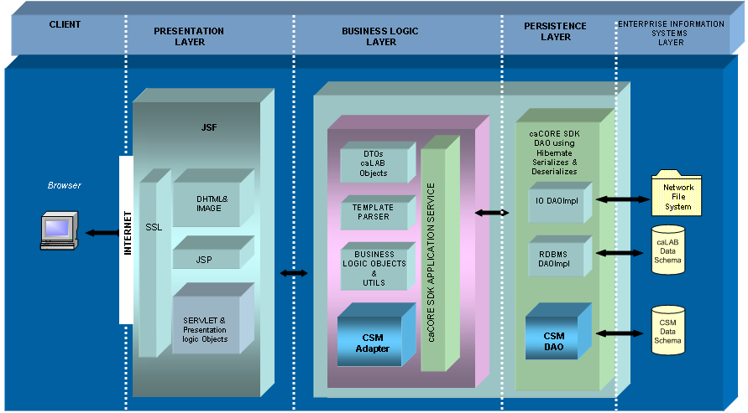

Figure 3.1. caLAB Architecture Layers

- Client Layer – initiates requests to the presentation layer and receives response from the system.
- Presentation Layer - responsible for the presentation of data, receiving user events and controlling the user interface.
- Business Logic Layer – Business-objects that implement the business rules operate from this layer and provide services to the client-tier. This tier encapsulates and protects the data from direct access by the clients.
- Persistence Layer – a transparent data management layer that receives requests for and delivers data to system data.
- Enterprise Information Systems Layer – houses the physical database instantiation and is the access point to any external system accessed by caLAB to access related foreign data elements.

Design Patterns Applied to Application Layers
This section of describes the architecture and the implementation details within each (aforementioned) n-tier application layer. The major products, frameworks, and patterns used in the implementation are described. Further detail on the patterns and mechanisms are made available in the Developer Guidelines document.

    - Client Layer

The caLAB client layer will be implemented as a HTML web application. caLAB will support the browser and user interface standards put forward by the NCICB User Interface working group. The application client layer will utilize Dynamic HTML and style sheets.

    - Presentation Layer
The presentation layer will be developed on a J2EE 1.4 implementation using Java Server Faces (JSF), JSP custom tags, and servlet technologies. Apache Tomcat 4.1.x will be used as the web container and is bundled in the JBoss 4.0.x application server. In the default configuration, Tomcat and JBoss share the same JVM and Tomcat delegates J2EE authentication / authorization to JBoss services, which will control the business logic objects.

Web Application Framework Approach
caLAB uses the Model View Controller (MVC) design pattern implemented in the Java Server Faces (JSF) web application frameworks http://java.sun.com/j2ee/javaserverfaces/. The JSF is focused on the view tier of an MVC-based architecture, offers similar functionality to Struts and, an array of presentation centric features. The frameworks between JSF and Struts can be used together. caLAB will initially rely on the JSF Framework.

Model 2 is a term used to indicate that the web-adapted version of the classic MVC pattern is being implemented.

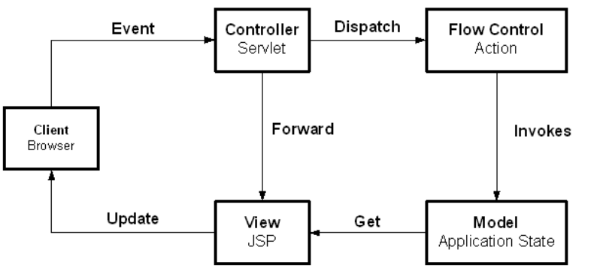
Figure 3.2. General MVC System Flow

The MVC pattern separates presentation-oriented responsibilities from application specific processing / controller responsibilities and business domain specific model. As a result, application maintainability is improved. In a MVC-based J2EE web application, JSPs are the “view” (web page presentation); a Java servlet is the “controller” and processes and delegates requests to Java components; and the “model” or business logic is implemented using business delegate Java objects.

caLAB will implement the presentation layer with JavaServer Faces technology. Using this approach provides a standard component API for specifying the state and behavior of a wide range of components, including simple components, such as input fields, and more complex components, such as scrollable data tables. A separate rendering model is also provided that defines how to render the components in various ways.

Additional Presentation Layer Design Pattern Usage
In addition to the MVC-based Struts framework used for View and Controller components of MVC, caLAB will employ several other design patterns in the presentation layer.

Business Delegate Pattern
The business delegate pattern (http://java.sun.com/blueprints/corej2eepatterns/Patterns/BusinessDelegate.html) is used to reduce coupling between the presentation layer and the business (also known as model or domain) layer. The business delegate hides the underlying implementation and details for accessing business services. In a J2EE application, the delegate is somewhat like a proxy object in that it provides an interface accessed by its clients but it normally delegates its implementation to other classes.

For caLAB, the presentation layer executes in a J2EE web container and the business, model or domain layer is implemented using custom Java manager classes and Plain Old Java Objects (POJOs). The business delegate allows classes running in the web application to execute the business services in a simpler approach. The delegate handles communication details such as JNDI lookup. The delegate can also encapsulate business layer decisions such as when to cache or retrieve data locally instead of going to business classes. The presentation client does not need to be aware of these details.

Session Data Manager Pattern
A web application’s ‘javax.servlet.http.HTTPSession’ object can be used to set and get objects specific to a user session. The session is convenient to access since it is accessible in each request. As a result, it is very easy to add or remove items to the session. This ease of use results in a lack of control over how the session is being used by developers. In addition, adding attributes to the session requires retrieving the key for the object. Instead of adding objects directly to the session, a Session Data Manager object is introduced that contains the logic to get and set objects from the session.

This lightweight object provides the application team with additional visibility as to how the session is being utilized because session objects are saved and retrieved from a central point. In addition, adding the wrapper provides a central way to change how session data is stored. For example, an application may wish to persist highly critical session data to a database or cache large session objects in an external cache and only store the session key in the session itself. This functionality is possible behind a Session Data Manager object.

Presentation Layer Sequence Diagram
The diagram below illustrates an example interaction between the major classes in the presentation framework. Please note that the sequence is drawn from a specification perspective to provide an overview of the normal sequence between these important classes.

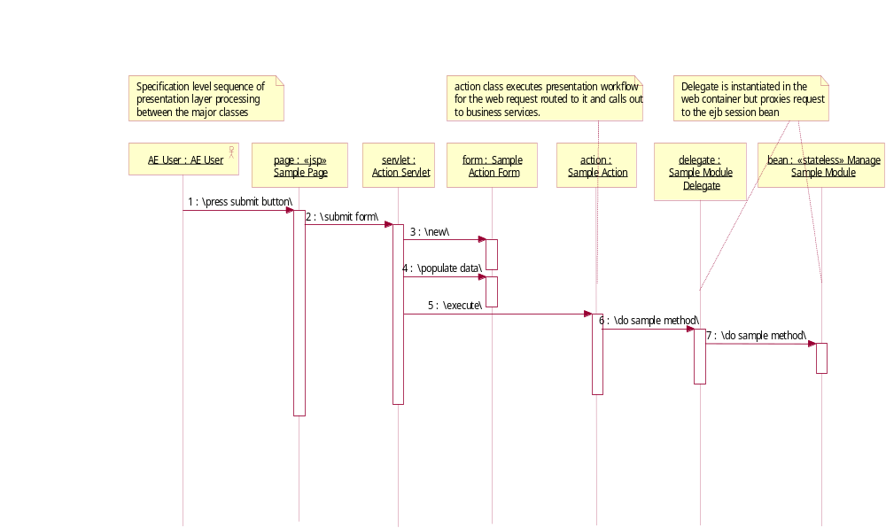
Figure 3.3. Presentation Layer Framework Sequence

    - Business Logic Layer
The business logic layer executes the business logic of the application. The business layer is presentation independent because presentation-specific logic is not built into these classes. As a result, it is possible to provide several separate presentations for the same application.

In the typical scenario, the business delegate will call a system/function manager acting in the Session Façade (described below) role. The façade will then delegate to the appropriate business classes that process the request and retrieve or store the data.

Session Façade Pattern
The session façade design pattern (http://java.sun.com/blueprints/corej2eepatterns/Patterns/SessionFacade.html) is used to encapsulate the complexity of interactions between business objects in a workflow. The façade or boundary class, hides these interactions and provides a simpler, course-grained access to clients. As a result, coupling between business and presentation layers is reduced, transaction control is centralized, and fewer interfaces are exposed to the client.

The implementation of the session façade pattern often includes a java manager class and one or more business objects that execute the actual business processing. In this case, the façade is lightweight, performs security and other transaction services but delegates implementation of the method to a business object that interacts with other business objects.

In caLAB, course-grained domain modules expose their functionality via session façade custom java classes. The presentation layer will have a business delegate boundary counterpart that interacts with the session façade.

Data Transfer Object (DTO) Pattern
The J2EE Data Transfer Objects design pattern (http://java.sun.com/blueprints/corej2eepatterns/Patterns/DataTransferObject.html) is used to encapsulate business data. It is frequently used when passing data from one application layer to another in order to provide generic and consolidated access to data from layer to layer. DTOs are generally lightweight, serializable and contain private data with public assessors.

    - Persistence Layer
The data access layer’s responsibility is to provide a transparent and lightweight mechanism for retrieve and submitting information from an external data store and return that information in a generic way. In caLAB, the primary approach for this is via Data Access Objects and a customized implementation of the open-source object-to-relational mapping tool, Hibernate version 3.0.

Data Access Objects Pattern
The data access object pattern (http://java.sun.com/blueprints/corej2eepatterns/Patterns/DataAccessObject.html) is used to encapsulate all access to a data source. While the object contains data source technology-specific logic in the object to interact with the external data source, clients are shielded from these details. Instead, clients typically provide and receive technology independent value objects containing the data.

In caLAB, our Data Access Objects are realized via the Hibernate DAO implementation.

Software Design
Modeling is the process of software design prior to the generation of code. The model is therefore the core of the software design process. Using a model, those responsible for a software development project's success can assure themselves that business functionality is complete and correct, end-user needs are met, and program design supports requirements for scalability, robustness, security, extendibility, and other characteristics, before implementation in code renders changes difficult and expensive to make.

Modeling can be performed using a number of different methodologies. In caLAB, developers will the the OMG's Unified Modeling Language™ (UML®). UML helps you specify, visualize, and document models of software systems, including their structure and design, in a way that meets all of these requirements. We will be using the UML implementation found in the UML Case Tool, Enterprise Architect (EA).

    - Domain Objects
At the core of the caLAB application are 1.) caLAB objects and 2.) Business Logic objects and respective relationships they share. The caLAB objects represent the data level LIMS objects (e.g., organization, experiment, bioassay, bioassay data, etc.) that are managed by the caCORE SDK to represent lab/organizations, the experiments they run, and the collection of assays in each experiment. The Business Logic objects are …… caLAB and Business level objects will be designed to be extendable, allowing for the capturing of experiment data specific for a particular lab. Each model may share several common business objects that in the context of a specific model type but, may have different associations. For this reason, this design captures the known caLAB object designs in separate UML diagrams with a diagram to render their high-level associations. These domain/business objects will be implemented as Plain Old Java Objects (POJOs).

The caLAB system will reference caCORE Software Development Kit (SDK). The caCORE SDK is a set of tools that can be used by an intermediate Java developer to create a 'caCORE-like' system. Such systems are constructed using certain design principles:
- UML Modeling
- n-tier architecture with open APIs
- controlled vocabularies
- registered metadata
A system built along these lines is said to be 'semantically integrated', that is, there exists runtime metadata that describes every class and class attribute in the API. The SDK consists of three components. The Semantic Connector assists in the annotation of the UML with appropriate controlled vocabulary terms. The UML Loader registers the annotated model in the caDSR, a metadata repository, and the Code Generator creates the software system in Java

caLAB Objects
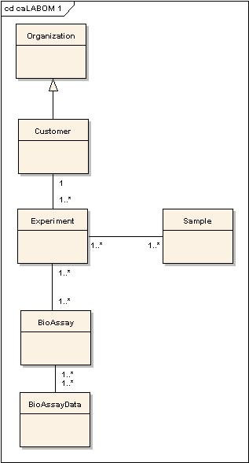

Figure 4.1 High-Level caLAB Objects

Organization
The Organization object captures data about entities like companies, universities, government agencies.

Customer
The Customer object captures data about a particular entity that requests for one or more experiments.

Experiment
The experiment object captures data about an experiment being performed in a laboratory. There may be one or more experiments for a particular organization.

BioAssay
The bioassay object represents a single assay as part of an experiment and as such, an experiment may have a collection of bioassays.

BioAssay Data
The bioassay data object represents a bioassay data input or output. The Bioassay data may be an output of one BioAssay and input data to another BioAssay data.

Sample
The Sample object represents a sample data.

    - Common Persistence Module
The Common Persistence Module is a lightweight Hibernate wrapper which exposes transparent retrieval and submission services for a specific application context. The persistence mechanism is transparent in that the java objects that are used to access data and that carry the retrieved data have no knowledge of the persistence implementation.

Common Persistence Architecture
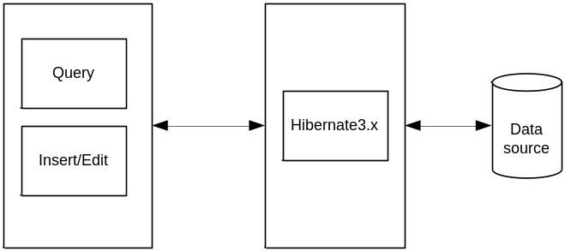

Figure 4.5 Common Persistence Architecture

As shown in the Figure 4.5, the common persistence API exposes the search, save, and delete services provided for by the Hibernate 3.x Object-Relational Mapping Tool.

Query-By-Example is a concept which Hibernate has implemented allowing for the querying of a database through the instantiation of “example" objects populated with search data.
Enhanced Query-By-Example is the mechanism in the COMMON-PERSISTENCE package that implements “enhanced” QBE functionality. Examples of this include:

- Object Graph Traversal
  - Dynamically builds Query Criteria thru traversing the “entire” object graph and member object properties (unlike basic QBE which only queries direct properties of the target search object).

    - Common Security Module (CSM)
The caLAB will be designed as a secure application that integrates with the NCICB authentication infrastructure. While the existing Oracle-based DESK application authentication and authorization services have a relational Database Management System (RDBMS) implementation, caLAB will rely on the approach that leverages the institute-wide LDAP directory service. Use of NCI’s LDAP infrastructure will support internal and external users across Java and non-Java applications supporting the use of a single username and password for ALL applications leveraging the LDAP directory service for authentication and authorization services.

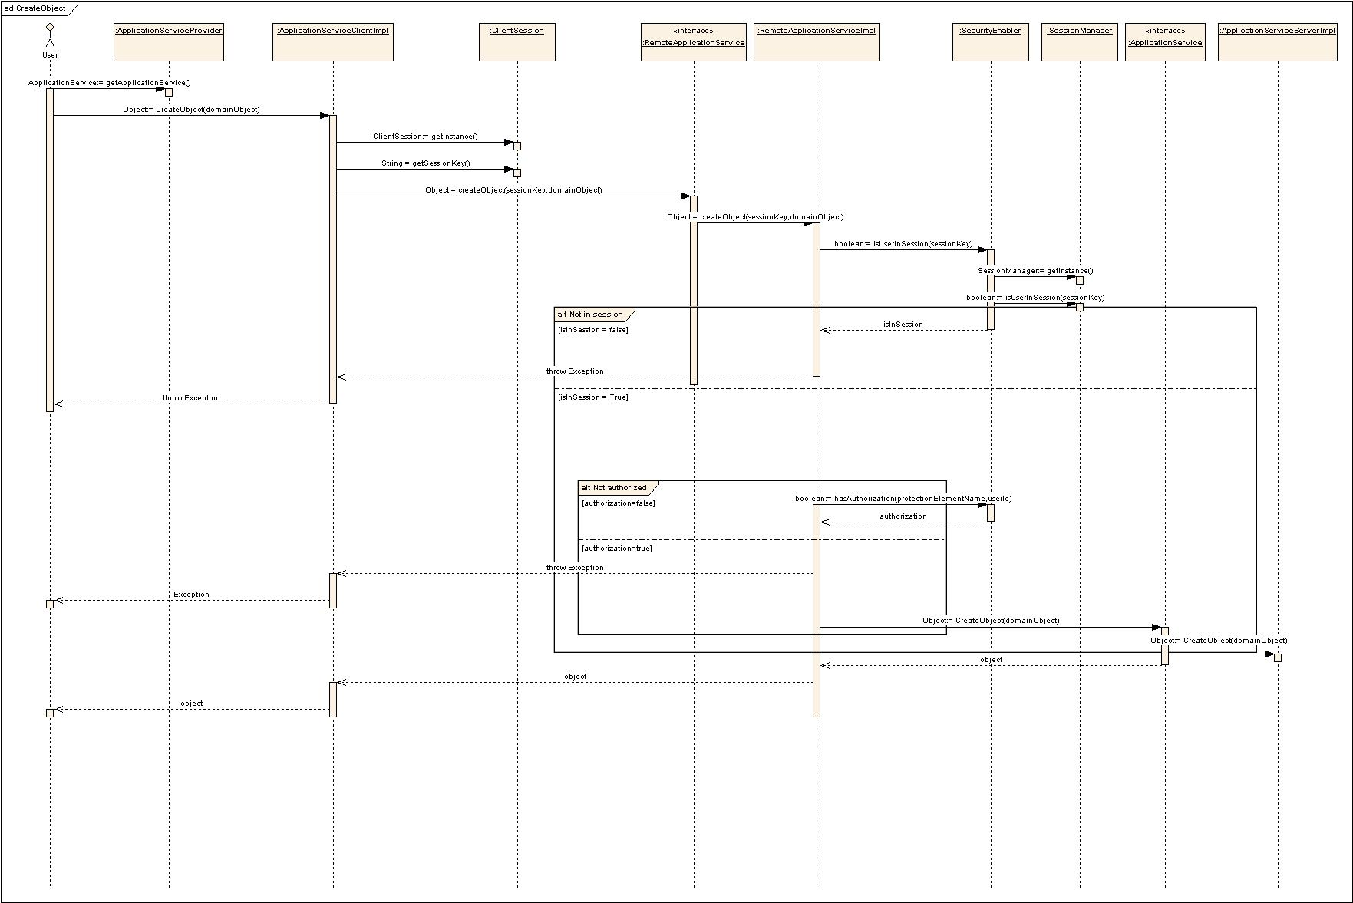

Using the authorization security service application, caLAB will provide an application security client that addresses caLAB application requirements. caLAB will likely log into the common security application on startup and retrieve the application’s role and privilege, which will be stored application-wide. User-specific information will be retrieved on each user’s login. Programmatic security will be completed locally using the retrieved objects.
1. User roles and authorizations are protocol-based.
2. Declarative security will be used for access. When caLAB only require role-based checks, declarative security can be used.
3. For protocol-specific security checks, programmatic security will be executed. User id, role and privilege information will be checked by protocol to determine access.
4. JSP custom tags will be used to check for roles and/or privileges in the web application. Tags should include or exclude content based on result of security checks.

    - Object Communication

TO DO: Show sequence diagrams per selected use cases

Deployment view

