Software Requirements Specification

cancer Nanotechnology Laboratory (caNanoLab) 1.6 Portal

NCI CBIIT, NCL

DOCUMENT REVISION HISTORY

Version Number | Date | Description
1.0 | Jan. 6, 2010 | Initial draft of caNanoLab Use Cases including 1.6 extensions
1.1 | Nov 29, 2010 | Updated to include only study concepts

Background/Summary
The caNanoLab effort is collaboration between the NCI CBIIT, the Nanotechnology Characterization Laboratory (NCL), and the Cancer Centers of Nanotechnology Excellence (CCNE), facilitating the development of standards and an informatics platform supporting nanotechnology in medicine. The NCL performs and standardizes the characterization of nanomaterials intended for cancer therapeutics and diagnostics. One of the goals of the collaboration is the establishment of nanoparticle characterization standards and a structured repository (caNanoLab) in support of data sharing with the CCNEs and cancer Biomedical Informatics Grid (caBIG®) participants. Data sharing in a standards based fashion is facilitated via the caBIG grid (caGrid) platform, which enables data sharing across centers in a federated approach.
The caNanoLab 1.6 effort extends former caNanoLab releases and provides support for studies and in vivo characterizations including animal information, treatment information, and pharmocokinetics (PK).

Table of Contents
Requirements Specification 1
cancer Nanotechnology Laboratory (caNanoLab) 1.6 Portal 1
Background/Summary 1
1. Introduction 4
1.1 Overview 4
1.2 Related Documents 4
2. Actors 6
3. Use Cases 7
3.1 Manage Studies 9
3.1.1. Search Studies 10
3.1.2. View Studies 11
3.1.3. Edit Studies 11
3.1.4. Submit a Study 12
3.1.4.1. Assign User or Group Access to Study 13
3.1.5. Manage Study Samples 15
3.1.5.1. Edit Study Sample 16
3.1.5.2. View Study Sample 17
3.1.5.3. Submit Study Sample 17
3.1.5.4. Delete Study Sample 18
3.1.6. Manage Study Characterizations 19
3.1.6.1. Submit Study Characterization 20
3.1.6.1.1. Manage Characterization Files 21
3.1.6.1.1.1. Edit Characterization File 22
3.1.6.1.1.2. Submit New File 22
3.1.6.1.1.3. View Characterization Files 23
3.1.6.2. Edit Study Characterizations 24
3.1.6.3. View Study Characterizations 24
3.1.7. Manage Characterization Data 26
3.1.7.1. Edit Data and Condition Matrix 27
3.1.7.2. Submit Data Condition Matrix 28
3.1.7.3. View Data and Condition Matrix 29
3.1.8. Manage Experiment Configs 29
3.1.8.1. Submit Experiment Configs 31
3.1.8.1.1. Submit New Technique 32
3.1.8.1.2. Submit New Instrument 32
3.1.8.2. Edit Experiment Configs 33
3.1.8.2.1. Edit Instrument 34
3.1.8.2.2. Edit Technique 35
3.1.8.3. View Experiment Configs 35
3.1.9. Manage Study Publications 36
3.1.9.1. Submit Study Publication 37
3.1.9.2. Edit Study Publication 38
3.1.9.3. Delete Study Publication 39
3.1.9.4. View Study Publication 39
3.1.10. Manage Study Protocols 40
3.1.10.1. Submit Study Protocols 41
3.1.10.2. Edit Study Protocols 42
3.1.10.3. Delete Study Protocols 43
3.1.10.4. View Study Protocols 43
4. Overall Requirements 45
5. Sign Off 46
Approval 46

Introduction

Overview
The goals of the caNanoLab effort are to:
- Provide for the efficient storage and retrieval of nanoparticle characterizations to expedite and validate the use of nanotechnology in medicine
- Develop and support an initial standard for representing nanoparticle characterizations to facilitate data sharing in a semantically interoperable fashion in the spirit of the cancer Biomedical Informatics Grid (caBIG™)
- Implement a system that facilitates data sharing in the nanotechnology community in a secure fashion
- Provide informatics support to the Nanotechnology Characterization Laboratory (NCL)
The caNanoLab 1.6 effort expands upon previous caNanoLab releases (.50, 1.0, 1.1, 1.2, 1.2.1, 1.3, 1.4, 1.4.1, 1.5). The major functionality in 1.6 includes:
- Support for the grouping of samples into studies
- Support for in vivo characterizations including animal information, treatment information, and pharmacokinetics (pk)
The purpose of this document is to identify and detail the use cases and requirements associated with the caNanoLab 1.6 Release.

Related Documents

Document Name | Version | Location
caNanoLab 1.5.2 Use Case Specification | 1.0 | CVS Server: cbiocvs2; Module: cananolab; Directory: docs
caNanoLab 1.5 Use Case Specification | 1.0 | CVS Server: cbiocvs2; Module: cananolab; Directory: docs
caNanoLab 1.4.1 Use Case Specification | 1.0 | CVS Server: cbiocvs2; Module: cananolab; Directory: docs
caNanoLab 1.4 Use Case Specification | 1.0 | CVS Server: cbiocvs2; Module: cananolab; Directory: docs
caNanoLab 1.3 Use Case Specification | 1.0 | CVS Server: cbiocvs2; module: cananolab; Directory: docs
caNanoLab 1.2 Scope Document | 1.0 | CVS Server: cbiocvs2; module: cananolab; Directory: docs
caNanoLab 1.2 Use Case Specification | 1.0 | CVS Server: cbiocvs2; Module: cananolab; Directory: docs
caNanoLab 1.0 Use Case Specification | 1.0 | CVS Server: cbiocvs2; Module: cananolab; Directory: docs
caNanoLab .50 Use Case Specification | 1.0 | CVS Server: cbiocvs2; module: cananolab; Directory: docs
caNanoLab 1.0 Security Configuration Document | 1.0 | caNanoLab 1.0 Security Configuration Document
caNanoLab 1.3 Architecture Checklist | 1.0 | NCICB CM team
caCORE SDK 4.0 Developer’s Guide | 1.1 | http://gforge.nci.nih.gov/docman/view.php/148/8650/caCORE%20SDK%204.0%20Developer's%20Guide_101007.pdf
caBIG Compatibility Guidelines | 2.0 | https://cabig.nci.nih.gov/guidelines_documentation/caBIGCompatGuideRev2_final.pdf

Actors
The table below describes the primary caNanoLab actors applicable to the caNanoLab Release 1.6 use cases as well as the intended.

Actor | Description | Authorization
Curator | A Curator can manage and search all samples, publications, protocols, and collaboration groups in the caNanoLab system, and can assign any data to be visible to public. The curator is also responsible for reviewing private data and assigning them to be public. The Curator needs to log into the system. | Create, update, delete and read all samples, publications, protocols and collaboration groups.  Assign data to be public.
Researcher | A Researcher is responsible for managing samples, publications, protocols and collaboration groups assigned to be manageable by the Researcher. The Researcher is responsible for submitting private data to the Curator for review. The Researcher can search all public data and private data assigned searchable by the Researcher. The Researcher needs to log into the caNanoLab system. | Create, update, delete and read private samples, publications, protocols and collaboration groups that the Researcher has access to.  Read all public data.
Public | A Public actor doesn’t need to log into the caNanoLab system and can only search publicly available samples, publications and protocols. | Read public studies, samples, publications and protocols.
Administrator | The Administrator, when logging into the UPT tool, is responsible for managing user accounts, user groups. When logging into the caNanoLab system, the Administrator is responsible for managing site preferences. | Submit, Access and Retrieve users and user groups and access privileges maintained in the NCI’s User Provisioning Tool (UPT).  Only when a user is assigned to be both a data curator and an administrator, the user can delete data from the System.

Use Cases
Figure 3-1 provides a high-level diagram of the caNanoLab 1.6 use cases. Primary user activities include:
- Manage Studies
- Manage Studies Samples
- Manage Studies Publications
- Manage Studies Protocols
- Manage Studies Characterizations
The sub-sections that follow provide detailed use cases associated with caNanoLab 1.6 activities
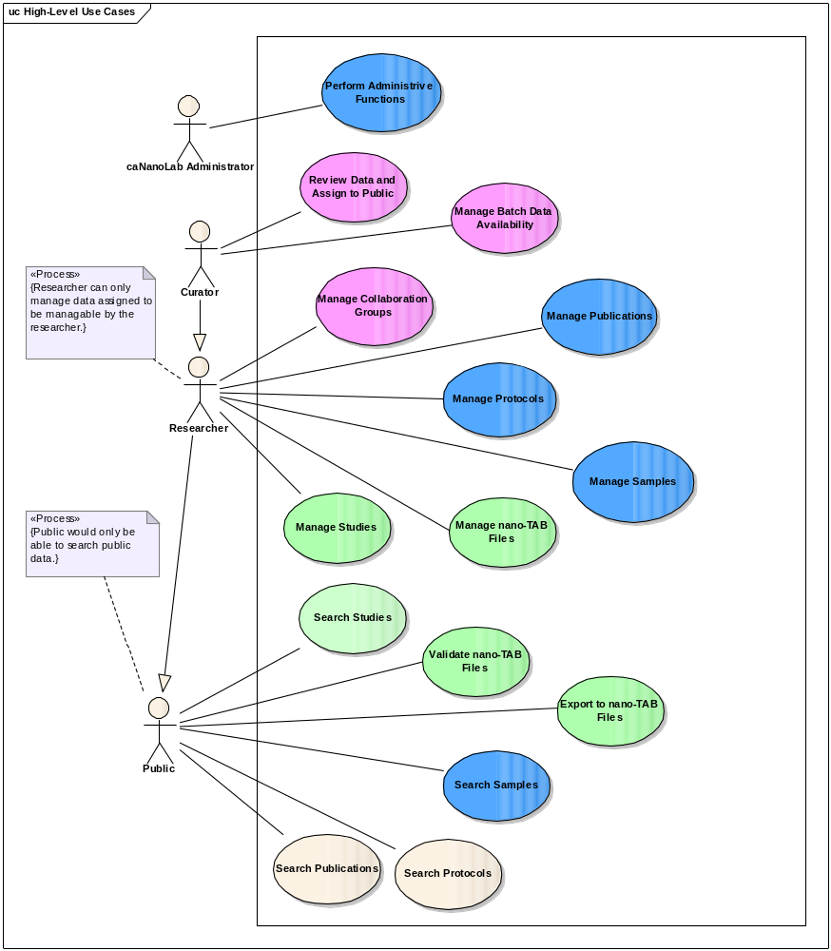
Figure 3-1 High-Level Use Cases

3.1 Manage Studies
Figure 3-2 provides a high-level diagram of the caNanoLab 1.6 use cases associated with managing a study.
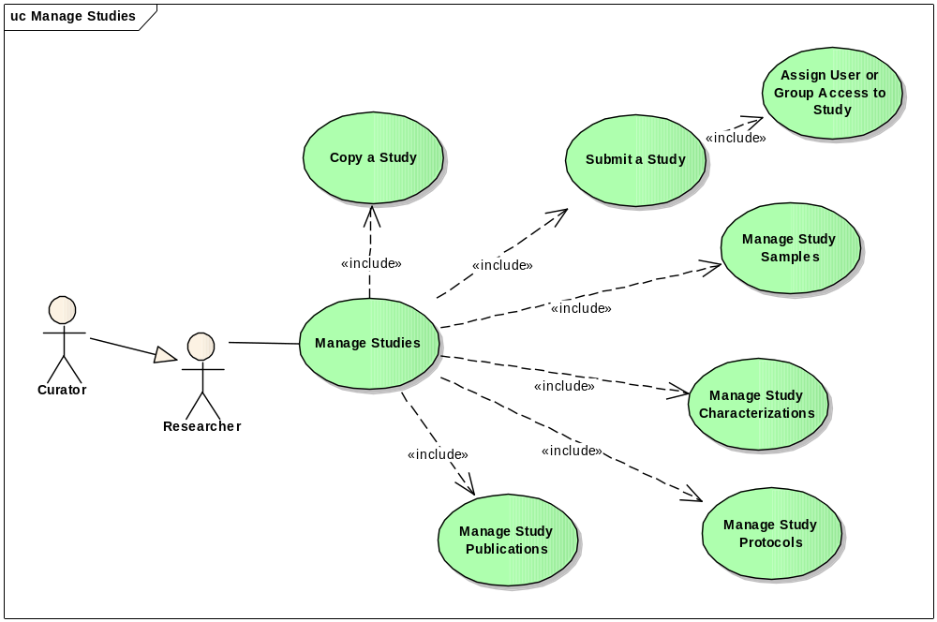
Figure 3-2 Manage Study
Use case details are provided below:

Use Case Name | Manage Studies
Use Case ID | 1.0
Primary Actor | Curator, Researcher, Public
Brief Description | The Manage Studies use case allows the Actor to search and submit study information and manage study components including samples, characterizations, protocols, and publications. Actors can also manage different types of studies like pre-clinical studies.
Trigger | The User desires to either search or submit a study and/or manage study information.
Pre-conditions | The User is authorized to access desired functionality. Data curators can submit a study and/or manage study information. Researcher can submit new study and edit studies owned by them. All users can search studies.
Flow of Events | - The User selects to search a study via the <Search Studies> use case  - The User selects to submit a study via the <Submit a Study> use case  - The User selects to manage study samples via the <Manage Study Samples> use case  - The User selects to manage study characterizations via the <Manage Study Characterizations> use case  - The User selects to manage study publications via the <Manage Study Publications> use case  - The User selects to manage study protocols via the <Manage Study Protocols> use case
Post Conditions | Success Condition: The appropriate page is displayed as identified in related Manage Study use cases based on a user’s authorizations  Error Conditions:  EC1: System Error during request submission  EC2: Database Error during data retrieval
Alternative Flow | Error Conditions:  EC1: System Error  - A system error has occurred which prevents processing of all related request  - The User contacts application help support  EC2: Database Error  - A database error has occurred which prevents data retrieval  - The System displays the error condition and application help contact information
Related Use Cases | Search Studies  Submit a Study  Edit a Study  Manage Study Samples  Manage Study Characterizations  Manage Study Publications  Manage Study Protocols

Search Studies
Use case details are provided below:

Use Case Name | Search Studies
Use Case ID | 1.1
Primary Actor | Data Curator, Researcher, Public
Brief Description | The Search Studies use case allows the Actor to search study information and view or edit the study information based on their role.
Trigger | The User desires to either search a study
Pre-conditions | The User is logged into the system.  The User is authorized to access desired functionality.
Flow of Events | The User selects to search a study link from the STUDY tab  The User enters the following as search criteria  Study name  Study Point of Contact  Study type  Study Design Type  Animal Study or Not?  Sample name  Disease  Keywords – this will search the study description and outcome  Study Owner  Search is case insensitive.  The User enters * to perform wildcard search.  The User clicks “Submit” to search for study within the entered search criteria
Post Conditions | Success Condition: The study search results page is displayed as identified in related Search Studies use cases based on a user’s authorizations  Error Conditions:  EC1: System Error during request submission  EC2: Database Error during data retrieval
Alternative Flow | Error Conditions:  EC1: System Error  - A system error has occurred which prevents processing of all related request  - The User contacts application help support  EC2: Database Error  - A database error has occurred which prevents data retrieval  - The System displays the error condition and application help contact information
Related Use Cases | Search Studies  Submit a Study  Manage Study Samples  Manage Study Characterizations  Manage Study Publications  Manage Study Protocols

View Studies
Use case details are provided below:

Use Case Name | View Studies
Use Case ID | 1.2
Primary Actor | Data Curator, Researcher, Public
Brief Description | The View Studies use case allows the Actor to view the study information.
Trigger | The User desires to either view a study information
Pre-conditions | The User is logged into the system.  The User is authorized to access desired functionality.
Flow of Events | The User selects to view a study link from the study search result page  The system displays the study summary information
Post Conditions | Success Condition: The appropriate page is displayed as identified in related View Studies use cases based on a user’s authorizations  Error Conditions:  EC1: System Error during request submission  EC2: Database Error during data retrieval
Alternative Flow | Error Conditions:  EC1: System Error  - A system error has occurred which prevents processing of all related request  - The User contacts application help support  EC2: Database Error  - A database error has occurred which prevents data retrieval  - The System displays the error condition and application help contact information
Related Use Cases | Search Studies  Submit a Study  View Study Samples  View Study Characterizations  View Study Publications  View Study Protocols

Edit Studies
Use case details are provided below:

Use Case Name | Edit Studies
Use Case ID | 1.3
Primary Actor | Data Curator, Researcher
Brief Description | The Edit Studies use case allows the Actor to edit study information.
Trigger | The User desires to edit a study
Pre-conditions | The User is logged into the system.  The User is authorized to access desired functionality.
Flow of Events | The User selects to Edit study link from the STUDY Search Result Page.  The System display Study summary information in editable mode.  The User edit study information.  The User clicks “Update” to save the study information.
Post Conditions | Success Condition: The system displays message indicated study is saved successfully  Error Conditions:  EC1: System Error during request submission  EC2: Database Error during data retrieval
Alternative Flow | Error Conditions:  EC1: System Error  - A system error has occurred which prevents processing of all related request  - The User contacts application help support  EC2: Database Error  - A database error has occurred which prevents data retrieval  - The System displays the error condition and application help contact information
Related Use Cases | Search Studies  Submit a Study  Manage Study Samples  Manage Study Characterizations  Manage Study Publications  Manage Study Protocols  Manage Point Of Contact

Submit a Study
Use case details are provided below:

Use Case Name | Submit a Study
Use Case ID | 1.4
Primary Actor | Data Curator, Researcher
Brief Description | The Submit Studies use case allows the Actor to submit new study information.
Trigger | The User desires to either submit a new study
Pre-conditions | The User is authorized to access desired functionality
Flow of Events | The User selects to submit a study link from the STUDY tab  The User enters study information:  Study Name  Study Title  Study Type  Is this study an animal study?  Study Design Types  Diseases (User will be able to browse EVS to get disease name)  Start Date  End Date  Publication Release Date  Submission Date  Study Description  Study Outcome  Point of Contact via <Submit Point of Contact> use case  Access to Study via <Assign User or Group Access to Study> use case  The User clicks Submit to submit study information.  The User is presented with options to add Study Sample or select from existing sample, add study protocol, add study publication, and add study characterization
Post Conditions | Success Condition: The appropriate page is displayed as identified in related Submit Study use cases based on a user’s authorizations  Error Conditions:  EC1: System Error during request submission  EC2: Database Error during data retrieval
Alternative Flow | Error Conditions:  EC1: System Error  - A system error has occurred which prevents processing of all related request  - The User contacts application help support  EC2: Database Error  - A database error has occurred which prevents data retrieval  - The System displays the error condition and application help contact information
Related Use Cases | Search Studies  Submit a Study  Manage Study Samples  Manage Study Characterizations  Manage Study Publications  Manage Study Protocols  Manage Point Of Contact  Assign User or Group Access to Study

Assign User or Group Access to Study

Use case details are provided below

Use Case Name | Assign User or Group Access to Study
Use Case ID | 1.4.1
Primary Actor | Curator, Researcher
Brief Description | The Assign Group or User Access to a Study use case allows the User to assign access privileges such as read only, read create update delete to a study for individual users or collaboration groups.
Trigger | The User desires to assign user or group level access privileges to a study
Pre-conditions | - The User logs in the system.  - The User clicks on the STUDY tab.  - The User clicks on the Submit a New Study link to open the Submit a New Study form. Alternatively, the User clicks on the Search Existing Studies link to open the Search Study Form; enters search criteria and clicks on the Search button to see a list of studies with Edit links. The user clicks on the Edit link next to the study to open the Update Study form.
Flow of Events | - The User clicks on the Add button next to “Access to the Study” to open up the Access Information form.  - The User submits the following information:  Access by (selecting either Collaboration Group by User)  Collaboration Group Name (or User Name depending on the radio button selection above)  Access to the Study (selecting from the drop down list)  The User clicks on the Save button in the Access Information form to save the access information.
Post Conditions | Success Condition: The newly saved study access information are saved as a row either in the existing Collaboration Group access table or the existing User access table depending on the Access By choice  Error Conditions:  EC1: System Error during request submission  EC2: Database Error during data retrieval
Alternative Flow | Alternate Conditions:  The User decides to delete or update an existing study access instead of adding a new access. The following flow of events happens:  - The User clicks on the Edit link in the existing Collaboration Group access table or the User access table to open up the Access Information form.  - The User either clicks on the Delete button to remove the access or clicks on the Save button to update the information in the form.  Error Conditions:  EC1: System Error  - A system error has occurred which prevents processing of all related request  - The User contacts application help support  EC2: Database Error  - A database error has occurred which prevents data retrieval  - The System displays the error condition and application help contact information
Related Use Cases | Search Studies  Submit a Study  Manage Users in a Collaboration Group

Manage Study Samples
Figure 3-3 provides a high-level diagram of the caNanoLab 1.6 use cases associated with managing study samples.

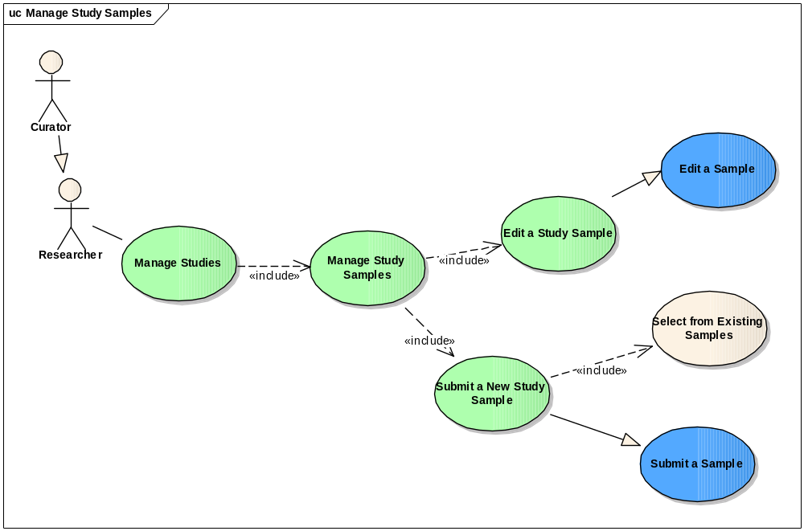

Figure 3-3 Manage Study Samples
Use case details are provided below:

Use Case Name | Manage Study Samples
Use Case ID | 1.5
Primary Actor | Data Curator, Researcher, Public
Brief Description | The Manage Studies Sample use case allows the Actor to submit, edit or view study samples.
Trigger | The User desires to either edit or submit or view a study sample
Pre-conditions | The User is authorized to access desired functionality
Flow of Events | The User selects to a study  The User selects the Sample category.  The User selects to submit a study samples via the <Submit Study Samples> use case.  The User selects to edit study samples via the <Edit Study Samples> use case.  The User selects to view study samples via the <View Study Samples> use case.
Post Conditions | Success Condition: The appropriate page is displayed as identified in related Manage Study Samples use cases based on a user’s authorizations  Error Conditions:  EC1: System Error during request submission  EC2: Database Error during data retrieval
Alternative Flow | Error Conditions:  EC1: System Error  - A system error has occurred which prevents processing of all related request  - The User contacts application help support  EC2: Database Error  - A database error has occurred which prevents data retrieval  - The System displays the error condition and application help contact information
Related Use Cases | Submit a Study  Manage Study Samples  Submit Study Sample  Edit Study Sample  View Study Sample

Edit Study Sample
Use case details are provided below:

Use Case Name | Edit Study Sample
Use Case ID | 1.5.1
Primary Actor | Data Curator, Researcher
Brief Description | The Edit Study Sample use case allows the Actor to edit study sample information. Data Curator can edit any study sample while researcher can edit only study sample they have access to.
Trigger | The User desires to edit a study sample.
Pre-conditions | The User is logged into the system.  The User is authorized to access desired functionality.
Flow of Events | The User selects to edit link from the STUDY search result page  The User selects SAMPLE category link from the side menu.  The System displays the study sample in the editable mode.  The User edit the sample information.  The User clicks “Update” to save for study sample information.
Post Conditions | Success Condition: The System displays message indicated the study sample is saved successfully.  Error Conditions:  EC1: System Error during request submission  EC2: Database Error during data retrieval
Alternative Flow | Error Conditions:  EC1: System Error  - A system error has occurred which prevents processing of all related request  - The User contacts application help support  EC2: Database Error  - A database error has occurred which prevents data retrieval  - The System displays the error condition and application help contact information
Related Use Cases | Search Studies  Submit Study Samples

View Study Sample
Use case details are provided below:

Use Case Name | View Study Sample
Use Case ID | 1.5.2
Primary Actor | Data Curator, Researcher, Public
Brief Description | The View Study Sample use case allows the Actor to view study sample information.
Trigger | The User desires to view study sample information.
Pre-conditions | The User is authorized to access desired functionality.
Flow of Events | The User selects to view a study link from the study search result page.  The User selects SAMPLE category link from the side menu.  The System displays study sample(s) sumary information in viewable mode.
Post Conditions | Success Condition: The appropriate page is displayed as identified in related View Study Samples use cases based on a user’s authorizations  Error Conditions:  EC1: System Error during request submission  EC2: Database Error during data retrieval
Alternative Flow | Error Conditions:  EC1: System Error  - A system error has occurred which prevents processing of all related request  - The User contacts application help support  EC2: Database Error  - A database error has occurred which prevents data retrieval  - The System displays the error condition and application help contact information
Related Use Cases | Search Studies  Edit a Study Sample  Manage Study Samples

Submit Study Sample
Use case details are provided below:

Use Case Name | Submit Study Sample
Use Case ID | 1.5.3
Primary Actor | Data Curator, Researcher
Brief Description | The Submit Study Sample use case allows the Actor to submit a new study information.
Trigger | The User desires to submit a new study sample
Pre-conditions | The User is logged into the system.  The User is authorized to access desired functionality.
Flow of Events | The User selects to new a study link from the STUDY tab. Or  The User selects SAMPLE category link from submenu.  The User has options to select from existing samples or new sample.  Case 1: The User selects from existing samples  The System displays list of available samples for user to select.  The User selects the samples (one or more).  The User clicks “Submit” to submit the study samples.  Case 2: The User selects to enter new sample  The System displays new sample submission form for user to enter name, contact information, keywords, set access to the sample.  The User clicks “Submit” to submit new sample for the study.
Post Conditions | Success Condition: The appropriate page is displayed as identified in related Submit Study Sample use cases based on a user’s authorizations  Error Conditions:  EC1: System Error during request submission  EC2: Database Error during data retrieval
Alternative Flow | Error Conditions:  EC1: System Error  - A system error has occurred which prevents processing of all related request  - The User contacts application help support  EC2: Database Error  - A database error has occurred which prevents data retrieval  - The System displays the error condition and application help contact information
Related Use Cases | Search Studies  Submit a Study  Manage Study Samples  Manage Study Characterizations  Manage Study Publications  Manage Study Protocols

Delete Study Sample

Use Case Name | Delete Study Sample
Use Case ID | 1.5.4
Primary Actor | Data Curator, Researcher
Brief Description | The Delete Study Sample use case allows the Actor to delete study sample information.
Trigger | The User desires to delete a sample from the study
Pre-conditions | The User is logged into the system.  The User is authorized to access desired functionality.
Flow of Events | The User selects to SAMPLE category submenu from the STUDY menu.  The System displays the SAMPLE information.  The User clicks on the “Delete” button. This will disassociate the sample from the study.
Post Conditions | Success Condition: The appropriate page is displayed as identified in related Delete Study Sample use cases based on a user’s authorizations  Error Conditions:  EC1: System Error during request submission  EC2: Database Error during data retrieval
Alternative Flow | Error Conditions:  EC1: System Error  - A system error has occurred which prevents processing of all related request  - The User contacts application help support  EC2: Database Error  - A database error has occurred which prevents data retrieval  - The System displays the error condition and application help contact information
Related Use Cases | Search Studies  Manage Study Samples  Manage Study Characterizations  Manage Study Publications  Manage Study Protocols

Manage Study Characterizations
Figure 3-6 provides a high-level diagram of the caNanoLab 1.6 use cases associated with managing study characterizations.
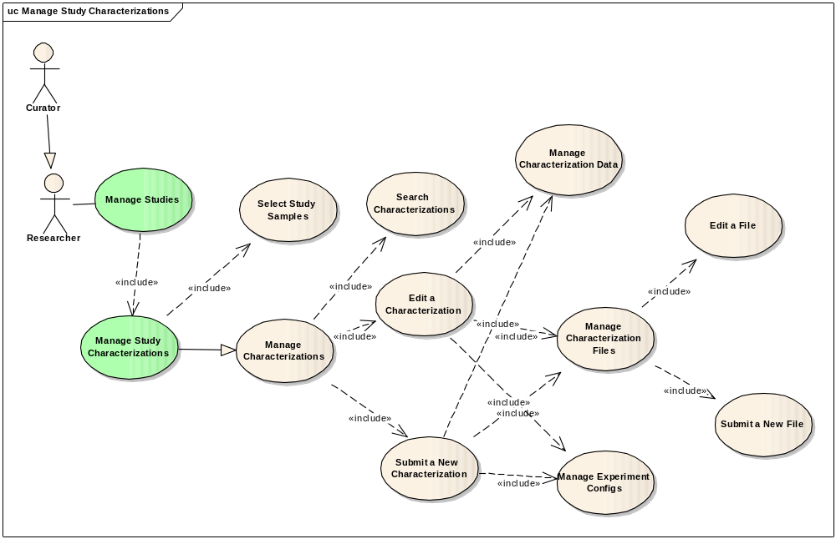
Figure 3-6 Manage Study Characterizations
Use case details are provided below:

Use Case Name | Manage Study Characterizations
Use Case ID | 1.6
Primary Actor | Data Curator, Researcher
Brief Description | The Manage Study Characterization use case allows the Actor to edit or submit study characterization information.
Trigger | The User desires to either edit or submit a study characterization
Pre-conditions | The User is authorized to access desired functionality
Flow of Events | The User selects to a study  The User selects the Characterization category.  The User selects to edit, submit physical, In Vitro, In Vivo characterization for the study.  The characterization form displays, allowing the user to complete entries on a form.  The user submits the Characterization form.
Post Conditions | Success Condition: The appropriate page is displayed as identified in related Manage Study Characterizations use cases based on a user’s authorizations  Error Conditions:  EC1: System Error during request submission  EC2: Database Error during data retrieval
Alternative Flow | Error Conditions:  EC1: System Error  - A system error has occurred which prevents processing of all related request  - The User contacts application help support  EC2: Database Error  - A database error has occurred which prevents data retrieval  - The System displays the error condition and application help contact information
Related Use Cases | Search Studies  Submit a Study  Manage Study Samples  Manage Study Characterizations  Manage Study Publications  Manage Study Protocols

Submit Study Characterization

Use Case Name | Submit Study Characterization
Use Case ID | 1.6.1
Primary Actor | Data Curator, Researcher
Brief Description | The Submit Study Characterization use case allows the Actor to submit study characterization information.
Trigger | The User desires to submit a study characterization
Pre-conditions | The User is authorized to access desired functionality
Flow of Events | The User selects to a study  The User selects the Characterization category.  The User selects to submit physical, In Vitro, In Vivo characterization for the study.  The characterization form displays, allowing the user to complete entries on a form.  The user submits the Characterization form.
Post Conditions | Success Condition: The appropriate page is displayed as identified in related Submit Study Characterizations use cases based on a user’s authorizations  Error Conditions:  EC1: System Error during request submission  EC2: Database Error during data retrieval
Alternative Flow | Error Conditions:  EC1: System Error  - A system error has occurred which prevents processing of all related request  - The User contacts application help support  EC2: Database Error  - A database error has occurred which prevents data retrieval  - The System displays the error condition and application help contact information
Related Use Cases | Search Studies  Submit a Study  Manage Study Samples  Manage Study Characterizations

Manage Characterization Files

Use Case Name | Manage Characterization Files
Use Case ID | 1.6.1.1
Primary Actor | Data Curator, Researcher, Public
Brief Description | The Manage Characterization Files use case allows the Actor to view, edit or submit study characterization files information.
Trigger | The User desires to either view, edit or submit a study characterization files.  Public user can only view characterization files.
Pre-conditions | The User is authorized to access desired functionality
Flow of Events | The User selects to a study  The User selects the Characterization category.  The User selects to edit characterization file via <Edit Characterization File> use case.  The User selects to submit characterization file via <Submit Characterization File> use case.  The User selects to view characterization file via <View Characterization File> use case
Post Conditions | Success Condition: The appropriate page is displayed as identified in related Manage Characterization Files use cases based on a user’s authorizations  Error Conditions:  EC1: System Error during request submission  EC2: Database Error during data retrieval
Alternative Flow | Error Conditions:  EC1: System Error  - A system error has occurred which prevents processing of all related request  - The User contacts application help support  EC2: Database Error  - A database error has occurred which prevents data retrieval  - The System displays the error condition and application help contact information
Related Use Cases | Search Studies  Submit a Study  Manage Study Samples  Manage Study Characterizations  Manage Study Publications  Manage Study Protocols

Edit Characterization File

Use Case Name | Edit Characterization File
Use Case ID | 1.6.1.1.1
Primary Actor | Data Curator, Researcher
Brief Description | The Edit Characterization File use case allows the Actor to edit study characterization file information.
Trigger | The User desires to edit characterization file information
Pre-conditions | The User is authorized to access desired functionality
Flow of Events | The User selects to a study  The User selects the Characterization category.  The User selects to Finding section.  The User selects to edit an existing File information.  The File form displays, allowing user to edit information on the page.  The User saves the File form.
Post Conditions | Success Condition: The appropriate page is displayed as identified in related Edit Characterization File use cases based on a user’s authorizations  Error Conditions:  EC1: System Error during request submission  EC2: Database Error during data retrieval
Alternative Flow | Error Conditions:  EC1: System Error  - A system error has occurred which prevents processing of all related request  - The User contacts application help support  EC2: Database Error  - A database error has occurred which prevents data retrieval  - The System displays the error condition and application help contact information
Related Use Cases | Search Studies  Submit a Study  Manage Study Samples  Manage Study Characterizations  Manage Study Publications  Manage Study Protocols

Submit New File

Use Case Name | Submit New Characterization File
Use Case ID | 1.6.1.1.2
Primary Actor | Data Curator, Researcher
Brief Description | The Submit New Characterization File use case allows the Actor to submit study characterization file information.
Trigger | The User desires to submit a study characterization file.
Pre-conditions | The User is authorized to access desired functionality
Flow of Events | The User selects to a study  The User selects the Characterization category.  The User selects to Finding section.  The User selects to add new File  The file form displays, allowing the user to complete entries on a form.  The user submits the File form.
Post Conditions | Success Condition: The appropriate page is displayed as identified in related Submit New Characterization File use cases based on a user’s authorizations  Error Conditions:  EC1: System Error during request submission  EC2: Database Error during data retrieval
Alternative Flow | Error Conditions:  EC1: System Error  - A system error has occurred which prevents processing of all related request  - The User contacts application help support  EC2: Database Error  - A database error has occurred which prevents data retrieval  - The System displays the error condition and application help contact information
Related Use Cases | Search Studies  Submit a Study  Manage Study Samples  Manage Study Characterizations

View Characterization Files

Use Case Name | View Characterization Files
Use Case ID | 1.6.1.1.3
Primary Actor | Data Curator, Researcher, Public
Brief Description | The View Study Characterization Files use case allows the Actor to view study characterization file information.
Trigger | The User desires to either search or view a study characterization file
Pre-conditions | The User is authorized to access desired functionality
Flow of Events | The User selects to a study  The User selects the Characterization category.  The characterization page displays, allowing the user to view the information including File information
Post Conditions | Success Condition: The appropriate page is displayed as identified in related View Characterization Files use cases based on a user’s authorizations  Error Conditions:  EC1: System Error during request submission  EC2: Database Error during data retrieval
Alternative Flow | Error Conditions:  EC1: System Error  - A system error has occurred which prevents processing of all related request  - The User contacts application help support  EC2: Database Error  - A database error has occurred which prevents data retrieval  - The System displays the error condition and application help contact information
Related Use Cases | Search Studies  Submit a Study  Manage Study Samples  Manage Study Characterizations  Manage Study Publications  Manage Study Protocols

Edit Study Characterizations

Use Case Name | Edit Study Characterizations
Use Case ID | 1.6.2
Primary Actor | Data Curator, Researcher
Brief Description | The Edit Study Characterization use case allows the Actor to edit study characterization information.
Trigger | The User desires edit a study characterization
Pre-conditions | The User is authorized to access desired functionality
Flow of Events | The User selects to a study  The User selects the Characterization category.  The User selects to edit, physical, In Vitro, In Vivo characterization for the study.  The characterization form displays, allowing the user to complete entries on a form.  The user submits the Characterization form.
Post Conditions | Success Condition: The appropriate page is displayed as identified in related Edit Study Characterization use cases based on a user’s authorizations  Error Conditions:  EC1: System Error during request submission  EC2: Database Error during data retrieval
Alternative Flow | Error Conditions:  EC1: System Error  - A system error has occurred which prevents processing of all related request  - The User contacts application help support  EC2: Database Error  - A database error has occurred which prevents data retrieval  - The System displays the error condition and application help contact information
Related Use Cases | Search Studies  Manage Study Samples  Manage Study Characterizations  Manage Study Publications  Manage Study Protocols

View Study Characterizations

Use Case Name | View Study Characterizations
Use Case ID | 1.6.3
Primary Actor | Public, Researcher
Brief Description | The View Study Characterization use case allows the Actor to view study characterization information.
Trigger | The User desires to view a study characterization.
Pre-conditions | The User is authorized to access desired functionality.
Flow of Events | The User selects to a study  The User selects the Characterization category.  The characterization page displays, allowing the user to view the information.
Post Conditions | Success Condition: The appropriate page is displayed as identified in related View Study Characterizations use cases based on a user’s authorizations  Error Conditions:  EC1: System Error during request submission  EC2: Database Error during data retrieval
Alternative Flow | Error Conditions:  EC1: System Error  - A system error has occurred which prevents processing of all related request  - The User contacts application help support  EC2: Database Error  - A database error has occurred which prevents data retrieval  - The System displays the error condition and application help contact information
Related Use Cases | Search Studies  View Study Samples  View Study Characterizations  View Study Publications  View Study Protocols

Manage Characterization Data
Figure 3-7 provides a high-level diagram of the caNanoLab 1.6 use cases associated with managing characterization data.
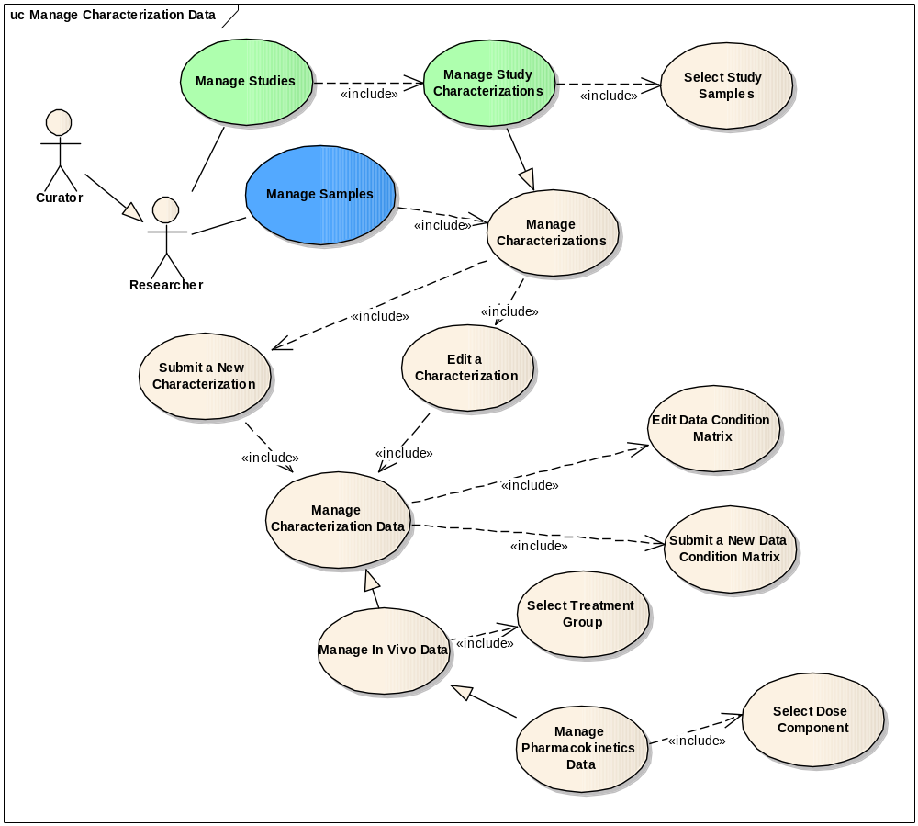
Figure 3-7 Manage Characterization Data
Use case details are provided below:

Use Case Name | Manage Characterization Data
Use Case ID | 1.7
Primary Actor | Data Curator, Researcher
Brief Description | The Manage Characterization Data use case allows the Actor to edit, or submit characterization data retrieved from the lab experiment.
Trigger | The User desires to either edit or submit a study characterization data
Pre-conditions | The User is authorized to access desired functionality
Flow of Events | The User selects a study.  The User selects the Characterization category  The User selects to add a characterization or update an existing characterization  The characterization form displays, allowing the user to complete entries on a form.  The User selects to add data condition via <Add Data Condition Matrix> use case.  The User selects to edit data condition via <Edit Data Condition Matrix> use case.  The User submits the characterization form.
Post Conditions | Success Condition: The appropriate page is displayed as identified in related Manage Study Characterization Data use cases based on a user’s authorizations  Error Conditions:  EC1: System Error during request submission  EC2: Database Error during data retrieval
Alternative Flow | Error Conditions:  EC1: System Error  - A system error has occurred which prevents processing of all related request  - The User contacts application help support  EC2: Database Error  - A database error has occurred which prevents data retrieval  - The System displays the error condition and application help contact information
Related Use Cases | Search Studies  Submit a Study  Manage Study Samples  Manage Study Characterizations

Edit Data and Condition Matrix

Use Case Name | Edit Data and Condition Matrix
Use Case ID | 1.7.1
Primary Actor | Data Curator, Researcher
Brief Description | The Edit Characterization Data Condition Matrix use case allows the Actor to edit characterization data retrieved from the lab experiment.
Trigger | The User desires to edit data condition matrix information
Pre-conditions | The User is authorized to access desired functionality
Flow of Events | The User selects a study.  The User selects the Characterization category  The User selects to edit a characterization  The characterization form displays,  The User selects to edit Data and Conditions information under the Finding section  The Data and Conditions form displays, allowing the user to update the information  The User saves the Data and Conditions form.
Post Conditions | Success Condition: The appropriate page is displayed as identified in related Edit Data and Condition Matrix use cases based on a user’s authorizations  Error Conditions:  EC1: System Error during request submission  EC2: Database Error during data retrieval
Alternative Flow | Error Conditions:  EC1: System Error  - A system error has occurred which prevents processing of all related request  - The User contacts application help support  EC2: Database Error  - A database error has occurred which prevents data retrieval  - The System displays the error condition and application help contact information
Related Use Cases | Search Studies  Manage Study Samples  Manage Study Characterizations  Manage Study Publications  Manage Study Protocols

Submit Data Condition Matrix

Use Case Name | Submit Data Condition Matrix
Use Case ID | 1.7.2
Primary Actor | Data Curator, Researcher
Brief Description | The Submit Data Condition Matrix use case allows the Actor to submit characterization data condition retrieved from the lab experiment.
Trigger | The User desires to either search or submit a study
Pre-conditions | The User is authorized to access desired functionality
Flow of Events | The User selects a study.  The User selects the Characterization category  The User selects to add a characterization or update an existing characterization  The characterization form displays, allowing the user to complete entries on a form.  The User selects to submit new Data and Condition under Finding section.  The Data and Conditions form displays, allowing the user to complete entries on the form.  The User saves the Data-Conditions form.
Post Conditions | Success Condition: The appropriate page is displayed as identified in related Submit Data Condition Matrix use cases based on a user’s authorizations  Error Conditions:  EC1: System Error during request submission  EC2: Database Error during data retrieval
Alternative Flow | Error Conditions:  EC1: System Error  - A system error has occurred which prevents processing of all related request  - The User contacts application help support  EC2: Database Error  - A database error has occurred which prevents data retrieval  - The System displays the error condition and application help contact information
Related Use Cases | Search Studies  Submit a Study  Manage Study Samples  Manage Study Characterizations  Manage Study Publications  Manage Study Protocols

View Data and Condition Matrix

Use Case Name | View Data and Condition Matrix
Use Case ID | 1.7.3
Primary Actor | Public
Brief Description | The View Data and Condition Matrix use case allows the Actor to view characterization data condition matrix retrieved from the lab experiment.
Trigger | The User desires to either view data condition information
Pre-conditions | The User is authorized to access desired functionality
Flow of Events | The User selects a study.  The User selects the Characterization category  The characterization information page displays in viewable format.
Post Conditions | Success Condition: The appropriate page is displayed as identified in related View Data and Matrix use cases based on a user’s authorizations  Error Conditions:  EC1: System Error during request submission  EC2: Database Error during data retrieval
Alternative Flow | Error Conditions:  EC1: System Error  - A system error has occurred which prevents processing of all related request  - The User contacts application help support  EC2: Database Error  - A database error has occurred which prevents data retrieval  - The System displays the error condition and application help contact information
Related Use Cases | Search Studies  View a Study  View Study Samples  View Study Characterizations  View Study Publications  View Study Protocols

Manage Experiment Configs
Figure 3-8 provides a high-level diagram of the caNanoLab 1.6 use cases associated with managing experiment configs.
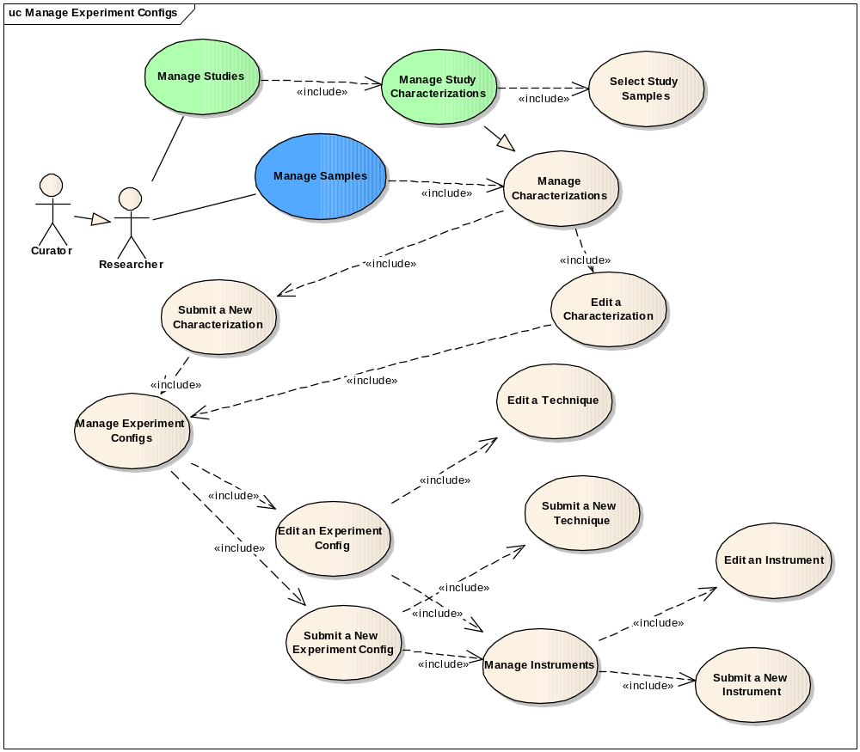

Figure 3-8 Manage Experiment Configs
Use case details are provided below:

Use Case Name | Manage Experiment Configs
Use Case ID | 1.8
Primary Actor | Data Curator, Researcher
Brief Description | The Manage Experiment Configs use case allows the Actor to search and submit Experiment Configs information for a study characterization.
Trigger | The User desires to either search or submit a study
Pre-conditions | The User is authorized to access desired functionality
Flow of Events | The User selects to a study via the <Search Studies> use case  The User selects the Characterization category.  The User selects to update Experiement Configs via <Edit Experiment Configs> use case.  The User selects to submit Experiement Configs via <Submit Experiment Configs> use case.
Post Conditions | Success Condition: The appropriate page is displayed as identified in related Manage Experiment Configs use cases based on a user’s authorizations  Error Conditions:  EC1: System Error during request submission  EC2: Database Error during data retrieval
Alternative Flow | Error Conditions:  EC1: System Error  - A system error has occurred which prevents processing of all related request  - The User contacts application help support  EC2: Database Error  - A database error has occurred which prevents data retrieval  - The System displays the error condition and application help contact information
Related Use Cases | Search Studies  Submit a Study  Manage Study Samples  Manage Study Characterizations  Manage Study Publications  Manage Study Protocols

Submit Experiment Configs

Use Case Name | Submit Experiment Configs
Use Case ID | 1.8.1
Primary Actor | Data Curator, Researcher
Brief Description | The Submit Experiment Configs use case allows the Actor to search and submit Experiment Configs information for a study characterization.
Trigger | The User desires to either search or submit a study
Pre-conditions | The User is authorized to access desired functionality
Flow of Events | The User selects to a study via the <Search Studies> use case  The User selects the Characterization category.  The User selects to submit new Experiment Configs for the Characterization.  The Characterization form displays, allowing the user to complete entries on a form including Technique and Instrument section  The User selects to submit New Technique via <Submit New Technique> use case.  The User selects to edit or add data for the characterization.  The User submits the form.
Post Conditions | Success Condition: The appropriate page is displayed as identified in related Submit Experiment Configs use cases based on a user’s authorizations  Error Conditions:  EC1: System Error during request submission  EC2: Database Error during data retrieval
Alternative Flow | Error Conditions:  EC1: System Error  - A system error has occurred which prevents processing of all related request  - The User contacts application help support  EC2: Database Error  - A database error has occurred which prevents data retrieval  - The System displays the error condition and application help contact information
Related Use Cases | Search Studies  Submit a Study  Manage Study Samples  Manage Study Characterizations  Manage Study Publications  Manage Study Protocols

Submit New Technique

Use Case Name | Submit New Technique
Use Case ID | 1.8.1.1
Primary Actor | Data Curator, Researcher
Brief Description | The Submit New Technique use case allows the Actor to submit Technique information for a study characterization.
Trigger | The User desires to either search or submit a study
Pre-conditions | The User is authorized to access desired functionality
Flow of Events | The User selects to a study via the <Search Studies> use case  The User selects the Characterization category.  The User selects to submit new Experiment Configs for the Characterization.  The Characterization form displays.  The User selects to submit new Technique  The Technique form display allowing the user to complete entries on a form.  The User submits the form.
Post Conditions | Success Condition: The appropriate page is displayed as identified in related Submit New Technique use cases based on a user’s authorizations  Error Conditions:  EC1: System Error during request submission  EC2: Database Error during data retrieval
Alternative Flow | Error Conditions:  EC1: System Error  - A system error has occurred which prevents processing of all related request  - The User contacts application help support  EC2: Database Error  - A database error has occurred which prevents data retrieval  - The System displays the error condition and application help contact information
Related Use Cases | Search Studies  Submit a Study  Manage Study Samples  Manage Study Characterizations  Manage Study Publications  Manage Study Protocols

Submit New Instrument

Use Case Name | Submit New Instrument
Use Case ID | 1.8.1.2
Primary Actor | Data Curator, Researcher
Brief Description | The Submit New Instrument use case allows the Actor to submit Instrument information for a study characterization.
Trigger | The User desires to either search or submit a study
Pre-conditions | The User is authorized to access desired functionality
Flow of Events | The User selects to a study via the <Search Studies> use case  The User selects the Characterization category.  The User selects to submit new Experiment Configs for the Characterization.  The Characterization form displays.  The User selects to submit new Instrument.  The Instrument form display, allowing the user to complete entries on a form.  The User submits the form.
Post Conditions | Success Condition: The appropriate page is displayed as identified in related Submit New Instrument use cases based on a user’s authorizations  Error Conditions:  EC1: System Error during request submission  EC2: Database Error during data retrieval
Alternative Flow | Error Conditions:  EC1: System Error  - A system error has occurred which prevents processing of all related request  - The User contacts application help support  EC2: Database Error  - A database error has occurred which prevents data retrieval  - The System displays the error condition and application help contact information
Related Use Cases | Search Studies  Submit a Study  Manage Study Samples  Manage Study Characterizations  Manage Study Publications  Manage Study Protocols

Edit Experiment Configs

Use Case Name | Edit Experiment Configs
Use Case ID | 1.8.2
Primary Actor | Data Curator, Researcher
Brief Description | The Edit Experiment Configs use case allows the Actor to edit Experiment Configs information for a study characterization.
Trigger | The User desires to either search or submit a study
Pre-conditions | The User is authorized to access desired functionality
Flow of Events | The User selects to a study via the <Search Studies> use case  The User selects the Characterization category.  The User selects to update Experiment Configs for the Characterization.  The Characterization form displays, allowing the user to update entries on a form.  The User selects to edit Instrument via <Edit Instrument> use case.  The User selects to edit Technique via <Edit Technique> use case.  The User submits the form.
Post Conditions | Success Condition: The appropriate page is displayed as identified in related Edit Experiment Configs use cases based on a user’s authorizations  Error Conditions:  EC1: System Error during request submission  EC2: Database Error during data retrieval
Alternative Flow | Error Conditions:  EC1: System Error  - A system error has occurred which prevents processing of all related request  - The User contacts application help support  EC2: Database Error  - A database error has occurred which prevents data retrieval  - The System displays the error condition and application help contact information
Related Use Cases | Search Studies  Submit a Study  Manage Study Samples  Manage Study Characterizations  Manage Study Publications  Manage Study Protocols

Edit Instrument

Use Case Name | Edit Instrument
Use Case ID | 1.8.1.2.1
Primary Actor | Data Curator, Researcher
Brief Description | The Edit Instrument use case allows the Actor to edit Instrument information for a study characterization.
Trigger | The User desires to either search or submit a study
Pre-conditions | The User is authorized to access desired functionality
Flow of Events | The User selects to a study via the <Search Studies> use case  The User selects the Characterization category.  The User selects to update Experiment Configs for the Characterization.  The Characterization form displays, allowing the user to complete entries on a form.  The User selects to edit Instrument section.  The Instrument form displays, allowing the user to update the information  The User saves the form.
Post Conditions | Success Condition: The appropriate page is displayed as identified in related Edit Instrument use cases based on a user’s authorizations  Error Conditions:  EC1: System Error during request submission  EC2: Database Error during data retrieval
Alternative Flow | Error Conditions:  EC1: System Error  - A system error has occurred which prevents processing of all related request  - The User contacts application help support  EC2: Database Error  - A database error has occurred which prevents data retrieval  - The System displays the error condition and application help contact information
Related Use Cases | Search Studies  Submit a Study  Manage Study Samples  Manage Study Characterizations  Manage Study Publications  Manage Study Protocols

Edit Technique

Use Case Name | Edit Technique
Use Case ID | 1.8.2.2
Primary Actor | Data Curator, Researcher
Brief Description | The Manage Experiment Configs use case allows the Actor to search and submit Experiment Configs information for a study characterization.
Trigger | The User desires to either search or submit a study
Pre-conditions | The User is authorized to access desired functionality
Flow of Events | The User selects to a study via the <Search Studies> use case  The User selects the Characterization category.  The User selects to update Experiment Configs for the Characterization.  The Characterization form displays, allowing the user to complete entries on a form.  The User selects to edit Technique section.  The Instrument form displays, allowing the user to update the information  The User saves the form.
Post Conditions | Success Condition: The appropriate page is displayed as identified in related Edit Technique use cases based on a user’s authorizations  Error Conditions:  EC1: System Error during request submission  EC2: Database Error during data retrieval
Alternative Flow | Error Conditions:  EC1: System Error  - A system error has occurred which prevents processing of all related request  - The User contacts application help support  EC2: Database Error  - A database error has occurred which prevents data retrieval  - The System displays the error condition and application help contact information
Related Use Cases | Search Studies  Submit a Study  Manage Study Samples  Manage Study Characterizations  Manage Study Publications  Manage Study Protocols

View Experiment Configs

Use Case Name | View Experiment Configs
Use Case ID | 1.8.3
Primary Actor | Public
Brief Description | The View Experiment Configs use case allows the Actor to view Experiment Configs information for a study characterization.
Trigger | The User desires to either search or submit a study
Pre-conditions | The User is authorized to access desired functionality
Flow of Events | The User selects to a study via the <Search Studies> use case  The User selects the Characterization category.  The Characterization form displays in viewable mode allowing the user to view characterization information including Experiment Configs.
Post Conditions | Success Condition: The appropriate page is displayed as identified in related View Experiment Configs use cases based on a user’s authorizations  Error Conditions:  EC1: System Error during request submission  EC2: Database Error during data retrieval
Alternative Flow | Error Conditions:  EC1: System Error  - A system error has occurred which prevents processing of all related request  - The User contacts application help support  EC2: Database Error  - A database error has occurred which prevents data retrieval  - The System displays the error condition and application help contact information
Related Use Cases | Search Studies  View Study Samples  View Study Characterizations  View Study Publications  View Study Protocols

Manage Study Publications
Figure 3-9 provides a high-level diagram of the caNanoLab 1.6 use cases associated with managing study publications.

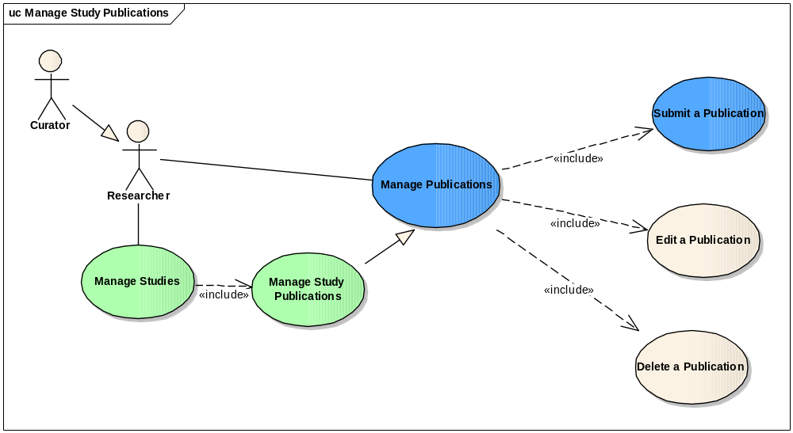
Figure 3-9 Manage Study Publications
Use case details are provided below:

Use Case Name | Manage Study Publications
Use Case ID | 1.9
Primary Actor | Data Curator, Researcher
Brief Description | The Manage Study Publications use case allows the Actor to edit, submit and delete study publication information.
Trigger | The User desires to either search or submit a study
Pre-conditions | The User is authorized to access desired functionality
Flow of Events | The User selects a study via the <Search Studies> use case  The User selects the Publication category  The User selects to edit publication via <Edit Study Publication> use case.  The User selects to submit publication via <Submit Study Publication> use case.  The User selects to delete publication via <Delete Study Publication> use case.
Post Conditions | Success Condition: The appropriate page is displayed as identified in related Manage Study Publications use cases based on a user’s authorizations  Error Conditions:  EC1: System Error during request submission  EC2: Database Error during data retrieval
Alternative Flow | Error Conditions:  EC1: System Error  - A system error has occurred which prevents processing of all related request  - The User contacts application help support  EC2: Database Error  - A database error has occurred which prevents data retrieval  - The System displays the error condition and application help contact information
Related Use Cases | Search Studies  Submit a Study  Manage Study Samples  Manage Study Characterizations  Manage Study Publications  Manage Study Protocols

Submit Study Publication

Use Case Name | Submit Study Publications
Use Case ID | 1.9.1
Primary Actor | Data Curator, Researcher
Brief Description | The Submit Study Publications use case allows the Actor to submit study publication information.
Trigger | The User desires to either search or submit a study
Pre-conditions | The User is authorized to access desired functionality
Flow of Events | The User selects a study via the <Search Studies> use case  The User selects the Publication category  The User selects to submit new publication for the study  The system displays Publication form allowing the user to complete entries on the form.  The User submits the form.
Post Conditions | Success Condition: The appropriate page is displayed as identified in related Submit Study Publication use cases based on a user’s authorizations  Error Conditions:  EC1: System Error during request submission  EC2: Database Error during data retrieval
Alternative Flow | Error Conditions:  EC1: System Error  - A system error has occurred which prevents processing of all related request  - The User contacts application help support  EC2: Database Error  - A database error has occurred which prevents data retrieval  - The System displays the error condition and application help contact information
Related Use Cases | Search Studies  Submit a Study  Manage Study Samples  Manage Study Characterizations  Manage Study Publications  Manage Study Protocols

Edit Study Publication

Use Case Name | Edit Study Publications
Use Case ID | 1.9.2
Primary Actor | Data Curator, Researcher
Brief Description | The Edit Study Publications use case allows the Actor to edit study publication information.
Trigger | The User desires to either search or submit a study
Pre-conditions | The User is authorized to access desired functionality
Flow of Events | The User selects a study via the <Search Studies> use case  The User selects the Publication category  The User selects to update an existing publication for the study by clicking on the Edit link for the publication.  The system displays Publication form allowing the user to complete entries on the form.  The User submits the form.
Post Conditions | Success Condition: The appropriate page is displayed as identified in related Edit Study Publication use cases based on a user’s authorizations  Error Conditions:  EC1: System Error during request submission  EC2: Database Error during data retrieval
Alternative Flow | Error Conditions:  EC1: System Error  - A system error has occurred which prevents processing of all related request  - The User contacts application help support  EC2: Database Error  - A database error has occurred which prevents data retrieval  - The System displays the error condition and application help contact information
Related Use Cases | Search Studies  Submit a Study  Manage Study Samples  Manage Study Characterizations  Manage Study Publications  Manage Study Protocols

Delete Study Publication

Use Case Name | Delete Study Publications
Use Case ID | 1.9.3
Primary Actor | Data Curator, Researcher
Brief Description | The Delete Study Publications use case allows the Actor to delete study publication information.
Trigger | The User desires to either search or submit a study
Pre-conditions | The User is authorized to access desired functionality
Flow of Events | The User selects a study via the <Search Studies> use case  The User selects the Publication category  The User selects to delete publication for the study by clicking the Edit link on the publication.  The system displays Publication form allowing the user to complete entries on the form.  The User clicks on the “Delete” button to delete the publication.
Post Conditions | Success Condition: The appropriate page is displayed as identified in related Delete Study Publication use cases based on a user’s authorizations  Error Conditions:  EC1: System Error during request submission  EC2: Database Error during data retrieval
Alternative Flow | Error Conditions:  EC1: System Error  - A system error has occurred which prevents processing of all related request  - The User contacts application help support  EC2: Database Error  - A database error has occurred which prevents data retrieval  - The System displays the error condition and application help contact information
Related Use Cases | Search Studies  Submit a Study  Manage Study Samples  Manage Study Characterizations  Manage Study Publications  Manage Study Protocols

View Study Publication

Use Case Name | View Study Publication
Use Case ID | 1.9.4
Primary Actor | Public, Researcher
Brief Description | The View Study Publication use case allows the Actor to view study publication information.
Trigger | The User desires to view study publication
Pre-conditions | The User is authorized to access desired functionality
Flow of Events | The User selects a study via the <Search Studies> use case  The User selects the Publication category  The system displays Publication page in view mode.
Post Conditions | Success Condition: The appropriate page is displayed as identified in related View Study Publication use cases based on a user’s authorizations  Error Conditions:  EC1: System Error during request submission  EC2: Database Error during data retrieval
Alternative Flow | Error Conditions:  EC1: System Error  - A system error has occurred which prevents processing of all related request  - The User contacts application help support  EC2: Database Error  - A database error has occurred which prevents data retrieval  - The System displays the error condition and application help contact information
Related Use Cases | Search Studies  Submit a Study  View Study Samples  View Study Characterizations

Manage Study Protocols
Figure 3-10 provides a high-level diagram of the caNanoLab 1.6 use cases associated with managing study protocols.

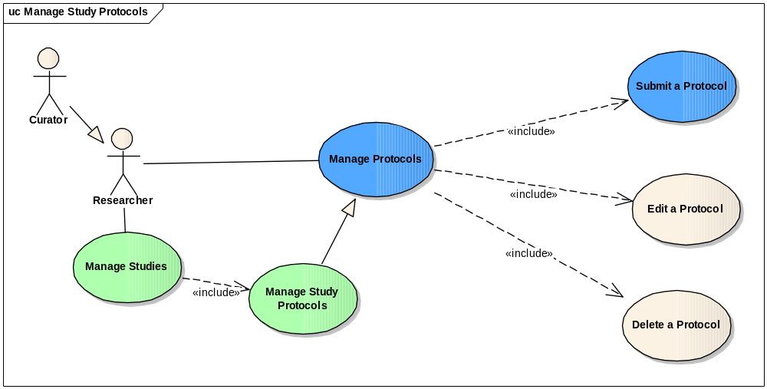
Figure 3-10 Manage Study Protocols
Use case details are provided below:

Use Case Name | Manage Study Protocols
Use Case ID | 1.10
Primary Actor | Data Curator, Researcher
Brief Description | The Manage Study Protocols use case allows the Actor to search and submit study information and manage study components including samples, characterizations, protocols, and publications. Actors can also manage different types of studies like pre-clinical studies.
Trigger | The User desires to either search or submit a study
Pre-conditions | The User is authorized to access desired functionality
Flow of Events | The User selects a study via the <Search Studies> use case  The User selects the Protocol category  The User selects to view protocol via <View Study Protocol> use case.  The User selects to edit protocol via <Edit Study Protocol> use case.  The User selects to submit protocol via <Submit Study Protocol> use case.  The User selects to delete protocol via <Delete Study Protocol> use case.
Post Conditions | Success Condition: The appropriate page is displayed as identified in related Manage Study Protocols use cases based on a user’s authorizations  Error Conditions:  EC1: System Error during request submission  EC2: Database Error during data retrieval
Alternative Flow | Error Conditions:  EC1: System Error  - A system error has occurred which prevents processing of all related request  - The User contacts application help support  EC2: Database Error  - A database error has occurred which prevents data retrieval  - The System displays the error condition and application help contact information
Related Use Cases | Search Studies  Submit a Study  Manage Study Samples  Manage Study Characterizations  Manage Study Publications  Manage Study Protocols

Submit Study Protocols

Use Case Name | Submit Study Protocols
Use Case ID | 1.10.1
Primary Actor | Data Curator, Researcher
Brief Description | The Submit Study Protocols use case allows the Actor to submit study protocols information.
Trigger | The User desires to either submit a study protocol
Pre-conditions | The User is authorized to access desired functionality
Flow of Events | The User selects a study via the <Search Studies> use case  The User selects the Protocol category  The User selects to submit new Protocol for the study  The system displays Protocol form allowing user to choose from existing protocols or submit new protocol  Case 1: The User selects an existing protocol. The protocol is associated with the study.  Case 2: The User selects to submit new protocol. The protocol form displays, allowing the user to complete the entries on the form.  The User submits the form.
Post Conditions | Success Condition: The appropriate page is displayed as identified in related Submit Study Protocol use cases based on a user’s authorizations  Error Conditions:  EC1: System Error during request submission  EC2: Database Error during data retrieval
Alternative Flow | Error Conditions:  EC1: System Error  - A system error has occurred which prevents processing of all related request  - The User contacts application help support  EC2: Database Error  - A database error has occurred which prevents data retrieval  - The System displays the error condition and application help contact information
Related Use Cases | Search Studies  Submit a Study  Manage Study Samples  Manage Study Characterizations  Manage Study Publications  Manage Study Protocols

Edit Study Protocols

Use Case Name | Edit Study Protocols
Use Case ID | 1.10.2
Primary Actor | Data Curator, Researcher
Brief Description | The Edit Study Protocol use case allows the Actor to edit study Protocol information.
Trigger | The User desires to edit a study protocol
Pre-conditions | The User is authorized to access desired functionality
Flow of Events | The User selects a study via the <Search Studies> use case  The User selects the Protocol category  The User selects to update a Protocol for the study by clicking on the Edit link for the protocol.  The system displays Protocol form allowing the user to update entries on the form.  The User submits the form.
Post Conditions | Success Condition: The appropriate page is displayed as identified in related Edit Study Protocol use cases based on a user’s authorizations  Error Conditions:  EC1: System Error during request submission  EC2: Database Error during data retrieval
Alternative Flow | Error Conditions:  EC1: System Error  - A system error has occurred which prevents processing of all related request  - The User contacts application help support  EC2: Database Error  - A database error has occurred which prevents data retrieval  - The System displays the error condition and application help contact information
Related Use Cases | Search Studies  Submit a Study  Manage Study Samples  Manage Study Characterizations  Manage Study Publications  Manage Study Protocols

Delete Study Protocols

Use Case Name | Delete Study Protocols
Use Case ID | 1.10.3
Primary Actor | Data Curator, Researcher
Brief Description | The Delete Study Protocol use case allows the Actor to delete study protocol.
Trigger | The User desires to delete a study protocol
Pre-conditions | The User is authorized to access desired functionality
Flow of Events | The User selects a study via the <Search Studies> use case  The User selects the Protocol category  The User selects to delete Protocol for the study by clicking on the Edit link for the protocol  The system displays Protocol form.  The User clicks “Delete” button to delete the protocol.
Post Conditions | Success Condition: The appropriate page is displayed as identified in related Delete Study Protocol use cases based on a user’s authorizations  Error Conditions:  EC1: System Error during request submission  EC2: Database Error during data retrieval
Alternative Flow | Error Conditions:  EC1: System Error  - A system error has occurred which prevents processing of all related request  - The User contacts application help support  EC2: Database Error  - A database error has occurred which prevents data retrieval  - The System displays the error condition and application help contact information
Related Use Cases | Search Studies  Submit a Study  Manage Study Samples  Manage Study Characterizations  Manage Study Publications  Manage Study Protocols

View Study Protocols

Use Case Name | View Study Protocols
Use Case ID | 1.10.4
Primary Actor | Public, Researcher
Brief Description | The View Study Protocol use case allows the Actor to view study Protocol.
Trigger | The User desires to view a study Protocol information.
Pre-conditions | The User is authorized to access desired functionality
Flow of Events | The User selects a study via the <Search Studies> use case  The User selects the Protocol category  The system displays Protocol form in view mode.
Post Conditions | Success Condition: The appropriate page is displayed as identified in related View Study Protocol use cases based on a user’s authorizations  Error Conditions:  EC1: System Error during request submission  EC2: Database Error during data retrieval
Alternative Flow | Error Conditions:  EC1: System Error  - A system error has occurred which prevents processing of all related request  - The User contacts application help support  EC2: Database Error  - A database error has occurred which prevents data retrieval  - The System displays the error condition and application help contact information
Related Use Cases | Search Studies  View Study Samples  View Study Characterizations  View Study Publications

4. Overall Requirements
The table below identifies the requirements for the caNanoLab 1.6 effort:

Prior-ity | Req # | Requirement | Use Case Name |  | Release #
 | 1.0 | The system shall allow …
 | 1.1.1 | The System shall allow users to … |  |  | 1.6
 | 2.0 | The system shall allow Authorized Users to … |  |  | 1.6

Sign Off

Approval

NCI CBIIT Rep Print Name Date
NCL Rep Print Name Date
NCI OC Rep Print Name Date
SAIC Rep Print Name Date

