Software Requirements Specification (As-Built)

cancer Laboratory Analysis Workbench (caLAB)
NCICB, NCL

DOCUMENT REVISION HISTORY

Version Number | Date | Description
1.0 | December 10, 2005 | - Initial draft containing high-level use cases
1.1 | December 22, 2005 | - Completion of file management use cases
1.2 | January 11, 2006 | - Updated file management use cases
1.3 | January 18, 2006 | - Updated file management use cases based on customer feedback.

Background/Summary
The cancer Laboratory Analysis Bench (caLAB) effort involves the design and development of core components of a caBIG compatible Laboratory Information Management System (LIMS). The effort also involves the deployment of a reference implementation of a core caLAB for operation in the Nanoparticle Characterization Laboratory (NCL). As such, the effort involves the development of core LIMS functionality that is of priority to the NCL with an understanding that prioritized NCL needs are also core LIMS features.
This document serves as an as-built document that identifies the core caLAB use cases (adaptive workflow, sample management, security, etc.) prioritized based on immediate NCL needs (file/meta data management). It is intended that this document serve as a living document that is modified throughout the iterative development life cycle.
Table of Contents
Requirements Specification (As-Built) 1
cancer Laboratory Analysis Workbench (caLAB) 1
Background/Summary 1
1 Introduction 5
1.1 Overview 5
1.1.1 caLAB 5
1.1.2 NCL Reference Implementation 6
1.2 Document Purpose 7
1.3 Related Documents 7
2 Actors and Authorization 8
2.1 Core caLAB Actors 8
2.2 NCL LIMS Actors 8
3 Use Cases 10
3.1 Login 11
3.1.1 Use Case 11
3.1.2 Supplemental Requirements 11
3.2 Manage File System 12
3.2.1 Manage File System 13
3.2.2 Navigate File System 13
3.2.3 Upload File 14
3.2.5 Rename File Error! Bookmark not defined.
3.2.6 Archive File Error! Bookmark not defined.
3.2.7 Search Error! Bookmark not defined.
3.2.8 Manage File Extensions Error! Bookmark not defined.
3.3 Manage Folder 20
3.3.1 Create Folder 20
3.3.2 Rename Folder 21
3.3.3 Archive Folder 22
4 General Requirements 24
4.1 Requirements Prioritization 24
4.2 NCL LIMS Requirements 26
5 Data Definitions 28
5.1 Common Data Elements (CDEs) 28
6 Sign Off 30
6.1 Approval 30
6.1.1 Iteration: 1.0 30
7 Appendix 31
7.1 Appendix A – Other LIMS Requirements 31

Introduction

Overview

caLAB
The primary goal of the caLAB effort is to develop core components of a Laboratory Information Management System (LIMS) that are compliant with the cancer Biomedical Informatics Grid (caBIG) data and technology standards and principles. Specifically, the effort involves:
- Developing a core LIMS based on caBIG principles of open source, open access, and interoperability (syntactic and semantic) via standard Common Data Elements (CDEs) and terminology
- Developing a core LIMS that can be utilized by a variety of laboratories operating diverse experiment modalities
- Engineering a core generic LIMS that can be customized and extended to support laboratory specific requirements
- Establishing an Open Development Initiative (ODI) that allows LIMS developers to contribute LIMS customizations and enhancements to the end user community
- Creating an affordable (free) “near” commercial grade LIMS that allows laboratories to focus on scientific research and scientific investments
The main components of a core LIMS include:

Component | Description
Adaptive Workflow | Supports the definition of laboratory specific workflows and workflow tasks (running assays, processing via laboratory instruments, analyzing results, etc.)
Sample Management | Provides the capability of accessioning samples, creating sample containers (e.g. plates), assigning controls, creating aliquots, and processing samples within a laboratory experiment
Reporting | Supports the generation of standard and custom reports and graphs, and provides a mechanism for users to export reports in a common spreadsheet format
Instrument Integration | Provides a generic module supporting bi-directional laboratory instrument integration
Inventory Management | Supports laboratory inventory tracking and allows authorized users to check-in/check-out samples and other laboratory supplies (e.g. reagents) to/from storage devices
Document Management | Controls basic file and folder management capabilities including file upload, download, and versioning
Meta Data Extensions | Allows authorized users to assign and create meta data fields in all aspects of the workflow (result annotations, sample annotations, QA/QC parameters)
Administrative/Security | Controls use access via user authentication and role based authorization
Configuration/Installation | Allows administrators to install and configure the LIMS for use in the laboratory environment
Typically, these core components are leveraged, to varying degrees, throughout the laboratory workflow process. Figure 1-1 provides an example laboratory process

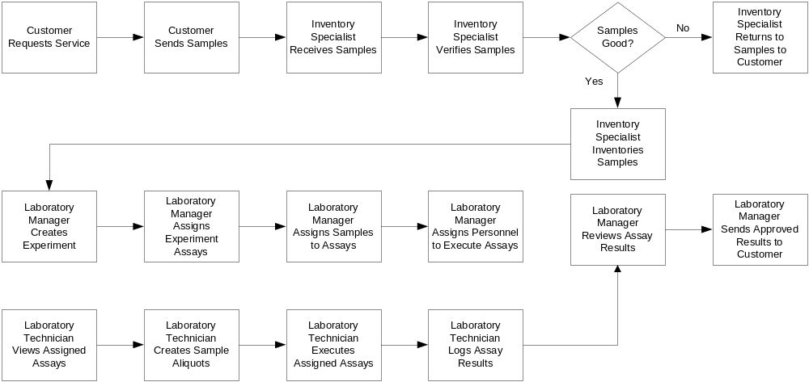
Figure 1-1 Example Laboratory Workflow

An example laboratory workflow [Figure 1-1] may involve a customer requesting laboratory services (e.g. applicant requesting nanoparticle validation, customer requesting genotyping services) and sending samples along with sample information to the performing laboratory. The performance site receives, inventories, and validates the samples. If the samples are valid, a laboratory manager creates the requested experiments, establishes the assays associated with the experiment, and assigns samples and laboratory personnel to the experiment. If the samples are not valid, the performance site returns the samples to the customer along with a description of the occurring issues. Once a lab manager creates an experiment and assigns valid samples and personnel to execute the experiment, that responsible lab technician performs the assay, creates aliquots of the samples, and executes the assay. Test results are logged into the system during assay execution and the lab results are reviewed and analyzed by the lab manager. Approved results are them provided back to the customer.
Although Figure 1-1 represents an example laboratory workflow, other laboratories may have different workflows, which may include analyzing results using specific analysis software, interfacing with specific laboratory equipment, bar coding, etc. As such, it is necessary to create a generic LIMS with an adaptive workflow component that can be extended to support diverse laboratories.
Working towards the implementation of a generic LIMS goal, caLAB will be implemented in an iterative fashion focusing on the immediate needs of the initial reference implementation laboratory, the Nanoparticle Characterization Laboratory (NCL), as defined in the caBIG LIMS Phase 1 Scope Document and the sub-section that follows. The caLAB system will be designed for extensibility to accommodate other laboratory needs that may be implemented in future efforts by external laboratories. A list of potential future LIMS functionality that has been identified by other laboratories is available in Appendix A of this document.

NCL Reference Implementation

To validate caLAB in a real laboratory setting, the effort involves deploying a reference implementation of caLAB at the Nanoparticle Characterization Laboratory (NCL). As such, core caLAB requirements have been prioritized to meet the immediate needs of the NCL. The prioritized requirements include support for the following core functionality in the initial iteration:
- Document Management – Allows NCL researchers to manage folders/files and supports file upload (e.g. assay results) to folders.
- Meta Data Extensions – Allows NCL researchers to associate meta data (e.g. particle type, size) with folders/files.
- Search – Generic search function that allows researchers to search for folders/files (e.g. assay results) based or customized meta data (e.g. filename, particle type, etc.)
While the above functionality will primarily support the immediate needs of the NCL, this functionality is essential in a core LIMS and as such, the use cases and design will be engineered in support of generic laboratory needs. It is intended that the system will be engineered in an iterative fashion focusing primarily on immediate NCL needs in the initial iteration. Sub-sequent iterations will support adaptive workflow, sample management, and security as this core functionality is of priority to the NCL and other laboratories.

Document Purpose
The purpose of this document is to provide a high-level use case diagram of caLAB use cases and identify the detailed use cases and requirements associated with each iteration. Due to the iterative nature of the caLAB development cycle, this document will serve as an as-built document that will be modified in each software iteration to include the detailed requirements and use cases associated with each iteration.

Related Documents

Document Name | Version | Location
caBIG LIMS Phase 1 Scope | 1.1 | https://ncicbintra.nci.nih.gov/lims/caBIG/p1req_scope.doc
caBIG LIMS Requirements Presentation | 1.0 | https://ncicbintra.nci.nih.gov/lims/caBIG/cabig_lims.ppt
NCL LIMS Requirements Spreadsheet | 1.0 | https://ncicbintra.nci.nih.gov/lims/caBIG/ncl_lims.xls
caBIG Compatibility Guidelines | 2.0 | https://cabig.nci.nih.gov/guidelines_documentation/caBIGCompatGuideRev2_final.pdf

Actors and Authorization

Core caLAB Actors
The table below describes the core caLAB actors as well as the intended authorization. It is intended that authorization levels, although defined below, will be configurable to accommodate diverse laboratory actor definitions. Authorization will not be implemented until completion of the security module.

Actor | Description | Authorization
User | Base user in which all LIMS actors are derived | Configurable
PI/Lab Director | Individual who is responsible for the design, scientific/technical conduct, administrative conduct, and reporting of research projects or customer service projects completed in the designated laboratory. The PI/Lab Director acts as the primary decision-maker and coordinates all lab activities either directly or indirectly. | Create, Edit, Delete, Read Experiment Protocols and Results
Lab Manager | Individual who is responsible for the overall development and implementation of the laboratory policies, projects, and services. The Lab Manager may perform experiments and/or supervise others to run experiments. The Lab Manager also analyzes results, writes reports, schedules equipment and personnel. Other responsibilities may include quality control, compliance adherence and hiring and training of personnel. | Create, Edit, Delete Experiment Protocols; Read Experiment Protocols and Results
Lab Technician | Individual who is responsible for sample preparation, running experiments/assays, recording results and observations, quality control, maintaining equipment, ordering supplies and cross-training other personnel. | Edit, Delete, Read Experiment Protocols and Results
Administrator/Superuser | The LIMS administrator installs and configures the system | All privileges
Staff Scientist | Individual who performs experiments and/or supervises others to run experiments. The Lab Manager also analyzes results, writes reports, schedules equipment and personnel. Other responsibilities may include quality control, compliance adherence and hiring and training of personnel. | Create, Edit, Delete Experiment Protocols for which they are responsible; Read Experiment Protocols and Results
Collaborator | Individual who performs specific experiments of relevance to the laboratory, records results, and drafts reports | Uploads results and reports, has access to specific projects
Customer | Individual who provides samples, reviews data/receives reports | Uploads results and reports, has access to specific projects after data curation

NCL LIMS Actors
The table below describes NCL specific actors and authorizations. NCL actors are extensions of the core caLAB actors.

Actor | Description | Authorization
PI/Lab Director (NCL Director) | The NCL Director monitors NP progress through cascade, integrates programmatic issues, communicates with applicant, communicates with OTIR directorate | Create, Edit, Delete, Read Assays and Assay Results
Staff Scientist  (Chemist) | The NCL chemist manages NP inventory and aliquots, decides which assays to run for physical characterization, analyzes results, writes reports, schedules equipment and personnel | Create, Edit, Delete Chem Assays;  Read Assays and Assay Results
Staff Scientist  (Immunologist) | The NCL immunologist decides which assays to run for immunotoxicity, analyzes results, writes reports, schedules equipment and personnel | Create, Edit, Delete Immuno Assays;  Read Assays and Assay Results
Staff Scientist  (Toxicologist) | The NCL toxicologist decides which assays to run for general toxicity, conducts in vivo studies, analyzes results, writes reports, schedules equipment and personnel | Create, Edit, Delete Tox Assays; Read Assays and Assay Results
Lab Technician | The NCL lab technician performs manual manipulations (assays), enters/responsible for raw data, maintains supply inventory (reagents, consumables) | Edit, Delete, Read Assays and Assay Results
Administrator | The NCL administrator installs and configures the system | All privileges
Collaborator  (Internal NCI) | The internal NCL collaborator (e.g. DTP) runs specific assays, drafts reports | Uploads results and reports, has access to specific projects
Collaborator  (External NCI, NIST Scientist) | The external NCL collaborator runs specific assays, drafts reports, and specifies physical characterizations | Uploads results and reports, has access to specific projects
Customers  (Applicant, Vendors) | The NCL applicant/vendor provides nanoparticles, reviews data, receives reports | Uploads results and reports, has access to specific projects after data curation

Use Cases
Figure 3-1 provides a high-level diagram of the Core LIMS use cases. Use cases intended for the initial release are indicated in yellow and are further described in the subsequent sections.
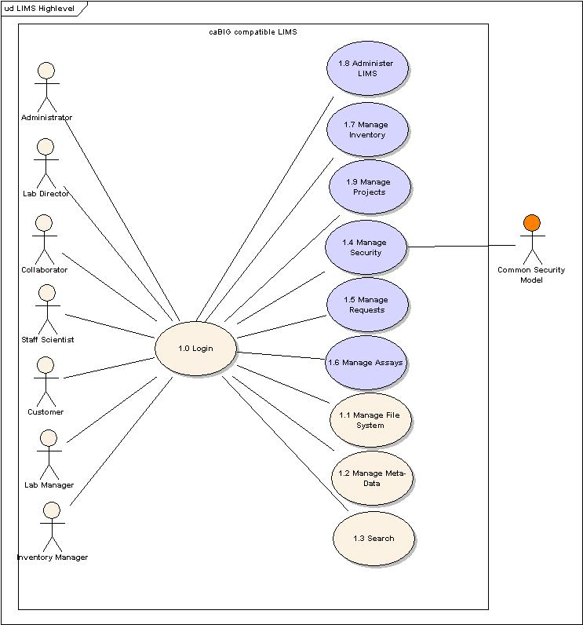
Figure 3-1 High-Level Use Case Diagram

3.1 Login

Use Case

Use Case Name | Log Into the System
Use Case ID | 1.0
Primary Actor | Users, System
Brief Description | The Login Use Case allows users to authenticate and access the system
Trigger | User has system access
Pre-conditions | User has accepted the security encryption certificate
Flow of Events | - The user enters login information including username and password  - The user submits the Login request  - The system authenticates the login information  - The system allows grants the authenticated user access to the LIMS
Post Conditions | Success Condition: User is granted entry.  Error Condition: Authentication Failed  Error Condition: Invalid Login Information  Error Condition: System Error
Alternative Courses of Action – Invalid User  Invalid Password  System Error | If a validation error occurs, the system throws an exception, displays an error message, and re-displays the Login page for data entry  a. Authentication Failed  - Display user authentication error  - Redirect user to Login Page and/or Administrator Link  b. Invalid Login Information  - Display invalid password for user error  - Redirect user to Login Page and/or Administrator Link  c. System Error  - Display System Error message  - Redirect user to Login Page and/or Administrator Link
Issues | - The first iteration will not include support for user authorization as this will be implemented upon completion of the security module  - The first iteration will not include support for semi-automated user account as this will be implemented upon completion of the security module  - The first iteration will not include a semi-automated process for requesting an account as this will be implemented upon completion of the security module  - System auditing will not be supported until completion of the security module.

Supplemental Requirements
The following supplemental requirements have been identified for this use case:

Req # | Supp Requirement Ref #
 | The system shall be configured with encryption enabled to ensure that login information is inaccessible

Manage File System
Figure 3-2 provides a high-level diagram of the Manage File use cases. Use cases intended for the initial release are indicated in yellow and are further described in the subsequent sections.
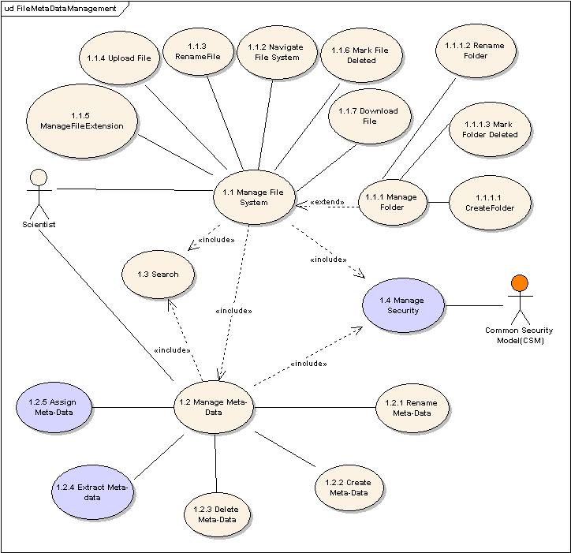
Figure 3-2 File and Meta Data Management Use Cases

Manage File System

Use Case Name | Manage File System
Use Case ID | 1.1
Primary Actor | User
Brief Description | The Manage File System use case allows users to upload & download files, rename folders, archive files & folders, and navigate the virtual network file system.
Trigger | The User selects the Manage File System operation
Pre-conditions | - The System is correctly configured to a virtual network file system.  - The User has authorized access into the virtual network file system.  - The User is logged into the System.  - The file system is displayed to the user.
Flow of Events | - The User may either navigate the virtual network file system or perform operation on assay files or folders. IF the user selects to perform operations on files and folders, then the User selects the Manage File System operation.  - The system displays the virtual network file system (i.e., made up of files and folders) as well operations that may be performed on files/folders.  - The User selects the desired file or folder to which the Manage File operation will be performed.  - The User selects from one of the following operations on files or folders:  - File  Upload File  Download File  Mark File Delete  - Folder  Create Folder Structure  Create New Folder  Rename Folder  Mark Folder Delete
Post Conditions | Success Condition: The User successfully selects the Manage File operation.  Error Conditions:  EC1: [Disk Space Exceeded] <Flow of Event 4>
Alternative Flow | Error Conditions:  EC1: [Disk Space Exceeded] <Flow Of Event 4>  - The Upload File operation was selected but the disk space has been exceeded.  - Notify the system administrator to allocate more disk space.
Related Use Cases | Create Folder Structure  Create New Folder  Download File  Mark File Delete  Mark Folder Delete  Navigate File System  Upload File  Rename Folder
Issues | None

Navigate File System

Use Case Name | Navigate File System
Use Case ID | 1.1.2
Primary Actor | User
Brief Description | The Navigate File System use case allows users to navigate a hierarchical file system (i.e., made up of files and folders) in which assay files are stored. The file structure is based on template rules governed by a Standard Operating Procedure (SOP).
Trigger | The User selects the Manage File operation and desires to navigate a file system.
Pre-conditions | - The System is correctly configured to a virtual network file system.  - The User has authorized access into the virtual network file system.  - The User is logged into the System.  - The file system is displayed alphabetically to the user.
Flow of Events | - The User selects to navigate the file system.  - The User clicks through a series of folders to navigate through the file system.
Post Conditions | Success Condition:  SC1: The User successfully navigates through the file system.  Error Conditions:  EC1: Virtual Network Incorrectly Configured.  EC2: Network connection is lost with underlying virtual network file  system.
Alternative Flow | Error Conditions:  EC1: [Virtual Network File System Incorrectly Configured] <Flow Of Event 2>  - IF the virtual file system is incorrectly configured to the virtual network file system, THEN the system administrator correctly configures the system to correctly recognize the virtual network file system.  - The System and the underlying virtual network file system are synchronized.  EC2: [Network Connect Lost] <Flow Of Event 2>  - IF the network looses connection with the virtual network file system THEN:  - The system administrator is notified  - The system administrator restores the network connection.  - The System and the underlying virtual network file system are synchronized.
Related Use Cases | Manage File System
Issues | None

Upload File

Use Case Name | Upload File
Use Case ID | 1.1.4
Primary Actor | User
Brief Description | The Upload File use case allows a User to upload one or more nano-particle assay files into the System.
Trigger | A User selects Upload File from the Manage File operation to upload a file into the System.
Pre-conditions | - The System is correctly configured to a virtual network file system.  - The User has authorized access into the virtual network file system.  - The User is logged into the System.
Flow of Events | - The User selects the Manage File System operation.  - The system displays the virtual network file system (i.e., made up of files and folders) as well operations that may be performed on files/folders.  - On the virtual network file system, the User selects a target folder into which the desired file will be uploaded.  - The User selects the Upload operation.  - The System displays the User’s local file system (i.e., made up of files and folders).  - The User navigates the local file system and selects one or more files or an entire folder to upload.  - A YES/NO confirmation screen displays a list of files indicating what will be uploaded into the system.  - IF the user selects YES:  - The User commits the Upload.  - The System uploads the selected file(s) or folder FROM the User’s local file system TO the virtual network file system and assigns the following file level meta data to the uploaded file(s):  - Creation Date  - File Status (e.g., Marked for Delete)  - Owner  - Submission Date  - Submitter  - IF the user selects NO:  - The Upload operation is canceled.  - The user remains at the current screen.
Post Conditions | Success Conditions:  SC1: The selected assay file list is successfully uploaded to the Sstem.  SC2: By default, any meta data associated the uploaded file is assigned to the target upload folder.  Error Conditions:  EC1: General Upload Error Occurs  EC2: Network Connection is Lost
Alternative Flow | Error Conditions  EC1: [General Upload Error] <Flow of Event 8>]  - An error occurs during upload.  - Files that erred during upload will not be uploaded.  - An error message displaying the files that were uploaded and those that did not upload will be displayed and logged to the system (e.g., for audit)  EC2: [Network Connection Lost] <Flow of Event 8>]  - IF the system looses connection while uploading file(s) to the virtual network file system THEN:  - The selected file(s) are not uploaded.  - The system administrator is notified by email.  - Files that erred during upload are not uploaded.  - An error message displays the files that were uploaded and those that did not upload; and logs this to the system (e.g., for audit)  - The system administrator restores the network connection.  - When the System and the underlying virtual network file system are synchronized then the User may re-try to upload the file(s).
Related Use Cases | Download File  Manage File System  Navigate File System
Issues | Should multiple folders upload?  In future iteration, the system will validate the selected file(s) or folder to determine if it can be uploaded to the target folder location (as defined by the File Management SOP).

Download File

Use Case Name | Download File
Use Case ID | 1.1.7
Primary Actor | User
Brief Description | The Download File use case allows a User to download one or more selected file(s) to a local file system.
Trigger | A User selects one or files to download from search results or from the virtual network file system.
Pre-conditions | - The System is correctly configured to a virtual network file system.  - The User has authorized access into the virtual network file system.  - The User is logged into the System.
Flow of Events | - The user selects to download one or more files (e.g., from the virtual network file system, search results window, etc.).  - The System displays the User’s local file system.  - User clicks a target folder in the local file system into which the selected file(s) will be downloaded.  - A YES/NO confirmation screen displays the file(s) that will be downloaded to the system.  - IF the user selects YES THEN  - The System downloads the selected file(s) FROM the virtual network file system TO the User’s local file system.  - If more than one file is selected, the System will compress/”zip” files and then execute the download.  - IF the user selects NO THEN the list of files are not downloaded and the System remains at the current screen.
Post Conditions | Success Conditions:  SC1: The selected assay file list is successfully downloaded to the User’s local file system.  Error Conditions:  EC1: General Upload Error Occurs  EC2: Network Connection is Lost
Alternative Flow | Error Conditions  EC1: [General Upload Error] <Flow of Event 4>]  - An error occurs during download.  - Files that erred during download will not be downloaded.  - An error message displaying the files that were downloaded and those that did not download will be displayed and logged to the system (e.g., for audit)  EC2: [Network Connection Lost] <Flow of Event 4>]  - IF the system looses connection while downloading file(s) from the virtual network file system to the User’s local file system THEN:  - The selected file(s) are not downloaded.  - The system administrator is notified by email.  - Files that erred during download are not downloaded.  - An error message displays the files that were downloaded and those that did not download; and logs this to the system (e.g., for audit)  - The system administrator restores the network connection.  - When the System and the underlying virtual network file system are synchronized then the User may re-try to download the file(s).
Related Use Cases | Manage File System  Navigate File System  Upload File
Issues | None

Mark File Delete

Use Case Name | Mark File Delete
Use Case ID | 1.1.6
Primary Actor | User
Brief Description | The Mark File Delete use case allows a User to mark a file as deleted.
Trigger | The User selects a file to mark for delete.
Pre-conditions | - The System is correctly configured to a virtual network file system.  - The User has authorized access into the virtual network file system.  - The User is logged into the System.
Flow of Events | - The User selects the Manage File System operation.  - The System displays the virtual network file system (i.e., made up of files and folders) as well operations that may be performed on files/folders.  - The User selects the desired file in the virtual network file system.  - The User selects the Mark For Delete operation.  - The System queries the user (i.e., Yes/No) to confirm the Mark For Delete operation.  - IF the user selects indicates Yes THEN  - System makes sure that files are not being used by any other project/experiment.  - System marks the selected file with a File Status of “Mark For Delete”  - System makes invisible the selected file from the virtual network file system.  ELSE the System will not mark the selected file with a File Status of “Mark For  Delete”.
Post Conditions | Success Condition:  SC1: The selected assay file is successfully marked for delete.  Alternate Condition:  AC1: Manually Delete File(s)  Error Condition:  None
Alternative Flow | Alternate Condition:  AC1: [Manually Delete Files]: <Flow of Event n/a>]  - A decision is made to delete files marked for delete.  - A list of files to manually delete permanently from the system are sent to the system administrator.  - The system administrator permanently deletes the files from the system.
Related Use Cases | Manage File System  Mark Folder Delete  Navigate File System
Issues | None

Search

Use Case Name | Search
Use Case ID | 1.3
Primary Actor | User
Brief Description | The Search Use Case allows the User to search for files in the System.
Trigger | The User selects the Search File functionality.
Pre-conditions | - The System is correctly configured to a virtual network file system.  - The User has authorized access into the virtual network file system.  - The User is logged into the System.
Flow of Events | - The User selects the Search operation.  - System displays the search screen and queries the User for the following search criteria: Wild card characters are allowed for fields marked with (*).  - File Name (*)  - Folder Name (*)  - Owner  - Submitter  - Submission Date  - Creation Date  - File Type  - File Status (e.g., Marked for Delete)  - Version  - Include Files Marked for Delete: (YES/NO)  - The user completes the search criteria and selects to search assay files based on the selected criteria.  - The System returns search results that matches the selected criteria.
Post Conditions | Success Condition:  SC1: The System successfully returns files and folders that match the search criteria with the following columns listed:  - Folder Path  - File Name  - Type  - Owner  - Submitter  - Submission Date  - Creation Date  - File Status  SC1: The System successfully returns meta data from the folder structure template.  Alternate Condition:  AC1: File/Folder Not Found  AC2: Many files/folders are returned.  Error Condition:  EC1: Invalid Search Criteria
Alternative Flow | Alternate Condition:  AC1: [File/Folder Not Found]: <Flow of Event 3>]  - The System returns an empty file/folder list.  - The System displays a message that no files were found that matches the selected criteria.  AC2: [Many files/folders are returned]: <Flow of Event 3>]  - The System organizes the returned file/folder list into separate ordered number pages (e.g., 1 2 3 4..).  - The User clicks a number indicating the next page of search results.  - The System displays the search results that correspond to the selected page.  Error Condition:  EC1: [Invalid Search Criteria]: <Flow of Event 3>]  - The System displays a message indicating that the user entered invalid search criteria.  - The System aborts the search.
Related Use Cases | Download File  Manage File System  Navigate File System
Issues | The Search Use case may need to be separated to include a 1.) Use case for Search Criteria 2.) Use case for Advanced Search.

Manage Folder

Create Folder Structure

Use Case Name | Create Folder Structure
Use Case ID | 1.1.1.1
Primary Actor | User
Brief Description | The Create Folder Structure use case allows the user to select from a list of folder structure templates so that the System may create an associated virtual network folder structure from the selected template.
Trigger | The User selects to add a new folder structure.
Pre-conditions | - The System is correctly configured to a virtual network file system.  - The User has authorized access into the virtual network file system.  - The User is logged into the System.
Flow of Events | - The User selects the Manage File System operation.  - The User selects the Add New Folder Structure function.  - The System will present a list of folder structure templates.  - The User selects the desired template for the folder structure into which files will be stored.  - The User submits the desired template.  - The System creates a folder structure based on the selected folder structure template and displays as the virtual network file system.
Post Conditions | Success Condition:  SC1: The System successfully creates the folder structure based on the selected template.  Error Conditions:  None
Alternative Flow | N/A
Related Use Cases | Manage File System  Navigate File System
Issues | None

Create New Folder

Use Case Name | Create Folder Structure
Use Case ID
Primary Actor | User
Brief Description | The Create New Folder use case allows the user to create a new folder in the folder hierarchy location that is allowed by the active folder structure template.
Trigger | The User selects to add a new folder.
Pre-conditions | - The System is correctly configured to a virtual network file system.  - The User has authorized access into the virtual network file system.  - The User is logged into the System.
Flow of Events | - The User selects the Manage File System operation.  - The User clicks a level in the folder structure where the create new folder operation is allowed.  - The user selects create new folder operation.  - The user enters a name for the new folder.  - The System creates the new folder in the allowable position indicated by the user and constrained by the folder structure template.
Post Conditions | Success Condition:  SC1: The System successfully creates the new folder in the position indicated by the user and constrained by the folder structure template.  Error Conditions:  None
Alternative Flow | N/A
Related Use Cases | Create Folder Structure  Manage File System
Issues | None

Rename Folder

Use Case Name | Rename Folder
Use Case ID | 1.1.1.2
Primary Actor | User
Brief Description | The Rename Folder Use Case allows a user to rename a folder in the System.
Trigger | The User selects a folder to change its name.
Pre-conditions | - The System is correctly configured to a virtual network file system.  - The User has authorized access into the virtual network file system.  - The User is logged into the System.
Flow of Events | - The User selects the Manage File System operation.  - The System displays the virtual network file system (i.e., made up of files and folders) as well operations that may be performed on files/folders.  - The User selects the desired folder in the virtual network file structure to change its name.  - The User selects the Rename operation.  - The System highlights the folder name indicating that it is ready for edit.  - The user names the folder.
Post Conditions | Success Condition: The folder is successfully renamed.  Error Conditions:  - Duplicate name occurs, Folder cannot be renamed.  - Folder name does not abide by standard naming conventions.
Alternative Flow | - [Duplicate Name Error]: <Flow of Event 6]  - The System displays an error indicating that the folder name already exists.  - IF the User enters a different folder name  THEN a different folder name is committed  ELSE the folder name will be left unchanged.  - [Invalid Naming Conventions]: <Flow of Event 6]  - The System displays an error indicating that the folder name does not abide by defined naming conventions.  - IF the User types a valid folder name  THEN a different folder name is saved  ELSE the folder name will be left unchanged.
Related Use Cases | Navigate File System  Rename File
Issues | None

Mark Folder Delete

Use Case Name | Mark Folder Delete
Use Case ID | 1.1.1.3
Primary Actor | User
Brief Description | The Mark Folder Delete Use Case allows a User to archive a folder and all of its file contents.
Trigger | The User selects a folder to mark for delete.
Pre-conditions | - The System is correctly configured to a virtual network file system.  - The User has authorized access into the virtual network file system.  - The User is logged into the System.
Flow of Events | - The User selects the Manage File System operation.  - The System displays the virtual network file system (i.e., made up of files and folders) as well operations that may be performed on files/folders.  - The User selects the desired folder in the virtual network file system.  - The User selects the Mark For Delete operation.  - The System queries the user (i.e., Yes/No) to confirm the Mark For Delete operation and list files within the folder that will also be marked for delete.  - IF the user selects indicates Yes THEN  - System marks the selected folder with a File Status of “Mark For Delete” and executes (Use Case: Mark File Delete) to mark files contained in the folder for delete.  - System makes invisible the selected folder and files contained in the folder from the virtual network file system.  ELSE the System will not mark the selected folder with a File Status of “Mark For  Delete”.
Post Conditions | Success Condition:  SC1: The selected folder is successfully marked for delete.  Error Condition:  None
Alternative Flow | None
Related Use Cases | Manage File System  Mark File Delete  Navigate File System
Issues | None

General Requirements

Requirements Prioritization

Req # | Requirement | Use Case Name | Release #
 | Adaptive Workflow
 | Allow authorized users to define laboratory workflow(s) including workflow tasks (run assay, run instrument) and result entry screens | Create Workflow | 1.0
 | Allow authorized users to visually define laboratory workflows
 | Allow authorized users to assign workflow tasks | Assign Workflow Tasks | 1.0
 | Allow authorized users to execute assigned workflow tasks | Assign Workflow Tasks | 1.0
 | Allow authorized users to create multiple runs of assigned workflow tasks (assay processing)
 | Allow authorized users to define workflow templates that can be copied and modified for re-use
 | Allow authorized users to link multiple workflows to create complex labor procedures
 | Sample Management
 | Allow authorized users to accession samples | Create Samples | 1.0
 | Allow authorized users to create sample containers (e.g. plates, tubes) and associate samples with containers | Create Samples | 1.0
 | Allow users to upload samples in batch via spreadsheet format | Import Samples | 1.0
 | Allow authorized users to create aliquots of sample | Create Samples | 1.0
 | Allow authorized users to combine samples and/or sample containers
 | Allow authorized users to bar code samples, aliquots, and sample containers
 | Allow authorized users to create/obtain unique bar code IDs for labeling)
 | Allow authorized users to track samples and view sample histories
 | Allow authorized users to specify additional sample meta data not included in the default set
 | Reporting
 | Allow authorized users to view standard reports and graphs
 | Allow authorized users to create custom reports and graphs
 | Allow authorized users to download reports in spreadsheet (MS Excel format)
 | Allow authorized users to print reports and graphs
 | Instrument Integration
 | Provide a generic module supporting bi-directional laboratory instrument integration
 | Support the generation of laboratory instrument input (e.g. sample lists)
 | Support the capture of laboratory instrument output
 | Support the usage of laboratory instruments within the laboratory workflow
 | Support the analysis of laboratory instrument output
 | Support analysis via third-party analysis software
 | Support statistical analysis based on multiple instrument outputs
 | Administrative (Security)
 | Support for user authentication (user, password) and authorization (roles, privileges) via the NCICB Common Security Module (CSM) | Security | .50
 | Support for user authorization (roles, privileges) via the NCICB Common Security Module (CSM) | Security | 1.0
 | Support for user management via NCICB user provisioning tools | Create User | 1.0
 | Create/manage users | Create User | 1.0
 | Assign user roles
 | Assign user skills
 | Support for laboratory management
 | Assign users to laboratories
 | Support for group management
 | Create groups of laboratories and/or users
 | Inventory Management
 | Allow authorized users to check-in and check-out samples and laboratory supplies to/from storage devices
 | Provide support for inventory receipt, validation, and distribution (shipping)
 | Allow authorized users to manage storage devices (freezers)
 | Allow authorized users to manage laboratory supplies (reagents, primers, test sets)
 | Allow authorized users to track inventory via bar codes
 | Allow authorized users to search for inventory
 | Allow authorized users to monitor quantity of utilized samples and supplies
 | Allow authorized users to monitor the capacity of storage devices
 | Configuration/Installation
 | Allow administrators to install and configure the LIMS for use in the laboratory environment
 | Provide user friendly install shields
 | Provide configurable parameters for security, RDBMS connection, file management, instrument integration
 | Document Management
 | Allow authorized users to upload documents (files, images) | Upload Files | .50
 | Allow authorized users to associate documents with workflow components (experiments, assays)
 | Allow authorized users to annotate uploaded documents via custom meta data tags | Create  Meta Data | .50
 | Allow authorized users to search for documents based on associated meta data | Search | .50
 | Provide automatic documents version control
 | Allow authorized users to export documents | Export Files | .50
 | Allow authorized users to create folders to provide custom views of submitted documents | Create Folders | .50
 | Meta Data Management
 | Allow authorized users to create custom meta data fields associated with files/folders | Create Meta Data | .50
 | Allow authorized users to create custom meta data fields in all aspects of the workflow (result annotations, sample annotations, QA/QC parameters)
 | Allow authorized users to search on custom meta data fields | Search | .50
 | General System Requirements
 | caBIG compatibility |  | .50+
 | Registered CDEs in the caDSR |  | .50+
 | Use of common terminology from the EVS |  | .50+
 | Well described information models and APIs |  | .50+
 | Open Source and Open Architecture |  | .50+
 | Data Archival/Retrieval
 | Web-Deployable Application |  | .50+
 | Leverage NCICB usability standards |  | .50+
 | Audit Trail for recording all authorized system events
 | Application Support
 | Performance/Scalability |  | 1.0+
 | Training/Documentation

NCL LIMS Requirements

Req # | Requirement | Use Case Name |  | Release #
 | Instrument Integration
Interface with NCL specific laboratory devices
[Need to specify equipment in separate requirements]
 | Capture and retrieve data and associated meta data from NCL devices
 | Support the analysis of captured data via third-party software
 | Capture and retrieve instrument validation scripts/data
 | Capture and retrieve instrument calibration and maintenance documentation
 | Meta Data Management
 | Creation and retrieval of custom metadata |  | Create  Meta Data | .50
 | Support the interface to third-party applications
 | Support the interface to analysis and modeling and simulation software
 | Support creation of workflows and linking of data to analysis and reporting modules
 | Support for validation data
 | Support for automated report generation
 | Support for meta data conforming to caBIG CDEs |  | Create  Meta Data | .50+
 | Support for sharing authorized data |  | Security | 1.0
 | Support for data archival/retrieval
 | Document Management
 | Capture and retrieval of documents and associated meta data |  | Search | .50
 | Support for document sharing to authorized users |  | Security | 1.0
 | Support for document searching |  | Search | .50
 | Support for document archival |  | Archive File | .50
 | Adaptive Workflow
 | Support for protocol and workflow management |  | Create Workflow | 1.0
 | Support for combining data capture, statistical analysis, and workflow management
 | Support for the capture of QA/QC data throughout the workflow pipeline
 | Inventory Management
 | Tracking and ordering of laboratory reagents and materials
 | Document tracking of material handling instructions
 | Workflow guiding material handling
 | Efficient generation of aliquots
 | Recording the storage, use and disposal of nanomaterials
 | Support for assays establishing the stability of nanomaterials
 | Administration
 | Support for proposal evaluation/acceptance workflow
 | Support for MTA document templates
 | Support for resource allocation and scheduling
 | Support for assay results review/approval workflow
 | Inclusion of training and testing modules
 | Support for regulatory compliance procedures
 | Support for audit trails
 | Usage of requirements traceability software
 | Collaboration Management
 | Tracking MTA/NDA/IP in a secure fashion
 | Tracking Third-Party Materials/Assays in a standard format
 | Provide resource projections
 | Support for electronic billing/payment
 | System Support
 | Support for maintenance and upgrades
 | Provide application support
 | Support product customizations
 | Establish User Groups
 | Provide Training
 | Support system security
 | Provide ease-of-use, system flexibility, upgradeability, scalability, and reliability
 | Usability
 | Provide Internet capability
 | Provide support for linking common office, laboratory, and analysis software
 | Provide platform compatibility
 | Provide the ability to interface to enterprise applications

Data Definitions

Common Data Elements (CDEs)

CDE # | Data Element | Description | Use Case Name
 | File/Folder Name | Name of file or folder | Manage File System
 | File/Folder Location | Virtual file path | Manage File System
 | File/Folder Submission Date | Date file was submitted | Manage File System
 | File/Folder Owner | Actor who submitted file | Manage File System
 | File Type | Type of file (e.g. MS Word, MS Excel) | Manage File System
 | Particle Type | e.g. Aluminum nanoparticle, black carbon nanoparticle, etc. | Meta Data Management
 | Physical Char: Size and Size Distribution | Value: (e.g., 80nm, 100nm)  Type: Primary Sphere Size, Agglomerate Size: (note: may be under aggregates)  Technique: (e.g., dynamic light scattering, Static Light Scattering, Photon Correlation Spectroscopy, etc.  Source: Instrument | Meta Data Management
 | Physical Char: Topology | Value: (e.g., % Dendrimer Metal Nanocomposites), network, hybridization, etc.)  Technique: (e.g. light scattering)  Source: Instrument
 | Physical Char: Molecular Weight | Value: (e.g., Mr=2000, 5000, and 10000)  Technique:  Source: Instrument
 | Physical Char: Aggregation | Value:  Technique: (e.g., optical confocal laser microscopy and high resolution X-ray microtomography, fluorescence and scanning electron microscopy, etc.)  Source: Instrument
 | Physical Char: Purity | TBD
 | Physical Char: Chemical Composition | Type: (e.g. metallic | carbon, oxygen, sulfer, nitrogen, and hydrogen)  Technique: (e.g., Inductively coupled Plasma, Optical Emission Spectrometer, ICP Mass Spectrometry, Glow discharge mass spectrometry, Dispersive X-ray spectrometer, Thermal offgasing, etc.)  Source: Instrument
 | Physical Char: Surface Characteristics | Value: (e.g., hydrophilic, etc.)  Technique: BET method (technique is influenced by the shape of the nanoparticle)  Instrument data:  Unit: m2/gm
 | Physical Char: Functionality | Value:  Energetic Material: Yes/No  Energy Release rate:  Energy Flux:  Reaction temperature:  Technique: Base Hydrolasys, Thermo-Gravimetric analysis (TGA), Scanning Calorimetrics (note: based on the composition, the technique to measure behavior may change)  Source: Instrument
 | Physical Char: Zeta Potential | The overall charge that the particle acquires in a particular medium. Zeta potential is an indication of the repulsive force that is present and can be used to predict the long-term stability of the product.  pH  Concentration of an additive:  Technique: (e.g., Zetasizer instrument)  Source: Instrument
 | Physical Char: Stability | TBD
 | Physical Char: Solubility | TBD

Sign Off

Approval

Iteration: 1.0

NCICB Rep Print Name Date
NCL Rep Print Name Date
NCI OC Rep Print Name Date
SAIC Rep Print Name Date

Appendix

Appendix A – Other LIMS Requirements
The caLAB system will be designed for extensibility. Throughout the high-level requirements analysis, the following functionality was identified as potential future LIMS extensions:

Component | Description
Analysis Tool Integration | Integrate with third-party analysis tools to process and analyze assay results throughout the analysis workflow
Quality Assurance (QA)/Quality Control (QC) | Provide QA/QC checks and capture associated parameters
CLIA Compliance | Provide support for the Common Laboratory Improvements Amendment (CLIA) which includes equipment calibration, lot management, skills certifications, and CLIA forms/reports
Ordering Module | Provide an automated ordering process to re-order depleted laboratory inventory
Electronic Signatures | Provide support for FDA 21 CFR Part 11
Billing | Interface with third-party billing systems to invoice customers for service requests
User/Laboratory Preferences | Allow users and laboratories to set preferences
Interfaces to third party systems | Provide interfaces for third party systems and data marts like the NCICB caArray gene expression system and the caBIG caTISSUE tissue bank
Support for HL7 Messaging | Provide the capability of importing/exporting HL7 (v2 and v3) laboratory messages
Audit Trail | Provide an audit trail to record all LIMS transactions
Although it is not intended that the above functionality will be implemented in the caLAB effort, this functionality may be implemented in future iterations and/or by external laboratories under the NCICB Open Data Initiative (ODI).
This functionality is included in this document as a representative only of system extensions. Understanding the high-level requirements for these extensions, will provide assistance in supporting the ongoing development of core LIMS standards (e.g. standard interfaces, etc.).

