Software Requirements Specification

cancer Nanotechnology Laboratory Analysis Workbench (caNanoLab) 1.2

NCICB, NCL

DOCUMENT REVISION HISTORY

Version Number | Date | Description
1.0 | July 15, 2007 | Initial draft containing caNanoLab 1.2 Remote Search functionality

Background/Summary
The caNanoLab effort is collaboration between the NCICB and the Nanotechnology Characterization Laboratory (NCL) facilitating the development of standards and an informatics platform supporting nanotechnology in medicine. The NCL performs and standardizes the characterization of nanomaterials intended for cancer therapeutics and diagnostics. One of the goals of the collaboration is the establishment of nanoparticle characterization standards in support of data sharing with the Cancer Centers of Nanotechnology Excellence (CCNEs) and caBIG™ participants. Data sharing in a standards based fashion is facilitated via the caBIG grid (caGrid) platform which enables data sharing across centers in a federated approach.
Working towards this data sharing goal, the caNanoLab 1.2 effort involves support for the sharing of in vivo characterizations (PK, toxicology) and nanoparticle characterization protocols.

Table of Contents
Requirements Specification 1
cancer Nanotechnology Laboratory Analysis Workbench (caNanoLab) 1.2 1
Background/Summary 1
1 Introduction 3
1.1 Overview 3
1.2 Related Documents 3
2 Actors 5
2.1 Actors 5
3 Use Cases 6
3.1 Submit Nanoparticle Characterization 7
3.1.1 Associate Protocol 8
3.1.2 Associate Instrument 9
3.1.3 Delete Characterization 10
3.1.4 Delete Multiple Characterization 11
3.1.5 Copy Characterization 12
3.1.6 Add Characterization File and Derived Data 13
3.1.7 Remove Characterization File and Derived Data 14
3.2 Protocol Management 16
3.2.1 Submit Protocol 16
3.2.2 Search Protocol 18
3.2.3 Update Protocol 18
3.3 Search Characterization Summary 19
Overall Requirements 21
1. Data Definitions 22
1.1 Concepts 22
2. Sign Off 32
2.1 Approval 32

Introduction

Overview
The goals of the caNanoLab effort are to:
- Provide for the efficient storage and retrieval of nanoparticle characterizations to expedite and validate the use of nanotechnology in medicine
- Develop and support an initial standard for representing nanoparticle characterizations to facilitate data sharing in a semantically interoperable fashion in the spirit of caBIG™
- Implement a system that facilitates data sharing in the nanotechnology community in a secure fashion
- Provide informatics support to the Nanotechnology Characterization Laboratory (NCL)
The caNanoLab 1.2 effort expands upon previous caNanoLab releases (.50, 1.0, 1.1) which focused on sample (nanoparticle) management, workflow execution (assay run creation, assay results management), nanoparticle annotation, nanoparticle grid services, and role-based security. Specifically, caNanoLab 1.2 functionality includes:
- In Vivo Characterization object model – Annotating nanoparticles with characterizations obtained from in vivo assays (Pharmacokinetics, Toxicology).
- Protocol Management – Configuring specific protocol name and version with associated protocol file, and searching the existing protocol in the system.
- Submit Particle Characterization
  - Characterization Deletion – Allow privileged user to delete existing characterization, and archive the deleted characterization for future use.
  - Multi-particle File Association – Users are able to copy characterization file and derived data from one particle to another.
  - Add/Remove Characterization Files/Derived Data – Allow user to add/remove Characterization File and/or Derived Data dynamically.
- Search Characterization Data Summary – Allow user to search on characterization description or characterization file description
The purpose of this document is to identify and detail the use cases, requirements, and additional metadata associated with the caNanoLab 1.2 Release.

Related Documents

Document Name | Version | Location
caNanoLab 1.2 Scope Document | 1.0 | CVS Server: cbiocvs2; module: caNanoLab; Directory: docs
caNanoLab 1.2 Use Case Specification | 1.0 | CVS Server: cbiocvs2; Module: caNanoLab; Directory: docs
caNanoLab 1.0 Use Case Specification | 1.0 | CVS Server: cbiocvs2; Module: caNanoLab; Directory: docs
caNanoLab .50 Use Case Specification | 1.0 | CVS Server: cbiocvs2; module: caNanoLab; Directory: docs
caNanoLab 1.0 Security Configuration Document | 1.0 | caNanoLab 1.0 Security Configuration Document
caNanoLab 1.2 Architecture Checklist | 1.0 | NCICB CM team
caCORE SDK and CSM | 1.1 | Refer caCORE Technical guide for the design document. ftp://ftp1.nci.nih.gov/pub/cacore/SDK/caCORE_SDK1.0.3_Programmers_Guide.pdf
caBIG Compatibility Guidelines | 2.0 | https://cabig.nci.nih.gov/guidelines_documentation/caBIGCompatGuideRev2_final.pdf

Actors

Actors
The table below describes the core caNanoLab actors applicable to the caNanoLab Release 1.2 use cases as well as the intended authorization. Intended authorizations focus on nanoparticle annotation functionality, which includes support for in vivo characterizations.

Actor | Description | Authorization
NCL  Lab Manager/PI | A Lab Manager/PI can manage all nanoparticle annotations, assay results, reports, and protocols. | Submit, Access, Retrieve nanoparticle annotations, reports, and protocols.
NCL  Lab Researcher | A Lab Researcher is responsible for conducting experiments associated with nanoparticle.  A Lab Researcher can search all nanoparticle data. | Access, Retrieve nanoparticle annotations, reports, and protocols.
Cancer Centers of Nanotechnology Excellence (CCNEs) | The CCNEs can retrieve all authorized nanoparticle annotations, reports, and protocols. | Access, Retrieve nanoparticle annotations, reports, and protocols visible to CCNEs.
caBIG/Public | The caBIG/public can retrieve all nanoparticle annotations, reports, and protocols published to the public. | Access, Retrieve nanoparticle annotations, reports, and protocols visible to the caBIG/public.

Use Cases
Figure 3-1 provides a high-level diagram of the caNanoLab 1.1 use cases associated with the remote search function.
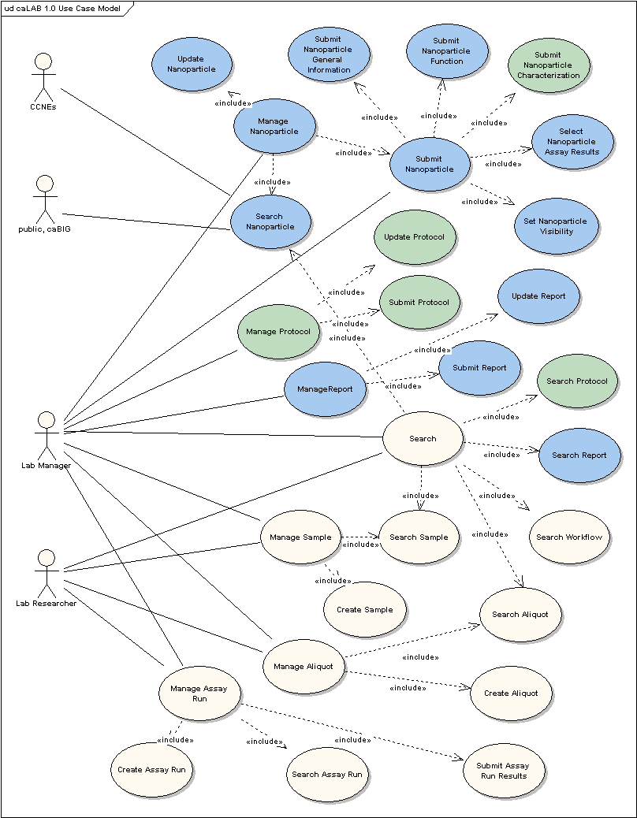

Figure 3 High-Level Use Case Diagram

Submit Nanoparticle Characterization
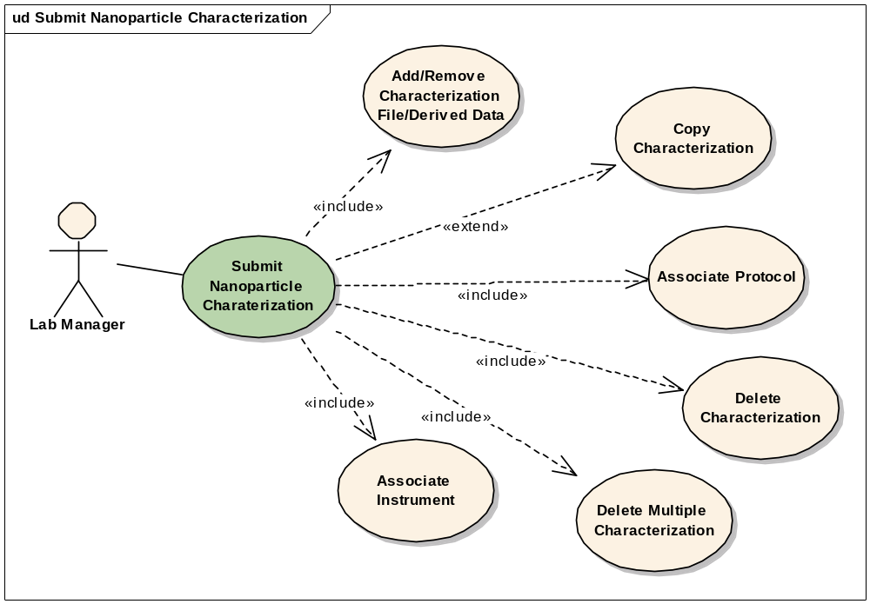
Figure 3-1 Submit Nanoparticle Characterization Use Case Diagram

Use Case Name | Submit Nanoparticle Characterization
Use Case ID | 2.0
Primary Actor | Authorized User
Brief Description | The Submit Nanoparticle Characterization use case allows users submit any physical, In Vitro, In Vivo characterization data retrieved from the lab experiment,
Trigger | The User desires to submit the characterization data and share with the community.
Pre-conditions | - The User is logged into the System.  - The User has the privilege to submit the particle data.
Flow of Events | - The User selects a particle.  - The User selects the characterization category.  - The User selects a particular characterization.  - A form displays allowing the user to complete entries on a form including the characterization information.  - The User enters and submits the experiment data into the system.
Post Conditions | Success Condition:  The User successfully submits the characterization data into the system.  Error Conditions:  EC1: System Error during Request Submission  EC2: Database Error during Request Submission
Alternative Flow | Alternate Conditions:  None  Error Conditions:  EC1: System Error  - A system error has occurred which prevents the submission of the submission request  EC2: Database Error  - A database error has occurred which prevents the submission of the submission request  - The System displays the error condition and application help contact information
Related Use Cases | Update Nanoparticle
Issues | For 1.2 release, it includes Associate Protocol, Associate Instrument, Delete Characterization, delete multiple Characterizations, Add/Remove Characterization File/Derived Data, Copy Characterization

Associate Protocol

Use Case Name | Associate Protocol
Use Case ID | 1.4.1
Primary Actor | Authorized User
Brief Description | The Associate Protocol use case allows users to associate a protocol with a particular characterization. The submission is a part of characterization submission.
Trigger | The User desires to associate a protocol with a characterization
Pre-conditions | - The User is logged the System  - The User has the privilege to submit the particle data  - Protocol information has already been submitted for the selected characterization category
Flow of Events | - The User selects a particle  - The User selects a characterization category  - The User selects to add a characterization or update an existing characterization  - The characterization form displays, allowing the user to complete entries on a form including a summary information section  - The System displays a drop-down list of protocol name-versions pre-loaded for the characterization category  - The User selects a protocol name-version from the drop-down list  - The User submits the characterization form  - The System associates the characterization with the selected protocol
Post Conditions | Success Condition:  The User successfully submits the association between the selected protocol and characterization. The System successfully associates the characterization with the protocol  Error Conditions:  EC1: System Error during Request Submission  EC2: Database Error during Request Submission
Alternative Flow | Alternate Conditions:  None  Error Conditions:  EC1: System Error  - A system error has occurred which prevents processing of the submission request  - The User contacts application help support  EC2: Database Error  - A database error has occurred which prevents processing of the submission request  - The System displays the error condition and application help contact information
Related Use Cases | Submit Nanoparticle Characterization
Issues/Notes | Note: If protocols have not been previously submitted for the characterization category during protocol submission, the user will not be able to select an existing protocol to associate.

Associate Instrument

Use Case Name | Associate Instrument
Use Case ID | 1.4.2
Primary Actor | Authorized User
Brief Description | The Associate Instrument use case allows users to create a new instrument configuration including instrument information and manufacturer information, and associate an instrument configuration with a particular characterization. The submission is a part of characterization submission.
Trigger | The User desires to submit instrument information and associate an instrument with a characterization
Pre-conditions | - The User is logged the System  - The User has the privilege to submit the particle data  - The System has loaded pre-defined instrument types, instrument type abbreviations and their associated manufacturers
Flow of Events | - The User selects a particle  - The User selects a characterization category  - The User selects to add a characterization or update an existing characterization  - The characterization form displays, allowing the user to complete entries on a form including a instrument information section  - The System displays an editable drop-down list of instrument types.  - User selects an existing instrument type or types in a new instrument type  - The System dynamically displays the instrument type abbreviation associated with the selected instrument type  - The System dynamically displays a drop-down list of manufacturers associated with the selected instrument type  - The User selects an existing manufacturer from the list or types in a new manufacturer  - The User enters a description about the instrument configuration  - The User submits the characterization form  - The System creates the instrument configuration and associates it with the characterization
Post Conditions | Success Condition:  The User successfully submits instrument configuration and the association between the selected instrument and the characterization. The System successfully saves the instrument configuration and associates the characterization with the instrument configuration  Error Conditions:  EC1: System Error during Request Submission  EC2: Database Error during Request Submission
Alternative Flow | Alternate Conditions:  None  Error Conditions:  EC1: System Error  - A system error has occurred which prevents processing of the submission request  - The User contacts application help support  EC2: Database Error  - A database error has occurred which prevents processing of the submission request  - The System displays the error condition and application help contact information
Related Use Cases | Submit Nanoparticle Characterization
Issues/Notes

Delete Characterization

Use Case Name | Delete Characterization
Use Case ID
Primary Actor | Authorized Users -- who belongs to both PI and Administrator group
Brief Description | The Delete Characterization use case allows authorized users to delete individual characterization in the system
Trigger | The user desires to delete the existing characterization
Pre-conditions | - The user is logged into the system and has the privilege to delete characterization
Flow of Events | - The User selects an existing characterization  - User click the “Delete” button  - User will be prompted to confirm the deletion.  - User confirms the delete.  - Upon successful deletion of the characterization, user comes to the conclusion page for messages.
Post Conditions | Success Condition: The user successfully deletes characterization, and database successfully removes the data.  Error Conditions:  EC1: System Error during Request Submission  EC2: Database Error during Retrieval or save
Alternative Flow | Alternate Conditions:  Error Conditions:  EC1: System Error  - A system error has occurred which prevents processing of all related request  - The User contacts application help support  EC2: Database Error  - A database error has occurred which prevents processing of the deletion  - The System displays the error condition and application help contact information
Related Use Cases | Delete multiple characterizations
Issues/Notes | Deleted characterization data should be archived into history tables.

Delete Multiple Characterization

Use Case Name | Delete multiple characterizations
Use Case ID
Primary Actor | Authorized Users -- who belongs to both PI and Administrator group
Brief Description | The Delete multiple characterizations use case allows authorized users to select and delete multiple characterizations of one particle
Trigger | The user desires to delete multiple characterizations
Pre-conditions | - The user is logged into the system and has the privilege to delete characterization
Flow of Events | - The user selects one particle’s characterization information  - User clicks on the “Delete” link on the side menu  - User will be directed to a page that contains a list of the characterizations name with a check box in front of it.  - User selects the unwanted characterization  - User clicks the “Delete” button on the page  - User will be prompted to confirm the deletion  - User may cancel the deletion and back to the characterization page or confirm the delete.  - Upon successful deletion of the characterization, user comes to the conclusion page for messages.
Post Conditions | Success Condition: The user successfully deletes unwanted characterization  Error Conditions:  EC1: System Error during Request Submission  EC2: Database Error during data deletion  EC3: The Characterization has been deleted by other user.
Alternative Flow | Alternate Conditions:  - The “Delete” button won’t show up if the characterization has not been persisted.  - User cancels the deletion process  Error Conditions:  EC1: System Error  - A system error has occurred which prevents processing of all related request  - The User contacts application help support  EC2: Database Error  - A database error has occurred which prevents processing of the submission request  - The System displays the error condition and application help contact information  EC3: Database Error  - A database error has occurred which prevents processing of the deletion request  - The System displays the specific error.
Related Use Cases | Delete Characterization
Issues/Notes | All deleted characterization should be archived into history tables.

Copy Characterization

Use Case Name | Copy Characterization
Use Case ID | 1.4.3
Primary Actor | Authorized User
Brief Description | The Copy Characterization use case allows users to copy characterization and associated characterization files and data from one particle to another from the same source
Trigger | The User desires to reduce data entry time by copying characterization from one particle to another.
Pre-conditions | - The User is logged into the System  - The User has the privilege to submit the characterization data  - The Systems loads all other particles from the same source
Flow of Events | - The User selects a particle  - The User selects a characterization category  - The User selects to add a characterization or update an existing characterization  - The characterization form displays, allowing the user to complete entries on a form including a copy section  - The System displays a list all other particle IDs from the same source as the selected particle.  - The User selects one or more particle IDs from the list to copy the particle characterization to and optionally selects whether to also copy the associated derived data.  - The User submits the characterization form  - The System creates copies of the characterization information (summary, instrument, characterization file, optionally data) and associates them to the selected particle IDs with auto-generated view-titles
Post Conditions | Success Condition:  The User successfully submits the copy information. The System successfully associates the copied-characterization with selected particles. The System displays a view title for the auto-copied characterization in a different color when the User selects a particle with copied characterization. The System displays the copied characterization form when the User selects to view/update the copied characterization  Error Conditions:  EC1: System Error during Request Submission  EC2: Database Error during Request Submission
Alternative Flow | Alternate Conditions:  None  Error Conditions:  EC1: System Error  - A system error has occurred which prevents processing of the submission request  - The User contacts application help support  EC2: Database Error  - A database error has occurred which prevents processing of the submission request  - The System displays the error condition and application help contact information
Related Use Cases | Submit Nanoparticle Assay Results, Add Characterization File and Derived Data, Remove Characterization File and Derived Data.
Issues/Notes

Add Characterization File and Derived Data

Use Case Name | Add Characterization File and Derived Data
Use Case ID | 1.4.4
Primary Actor | Authorized User
Brief Description | The Add Characterization File and Derived Data use case allows users to upload one or more characterization files, enter high-level derived data, and associate them to a characterization.
Trigger | The User desires to associate characterization files and high-level derived data to a characterization.
Pre-conditions | - The User is logged into the System  - The User has the privilege to submit the characterization data  - The Systems has loaded pre-defined file types, data categories, derived data names, statistics types and value units.
Flow of Events | - The User selects a particle  - The User selects a characterization category  - The User selects to add a characterization or update an existing characterization  - The characterization form displays, allowing the user to complete entries on a form including a characterization file section. All fields in the characterization file section are optional  - The User clicks on “Add File” link  - The System displays a box containing an editable drop-down list for file types, an editable multi-select for data categories and a “Load File” button  - The User selects a file type from the list and selects one or more data categories from the list.  - The User clicks on “Load File” button.  - The System goes through the Submit Nanoparticle Assay Results use case.  - The System displays an URL for the uploaded file.  - The User clicks on “Add Derived Data” link  - The System displays a box containing a row of an editable drop-down list for derived data name, an editable drop-down list for statistics type, an input field for data value, an editable drop-down list for value unit, and a drop-down list for data category associated with the data name. The System pre-populates the data category drop-down list with user-selected file data categories.  - The User selects/enters a derived data name, a statistics type, enters a value for selects/enters a value unit and selects a data category.  - The User repeats step 5 through step 13 to add additional files and derived data.  - The User submits the characterization form  - The System creates the characterization file and data information and associates them to the selected characterization
Post Conditions | Success Condition:  The System successfully saves the characterization file and data to the database, successfully saves the file to the file system, and successfully associates characterization files and data to the selected characterization and particle.  Error Conditions:  EC1: System Error during Request Submission  EC2: Database Error during Request Submission
Alternative Flow | Alternate Conditions:  None  Error Conditions:  EC1: System Error  - A system error has occurred which prevents processing of the submission request  - The User contacts application help support  EC2: Database Error  - A database error has occurred which prevents processing of the submission request  - The System displays the error condition and application help contact information
Related Use Cases | Submit Nanoparticle Assay Results
Issues/Notes

Remove Characterization File and Derived Data

Use Case Name | Remove Characterization File and Derived Data
Use Case ID | 1.4.4
Primary Actor | Authorized User
Brief Description | The Remove Characterization File and Derived Data use case allows users to remove one or more previously loaded characterization files and previously entered derived data associated with a characterization.
Trigger | The User desires to disassociate and remove characterization files and high-level derived data from a characterization.
Pre-conditions | - The User is logged into the System  - The User has the privilege to submit the characterization data  - The User has previously uploaded characterization files and/or entered derived data for the selected characterization
Flow of Events | - The User selects a particle  - The User selects a characterization category  - The User selects to add a characterization or update an existing characterization  - The characterization form displays, allowing the user to complete entries on a form including a characterization file section. All fields in the characterization file section are optional  - For each previously loaded characterization file, the System displays a box containing an editable drop-down list for file types, an editable multi-select for data categories and a “Load File” button  - The User clicks on the red cross on the upper right corner of the box  - The System updates the form and removes the characterization file and associated data from the display  - For previously entered derived data, the System displays a box containing rows of data name, statistics type, value, unit and data category.  - The User clicks on “Remove” link  - The System updates the form and removes the data row from the display  - The User repeats step 5 through step 10 to remove additional files and derived data.  - The User submits the characterization form  - The System commits the removing of characterization file and data and disassociates them from the selected characterization
Post Conditions | Success Condition:  The System successfully removes the characterization file and data to the database, and successfully disassociates characterization files and data from the selected characterization and particle.  Error Conditions:  EC1: System Error during Request Submission  EC2: Database Error during Request Submission
Alternative Flow | Alternate Conditions:  None  Error Conditions:  EC1: System Error  - A system error has occurred which prevents processing of the submission request  - The User contacts application help support  EC2: Database Error  - A database error has occurred which prevents processing of the submission request  - The System displays the error condition and application help contact information
Related Use Cases | Submit Nanoparticle Assay Results
Issues/Notes

Protocol Management
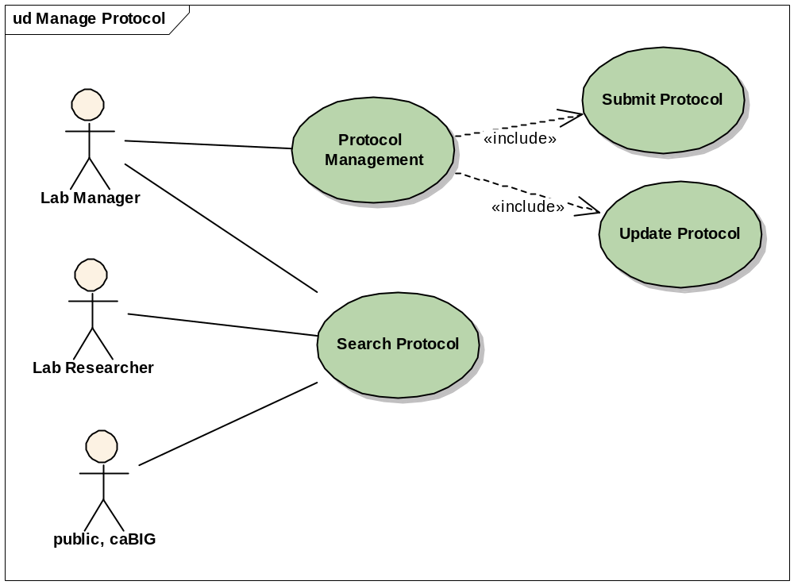
Figure 3-2 Manage Protocol Use Case Diagram

Submit Protocol

Use Case Name | Submit Protocol
Use Case ID | 4.0
Primary Actor | Authorized User
Brief Description | The Manage Protocol use case allows authorized users to manage laboratory protocols used in nanoparticle characterizations.
Trigger | The user desires to manage his/her laboratory protocols
Pre-conditions | - The user is logged into the system and has the privilege to submit/update /search protocols
Flow of Events | - The User selects to submit protocol option under submit part of the menu  - User must enter or select a protocol type from the protocol type dropdown box.  - User must enter or select an existing protocol name if the protocol type selected has protocols created from the protocol name dropdown box.  - User must enter or select an existing version string from the version dropdown box.  - If user selects an existing version string, then the rest of the fields will be populated using data retrieved from the database for the selected protocol.  - If user enters a new version string, then user may enter optional data for the rest of the fields.  - Any data entered will be saved into the database upon clicking Submit button. If the protocol already exists, any changes will be saved to replace existing data.  - If an existing protocol is selected, and it has an associated file, the file name will be displayed next to Protocol File label but before the file browser.  - User may click the file name to download it.  - User may select another file to replace the existing one.  - Upon successful submission of the protocol, user comes to the conclusion page for two messages.
Post Conditions | Success Condition: The user successfully submits protocols, and database successfully persists the data.  Error Conditions:  EC1: System Error during Request Submission  EC2: Database Error during Retrieval or save  EC3: Missing any of required fields: protocol type, protocol name, and protocol version.
Alternative Flow | Alternate Conditions:  - None  Error Conditions:  EC1: System Error  - A system error has occurred which prevents processing of all related request  - The User contacts application help support  EC2: Database Error  - A database error has occurred which prevents processing of the submission, update, or search request  - The System displays the error condition and application help contact information  EC3: Missing Data Error  - Upon submission of data, any missing data will be listed on top of the page and user is given opportunity to provide these data again.
Related Use Cases | Submit protocol
Issues/Notes | - From step 5 in Flow of Events, if optional fields are populated with existing data, or new data, or modified data, any change in protocol type, protocol name, or version will clear these fields, and user must re-enter them even he/she returns to the same protocol/type/name/version.  - In essence, this submit page does two things, one to create a new protocol and one to edit and update an existing protocol.  - Protocols with same type and same name are treated as different protocols if their versions are different.  - The Reset button will restart the page as you start it from the Submit menu.

Search Protocol

Use Case Name | Search Protocol
Use Case ID | 4.1
Primary Actor | Authorized User
Brief Description | The Search Protocol use case allows authorized users to submit a new laboratory protocol used in nanoparticle characterizations.
Trigger | The user desires to search existing protocol
Pre-conditions | - The user is logged into the system and has the privilege to search protocol
Flow of Events | - The user selects the search option under Search part of the menu  - User enters search criteria by selecting a protocol type, typing in a protocol name, or protocol file title. Or leave every field blank.  - The user clicks the submit button to start search.  - If entered criteria do not find any protocols, a message will be displayed on top of the page.  - A list of found protocols is listed in the next page.  - The protocol name is displayed as a link.
Post Conditions | Success Condition: The user successfully searches the database with optional successful update of the protocols.  Error Conditions:  EC1: System Error during Request Submission  EC2: Database Error during data Storage
Alternative Flow | Alternate Conditions:  - The user cancels the submission process  Error Conditions:  EC1: System Error  - A system error has occurred which prevents processing of all related request  - The User contacts application help support  EC2: Database Error  - A database error has occurred which prevents processing of the submission request  - The System displays the error condition and application help contact information
Related Use Cases | Update Protocol
Issues/Notes | - User can do a wild card search by appending a star(*) to the end of the search string. The file title field is case insensitive, while the name field is.  - The protocol’s type, name and version are unchangeable.  - For user without editing privilege, the protocol detail page is plain text.

Update Protocol

Use Case Name | Update Protocol
Use Case ID | 4.1
Primary Actor | Authorized User
Brief Description | The Update Protocol use case allows authorized users to submit a new laboratory protocol used in nanoparticle characterizations.
Trigger | The user desires to update his/her laboratory protocol
Pre-conditions | - The user is logged into the system and has the privilege to search/update protocol
Flow of Events | - The user selects the search option under Search part of the menu  - User enters search criteria by selecting a protocol type, typing in a protocol name, or protocol file title. Or leave every field blank.  - The user clicks the submit button to start search.  - If entered criteria do not find any protocols, a message will be displayed on top of the page.  - A list of found protocols is listed in the next page.  - The protocol name is displayed as a link.  - Click of protocol name link leads to the protocol detail page, with an option to edit the protocol: file title, visibility, and description.  - The existing file name is displayed as a link for download if the protocol has an associated file.  - Any changes made to these three fields will be saved into the database when the submit button is pressed.  - The update is concluded in the message page.
Post Conditions | Success Condition: The user successfully searches the database with optional successful update of the protocols.  Error Conditions:  EC1: System Error during Request Submission  EC2: Database Error during data Storage
Alternative Flow | Alternate Conditions:  - The user cancels the submission process  Error Conditions:  EC1: System Error  - A system error has occurred which prevents processing of all related request  - The User contacts application help support  EC2: Database Error  - A database error has occurred which prevents processing of the submission request  - The System displays the error condition and application help contact information
Related Use Cases | Search Protocol
Issues/Notes | - User can do a wild card search by appending a star(*) to the end of the search string. The file title field is case insensitive, while the name field is.  - The protocol’s type, name and version are unchangeable.  - For user without editing privilege, the protocol detail page is plain text.

Search Characterization Summary

Use Case Name | Search Characterization Summary
Use Case ID
Primary Actor | Authorized Users
Brief Description | The Search Characterization Summary use case extends the “Search Nanoparticle” use case
Trigger | The user desires to search particle based on characterization description or characterization file/derived data description
Pre-conditions | - The user is logged into the system and has the privilege to search nanoparticle
Flow of Events | - The User selects “Search Nanoparticle”  - User enter search criteria for “summary/description”
Post Conditions | Success Condition: The User successfully retrieves the search results  Alternate Condition:  AC1: User does not select search criteria  AC2: No result is found  Error Conditions:  EC1: System Error during Request Submission or Retrieval  EC2: Database Error during Retrieval
Alternative Flow | Alternate Condition:  AC1: User does not select search criteria  1. The System displays a list of “all” particles visible to the User  AC2: No result is found  1. A “No results found” message is displayed  Error Conditions:  EC1: System Error  - A system error has occurred which prevents processing of the submission request  - The User contacts application help support  EC2: Database Error  - A database error has occurred which prevents processing of the search request  - The System displays the error condition and application help contact information
Related Use Cases | Search Nanoparticle
Issues/Notes

Overall Requirements
The table below identifies the requirements for the caNanoLab 1.2 effort.

Prior-ity | Req # | Requirement | Use Case Name |  | Release #
 | 1.0 | The system shall allow users to create protocol and associate protocol to characterization
 | 1.1 | The system shall allow Users to create protocol and upload protocol file. |  |  | 1.2
 | 1.1.1 | The system shall allow Users to search existing protocols |  |  | 1.2
 | 1.2 | The system shall allow users to associate existing protocol to characterization. |  |  | 1.2
 | 2.0 | The system shall allow users to associate characterization and characterization file to multiple particles.
 | 2.1 | The system shall allow user to copy characterization, characterization file and derived data to multiple particles. |  |  | 1.2
 | 3.0 | The system shall allow users to associate Instrument
 | 3.1 | The system shall allow user to associate instrument configuration to characterization |  |  | 1.2
 | 4.0 | The system shall allow users to search on characterization description or characterization file description
 | 4.1 | The system shall allow user to copy characterization, characterization file and derived data to multiple particles. |  |  | 1.2
 | 5.0 | The system shall allow users to search on characterization description or characterization file description
 | 5.1 | The system shall allow user to search particles based on either characterization description or assay result description |  |  | 1.2
 | 6.0 | The system shall be engineered for caBIG compatibility
 | 3.1 | The system shall leverage the caCORE SDK and associated components |  |  | 1.2
 | 3.2 | Concepts for supported objects/attributes shall be registered in the EVS |  |  | 1.2
 | 3.3 | The object model shall be loaded into the caDSR |  |  | 1.2
 |  | The system shall support additional CDE refinement |  |  | 1.2

Data Definitions

Concepts
The sections below detail the caLAB 1.2 required concepts. Definitions are maintained in the NCI’s Enterprise Vocabulary Services (EVS).

Object | Attribute | Data Type | Valid Values | Concept ID | EVS Definition
InVivoCharacterization |  | Object |  | Bioassay_in_vivo Code: C18641 | DEFINITION: The appraisal of the biological properties or activities of a substance by testing its effect on an organism.
Pharmacokinetics |  | Object |  | PK Needs to be added as a FULL_SYN Pharmacokinetics Code: C15299 | DEFINITION: The characteristic movements of drugs within biological systems, as affected by absorption, distribution, binding, elimination, biotransformation, and excretion; particularly the rates of such movements.
PharmacokineticsParameter (If this object is necessary call it PharmacokineticsFinding) |  | Object |  | Pharmacokinetics Code: C15299 Finding Code: C61036 | Pharmacokinetics DEFINITION: The characteristic movements of drugs within biological systems, as affected by absorption, distribution, binding, elimination, biotransformation, and excretion; particularly the rates of such movements.  Finding DEFINITION: The result of an examination or inquiry.
 | AUC | Measurement |  | FULL_SYN Area_under_Curve Code: C64774 | DEFINITION: The area between the x-axis and the curve given by the integrand. It is equal to the definite integral of a function. In the field of pharmacokinetics, the area under the curve (AUC) is the area under the curve in a plot of concentration of a drug in plasma against time. AUC is usually given for the time interval zero to infinity, and other time intervals are indicated.
 | bioavailability | Measurement |  | New concept Bioavailability | PROPOSED DEFINITION: The fraction of an administered dose of a drug or compound that is available at the site of action.
 | clearance | Measurement |  | New concept Biological_Clearance_Rate | PROPOSED DEFINITION: The rate at which an exogenous substance is removed or cleared from the body.
 | blood clearance metadata |  |  | Blood Code: C12434 Biological_Clearance_Rate Code: TBD (see above)
 | halfLife | Measurement |  | New concept Biological_Half_Life | PROPOSED DEFINITION: The time required for half of a substance to be removed from the whole or a part of an organism by either a physical or a chemical process.
 | volume of distribution | Measurement |  | New concept Distribution_Volume | PROPOSED DEFINITION: The apparent volume occupied by an exogenous compound after it is administered to an organism. This value assumes that the compound is uniformly distributed in the body of the organism at the concentration found in its plasma or another tissue.
 | Cmax | Measurement |  | New concept Cmax | PROPOSED DEFINITION: This is a measurement that quantifies the maximum concentration of an experimental substance or drug in the blood or a target organ after dose administration.
 | Tmax | Measurement |  | New concept Tmax | PROPOSED DEFINITION: The time it takes to reach the maximum concentration (Cmax) of an exogenous compound or drug in an organ or tissue after a dose is administered.
 | description | String |  | Code: C25365 | DEFINITION: A written or verbal account, representation, statement, or explanation of something.
ToxicologyFinding |  | Object |  | New concept Toxicology_Finding | PROPOSED DEFINITION: A quantitative analysis of the toxicity of a chemical compound.
Tissue |  |  |  | Code: C12801 | DEFINITION: An anatomical structure consisting of similarly specialized cells and intercellular matrix, aggregated according to genetically determined spatial relationships, performing a specific function.
 | id | Long |  | Identifier Code: C25364 | DEFINITION: One or more characters used to identify, name, or characterize the nature, properties, or contents of a thing.
 | name | String |  | Name_Generic_Concept Code: C42614 | DEFINITION: The words or language units by which a thing is known.
ADMEFinding |  | Object |  | New concept ADME_Finding | PROPOSED DEFINITION: The result of the investigation of the absorption, distribution, metabolism, and excretion (ADME) of an experimental substance by an organism.
 | dataAnalysisMethod | String
 | doseGroupComponentName | String
ClinicalChemistryFinding |  | Object |  | New concept Clinical_Chemistry_Finding | PROPOSED DEFINITION: The results of any chemical or enzymatic analyses of body fluids and tissues of an organism.
 | doseGroupComponentName | String
HematologyFinding |  | Object |  | Hematology Code: C16673 Finding Code: C61036 | Hematology DEFINITION: The branch of medicine that deals with the blood and blood-forming organs and the diseases thereof. Finding DEFINITION: The result of an examination or inquiry.
 | doseGroupComponentName | String
PathologyFinding |  | Object |  | Pathology_Report Code: C28277 | Pathology_Report DEFINITION: A report that provides a description of the gross and microscopic examination of the specimen and is used to make a diagnosis and to determine treatment. It defines which structures and organs of the body are involved by the tumor, verifies the primary site of the cancer and describes the extent to which it has spread.
 | doseGroupComponentName | String
Lesion |  | Object |  | New concept Lesion_Generic | PROPOSED DEFINITION: Any observable abnormal structural change in a bodily part.
 | color | String |  | Code: C37927 | DEFINITION: The appearance of objects (or light sources) described in terms of a person's perception of their hue and lightness (or brightness) and saturation.
 | description |  |  | Code: C25365 | DEFINITION: A written or verbal account, representation, statement, or explanation of something.
 | grade Histopathologic_Grade? |  |  | Histopathologic_Grade Code: C18000 | DEFINITION: The degree of abnormality of cancer cells, a measure of differentiation, the extent to which cancer cells are similar in appearance and function to healthy cells of the same tissue type. The degree of differentiation often relates to the clinical behavior of the particular tumor. Based on the microscopic findings, tumor grade is commonly described by one of four degrees of severity. Histopathologic grade of a tumor may be used to plan treatment and estimate the future course, outcome, and overall prognosis of disease. Certain types of cancers, such as soft tissue sarcoma, primary brain tumors, lymphomas, and breast have special grading systems.
 | id (identifier) |  |  | Identifier Code: C25364 | DEFINITION: One or more characters used to identify, name, or characterize the nature, properties, or contents of a thing.
 | size | String |  | Code: C25681 | DEFINITION: The physical magnitude of something.
 | type |  |  | Code: C25284 | DEFINITION: Something distinguishable as an identifiable class based on common qualities.
HistopathologyFinding metadata |  | Object |  | Histopathology Code: C18190 Finding Code: C61036 | Histopathology DEFINITION: The microscopic study of characteristic tissue abnormalities by employing various cytochemical and immunocytochemical stains. Finding DEFINITION: The result of an examination or inquiry.
GrossPathologyFinding metadata |  | Object |  | Gross Code: C43566 Pathology_Report Code: C18189 | Gross DEFINITION: Visible to the naked eye. Pathology_Report DEFINITION: A report that provides a description of the gross and microscopic examination of the specimen and is used to make a diagnosis and to determine treatment. It defines which structures and organs of the body are involved by the tumor, verifies the primary site of the cancer and describes the extent to which it has spread.
ClinicalObservation metadata |  |  |  | Clinical Code: C25398 Observation Code: C25598 | Clinical DEFINITION: Relating to the examination and treatment of patients dependent on direct observation. The term may also refer to the institution (clinic) providing this activity. Observation DEFINITION: Watching something and taking note of what happens.
 | description |  |  | Code: C25365 | DEFINITION: A written or verbal account, representation, statement, or explanation of something.
HematologyFinding |  | Object |  | Hematology Code: C16673 Finding Code: C61036 | Hematology DEFINITION: The branch of medicine that deals with the blood and blood-forming organs and the diseases thereof. Finding DEFINITION: The result of an examination or inquiry.
 | doseGroupComponentName | String
 | administrativeRoute | String |  | Drug_Route_of_Administration Code: C38114 | DEFINITION: A part of the body through or into which, or the way in which, the medicinal product is intended to be introduced. In some cases a medicinal product can be intended for more than one route and/or method of administration.
 | ageAtTreatment metadata | String |  | Age Code: C25150 Treatment FULL_SYN Therapeutic_Procedure Code: C49236 | Age DEFINITION: How long something has existed; elapsed time since birth. Therapeutic_Procedure DEFINITION: An action or administration of therapeutic agents to produce an effect that is intended to alter the course of a pathologic process.
 | description | String |  | Code: C25365 | DEFINITION: A written or verbal account, representation, statement, or explanation of something.
 | id | Long |  | Identifier Code: C25364 | DEFINITION: One or more characters used to identify, name, or characterize the nature, properties, or contents of a thing.
 | regimen | String |  | Treatment_Regimen Code: C15697 | DEFINITION: A treatment plan that specifies the dosage, the schedule, and the duration of treatment.
 | surgeryType metadata | String |  | Surgery Code: C17173 Type Code: C25284 | Surgery DEFINITION: The branch of medical science that treats disease or injury by operative procedures. Type DEFINITION: Something distinguishable as an identifiable class based on common qualities.
DoseGroup Metadata |  | Object |  | Dose Code: C25488 Group Code: C43359 | Dose DEFINITION: A quantity of an agent (such as substance or energy) administered, taken, or absorbed at one time. Group DEFINITION: Any number of entities (members) considered as a unit.
 | description | String |  | Code: C25365 | DEFINITION: A written or verbal account, representation, statement, or explanation of something.
 | gender | String |  | Sex Code: C28421 | DEFINITION: The assemblage of physical properties or qualities by which male is distinguished from female; the physical difference between male and female; the distinguishing peculiarity of male or female.
 | id | Long |  | Identifier Code: C25364 | DEFINITION: One or more characters used to identify, name, or characterize the nature, properties, or contents of a thing.
 | name | String |  | Name_Generic_Concept Code: C42614 | DEFINITION: The words or language units by which a thing is known.
 | numberOfAnimals metadata | Integer |  | Number Code: C25337 Animal Code: C14182 | Number DEFINITION: A numeral or string of numerals expressing value, quantity, or identification. Animal DEFINITION: A living organism that has membranous cell walls, requires oxygen and organic foods, and is capable of voluntary movement, as distinguished from a plant or mineral.
 | particleName metadata | String |  | Nanoparticle Code: C62308 Identifier Code: C25364 | Nanoparticle DEFINITION: A small, stable particle whose size is measured in nanometers. These particles are used in various biomedical applications in which they can be utilized as drug carriers or imaging agents. Various targeting agents, such as antibodies, drugs, imaging agents, and reporters can be attached to the surface of a nanoparticle. Identifier DEFINITION: One or more characters used to identify, name, or characterize the nature, properties, or contents of a thing.
DoseGroupComponent Metadata |  | Object
 | description | String |  | Code: C25365 | DEFINITION: A written or verbal account, representation, statement, or explanation of something.
 | dose | Measurement |  | Code: C25488 | DEFINITION: A quantity of an agent (such as substance or energy) administered, taken, or absorbed at one time.
 | dosingVolume | Measurement |  | New concept Dosing_Volume | PROPOSED DEFINITION: The volume of liquid administered to an organism that contains a known amount (dose) of an exogenous compound or drug.
 | id (identifier) | Long |  | Code: C25681 | DEFINITION: The physical magnitude of something.
 | name | String |  | Name_Generic_Concept Code: C42614 | DEFINITION: The words or language units by which a thing is known.
Diagnostic Efficacy |  |  |  | New concept Diagnostic Efficacy | PROPOSED DEFINITION: The ability of a detection reagent or method to be used as a diagnostic or experimental marker.
Therapeutic Efficacy |  |  |  | New concept Therapeutic Efficacy | PROPOSED DEFINITION: The ability of a drug or chemical agent to treat a disease.
Imaging | type Can you combine Object and Attribute into ImagingTechnique? | String |  | Imaging_Technique Code: C17369 | DEFINITION: Any technology or method which helps in visualization of any biological process, cell, tissue or organ for the screening, diagnosis, surgical procedure or therapy.
AnimalModel |  | Object |  | New concept Animal_Model_Generic | PROPOSED DEFINITION: An animal that is amenable to experimentation and whose physiological or pathologic mechanisms are sufficiently similar to those of a human for the animal to serve as a model.
 | age | Measurement |  | Code: C25150 | DEFINITION: How long something has existed; elapsed time since birth.
 | bodyWeight metadata | Measurement |  | Body Code: C13041 Weight Code: C25208 | Body DEFINITION: The entire physical structure of an organism. It is composed of anatomic systems, regions, cavities, and spaces. Weight DEFINITION: The vertical force exerted by a mass as a result of gravity.
 | description | String |  | Code: C25365 | DEFINITION: A written or verbal account, representation, statement, or explanation of something.
 | gender | String |  | Sex Code: C28421 | DEFINITION: The assemblage of physical properties or qualities by which male is distinguished from female; the physical difference between male and female; the distinguishing peculiarity of male or female.
 | id | Long |  | Identifier Code: C25364 | DEFINITION: One or more characters used to identify, name, or characterize the nature, properties, or contents of a thing.
 | strain | String |  | FULL_SYN Organism_Strains Code: C14419 | Organism_Strains DEFINITION: A population or type of organisms that is genetically different from others of the same species and possessing a set of defined characteristics.
 | camodid (identifier) |  |  | Cancer_Models_Database Code: C43619 Identifier Code: C25364 | Cancer_Models_Database DEFINITION: The cancer Models Database (caMOD) allows researchers to retrieve and submit animal models of cancer. caMOD currently supports the Mouse Models of Human Cancer Consortium (MMHCC). Identifier DEFINITION: One or more characters used to identify, name, or characterize the nature, properties, or contents of a thing.
Animal |  | Object |  | Code: C14182 | DEFINITION: A living organism that has membranous cell walls, requires oxygen and organic foods, and is capable of voluntary movement, as distinguished from a plant or mineral.
 | id Identifier? Yes | Long |  | Identifier Code: C25364 | DEFINITION: One or more characters used to identify, name, or characterize the nature, properties, or contents of a thing.
InVivoFinding metadata |  | Object |  | in vivo Code: 15744 Finding Code: C61036 | in vivo DEFINITION: Located or occurring in the body; the opposite of in vitro (located or occurring outside the body). Finding DEFINITION: The result of an examination or inquiry.
 | isIndividualAnimal | Boolean
DerivedBioAssayData |  | Object |  |  | There should be a definition for this as it is a data element in the MAGE standard
 | category | String |  | Code: C25372 | DEFINITION: This term is used informally to mean a class of things.
 | id (identifier) | Long |  | Identifier Code: C25364 | DEFINITION: One or more characters used to identify, name, or characterize the nature, properties, or contents of a thing.
DerivedBioAssayData: ClinicalChemistryFinding | type | Electrolyte Balance; Carbohydrate Metabolism; Tissue Function
DerivedBioAssayData: HematologyFinding | type | Red Blood Cells; White Blood Cells; Clotting Potential
DerivedBioAssayData: GrossPathologyFinding | type | Number of Animals with Lesions
DerivedBioAssayData: OrganWeight | type | Absolute Weight; Per Body Weight; Per Brain Weight
DerivedBioAssayData: ADMEFinding | type | % Injected Dose/mL; % Injected Dose/Gram; % Injected Dose/Tissue Type

Sign Off

Approval

NCICB Rep Print Name Date
NCL Rep Print Name Date
NCI OC Rep Print Name Date
SAIC Rep Print Name Date

