Software Requirements Specification

cancer Nanotechnology Laboratory Analysis Workbench (caNanoLab) 1.0

NCICB, NCL

DOCUMENT REVISION HISTORY

Version Number | Date | Description
1.0 | August 14, 2006 | Initial draft containing high-level use cases and nanoparticle metadata
1.1 | August 24, 2006 | Draft Iteration 1 use cases
1.2 | September 28, 2006 | Draft Iteration 2 use cases
1.3 | October 14, 2006 | Draft Iteration 3 use cases
1.4 | November 22, 2006 | Draft Iteration 4 use cases

Background/Summary
The caNanoLab effort is collaboration between the NCICB and the Nanotechnology Characterization Laboratory (NCL) facilitating the development of standards and an informatics platform supporting nanotechnology in medicine. The NCL performs and standardizes the characterization of nanomaterials intended for cancer therapeutics and diagnostics. One of the goals of the collaboration is the establishment of nanoparticle characterization standards in support of data sharing with the Cancer Centers of Nanotechnology Excellence (CCNEs) and caBIG™ participants.

Table of Contents
Requirements Specification 1
cancer Nanotechnology Laboratory Analysis Workbench (caNanoLab) 1.0 1
Background/Summary 1
1 Introduction 4
1.1 Overview 4
1.2 Related Documents 4
2 Actors 6
2.1 Actors 6
3 Use Cases 7
3.1 Manage Nanoparticle 8
3.1.1 Submit Nanoparticle 8
3.1.1.1 Submit Nanoparticle General Information 9
3.1.1.2 Set Nanoparticle Visibility 10
3.1.1.3 Submit Nanoparticle Function 11
3.1.1.4 Submit Nanoparticle Characterization 13
3.1.1.4.1 Add Nanoparticle Physical Characterization 14
3.1.1.4.2 Add Particle Composition 15
3.1.1.4.3 Add Nanoparticle In Vitro Characterization 16
3.1.1.4.4 Associate Assay Results 17
3.1.1.5 Submit Nanoparticle Assay Results 18
3.1.2 Search Nanoparticle 20
3.1.2.1 View Nanoparticle Search Results 21
3.1.2.2 View Nanoparticle Details 22
3.1.3 Update Nanoparticle 23
3.2 Manage Reports 24
3.2.1 Submit Report 24
3.2.2 Update Report Metadata 25
3.2.3 Search Reports 26
3.2.4 View Report Search Results 27
3.2.5 View Report 28
Overall Requirements 29
4 Data Definitions 31
4.1 Concepts 31
4.1.1 Particle Metadata 31
4.1.2 Function Metadata 34
4.1.3 Physical Characterization Metadata 46
4.1.4 In Vitro Characterization Metadata 50
4.1.5 Characterization Metadata 52
5 Sign Off 60
5.1 Approval 60
Appendix A - Particle Composition Detail 61
Appendix B - Function Detail 63

Introduction

Overview
The caNanoLab 1.0 effort expands upon the caLAB .50 release which focused on capturing the workflow in the Nanotechnololgy Characterization Laboratory (NCL) and associated workflow artifacts (result files). caLAB .50 features included:
- Sample Management – Accessioning samples (nanoparticles), creating aliquots, searching samples and aliquots
- Execute Workflow – Creating assay runs, assigning inputs (aliquots) and outputs (result files) to assay runs, searching workflow components for assay results
- File Upload – Uploading assay results
- Basic Security – User authentication via the NCI’s Common Security Module (CSM)
The primary goals of the caNanoLab Release 1.0 effort are to:
- Provide for the efficient storage and retrieval of nanoparticle characterizations to expedite and validate the use of nanotechnology in medicine
- Develop and support an initial standard for representing nanoparticle characterizations to facilitate data sharing in a semantically interoperable fashion in the spirit of caBIG™
- Implement a system that facilitates data sharing in the nanotechnology community in a secure fashion
Release 1.0 features focus on annotating nanoparticles and sharing these annotations with the nanotechnology community in a secure fashion. caNanoLab 1.0 features include:
- Annotate Nanoparticles – Annotating nanoparticles with characterizations, searching and retrieving nanoparticle characterizations; Nanoparticle annotations included general information about a nanoparticle, nanoparticle function, characterizations obtained from physical and in vitro characterizations, and assay result files/reports.
- Advanced Security – User authorization via the CSM, User management via the NCI’s User Provisioning Toolkit (UPT).
The purpose of this document is to identify and details the caNanoLab 1.0 use cases, requirements, and metadata associated with each nanoparticle.

Related Documents

Document Name | Version | Location
caNanoLab 1.0 Scope Document | 1.5 | CVS Server: cbiocvs2; module: caNanoLab; Directory: docs
caNanoLab 1.0 Use Case Specification | 1.0 | CVS Server: cbiocvs2; Module: caNanoLab; Directory: docs
caNanoLab 1.0 Wireframes | 1.0 | CVS Server: cbiocvs2; module: caNanoLab; Directory: docs
caNanoLab 1.0 Security Configuration Document | 1.0 | caNanoLab 1.0 Security Configuration Document
caNanoLab 1.0 Architecture Checklist | 1.0 | NCICB CM team
caNanoLab .50 Use Case Specification | 1.0 | CVS Server: cbiocvs2; module: caNanoLab; Directory: docs
caCORE SDK and CSM | 1.1 | Refer caCORE Technical guide for the design document. ftp://ftp1.nci.nih.gov/pub/cacore/SDK/caCORE_SDK1.0.3_Programmers_Guide.pdf
caBIG Compatibility Guidelines | 2.0 | https://cabig.nci.nih.gov/guidelines_documentation/caBIGCompatGuideRev2_final.pdf

Actors

Actors
The table below describes the core caNanoLab actors applicable to the caNanoLab Release 1.0 use cases as well as the intended authorization. Intended authorizations focus on metadata support use cases only.

Actor | Description | Authorization
NCL  Lab Manager/PI | A Lab Manager/PI can manage all nanoparticle annotations, assay results, reports. | Submit, Access, Retrieve nanoparticle annotations and reports.
NCL  Lab Researcher | A Lab Researcher is responsible for conducting experiments associated with nanoparticle.  A Lab Researcher can search all nanoparticle data. | Access, Retrieve nanoparticle annotations and reports.
NCL Administrator | An NCL Administrator can manage user accounts, groups, roles, protected data elements, and protected data groups.  An NCL Administrator can assign privileges to users/groups. | Submit, Access, Retrieve user accounts, groups, roles, protected data elements, and protected data groups.
Cancer Centers of Nanotechnology Excellence (CCNEs) | The CCNEs can retrieve all authorized nanoparticle annotations and reports. | Access, Retrieve nanoparticle annotations and reports visible to CCNEs.
caBIG/Public | The caBIG/public can retrieve all nanoparticle annotations and reports published to the public. | Access, Retrieve nanoparticle annotations and reports visible to the caBIG/public.

Use Cases
Figure 3-1 provides a high-level diagram of the caNanoLab 1.0 use cases associated with the nanoparticle annotation function. Use cases included in this release are indicated in blue and are further described in the subsequent sections. Use cases indicated in yellow are associated with caLAB .50 and are further described in the caLAB .50 Use Case Specification.
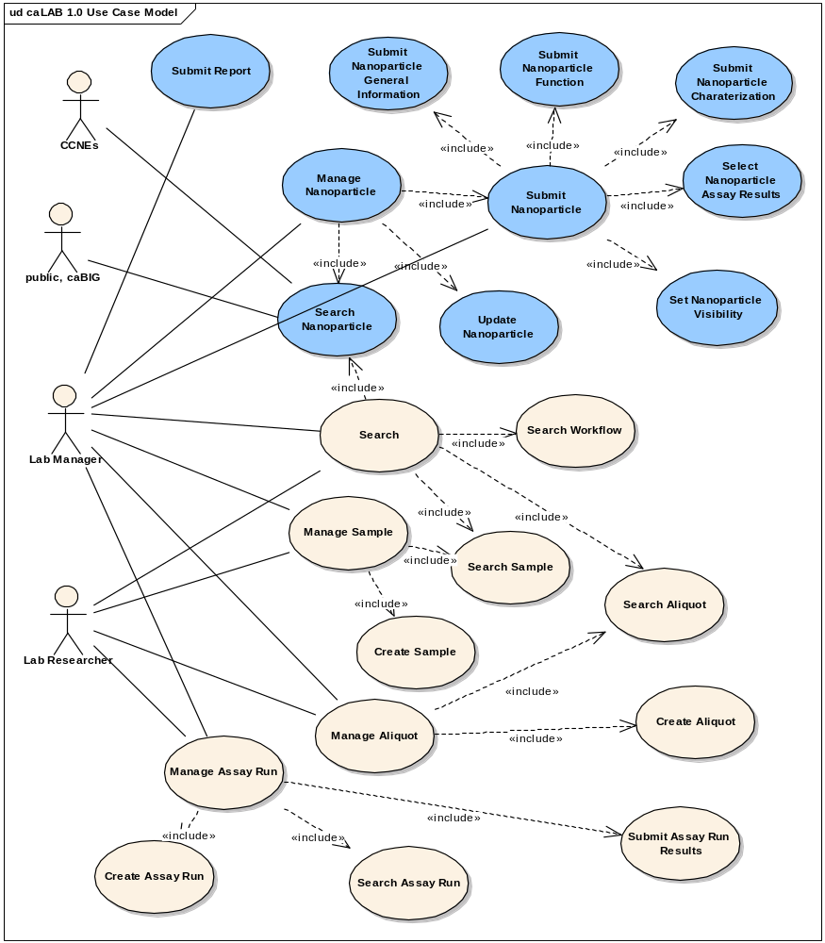
Figure 3-1 High-Level Use Case Diagram

Manage Nanoparticle

Submit Nanoparticle
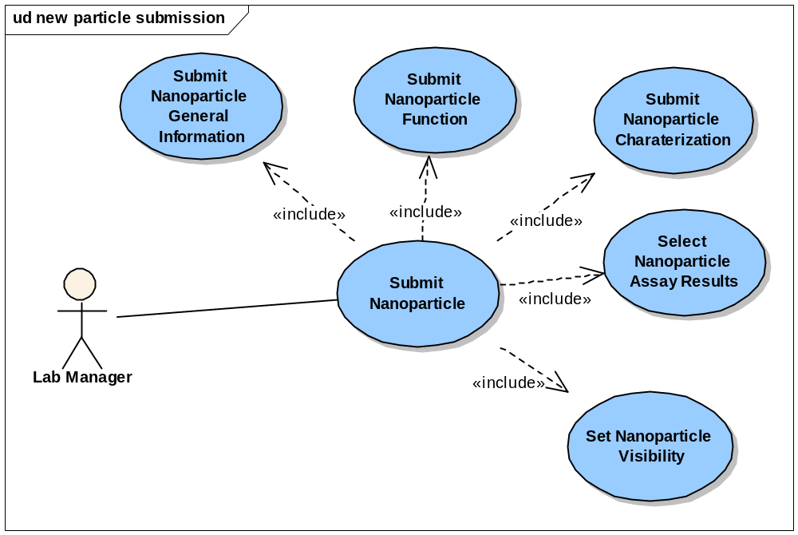
Figure 3-2 Submit Nanoparticle Use Cases

Use Case Name | Submit Nanoparticle
Use Case ID | 1.0
Primary Actor | Authorized User
Brief Description | The Submit Nanoparticle use case allows users to submit general information about the particle, the particle function, nanoparticle characterizations (physical and in vitro) and nanoparticle assay results
Trigger | The User desires to submit nanoparticle annotations for sharing with the appropriate user group and selects submit nanoparticle
Pre-conditions | - The User is logged into the System  - The User chooses to submit nanoparticle annotations  - The sample in which the nanoparticle applies has already been accessioned into the system
Flow of Events | - The User selects to Annotate the nanoparticle  - The User submits general information about the particle including the visibility of the particle  - The User submits particle function  - The User submits nanoparticle characterizations and associated assay results
Post Conditions | Success Condition:  The User successfully submits the particle information into the system  Error Conditions:  EC1: System Error during Request Submission  EC2: Database Error during Request Submission
Alternative Flow | Alternate Conditions:  None  Error Conditions:  EC1: System Error  - A system error has occurred which prevents processing of the submission request  - The User contacts application help support  EC2: Database Error  - A database error has occurred which prevents processing of the submission request  - The System displays the error condition and application help contact information
Related Use Cases | Submit Nanoparticle General Information  Submit Nanoparticle Characterization  Submit Nanoparticle Function  Submit Nanoparticle Assay Result  Submit Nanoparticle Report  Submit Nanoparticle Visibility
Issues | None

Submit Nanoparticle General Information

Use Case Name | Submit Nanoparticle General Information
Use Case ID | 1.1
Primary Actor | Authorized User
Brief Description | The Submit Nanoparticle General Information use case allows users to submit general information about a nanoparticle
Trigger | The User desires to submit general information about a nanoparticle for sharing with the appropriate user group and selects annotate nanoparticle
Pre-conditions | - The User is logged into the System  - The User has the privilege to submit the particle data  - The sample in which the nanoparticle applies has already been accessioned into the system
Flow of Events | - The User selects annotate particle  - The User selects the type of particle, the particle ID, and enters any particle keywords related to this particle  - The User submits the particle general information to the system
Post Conditions | Success Condition:  The User successfully submits the general information data into the system  Error Conditions:  EC1: System Error during Request Submission  EC2: Database Error during Request Submission
Alternative Flow | Error Conditions:  EC1: System Error  - A system error has occurred which prevents the submission of the submission request  - The User contacts application help support  EC2: Database Error  - A database error has occurred which prevents processing of the submission request  - The System displays the error condition and application help contact information
Related Use Cases | Submit Nanoparticle  Set Nanoparticle Visibility
Issues/Notes | None

Set Nanoparticle Visibility
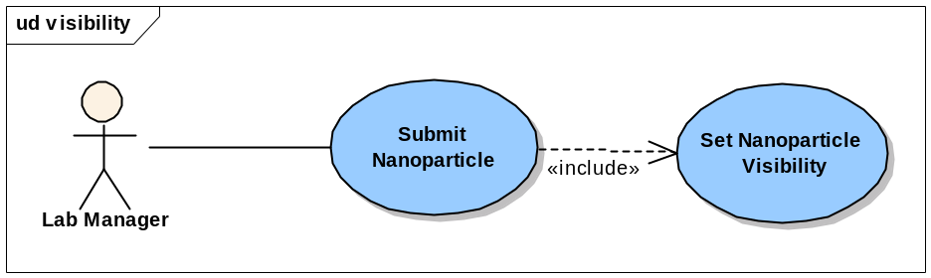
Figure 3-3 Set Nanoparticle Visibility Use Cases

Use Case Name | Set Nanoparticle Visibility
Use Case ID | 1.2
Primary Actor | Authorized User
Brief Description | The Set Nanoparticle Visibility use case allows users to limit the visibility of the submitted nanoparticle annotations to pre-defined User Groups
Trigger | The User desires to submit nanoparticle annotations and assay results for sharing with the appropriate user group and selects submit nanoparticle
Pre-conditions | - The User is logged into the System  - The User chooses to submit the general information of the particle and assay results for the particle  - User groups have been defined in the common security module.
Flow of Events | - The User selects the User Groups that are able to search/view the particle experiment data  - The User submits the particle visibility to the system
Post Conditions | Success Condition:  The User successfully set the visibility of the particle  Error Conditions:  EC1: System Error during Request Submission  EC2: Database Error during Request Submission
Alternative Flow | Alternate Conditions:  AC1: Deselect User Group  - The User de-selects the visibility of a selected User Group  - The de-selected User Group no longer has privileges to view the particle annotations  Alternate Conditions:  AC2: No User Group selected  - The User does not select User Group  - The default User Group (NCL researcher) is automatically assigned visibility  Error Conditions:  EC1: System Error  - A system error has occurred which prevents the submission of the submission request  - The User contacts application help support  EC2: Database Error  - A database error has occurred which prevents processing of the submission request  - The System displays the error condition and application help contact information
Related Use Cases | Submit Nanoparticle General Information
Issues/Notes | None

Submit Nanoparticle Function
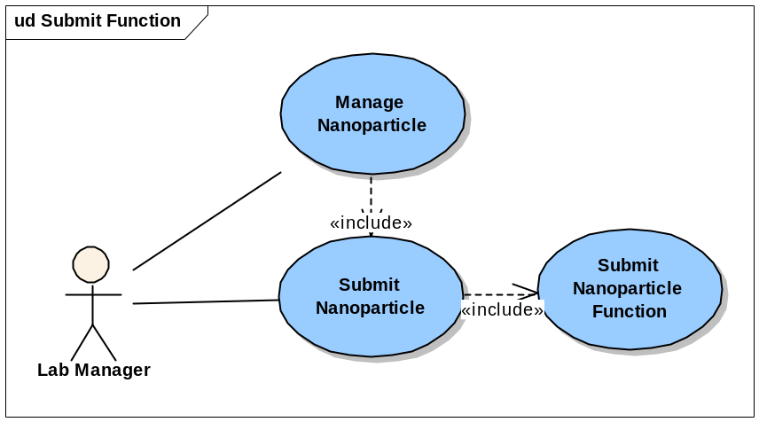
Figure 3-4 Submit Nanoparticle Function Use Cases

Use Case Name | Submit Nanoparticle Function
Use Case ID | 1.3
Primary Actor | Authorized User
Brief Description | The Submit Nanoparticle Function use case allows users to submit the function of the nanoparticle in the biomedical domain. Particle functions include: Therapeutic, Targeting (active, passive), Diagnostic Imaging, and Diagnostic Reporting.
Trigger | The User desires to submit the particle function data into the system and share with the community
Pre-conditions | - The User is logged into the System  - The User has the privilege to submit the particle data  - General information about the particle has already been submitted
Flow of Events | - The User selects a particle  - The User selects the particle Function Type (Therapeutic, Targeting (active, passive), Diagnostic Imaging, and Diagnostic Reporting)  - A form displays allowing the user to complete entries on a form including the particle linkage, agent, and agent targets  - The User specifies the linkage type (attachment, encapsulation, association, other)  - The User specifies the number of agents and enters the agent type and characteristics associated with each agent type  - The User specifies the number of agent targets and enters the agent target type and characteristics associated with each target  - The User submits the function information into the system
Post Conditions | Success Condition:  - The User successfully submits the particle function into the system.  - The User can choose to submit multiple functions for the same particle  Error Conditions:  EC1: System Error during Request Submission  EC2: Database Error during Request Submission
Alternative Flow | Alternate Conditions:  None  Error Conditions:  EC1: System Error  - A system error has occurred which prevents the submission of the submission request  - The User contacts application help support  EC2: Database Error  - A database error has occurred which prevents processing of the submission request  - The System displays the error condition and application help contact information
Related Use Cases | Submit Nanoparticle General Information
Issues/Notes | None  Note: Please refer to the Appendix B for detailed information about each particle function type

Submit Nanoparticle Characterization
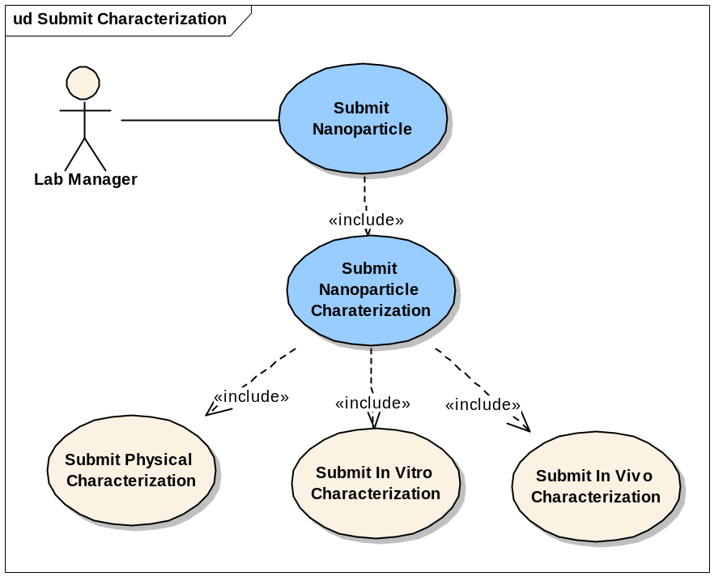
Figure 3-5 Submit Nanoparticle Characterization Use Cases

Use Case Name | Submit Nanoparticle Characterization
Use Case ID | 1.4
Primary Actor | Authorized User
Brief Description | The Submit Nanoparticle Characterization use case allows users to submit any physical and in vitro characterizations data obtained from the analysis of assay results
Trigger | The User desires to submit the characterization data and share with the community
Pre-conditions | - The User is logged the System  - The User has the privilege to submit the particle data  - General information about the particle has already been submitted
Flow of Events | - The User selects a particle  - The User selects the characterization category  - The User selects a particular characterization  - A form displays allowing the user to complete entries on a form including the characterization information  - The User enters and submits the experiment data into the system.
Post Conditions | Success Condition:  - The User successfully submits the characterization data into the system  - The User can submit multiple characterizations of the same or varying types  Error Conditions:  EC1: System Error during Request Submission  EC2: Database Error during Request Submission
Alternative Flow | Alternate Conditions:  None  Error Conditions:  EC1: System Error  - A system error has occurred which prevents processing of the submission request  - The User contacts application help support  EC2: Database Error  - A database error has occurred which prevents processing of the submission request  - The System displays the error condition and application help contact information
Related Use Cases | Update Nanoparticle
Issues/Notes | Support for in vivo characterizations will not be implemented in the caNanoLab 1.0 release.

Add Nanoparticle Physical Characterization

Use Case Name | Add Nanoparticle Physical Characterization
Use Case ID | 1.4.1
Primary Actor | Authorized User
Brief Description | The Add Nanoparticle Physical Characterization use case allows users to submit any physical characterization data obtained from the analysis of assay results. Physical Characterizations include: Particle Composition, Size, Shape, Purity, Morphology, Molecular Weight, and Surface.
Trigger | The User desires to submit the physical characterization data and share with the community
Pre-conditions | - The User is logged into the System  - The User has the privilege to submit the physical characterization data  - General information about the particle has already been submitted
Flow of Events | - The User selects a particle  - The User selects to add the physical characterization  - The User selects a particular characterization, such as Composition, Size, Shape, Purity, Morphology, Molecular Weight, or Surface  - A physical characterization form displays allowing the user to complete entries on a form including the characterization information  - The User can specify the Source of the characterization and a description of characterization details  - The User can enter the instrument information, such as Instrument Type, Manufacturer, and Description etc to the physical characterization (except for Particle Composition)  - The User can enter assay result files (except for Particle Composition)  - The User enters and submits the physical characterization data into the system
Post Conditions | Success Condition:  - The User successfully submits the physical characterization data into the system  - The User can submit multiple characterizations for the same or varying characterization types  Error Conditions:  EC1: System Error during Request Submission  EC2: Database Error during Request Submission
Alternative Flow | Alternate Conditions:  None  Error Conditions:  EC1: System Error  - A system error has occurred which prevents processing of the submission request  - The User contacts application help support  EC2: Database Error  - A database error has occurred which prevents processing of the submission request  - The System displays the error condition and application help contact information
Related Use Cases | Update Nanoparticle  Add Particle Composition  Submit Nanoparticle Assay Results
Issues/Notes | Stability and related stressors associated with all characterizations will not be implemented in caNanoLab 1.0. Stability and stressor information can be included in the description fields of each characterization.

Add Particle Composition

Use Case Name | Add Nanoparticle Composition
Use Case ID | 1.4.1.1
Primary Actor | Authorized User
Brief Description | The Add Particle Composition use case allows users to submit the composition of a particle based on the Particle Type (dendrimer, fullerene, carbon nanotube, liposome, emulsion, metal particle, quantum dot, complex particle)
Trigger | The User desires to submit the particle composition data and share with the community
Pre-conditions | - The User is logged into the System  - The User has the privilege to submit the physical characterization data  - General information about the particle has already been submitted
Flow of Events | - The User selects a particle  - The User selects to add the physical characterization  - The User selects to add a particle Composition  - A particle composition form displays, based on the type of the particle selected, allowing the user to complete entries on a form including the composition of the particle  - The User can specify the Source of the composition and a description of composition details  - The User can specify additional composing elements  - The User enters and submits the particle composition data into the system
Post Conditions | Success Condition:  - The User successfully submits the particle composition data into the system  - The User can submit multiple compositions for particle  Error Conditions:  EC1: System Error during Request Submission  EC2: Database Error during Request Submission
Alternative Flow | Alternate Conditions:  None  Error Conditions:  EC1: System Error  - A system error has occurred which prevents processing of the submission request  - The User contacts application help support  EC2: Database Error  - A database error has occurred which prevents processing of the submission request  - The System displays the error condition and application help contact information
Related Use Cases | Update Nanoparticle  Add Nanoparticle Physical Characterization
Issues/Notes | The functionality for complex particles needs to be enhanced in a later release to allow users to associate two different particles in a complex. Currently, only composing elements are implemented in caNanoLab 1.0.  Note: Please refer to the Appendix A for details of the Physical Composition associated with each particle type

Add Nanoparticle In Vitro Characterization

Use Case Name | Add Nanoparticle In Vitro Characterization
Use Case ID | 1.4.2
Primary Actor | Authorized User
Brief Description | The Add Nanoparticle In Vitro Characterization use case allows users to submit any In Vitro characterization data obtained from the analysis of assay results, such as Oxidative Stress, Enzyme Induction, Caspase3 Activation, Plate Aggregation, Hemolysis, Coagulation, Plasma Protein Binding, Complement Activation, Cytokine Induction, Chemotaxis, NK Cell Cytotoxic Activity, Leukocyte Proliferation, CFU-GM, Phagocytosis, and Oxidative Burst
Trigger | The User desires to add the In Vitro characterization data and share with the community
Pre-conditions | - The User is logged into the System  - The User has the privilege to submit the physical characterization data  - General information about the particle has already been submitted
Flow of Events | - The User selects a particle  - The User selects to add the in vitro characterization  - The User selects a particular characterization, such as Oxidative Stress, Enzyme Induction, Caspase3 Activation, Plate Aggregation, Hemolysis, Coagulation, Plasma Protein Binding, Complement Activation, Cytokine Induction, Chemotaxis, NK Cell Cytotoxic Activity, Leukocyte Proliferation, CFU-GM, Phagocytosis, and Oxidative Burst.  - An in vitro characterization form displays allowing the user to complete entries on a form including the characterization information.  - The User can specify the Source of the characterization and a description of characterization details  - The User can enter the instrument information, such as Instrument Type, Manufacturer, and Description etc to the physical characterization (except for Particle Composition)  - The User can enter assay result files  - The User enters and submits the In Vitro characterization data into the system
Post Conditions | Success Condition:  - The User successfully submits the physical characterization data into the system.  - The User can submit multiple characterizations for the same or varying characterization types  Error Conditions:  EC1: System Error during Request Submission  EC2: Database Error during Request Submission
Alternative Flow | Alternate Conditions:  None  Error Conditions:  EC1: System Error  - A system error has occurred which prevents processing of the submission request  - The User contacts application help support  EC2: Database Error  - A database error has occurred which prevents processing of the submission request  - The System displays the error condition and application help contact information
Related Use Cases | Update Nanoparticle  Submit Nanoparticle Assay Results
Issues/Notes

Associate Assay Results

Use Case Name | Associate Assay Results
Use Case ID | 1.4.3
Primary Actor | Authorized User
Brief Description | The Associate Assay Results use case allows users to associate multiple assay results (characterization graph, chart, or spreadsheet) and datum with a particular characterization. Actual submission of the Assay Results (files) is described in the Submit Assay Results use case.
Trigger | The User desires to associate Assay Results (one or multiple) and/or datum with a characterization
Pre-conditions | - The User is logged into the System  - The User has the privilege to submit the characterization data
Flow of Events | - The User selects a particle  - The User selects to add a characterization  - The characterization form (except composition) displays allowing the user to complete entries on a form including the characterization information and assay result files  - The User enters the number of assay results (e.g. size distribution graphs) and selects to Update the assay results  - The System refreshes the screen based on the number of assay results entered  - The User submits the assay results via the Submit Assay Results use case  - The User submits characterization annotations (e.g. graph type – volume/intensity, Z average size, PDI, etc. for distribution graphs) associated with each assay result type  - The User enters the number data points “datum” (e.g. % cell viability, conditions) for specific characterization types  - The System refreshes the screen based on the number of data points entered  - The User submits the assay results annotations and data points  - The System associates the characterization with the assay results annotations and data points
Post Conditions | Success Condition:  The User successfully submits assay results annotations and data points. The System successfully associates the characterization with the assay results annotations and data points  Error Conditions:  EC1: System Error during Request Submission  EC2: Database Error during Request Submission
Alternative Flow | Alternate Conditions:  None  Error Conditions:  EC1: System Error  - A system error has occurred which prevents processing of the submission request  - The User contacts application help support  EC2: Database Error  - A database error has occurred which prevents processing of the submission request  - The System displays the error condition and application help contact information
Related Use Cases | Submit Nanoparticle Assay Results
Issues/Notes

Submit Nanoparticle Assay Results

Use Case Name | Submit Nanoparticle Assay Results
Use Case ID | 1.5
Primary Actor | Authorized User
Brief Description | The Submit Nanoparticle Assay Results use case allows users to submit an assay result (file – distribution graph, histogram, etc.)
Trigger | The User desires to submit an assay result file which illustrates a nanoparticle characterization into the system and share it with the community
Pre-conditions | - The User is logged into the System  - The User has the privilege to submit the particle data  - General information about the particle has already been submitted  - The User has selected to submit a characterization (except composition)
Flow of Events | - The User selects a particle  - The User selects to submit a characterization (except composition)  - The User selects the number of assay results to submit  - The User selects to submit an assay result file  - A form displays allowing the user to upload an assay result file (default) or select from a list of existing assay result files that have previously been uploaded in the caNanoLab workflow and associated with the selected particle  - The User selects to upload or associate an existing files  - The User enters a title and description of the file  - The User enters keywords associated with the file  - The User sets the visibility of the file  - The User selects and submits the assay results into the system.
Post Conditions | Success Condition:  The User successfully submits the assay results into the system.  Error Conditions:  EC1: System Error during Request Submission  EC2: Database Error during Request Submission
Alternative Flow | Alternate Conditions:  None  Error Conditions:  EC1: System Error  - A system error has occurred which prevents processing of the submission request  - The User contacts application help support  EC2: Database Error  - A database error has occurred which prevents processing of the search request  - The System displays the error condition and application help contact information
Related Use Cases | Submit Nanoparticle Characterization
Issues/Notes | Note: If assay result files have not been previously uploaded for the particle during workflow execution, the user will not be able to select an existing result file to associate. The user can choose to upload a new file.

Search Nanoparticle
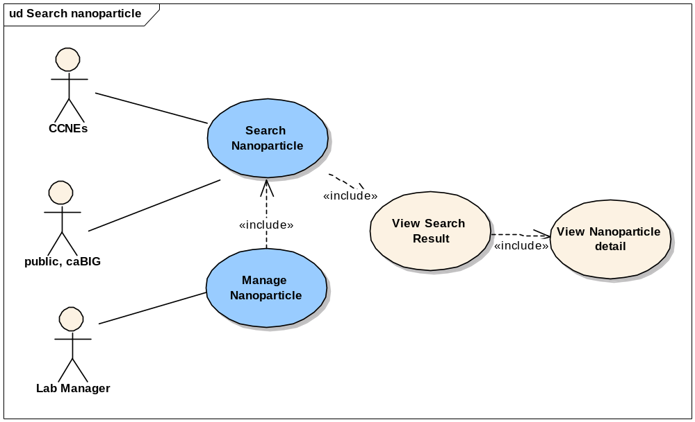
Figure 3-6 Search Nanoparticle Use Cases

Use Case Name | Search Nanoparticle
Use Case ID | 2.0
Primary Actor | Authorized User
Brief Description | The Search Nanoparticle use case allows authorized Users to search for nanoparticles that satisfy the Users search criteria
Trigger | The User desires to search for nanoparticles that satisfy the certain search criteria
Pre-conditions | - The User is logged into the System  - The User selects to search for nanoparticles and their characterizations
Flow of Events | - The user enters following optional search criteria:  - Particle source  - Particle type  - Particle function types  - Particle characterization types  - Particle keywords, or Assay result keywords (one keyword/line)  - The user submits the search criteria to the system.
Post Conditions | Success Condition: The User successfully retrieves the search results  Alternate Condition:  AC1: User does not select search criteria  AC2: No result is found  Error Conditions:  EC1: System Error during Request Submission or Retrieval  EC2: Database Error during Retrieval
Alternative Flow | Alternate Condition:  AC1: User does not select search criteria  1. The System displays a list of “all” particles visible to the User  AC2: No result is found  1. A “No results found” message is displayed  Error Conditions:  EC1: System Error  - A system error has occurred which prevents processing of the submission request  - The User contacts application help support  EC2: Database Error  - A database error has occurred which prevents processing of the search request  - The System displays the error condition and application help contact information
Related Use Cases | View Nanoparticle Details  View Search Results
Issues/Notes | Function and Assay Result keywords will be implemented in the future iteration.

View Nanoparticle Search Results

Use Case Name | View Nanoparticle Search Results
Use Case ID | 2.1
Primary Actor | Authorized Users
Brief Description | The View Search Results use case allows a user to view search results based on selected criteria as described in the <Search Nanoparticle> use case
Trigger | The User enters in search criteria as defined in the <Search Nanoparticle> use case and submits a request to search nanoparticles
Pre-conditions | - The User is logged into the System  - The User has entered in Search Criteria on the Search Nanoparticle screen and has submitted the search request
Flow of Events | - The User views the search results in tabular form based on the requested criteria  - The search results table contain the: Nanoparticle ID, particle type, characterization type
Post Conditions | Success Condition:  The User successfully views the search results table and, based on the User’s authorization, can select a Nanoparticle ID to either:  - Retrieve additional details <USECASE: View Nanoparticle Details>  - Edit information <USECASE: Update Nanoparticle>
Alternative Flow | Alternate Condition:  None  Error Conditions:  EC1: System Error  - A system error has occurred which prevents processing of the submission request  - The User contacts application help support  EC2: Database Error  - A database error has occurred which prevents processing of the search request  - The System displays the error condition and application help contact information
Related Use Cases | Search Nanoparticle  View Nanoparticle Details
Issues/Notes

View Nanoparticle Details

Use Case Name | View Nanoparticle Details
Use Case ID | 2.2
Primary Actor | Authorized Users
Brief Description | The View Nanoparticle Details use case allows a user to view nanoparticle annotations (characterizations, assay results, etc.) when selecting a Nanoparticle ID from the Search Results screen
Trigger | The User selects the Nanoparticle from the Search Result Screen
Pre-conditions | - The User is logged into the System  - The User has entered Search Criteria on the Search Nanoparticle screen and has submitted the search request  - The User has successfully obtained search results
Flow of Events | - The User Selects one Nanoparticle ID  - The User is presented with the Nanoparticle Details page, which displays the details about the Nanoparticle annotations submitted by NCL. Details provided are read-only views of the data if the User does not have privilege to update the nanoparticle. If the User does have update privileges, an editable view of the data is displayed.
Post Conditions | Success Condition:  The User successfully views the nanoparticle details  Error Conditions:  EC1: System Error during Request Submission  EC2: Database Error during Retrieval
Alternative Flow | Alternate Condition:  None  Error Conditions:  EC1: System Error  - A system error has occurred which prevents processing of the submission request  - The User contacts application help support  EC2: Database Error  - A database error has occurred which prevents processing of the search request  - The System displays the error condition and application help contact information
Related Use Cases | View Search Results  Update Nanoparticle
Issues/Notes

Update Nanoparticle
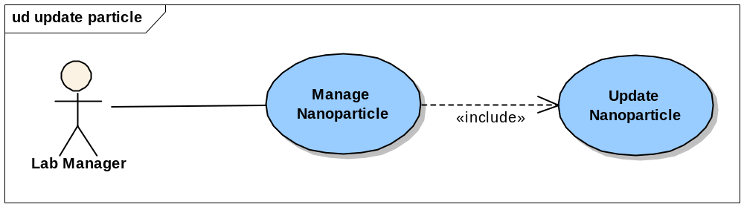
Figure 3-7 Update Nanoparticle Use Cases

Use Case Name | Update Nanoparticle
Use Case ID | 3.0
Primary Actor | Authorized User
Brief Description | The Update Nanoparticle use case allows users to update already submitted nanoparticle annotations
Trigger | The User desires to update the already submitted nanoparticle annotations
Pre-conditions | - The User is logged into the System and has the privilege to submit/update nanoparticle annotations  - The User has entered Search Criteria on the Search Nanoparticle screen and has submitted a search request  - The User has successfully obtained search results  - The User selects the individual particle to view/update the annotations
Flow of Events | - The User overwrites the previous entered data, such as general information, particle function, composition, physical characterizations, assay results, etc. and submits the updates into the system
Post Conditions | Success Condition: The User successfully update the nanoparticle annotations  Error Conditions:  EC1: System Error during Request Submission  EC2: Database Error during Retrieval
Alternative Flow | Alternate Conditions:  - The User selects to submit a particle via the Annotate Nanoparticles screen  - The User selects to search for an existing particle  - The existing data is displayed on the screen  - The User can update the data and resubmit into the system  Error Conditions:  EC1: System Error  - A system error has occurred which prevents processing of the submission request  - The User contacts application help support  EC2: Database Error  - A database error has occurred which prevents processing of the search request  - The System displays the error condition and application help contact information
Related Use Cases | Search Nanoparticle
Issues/Notes | None

Manage Reports

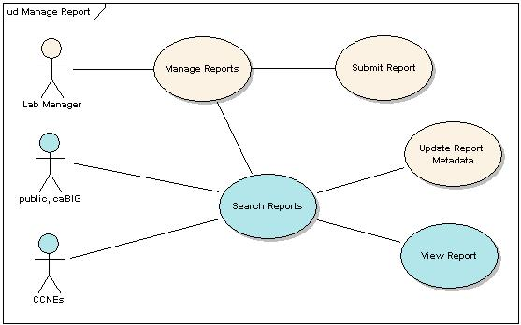
Figure 3-8 Manage Report Use Cases

Submit Report

Use Case Name | Submit Report
Use Case ID | 4.0
Primary Actor | Authorized User
Brief Description | The Submit Report use case allows authorized Users to submit final vendor reports or associated files. Reports or associated files can be affiliated with one or multiple nanoparticles.
Trigger | The User desires to submit final reports or associated files
Pre-conditions | - The User is logged into the System and has the privilege to submit/update reports  - Nanoparticles associated with the report have already been accessioned into the system
Flow of Events | - The User selects to Submit Reports  - The User selects the particle and lot IDs (e.g. particle ID-Lot ID) associated with the report  - The User selects the Report Type (NCL Report, Associated Files)  - The User enters a Report Title  - The User can enter an optional Description and Comments  - The User selects the visibility of the report  - The User submits the report and/or associated file into the system
Post Conditions | Success Condition: The User successfully submits the report and/or associated file  Error Conditions:  EC1: System Error during Request Submission  EC2: Database Error during Retrieval
Alternative Flow | Alternate Conditions:  - None  Error Conditions:  EC1: System Error  - A system error has occurred which prevents processing of the submission request  - The User contacts application help support  EC2: Database Error  - A database error has occurred which prevents processing of the search request  - The System displays the error condition and application help contact information
Related Use Cases | Update Report Metadata
Issues/Notes | None

Update Report Metadata

Use Case Name | Update Report Metadata
Use Case ID | 4.1
Primary Actor | Authorized User
Brief Description | The Update Report Metadata use case allows users to update metadata from a vendor report or associated files that has already been submitted
Trigger | The User desires to update the already submitted report/associated file
Pre-conditions | - The User is logged into the System and has the privilege to submit/update a final vendor report/associated file  - The User has entered Search Criteria on the Search Report screen and has submitted a search request  - The User has successfully obtained search results  - The User selects the individual report or associated file to update
Flow of Events | - The User overwrites the previous entered data (nanoparticle IDs, report types, title, description, comment, visibility) and file  - The System assigns a timestamp to the new file and associates this file as the latest version of the file
Post Conditions | Success Condition: The User successfully updates the report/associated file  Error Conditions:  EC1: System Error during Request Submission  EC2: Database Error during Retrieval
Alternative Flow | Alternate Conditions:  None  Error Conditions:  EC1: System Error  - A system error has occurred which prevents processing of the submission request  - The User contacts application help support  EC2: Database Error  - A database error has occurred which prevents processing of the search request  - The System displays the error condition and application help contact information
Related Use Cases | Search Reports
Issues/Notes | None

Search Reports

Use Case Name | Search Reports
Use Case ID | 4.2
Primary Actor | Authorized User
Brief Description | The Search Reports use case allows authorized Users to search for reports/associated files that satisfy the Users search criteria
Trigger | The User desires to search for reports that satisfy the certain search criteria
Pre-conditions | - The User is logged into the System  - The User selects to search for reports
Flow of Events | - The user enters following optional search criteria:  - Particle  - Report Type  - Report Title  - The user submits the search criteria to the system
Post Conditions | Success Condition: The User successfully retrieves the search results  Alternate Condition:  AC1: User does not select search criteria  AC2: No result is found  Error Conditions:  EC1: System Error during Request Submission or Retrieval  EC2: Database Error during Retrieval
Alternative Flow | Alternate Condition:  AC1: User does not select search criteria  1. The System displays a list of “all” reports visible to the User  AC2: No result is found  1. A “No results found” message is displayed  Error Conditions:  EC1: System Error  - A system error has occurred which prevents processing of the submission request  - The User contacts application help support  EC2: Database Error  - A database error has occurred which prevents processing of the search request  - The System displays the error condition and application help contact information
Related Use Cases | View Report  View Report Search Results
Issues/Notes

View Report Search Results

Use Case Name | View Report Search Results
Use Case ID | 4.2.1
Primary Actor | Authorized Users
Brief Description | The View Report Search Results use case allows a user to view search results based on selected criteria as described in the <Search Reports> use case
Trigger | The User enters in search criteria as defined in the <Search Reports> use case and submits a request to search for reports
Pre-conditions | - The User is logged into the System  - The User has entered in Search Criteria on the Search Reports screen and has submitted the search request
Flow of Events | - The User views the search results in tabular form based on the requested criteria  - The search results table contain the: Report Title, Report Type, Report Description
Post Conditions | Success Condition:  The User successfully views the search results table and, based on the User’s authorization, can select a Report Title to either:  - Retrieve additional details <USECASE: View Report>  - Edit information <USECASE: Update Report Metadata>
Alternative Flow | Alternate Condition:  None  Error Conditions:  EC1: System Error  - A system error has occurred which prevents processing of the submission request  - The User contacts application help support  EC2: Database Error  - A database error has occurred which prevents processing of the search request  - The System displays the error condition and application help contact information
Related Use Cases | Search Reports  View Report
Issues/Notes

View Report

Use Case Name | View Report
Use Case ID | 4.2.2
Primary Actor | Authorized Users
Brief Description | The View Report use case allows a user to view a report or associated file when selecting a Report Title from the Search Results screen
Trigger | The User selects the Report Title from the Search Result Screen
Pre-conditions | - The User is logged into the System  - The User has entered Search Criteria on the Search Report screen and has submitted the search request  - The User has successfully obtained search results
Flow of Events | - The User Selects a Report Title  - The User is presented with the Nanoparticle Report Details page, which displays the details about the report/associated files submitted by NCL. Details provided are read-only views of the data if the User does not have privilege to update the report. If the User does have update privileges, an editable view of the report data is displayed.
Post Conditions | Success Condition:  The User successfully views the report details  Error Conditions:  EC1: System Error during Request Submission  EC2: Database Error during Retrieval
Alternative Flow | Alternate Condition:  None  Error Conditions:  EC1: System Error  - A system error has occurred which prevents processing of the submission request  - The User contacts application help support  EC2: Database Error  - A database error has occurred which prevents processing of the search request  - The System displays the error condition and application help contact information
Related Use Cases | View Report Search Results  Update Report Metadata
Issues/Notes

Overall Requirements
The table below identifies the requirements for the caNanoLab Phase 2 (caNanoLab 1.0) effort. Requirements captured during the iterative caNanoLab 1.0 requirements analysis are also included and marked for potential future release inclusion.

Prior-ity | Req # | Requirement | Use Case Name |  | Release #
 | 1.0 | The system shall provide advanced security
 | 1.1 | The system shall provide support for role based authorization |  |  | 1.0
 | 1.1.1 | The system shall allow administrators to configure groups and group privileges (read only, read-write) |  |  | 1.0
 | 1.1.1 | The system shall leverage the NCICB Common Security Module (CSM) for user authorization |  |  | 1.0
 | 1.2 | The system shall provide support for user management |  |  | 1.0
 | 1.2.1 | The system shall leverage the NCICB User Provisioning Toolkit (UPT) for user management |  |  | 1.0
 | 2.0 | The system shall support submission and retrieval of nanoparticle annotations
 | 2.1 | The system shall allow users to annotate and search nanoparticles based on the nanoparticle composition specific to each nanoparticle type |  |  | 1.0
 | 2.1.2 | The system shall support nanoparticle types including: carbon nanotube, complex particle, dendrimer, emulsion, fullerene, liposome, metal particle, polymer, and quantum dot |  |  | 1.0
 | 2.2 | The system shall allow users to annotate and search nanoparticles based on nanoparticle characterization |  |  | 1.0
 | 2.2.1 | The system shall provide support for physical characterizations |  |  | 1.0
 | 2.2.1.1 | The system shall support physical characterizations including: composition, size, molecular weight, morphology, shape, surface area, solubility, and purity |  |  | 1.0
 | 2.2.1.2 | The system shall support particle stability and associate stressors with all physical characterizations |  |  | Future
 | 2.2.2 | The system shall provide support for in vitro characterizations |  |  | 1.0
 | 2.2.2.1 | The system shall support in vitro characterizations including: Toxicity (cytotoxicity, immunotoxicity) |  |  | 1.0
 | 2.2.2.2 | The system shall support in vitro characterizations including: metabolic stability |  |  | Future
 | 2.2.3 | The system shall provide support for in vivo characterizations |  |  | Future
 | 2.3 | The system shall allow authorized users to submit assay results (e.g. distribution graphs) and associate assay results with annotations (e.g. size distribution graph, z-avg. size, PDI) |  |  | 1.0
 | 2.4 | The system shall allow users to annotate and search nanoparticles based on nanoparticle function |  |  | 1.0
 | 2.4.1 | The system shall support nanoparticle functions including: Therapeutic, Targeting, Diagnostic Imaging, Diagnostic Reporting
 | 2.5 | The system shall allow authorized users to specify the visibility of the nanoparticle to pre-defined groups |  |  | 1.0
 | 2.6 | The system shall allow users to upload and retrieve nanoparticle reports |  |  | 1.0
 | 2.6.1 | The system shall allow users to associate reports with multiple nanoparticles |  |  | 1.0
 | 2.6.2 | The system shall allow users to set the visibility of the reports to pre-defined groups |  |  | 1.0
 | 3.0 | The system shall be engineered for caBIG compatibility
 | 3.1 | The system shall leverage the caCORE SDK and associated components |  |  | 1.0
 | 3.2 | Concepts for supported objects/attributes shall be registered in the EVS |  |  | 1.0
 | 3.3 | The object model shall be loaded into the caDSR |  |  | 1.0

Data Definitions

Concepts
The sections below detail the caNanoLab 1.0 required concepts. Definitions are maintained in the NCI’s Enterprise Vocabulary Services (EVS).

Particle Metadata

Object | Concept ID | Attributes | Data Type | Valid Values | Description
Nanoparticle | C62308 |  | Object |  | NCI|A small, stable particle whose size is measured in nanometers. These particles are used in various biomedical applications in which they can be utilized as drug carriers or imaging agents. Various targeting agents, such as antibodies, drugs, imaging agents, and reporters can be attached to the surface of a nanoparticle
Nanoparticle |  | Classification | Ontology | Organic  - Hydrocarbon (Dendrimer, Polymer)  - Carbon (Buckyball/ Fullerene, Carbon Nanotube)  - Liposome  - Emulsion  Inorganic (Metal Particle, Quantum Dot)  Complex | The classification of discrete nanoparticle entities.
Classification | C63848 | Organic | Ontology | Children:  Hydrocarbon (Dendrimer, Polymer) | A substance relating to or containing elemental carbon or carbon compounds.
Classification | C552 | Hydrocarbon | Ontology | Children:  Dendrimer, Polymer | NCI|A group of organic compounds that consist of only hydrogen (H) and carbon (C) atoms and are involved in energy production. They may be cyclic or non-cyclic compounds. They may have double bonds, single bonds or both with carbon forming the backbone.
Classification | C63798 | Carbon | Ontology | Children:  Buckyball, Fullerene, Carbon Nanotube | A nonmetallic tetravalent element that is contained within the periodic table. The element is denoted with the symbol C and atomic number 6.
Classification | C579 | Inorganic | Ontology | Metal Particle,  Quantum Dot | MSH2002_06_01|A broad class of substances encompassing all those that do not include carbon and its derivatives as their principal elements. However, carbides, carbonates, cyanides, cyanates, and carbon disulfide are included in this class.
Classification | C62364 | Complex | String |  | NCI|A nanoparticle bound to another moiety of interest via a chemical or physical interaction.
Sample | Type: C25284  Specimen:  C19157  C0370003 | Type | Valued List | Quantum Dot  Dendrimer  Fullerene/Buckyball  Polymer  Liposome  MetalParticle  Carbon Nanotube  Emulsion | Type:  NCI|Something distinguishable as an identifiable class based on common qualities.  Specimen:  NCI|A part of a thing, or of several things, taken to demonstrate or to determine the character of the whole, e.g. a substance, or portion of material obtained for use in testing, examination, or study; particularly, a preparation of tissue or bodily fluid taken for examination or diagnosis.
Sample Type | C62378 | QuantumDot |  |  | Nanometer-sized semiconductor particles made of cadmium selenide (CdSe), cadmium sulfide (CdS) or cadmium telluride (CdTe) with an inert polymer coating. The semiconductor material used for the core is chosen based upon the emission wavelength range being targeted: CdS for UV-blue, CdSe for the bulk of the visible spectrum, and CdTe for far red and near infrared. The size of the particle determines the exact color of a given quantum dot. The polymer coating protects cells from cadmium toxicity but also facilitates the attachment of any variety of targeting molecules, including monoclonal antibodies directed to tumor-specific biomarkers. Because of their small size, quantum dots can function as cell- and even molecule-specific markers that will not interfere with the normal cellular functions.
Sample Type | C62380 | Buckyball | String |  | A nanoparticle characterized by a spherical geometry and hollow interior that is comprised of 60 carbon atoms. This configuration is the most common type of fullerene.
Sample Type | C62382 | Fullerene | String |  | NCI|One of three known pure forms of carbon that exhibits a spherical shape with a hollow interior. The number of carbon atoms comprising fullerenes is variable and several stable spherical carbon structures containing 70 or more atoms have been documented.
Sample Type | C62363 | Dendrimer | String |  | NCI|A polymeric molecule which has a highly branched, three-dimensional architecture. Dendrimers are synthesized from monomers and new branches are added in discrete steps to form a tree-like architecture. A high level of synthetic control is achieved through step-wise reactions and purification at each step to regulate the size, architecture, functionality and monodispersity of the molecules. These polymers have desirable pharmacokinetic properties and a polyvalent array of surface groups that make them potential drug delivery vesicles.
Sample Type | C48803 | Polymer | String |  | NCI|A molecule made up of a linked series of repeated monomers.
Sample Type | C63845 | Monomer | String |  | A chemical subunit that can undergo polymerization by bonding to other subunits.
Sample Type | C18208 | Liposome | String |  | NCI|Substances composed of layers of lipid that form hollow microscopic spheres within which drugs or agents could be contained for enhanced safety and efficacy.
Sample Type | Metal  C637  Particle  C62308 | MetalParticle | String |  | Metal  NCI|Electropositive chemical elements characterized by ductility, malleability, luster, and conductance of heat and electricity. They can replace the hydrogen of an acid and form bases with hydroxyl radicals. |On-line Medical Dictionary  Particle  NCI|A small, stable particle whose size is measured in nanometers. These particles are used in various biomedical applications in which they can be utilized as drug carriers or imaging agents. Various targeting agents, such as antibodies, drugs, imaging agents, and reporters can be attached to the surface of a nanoparticle
Sample Type | Nanotube  C62389 | CarbonNanotube | String |  | Carbon: An element with an atomic number 6  Nanotube: Fullerene-like nanostructures that consist of graphene cylinders. The ends of the construct are closed with pentagonal-shaped rings.
Sample Type | C63807 | Emulsion | String |  | A suspension of liquid within another liquid or a dispersion consisting of two or more liquid phases.
All | C25365 | Description |  |  | NCI|A written or verbal account, representation, statement, or explanation of something.

Function Metadata

Object | Concept ID |  | Attributes | Data Type | Valid Values | Description
Function | Nanoparticle Functionality  C62335 |  |  | Object |  | The characteristic behavior of a nanoparticle that results from the chemical and physical composition and properties of the entity.  Nanoparticle Functionality:  NCI|The chemical elements of which a nanoparticle is composed
Function | Type  C25284 |  | Type | Valued List | Targeting, Diagnostic Imaging, Diagnostic Reporting, Therapeutic | NCI|Something distinguishable as an identifiable class based on common qualities.
Therapeutic | Clinical Nanoparticle Application  Nanoparticle-Mediated Drug Delivery: |  |  |  |  | The use of nanoparticles for therapeutic applications in a clinical setting.  This method entails the attachment of a drug to the surface of nanoparticles. The role of the nanoparticle is to facilitate delivery of the drug to a cellular target that it would not reach in its free form.
Function | C28002 |  | ActivationMethod | String |  | NCI-GLOSS|In biology, to stimulate a cell in a resting state to become active. This causes biochemical and functional changes in the activated cell.
Linkage | Molecular Interaction  C18219 |  |  | Object | (Attachment, Encapsulation) | Involves temporary, non-covalent binding of two or more molecules as a result of intermolecular physical forces and often involves spatial complementarity between the interacting objects.
Attachment | C61470 |  |  | Object |  | NCI|The act of affixing one thing to another.
Attachment | Molecular Interaction  C18219  Type  C25284 |  | BondType | String |  | Molecular Interaction  Involves temporary, non-covalent binding of two or more molecules as a result of intermolecular physical forces and often involves spatial complementarity between the interacting objects.  Type  NCI|Something distinguishable as an identifiable class based on common qualities.
Encapsulation | C14142 |  |  | Object |  | NCI-GLOSS|(en-KAP-soo-lay-ted) Confined to a specific, localized area and surrounded by a thin layer of tissue.
Encapsulation | C14142 |  | Localization | String |  | NCI-GLOSS|(en-KAP-soo-lay-ted) Confined to a specific, localized area and surrounded by a thin layer of tissue.
Agent | C1708 |  |  | Object |  | NCI|An active power or cause (as principle, substance, physical or biological factor, etc.) that produces a specific effect.
AgentTarget | Agent  C1708  Target  C25702 |  |  | Object |  | Agent  NCI|An active power or cause (as principle, substance, physical or biological factor, etc.) that produces a specific effect.  Target  NCI|An object fixed as a goal or point of examination; something to point at; a destination.
Peptide | C735 |  |  | Object |  | NCI|Organic compound composed of amino acids linked together chemically by peptide bonds. The peptide bond always involves a single covalent link between the alpha-carboxyl (oxygen-bearing carbon) of one amino acid and the amino nitrogen of a second amino acid.
Peptide | C13299 |  | Sequence | String |  | NCI|The sequence of nucleotide residues along a DNA chain.
Antibody | C16295 |  |  | Object |  | NCI|An antibody is a type of protein made by B-lymphocytes in response to a foreign substance (antigen). Each antibody only binds to a specific antigen, helping to destroy the antigen directly or by assisting white blood cells to destroy the antigen.
Antibody | Antibody  C16295  Name  C42614 |  | Name | Valued List | Herceptin | NCI|An antibody is a type of protein made by B-lymphocytes in response to a foreign substance (antigen). Each antibody only binds to a specific antigen, helping to destroy the antigen directly or by assisting white blood cells to destroy the antigen.  Name  NCI|The words or language units by which a thing is known.
Antibody | C45293 |  | Species | Valued List | Human, Mouse, Rat | NCI|A group of organisms that differ from all other groups of organisms and that are capable of breeding and producing fertile offspring.
DNA | C449 |  |  | Object |  | A long linear double-stranded polymer formed from nucleotides attached to a deoxyribose backbone and found in the nucleus of a cell; associated with the transmission of genetic information.
DNA | C13299 |  | Sequence | String |  | NCI|The sequence of nucleotide residues along a DNA chain.
SmallMolecule | C48809 |  |  | Object |  | NCI|A molecule with a low molecular weight that is not determined by a genome sequence.
SmallMolecule | Small Molecule  C48809  Name  C42614 |  | Name | String |  | NCI|A molecule with a low molecular weight that is not determined by a genome sequence.  Name  NCI|The words or language units by which a thing is known.
SmallMolecule | C43366 |  | CompoundName | String |  | NCI|A substance formed by chemical union of two or more elements or ingredients in definite proportion by weight.
Probe | C43523 |  |  | Object |  | NCI|General term for a piece of DNA or RNA corresponding to a gene or sequence of interest, that has been labeled either radioactively or with some other detectable molecule, such as biotin, digoxygenin or fluorescein. As stretches of DNA or RNA with complementary sequences will (hybridize), a probe will label viral plaques, bacterial colonies or bands on a gel that contain the gene of interest. |On-line Medical Dictionary
Probe | Probe  C43523  Type  C25284 |  | Type |  |  | Probe  NCI|General term for a piece of DNA or RNA corresponding to a gene or sequence of interest, that has been labeled either radioactively or with some other detectable molecule, such as biotin, digoxygenin or fluorescein. As stretches of DNA or RNA with complementary sequences will (hybridize), a probe will label viral plaques, bacterial colonies or bands on a gel that contain the gene of interest. |On-line Medical Dictionary  Type  NCI|Something distinguishable as an identifiable class based on common qualities.
Probe | Probe  C43523  Name  C42614 |  | Name |  |  | Probe  NCI|General term for a piece of DNA or RNA corresponding to a gene or sequence of interest, that has been labeled either radioactively or with some other detectable molecule, such as biotin, digoxygenin or fluorescein. As stretches of DNA or RNA with complementary sequences will (hybridize), a probe will label viral plaques, bacterial colonies or bands on a gel that contain the gene of interest. |On-line Medical Dictionary  Name  NCI|The words or language units by which a thing is known.
ImageContrastAgent | C390 |  |  | Object |  | NCI|Substances administered during diagnostic procedures that allows delineation of internal structures. Contrast agents appear opaque due to the difference in absorption of X-rays or other electromagnetic waves and surrounding tissue.
ImageContrastAgent | Contrast Agent  C390  Name  C42614 |  | Name | String |  | Contrast Agent  NCI|Substances administered during diagnostic procedures that allows delineation of internal structures. Contrast agents appear opaque due to the difference in absorption of X-rays or other electromagnetic waves and surrounding tissue.  Name  NCI|The words or language units by which a thing is known.
ImageContrastAgent | Contrast Agent  C1966  Type  C25284 |  | Type | String |  | Contrast Agent  NCI|Substances administered during diagnostic procedures that allows delineation of internal structures. Contrast agents appear opaque due to the difference in absorption of X-rays or other electromagnetic waves and surrounding tissue.  Type  NCI|Something distinguishable as an identifiable class based on common qualities.
Receptor | C17067 |  |  | Object |  | MSH2001|Cell surface proteins that bind signaling molecules external to the cell with high affinity and convert this extracellular event into one or more intracellular signals that alter the behavior of the target cell (From Alberts, Molecular Biology of the Cell, 2nd ed, pp693-5). Cell surface receptors, unlike enzymes, do not chemically alter their ligands.
Receptor | Receptor  C17067  Name  C42614 |  | Name | Valued List |  | Receptor  MSH2001|Cell surface proteins that bind signaling molecules external to the cell with high affinity and convert this extracellular event into one or more intracellular signals that alter the behavior of the target cell (From Alberts, Molecular Biology of the Cell, 2nd ed, pp693-5). Cell surface receptors, unlike enzymes, do not chemically alter their ligands.  Name  NCI|The words or language units by which a thing is known.
Antigen | C268 |  |  | Object |  | NCI|Any substance, generally a protein that stimulates the immune system and elicits an immune response. Recognition by the immune system elicits either a T-lymphocyte response, recognizing processed antigens, or a B-lymphocyte response, producing antibodies that bind to unprocessed antigens.
Antigen | Antigen  C268  Name  C42614 |  | Name | Valued List | Her2 | Antigen  NCI|Any substance, generally a protein that stimulates the immune system and elicits an immune response. Recognition by the immune system elicits either a T-lymphocyte response, recognizing processed antigens, or a B-lymphocyte response, producing antibodies that bind to unprocessed antigens.  Name  NCI|The words or language units by which a thing is known.
Physical Composition Metadata

Object | Concept ID | Attributes | Data Type | Valid Values | Description
Characterization | Nanoparticle Characterization:  C62317 |  | Object |  | A series of analytical methods that provide information about nanoscale entities such as composition, structure and defects. This information is critical for nanoparticle preparation, the study of properties, use, and reproducibility of the material.
Characterization | C25683 | Source | String |  | NCI|Where something is available or from where it originates.
Characterization | Classification:  C25372 | Classification | Valued List | Physical, In Vitro, In Vivo | NCI|This term is used informally to mean a class of things.
Physical | Physical:  C25618 |  | Object |  | Physical:  NCI|Having substance or material existence; concerned with material things; of or pertaining to the body as distinguished from the mind or spirit.  Nanoparticle related def:  The isolation and description of information related to materials properties. This analysis enables the quantification of thermal, electrical and mechanical parameters of these entities.
ParticleComposition | Particle:  (Nanoparticle)  C62308  Composition:  C53414 |  | Object |  | Particle:  A small, stable particle, whose size is measured in nanometers. These particles are used in biomedical applications in which they are utilized as drug carriers or imaging agents. Various targeting agents, such as antibodies, drugs, imaging agents, and reporters can be attached to the surface of a nanoparticle.  Composition:  NCI|The way in which something is made, especially in terms of its different parts; its constituents.
Composing  Element | Composition:  C53414  Element:  C48792 |  | Object |  | Composition:  NCI|The way in which something is made, especially in terms of its different parts; its constituents.  Element:  NCI|An artifact that is one of the individual parts of which a composite entity is made up, especially a part that can be separated from or attached to a system.
Composing  Element | Chemical:  C48807C0220806  Name:  C42614 | ChemicalName | String |  | Chemical:  NCI|A substance with a defined atomic or molecular structure that results from, or takes part in, reactions involving changes in its structure, composition, or properties.  Name: The words or language units by which a thing is known.
Composing  Element | Element:  C48792  Type: C25284 | elementType | String | Monomer (in case of polymer)  Lipid (in case of liposome)  Core  Shell  Coating  Other Nanoparticles (in case of complex) | Element:  NCI|An artifact that is one of the individual parts of which a composite entity is made up; especially a part that can be separated from or attached to a system.  Type:  NCI|Something distinguishable as an identifiable class based on common qualities.
Core | C25327 |  | String |  | NCI|The center of an object; indispensable
Shell | C62375 |  | String |  | NCI|A nanoparticle composed of a metallic shell surrounding a semiconductor. When nanoshells reach a target cancer cell, they can be irradiated with near-infrared light or excited with a magnetic field; either of these exposures will cause the nanoshell to become hot, thereby killing the cancer cell. The metal spheres can absorb or scatter light at several wavelengths, making them well suited for several clinical applications.
Coating | Coating Excipient:  C42663 |  | String |  | NCI|Therapeutically inactive ingredient of pharmaceutical dosage form used to protect it against premature physical breakup and to prevent unwanted environmental interactions. Coating can mask bad taste and allow pills to be swallowed easily. Several types of coatings are used: thin film, sugar coating, enteric coating (the most unpredictable because such coated tablets may pass through the stomach intact and be released into the intestine at unpredictable intervals all at one time rather than slowly over a period of time. Typical pill coatings include zein, shellac, or sugars.
Dendrimer Composition | Composition:  C53414 |  | Object |  | Composition:  NCI|The way in which something is made, especially in terms of its different parts; its constituents.
Dendrimer  Composition | C49065 | Branch | String | 1-2  1-3 … | NCI|An administrative division of some larger or more complex organization.
Dendrimer  Composition | Repeat:  C47942  Unit:  C44278 | RepeatUnit | String | NH2, CH2 … | Repeat:  NCI|Two or more adjacent copies of an identical pattern.  Unit:  NCI|A single undivided thing occurring in the composition of something else.
Dendrimer  Composition | C48151  CL342832 | Generation | Float | 0,.5,1.0, 1.5, 2, 2.5 – 10 | NCI|The act of bringing into being.
Dendrimer  Composition | Molecular:  C25574  Chemical  Formula:  CL342698 | MolecularFormula | String | CH2 | Molecular:  NCI|Relating to or produced by or consisting of molecules.  Chemical Formula:  NCI|A representation of a substance using symbols for its constituent elements.
SurfaceGroups | Surface:  C25245  Group:  C43359 |  | Object |  | Surface:  NCI|The extended two-dimensional outer boundary of a three-dimensional object.  Group:  NCI|Any number of entities (members) considered as a unit.
SurfaceGroups | C42614 | Name | Valued List | Amine, Carboxyl Acid, Hydroxy, etc | NCI|The words or language units by which a thing is known.
SurfaceGroups | Synonym for Qualifier  C41009 | Modifier | String |  | Qualifier:  NCI|A term that helps define and render a concept unique.
CarbonNanotube  Composition | Composition:  C53414  Carbon, Nanotube: |  | Object |  | Nanotube: Fullerene-like nanostructures that consist of graphene cylinders. The ends of the construct are closed with pentagonal-shaped rings.  Composition:  NCI|The way in which something is made, especially in terms of its different parts; its constituents.
CarbonNanotube  Composition |  | Chirality | Float |  | The spatial position or orientation of functional groups located within a molecule. The structural identification of stereoisomers is often of interest.
CarbonNanotube  Composition | Growth:  C18825  Diameter:  C25285 | GrowthDiameter | Float |  | Growth:  NCI|Processes that promote either specific or nonspecific formation of additional tissue mass, typically by cell proliferation.  Diameter:  NCI|The length of a straight line passing through the center of a circle or sphere and connecting two points on the circumference.
CarbonNanotube  Composition | Average:  C37917  Length:  C25334 | AverageLength | Float |  | Average:  NCI|A statistical calculation describing the central tendency of a set of numbers; used to interpret quantitative data.  Length:  NCI|The linear extent in space from one end of something to the other end, or the extent of something from
CarbonNanotube  Composition | Type: C25284 | WallType |  | Single (SWNT)  Double (DWNT)  Multi Walled (MWNT) | Wall:  Type:  NCI|Something distinguishable as an identifiable class based on common qualities.
Single-Walled Nanotube (SWNT) | C62392 |  | String |  | A carbon nanotube comprised of a single layer of graphitic carbon. These tubes may be metallic or semi-conducting depending on the chirality of the tube.
Double-Walled Nanotube (DWNT) | C62390 |  | String |  | A carbon nanotube comprised of two layers of graphitic carbon.
Multi-Walled Nanotube (MWNT) | C62391 |  | String |  | A nanotube consisting of single-walled nanotubes layered inside each other.
Liposome  Composition | Liposome:  C18208  Composition:  C53414 |  | Object |  | Liposome:  NCI|Substances composed of layers of lipid that form hollow microscopic spheres within which drugs or agents could be contained for enhanced safety and efficacy.  Composition:  NCI|The way in which something is made, especially in terms of its different parts; its constituents.
Liposome  Composition | Polymerization:  C34072 | IsPolymerized | Boolean |  | NCI|Polymerization consists of enzymatic reactions that form a compound (polymer), usually of high molecular weight, by combination of simpler molecules (monomers).
Liposome  Composition | Polymer:  C48803  Name:  C42614 | PolymerName | String |  | Polymer:  NCI|A molecule made up of a linked series of repeated monomers.  Name: The words or language units by which a thing is known.
Buckyball Composition  (Fullerene) | Composition:  C53414 |  | Object |  | Composition:  NCI|The way in which something is made, especially in terms of its different parts; its constituents.
Buckyball  Composition  (Fullerene) | Number:  C25337 | NumberOfCarbon | String |  | Number: NCI|A numeral or string of numerals expressing value, quantity, or identification.
Polymer  Composition | Composition:  C53414 |  | Object |  | Composition:  NCI|The way in which something is made, especially in terms of its different parts; its constituents.
Polymer  Composition | Cross Link:  C47936 | IsCrossLink | Boolean |  | Cross Link:  NCI|Any covalent linkage between two polymers or between two different regions of the same polymer.
Polymer  Composition | Cross Link:  C47936  Level (Degree):  C25554 | CrossLinkDegree | Measurement | % | Cross Link:  NCI|Any covalent linkage between two polymers or between two different regions of the same polymer.  Level:  NCI|A position on a scale measuring intensity, quality, or amount.
Polymer  Composition | Initiator:  C54190 | initiator | Valued List | Free Radicals,  Peroxide | Initiator:  NCI|An act that sets in motion some course of events; a device that activates or releases or causes something to happen.
QuantumDot Composition | C62378  Composition:  C53414 |  | Object |  | Quantum Dot:  Nanometer-sized semiconductor particles, made of cadmium selenide (CdSe), cadmium sulfide (CdS) or cadmium telluride (CdTe) with an inert polymer coating. The semiconductor material used for the core is chosen based upon the emission wavelength range being targeted: CdS for UV-blue, CdSe for the bulk of the visible spectrum, and CdTe for far red and near infrared. The size of the particle determines the exact color of a given quantum dot. The polymer coating protects cells from cadmium toxicity but also facilitates the attachment of any variety of targeting molecules, including monoclonal antibodies directed to tumor-specific biomarkers. Because of their small size, quantum dots can function as cell- and even molecule-specific markers that will not interfere with the normal cellular functions. (hybrid)  Composition:  NCI|The way in which something is made, especially in terms of its different parts; its constituents.
MetalParticle  Composition | Metal:  C637  Particle (Nanoparticle):  C62308  Composition:  C53414 |  | Object |  | Metal Particle:  A small, stable particle, whose size is measured in nanometers. These particles are used in biomedical applications in which they are utilized as drug carriers or imaging agents. Various targeting agents, such as antibodies, drugs, imaging agents, and reporters can be attached to the surface of a nanoparticle.  Metal:  NCI|Electropositive chemical elements characterized by ductility, malleability, luster, and conductance of heat and electricity. They can replace the hydrogen of an acid and form bases with hydroxyl radicals.|On-line Medical Dictionary  Particle (Nanoparticle):  NCI|A small, stable particle whose size is measured in nanometers. These particles are used in various biomedical applications in which they can be utilized as drug carriers or imaging agents. Various targeting agents, such as antibodies, drugs, imaging agents, and reporters can be attached to the surface of a nanoparticle  Composition:  NCI|The way in which something is made, especially in terms of its different parts; its constituents.
Emulsion  Composition | Emulsion Dosage Form  C42913  Composition:  C53414 |  | Object |  | Emulsion Dosage Form:  NCI|A dosage form consisting of a two-phase system comprised of at least two immiscible liquids (1), one of which is dispersed as droplets (internal or dispersed phase) within the other liquid (external or continuous phase), generally stabilized with one or more emulsifying agents. Note 1: A liquid is pourable; it flows and conforms to its container at room temperature. It displays Newtonian or pseudoplastic flow behavior. Note 2: Emulsion is used as a dosage form term unless a more specific term is applicable, e.g. cream, lotion, ointment.  Composition:  NCI|The way in which something is made, especially in terms of its different parts; its constituents.
Emulsion  Composition | Emulsion Dosage Form  C42913  Type: C25284 | emulsionType |  | Polymer | Emulsion Dosage Form:  NCI|A dosage form consisting of a two-phase system comprised of at least two immiscible liquids (1), one of which is dispersed as droplets (internal or dispersed phase) within the other liquid (external or continuous phase), generally stabilized with one or more emulsifying agents. Note 1: A liquid is pourable; it flows and conforms to its container at room temperature. It displays Newtonian or pseudoplastic flow behavior. Note 2: Emulsion is used as a dosage form term unless a more specific term is applicable, e.g. cream, lotion, ointment.  Type:  NCI|Something distinguishable as an identifiable class based on common qualities.
Emulsion  Composition | Molecular:  C25574  Form:  C19464  C0376315 | molecularFormula | String |  | Molecular:  NCI|Relating to or produced by or consisting of molecules.  Form:  NCI|A printed or electronic document with spaces to be filled out.
Emulsion  Composition | Polymerization:  C34072 | IsPolymerized | Boolean |  | NCI|Polymerization consists of enzymatic reactions that form a compound (polymer), usually of high molecular weight, by combination of simpler molecules (monomers).
Emulsion  Composition | Polymer:  C48803  Name:  C42614  CL347309 | PolymerName | String |  | Polymer:  NCI|A molecule made up of a linked series of repeated monomers.  Name:  The words or language units by which a thing is known.
ComplexComposition | Complex:  C62364  Composition:  C53414 |  | Object |  | Complex:  NCI|A nanoparticle bound to another moiety of interest via a chemical or physical interaction.  Composition:  NCI|The way in which something is made, especially in terms of its different parts; its constituents.
ComplexComposition | Name:  C42614 | Name | String |  | Name: The words or language units by which a thing is known
ComplexComposition | Description:  C25365 | Description | String |  | Description:  NCI|A written or verbal account, representation, statement, or explanation of something.

Physical Characterization Metadata

Object | Concept ID | Attributes | Data Type | Valid Values | Description
MolecularWeight | C43521 |  | Object |  | NCI|The sum of the relative atomic masses of the constituent atoms of a molecule.
Size | C25681 |  | Object |  | Size of the nanoparticle in nm based on volume or intensity  Size:  NCI|The physical magnitude of something
Solubility | C60821 |  | Object |  | What molecules modify the surface (e.g. what chemical ligands attach to the molecule); A distinguishing feature present on the surface of a nanoparticle.  Solubility:  NCI|The quantity of a particular substance that can dissolve in a particular solvent (yielding a saturated solution).
Solubility | C45790 | Solvent | String |  | NCI|A liquid that dissolves or that is capable of dissolving; the component of a solution that is present in greater amount. (Online-Medical Dictionary)
Solubility | Concentration:  C41185 | CriticalConcentration | Measurement |  | NCI|The quantity of a substance per unit volume or weight; a measure of the amount of substance present in a unit amount of mixture, particularly, the amount of solute dissolved in a solvent. The amounts can be expressed as moles, masses, volumes, or par
Solubility | Solubility:  C60821 | isSoluble | Boolean |  | Solubility:  NCI|The quantity of a particular substance that can dissolve in a particular solvent (yielding a saturated solution).
Surface | C25245 |  | Object |  | NCI|The extended two-dimensional outer boundary of a three-dimensional object.
Surface | Type:  C25284 | Type | Valued List |  | NCI|Something distinguishable as an identifiable class based on common qualities.
Surface | Area:  C25244 | SurfaceArea | Measurement |  | NCL - Total area that a solution can wet (m2/Kg)  Area:  NCI|The extent of a 2-dimensional surface enclosed within a boundary.
Surface | Charge:  C48050 | SurfaceCharge | Measurement |  | NCL: Measurement of surface charge (absence of electrons) (coulombs/n2)  Charge: NCI|The quantity of unbalanced electricity in a body (either positive or negative) and construed as an excess or deficiency of electrons.
Surface | C62354 | ZetaPotential | Measurement |  | NCI|The magnitude of the electrical potential as generated by ion accumulation at the particulate surface. This surface consists of two layers, the Stern layer and the diffuse layer, which comprise an electrical double-layer. The measurement of the electrical potential provides important information regarding the dispersion mechanism, the degree of particle dispersion and the electrostatic potential of the sample.
Surface | C32749  Hydrophobic Portion of the Plasma Membrane | IsHydrophobic | Boolean |  | The inherent characteristic of a molecule or substance to be immiscible in water. The property means that the moiety of interest does not dissolve in, absorb, or mix easily with water.
SurfaceChemistry | Surface:  C25245  Chemistry:  C16414 |  | Object |  | NCL - What molecules are leveraged to modify the surface  Surface: NCI|The extended two-dimensional outer boundary of a three-dimensional object  Chemistry: NCI|The science of the composition, structure, properties, and reactions of matter, especially of atomic and molecular systems.
SurfaceChemistry |  | Molecule | String |  | An aggregate of two or more atoms in a defined arrangement held together by chemical bonds.
SurfaceChemistry | C45781 | Density | Measurement |  | NCI|The amount of something per unit size.
Morphology | C17943 |  | Object |  | Shape of the nanoparticle crystal; Physical structure.  Morphology:  NCI|The science of the form and structure of organisms (plants, animals, and other forms of life), or of their parts, and the study or science of the same. In pathology, the specific appearance of cells and tissues (normal and abnormal) under the light or electron microscope.
Morphology | Type:  C25284 | Type | Valued List | Powder, Liquid, Solid, Crystalline, Copolymer, Fibril, Colloid, Oil | Type:  NCI|Something distinguishable as an identifiable class based on common qualities.
Morphology Type |  | Copolymer |  |  | A chemical structure with a high molecular weight that is comprised of two or more monomer subunits. The monomers can be of the same or different composition. (Heteropolymer will be added as a synonym)
Morphology Type | C63809 | Fibril |  |  | A small slender fiber or filament
Shape | C25677 |  | Object |  | NCI|The spatial arrangement of something as distinct from its substance.
Shape | Type:  C25284 | Type | Valued List | Cubic, Hexagonal, Irregular, Needle, Oblate, Rod, Spherical, Tetrahedral, Tetrapod, Triangular, Elliptical, Composite, Cylindrical, Vesicular, Ellipsoid | Type:  NCI|Something distinguishable as an identifiable class based on common qualities.
Shape Type | C63806 | Cylinder |  |  | A surface formed by circles of a given radius that are contained in a plane perpendicular to a given axis, whose centers align on the axis.
Shape Type | C63804 | Cube |  |  | An object that is comprised of six regular, solid, congruent square faces and has three equal axes at right angles to each other.
Shape Type | C63815 | Irregular |  |  | Lacking perfect symmetry or evenness.
Shape Type | C63846 | Needle |  |  | The geometry of an object that resembles a needle, meaning that it has a long slender cylindrical shape.
Shape Type | C63847 | Oblate |  |  | The geometry of an object that is shaped like a spheroid and compressed at the poles.
Shape Type | C63856 | Tetrahedron |  |  | The geometry of an object, which is comprised of a polyhedron containing four faces. Tetrahedral will be added as a synonym of tetrahedron
Shape Type | C63857 | Tetrapod |  |  | The geometry of an object that consists of four rods in a tetrahedral arrangement.
Shape | Dimension:  C25483  Maximum:  C25564 | maxDimension | Float |  | Dimension:  NCI|The magnitude of something in a particular direction, especially length or width or height.  Maximum:  NCI|The largest possible quantity or degree
Shape | Dimension:  C25483  Minimum: C25570 | minDimension | Float |  | Dimension:  NCI|The magnitude of something in a particular direction, especially length or width or height.  Minimum:  NCI|The smallest possible quantity
Purity | C62352 |  | Object |  | NCI|A quantitative assessment of the homogeneity or uniformity of a mixture. Alternatively, purity refers to the degree of being free of contaminants or heterogeneous components.
Purity | Homogeneity: C61365 | HomogeneityInLigand | String |  | NCI|The quality or state of being similar or comparable in kind or nature or of being uniform throughout in composition
Purity | Residual  C37895  Solvent  C45790 | ResidualSolvents | String |  | Residual  NCI|Remaining or left behind  Solvent  NCI|A liquid that dissolves or that is capable of dissolving; the component of a solution that is present in greater amount.
Purity |  | FreeComponents | String
MeasurementType |  | Aggregation | String |  | A process by which particles collect to form a cohesive mass or cluster. The resulting structure is called an aggregate.

In Vitro Characterization Metadata

Object | Concept ID | Attributes | Data Type | Valid Values | Description
Toxicity | C27990 |  | Object |  | NCI|The finding of bodily harm due to the poisonous effects of something.
OxidativeBurst |  |  | Object |  | A process that consists of the rapid release of reactive oxygen species. The process frequently occurs in cells when superoxide radical and hydrogen peroxide species are released.
EnzymeInduction | C41564 |  | Object |  | NCI|Enzyme Induction involves initiation of function of a biological molecule (usually protein, RNA, or DNA) that possesses catalytic activity.
Immunotoxicity | C63814 |  | Object |  | Adverse effects to the immune system
Immunotoxicity | C25284 | Type | Valued List | BloodContact, ImmuneCellFunction | NCI|Something distinguishable as an identifiable class based on common qualities.
PlateletAggregation | C16999 |  | Object |  | NCI|The accumulation and adherence of platelets to form a clot or thrombus. When injury or bleeding occurs, platelets clump together at the site of injury; they expand and adhere to the injured area, thereby acting as a plug to reduce the bleeding. Platelet dysfunction can result in blood clotting and bleeding disorders.
Hemolysis | C37965 |  | Object |  | Disruption of the integrity of the erythrocyte membrane causing release of hemoglobin.
PlasmaProteinBinding | Plasma  C13356 |  | Object |  | Plasma  NCI-GLOSS|(PLAS-ma) The clear, yellowish, fluid part of the blood that carries the blood cells. The proteins that form blood clots are in plasma.
Coagulation | C20812 |  | Object |  | NCI|The process of clot formation.
Chemotaxis | C16422 |  | Object |  | The characteristic directional movement or orientation of an organism or cell along a chemical concentration gradient either toward or away from the chemical stimulus.
ComplementActivation | C21519 |  | Object |  | NCI|The complement system consists of more than 30 proteins engaged in host defense. It provides both an independent immune system capable of attacking microbes as well as other foreign material and an adjunct to the antibody system. Once activated, the complement system fires in a cascade-like fashion in which one component activates the next. Both swift and powerful, millions of complement components can deposit on an invading microbe within only a few minutes. Such a potent system requires strict regulation to avoid host injury. Membrane cofactor protein (MCP) is one critical regulator aimed at controlling inadvertent complement activation on host cells and nearly every cell examined expresses MCP on its cell membrane.
CytokineInduction | C20464 |  | Object |  | A class of soluble glycoproteins, which act nonenzymatically through specific receptors to regulate immune responses. Cytokines are derived from both immune and non-immune cells and are intercellular mediators that differ from hormones in that they are produced by a number of tissue or cell types rather than by specialized glands.
Phagocytosis | C26115 |  | Object |  | NCI|Endocytosis of particulate material, such as microorganisms or cell fragments, into membranous phagosomes that fuse with lysosomes and result in digestion of the ingested material. (NCI)
LeukocyteProliferation | Leukocytes  C12529  Proliferation  C37897 |  | Object |  | Leukocytes  NCI-GLOSS|(LOO-ko-sites) White blood cell. Refers to a blood cell that does not contain hemoglobin. White blood cells include lymphocytes, neutrophils, eosinophils, macrophages, and mast cells. These cells are made by bone marrow and help the body fight infection and other diseases.  Proliferation  NCI|Growth and reproduction of new similar forms, e.g. cells, buds, or offspring.
CFU-GM |  |  | Object |  | A functional (qualitative) as well as quantitative assay that is utilized as an indicator of granulopoiesis reconstitution
NKCellCytoxicActivity | C19940 |  | Object |  | NCI|NK Cell Activation involves interaction with virus-infected or transformed cells by diverse adhesion or co-stimulatory molecules and release of cytokines, chemokines, and lethal chemicals from granules.
Cytotoxicity | C27988 |  | Object |  | NCI|The adverse effect of some iatrogenic therapies. It is an accepted side effect in radiation therapy where the desired effect is to kill rapidly growing tumor cells. In the killing of tumor cells, other cells that are rapidly growing e.g. hair, mucous membranes are also killed.
Cytotoxicity | C16403 | CellLine | Valued List | Kidney | NCI|A permanently established cell culture that will proliferate indefinitely given appropriate fresh medium and space.|On-line Medical Dictionary
Cytotoxicity | C41515 | CellDeathMethod | Valued List | Apoptosis, necrosis | NCI|A Cell Death Process consists of activities of biologic molecules, biologic complexes, or subcellular components within a cell or among cells that lead to the termination of a cell's ability to carry out vital functions such as metabolism, growth, reproduction, responsiveness, and adaptability.
Caspase3Activation | C42784 |  | Object |  | NCI|Caspase Activation involves induction of the activity of intracellular cysteine endopeptidase family members kept inactive by mitochondrial surface proteins (BcL-2 Family) and involved in initial signaling and downstream proteolytic cleavages (at P1 aspartic acids) in inflammation and apoptotic cell death when signals block BcL-2 function and activators initiate caspase cascades.
CellViability | C21099 |  | Object |  | NCI|A cellular process that directly affects the ability of a cell to proliferate, grow, divide, or repair damaged cell components. (NCI)
GlucuronidationSulphation |  |  | Object |  | An inactivating and detoxification pathway for a variety of exogenous and endogenous molecules, including drugs, pollutants, bilirubin, androgens, estrogens, mineralocorticoids, glucocorticoids, fatty acid derivatives, retinoids and bile acids. Glucuronic acid is highly soluble in water and is often linked to poisonous substances to allow for subsequent elimination, and to hormones to allow for easier transport. Also commonly drugs are linked to glucuronic acid to allow for easier delivery. Excretion occurs via urine or bile.

Characterization Metadata

Object | Concept ID | Attributes | Data Type | Valid Values | Description
Instrument | Instrumentation:  C16742 |  | Object |  | Instrumentation:  NCI|Any object, or item of electrical or electronic equipment, which is designed to carry out a specific function or set of functions.
Instrument | Description:  C25365 | Description | String |  | Description:  NCI|A written or verbal account, representation, statement, or explanation of something.
Instrument | Manufacture:  C25392 | Manufacturer | String |  | Manufacture:  NCI|A person, an enterprise, or an entity that produces finished goods.
Instrument | C42610 | Abbreviation | String | LS, DLS, SLS, FFF, HPCL, NHPLC, AFM, TEM etc. | Abbreviation:  NCI|A shortened form of a word or phrase.
Instrument | Type: C25284 | Type | Valued List | Light Scattering (LS), Dynamic Light Scattering (DLS), Static Light Scattering (SLS), Spectrometer, Inductively-Coupled Plasma Optical Emission Spectrometer, Emission Spectrometer,  Optical Emission Spectrometer, Photon Correlation Spectroscopy, Mass Spectrometer, Glow Discharge Mass Spectrometry, Inductively-Coupled Plasma Mass Spectrometer, Field Flow Fractionation (FFF), Fluorimetry, Size Exclusion Chromatography,  Multiple Angle Light Scattering (MALS),  High Performance Liquid Chromatography (HPLC), Atomic Force Microscope (AFM), Transmission Electron Microscope (TEM), Capillary Electrophoresis, Particle Count and Size Analyzer, UV-VIS Spectra | NCI|Something distinguishable as an identifiable class based on common qualities.  Note: Some instrument types may be techniques
Light Scattering (LS) | C62323 |  | String |  | Dispersal of a beam of light into a range of directions as a result of physical interactions.
DynamicLightScattering (DLS) | Photon Correlation Spectroscopy  C62329 |  | String |  | An analytical technique used to measure the Brownian motion of particles in a solvent. The rate of movement is a function of particle size, solvent viscosity and temperature.  Photon Correlation Spectroscopy  NCI|A type of spectroscopy that utilizes a laser beam to irradiate a sample containing particles in suspension, resulting in light scattering. Rapid fluctuations in scattering intensity, around a mean value at a certain angle, occur because of particle diffusion and are dependent upon on particle size. The calculated correlation function yields a diffusion coefficient, for a given temperature and viscosity, which can be used to calculate particle size.
Static Light Scattering (SLS) | C62325 |  | String |  | The average scattering intensity as a function of both the angle and concentration of particles in dilute solutions.
Spectrometer | C62336 |  | String |  | A type of analytical instrument used to measure certain physical properties such as energy, mass and wavelength via the dispersion of radiant energy or particles into a spectrum.
Inductively-Coupled Plasma Optical Emission Spectrometer | C62338 |  | String |  | A spectrometer in which a sample is introduced, either by spraying or ultrasonic nebulization, into inductively-coupled plasma generated from argon gas. This process excites dissolved metals, thereby causing them to emit radiation in both the UV and visible spectrum. The emitted radiation is dispersed by a grating monochrometer and detected with photomultiplier tubes.
Emission Spectrometer | C62337 |  | String |  | A spectrometer that applies some form of energy to a substance, thereby causing emission of electromagnetic radiation, which is then, quantified using a detector.
Optical Emission Spectrometer | C62339 |  | String |  | An emission spectrometer that generates a high-energy spark across an argon-filled gap between an electrode and a solid sample, causing emission of radiation from the excited sample surface and resulting in wavelengths characteristic of the elemental composition.
Photon Correlation Spectroscopy | C62329 |  | String |  | A type of spectroscopy that utilizes a laser beam to irradiate a sample containing particles in suspension, resulting in light scattering. Rapid fluctuations in scattering intensity, around a mean value at a certain angle, occur because of particle diffusion and are dependent upon on particle size. The calculated correlation function yields a diffusion coefficient, for a given temperature and viscosity, which can be used to calculate particle size.
Mass Spectrometer | C47875 |  | String |  | Used for certain nanoparticle types only; Does not work for gold particles and liposomes; Measures mass vs. intensity  Mass Spectrometer:  NCI|An instrument that determines the exact mass of charged particles or ions by measuring the flight path through a set of magnetic and electric fields.
Glow Discharge Mass Spectrometry | C62327 |  | String |  | NCI|A mass spectrometry technique in which a solid sample is atomized and ionized by sputtering in low-pressure direct-current plasma prior to the separation and detection of the ions in a mass analyzer.
Inductively-Coupled Plasma Mass Spectrometry | C62328 |  | String |  | A mass spectrometry technique that uses inductively-coupled plasma generated from argon gas to atomize and ionize a sample. The resulting ions are separated and analyzed using a mass spectrometer.
Spectrophotometer | C62333 |  | String |  | A photometer that measures the intensity of light as a function of wavelength.
Field Flow Fractionation (FFF) | C62321 |  | String |  | An analytical technique used to separate a multi-component sample by applying a retarding force or gradient to a sample in a solvent stream, which drives the sample toward a thin channel wall. The velocity at which a component leaves the center solvent stream is dependent on its physical characteristics.
Fluorimetry | C62322 |  | String |  | An analytical method that utilizes ultraviolet light to excite the sample and detects the fluorescence emitted during the return of the sample to its ground state.
Size Exclusion Chromatography | Size:  C25681  Exclusion:  C25370  Chromatography:  C16431 |  | String |  | Size:  NCI|The physical magnitude of something.  Exclusion:  NCI|The act of restricting entrance or barring from participation.  Chromatography:  NCI|A technique for the separation of complex mixtures that relies on the differential affinities of substances for a gas or liquid mobile medium and for a stationary adsorbing medium through which they pass.
Multiple Angle Light Scattering (MALS) | Light Scattering  C62323 |  | String |  | A light scattering technique involving measurement of the amount of light scattered by a suspension at multiple angles relative to the incident laser beam. Masses and the root mean square radius or a measure of geometric size can be determined using this technique on a mega Dalton scale.  Light Scattering  NCI|Dispersal of a beam of light into a range of directions as a result of physical interactions.
Nano High Performance Liquid Chromatography (NHPLC) | Nanoparticle:  C62308  HPLC:  C16434 |  | String |  | Nanoparticle:  A small, stable particle, whose size is measured in nanometers. These particles are used in biomedical applications in which they are utilized as drug carriers or imaging agents. Various targeting agents, such as antibodies, drugs, imaging agents, and reporters can be attached to the surface of a nanoparticle.  HPLC:  NCI|Frequently referred to simply as HPLC, this form of column chromatography is used frequently in biochemistry. The analyte is forced through a column by liquid at high pressure, which decreases the time the separated components remain on the stationary phase. Less time on the column then translates to narrower peaks in the resulting chromatogram and thence to better selectivity and sensitivity
High Performance Liquid Chromatography (HPLC) | C16434 |  | String |  | NCI|Frequently referred to simply as HPLC, this form of column chromatography is used frequently in biochemistry. The analyte is forced through a column by liquid at high pressure, which decreases the time the separated components remain on the stationary phase. Less time on the column then translates to narrower peaks in the resulting chromatogram and thence to better selectivity and sensitivity
Atomic Force Microscope (AFM) | C17754 |  | String |  | NCI|An atomic force microscope measures the attractive or repulsive force between a sample surface and a sharp tip. The tip is attached to a cantilever, and the displacement of the cantilever is measured as the tip is scanned across the sample, leading to surface visualization. AFMs can give images with a resolution of 10 pm, and can scan samples in air and under liquids.|MATTER Glossary; http://www.matter.org.uk/glossary/
Transmission Electron Microscope (TEM) | C18216 |  | String |  | An electron microscopy imaging technique that is utilized to examine structural components of a sample by passing electrons through the specimen.
Capillary Electrophoresis | C17637 |  | String |  | NCI|An electrophoresis technique, in which a sample is introduced into a capillary tube and the components are separated by the application of high voltage. Due to the large surface to volume ratio, cooling is more efficient, allowing use of higher voltages. As a result, separation occurs more quickly and sensitivity is increased. The technique allows for separation of proteins, nucleic acids, and carbohydrates
Particle Count and Size Analyzer | C62330 |  |  |  | An instrument that measures changes in the electrical resistance of an electrolyte solution produced by suspended nonconductive particles. Changes in resistance determine both the concentration and size distribution of the particles.
UV-VIS Spectra | C63858 |  | String |  | A spectrum that contains wavelength values that correspond to ultraviolet (UV) and visible (VIS) light properties. (UV-Visible will be added as a synonym)
Characterization Protocol | Protocol  C42651 |  | Object |  | NCI|A rule which guides how an activity should be performed.
Characterization Protocol | Name  C42614 | Name | String |  | NCI|The words or language units by which a thing is known.
Characterization Protocol | C25714 | Version | String |  | NCI|A form or variant of a type or original; one of a sequence of copies of a program, each incorporating new modifications.
DerivedBioAssayData | Derived  C42885  Bioassay  C16341 |  | Object |  | Derived  NCI|To take, obtain, or receive from a source; having been determined by mathematical computation.  Bioassay  NCI|A laboratory test/analysis of biological activity of a substance by studying its effect on an organism or in test tube under controlled conditions.
DerivedBioAssayData | C42883 | File | LabFile |  | NCI|A set of related records (either written or electronic) kept together.
DerivedBioAssayData | C25284 | Type | Ontology | For Size:  Volume Distribution, Number Distribution, Intensity Distribution  For Molecular Weight:  Volume Distribution, Number Distribution, Mass Distribution  For Hemolysis:  Hemolytic Properties  Etc. | NCI|Something distinguishable as an identifiable class based on common qualities.
Datum | C43600 |  | Object |  | NCI|A single item of factual information derived from measurement or research
Datum | C25284 | Type | String | Type:  For Size/Weight Distribution:  Average/Mean, Z-Average, PDI  For Hemolysis Distribution: Percent Hemolysis | NCI|Something distinguishable as an identifiable class based on common qualities.
Datum | C63860 | Z-Average |  |  | A parameter used for calculations involving mechanical properties. The parameter is measured by using dynamic light scattering to obtain the intensity weighted mean hydrodynamic size of a collection of particles.
Datum | C63852 | PolydispersityIndex | Measurement | .165 | A measure of the distribution of molecular weights in a given polymer sample. The PDI calculated is the weight average molecular weight divided by the number average molecular weight. It indicates the distribution of individual molecular weights in a population of polymers.
Datum | C49100 | Value | Measurement |  | NCI|The information contained in a data field; may represent a numeric quantity, a textual characterization, a date or time measurement, or some other state depending on the nature of the attribute.
Condition | C25457 |  | Object |  | NCI|A state of being, such as a state of health or physical being.
Condition | C25284 | Type | String | Type:  For Cell Viability:  Particle, Concentration, Time  For Hemolysis:  Particle, Concentration | NCI|Something distinguishable as an identifiable class based on common qualities.
Condition | C49100 | Value | Measurement |  | NCI|The information contained in a data field; may represent a numeric quantity, a textual characterization, a date or time measurement, or some other state depending on the nature of the attribute.
Control | C61299 |  | Object |  | NCI|The act of directing or determining; regulation or maintenance of a function or action; a relation of constraint of one entity (thing or person or group) by another.
Control | C42614 | Name | String |  | NCI|The words or language units by which a thing is known.
Control | C49647 | Type | Valued List | Negative, Positive | NCI|A characteristic of a treatment regimen employed as a comparator against which the study treatment is evaluated. (CDISC Glossary Group)
Keyword | C43513 |  | Object |  | NCI|A small set of words designed to convey the subject of a technical article.
Ontology | C21270 |  | Interface |  | NCI|In information science, an explicit formal specification of how to represent the objects, concepts and other entities that are assumed to exist in some area of interest and the relationships among them.
Report | C25375 |  | Object |  | NCI|A short textual account; having provided a short account.
Report | C42774 | Title | String |  | NCI|A general or descriptive designator for an object, work of art, or literary composition.
Report | C25365 | Description | String |  | NCI|A written or verbal account, representation, statement, or explanation of something.

Sign Off

Approval

NCICB Rep Print Name Date
NCL Rep Print Name Date
NCI OC Rep Print Name Date
SAIC Rep Print Name Date

Appendix A - Particle Composition Detail

Composition Type | Attributes on the Input Form | Notes
DendrimerComposition | - Branch  - Generation  - MolecularFormula  - RepeatUnit  - A collection of SurfaceGroups  - A collection of ComposingElements | The collection of ComposingElement for a dendrimer is a core with its description field as “dimer”.
PolymerComposition | - isCrossLink  - CrossLinkDegree  - Initiator  - a collection of ComposingElements (multiple monomers)
FullereneComposition | - NumberOfCarbons  - Chirality  - GrowthDiameter  - AverageLength  - A collection of ComposingElements | wallType is either single or multiple.  The ComposingElements can be atoms other than carbon.
LiposomeComposition | - isPolymerized  - PolymerName  - A collection of ComposingElements (multiple lipids) | polymerName is required only when isPolymerized=true.  When LipsomeComposition is polymerized, it becomes a ComplexComposition.
EmulsionComposition | - EmulsionType  - MolecularFormula  - DropletSize  - isPolymerized  - PolymerName | emulsionType is a descriptor field where user types water, oil, etc.  polymerName is required when isPolymerized=true. When  EmulsionComposition is polymerized, it becomes a ComplexComposition.
MetaParticleComposition | - A collection of ComposingElements (zero or one core, multiple shells, multiple coatings)
QuantumDotComposition | - A collection of ComposingElements  (one core, multiple shells,  multiple coatings)
ComplexComposition | - Name  - Description  - A collection of ComposingElements (multiple nanoparticles of different types)  Each ComposingElement can have its own specific Composition and child ComposingElements.  For example: A complex nanoparticle could be a liposome embedded within a quantum dot. In this case, there are two ComposingElements, one of type Liposome, and one of type Quantum Dot. The ComposingElement of type Liposome has a LiposomeComposition as defined earlier. The ComposingElement of type Quantum Dot has a QuantomDotComposition as defined earlier. | After a user specifies the types of composing nanoparticles, there will a link for each nanoparticle type, from which the user can optionally go to the input form and fill out details for that type of nanoparticle.  In the description field, users can specify how one type of nanoparticle is contained in another type.

Appendix B - Function Detail

Function Type | Attributes to be Captured on the Input Form | Notes
Targeting (Active) | - Linkage Type (Attachment, Encapsulation)  - Bond Type (for Attachment linkage)  - Localization (for Encapsulation linkage)  - Agent Type (Small Molecule, Peptide, Antibody)  - Agent Target (Antigen, Receptor)  - Description | Additional parameters will be included on the input form based on the selected Agent and Agent target  For Active Targeting both an Agent and Agent Target are required.
Targeting (Passive) | - Description | For Passive Targeting, there is no Agent Target. Any Target such as “vasculature” would be entered in the Description field.
Diagnostic Imaging | - Linkage Type (Attachment, Encapsulation)  - Bond Type (for Attachment linkage)  - Localization (for Encapsulation linkage)  - Agent Type (Small Molecule, Image Contrast Agent)  - Agent Target (Antigen)  - Activation Method  - Description | Additional parameters will be included on the input form based on the selected Agent and Agent target  Linkage can be Attachment or Encapsulation in Diagnostic Imaging particles
Diagnostic Reporting | - Linkage Type (Attachment, Encapsulation)  - Bond Type (for Attachment linkage)  - Localization (for Encapsulation linkage)  - Activation Method  - Agent Type (Peptide, Probe, DNA, Small Molecule)  - Agent Target (Antigen)  - Description | Additional parameters will be included on the input form based on the selected Agent and Agent target  A Probe Type may be “Fluorescent” in Probe Agents
Therapeutic | - Linkage Type (Attachment, Encapsulation)  - Bond Type (for Attachment linkage)  - Localization (for Encapsulation linkage)  - Agent Type (Small Molecule, Peptide, Antibody)  - Agent Target (Antigen, Receptor)  - Activation Method  - Description | Additional parameters will be included on the input form based on the selected Agent and Agent target

Note: The original caLAB project was renamed to caNanoLab during Release 1.0 to emphasize the focus on nanotechnology laboratories.

