Software Requirements Specification

cancer Nanotechnology Laboratory (caNanoLab) 1.5

NCICBIIT, NCL

DOCUMENT REVISION HISTORY

Version Number | Date | Description
1.0 | Nov. 18, 2008 | Initial draft containing caNanoLab 1.5 Use Cases

Background/Summary
The caNanoLab effort is collaboration between the NCICBIIT, the Nanotechnology Characterization Laboratory (NCL), and the Cancer Centers for Nanotechnology of Excellence (CCNE), facilitating the development of standards and an informatics platform supporting nanotechnology in medicine. The NCL performs and standardizes the characterization of nanomaterials intended for cancer therapeutics and diagnostics. One of the goals of the collaboration is the establishment of nanoparticle characterization standards in support of data sharing with the CCNEs and cancer Biomedical Informatics Grid (caBIG™) participants. Data sharing in a standards based fashion is facilitated via the caBIG grid (caGrid) platform, which enables data sharing across centers in a federated approach.
The effort of the caNanoLab release 1.5 enhances the contact organization information management. The public user will be able to view contact organization information for the publicly available nanoparticles in both local and remote systems. The user with submit or update privilege will be able to create or update contact organization information for nanoparticle samples.

Table of Contents
Requirements Specification 1
cancer Nanotechnology Laboratory (caNanoLab) 1.5 1
Background/Summary 1
1. Introduction 3
1.1 Overview 3
1.2 Related Documents 3
2. Actors 5
3. Use Cases 6
3.1 View Contact Organization 6
3.1.1. View Contact Organization for Selected Nanoparticle 7
3.2 Enhanced Contact Organization Submission and Update 7
3.2.1 Submit or Update Contact Organization for Selected Nanoparticle 9
3.2.2. Submit New Contact Organization for Selected Nanoparticle 10
3.2.3. Submit or Update Contact Organization for New Nanoparticle Sample 11
3.2.4. Submit New Contact Organization for New Nanoparticle Sample 12
4. Overall Requirements 14
5. Sign Off 15
Approval 15

Introduction

Overview
The goals of the caNanoLab effort are to:
- Provide for the efficient storage and retrieval of nanoparticle characterizations to expedite and validate the use of nanotechnology in medicine
- Develop and support an initial standard for representing nanoparticle characterizations to facilitate data sharing in a semantically interoperable fashion in the spirit of the cancer Biomedical Informatics Grid (caBIG™)
- Implement a system that facilitates data sharing in the nanotechnology community in a secure fashion
- Provide informatics support to the Nanotechnology Characterization Laboratory (NCL)
- The caNanoLab 1.5 effort expands upon previous caNanoLab releases (.50, 1.0, 1.1, 1.2, 1.2.1, 1.3, 1.4, 1.4.1). The major functionality in 1.5 includes:
  - View Public Contact Organization – Allow researchers to view publicly available sources stored both locally and across production caNanoLab grid services without login.
  - Create or Update Contact Orgnization - Allow researchers submit or update sources in the local system.
The purpose of this document is to identify and detail the use cases and requirements associated with the caNanoLab 1.5 Release.

Related Documents

Document Name | Version | Location
caNanoLab 1.5 Use Case Specification | 1.0 | CVS Server: cbiocvs2; Module: cananolab; Directory: docs
caNanoLab 1.4.1 Use Case Specification | 1.0 | CVS Server: cbiocvs2; Module: cananolab; Directory: docs
caNanoLab 1.4 Use Case Specification | 1.0 | CVS Server: cbiocvs2; Module: cananolab; Directory: docs
caNanoLab 1.3 Use Case Specification | 1.0 | CVS Server: cbiocvs2; module: cananolab; Directory: docs
caNanoLab 1.2 Scope Document | 1.0 | CVS Server: cbiocvs2; module: cananolab; Directory: docs
caNanoLab 1.2 Use Case Specification | 1.0 | CVS Server: cbiocvs2; Module: cananolab; Directory: docs
caNanoLab 1.0 Use Case Specification | 1.0 | CVS Server: cbiocvs2; Module: cananolab; Directory: docs
caNanoLab .50 Use Case Specification | 1.0 | CVS Server: cbiocvs2; module: cananolab; Directory: docs
caNanoLab 1.0 Security Configuration Document | 1.0 | caNanoLab 1.0 Security Configuration Document
caNanoLab 1.3 Architecture Checklist | 1.0 | NCICB CM team
caCORE SDK 4.0 Developer’s Guide | 1.1 | http://gforge.nci.nih.gov/docman/view.php/148/8650/caCORE%20SDK%204.0%20Developer's%20Guide_101007.pdf
caBIG Compatibility Guidelines | 2.0 | https://cabig.nci.nih.gov/guidelines_documentation/caBIGCompatGuideRev2_final.pdf

Actors
The table below describes the primary caNanoLab actors applicable to the caNanoLab Release 1.5 use cases as well as the intended authorization.

Actor | Description | Authorization
Data Curator | A Data Curator can manage documents. | Submit, Access and Retrieve documents.
Researcher | A Researcher can search document data. | Access and Retrieve documents.
Public | The public can retrieve all document published to the public group. | Access and Retrieve documents visible to the public.
Administrator | An administrator is responsible for managing user accounts and user groups and user group access roles. | Submit, Access and Retrieve users and user groups and access privileges in the UPT tool.  Only when a user is assigned to be both a data curator and an administrator, the user can delete document data from the System.

Use Cases

3.1 View Contact Organization
Figure 3-1 provides a high-level diagram of the caNanoLab 1.5 use cases associated with the contact organization enhancement function. caNanoLab 1.5 use cases are highlighted in blue and leverage existing caNanoLab use cases for viewing contact organization.
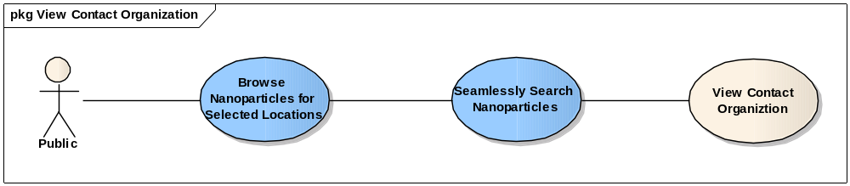
Figure 3-1 Public View Contact Organization High-Level Use Case Diagram

View Contact Organization for Selected Nanoparticle

Use Case Name | View Contact Organization for Selected Nanoparticle
Use Case ID | 12.1
Primary Actor | Public User
Brief Description | The View Contact Orgnization for Selected Nanoparticle use case allows the User to select one publicly available nanoparticle and to view its publicly available organization and contact information without logging in.
Trigger | The User desires to view contact organization of a publicly available nanoparticle.
Pre-conditions | The User successfully found a list of publicly available nanoparticles following use case 8.3, <Browse Nanoparticles for Selected Locations>, or use case 8.4, <Seamlessly Search Nanoparticle>, in the use case document, caNanoLab 1.4 Use Cases.
Flow of Events | - The User selects one nanoparticle from the nanoparticle search result list and clicks the link of the nanoparticle sample name.  - The Nanoparticle General Information page displays.  - The User clicks the View Detail link next to the Primary Contact Organization.
Post Conditions | Success Condition: The Contact Organization page is displayed with the following information:  - Organization Name  - Address  - List of public Point of Contact with name, email and phone number  Error Conditions:  EC1: System Error during Request Submission  EC2: Database Error during Document Retrieval
Alternative Flow | Error Conditions:  EC1: System Error  - A system error has occurred which prevents processing of all related request  - The User contacts application help support  EC2: Database Error  - A database error has occurred which prevents processing of the contact organization retrieval request  The System displays the error condition and application help contact information
Related Use Cases | Browse Nanoparticles for Selected Locations  Seamlessly Search Nanoparticle

3.2 Enhanced Contact Organization Submission and Update
Figure 3-2 provides a high-level diagram of the caNanoLab 1.5 use cases associated with submitting or updating contact organization information. caNanoLab 1.5 use cases are highlighted in blue and leverage existing caNanoLab use cases for Submit Contact Organization.
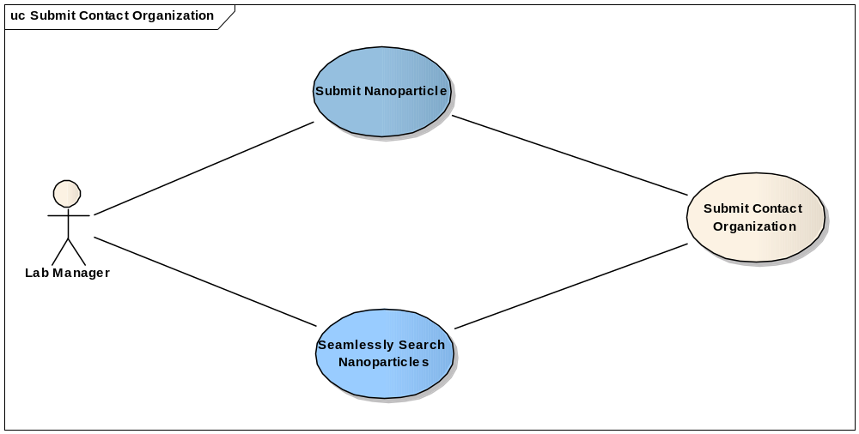
Figure 3-2 Contact Orgnization Submission High-Level Use Case Diagram

3.2.1 Submit or Update Contact Organization for Selected Nanoparticle

Use Case Name | Submit or Update Contact Organization for Selected Nanoparticle
Use Case ID | 13.1
Primary Actor | Data Curator
Brief Description | The Submit or Update Contact Organization for Selected Nanoparticle use case allows Data Curator to submit or update contact organization for a selected nanoparticle in the local system. The contact organization can be affiliated with one or multiple nanoparticles.
Trigger | The User desires to submit or update contact organization information.
Pre-conditions | - The User is logged into the System and has the privilege to submit/update contact organization.  - The User has found a list of nanopartilces from the local system.
Flow of Events | - The User selects one nanoparticle from the search result list and clicks the link of the nanoparticle sample name.  - The Nanoparticle General Information page displays.  - The User selects the primary contact organization from the Primary Contact Organization drop down menu.  - The User clicks the View Detail link next to the Primary Contact Organization drop down menu.  - The Contact Organization page is displayed with the organization information.  - The User clicks the edit button.  - The Submit Contact Organization page is displayed.  - The User enters organization Name.  - The User enters Address, City, State, Postal Code and Country information.  - The User enters Point of Contact information as described from step 11 to 16.  - The User enters First Name, M.I., and Last Name of the contact.  - The User selects contact Role, the contact role can be Investigator, Manufacturer, or a new role by selecting Other option.  - The User enters Email.  - The User selects Email Visibility.  - The User enters Phone Number.  - The User selects Phone Number Visibility.  - The User can add multiple contacts by clicking on Add Point of Contact link and repeat steps 11 to 16.  - The User enters Visibility for the Contact Organization.  - The User can add other organization by clicking on Add Other Organization link and then repeat steps 8 – 18.  - The User submits the contact organization into the system
Post Conditions | Success Condition: The User successfully submits the contact organization and returns to the Nanoparticle General Information page.  Error Conditions:  EC1: System Error during Request Submission  EC2: Database Error during Retrieval
Alternative Flow | Error Conditions:  EC1: System Error  - A system error has occurred which prevents processing of the submission request  - The User contacts application help support  EC2: Database Error  - A database error has occurred which prevents processing of the search request  - The System displays the error condition and application help contact information
Related Use Cases | Search Nanoparticle Sample
Issues/Notes | None

3.2.2. Submit New Contact Organization for Selected Nanoparticle

Use Case Name | Submit New Contact Organization for Selected Nanoparticle
Use Case ID | 13.2
Primary Actor | Data Curator
Brief Description | The Submit New Contact Organization for Selected Nanoparticle use case allows Data Curator to submit a new contact organization for a selected nanoparticle in the local system. The contact organization can be affiliated with one or multiple nanoparticles.
Trigger | The User desires to submit a new contact organization.
Pre-conditions | - The User is logged into the system and has the privilege to submit contact organization.  - The User has found a list of nanopartilces from the local system.
Flow of Events | - The User selects one nanoparticle and clicks the link of the nanoparticle sample name.  - The Nanoparticle General Information page displays.  - The User can not find the desired organization from the Primary Contact Organization drop down menu and wants to add a new one by selecting the Other option.  - The Submit Contact Organization page is displayed.  - The User enters organization Name.  - The User enters Address, City, State, Postal Code and Country information.  - The User enters Point of Contact information as described from step 8 to 13.  - The User enters First Name, M.I., and Last Name of the contact.  - The User selects contact role, the contact role can be Investigator, Manufacturer, or a new role by selecting Other option.  - The User enters Email.  - The User selects Email Visibility.  - The User enters Phone Number.  - The User selects Phone Number Visibility.  - The User can add multiple contacts by clicking on Add Point of Contact link and repeat steps 8 to 13.  - The User enters Visibility for the Contact Organization.  - The User can add other organization by clicking on Add Other Organization link and then repeat steps 5 – 15.  - The User submits the contact organization into the system
Post Conditions | Success Condition: The User successfully submits the contact organization and returns to the Nanoparticle General Information page.  Error Conditions:  EC1: System Error during Request Submission  EC2: Database Error during Retrieval
Alternative Flow | Error Conditions:  EC1: System Error  - A system error has occurred which prevents processing of the submission request  - The User contacts application help support  EC2: Database Error  - A database error has occurred which prevents processing of the search request  - The System displays the error condition and application help contact information
Related Use Cases | Search Nanoparticle Sample
Issues/Notes | None

3.2.3. Submit or Update Contact Organization for New Nanoparticle Sample

Use Case Name | Submit or Update Source for New Nanoparticle Sample
Use Case ID | 13.3
Primary Actor | Data Curator
Brief Description | The Submit or Update Contact Organization for New Nanoparticle Sample use case allows Data Curator to submit or update contact organization when submitting a new nanoparticle sample to the local system. The contact organization can be affiliated with one or multiple nanoparticles.
Trigger | The User desires to submit or update contact organization when submitting a new nanoparticle sample.
Pre-conditions | - The User is logged into the System and has the privilege to submit/update nanoparticle sample and source.  - The User clicks on Nanoparticles tab.  - The User clicks the link, Submit a New Nanoparticle Sample.  - The Submit Nanoparticle Sample page is displayed.
Flow of Events | - The User selects the primary contact organization from the Primary Contact Organization drop down menu.  - The User clicks the View Detail link next to the Primary Contact Organization drop down menu.  - The Contact Organization page is displayed with the organization information.  - The User clicks the edit button.  - The Submit Contact Organization page is displayed.  - The User enters organization Name.  - The User enters Address, City, State, Postal Code and Country information.  - The User enters Point of Contact information as described from step 9 to 14.  - The User enters First Name, M.I., and Last Name of the contact.  - The User selects contact Role, the contact role can be Investigator, Manufacturer, or a new role by selecting Other option.  - The User enters Email.  - The User selects Email Visibility.  - The User enters Phone Number.  - The User selects Phone Number Visibility.  - The User can add multiple contacts by clicking on Add Point of Contact link and repeat steps 9 to 14.  - The User enters Visibility for the Contact Organization.  - The User can add other organization by clicking on Add Other Organization link and then repeat steps 6 – 16.  - The User submits the contact organization into the system
Post Conditions | Success Condition: The User successfully submits or updates the contact organization and returns to the Submit Nanoparticle Sample page.  Error Conditions:  EC1: System Error during Request Submission  EC2: Database Error during Retrieval
Alternative Flow | Error Conditions:  EC1: System Error  - A system error has occurred which prevents processing of the submission request  - The User contacts application help support  EC2: Database Error  - A database error has occurred which prevents processing of the search request  - The System displays the error condition and application help contact information
Related Use Cases | Submit Nanoparticle Sample
Issues/Notes | None

3.2.4. Submit New Contact Organization for New Nanoparticle Sample

Use Case Name | Submit New Contact Organization for New Nanoparticle Sample
Use Case ID | 13.4
Primary Actor | Data Curator
Brief Description | The Submit new Contact Organization for New Nanoparticle Sample use case allows Data Curator to submit a new contact organization when submitting a new nanoparticle sample to the local system. The contact Organization can be affiliated with one or multiple nanoparticles.
Trigger | The User desires to submit or a contact organization when submitting a new nanoparticle sample.
Pre-conditions | - The User is logged into the System and has the privilege to submit/update nanoparticle sample and source.  - The User clicks on Nanoparticles tab.  - The User clicks the link, Submit a New Nanoparticle Sample.  - The Submit Nanoparticle Sample page is displayed.
Flow of Events | - The User can not find the desired organization from the Primary Contact Organization drop down menu and wants to add a new one by selecting the Other option.  - The Submit Contact Organization page is displayed.  - The User enters organization Name.  - The User enters Address, City, State, Postal Code and Country information.  - The User enters Point of Contact information as described from step 6 to 11.  - The User enters First Name, M.I., and Last Name of the contact.  - The User selects contact role, the contact role can be Investigator, Manufacturer, or a new role by selecting Other option.  - The User enters Email.  - The User selects Email Visibility.  - The User enters Phone Number.  - The User selects Phone Number Visibility.  - The User can add multiple contacts by clicking on Add Point of Contact link and repeat steps 6 to 11.  - The User enters Visibility for the Contact Organization.  - The User can add other organization by clicking on Add Other Organization link and then repeat steps 3 – 13.  - The User submits the contact organization into the system
Post Conditions | Success Condition: The User successfully submits or updates the contact organization and returns to the Submit Nanoparticle Sample page.  Error Conditions:  EC1: System Error during Request Submission  EC2: Database Error during Retrieval
Alternative Flow | Error Conditions:  EC1: System Error  - A system error has occurred which prevents processing of the submission request  - The User contacts application help support  EC2: Database Error  - A database error has occurred which prevents processing of the search request  - The System displays the error condition and application help contact information
Related Use Cases | Submit Nanoparticle Sample
Issues/Notes | None

4. Overall Requirements
The table below identifies the requirements for the caNanoLab 1.5 effort:

Prior-ity | Req # | Requirement | Use Case Name |  | Release #
 | 1.0 | The system shall allow Public Users to browse publicly available data without User login
 | 1.1.1 | The System shall allow users to view locally stored sources as well as the publicly available sources stored in remote caNanoLab grid services. |  |  | 1.5
 | 2.0 | The system shall allow Authorized Users to submit or update Sources with User login |  |  | 1.5

Sign Off

Approval

NCICBIIT Rep Print Name Date
NCL Rep Print Name Date
NCI OC Rep Print Name Date
SAIC Rep Print Name Date

