Architectural Review Checklist

caNanoLab

1.5.2

Revision Document History
Date | Version | Description | Author
04/17/10 | 1.0 | First draft | NCICB Dedicated Support

Table of Contents
1. Introduction 6
1.1 Purpose 6
1.2 Guidelines for Completing the ARC 6
2. Project Details 6
2.1 General Information 6
2.1.1 Project Description 6
2.1.2 Contact Information 6
2.1.3 Major Deployment Milestones 7
2.2 Architectural Details 7
2.2.1 High level architectural description: 7
2.2.2 High Level Design Diagram (If available): 7
2.2.3 Implementation language(s) used? 7
2.2.4 Will connections/requests to the application be session based (i.e. statefull versus stateless)? If so, is there any reason why application would not support “sticky session” load balancing? 8
2.2.5 Will the application be caching data? If so, what is being cached and how much data will be cached? 8
2.2.6 What data files will be created (if any)? How much data will be saved on an on going basis? 8
2.2.7 Will this application need a database schema(s) created on the NCICB infrastructure? If so, what is the maximum number of objects to be stored? 8
2.2.8 Are there any external/non-NCICB data sources that will be accessed by the application? 8
2.2.9 If this is a web-based application, what are the preferred virtual hosts names to be registered? 8
2.2.10 Any additional architectural details that may be of significance to the needed deployment environment. 8
2.3 Performance Requirements 9
2.3.1 Total number of users for this application? 9
2.3.2 Peak number of concurrent users? 9
2.3.3 Peak number of requests/minute? 9
2.3.4 Up time requirements? 9
2.3.5 Acceptable down time when recovering from major systems disaster? 9
2.4 NCICB Project Dependencies 9
2.5 Configuration Management Details 9
2.5.1 Version Control 9
2.5.2 Change Control 9
2.5.3 Migration to CVS 10
2.5.4 Users 10
2.5.5 Build Process 10
2.5.6 Other CM Needs 10
2.6 Additional Notes 10
3. System Requirements 10
3.1 Operating System 10
3.2 Software (Technology Stack) 10
3.2.1 Web Server: Apache 2.2.3 10
3.2.2 App Server: JBoss 4.0.5 10
3.2.3 Database Server: Oracle 9i or later and MySQL 5.0.x 10
3.2.4 Other software components: Java 1.5.x, Globus 4.0.3 and Tomcat 5.0.28 for grid service deployment. 10
3.3 Server Hardware 11
3.3.1 Server: 11
3.3.2 Minimum processor speed: 3.4GHz 11
3.3.3 Minimum memory: 4GB 11
3.3.4 Minimum local drive space: approx 20M(calab.war) / 20MB for temp files under JBOSS/temp which get deleted after session timeout/logoff. 11
3.4 Storage 11
3.4.1 Expected file server disk storage (in MB): 1G for file system storage 11
3.4.2 Expected database storage (in MB):10GB 11
3.4.3 Expected ftp storage (in MB): 0.0 11
3.4.4 Expected media/image storage (in MB):0.0 11
3.5 Load Balancing/Fault Tolerance 11
3.5.1 Does the application support load balancing? Not tested 11
3.5.2 Implement load balancing – YES, depending on results of testing. 11
3.6 Networking 11
3.6.1 Any application specific port assignments? NO 11
3.6.2 Any additional configuration? NO 11
3.7 Additional Notes 11
4. Proposed NCICB Deployment Environment (To be answered by systems team) 11
4.1 Hardware 11
4.2 Technology Stack 11
4.3 File Server 11
4.4 Database 11
4.5 Networking 12
4.6 Other Resources 12
5. Impact Assessment (To be answered by systems team) 12
5.1 Overview 12
5.2 Cost 12
5.3 Timeline to implement 12
5.4 Additional Notes 12
6. Acceptance 12
7. Appendix 1 - Future Systems Requirements 13
7.1 New Architecture Diagram 13
7.2 Notes on the design change 13
7.3 Hardware 13
7.3.1 Servers 13
7.3.2 Processor speed 13
7.3.3 Memory 13
7.3.4 Drive Space 13
7.4 Software (Technology Stack) 13
7.4.1 Web Server 13
7.4.2 App Server 13
7.4.3 Other components 13
7.5 Fault Tolerance (Redundancy) 13
7.5.1 Does the application support load balancing? 13
7.5.2 Implement load balancing – YES/NO 13
7.5.3 Load balancing requirements 13
7.5.4 Fault tolerance solution suggested 13
7.5.5 Additional requirements (if any) 13
7.6 Performance Enhancements 13
7.6.1 Processing Power 13
7.6.2 Memory 13
7.6.3 I/O 13
7.6.4 Other needs 13

Introduction

Purpose
The purpose of the Architectural Review Checklist (ARC) is to help identify the deployment environment (both hardware and software components) necessary for an application to execute optimally within the NCICB IT infrastructure. The ARC is considered to be a dynamic artifact for any NCICB project and should be maintained in the configuration library (i.e. CVS) for each project. For new projects, this document template will be automatically checked into the projects repository by the SCM team upon project initiation. The ARC should be reviewed on at least a quarterly basis to capture any application design changes that may effect the deployment environment necessary for optimal performance.

Guidelines for Completing the ARC
The ARC is divided into 4 main sections. The first section (Project Details) is meant to capture general information about the project. The project development team should fill out the Project Details section and return it to the systems team. The second section (Systems Requirements) is meant to capture details of specific system requirements for the project. Both the development and system teams will preferably answer the Systems Requirement section jointly. However, depending on the development teams familiarity with the NCICB infrastructure, they may choose to answer either all or parts of this section on their own. The third section (Planned Deployment Environment) specifies the proposed deployment environment for the application and is to be answered by the systems team based on the response to section 1 & 2. Finally, the last section (Impact Assessment) describes the impact (additional hardware/software costs, staffing resources…) to the existing NCICB IT infrastructure in order to support this application. Upon completion of the Deployment Environment and Impact Assessment sections, the systems team will return the ARC to the development team for final review and comments.

Project Details

General Information

Project Description

The caNanoLab effort is collaboration between the NCI Center for Biomedical Informatics and Information Technology (NCICBIIT), and the Nanotechnology Characterization Laboratory (NCL), and Cancer Centers of Nanotechnology Excellence (CCNEs). The project goal is to develop a data portal that allows researchers to share information on nanoparticles including the composition of the particle, the functions (e.g. therapeutic, targeting, diagnostic imaging) of the particle, the characterizations of the particle from physico-chemical (e.g. size, molecular weight, surface) and in vitro (e.g. cytotoxicity, blood contact) nanoparticle assays, and the protocols of these characterization. The data portal is designed to facilitate information sharing in the biomedical nanotechnology research community to expedite and validate the use of nanotechnology in biomedicine under the spirit of the NCI’s cancer Biomedical Informatics Grid(caBIG™) program.

Contact Information
Title | Name | Phone | Email
Project Manager | Sharon Gaheen | 301.451.6345 | settneks@mail.nih.gov
Team Lead/Architect | Sue Pan – Tech Lead | 301.443.6226 | pansu@mail.nih.gov
SCM Coordinator | Sue Pan | 301.443.6226 | pansu@mail.nih.gov

Major Deployment Milestones
Milestone | Date
Planned Release to QA | April 1, 2010
Planned Release to Staging | April 23, 2010
Planned Release to Production | May 1, 2010

Architectural Details

High level architectural description:
caNanoLab is a J2EE n-tier web application built with Struts and Hibernate Frameworks. The client tier consists of web browsers serving HTMLs, JavaScripts, images and Cascading Style Sheets (CSS). The presentation tier is implemented using Java Server Page (JSPs), servlets (Struts ActionServlet, actions and action forms), tag libraries (Struts tag library, Java Standard Tag Library (JSTL), and Display table tag library). The business tier is implemented using Java classes including business domain objects, data transfer objects, service classes handling business logics and utilities classes. The persistence tier is implemented using Hibernate’s object to relational mapping mechanism. The resource tier consists of a database and a file repository located on a file system.

High Level Design Diagram (If available):
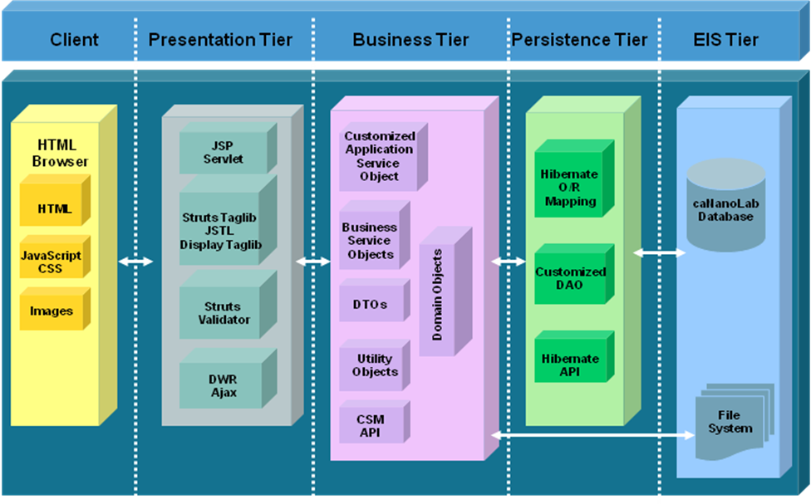

Implementation language(s) used?
Java

Will connections/requests to the application be session based (i.e. statefull versus stateless)? If so, is there any reason why application would not support “sticky session” load balancing?

The caNanoLab application makes use of HTTP sessions in some cases to maintain the states between client browser and the web server. No known reason why sticky session load balancing cannot be used, but it would need to be thoroughly tested before production deployment.

Will the application be caching data? If so, what is being cached and how much data will be cached?

The caNanoLab application is built based on caCORE SDK 4.0 and uses its default configurations for EHCache (Easy Hibernate Cache) and store its cache files on disk. The default location of these files is set to a temporary directory mapped by the “java.io.tmpdir” property. As of caNanoLab release 1.5.1, there are 107 cache files (one for each class) generated by the cache stored in the temporary directory.

The caNanoLab application itself caches caNanoLab grid nodes (hostnames and URLs) discovered from the production grid index server and the public data counts from each of the grid nodes in the application context in memory. The default HTTP response caching by HTML browsers is used in most pages except in a few cases where cache-control setting is set to private.

What data files will be created (if any)? How much data will be saved on an on going basis?

The caNanoLab application allows users to upload a variety of file types, e.g. images, spreadsheet, graphs, documents, etc. These files will be uploaded to a directory on the NCI CBIIT production server. We currently have about 120 MB of data uploaded so far. We expect the amount of data uploads to double this size in the next year.

Will this application need a database schema(s) created on the NCICB infrastructure? If so, what is the maximum number of objects to be stored?

Yes. The current database schema has less than 100 tables.

Are there any external/non-NCICB data sources that will be accessed by the application?

No.

If this is a web-based application, what are the preferred virtual hosts names to be registered?

cananolab.nci.nih.gov

Any additional architectural details that may be of significance to the needed deployment environment.

CSM 4.1 and UPT 4.1 are used in the application for authentication and authorization. A separate UPT needs to be deployed along with the web application. A CSM schema is created within the application.

Performance Requirements

Total number of users for this application?

Approximately ~30 user accounts.

Peak number of concurrent users?

We expect 15 concurrent hits.

Peak number of requests/minute?

Less than 50 requests/minute.

Up time requirements?

24/7. Starting from release 1.5.1, the caNanoLab NCI CBIIT instance will be a central instance hosting

Acceptable down time when recovering from major systems disaster?
24 hours preferably in a weekend.

NCICB Project Dependencies
caCORE SDK, CSM, UPT, EVS, caGrid 1.3

Configuration Management Details
Our application code base is maintained by SVN under the module name cananolab. We generate different SVN release tags for different deployments, e.g. QA tags for different QA builds, DOWNLOAD tags for different download builds. We also generate SVN branches when we need to work on two releases at the same time.

Version Control
What version control software are you currently using, if any?
SVN

Change Control
What are your current change control practices? What procedures are in place to determine whether to implement a change request?
The caNanoLab project is being implemented via an iterative process following the RUP paradigm. Change control is implemented via direct communication with the NCL and NCI representatives at weekly and monthly meetings and with CCNEs researchers throughout the course of the effort. The NCICB will set priorities based on end user requirements.

Migration to CVS
Already in SVN.

Users
Provide a list of all developers who require access to your repository modules.
Sue Pan
Le Thai
Sharon Gaheen
Please see others at the Gforge site http://gforge.nci.nih.gov/projects/calab/

Build Process
We use Ant for building the web application.

Other CM Needs
None.

Additional Notes

System Requirements

Operating System
Linux

Software (Technology Stack)

Web Server: Apache 2.2.3

App Server: JBoss 4.0.5

Database Server: MySQL 5.0.x

Other software components: Java 1.5.x, as well as Globus 4.0.3 and Tomcat 5.0.28 for grid service deployment.

Server Hardware

Server:

Minimum processor speed:

Minimum memory: 1GB

Minimum local drive space: approx 2M(calab.war) / 20MB for temp files under JBOSS/temp which get deleted after session timeout/logoff.

Storage

Expected file server disk storage (in MB): 1G for file system storage

Expected database storage (in MB):10GB

Expected ftp storage (in MB): 0.0

Expected media/image storage (in MB):0.0

Load Balancing/Fault Tolerance

Does the application support load balancing? Not tested

Implement load balancing – YES, depending on results of testing.

Networking

Any application specific port assignments? NO

Any additional configuration? NO

Additional Notes

Proposed NCICB Deployment Environment (To be answered by systems team)

Hardware
<<dev, qa, staging, production servers to be used>>

Technology Stack
<<specific technology stack to be used>>

File Server
<<space allocation on big IP, NFS mount points, initial size allocation…>>

Database
<<database server to used, schema names to be created, initial size, maximum size…>>

Networking
<<e.g. any BigIP configuration necessary, …>>

Other Resources
<<e.g. ftp server access, media server access, …>>

Impact Assessment (To be answered by systems team)

Overview

Cost

Timeline to implement

Additional Notes

Acceptance
Project Lead ( ) | Project Coordinator – NCICB ( )
Systems Team | SCM Administrator

Appendix 1 - Future Systems Requirements
In this section, describe any projected future anticipated requirements for your system.

New Architecture Diagram

Notes on the design change

Hardware

Servers

Processor speed

Memory

Drive Space

Software (Technology Stack)

Web Server

App Server

Other components

Fault Tolerance (Redundancy)

Does the application support load balancing?

Implement load balancing – YES/NO

Load balancing requirements

Fault tolerance solution suggested

Additional requirements (if any)

Performance Enhancements

Processing Power

Memory

I/O

Other needs

