Software Requirements Specification (As-Built)

cancer Laboratory Analysis Workbench (caLAB)
NCICB, NCL, LPG

DOCUMENT REVISION HISTORY

Version Number | Date | Description
1.0 | December 10, 2005 | - Initial draft containing high-level use cases
1.1 | December 22, 2005 | - Completion of file management use cases
1.2 | January 11, 2006 | - Updated file management use cases
1.3 | January 18, 2006 | - Updated to include LPG comments  - Updated file management use cases based on customer feedback
1.4 | February 16, 2006 | - Re-structured the document to address the modification of file management use cases to workflow use cases  - Added new use cases supporting sample management

Background/Summary
The cancer Laboratory Analysis Bench (caLAB) effort involves the design and development of core components of a caBIG compatible Laboratory Information Management System (LIMS). The effort also involves the deployment of a reference implementation of a core caLAB for operation in the Nanoparticle Characterization Laboratory (NCL). As such, the effort involves the development of core LIMS functionality that is of priority to the NCL with an understanding that prioritized NCL needs are also core LIMS features.
This document serves as an as-built document that identifies the core caLAB use cases (adaptive workflow, sample management, security, etc.) prioritized based on immediate NCL needs (file/meta data management). It is intended that this document serve as a living document that is modified throughout the iterative development life cycle.

Table of Contents
Requirements Specification (As-Built) 1
cancer Laboratory Analysis Workbench (caLAB) 1
Background/Summary 1
1 Introduction 4
1.1 Overview 4
1.1.1 caLAB 4
1.1.2 NCL Reference Implementation 5
1.2 Document Purpose 6
1.3 Related Documents 6
2 Actors and Authorization 7
2.1 Core caLAB Actors 7
2.2 NCL LIMS Actors 8
3 Use Cases 9
3.1 Login 10
3.1.1 Use Case Error! Bookmark not defined.
3.1.2 Supplemental Requirements Error! Bookmark not defined.
3.2 Manage File System Error! Bookmark not defined.
3.2.1 Manage File System Error! Bookmark not defined.
3.2.2 Navigate File System Error! Bookmark not defined.
3.2.3 Upload File Error! Bookmark not defined.
3.2.4 Download File Error! Bookmark not defined.
3.2.5 Mark File Delete Error! Bookmark not defined.
3.2.6 Search Error! Bookmark not defined.
3.3 Manage Folder Error! Bookmark not defined.
3.3.1 Create Folder Structure Error! Bookmark not defined.
3.3.2 Create New Folder Error! Bookmark not defined.
3.3.3 Rename Folder Error! Bookmark not defined.
3.3.4 Mark Folder Delete Error! Bookmark not defined.
4 General Requirements 32
4.1 Requirements Prioritization 32
4.2 NCL LIMS Requirements 34
5 Data Definitions 36
5.1 Common Data Elements (CDEs) 36
6 Sign Off 38
6.1 Approval 38
6.1.1 Iteration: 1.0 38
7 Appendix 39
7.1 Appendix A – Other LIMS Requirements 39

Introduction

Overview

caLAB
The primary goal of the caLAB effort is to develop core components of a Laboratory Information Management System (LIMS) that are compliant with the cancer Biomedical Informatics Grid (caBIG) data and technology standards and principles. Specifically, the effort involves:
- Developing a core LIMS based on caBIG principles of open source, open access, and interoperability (syntactic and semantic) via standard Common Data Elements (CDEs) and terminology
- Developing a core LIMS that can be utilized by a variety of laboratories operating diverse experiment modalities
- Engineering a core generic LIMS that can be customized and extended to support laboratory specific requirements
- Establishing an Open Development Initiative (ODI) that allows LIMS developers to contribute LIMS customizations and enhancements to the end user community
- Creating an affordable (free) “near” commercial grade LIMS that allows laboratories to focus on scientific research and scientific investments
The main components of a core LIMS include:

Component | Description
Adaptive Workflow | Supports the definition of laboratory specific workflows and workflow tasks (running assays, processing via laboratory instruments, analyzing results, etc.)
Sample Management | Provides the capability of accessioning samples, creating sample containers (e.g. plates), assigning controls, creating aliquots, and processing samples within a laboratory experiment
Reporting | Supports the generation of standard and custom reports and graphs, and provides a mechanism for users to export reports in a common spreadsheet format
Instrument Integration | Provides a generic module supporting bi-directional integration of laboratory instruments and analytical software
Inventory Management | Supports laboratory inventory tracking and allows authorized users to check-in/check-out samples and other laboratory supplies (e.g. reagents) to/from storage devices
Document Management | Controls basic file and folder management capabilities including file upload, download, and versioning
Meta Data Extensions | Allows authorized users to assign and create meta data fields in all aspects of the workflow (result annotations, sample annotations, QA/QC parameters)
Administrative/Security | Controls use access via user authentication and role based authorization
Configuration/Installation | Allows administrators to install and configure the LIMS for use in the laboratory environment
Typically, these core components are leveraged, to varying degrees, throughout the laboratory workflow process. Figure 1-1 provides an example laboratory process

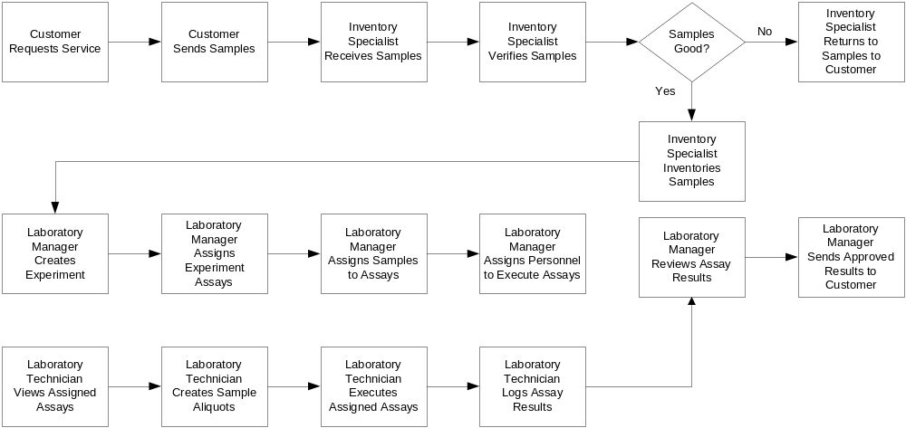
Figure 1-1 Example Laboratory Workflow

An example laboratory workflow [Figure 1-1] may involve a customer requesting laboratory services (e.g. applicant requesting nanoparticle validation, customer requesting genotyping services) and sending samples along with sample information to the performing laboratory. The performance site receives, inventories, and validates the samples. If the samples are valid, a laboratory manager creates the requested experiments, establishes the assays associated with the experiment, and assigns samples and laboratory personnel to the experiment. If the samples are not valid, the performance site returns the samples to the customer along with a description of the occurring issues. Once a lab manager creates an experiment and assigns valid samples and personnel to execute the experiment, that responsible lab technician performs the assay, creates aliquots of the samples, and executes the assay. Test results are logged into the system during assay execution and the lab results are reviewed and analyzed by the lab manager. Approved results are then provided back to the customer.
Although Figure 1-1 represents an example laboratory workflow, other laboratories may have different workflows, which may include analyzing results using specific analysis software, interfacing with specific laboratory equipment, bar coding, etc. As such, it is necessary to create a generic LIMS with an adaptive workflow component that can be extended to support diverse laboratories.
Working towards the implementation of a generic LIMS goal, caLAB will be implemented in an iterative fashion focusing on the immediate needs of the initial reference implementation laboratory, the Nanoparticle Characterization Laboratory (NCL), as defined in the caBIG LIMS Phase 1 Scope Document and the sub-section that follows. The caLAB system will be designed for extensibility to accommodate other laboratory needs that may be implemented in future efforts by external laboratories. A list of potential future LIMS functionality that has been identified by other laboratories is available in Appendix A of this document.

NCL Reference Implementation

To validate caLAB in a real laboratory setting, the effort involves deploying a reference implementation of caLAB at the Nanoparticle Characterization Laboratory (NCL). As such, core caLAB requirements have been prioritized to meet the immediate needs of the NCL. The prioritized requirements include support for the following core functionality in the initial iteration:
- Basic Workflow – Allows NCL researchers to execute a defined and configuratble laboratory workflow. Execution includes supporting assay inputs (aliquots, files) and outputs (file).
- Sample Management – Allows NCL researchers to accession samples and/or create sample aliquots for use within an assay.
- Search – Generic search function that allows researchers to search workflow components and samples.
While the above functionality will primarily support the immediate needs of the NCL, this functionality is essential in a core LIMS and as such, the use cases and design will be engineered in support of generic laboratory needs. It is intended that the system will be engineered in an iterative fashion focusing primarily on immediate NCL needs in the initial iteration. Sub-sequent iterations will support adaptive workflow, nanoparticle characterization management, and security as this core functionality is of priority to the NCL and other laboratories.

Document Purpose
The purpose of this document is to provide a high-level use case diagram of caLAB use cases and identify the detailed use cases and requirements associated with each iteration. Due to the iterative nature of the caLAB development cycle, this document will serve as an as-built document that will be modified in each software iteration to include the detailed requirements and use cases associated with each iteration.

Related Documents

Document Name | Version | Location
caBIG LIMS Phase 1 Scope | 1.1 | https://ncicbintra.nci.nih.gov/lims/caBIG/p1req_scope.doc
caBIG LIMS Requirements Presentation | 1.0 | https://ncicbintra.nci.nih.gov/lims/caBIG/cabig_lims.ppt
NCL LIMS Requirements Spreadsheet | 1.0 | https://ncicbintra.nci.nih.gov/lims/caBIG/ncl_lims.xls
caBIG Compatibility Guidelines | 2.0 | https://cabig.nci.nih.gov/guidelines_documentation/caBIGCompatGuideRev2_final.pdf

Actors and Authorization

Core caLAB Actors
The table below describes the core caLAB actors as well as the intended authorization. It is intended that authorization levels, although defined below, will be configurable to accommodate diverse laboratory actor definitions. Authorization will not be implemented until completion of the security module.

Actor | Description | Authorization
User | Base user in which all LIMS actors are derived | Configurable
PI/Lab Director | Individual who is responsible for the design, scientific/technical conduct, administrative conduct, and reporting of research projects or customer service projects completed in the designated laboratory. The PI/Lab Director acts as the primary decision-maker and coordinates all lab activities either directly or indirectly. | Create, Edit, Delete, Read Experiment Protocols and Results
Lab Manager | Individual who is responsible for the overall development and implementation of the laboratory policies, projects, and services. The Lab Manager may perform experiments and/or supervise others to run experiments. The Lab Manager also analyzes results, writes reports, schedules equipment and personnel. Other responsibilities may include quality control, compliance adherence and hiring and training of personnel. | Create, Edit, Delete Experiment Protocols; Read Experiment Protocols and Results
Lab Researcher | Individual who is responsible for sample preparation, running experiments/assays, recording results and observations, quality control, maintaining equipment, ordering supplies and cross-training other personnel. | Edit, Read Experiment Protocols and Results
Administrator/Superuser | The LIMS administrator installs and configures the system | All privileges
Staff Scientist | Individual who performs experiments and/or supervises others to run experiments. The Staff Scientist also analyzes results, writes reports, schedules equipment and personnel. Other responsibilities may include quality control, compliance adherence and hiring and training of personnel. | Create, Edit, Delete Experiment Protocols for which they are responsible; Read Experiment Protocols and Results
Collaborator | Individual who performs specific experiments of relevance to the laboratory, records results, and drafts reports | Uploads results and reports, has access to specific projects
Customer | Individual who provides samples, reviews data/receives reports | Uploads results and reports, has access to specific projects after data curation
Inventory Manager | Individual who enters supplies and reagents into the LIMS | Edit and Read Inventory

NCL LIMS Actors
The table below describes NCL specific actors and authorizations. NCL actors are extensions of the core caLAB actors.

Actor | Description | Authorization
PI/Lab Director (NCL Director) | The NCL Director monitors NP progress through cascade, integrates programmatic issues, communicates with applicant, communicates with OTIR directorate | Create, Edit, Delete, Read Assays and Assay Results
Staff Scientist  (Chemist) | The NCL chemist manages NP inventory and aliquots, decides which assays to run for physical characterization, analyzes results, writes reports, schedules equipment and personnel | Create, Edit, Delete Chem Assays;  Read Assays and Assay Results
Staff Scientist  (Immunologist) | The NCL immunologist decides which assays to run for immunotoxicity, analyzes results, writes reports, schedules equipment and personnel | Create, Edit, Delete Immuno Assays;  Read Assays and Assay Results
Staff Scientist  (Toxicologist) | The NCL toxicologist decides which assays to run for general toxicity, conducts in vivo studies, analyzes results, writes reports, schedules equipment and personnel | Create, Edit, Delete Tox Assays; Read Assays and Assay Results
Lab Technician (Lab Researcher) | The NCL lab technician performs manual manipulations (assays), enters/responsible for raw data, maintains supply inventory (reagents, consumables) | Edit, Delete, Read Assays and Assay Results
Administrator | The NCL administrator installs and configures the system | All Privileges
Collaborator  (Internal NCI) | The internal NCL collaborator (e.g. DTP) runs specific assays, drafts reports | Uploads results and reports, has access to specific projects
Collaborator  (External NCI, NIST Scientist) | The external NCL collaborator runs specific assays, drafts reports, and specifies physical characterizations | Uploads results and reports, has access to specific projects
Customers  (Applicant, Vendors) | The NCL applicant/vendor provides nanoparticles, reviews data, receives reports | Uploads results and reports, has access to specific projects after data curation

Use Cases
Figure 3-1 provides a high-level diagram of the Core LIMS use cases. Use cases intended for the initial release are indicated in yellow and are further described in the subsequent sections.
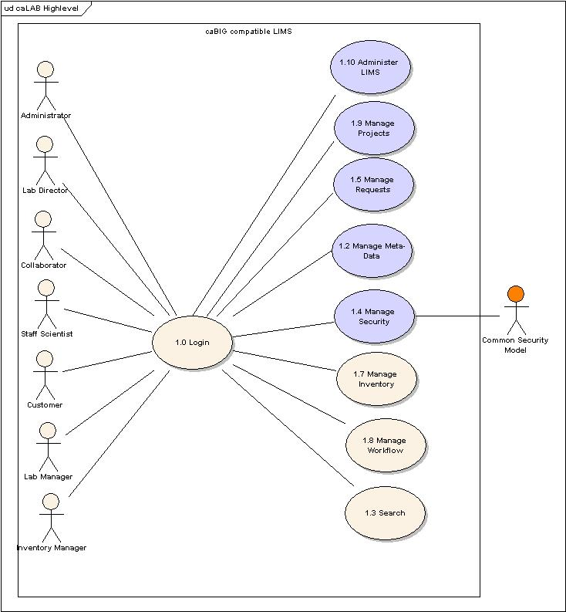
Figure 3-1 High-Level Use Case Diagram

Login

Use Case Name | Log Into the System
Use Case ID | 1.0
Primary Actor | Users, System
Brief Description | The Login Use Case allows users to authenticate and access the system
Trigger | User has system access
Pre-conditions | User has accepted the security encryption certificate
Flow of Events | - The user enters login information including username and password  - The user submits the Login request  - The system authenticates the login information  - The system allows grants the authenticated user access to the LIMS
Post Conditions | Success Condition: User is granted entry.  Error Condition: Authentication Failed  Error Condition: Invalid Login Information  Error Condition: System Error
Alternative Courses of Action – Invalid User  Invalid Password  System Error | If a validation error occurs, the system throws an exception, displays an error message, and re-displays the Login page for data entry  a. Authentication Failed  - Display user authentication error  - Redirect user to Login Page and/or Administrator Link  b. Invalid Login Information  - Display invalid password for user error  - Redirect user to Login Page and/or Administrator Link  c. System Error  - Display System Error message  - Redirect user to Login Page and/or Administrator Link
Issues | - The first iteration will not include support for user authorization as this will be implemented upon completion of the security module  - The first iteration will not include support for semi-automated user account as this will be implemented upon completion of the security module  - The first iteration will not include a semi-automated process for requesting an account as this will be implemented upon completion of the security module  - System auditing will not be supported until completion of the security module.

Manage Workflow
Figure 3-2 provides a high-level diagram of the Manage File use cases. Use cases intended for the initial release are indicated in yellow and are further described in the subsequent sections.
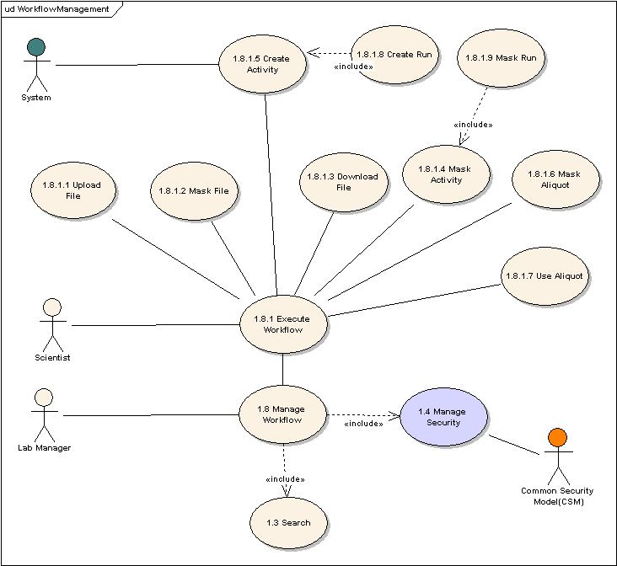
Figure 3-2 Workflow Management Use Cases

Use Case Name | Manage Workflow
Use Case ID | 1.8
Primary Actor | User
Brief Description | The Manage Workflow use case allows users to execute the workflow, upload & download experiment files, create runs, mask files & folders, and navigate the virtual network file system.
Trigger | The User selects the Manage Workflow operation
Pre-conditions | - The System is correctly configured to a virtual network file system.  - The User has authorized access into the virtual network file system.  - The User is logged into the System.  - The file system is displayed to the user.
Flow of Events | - The User may either navigate the virtual network file system (by executing USECASE: Navigate Workflow) or perform operation on assay files or folders.  - The system displays the virtual network file system (i.e., made up of files and folders) as well operations that may be performed on files/folders.  - The User selects the desired file or folder to which the Manage Workflow operation will be performed.  - The User selects from one of the following operations on files or folders:  - File  Upload File  Download File  Mask File  - Folder  Create New Folder  Create Run  Rename Folder  Mask Folder
Post Conditions | Success Condition: The User successfully selects a Manage Workflow operation.  Error Conditions:  None
Alternative Flow | Alternate Conditions:  None  Error Conditions:  None
Related Use Cases | Create New Folder  Download File  Mask File  Mask Folder  Navigate Workflow  Rename Folder  Upload File
Issues | None

Navigate Workflow

Use Case Name | Navigate Workflow
Use Case ID | TBD
Primary Actor | User
Brief Description | The Navigate Workflow use case allows users to navigate a hierarchical file system (i.e., made up of files and folders) in which assay files are stored. The file structure is based on template rules governed by a Standard Operating Procedure (SOP).
Trigger | The User selects the Manage Workflow operation and desires to navigate a file system.
Pre-conditions | - The System is correctly configured to a virtual network file system.  - The User has authorized access into the virtual network file system.  - The User is logged into the System.  - By default the file system is displayed alphabetically to the user.
Flow of Events | - The User selects to navigate the file system.  - The User clicks through a series of folders to navigate through the file system.
Post Conditions | Success Condition:  SC1: The User successfully navigates through the file system.  Error Conditions:  EC1: Virtual Network Incorrectly Configured.  EC2: Network connection is lost with underlying virtual network file  system.
Alternative Flow | Alternate Conditions:  None  Error Conditions:  EC1: [Virtual Network File System Incorrectly Configured] <Flow Of Event 2>  - IF the virtual file system is incorrectly configured to the virtual network file system, THEN the system administrator correctly configures the system to correctly recognize the virtual network file system.  - The System and the underlying virtual network file system are synchronized.  EC2: [Network Connect Lost] <Flow Of Event 2>  - IF the network looses connection with the virtual network file system THEN:  - The system administrator is notified  - The system administrator restores the network connection.  - The System and the underlying virtual network file system are synchronized.
Related Use Cases | Manage Workflow
Issues | None

Upload File

Use Case Name | Upload File
Use Case ID | 1.8.1.1
Primary Actor | User
Brief Description | The Upload File use case allows a User to upload one or more nano-particle assay files into the System. Folders/directories in which a file may be uploaded is defined by the Manage Workflow SOP.
Trigger | A User selects Upload File from the Manage Workflow operation to upload a file into the System.
Pre-conditions | - The System is correctly configured to a virtual network file system.  - The User has authorized access into the virtual network file system.  - The User is logged into the System.
Flow of Events | - The User selects the Manage Workflow operation.  - The System displays the virtual network file system (i.e., made up of files and folders).  - On the virtual network file system, the User selects a target folder into which the desired file will be uploaded and a list of operations are displayed on which the user can click.  - The User selects the Upload operation.  - The System displays the User’s local file system (i.e., made up of files and folders).  - The User navigates the local file system and selects one or more files or an entire folder to upload and clicks to confirm the selection.  - A YES/NO confirmation screen displays a list of files indicating what will be uploaded into the system.  - IF the user selects YES:  - The System uploads the selected file(s) or folder FROM the User’s local file system TO the virtual network file system.  - The System assigns the following file level meta data to the uploaded file(s):  - Creation Date  - File Status (e.g., Masked)  - Owner  - Submission Date  - Submitter  - IF the user selects NO:  - The Upload operation is cancelled.  - The user remains at the current screen.
Post Conditions | Success Conditions:  SC1: The selected assay file list is successfully uploaded to the System.  SC2: By default, any meta data associated with the uploaded file is assigned to the target upload folder.  Error Conditions:  EC1: General Upload Error Occurs  EC2: Network Connection is Lost
Alternative Flow | Alternate Conditions:  None  Error Conditions:  EC1: [General Upload Error] <Flow of Event 8>]  - An error occurs during upload.  - Files that erred during upload will not be uploaded.  - An error message displaying the files that were uploaded and those that did not upload will be displayed and logged to the system (e.g., for audit)  EC2: [Network Connection Lost] <Flow of Event 8>]  - IF the system looses connection while uploading file(s) to the virtual network file system THEN:  - The selected file(s) are not uploaded.  - The system administrator is notified by email.  - Files that erred during upload are not uploaded.  - An error message displays the files that were uploaded and those that did not upload; and logs this to the system (e.g., for audit)  - The system administrator restores the network connection.  - When the System and the underlying virtual network file system are synchronized then the User may re-try to upload the file(s).
Related Use Cases | Download File  Manage Workflow  Navigate Workflow
Issues | None

Download File

Use Case Name | Download File
Use Case ID | 1.8.1.3
Primary Actor | User
Brief Description | The Download File use case allows a User to download one or more selected file(s) from the System to a local file system.
Trigger | A User selects one or files to download from search results or from the virtual network file system.
Pre-conditions | - The System is correctly configured to a virtual network file system.  - The User has authorized access into the virtual network file system.  - The User is logged into the System.
Flow of Events | - The user selects to download one or more files (e.g., from the virtual network file system, search results window, etc.).  - The System displays the User’s local file system.  - User clicks a target folder in the local file system into which the selected file(s) will be downloaded.  - A YES/NO confirmation screen displays the file(s) that will be downloaded to the system.  - IF the user selects YES THEN  - The System downloads the selected file(s) FROM the virtual network file system TO the User’s local file system.  - If more than one file is selected, the System will:  - Compress/”zip” files.  - Execute the download (as indicated in 5a).  - IF the user selects NO THEN the list of files are not downloaded and the System remains at the current screen.
Post Conditions | Success Conditions:  SC1: The selected assay file list is successfully downloaded to the User’s local file system.  Error Conditions:  EC1: General Upload Error Occurs  EC2: Network Connection is Lost
Alternative Flow | Alternate Conditions:  None  Error Conditions  EC1: [General Upload Error] <Flow of Event 4>]  - An error occurs during download.  - Files that erred during download will not be downloaded.  - An error message displaying the files that were downloaded and those that did not download will be displayed and logged to the system (e.g., for audit)  EC2: [Network Connection Lost] <Flow of Event 4>]  - IF the system looses connection while downloading file(s) from the virtual network file system to the User’s local file system THEN:  - The selected file(s) are not downloaded.  - The system administrator is notified by email.  - Files that erred during download are not downloaded.  - An error message displays the files that were downloaded and those that did not download; and logs this to the system (e.g., for audit)  - The system administrator restores the network connection.  - When the System and the underlying virtual network file system are synchronized then the User may re-try to download the file(s).
Related Use Cases | Manage Workflow  Navigate Workflow  Upload File
Issues | None

Mask File

Use Case Name | Mask File
Use Case ID | 1.8.1.2
Primary Actor | User
Brief Description | The Mask File use case allows a User to mark a file to be hidden from a search results set. File Masking is representative of hiding the file from view. In this use case the file IS NOT deleted.
Trigger | The User selects a file to mask.
Pre-conditions | - The System is correctly configured to a virtual network file system.  - The User has authorized access into the virtual network file system.  - The User is logged into the System.
Flow of Events | - The User selects the Workflow operation.  - The System displays the virtual network file system (i.e., made up of files and folders).  - The User navigates to the desired experiment file in the virtual network file system and clicks the desired file.  - The System displays a list of operations that may be performed on the file.  - The user clicks the Mask File operation.  - The System queries the user (i.e., Yes/No) to confirm the Mask File operation.  - IF the user selects to indicates “Yes” THEN The:  - System makes sure that files are not being used by any other project/experiment.  - System marks the selected file with a File Status of “Masked”  - System makes invisible the selected file from the virtual network file system.  ELSE the System will not execute the Mask File operation.
Post Conditions | Success Condition:  SC1: The selected assay file is successfully marked as masked.  Alternate Condition:  AC1: Manually Delete File(s)  Error Condition:  None
Alternative Flow | Alternate Condition:  AC1: [Manually Delete Files]: <Flow of Event 8]  - A decision is made to delete the file(s) that have the status “Masked”.  - A report listing the file(s) that need to be manually deleted permanently from the system are sent to the system administrator.  - The system administrator receives the report and permanently deletes the file(s) that appear on the report from the system.  - The file(s) with a status of “Mask” are deleted from the System.  Error Conditions:  N/A
Related Use Cases | Manage Workflow  Mask Folder  Navigate Workflow
Issues | None

Mask Run

Use Case Name | Mask Run
Use Case ID | 1.8.1.9
Primary Actor | User
Brief Description | The Mask Folder use case allows a User to mark a folder as “Masked” and thus hidden from a search results set. Marking the folder as Masked also marks files contained within the folder as masked.  Folder Masking is representative of hiding the folder from view. In this use case the folder IS NOT deleted.
Trigger | The User selects a folder to mask.
Pre-conditions | - The System is correctly configured to a virtual network file system.  - The User has authorized access into the virtual network file system.  - The User is logged into the System.
Flow of Events | - The User selects the Manage Workflow System operation.  - The System displays the virtual network file system (i.e., made up of files and folders).  - The User selects the desired folder in the virtual network file system to mask.  - The User selects the Mask Folder operation.  - The System queries the user (i.e., Yes/No) to confirm the Mask Folder operation and displays a list of files within the folder that will also be assign the Mask status.  - IF the user selects Yes THEN The:  - System marks the selected folder with a File Status of “Masked” and executes (Use Case: Mask File) to mask files contained in the folder.  - System makes invisible the selected folder and files contained in the folder from the virtual network file system.  ELSE the System will not mark the selected folder with a File Status of “Masked”.
Post Conditions | Success Condition:  SC1: The selected folder is successfully marked with a status of “Masked”.  SC2: The selected folder is made invisible to the System.  Error Condition:  None
Alternative Flow | Alternate Conditions:  None  Error Conditions:  None
Related Use Cases | Manage Workflow System  Mask File  Navigate Workflow
Issues | None

Create Workflow

Use Case Name | Create Workflow
Use Case ID | TBD
Primary Actor | User
Brief Description | The Create workflow provides steps for submitting a biological sample, tracking samples/aliquots, markers, and reagents. Within Create Workflow, protocols and experimental details may be tracked at every step in the workflow. Additionally, the System provides numerous paths through the workflow, enabling the laboratory to tailor the experiment design to specific needs.  For this iteration, the Create Workflow use case will entail the System automatically loading a template on start-up that reflects a predefined workflow structure.
Trigger | The user logs into the System.
Pre-conditions | - The System is correctly configured to a virtual network file system.  - The User has authorized access into the virtual network file system.  - The Workflow template has been correctly created and saved to the system.
Flow of Events | - The System loads a predefined workflow template.  - The System displays the workflow as a set of folders that a user may navigate (by execute USECASE: Navigate Workflow).
Post Conditions | Success Condition:  SC1: The Workflow is successfully created and loaded into the system.  Error Condition:  EC1: Workflow Template Not Found
Alternative Flow | Alternate Conditions:  None  Error Condition  EC1: [Workflow Template Not Found] <Flow of Event 1>]  - The System cannot locate the Workflow template.  - The System displays an error to the user stating that the default workflow template cannot be found.  - The System notifies the system administrator and logs the error (e.g., for audit).  - The System Administrator configures the system with a default workflow template.
Related Use Cases | Navigate Workflow  Execute Workflow
Issues | None

Execute Workflow

Use Case Name | Execute Workflow
Use Case ID | 1.8.1
Primary Actor | User
Brief Description | The Execute Workflow use case allows a user to initiate a workflow to facilitate running experimental tasks.
Trigger | The user logs into the System.
Pre-conditions | - The System is correctly configured to a virtual network file system.  - The User has authorized access into the virtual network file system.  - The Workflow template has been correctly created and saved to the system.
Flow of Events | - The user selects to execute the workflow from the Workflow function.  - The System loads a predefined workflow template.  - The System displays the workflow as a set of folders that a user may navigate (by execute USECASE: Navigate Workflow).  - The System makes available the following workflow activities that may be administered by the user:  - Create Inputs  - Create Outputs  - Create Protocol  - Assign Approval  - Assign Qualified Persons  - Assign Route  - Modify Activity  - Copy Activity  - Delete Activity
Post Conditions | Success Condition:  SC1: The Workflow is successfully created and loaded into the system.  Error Condition:  None
Alternative Flow | Alternate Conditions:  None  Error Condition  None
Related Use Cases | Navigate Workflow  Create Workflow
Issues | None

Create Run

Use Case Name | Create Run
Use Case ID | 1.8.1.8
Primary Actor | User
Brief Description | The Create Run Use Case creates a new run folder and corresponding input and output folders. The Create Run Use Case numbers the runs folders sequentially.
Trigger | The user selects to Create a Run.
Pre-conditions | - The System is correctly configured to a virtual network file system.  - The User has authorized access into the virtual network file system.  - The System loads and displays the workflow.
Flow of Events | - The User selects an assay protocol (e.g., STE-1)  - The System displays a set of workflow operations for the selected protocol.  - The User selects to execute the Create Run operation.  - The System creates the following set of folders:  - “Run n” folder where n represents the next folder number in sequence.  - “In” sub-folder under the newly created “Run n” folder.  - “Out” sub-folder under the new created “Run n” folder.
Post Conditions | Success Condition:  SC1: The Run folder and subfolders are successfully created under the selected protocol.  Error Condition:  None
Alternative Flow | Alternate Conditions:  None  Error Condition  None
Related Use Cases | Navigate Workflow  Execute Workflow
Issues | None

Sample Management
Figure 3-2 provides a high-level diagram of the Sample Management use cases. Use cases intended for the initial release are indicated in yellow and are further described in the subsequent sections.
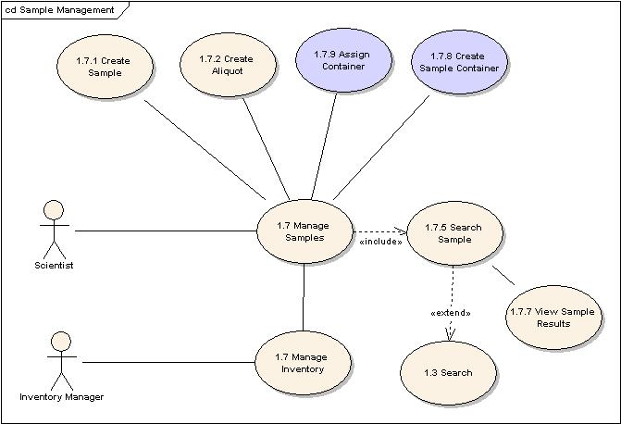
Figure 3-3 Sample Management Use Cases

Manage Sample

Use Case Name | Manage Sample
Use Case ID | 1.7.1
Primary Actor | User, System
Brief Description | The Manage Sample use case allows a user to create samples. Samples are created in the system once received by the laboratory.
Trigger | The User selects the Manage Sample operation
Pre-conditions | The User is logged into the System
Flow of Events | - The User selects to perform administrative tasks  - The System displays the administrative tasks including sample management  - The User selects to perform sample management  - The User is presented with a list of sample management functionality including create samples and create aliquots
Post Conditions | Success Condition: The User successfully retrieves sample management functionality  Error Conditions:  EC1: System Error
Alternative Flow | Error Conditions:  EC1: System Error  - A system error has occurred which prevents the retrieval of sample management functionality  - Notify the system administrator to report the error condition
Related Use Cases | Manage Inventory  Create Sample
Issues/Notes | Authorization (security) will not be implemented in iteration 1. As such, any user can select to manage samples.

Create Sample

Use Case Name | Create Sample
Use Case ID | 1.7.1.1
Primary Actor | User, System
Brief Description | The Create Sample use case allows a user to accession samples. Samples are accessioned in the system once received by the laboratory.
Trigger | The User selects the Create Sample operation
Pre-conditions | - The User is logged into the System  - The User has selected to Manage Samples <Manage Sample Use Case>
Flow of Events | - The User selects to Create Samples  - The System displays the Create Sample screen with the Sample ID auto-incremented  - The User can select to Edit the Sample ID or maintain the auto-generated Sample ID  - The User can enter information about the sample including: Sample Type, Description, Source, Source ID, Date Received, Solubility  - The User must enter the Lot ID and can enter information about the lot including: Lot Description, # of Containers, Container Type  - The System will dynamically display container specific meta data based on the # of containers entered by the user  - The User can enter information associated with the sample container including container type, quantity, concentration, volume, diluents/solvent, safety precautions, storage conditions, and storage location (room, freezer, shelf, box)  - The User can enter general comments  - The User submits the request and the Sample meta data is persisted in the System along with audit information including the User name that submitted the request and the date/time the request was submitted
Post Conditions | Success Condition: The User successfully creates a sample  Error Conditions:  EC1: System Error during Submission  EC2: Database Error during Submission  EC3: Duplicate Sample and Lot IDs submitted  EC4: Required Field not Completed
Alternative Flow | Error Conditions:  EC1: System Error  - A system error has occurred which prevents the submission of the sample  - Notify the system administrator to report the error condition  EC2: Database Error  - A database error has occurred which prevents the complete submission of the sample  - The System rollback the transaction  - The System displays the error condition and application help contact information  - Notify the system administrator to report the error condition  EC3: Duplicate Sample and Lot IDs submitted  - The User submits a Sample that has a duplicate sample ID and Lot ID  - The System displays a message indicate the duplicate entry  - The User must modify the Sample ID or Lot ID to complete the sample submission  EC4: Required Field Not Completed  - The User submits a Sample that does not include the required fields sample ID and Lot ID  - The System displays a message indicating that required fields must be completed and highlights the required field that has not been completed  - The User must enter the required field to complete the sample submission
Related Use Cases | Manage Sample  Create Aliquot
Issues/Notes | - The auto-generated Sample ID can be an alphanumeric string (e.g. NCL6). The System will have to be designed to be configurable to accommodate other laboratory Sample ID naming conventions. Recommend in this first phase adding a configurable sample ID string in a properties file that is concatenated with an auto-generated number.  - The storage room and freezer should be a pull-down list and should default to a pre-set value  - Upon entry of additional containers, the additional container should be defaulted to the values entered in the initial containers to assist with data entry (e.g. Sample # 2 container has same quantity, storage info etc. as what was entered in Sample #1 container. Sample #2 container could then be modified as needed.)

Create Aliquot

Use Case Name | Create Aliquot
Use Case ID | 1.7.1.1.1
Primary Actor | User, System
Brief Description | The Create Aliquot use case allows a user to create aliquots of accessioned samples. An aliquot is a measured portion of a sample extracted for analysis. Multiple aliquots of samples can be created and aliquots can be created outside the context of an experiment assay. Additionally, an aliquot can be created of an aliquot.
Trigger | The User selects the Create Aliquot operation
Pre-conditions | 1. The User is logged into the System  2. The User has selected to Manage Samples <Manage Sample Use Case>  3. A sample has already been created for the aliquot to be created
Flow of Events | 1. The User selects to Create Aliquots  2.The System displays the Create Aliquot screen  - The User selects the desired Sample/Lot ID and/or Aliquot ID which is required to create an aliquot  - The User enters the # of desired aliquots  - The System will dynamically display container specific meta data based on the # of aliquots entered by the user  - The User can enter information associated with the aliquot container including container type, quantity, concentration, volume, diluents/solvent, how the aliquot was created (e.g. liatholized), storage conditions, and storage location (room, freezer, shelf, box)  - The User can enter general comments  - The User submits the request and the aliquots are persisted in the System along with audit information including the User name that submitted the request and the date/time the request was submitted
Post Conditions | Success Condition: The User successfully creates the desired # of aliquots  Error Conditions:  EC1: System Error during Submission  EC2: Database Error during Submission  EC3: Required Sample/Lot/Aliquot ID is not selected
Alternative Flow | Error Conditions:  EC1: System Error  1. A system error has occurred which prevents the submission of the aliquots  2.Notify the system administrator to report the error condition  EC2: Database Error  - A database error has occurred which prevents the complete submission of the aliquots  - The System rolls back the transaction  - The System displays the error condition and application help contact information  - Notify the system administrator to report the error condition  EC3: Required Sample/Lot/Aliquot ID Not Selected  - The User submits a request to create and aliquot but does not select a Sample/Lot/Aliquot ID  - The System displays a message indicating that required field must be completed and highlights the required field that has not been completed  - The User must enter the required field to complete the sample submission
Related Use Cases | Manage Sample  Create Sample
Issues/Notes | 1.The aliquot ID will be auto-generated based on the selected Sample/Lot ID/Aliquot ID (e.g. NCL6-7105-1, NCL6-7105-1-1) selected. If the user selects to create an aliquot of a Sample/Lot ID that already contains aliquots, the new aliquot is assigned the next ID in sequence.  2. The storage room and freezer should be a pull-down list and should default to a pre-set value  3. Upon entry of additional aliquots within the same create aliquot operation, the additional containers should be defaulted to the values entered in the initial container to assist with data entry (e.g. Aliquot # 2 has same quantity, storage info etc. as what was entered in Aliquot #1. Aliquot #2 could then be modified as needed.)

Use Aliquot

Use Case Name | Use Aliquot
Use Case ID | 1.7.2
Primary Actor | User, System
Brief Description | The Use Aliquot use case allows a user to use aliquots within a laboratory workflow activity (e.g. input to an assay run).
Trigger | The User selects the Use Aliquot operation
Pre-conditions | - 1.The User is logged into the System  - The User has selected to Execute Workflow <Execute Workflow Use Case>  - An activity exists within the workflow that specifies the use of an aliquot (e.g. input to an assay run)
Flow of Events | - The User selects to Use Aliquots  - The System displays the Use Aliquot screen  - The User selects the desired Sample/Lot ID/Aliquot IDs to use  - The User can enter general comments regarding usage of the aliquots  - The User submits the request and the aliquots are associated with the activity within the workflow (assay run)
Post Conditions | Success Condition: The User successfully specifies aliquots used in the activity and the comments are associated with all aliquots selected for usage. The aliquots selected are displayed within the workflow activity.  Error Conditions:  EC1: System Error during Submission  EC2: Database Error during Submission  EC3: Required Sample/Lot/Aliquot ID is not selected  EC4: Desired Sample/Lot/Aliquot ID does not appear in the list selection
Alternative Flow | Error Conditions:  EC1: System Error  A system error has occurred which prevents the usage of the aliquots  Notify the system administrator to report the error condition  EC2: Database Error  - A database error has occurred which prevents the complete usage of the aliquots  - The System rollsback the transaction  - The System displays the error condition and application help contact information  - Notify the system administrator to report the error condition  EC3: Required Sample/Lot/Aliquot ID Not Selected  - The User submits a request to use aliquots but does not select a Sample/Lot/Aliquot ID  - The System displays a message indicating that required field must be completed and highlights the required field that has not been completed  - The User must enter the required field to use the aliquot  EC4: Desired Sample/Lot/Aliquot ID does not appear in the list selection  - The User must create the Aliquot as defined in the <Create Aliquot> use case
Related Use Cases | Execute Workflow  Create Aliquot
Issues/Notes | 1.The same aliquot can be used in multiple assays and assay runs

Mask Aliquot

Use Case Name | Use Aliquot
Use Case ID | 1.7.2
Primary Actor | User, System
Brief Description | The Mask Aliquot use case allows a user to mask (mark as deleted) aliquots used within a laboratory workflow activity (e.g. input to an assay run).
Trigger | The User selects (mouse over) the Aliquot used in the workflow activity
Pre-conditions | 1.The User is logged into the System  2.The User has selected to Execute Workflow <Execute Workflow Use Case>  3.An activity exists within the workflow that specifies the aliquot used in the activity
Flow of Events | 1. The User selects to Mask the Aliquot  2.The System displays a confirmation popup indicating the desire to mask the aliquot along with a reason for masking the aliquot  3.The User submits the request and the aliquot associated with the activity within the workflow (assay run) is masked (no longer visible in the workflow)  4. The System records the auditing information associated with the user who masked the aliquot
Post Conditions | Success Condition: The User successfully masks the aliquots used in the activity and the submits the reasons for masking. The aliquot masked is removed from the workflow activity.  Error Conditions:  EC1: System Error during Submission  EC2: Database Error during Submission
Alternative Flow | Error Conditions:  EC1: System Error  1.A system error has occurred which prevents the masking of the aliquots  - Notify the system administrator to report the error condition  EC2: Database Error  1. A database error has occurred which prevents the masking of the aliquots  2. The System rolls back the transaction  - The System displays the error condition and application help contact information  - Notify the system administrator to report the error condition
Related Use Cases | Execute Workflow  Use Aliquot
Issues/Notes | 1.Since security is not provided in this iteration, any User can mask any aliquot used within the run; however, the database records the activity and no sample data is deleted from the database.

Search Sample

Use Case Name | Search Sample
Use Case ID | 1.7.1.1.1
Primary Actor | User, System
Brief Description | The Search Sample use case allows a user to search for samples and sample derivatives (aliquots)
Trigger | The User selects the Search Sample operation
Pre-conditions | - The User is logged into the System  - The User has selected to perform a Search
Flow of Events | 1. The User selects to Search Samples  2.The System displays the Search Sample screen  The User can select to search by Sample ID, Lot ID, Aliquot ID, Sample Type, Source ID, Data Received, Date Accessioned, Submitter, and Storage Location  The System will automatically AND all search criteria  The User submits the request and the search results are displayed in tabular format
Post Conditions | Success Condition: The User successfully retrieves the search results  Alternate Condition:  AC1: User does not select search criteria  Error Conditions:  EC1: System Error during Request Submission or Retrieval  EC2: Database Error during Retrieval
Alternative Flow | Alternate Condition:  AC1: User does not select search criteria  1. User retrieves a list of all samples in the system  Error Conditions:  EC1: System Error  - A system error has occurred which prevents the submission of the search request  - Notify the system administrator to report the error condition  EC2: Database Error  - A database error has occurred which prevents the submission of the search request  - The System displays the error condition and application help contact information  - Notify the system administrator to report the error condition
Related Use Cases | Search  View Search Results
Issues/Notes

View Search Results

Use Case Name | View Search Results
Use Case ID | 1.7.1.1.1
Primary Actor | User, System
Brief Description | The View Search Results use case allows a user to view search results based on selected criteria as described in the <Search Sample> use case
Trigger | The User enters in search criteria as defined in the <Search Sample? Use cases and submits a request to search samples
Pre-conditions | - The User is logged into the System  - The User has entered in Search Criteria on the Search Sample screen and has submitted the search request
Flow of Events | 1.The User views the search results in tabular form based on the requested criteria  2.The search results table contain the Sample ID, Lot ID, Aliquot ID, Particle Type, Accessioned Date, Location, Creation Date, Submitter
Post Conditions | Success Condition: The User successfully views the search results table and can select a Sample ID, Lot ID, or Aliquot ID to retrieve additional details as defined in the <View Sample Details> use case
Alternative Flow
Related Use Cases | View Sample Details
Issues/Notes

View Sample Details

Use Case Name | View Sample Details
Use Case ID | 1.7.1.1.1
Primary Actor | User, System
Brief Description | The View Sample Details use case allows a user to view sample details when selecting a Sample ID, Lot ID, or Aliquot ID from the Search Results screen.
Trigger | The User selects the Sample ID, Lot ID, or Aliquot ID
Pre-conditions | 1.The User is logged into the System  2.The User has entered in Search Criteria on the Search Sample screen and has submitted the search request  3. The User has successfully obtained search results
Flow of Events | 1.The User Selects the Sample ID, Lot ID, or Aliquot ID from the Search Results screen  2.The User is presented with the Sample Details page, which displays details about the Sample or Aliquot selected. Details provided are read-only views of meta data defined in the Create Sample and Create Aliquot use cases
Post Conditions | Success Condition: The User successfully views the sample or aliquot details
Alternative Flow
Related Use Cases | View Search Results  Edit Sample
Issues/Notes

Edit
Next Release

General Requirements

Requirements Prioritization

Req # | Requirement | Use Case Name | Release #
 | Adaptive Workflow
 | Allow authorized users to define laboratory workflow(s) including workflow tasks (run assay, run instrument) and result entry screens | Create Workflow | 1.0
 | Allow authorized users to visually define laboratory workflows
 | Allow authorized users to assign workflow tasks | Assign Workflow Tasks | 1.0
 | Allow authorized users to execute assigned workflow tasks | Assign Workflow Tasks | 1.0
 | Allow authorized users to create multiple runs of assigned workflow tasks (assay processing) | Assign Workflow Tasks | 1.0
 | Allow authorized users to define workflow templates that can be copied and modified for re-use | Assign Workflow Tasks | 1.0
 | Allow authorized users to link multiple workflows to create complex labor procedures | Assign Workflow Tasks | 1.0
 | Sample Management
 | Allow authorized users to accession samples | Create Samples | 1.0
 | Allow authorized users to create sample containers (e.g. plates, tubes) and associate samples with containers | Create Samples | 1.0
 | Allow users to upload samples in batch via spreadsheet format | Import Samples | 1.0
 | Allow authorized users to create aliquots of sample | Create Samples | 1.0
 | Allow authorized users to combine samples and/or sample containers |  | 1.0
 | Allow authorized users to bar code samples, aliquots, and sample containers | Create Samples
 | Allow authorized users to create/obtain unique bar code IDs for labeling)
 | Allow authorized users to track samples and view sample histories | Create Samples | 1.0
 | Allow authorized users to specify additional sample meta data not included in the default set
 | Reporting
 | Allow authorized users to view standard reports and graphs |  | 1.0
 | Allow authorized users to create custom reports and graphs
 | Allow authorized users to download reports in spreadsheet (MS Excel format) |  | 1.0
 | Allow authorized users to print reports and graphs |  | 1.0
 | Instrument Integration
 | Provide a generic module supporting bi-directional laboratory instrument integration
 | Support the generation of laboratory instrument input (e.g. sample lists) |  | 1.0
 | Support the capture of laboratory instrument output |  | 1.0
 | Support the usage of laboratory instruments within the laboratory workflow
 | Support the analysis of laboratory instrument output
 | Support analysis via third-party analysis software
 | Support statistical analysis based on multiple instrument outputs
 | Administrative (Security)
 | Support for user authentication (user, password) and authorization (roles, privileges) via the NCICB Common Security Module (CSM) | Security | .50
 | Support for user authorization (roles, privileges) via the NCICB Common Security Module (CSM) | Security | 1.0
 | Support for user management via NCICB user provisioning tools | Create User | 1.0
 | Create/manage users | Create User | 1.0
 | Assign user roles |  | 1.0
 | Assign user skills |  | 1.0
 | Support for laboratory management |  | 1.0
 | Assign users to laboratories |  | 1.0
 | Support for group management
 | Create groups of laboratories and/or users
 | Inventory Management
 | Allow authorized users to check-in and check-out samples and laboratory supplies to/from storage devices |  | 1.0
 | Provide support for inventory receipt, validation, and distribution (shipping)
 | Allow authorized users to manage storage devices (freezers) |  | 1.0
 | Allow authorized users to manage laboratory supplies (reagents, primers, test sets) |  | 1.0
 | Allow authorized users to track inventory via bar codes
 | Allow authorized users to search for inventory |  | 1.0
 | Allow authorized users to monitor quantity of utilized samples and supplies
 | Allow authorized users to monitor the capacity of storage devices
 | Configuration/Installation
 | Allow administrators to install and configure the LIMS for use in the laboratory environment |  | 1.0
 | Provide user friendly install shields |  | 1.0
 | Provide configurable parameters for security, RDBMS connection, file management, instrument integration |  | 1.0
 | Document Management
 | Allow authorized users to upload documents (files, images) | Upload Files | .50
 | Allow authorized users to copy documents
 | Allow authorized users to paste documents
 | Allow authorized users to associate documents with workflow components (experiments, assays) |  | 1.0
 | Allow authorized users to annotate uploaded documents via custom meta data tags | Create  Meta Data | .50
 | Allow authorized users to search for documents based on associated meta data | Search | .50
 | Provide automatic documents version control
 | Allow authorized users to export documents | Export Files | .50
 | Allow authorized users to create folders to provide custom views of submitted documents | Create Folders | .50
 | Meta Data Management
 | Allow authorized users to create custom meta data fields associated with files/folders | Create Meta Data | .50
 | Allow authorized users to create custom meta data fields in all aspects of the workflow (result annotations, sample annotations, QA/QC parameters)
 | Allow authorized users to search on custom meta data fields | Search | .50
 | General System Requirements
 | caBIG compatibility |  | .50+
 | Registered CDEs in the caDSR |  | .50+
 | Use of common terminology from the EVS |  | .50+
 | Well described information models and APIs |  | .50+
 | Open Source and Open Architecture |  | .50+
 | Data Archival/Retrieval
 | Web-Deployable Application |  | .50+
 | Leverage NCICB usability standards |  | .50+
 | Audit Trail for recording all authorized system events |  | 1.0
 | Application Support
 | Performance/Scalability |  | 1.0+
 | Training/Documentation

NCL LIMS Requirements

Req # | Requirement | Use Case Name |  | Release #
 | Instrument Integration
Interface with NCL specific laboratory devices
[Need to specify equipment in separate requirements]
 | Capture and retrieve data and associated meta data from NCL devices
 | Support the analysis of captured data via third-party software
 | Capture and retrieve instrument validation scripts/data
 | Capture and retrieve instrument calibration and maintenance documentation
 | Meta Data Management
 | Creation and retrieval of custom metadata |  | Create  Meta Data | .50
 | Support the interface to third-party applications
 | Support the interface to analysis and modeling and simulation software
 | Support creation of workflows and linking of data to analysis and reporting modules
 | Support for validation data
 | Support for automated report generation
 | Support for meta data conforming to caBIG CDEs |  | Create  Meta Data | .50+
 | Support for sharing authorized data |  | Security | 1.0
 | Support for data archival/retrieval
 | Document Management
 | Capture and retrieval of documents and associated meta data |  | Search | .50
 | Support for document sharing to authorized users |  | Security | 1.0
 | Support for document searching |  | Search | .50
 | Support for document archival |  | Archive File | .50
 | Adaptive Workflow
 | Support for protocol and workflow management |  | Create Workflow | 1.0
 | Support for combining data capture, statistical analysis, and workflow management
 | Support for the capture of QA/QC data throughout the workflow pipeline
 | Inventory Management
 | Tracking and ordering of laboratory reagents and materials
 | Document tracking of material handling instructions
 | Workflow guiding material handling
 | Efficient generation of aliquots
 | Recording the storage, use and disposal of nanomaterials
 | Support for assays establishing the stability of nanomaterials
 | Administration
 | Support for proposal evaluation/acceptance workflow
 | Support for MTA document templates
 | Support for resource allocation and scheduling
 | Support for assay results review/approval workflow
 | Inclusion of training and testing modules
 | Support for regulatory compliance procedures
 | Support for audit trails
 | Usage of requirements traceability software
 | Collaboration Management
 | Tracking MTA/NDA/IP in a secure fashion
 | Tracking Third-Party Materials/Assays in a standard format
 | Provide resource projections
 | Support for electronic billing/payment
 | System Support
 | Support for maintenance and upgrades
 | Provide application support
 | Support product customizations
 | Establish User Groups
 | Provide Training
 | Support system security
 | Provide ease-of-use, system flexibility, upgradeability, scalability, and reliability
 | Usability
 | Provide Internet capability
 | Provide support for linking common office, laboratory, and analysis software
 | Provide platform compatibility
 | Provide the ability to interface to enterprise applications

Data Definitions

Common Data Elements (CDEs)

CDE # | Data Element | Description | Use Case Name
 | File/Folder Name | Name of file or folder | Manage File System
 | File/Folder Location | Virtual file path | Manage File System
 | File/Folder Submission Date | Date file was submitted | Manage File System
 | File/Folder Owner | Actor who submitted file | Manage File System
 | File Type | Type of file (e.g. MS Word, MS Excel) | Manage File System
 | Particle Type | e.g. Aluminum nanoparticle, black carbon nanoparticle, etc. | Meta Data Management
 | Physical Char: Size and Size Distribution | Value: (e.g., 80nm, 100nm)  Type: Primary Sphere Size, Agglomerate Size: (note: may be under aggregates)  Technique: (e.g., dynamic light scattering, Static Light Scattering, Photon Correlation Spectroscopy, etc.  Source: Instrument | Meta Data Management
 | Physical Char: Topology | Value: (e.g., % Dendrimer Metal Nanocomposites), network, hybridization, etc.)  Technique: (e.g. light scattering)  Source: Instrument
 | Physical Char: Molecular Weight | Value: (e.g., Mr=2000, 5000, and 10000)  Technique:  Source: Instrument
 | Physical Char: Aggregation | Value:  Technique: (e.g., optical confocal laser microscopy and high resolution X-ray microtomography, fluorescence and scanning electron microscopy, etc.)  Source: Instrument
 | Physical Char: Purity | TBD
 | Physical Char: Chemical Composition | Type: (e.g. metallic | carbon, oxygen, sulfur, nitrogen, and hydrogen)  Technique: (e.g., Inductively coupled Plasma, Optical Emission Spectrometer, ICP Mass Spectrometry, Glow discharge mass spectrometry, Dispersive X-ray spectrometer, Thermal offgasing, etc.)  Source: Instrument
 | Physical Char: Surface Characteristics | Value: (e.g., hydrophilic, etc.)  Technique: BET method (technique is influenced by the shape of the nanoparticle)  Instrument data:  Unit: m2/gm
 | Physical Char: Functionality | Value:  Energetic Material: Yes/No  Energy Release rate:  Energy Flux:  Reaction temperature:  Technique: Base Hydrolysis, Thermo-Gravimetric analysis (TGA), Scanning Calorimetrics (note: based on the composition, the technique to measure behavior may change)  Source: Instrument
 | Physical Char: Zeta Potential | The overall charge that the particle acquires in a particular medium. Zeta potential is an indication of the repulsive force that is present and can be used to predict the long-term stability of the product.  pH  Concentration of an additive:  Technique: (e.g., Zetasizer instrument)  Source: Instrument
 | Physical Char: Stability | TBD
 | Physical Char: Solubility | TBD

Sign Off

Approval

Iteration: 1.0

NCICB Rep Print Name Date
NCL Rep Print Name Date
LPG Rep Print Name Date
NCI OC Rep Print Name Date
SAIC Rep Print Name Date

Appendix

Appendix A – Other LIMS Requirements
The caLAB system will be designed for extensibility. Throughout the high-level requirements analysis, the following functionality was identified as potential future LIMS extensions:

Component | Description
Analysis Tool Integration | Integrate with third-party analysis tools to process and analyze assay results throughout the analysis workflow
Quality Assurance (QA)/Quality Control (QC) | Provide QA/QC checks and capture associated parameters
CLIA Compliance | Provide support for the Common Laboratory Improvements Amendment (CLIA) which includes equipment calibration, lot management, skills certifications, and CLIA forms/reports
Ordering Module | Provide an automated ordering process to re-order depleted laboratory inventory
Electronic Signatures | Provide support for FDA 21 CFR Part 11
Billing | Interface with third-party billing systems to invoice customers for service requests
User/Laboratory Preferences | Allow users and laboratories to set preferences
Interfaces to third party systems | Provide interfaces for third party systems and data marts like the NCICB caArray gene expression system and the caBIG caTISSUE tissue bank
Support for HL7 Messaging | Provide the capability of importing/exporting HL7 (v2 and v3) laboratory messages
Audit Trail | Provide an audit trail to record all LIMS transactions
Although it is not intended that the above functionality will be implemented in the caLAB effort, this functionality may be implemented in future iterations and/or by external laboratories under the NCICB Open Data Initiative (ODI).
This functionality is included in this document as a representative only of system extensions. Understanding the high-level requirements for these extensions will provide assistance in supporting the ongoing development of core LIMS standards (e.g. standard interfaces, etc.).

