Software Requirements Specification

cancer Laboratory Analysis Workbench (caLAB) 1.0

NCICB, NCL

DOCUMENT REVISION HISTORY

Version Number | Date | Description
1.0 | August 14, 2006 | Initial draft containing high-level use cases and nanoparticle metadata
1.1 | August 24, 2006 | Draft Iteration 1 use cases
1.2 | September 28, 2006 | Draft Iteration 2 use cases
1.3 | October 14, 2006 | Draft Iteration 3 use cases
1.4 | November 22, 2006 | Draft Iteration 4 use cases

Background/Summary
The caLAB effort is collaboration between the NCICB and the Nanotechnology Characterization Laboratory (NCL) facilitating the development of standards and an informatics platform supporting nanotechnology in medicine. The NCL performs and standardizes the characterization of nanomaterials intended for cancer therapeutics and diagnostics. One of the goals of the collaboration is the establishment of nanoparticle characterization standards in support of data sharing with the Cancer Centers of Nanotechnology Excellence (CCNEs) and caBIG™ participants.

Table of Contents
Background/Summary 1
1 Introduction 3
1.1 Overview 3
1.2 Related Documents 3
2 Actors and Goals 5
2.1 Actors 5
3 Use Cases 6
3.1 Manage Nanoparticle 7
3.1.1 Submit Nanoparticle 7
3.1.2 Submit Nanoparticle General Information 8
3.1.3 Set Nanoparticle Visibility 9
3.1.4 Submit Nanoparticle Characterization 10
3.1.5 Submit Nanoparticle Function 14
3.1.6 Submit Nanoparticle Assay Results 15
3.2 Search Nanoparticle 16
3.2.1 Search Nanoparticle 16
3.2.2 View Search Result 17
3.2.3 View Nanoparticle Details 18
3.3 Update Nanoparticle 19
4 Overall Requirements 21
4.1 Requirements Prioritization 21
5 Data Definitions 23
5.1 Concepts 23
5.1.1 Particle Metadata 23
5.1.2 Function Metadata 26
5.1.3 Physical Composition Metadata 28
5.1.4 Physical Characterization Metadata 35
5.1.5 In Vitro Characterization Metadata 39
5.1.6 Characterization (Base) Metadata 41
6 Sign Off 49
6.1 Approval 49
6.1.1 Iteration: 1.0 49
Appendix A - Physical Composition Detail 50
Appendix B - Function Detail 52

Introduction

Overview
The caLAB 1.0 effort expands upon the caLAB .50 release which focused on capturing the workflow in the Nanotechnololgy Characterization Laboratory (NCL) workflow and associated workflow artifacts (result files). caLAB .50 features included:
- Sample Management – Accessioning samples (nanoparticles), creating aliquots, searching samples and aliquots
- Execute Workflow – Creating assay runs, assigning inputs (aliquots) and outputs (result files) to assay runs, searching workflow components for assay results
- File Upload – Uploading assay results
- Basic Security – User authentication via the NCI’s Common Security Module (CSM)
The primary goals of the caLAB Release 1.0 effort are to:
- Provide for the efficient storage and retrieval of nanoparticle characterizations to expedite and validate the use of nanotechnology in medicine
- Develop and support an initial standard for representing nanoparticle characterizations to facilitate data sharing in a semantically interoperable fashion in the spirit of caBIG™
- Implement a system that facilitates data sharing in the nanotechnology community in a secure fashion
Release 1.0 features focus on annotating nanoparticles and sharing these annotations with the nanotechnology community in a secure fashion. caLAB 1.0 features include:
- Annotate Nanoparticles – Annotating nanoparticles with characterizations, searching and retrieving nanoparticle characterizations; Nanoparticle annotations included general information about a nanoparticle, nanoparticle function, characterizations obtained from physical and in vitro characterizations, and assay result files/reports.
- Advanced Security – User authorization via the CSM, User management via the NCI’s User Provisioning Toolkit (UPT).
The purpose of this document is to identify and details the caLAB 1.0 use cases, requirements, and metadata associated with each nanoparticle.

Related Documents

Document Name | Version | Location
caLAB 1.0 Scope Document | 1.4 | CVS Server: cbiocvs2; module: calab; Directory: docs
caLAB 1.0 Use Case Specification | 1.0 | CVS Server: cbiocvs2; Module: calab; Directory: docs
caLAB 1.0 Wireframes | 1.0 | CVS Server: cbiocvs2; module: calab; Directory: docs
caLAB 1.0 Security Configuration Document | 1.0 | caLAB 1.0 Security Configuration Document
caLAB 1.0 Architecture Checklist | 1.0 | NCICB CM team
caLAB .50 Use Case Specification | 1.0 | CVS Server: cbiocvs2; module: calab; Directory: docs
caCORE SDK and CSM | 1.1 | Refer caCORE Technical guide for the design document. ftp://ftp1.nci.nih.gov/pub/cacore/SDK/caCORE_SDK1.0.3_Programmers_Guide.pdf
caBIG Compatibility Guidelines | 2.0 | https://cabig.nci.nih.gov/guidelines_documentation/caBIGCompatGuideRev2_final.pdf

Actors and Goals

Actors
The table below describes the core caLAB actors applicable to the caLAB Release 1.0 use cases as well as the intended authorization. Intended authorizations focus on metadata support use cases only.

Actor | Description | Authorization
NCL  Lab Manager/PI | A Lab Manager/PI can manage all nanoparticle annotations, assay results, reports. | Submit, Access, Retrieve nanoparticle annotations and reports.
NCL  Lab Researcher | A Lab Researcher is responsible for conducting experiments associated with nanoparticle.  A Lab Researcher can search all nanoparticle data. | Access, Retrieve nanoparticle annotations and reports.
NCL Administrator | An NCL Administrator can manage user accounts, groups, roles, protected data elements, and protected data groups.  An NCL Administrator can assign privileges to users/groups. | Submit, Access, Retrieve user accounts, groups, roles, protected data elements, and protected data groups.
Cancer Centers of Nanotechnology Excellence (CCNEs) | The CCNEs can retrieve all authorized nanoparticle annotations and reports. | Access, Retrieve nanoparticle annotations and reports visible to CCNEs.
CaBIG/Public | The caBI/public can retrieve all nanoparticle annotations and reports published to the public. | Access, Retrieve nanoparticle annotations and reports visible to the caBIG/public.

Use Cases
Figure 3-1 provides a high-level diagram of the caLAB 1.0 use cases associated with the nanoparticle annotation function. Use cases included in this release are indicated in blue and are further described in the subsequent sections. Use cases indicated in yellow are associated with caLAB .50 and are further described in the caLAB .50 Use Case Specification.
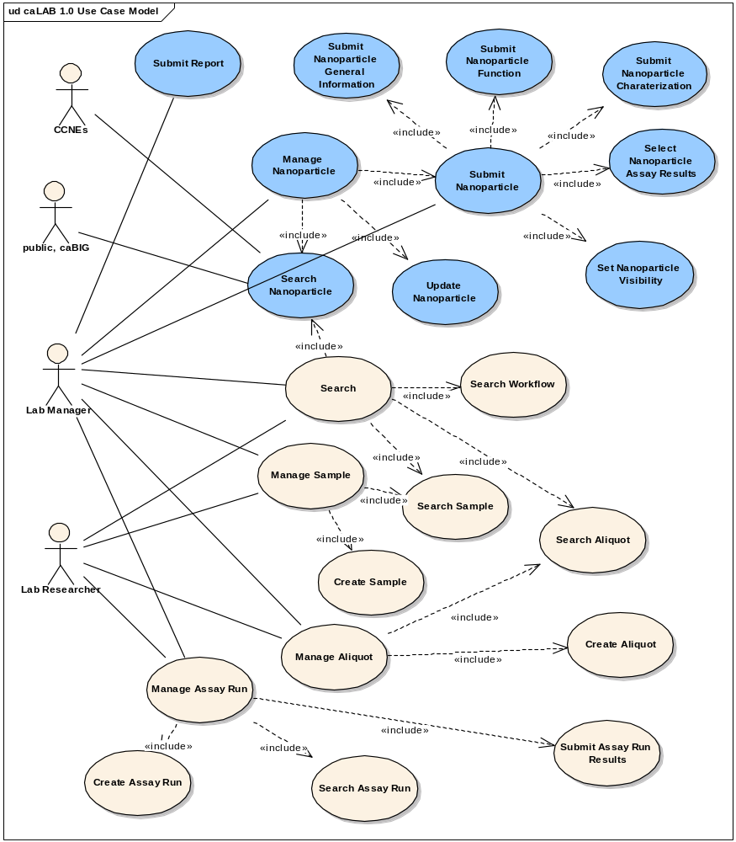
Figure 3-1 High-Level Use Case Diagram

Manage Nanoparticle

Submit Nanoparticle
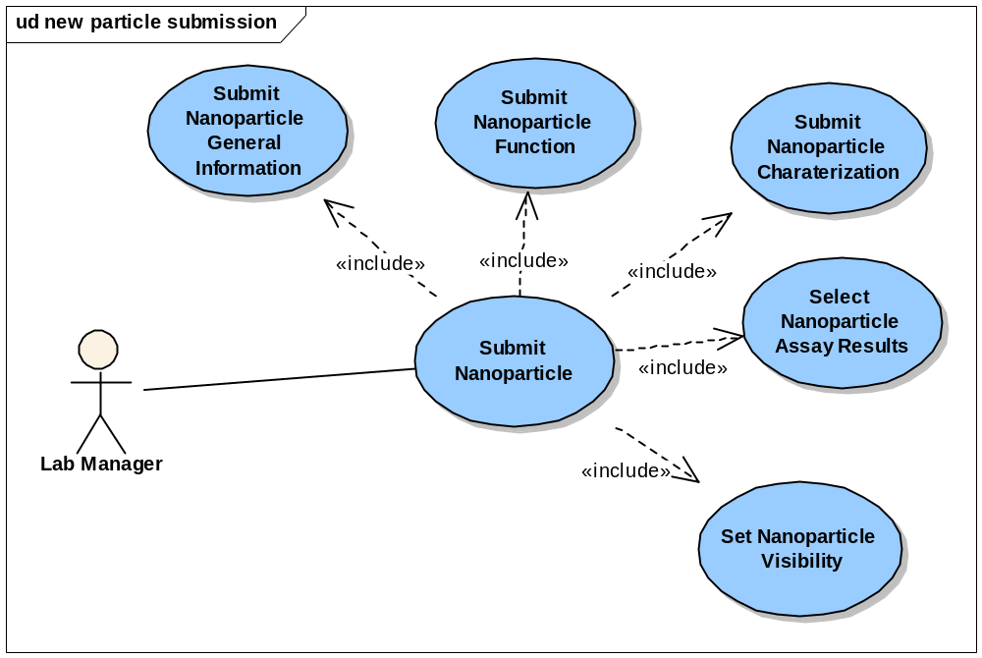
Figure 3-2 Submit Nanoparticle Use Cases

Use Case Name | Submit Nanoparticle
Use Case ID | 1.0
Primary Actor | Authorized User
Brief Description | The Submit Nanoparticle use case allows users to submit general information about the particle, the particle function, nanoparticle characterizations (physical and in vitro) and nanoparticle assay results
Trigger | The User desires to submit nanoparticle annotations and assay results for sharing with the appropriate user group and selects submit nanoparticle
Pre-conditions | - The User is logged into the System  - The User chooses to submit nanoparticle annotations and assay results  - The sample in which the nanoparticle applies has already been accessioned into the system
Flow of Events | - The User selects to Annotate the nanoparticle  - The User submits general information about the particle including the visibility of the particle  - The User submits particle function  - The User submits nanoparticle characterizations and associated assay results
Post Conditions | Success Condition:  The User successfully submits the particle information into the system  Error Conditions:  EC1: System Error during Request Submission  EC2: Database Error during Request Submission
Alternative Flow | Alternate Conditions:  None  Error Conditions:  EC1: System Error  - A system error has occurred which prevents the submission of the submission request  EC2: Database Error  - A database error has occurred which prevents the submission of the submission request  - The System displays the error condition and application help contact information
Related Use Cases | Submit Nanoparticle General Information  Submit Nanoparticle Characterization  Submit Nanoparticle Function  Submit Nanoparticle Assay Result  Submit Nanoparticle Report  Submit Nanoparticle Visibililty
Issues | None

Submit Nanoparticle General Information

Use Case Name | Submit Nanoparticle General Information
Use Case ID | 1.1
Primary Actor | Authorized User
Brief Description | The Submit Nanoparticle General Information use case allows users to submit general information about a nanoparticle
Trigger | The User desires to submit general information about a nanoparticle for sharing with the appropriate user group and selects annotate nanoparticle
Pre-conditions | - The User is logged into the System  - The User has the privilege to submit the particle data  - The sample in which the nanoparticle applies has already been accessioned into the system
Flow of Events | - The User selects annotate particle  - The User selects the type of particle, the particle ID, and the particle keywords related to this particle  - The User submits the particle general information to the system
Post Conditions | Success Condition:  The User successfully submits the general information data into the system  Error Conditions:  EC1: System Error during Request Submission  EC2: Database Error during Request Submission
Alternative Flow | Error Conditions:  EC1: System Error  - A system error has occurred which prevents the submission of the submission request  EC2: Database Error  - A database error has occurred which prevents the submission of the submission request  - The System displays the error condition and application help contact information
Related Use Cases | Submit nanoparticle
Issues | None

Set Nanoparticle Visibility
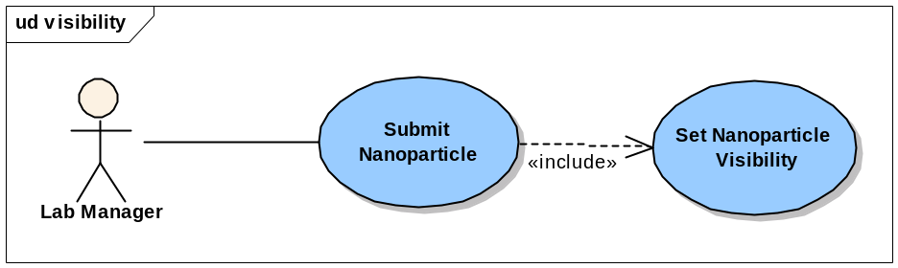
Figure 3-3 Set Nanoparticle Visibility Use Cases

Use Case Name | Set Nanoparticle Visibility
Use Case ID | 1.2
Primary Actor | Authorized User
Brief Description | The Set Nanoparticle Visibility use case allows users to limit the visibility of the submitted nanoparticle annotations to pre-defined User Groups
Trigger | The User desires to submit nanoparticle annotations and assay results for sharing with the appropriate user group and selects submit nanoparticle
Pre-conditions | - The User is logged into the System  - The User chooses to submit the general information of the particle and assay results for the particle
Flow of Events | - The User selects the user groups that are able to search/view the particle experiment data  - The User submits the particle visibility to the system
Post Conditions | Success Condition:  The User successfully set the visibility of the particle  Error Conditions:  EC1: System Error during Request Submission  EC2: Database Error during Request Submission
Alternative Flow | Alternate Conditions:  None  Error Conditions:  EC1: System Error  - A system error has occurred which prevents the submission of the submission request  EC2: Database Error  - A database error has occurred which prevents the submission of the submission request  - The System displays the error condition and application help contact information
Related Use Cases | Submit Nanoparticle General Information
Issues | None

Submit Nanoparticle Characterization
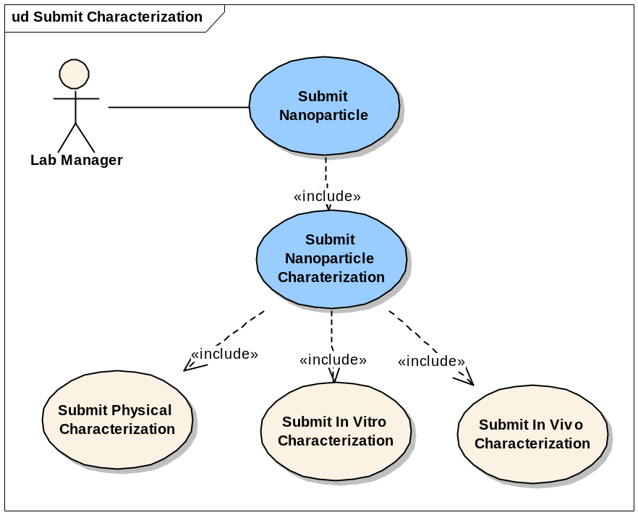
Figure 3-4 Submit Nanoparticle Characterization Use Cases

Use Case Name | Submit Nanoparticle Characterization
Use Case ID | 2.0
Primary Actor | Authorized User
Brief Description | The Submit Nanoparticle Characterization use case allows users submit any physical, In Vitro, In Vivo characterization data retrieved from the lab experiment,
Trigger | The User desires to submit the characterization data and share with the community.
Pre-conditions | - The User is logged into the System.  - The User has the privilege to submit the particle data.
Flow of Events | - The User selects a particle.  - The User selects the characterization category.  - The User selects a particular characterization.  - A form displays allowing the user to complete entries on a form including the characterization information.  - The User enters and submits the experiment data into the system.
Post Conditions | Success Condition:  The User successfully submits the characterization data into the system.  Error Conditions:  EC1: System Error during Request Submission  EC2: Database Error during Request Submission
Alternative Flow | Alternate Conditions:  None  Error Conditions:  EC1: System Error  - A system error has occurred which prevents the submission of the submission request  EC2: Database Error  - A database error has occurred which prevents the submission of the submission request  - The System displays the error condition and application help contact information
Related Use Cases | Update Nanoparticle
Issues | For the second iteration of caLAB 1.0, the only characterization will be implemented is Composition. The rest will be implemented in the later iteration.

Add Nanoparticle Physical Characterization
Use Case Name | Add Nanoparticle Physical Characterization
Use Case ID
Primary Actor | Authorized User
Brief Description | The Add Nanoparticle Physical Characterization use case allows users submit any physical characterization data retrieved from the lab experiment, such as Particle Composition, Size, Shape, Purity, Morphology, Molecular Weight, Surface, Stability, Functional.
Trigger | The User desires to submit the physical characterization data and share with the community.
Pre-conditions | - The User is logged into the System.  - The User has the privilege to submit the physical characterization data.
Flow of Events | - The User selects a particle.  - The User selects to add the physical characterization.  - The User selects a particular characterization, such as Composition, Size, Shape, Purity, Morphology, Molecular Weight, Surface, Stability, Functional.  - A physical characterization form displays allowing the user to complete entries on a form including the characterization information.  - The User should be able to enter the instrument information, such as Manufacturer, Abbreviation, etc to the physical characterization other than Particle Composition.  - The User enters and submits the physical characterization data into the system.  - The User is able to enter multiple physical characterization data into the system by repeating step 2~6.
Post Conditions | Success Condition:  The User successfully submits the physical characterization data into the system.  Error Conditions:  EC1: System Error during Request Submission  EC2: Database Error during Request Submission
Alternative Flow | Alternate Conditions:  None  Error Conditions:  EC1: System Error  - A system error has occurred which prevents the submission of the submission request  EC2: Database Error  - A database error has occurred which prevents the submission of the submission request  - The System displays the error condition and application help contact information
Related Use Cases | Update Nanoparticle
Issues | For the second iteration of caLAB 1.0, the only characterization will be implemented is Composition. The rest will be implemented in the later iteration.

Pleaase refer to the Appedix A for the Physical Composition Detail.

Add Nanoparticle In Vitro Characterization

Use Case Name | Add Nanoparticle In Vitro Characterization
Use Case ID
Primary Actor | Authorized User
Brief Description | The Add Nanoparticle In Vitro Characterization use case allows users submit any In Vitro characterization data retrieved from the lab experiment, such as Oxidative Stress, Enzyme Induction, Caspase3 Activation, Plate Aggregation, Hemolysis, Coagulation, Plasma Protein Binding, Complement Activation, Cytokine Induction, Chemotaxis, NK Cell Cytotoxic Activity, Leukocyte Proliferation, CFU-GM, Phagocytosis, Oxidative Burst, CYP450, ROS and Glucuronidation Sulphation.
Trigger | The User desires to add the In Vitro characterization data and share with the community.
Pre-conditions | - The User is logged into the System.  - The User has the privilege to submit the physical characterization data.
Flow of Events | - The User selects a particle.  - The User selects to add the in vitro characterization.  - The User selects a particular characterization, such as Oxidative Stress, Enzyme Induction, Caspase3 Activation, Plate Aggregation, Hemolysis, Coagulation, Plasma Protein Binding, Complement Activation, Cytokine Induction, Chemotaxis, NK Cell Cytotoxic Activity, Leukocyte Proliferation, CFU-GM, Phagocytosis, and Oxidative Burst.  - An in vitro characterization form displays allowing the user to complete entries on a form including the characterization information.  - The User should be able to enter the instrument information, such as Manufacturer, Abbreviation, etc to the in vitro characterization.  - The User enters and submits the In Vitro characterization data into the system.  - The User is able to enter multiple In Vitro characterization data into the system.
Post Conditions | Success Condition:  The User successfully submits the physical characterization data into the system.  Error Conditions:  EC1: System Error during Request Submission  EC2: Database Error during Request Submission
Alternative Flow | Alternate Conditions:  None  Error Conditions:  EC1: System Error  - A system error has occurred which prevents the submission of the submission request  EC2: Database Error  - A database error has occurred which prevents the submission of the submission request  - The System displays the error condition and application help contact information
Related Use Cases | Update Nanoparticle
Issues | For the second iteration of caLAB 1.0, the only characterization will be implemented is Composition. The rest will be implemented in the later iteration.

Associate Distribution Graph or other type of files to each Characterization
Use Case Name | Associate Characterization Table to each Characterization
Use Case ID
Primary Actor | Authorized User
Brief Description | The Associate Characterization Table to each Characterization use case allows users submit multiple Characterization Graph, Chart, or Spread Sheet associated with a particular Physical or In Vitro Characterization
Trigger | The User desires to add the In Vitro characterization data and share with the community.
Pre-conditions | - The User is logged into the System.  - The User has the privilege to submit the physical characterization data.
Flow of Events | - The User selects a particle.  - The User selects to add the physical or in vitro characterization.  - The User selects a particular characterization.  - Physical or In vitro characterization form displays allowing the user to complete entries on a form including the characterization information.  - The User should be able to select from either a list of files that already uploaded in the system via executing workflow or uploading file to the system.  - The User should be able to assign visibility that will override the characterization visibility for the file.  - The User should be able to submit the file information with the characterization info together to the system.
Post Conditions | Success Condition:  The User successfully submits the physical characterization data into the system.  Error Conditions:  EC1: System Error during Request Submission  EC2: Database Error during Request Submission
Alternative Flow | Alternate Conditions:  None  Error Conditions:  EC1: System Error  - A system error has occurred which prevents the submission of the submission request  EC2: Database Error  - A database error has occurred which prevents the submission of the submission request  - The System displays the error condition and application help contact information
Related Use Cases | Update Nanoparticle
Issues | For the second iteration of caLAB 1.0, the only characterization will be implemented is Composition. The rest will be implemented in the later iteration.

Submit Nanoparticle Function
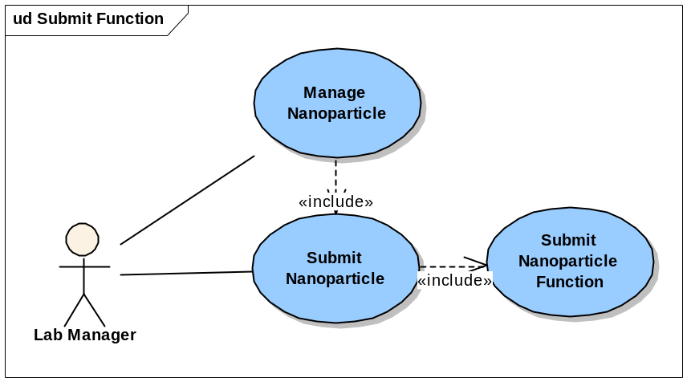
Figure 3-5 Submit Nanoparticle Function Use Cases

Use Case Name | Submit Nanoparticle Function
Use Case ID
Primary Actor | Authorized User
Brief Description | The Submit Nanoparticle Function use case allows users to submit the functionalities that the particle presents or is capable of, such as Targeting, Imaging, Reporting, or Therapeutic.
Trigger | The User desires to submit the particle function data into the system and share with the community.
Pre-conditions | - The User is logged into the System.  - The User has the privilege to submit the particle data.
Flow of Events | - The User selects a particle.  - The User selects the Function type.  - A form displays allowing the user to complete entries on a form including the function information.  - The User should be able to enter multiple functionalities for a particle.  - The User should be able to specify the agent and linkage type for a function
Post Conditions | Success Condition:  The User successfully submits the characterization data into the system.  Error Conditions:  EC1: System Error during Request Submission  EC2: Database Error during Request Submission
Alternative Flow | Alternate Conditions:  None  Error Conditions:  EC1: System Error  - A system error has occurred which prevents the submission of the submission request  EC2: Database Error  - A database error has occurred which prevents the submission of the submission request  - The System displays the error condition and application help contact information
Related Use Cases
Issues | None

Pleaase refer to the Appedix B for the Function Detail.

Submit Nanoparticle Assay Results

Figure 3-6 Submit Nanoparticle Assay Results Use Cases

Use Case Name | Submit Nanoparticle Assay Results
Use Case ID
Primary Actor | Authorized User
Brief Description | The Submit Nanoparticle use case allows users to submit the uploaded assay result file.
Trigger | The User desires to submit the particle assay result file into the system and share it with the community.
Pre-conditions | - The User is logged into the System.  - The User has the privilege to submit the particle data.
Flow of Events | - The User selects a particle.  - The User selects the Assay Result.  - A form displays allowing the user to select from a list of file names.  - The User selects and submits the assay results into the system.
Post Conditions | Success Condition:  The User successfully submits the characterization data into the system.  Error Conditions:  EC1: System Error during Request Submission  EC2: Database Error during Request Submission
Alternative Flow | Alternate Conditions:  None  Error Conditions:  EC1: System Error  - A system error has occurred which prevents the submission of the search request  EC2: Database Error  - A database error has occurred which prevents the submission of the search request  - The System displays the error condition and application help contact information
Related Use Cases
Issues | None

Search Nanoparticle
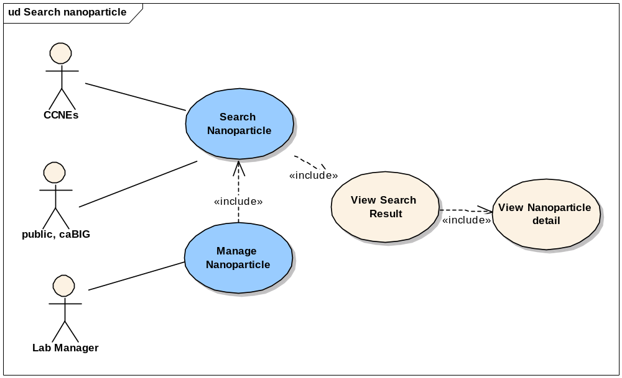
Figure 3-7 Search Nanoparticle Use Cases

Search Nanoparticle

Use Case Name | Search Nanoparticle
Use Case ID
Primary Actor | Authorized User
Brief Description | The Search Nanoparticle use case allows users to search the visible particles that satisfied the search criteria.
Trigger | The User desires to search the particles satisfied the certain search criteria
Pre-conditions | - The User is logged into the System.  - The User selects searching particle data.
Flow of Events | - The user enters following search criteria:  - Particle source  - Particle type  - Particle function types  - Particle characterization types  - Particle keywords, or Assay result keywords  - The user submits the search criteria to the system.
Post Conditions | Success Condition: The User successfully retrieves the search results  Alternate Condition:  AC1: User does not select search criteria  AC2: No result is found.  Error Conditions:  EC1: System Error during Request Submission or Retrieval  EC2: Database Error during Retrieval
Alternative Flow | Alternate Condition:  AC1: User does not select search criteria  1. User retrieves a list of all particles in the system  AC2: No result is found.  1. A “No results found” message will be displayed.  Error Conditions:  EC1: System Error  - A system error has occurred which prevents the submission of the search request  EC2: Database Error  - A database error has occurred which prevents the submission of the search request  - The System displays the error condition and application help contact information
Related Use Cases | View Particle Detail Information
Issues | Function and Assay Result keywords will be implemented in the future iteration.

View Search Result

Use Case Name | View Search Results
Use Case ID
Primary Actor | Authorized Users
Brief Description | The View Search Sample Results use case allows a user to view search results based on selected criteria as described in the <Search Nanoparticle> use case
Trigger | The User enters in search criteria as defined in the <Search Nanoparticle> Use cases and submits a request to search nanoparticles.
Pre-conditions | - The User is logged into the System.  - The User has entered in Search Criteria on the Search Nanoparticle screen and has submitted the search request
Flow of Events | - The User views the search results in tabular form based on the requested criteria.  - The search results table contain the: Nanoparticle ID, particle type
Post Conditions | Success Condition:  The User successfully views the search results table and can select a Nanoparticle ID  - Retrieve additional details <USECASE: View Nanoparticle Details>.  - Edit information <USECASE: Update Nanoparticle>
Alternative Flow | Alternate Condition:  None  Error Conditions:  EC1: System Error  - A system error has occurred which prevents the submission of the search request  EC2: Database Error  - A database error has occurred which prevents the submission of the search request  - The System displays the error condition and application help contact information
Related Use Cases | Search Nanoparticle  View Nanoparticle Details
Issues/Notes

View Nanoparticle Details

Use Case Name | View Nanoparticle Details
Use Case ID
Primary Actor | Authorized Users
Brief Description | The View Nanoparticle Details use case allows a user to view particle metadata details when selecting a Nanoparticle ID from the Search Results screen.
Trigger | The User selects the Nanoparticle from Search Result Screen
Pre-conditions | - The User is logged into the System.  - The User has entered Search Criteria on the Search Nanoparticle screen and has submitted the search request.  - The User has successfully obtained search results.
Flow of Events | - The User Selects one Nanoparticle ID  - The User is presented with the Nanoparticle Details page, which displays the details about the Nanoparticle metadata submitted by NCL. Details provided are read-only views of metadata defined if user does not have privilege to update the nanoparticle, otherwise, it is a editable view.
Post Conditions | Success Condition:  The User successfully views the nanoparticle details.  Error Conditions:  EC1: System Error during Request Submission  EC2: Database Error during Retrieval
Alternative Flow | Alternate Condition:  None  Error Conditions:  EC1: System Error  - A system error has occurred which prevents the submission of the search request  EC2: Database Error  - A database error has occurred which prevents the submission of the search request  - The System displays the error condition and application help contact information
Related Use Cases | View Search Results  Update Nanoparticle
Issues/Notes

Update Nanoparticle
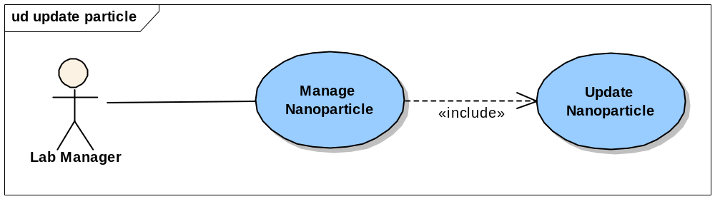
Figure 3-8 Update Nanoparticle Use Cases

Use Case Name | Update Nanoparticle
Use Case ID
Primary Actor | Authorized User
Brief Description | The Update Nanoparticle use case allows users to update already submitted particle experiment data.
Trigger | The User desires to update the already submitted particle experiment data
Pre-conditions | - The User is logged into the System and has the privilege to submit/update particle.  - The User has entered Search Criteria on the Search Nanoparticle screen and has submitted the search request.  - The User has successfully obtained search results.  - The User selects the individual particle to view/update the experiment data
Flow of Events | - The User overwrites the previous entered data, such as keyword, function, characterization, and submit into the system.
Post Conditions | Success Condition: The User successfully update the particle experiment data  Error Conditions:  EC1: System Error during Request Submission  EC2: Database Error during Retrieval
Alternative Flow | Alternate Conditions:  - The User selects to submit particle,  - The User selects a particle that has been submitted in the system  - The existing data will display on the screen  - The User can update the value and resubmit into the system  Error Conditions:  EC1: System Error  - A system error has occurred which prevents the submission of the search request  EC2: Database Error  - A database error has occurred which prevents the submission of the search request  - The System displays the error condition and application help contact information
Related Use Cases | Search Nanoparticle
Issues | None

Overall Requirements

Requirements Prioritization
The table below identifies the requirements for the caLAB Phase 2 (caLAB 1.0) effort. Requirements captured during the iterative caLAB 1.0 requirements analysis are also included and marked for potential future release inclusion.

Prior-ity | Req # | Requirement | Use Case Name |  | Release #
 | 1.0 | The system shall provide advanced security
 | 1.1 | The system shall provide support for role based authorization |  |  | 1.0
 | 1.1.1 | The system shall allow administrators to configure groups and group privileges (read only, read-write) |  |  | 1.0
 | 1.1.1 | The system shall leverage the NCICB Common Security Module (CSM) for user authorization |  |  | 1.0
 | 1.2 | The system shall provide support for user management |  |  | 1.0
 | 1.2.1 | The system shall leverage the NCICB User Provisioning Toolkit (UPT) for user management |  |  | 1.0
 | 2.0 | The system shall support submission and retrieval of nanoparticle annotations
 | 2.1 | The system shall allow users to annotate and search nanoparticles based on the nanoparticle composition specific to each nanoparticle type |  |  | 1.0
 | 2.1.2 | The system shall support nanoparticle types including: carbon nanotube, complex particle, dendrimer, emulsion, fullerene, liposome, metal particle, polymer, and quantum dot |  |  | 1.0
 | 2.2 | The system shall allow users to annotate and search nanoparticles based on nanoparticle characterization |  |  | 1.0
 | 2.2.1 | The system shall provide support for physical characterizations |  |  | 1.0
 | 2.2.1.1 | The system shall support physical characterizations including: composition, size, molecular weight, morphology, shape, surface area, solubility, and purity |  |  | 1.0
 | 2.2.1.2 | The system shall support particle stability and associate stressors with all physical characterizations |  |  | Future
 | 2.2.2 | The system shall provide support for in vitro characterizations |  |  | 1.0
 | 2.2.2.1 | The system shall support in vitro characterizations including: Toxicity (cytotoxicity, immunotoxicity) |  |  | 1.0
 | 2.2.2.2 | The system shall support in vitro characterizations including: metabolic stability |  |  | Future
 | 2.2.3 | The system shall provide support for in vivo characterizations |  |  | Future
 | 2.3 | The system shall allow authorized users to submit assay results (e.g. distribution graphs) and associate assay results with annotations (e.g. size distribution graph, z-avg. size, PDI) |  |  | 1.0
 | 2.4 | The system shall allow users to annotate and search nanoparticles based on nanoparticle function |  |  | 1.0
 | 2.4.1 | The system shall support nanoparticle functions including: Therapeutic, Targeting, Diagnostic Imaging, Diagnostic Reporting
 | 2.5 | The system shall allow authorized users to specify the visibility of the nanoparticle to pre-defined groups |  |  | 1.0
 | 2.6 | The system shall allow users to upload and retrieve nanoparticle reports |  |  | 1.0
 | 2.6.1 | The system shall allow users to associate reports with multiple nanoparticles |  |  | 1.0
 | 2.6.2 | The system shall allow users to set the visibility of the reports to pre-defined groups |  |  | 1.0
 | 3.0 | The system shall be engineered for caBIG compatibility
 | 3.1 | The system shall leverage the caCORE SDK and associated components |  |  | 1.0
 | 3.2 | Concepts for supported objects/attributes shall be registered in the EVS |  |  | 1.0
 | 3.3 | The object model shall be loaded into the caDSR |  |  | 1.0

Data Definitions

Concepts
The sections below detail the caLAB 1.0 required concepts. Definitions are maintained in the NCI’s Enterprise Vocabulary Services (EVS).

Particle Metadata

Object | Concept ID | Attributes | Data Type | Valid Values | Description
Nanoparticle | C62308  (In Pre-Thesaurus] |  | Object |  | NCI|A small, stable particle whose size is measured in nanometers. These particles are used in various biomedical applications in which they can be utilized as drug carriers or imaging agents. Various targeting agents, such as antibodies, drugs, imaging agents, and reporters can be attached to the surface of a nanoparticle
Nanoparticle |  | Classification | Ontology | Organic  - Hydrocarbon (Dendrimer, Polymer)  - Carbon (Buckyball/ Fullerene, Carbon Nanotube)  - Liposome  - Emulsion  Inorganic (Metal Particle, Quantum Dot)  Complex | The classification of discrete nanoparticle entities.
Classification | C718 | Organic | Ontology | Children:  Hydrocarbon (Dendrimer, Polymer) | NCI|Molecule that contains atoms of the element carbon, usually combined with itself and with atoms of one or more other element such as hydrogen, oxygen, nitrogen, sulfur, phosphorus, chlorine, or fluorine. Excludes carbides, carbonates and carbon oxides.|from EPA Terminology Reference System and Wikipedia
Classification | C552 | Hydrocarbon | Ontology | Children:  Dendrimer, Polymer | NCI|A group of organic compounds that consist of only hydrogen (H) and carbon (C) atoms and are involved in energy production. They may be cyclic or non-cyclic compounds. They may have double bonds, single bonds or both with carbon forming the backbone.
Classification |  | Carbon | Ontology | Children:  Buckeyball, Fullerene, Carbon Nanotube
Classification | C579 | Inorganic | Ontology | Metal Particle,  Quantum Dot | MSH2002_06_01|A broad class of substances encompassing all those that do not include carbon and its derivatives as their principal elements. However, carbides, carbonates, cyanides, cyanates, and carbon disulfide are included in this class.
Classification | C62364  (In Pre-Thesaurus) | Complex | String |  | NCI|A nanoparticle bound to another moiety of interest via a chemical or physical interaction.
Sample | Type: C25284  Specimen:  C19157  C0370003 | Type | Valued List | Quantum Dot  Dendrimer  Fullerene/Buckyball  Polymer  Liposome  MetalParticle  Carbon Nanotube  Emulsion | Type:  NCI|Something distinguishable as an identifiable class based on common qualities.  Specimen:  NCI|A part of a thing, or of several things, taken to demonstrate or to determine the character of the whole, e.g. a substance, or portion of material obtained for use in testing, examination, or study; particularly, a preparation of tissue or bodily fluid taken for examination or diagnosis.
Sample Type | C62378  (In Pre-Thesaurus] | QuantumDot |  |  | Nanometer-sized semiconductor particles, made of cadmium selenide (CdSe), cadmium sulfide (CdS) or cadmium telluride (CdTe) with an inert polymer coating. The semiconductor material used for the core is chosen based upon the emission wavelength range being targeted: CdS for UV-blue, CdSe for the bulk of the visible spectrum, and CdTe for far red and near infrared. The size of the particle determines the exact color of a given quantum dot. The polymer coating protects cells from cadmium toxicity but also facilitates the attachment of any variety of targeting molecules, including monoclonal antibodies directed to tumor-specific biomarkers. Because of their small size, quantum dots can function as cell- and even molecule-specific markers that will not interfere with the normal cellular functions.
Sample Type | C62380  (In Pre-Thesaurus] | Buckyball | String |  | A nanoparticle characterized by a spherical geometry and hollow interior that is comprised of 60 carbon atoms. This configuration is the most common type of fullerene.
Sample Type | C62382  (In Pre-Thesaurus] | Fullerene | String |  | NCI|One of three known pure forms of carbon that exhibits a spherical shape with a hollow interior. The number of carbon atoms comprising fullerenes is variable and several stable spherical carbon structures containing 70 or more atoms have been documented.
Sample Type | C62363  (In Pre-Thesaurus) | Dendrimer | String |  | NCI|A polymeric molecule which has a highly-branched, three-dimensional architecture. Dendrimers are synthesized from monomers and new branches are added in discrete steps to form a tree-like architecture. A high level of synthetic control is achieved through step-wise reactions and purification at each step to regulate the size, architecture, functionality and monodispersity of the molecules. These polymers have desirable pharmacokinetic properties and a polyvalent array of surface groups that make them potential drug delivery vesicles.
Sample Type | C48803 | Polymer | String |  | NCI|A molecule made up of a linked series of repeated monomers.
Sample Type |  | Monomer | String
Sample Type | C18208 | Liposome | String |  | NCI|Substances composed of layers of lipid that form hollow microscopic spheres within which drugs or agents could be contained for enhanced safety and efficacy.
Sample Type |  | MetalParticle | String
Sample Type | Nanotube  C62389  (In Pre-Thesaurus) | CarbonNanotube | String |  | Carbon: An element with an athomic number 6  Nanotube: Fullerene-like nanostructures that consist of graphene cylinders. The ends of the construct are closed with pentagonal-shaped rings.
Sample Type | Emulsion Dosage Form  C42913 | Emulsion | String |  | NCI|A dosage form consisting of a two-phase system comprised of at least two immiscible liquids (1), one of which is dispersed as droplets (internal or dispersed phase) within the other liquid (external or continuous phase), generally stabilized with one or more emulsifying agents. Note 1: A liquid is pourable; it flows and conforms to its container at room temperature. It displays Newtonian or pseudoplastic flow behavior. Note 2: Emulsion is used as a dosage form term unless a more specific term is applicable, e.g. cream, lotion, ointment.
All | C25365 | Description |  |  | NCI|A written or verbal account, representation, statement, or explanation of something.

Function Metadata

Object | Concept ID | Attributes | Data Type | Valid Values | Description
Function | Nanoparticle Functionality  C62335 |  | Object |  | The characteristic behavior of a nanoparticle that results from the chemical and physical composition and properties of the entity.  Nanoparticle Functionality:  NCI|The chemical elements of which a nanoparticle is composed
Function |  | Type | Valued List | Targeting, Diagnostic Imaging, Diagnostic Reporting, Therapeutic
Therapeutic | Clinical Nanoparticle Application  Nanoparticle-Mediated Drug Delivery: |  |  |  | The use of nanoparticles for therapeutic applications in a clinical setting.  This method entails the attachment of a drug to the surface of nanoparticles. The role of the nanoparticle is to facilitate delivery of the drug to a cellular target that it would not reach in its free form.
Function |  | ActivationMethod | String
Linkage |  |  | Object | (Attachment, Encapsulation)
Attachment |  |  | Object
Attachment |  | BondType | String
Encapsulation |  |  | Object
Encapsulation |  | Localization | String
Agent |  |  | Object
AgentTarget |  |  | Object
Peptide | C735 |  | Object |  | NCI|Organic compound composed of amino acids linked together chemically by peptide bonds. The peptide bond always involves a single covalent link between the alpha-carboxyl (oxygen-bearing carbon) of one amino acid and the amino nitrogen of a second amino acid.
Peptide |  | Sequence | String | FcFv
Antibody |  |  | Object
Antibody |  | Name | Valued List | Herceptin
Antibody |  | Species | Valued List | Human, Mouse, Rat
DNA |  |  | Object
DNA |  | Sequence | String
SmallMolecule |  |  | Object
SmallMolecule |  | Name | String
SmallMolecule |  | CompoundName | String
Probe |  |  | Object
Probe |  | Type
Probe |  | Name
ImageContrastAgent |  |  | Object
ImageContrastAgent |  | Name | String
ImageContrastAgent |  | Type | String
Receptor |  |  | Object
Receptor |  | Name | Valued List
Antigen |  |  | Object
Antigen |  | Name | Valued List | Her2

Physical Composition Metadata

Object | Concept ID | Attributes | Data Type | Valid Values | Description
Characterization | Nanoparticle Characterization:  C62317  (In Pre-Thesaurus) |  | Object |  | A series of analytical methods that provide information about nanoscale entities such as composition, structure and defects. This information is critical for nanoparticle preparation, the study of properties, use, and reproducibility of the material.
Characterization | C25683 | Source | String |  | NCI|Where something is available or from where it originates.
Characterization | Classification:  C25372 | Classification | Valued List | Physical, In Vitro, In Vivo | NCI|This term is used informally to mean a class of things.
Physical | Physical:  C25618 |  | Object |  | Physical:  NCI|Having substance or material existence; concerned with material things; of or pertaining to the body as distinguished from the mind or spirit.  Nanoparticle related def:  The isolation and description of information related to materials properties. This analysis enables the quantification of thermal, electrical and mechanical parameters of these entities.
ParticleComposition | Particle:  (Nanoparticle)  C62308  (In Pre-Thesaurus]  Composition:  C53414 |  | Object |  | Particle:  A small, stable particle, whose size is measured in nanometers. These particles are used in biomedical applications in which they are utilized as drug carriers or imaging agents. Various targeting agents, such as antibodies, drugs, imaging agents, and reporters can be attached to the surface of a nanoparticle.  Composition:  NCI|The way in which something is made, especially in terms of its different parts; its constituents.
Composing  Element | Composition:  C53414  Element:  C48792 |  | Object |  | Composition:  NCI|The way in which something is made, especially in terms of its different parts; its constituents.  Element:  NCI|An artifact that is one of the individual parts of which a composite entity is made up; especially a part that can be separated from or attached to a system.
Composing  Element | Chemical:  C48807C0220806  Name:  C42614 | ChemicalName | String |  | Chemical:  NCI|A substance with a defined atomic or molecular structure that results from, or takes part in, reactions involving changes in its structure, composition, or properties.  Name: The words or language units by which a thing is known.
Composing  Element | Element:  C48792  Type: C25284 | elementType | String | Monomer (in case of polymer)  Lipid (in case of liposome)  Core  Shell  Coating  Other Nanoparticles (in case of complex) | Element:  NCI|An artifact that is one of the individual parts of which a composite entity is made up; especially a part that can be separated from or attached to a system.  Type:  NCI|Something distinguishable as an identifiable class based on common qualities.
Core | C25327 |  | String |  | NCI|The center of an object; indispensable
Shell |  |  | String
Coating | Coating Excipient:  C42663 |  | String |  | NCI|Therapeutically inactive ingredient of pharmaceutical dosage form used to protect it against premature physical breakup and to prevent unwanted environmental interactions. Coating can mask bad taste and allow pills to be swallowed easily. Several types of coatings are used: thin film, sugar coating, enteric coating (the most unpredictable because such coated tablets may pass through the stomach intact and be released into the intestine at unpredictable intervals all at one time rather than slowly over a period of time. Typical pill coatings include zein, shellac, or sugars.
Dendrimer Composition | Composition:  C53414 |  | Object |  | Composition:  NCI|The way in which something is made, especially in terms of its different parts; its constituents.
Dendrimer  Composition | C49065 | Branch | String | 1-2  1-3 … | NCI|An administrative division of some larger or more complex organization.
Dendrimer  Composition | Repeat:  C47942  Unit:  C44278 | RepeatUnit | String | NH2, CH2 … | Repeat:  NCI|Two or more adjacent copies of an identical pattern.  Unit:  NCI|A single undivided thing occurring in the composition of something else.
Dendrimer  Composition | C48151  CL342832 | Generation | Float | 0,.5,1.0, 1.5, 2, 2.5 – 10 | NCI|The act of bringing into being.
Dendrimer  Composition | Molecular:  C25574  Chemical  Formula:  CL342698 | MolecularFormula | String | CH2 | Molecular:  NCI|Relating to or produced by or consisting of molecules.  Chemical Formula:  NCI|A representation of a substance using symbols for its constituent elements.
SurfaceGroups | Surface:  C25245  Group:  C43359 |  | Object |  | Surface:  NCI|The extended two-dimensional outer boundary of a three-dimensional object.  Group:  NCI|Any number of entities (members) considered as a unit.
SurfaceGroups | C42614 | Name | Valued List | Amine, Carboxyl Acid, Hydroxy, etc | NCI|The words or language units by which a thing is known.
SurfaceGroups | Synonym for Qualifier  C41009 | Modifier | String |  | Qualifier:  NCI|A term that helps define and render a concept unique.
CarbonNanotube  Composition | Composition:  C53414  Carbon, Nanotube:  (In Pre-Thesaurus] |  | Object |  | Nanotube: Fullerene-like nanostructures that consist of graphene cylinders. The ends of the construct are closed with pentagonal-shaped rings.  Composition:  NCI|The way in which something is made, especially in terms of its different parts; its constituents.
CarbonNanotube  Composition |  | Chirality | Float
CarbonNanotube  Composition | Growth:  C18825  Diameter:  C25285 | GrowthDiameter | Float |  | Growth:  NCI|Processes that promote either specific or nonspecific formation of additional tissue mass, typically by cell proliferation.  Diameter:  NCI|The length of a straight line passing through the center of a circle or sphere and connecting two points on the circumference.
CarbonNanotube  Composition | Average:  C37917  Length:  C25334 | AverageLength | Float |  | Average:  NCI|A statistical calculation describing the central tendency of a set of numbers; used to interpret quantitative data.  Length:  NCI|The linear extent in space from one end of something to the other end, or the extent of something from
CarbonNanotube  Composition | Type: C25284 | WallType |  | Single (SWNT)  Double (DWNT)  Multi Walled (MWNT) | Wall:  Type:  NCI|Something distinguishable as an identifiable class based on common qualities.
Single-Walled Nanotube (SWNT) | C62392  (In Pre-Thesaurus] |  | String |  | A carbon nanotube comprised of a single layer of graphitic carbon. These tubes may be metallic or semi-conducting depending on the chirality of the tube.
Double-Walled Nanotube (DWNT) | C62390  (In Pre-Thesaurus] |  | String |  | A carbon nanotube comprised of two layers of graphitic carbon.
Multi-Walled Nanotube (MWNT) | C62391  (In Pre-Thesaurus] |  | String |  | A nanotube consisting of single-walled nanotubes layered inside each other.
Liposome  Composition | Liposome:  C18208  Composition:  C53414 |  | Object |  | Liposome:  NCI|Substances composed of layers of lipid that form hollow microscopic spheres within which drugs or agents could be contained for enhanced safety and efficacy.  Composition:  NCI|The way in which something is made, especially in terms of its different parts; its constituents.
Liposome  Composition | Polymerization:  C34072 | IsPolymerized | Boolean |  | NCI|Polymerization consists of enzymatic reactions that form a compound (polymer), usually of high molecular weight, by combination of simpler molecules (monomers).
Liposome  Composition | Polymer:  C48803  Name:  C42614 | PolymerName | String |  | Polymer:  NCI|A molecule made up of a linked series of repeated monomers.  Name: The words or language units by which a thing is known.
Buckyball Composition  (Fullerene) | Composition:  C53414 |  | Object |  | Composition:  NCI|The way in which something is made, especially in terms of its different parts; its constituents.
Buckyball  Composition  (Fullerene) | Number:  C25337 | NumberOfCarbon | String |  | Number: NCI|A numeral or string of numerals expressing value, quantity, or identification.
Polymer  Composition | Composition:  C53414 |  | Object |  | Composition:  NCI|The way in which something is made, especially in terms of its different parts; its constituents.
Polymer  Composition | Cross Link:  C47936 | IsCrossLink | Boolean |  | Cross Link:  NCI|Any covalent linkage between two polymers or between two different regions of the same polymer.
Polymer  Composition | Cross Link:  C47936  Level (Degree):  C25554 | CrossLinkDegree | Measurement | % | Cross Link:  NCI|Any covalent linkage between two polymers or between two different regions of the same polymer.  Level:  NCI|A position on a scale measuring intensity, quality, or amount.
Polymer  Composition | Initiator:  C54190 | initiator | Valued List | Free Radicals,  Peroxide | Initiator:  NCI|An act that sets in motion some course of events; a device that activates or releases or causes something to happen.
QuantumDot Composition | C62378  (In Pre-Thesaurus)  Composition:  C53414 |  | Object |  | Quantum Dot:  Nanometer-sized semiconductor particles, made of cadmium selenide (CdSe), cadmium sulfide (CdS) or cadmium telluride (CdTe) with an inert polymer coating. The semiconductor material used for the core is chosen based upon the emission wavelength range being targeted: CdS for UV-blue, CdSe for the bulk of the visible spectrum, and CdTe for far red and near infrared. The size of the particle determines the exact color of a given quantum dot. The polymer coating protects cells from cadmium toxicity but also facilitates the attachment of any variety of targeting molecules, including monoclonal antibodies directed to tumor-specific biomarkers. Because of their small size, quantum dots can function as cell- and even molecule-specific markers that will not interfere with the normal cellular functions. (hybrid)  Composition:  NCI|The way in which something is made, especially in terms of its different parts; its constituents.
MetalParticle  Composition | Metal:  C637  Particle (Nanoparticle):  C62308  (In Pre-Thesaurus]  Composition:  C53414 |  | Object |  | Metal Particle:  A small, stable particle, whose size is measured in nanometers. These particles are used in biomedical applications in which they are utilized as drug carriers or imaging agents. Various targeting agents, such as antibodies, drugs, imaging agents, and reporters can be attached to the surface of a nanoparticle.  Metal:  NCI|Electropositive chemical elements characterised by ductility, malleability, luster, and conductance of heat and electricity. They can replace the hydrogen of an acid and form bases with hydroxyl radicals.|On-line Medical Dictionary  Particle (Nanoparticle):  NCI|A small, stable particle whose size is measured in nanometers. These particles are used in various biomedical applications in which they can be utilized as drug carriers or imaging agents. Various targeting agents, such as antibodies, drugs, imaging agents, and reporters can be attached to the surface of a nanoparticle  Composition:  NCI|The way in which something is made, especially in terms of its different parts; its constituents.
Emulsion  Composition | Emulsion Dosage Form  C42913  Composition:  C53414 |  | Object |  | Emulsion Dosage Form:  NCI|A dosage form consisting of a two-phase system comprised of at least two immiscible liquids (1), one of which is dispersed as droplets (internal or dispersed phase) within the other liquid (external or continuous phase), generally stabilized with one or more emulsifying agents. Note 1: A liquid is pourable; it flows and conforms to its container at room temperature. It displays Newtonian or pseudoplastic flow behavior. Note 2: Emulsion is used as a dosage form term unless a more specific term is applicable, e.g. cream, lotion, ointment.  Composition:  NCI|The way in which something is made, especially in terms of its different parts; its constituents.
Emulsion  Composition | Emulsion Dosage Form  C42913  Type: C25284 | emulsionType |  | Polymer | Emulsion Dosage Form:  NCI|A dosage form consisting of a two-phase system comprised of at least two immiscible liquids (1), one of which is dispersed as droplets (internal or dispersed phase) within the other liquid (external or continuous phase), generally stabilized with one or more emulsifying agents. Note 1: A liquid is pourable; it flows and conforms to its container at room temperature. It displays Newtonian or pseudoplastic flow behavior. Note 2: Emulsion is used as a dosage form term unless a more specific term is applicable, e.g. cream, lotion, ointment.  Type:  NCI|Something distinguishable as an identifiable class based on common qualities.
Emulsion  Composition | Molecular:  C25574  Form:  C19464  C0376315 | molecularFormula | String |  | Molecular:  NCI|Relating to or produced by or consisting of molecules.  Form:  NCI|A printed or electronic document with spaces to be filled out.
Emulsion  Composition | Polymerization:  C34072 | IsPolymerized | Boolean |  | NCI|Polymerization consists of enzymatic reactions that form a compound (polymer), usually of high molecular weight, by combination of simpler molecules (monomers).
Emulsion  Composition | Polymer:  C48803  Name:  C42614  CL347309 | PolymerName | String |  | Polymer:  NCI|A molecule made up of a linked series of repeated monomers.  Name:
  NCI|The words or language units by which a thing is known.
ComplexComposition | Complex:  C62364  (In Pre-Thesaurus)  Composition:  C53414 |  | Object |  | Complex:  NCI|A nanoparticle bound to another moiety of interest via a chemical or physical interaction.  Composition:  NCI|The way in which something is made, especially in terms of its different parts; its constituents.
ComplexComposition | Name:  C42614 | Name | String |  | Name: The words or language units by which a thing is known
ComplexComposition | Description:  C25365 | Description | String |  | Description:  NCI|A written or verbal account, representation, statement, or explanation of something.

Physical Characterization Metadata

Object | Concept ID | Attributes | Data Type | Valid Values | Description
MolecularWeight | C43521 |  | Object |  | NCI|The sum of the relative atomic masses of the constituent atoms of a molecule.
Size | C25681 |  | Object |  | Size of the nanoparticle in nm based on volume or intensity  Size:  NCI|The physical magnitude of something
Solubility | C60821 |  | Object |  | What molecules modify the surface (e.g. what chemical ligands attach to the molecule); A distinguishing feature present on the surface of a nanoparticle.  Solubility:  NCI|The quantity of a particular substance that can dissolve in a particular solvent (yielding a saturated solution).
Solubility | C45790 | Solvent | String |  | NCI|A liquid that dissolves or that is capable of dissolving; the component of a solution that is present in greater amount. (Online-Medical Dictionary)
Solubility | Concentration:  C41185 | CriticalConcentration | Measurement |  | NCI|The quantity of a substance per unit volume or weight; a measure of the amount of substance present in a unit amount of mixture, particularly, the amount of solute dissolved in a solvent. The amounts can be expressed as moles, masses, volumes, or par
Solubility | Solubility:  C60821 | isSoluble | Boolean |  | Solubility:  NCI|The quantity of a particular substance that can dissolve in a particular solvent (yielding a saturated solution).
Surface | C25245 |  | Object |  | NCI|The extended two-dimensional outer boundary of a three-dimensional object.
Surface | Type:  C25284 | Type | Valued List |  | NCI|Something distinguishable as an identifiable class based on common qualities.
Surface | Area:  C25244 | SurfaceArea | Measurement |  | NCL - Total area that a solution can wet (m2/Kg)  Area:  NCI|The extent of a 2-dimensional surface enclosed within a boundary.
Surface | Charge:  C48050 | SurfaceCharge | Measurement |  | NCL: Measurement of surface charge (absence of electrons) (coulombs/n2)  Charge: NCI|The quantity of unbalanced electricity in a body (either positive or negative) and construed as an excess or deficiency of electrons.
Surface | C62354 | ZetaPotential | Measurement |  | NCI|The magnitude of the electrical potential as generated by ion accumulation at the particulate surface. This surface consists of two layers, the Stern layer and the diffuse layer, which comprise an electrical double-layer. The measurement of the electrical potential provides important information regarding the dispersion mechanism, the degree of particle dispersion and the electrostatic potential of the sample.
Surface | C32749  Hydrophobic Portion of the Plasma Membrane | IsHydrophobic | Boolean
SurfaceChemistry | Surface:  C25245  Chemistry:  C16414 |  | Object |  | NCL - What molecules are leveraged to modify the surface  Surface: NCI|The extended two-dimensional outer boundary of a three-dimensional object  Chemistry: NCI|The science of the composition, structure, properties, and reactions of matter, especially of atomic and molecular systems.
SurfaceChemistry |  | Molecule | String
SurfaceChemistry | C45781 | Density | Measurement |  | NCI|The amount of something per unit size.
Morphology | C17943 |  | Object |  | Shape of the nanoparticle crystal; Physical structure.  Morphology:  NCI|The science of the form and structure of organisms (plants, animals, and other forms of life), or of their parts, and the study or science of the same. In pathology, the specific appearance of cells and tissues (normal and abnormal) under the light or electron microscope.
Morphology | Type:  C25284 | Type | Valued List | Powder, Liquid, Solid, Crystalline, Copolymer, Fibril, Colloid, Oil | Type:  NCI|Something distinguishable as an identifiable class based on common qualities.
Shape | C25677 |  | Object |  | NCI|The spatial arrangement of something as distinct from its substance.
Shape | Type:  C25284 | Type | Valued List | Cubic, Hexagonal, Irregular, Needle, Oblate, Rod, Spherical, Tetrahedral, Tetrapod, Triangular, Elliptical, Composite, Cylindrical, Vesicular, Ellipsoid | Type:  NCI|Something distinguishable as an identifiable class based on common qualities.
Shape | Dimension:  C25483  Maximum:  C25564 | maxDimension | Float |  | Dimension:  NCI|The magnitude of something in a particular direction, especially length or width or height.  Maximum:  NCI|The largest possible quantity or degree
Shape | Dimension:  C25483  Minimum: C25570 | minDimension | Float |  | Dimension:  NCI|The magnitude of something in a particular direction, especially length or width or height.  Minimum:  NCI|The smallest possible quantity
Purity | C62352 |  | Object |  | NCI|A quantitative assessment of the homogeneity or uniformity of a mixture. Alternatively, purity refers to the degree of being free of contaminants or heterogeneous components.
Purity | Homogeneity: C61365 | HomogeneityInLigand | String |  | NCI|The quality or state of being similar or comparable in kind or nature or of being uniform throughout in composition
Purity |  | ResidualSolvents | String
Purity |  | FreeComponents | String
Stability | C54072 |  | Object |  | NCI|The quality of being free from change or variation or not taking part readily in chemical change.
Stability |  | Measurement Type | Valued List | Size, aggregation, HPLC
MeasurementType |  | Aggregation | String |  | A process by which particles collect to form a cohesive mass or cluster. The resulting structure is called an aggregate.
Stability |  | LongTermStorage | Measurement | Time
Stability |  | ShortTermStorage | Measurement | Time
Stability |  | ReleaseKinetics | String
Stability |  | stressResult | String
Stressor | C54571 |  | Object |  | NCI|An agent, stimulus, activity, or event that causes stress on an organism, speeds up a reaction rate, or keeps a reaction rate the same.
Stressor |  | Type | Valued List | Thermal, PH, Freeze Thaw, Photo, Centrifugation, lyophilization, chemical
Stressor |  | Value | Measurement
Stressor |  | Description | String
Stressor Type |  | Thermal | String
Stressor Type |  | PH | Measurement | 7+-0.5 | pH of nanoparticles; Must ensure PH is within the physiological range (pH 7 +- 0.5)
Stressor Type |  | FreezeThaw | String
Stressor Type |  | Photo | String
Stressor Type |  | centrifugation | String
Stressor Type |  | Lyophilization | String |  | Remove H2O; Freeze dry the particle
Stressor Type |  | Chemical | String
Functional |  |  | Object
Functional |  | Type | Valued List | Relaxivity  Spectral -> NMR, UV-Visible, Fluorescent, Spectroscopy, Phosphorescent

In Vitro Characterization Metadata

Object | Concept ID | Attributes | Data Type | Valid Values | Description
Toxicity |  |  | Object
OxidativeStress |  |  | Object
EnzymeInduction |  |  | Object
Immunotoxicity |  |  | Object
Immunotoxicity |  | Type | Valued List | BloodContact, ImmuneCellFunction
PlateAggregation |  |  | Object
Hemolysis |  |  | Object
PlasmaProteinBinding |  |  | Object
Coagulation |  |  | Object
OxidativeBurst |  |  | Object
Chemotaxis |  |  | Object
ComplementActivation |  |  | Object
CytokineInduction |  |  | Object
Phagocytosis |  |  | Object
LeukocyteProliferation |  |  | Object
CFU-GM |  |  | Object
NKCellCytoxicActivity |  |  | Object
Cytotoxicity |  |  | Object |  | Examines what the nanoparticle kills (cell, dosage); dependent on the cell type (kidney, liver)
Cytotoxicity |  | CellLine | Valued List | Kidney | Cell Line in which the assay is performed
 |  | CellDeathMethod | Valued List | Apoptosis, necrosis
Caspase3Activation |  |  | Object
CellViability |  |  | Object
Metabolic Stability |  |  | Object
CYP450 |  |  | Object
ROS |  |  | Object
GlucuronidationSulphation |  |  | Object

Characterization (Base) Metadata

Object | Concept ID | Attributes | Data Type | Valid Values | Description
Instrument | Instrumentation:  C16742 |  | Object |  | Instrumentation:  NCI|Any object, or item of electrical or electronic equipment, which is designed to carry out a specific function or set of functions.
Instrument | Description:  C25365 | Description | String |  | Description:  NCI|A written or verbal account, representation, statement, or explanation of something.
Instrument | Manufacture:  C25392 | Manufacturer | String |  | Manufacture:  NCI|A person, an enterprise, or an entity that produces finished goods.
Instrument | C42610 | Abbreviation | String | LS, DLS, SLS, FFF, HPCL, NHPLC, AFM, TEM etc. | Abbreviation:  NCI|A shortened form of a word or phrase.
Instrument | Type: C25284 | Type | Valued List | Light Scattering (LS), Dynamic Light Scattering (DLS), Static Light Scattering (SLS), Spectrometer, Inductively-Coupled Plasma Optical Emission Spectrometer, Emission Spectrometer,  Optical Emmision Spectrometer, Photon Correlation Spectroscopy, Mass Spectrometer, Glow Discharge Mass Spectrometry, Inductively-Coupled Plasma Mass Spectrometer, Field Flow Fractionation (FFF), Fluorimetry, Size Exlcusion Chromatography,  Multiple Angle Light Scattering (MALS),  High Performance Liquid Chromatography (HPLC), Atomic Force Microscope (AFM), Transmission Electron Microscope (TEM), Capillary Electrophoresis, Particle Count and Size Analyzer, UV-VIS Spectra | NCI|Something distinguishable as an identifiable class based on common qualities.  Note: Some instrument types may be techniques; NCL to provide an ontology on instrument types/manufacturers for each type of characterization. For example:  - Size Characterization  - Instruments  - Dynamic Light Scattering (DLS)  - Manufacturer X  - Manufacture Y
Light Scattering (LS) | C62323  (In Pre-Thesaurus) |  | String |  | Dispersal of a beam of light into a range of directions as a result of physical interactions.
DynamicLightScattering (DLS) |  |  | String |  | An analytical technique used to measure the Brownian motion of particles in a solvent. The rate of movement is a function of particle size, solvent viscosity and temperature.
Static Light Scattering (SLS) | C62325  (In Pre-Thesaurus) |  | String |  | The average scattering intensity as a function of both the angle and concentration of particles in dilute solutions.
Spectrometer | C62336  (In Pre-Thesaurus) |  | String |  | A type of analytical instrument used to measure certain physical properties such as energy, mass and wavelength via the dispersion of radiant energy or particles into a spectrum.
Inductively-Coupled Plasma Optical Emission Spectrometer | C62338  (In Pre-Thesaurus) |  | String |  | A spectrometer in which a sample is introduced, either by spraying or ultrasonic nebulization, into inductively-coupled plasma generated from argon gas. This process excites dissolved metals, thereby causing them to emit radiation in both the UV and visible spectrum. The emitted radiation is dispersed by a grating monochrometer and detected with photomultiplier tubes.
Emission Spectrometer | C62337  (In Pre-Thesaurus) |  | String |  | A spectrometer that applies some form of energy to a substance, thereby causing emission of electromagnetic radiation which is then quantified using a detector.
Optical Emmision Spectrometer | C62339  (In Pre-Thesaurus) |  | String |  | An emission spectrometer that generates a high-energy spark across an argon-filled gap between an electrode and a solid sample, causing emission of radiation from the excited sample surface and resulting in wavelengths characteristic of the elemental composition.
Photon Correlation Spectroscopy | C62329  (In Pre-Thesaurus) |  | String |  | A type of spectroscopy that utilizes a laser beam to irradiate a sample containing particles in suspension, resulting in light scattering. Rapid fluctuations in scattering intensity, around a mean value at a certain angle, occur because of particle diffusion and are dependent upon on particle size. The calculated correlation function yields a diffusion coefficient, for a given temperature and viscosity, which can be used to calculate particle size.
Mass Spectrometer | C47875 |  | String |  | Used for certain nanoparticle types only; Does not work for gold particles and liposomes; Measures mass vs. intensity  Mass Spectrometer:  NCI|An instrument that determines the exact mass of charged particles or ions by measuring the flight path through a set of magnetic and electric fields.
Glow Discharge Mass Spectrometry | C62327  (In Pre-Thesaurus) |  | String |  | A mass spectrometry technique in which a solid sample is atomized and ionized by sputtering in low-pressure direct-current plasma prior to the separation and detection of the ions in a mass analyzer.
Inductively-Coupled Plasma Mass Spectrometry | C62328  (In Pre-Thesaurus) |  | String |  | A mass spectrometry technique that uses inductively-coupled plasma generated from argon gas to atomize and ionize a sample. The resulting ions are separated and analyzed using a mass spectrometer.
Spectrophotometer | C62333  (In Pre-Thesaurus) |  | String |  | A photometer that measures the intensity of light as a function of wavelength.
Field Flow Fractionation (FFF) | C62321  (In Pre-Thesaurus) |  | String |  | An analytical technique used to separate a multi-component sample by applying a retarding force or gradient to a sample in a solvent stream, which drives the sample toward a thin channel wall. The velocity at which a component leaves the center solvent stream is dependent on its physical characteristics.
Fluorimetry | C62322  (In Pre-Thesaurus) |  | String |  | An analytical method that utilizes ultraviolet light to excite the sample and detects the fluorescence emitted during the return of the sample to its ground state.
Size Exclusion Chromatography | Size:  C25681  Exclusion:  C25370  Chromotagraphy:  C16431 |  | String |  | Size:  NCI|The physical magnitude of something.  Exlcusion:  NCI|The act of restricting entrance or barring from participation.  Chromatography:  NCI|A technique for the separation of complex mixtures that relys on the differential affinities of substances for a gas or liquid mobile medium and for a stationary adsorbing medium through which they pass.
Multiple Angle Light Scattering (MALS) |  |  | String |  | A light scattering technique involving measurement of the amount of light scattered by a suspension at multiple angles relative to the incident laser beam. Masses and the root mean square radius or a measure of geometric size can be determined using this technique on a mega Dalton scale.
Nano High Performance Liquid Chromatography (NHPLC) | Nanoparticle:  C62308  (In Pre-Thesaurus)  HPLC:  C16434 |  | String |  | Nanoparticle:  A small, stable particle, whose size is measured in nanometers. These particles are used in biomedical applications in which they are utilized as drug carriers or imaging agents. Various targeting agents, such as antibodies, drugs, imaging agents, and reporters can be attached to the surface of a nanoparticle.  HPLC:  NCI|Frequently referred to simply as HPLC, this form of column chromatography is used frequently in biochemistry. The analyte is forced through a column by liquid at high pressure, which decreases the time the separated components remain on the stationary phase. Less time on the column then translates to narrower peaks in the resulting chromatogram and thence to better selectivity and sensitivity. (from Wikipedia)
High Performance Liquid Chromatography (HPLC) | C16434 |  | String |  | NCI|Frequently referred to simply as HPLC, this form of column chromatography is used frequently in biochemistry. The analyte is forced through a column by liquid at high pressure, which decreases the time the separated components remain on the stationary phase. Less time on the column then translates to narrower peaks in the resulting chromatogram and thence to better selectivity and sensitivity. (from Wikipedia)
Atomic Force Microscope (AFM) | C17754  (In Pre-Thesaurus) |  | String |  | NCI|An atomic force microscope measures the attractive or repulsive force between a sample surface and a sharp tip. The tip is attached to a cantilever, and the displacement of the cantilever is measured as the tip is scanned across the sample, leading to surface visualization. AFMs can give images with a resolution of 10 pm, and can scan samples in air and under liquids.|MATTER Glossary; http://www.matter.org.uk/glossary/
Transmission Electron Microscope (TEM) | C18216 |  | String |  | NCI|Electron microscopy in which the electron beam passes through the sample.
Capillary Electrophoresis | C17637 |  | String |  | NCI|An electrophoresis technique, in which a sample is introduced into a capillary tube and the components are separated by the application of high voltage. Due to the large surface to volume ratio, cooling is more efficient, allowing use of higher voltages. As a result, separation occurs more quickly and sensitivity is increased. The technique allows for separation of proteins, nucleic acids, and carbohydrates
Particle Count and Size Analyzer | C62330  (In Pre-Thesaurus) |  |  |  | An instrument that measures changes in the electrical resistance of an electrolyte solution produced by suspended nonconductive particles. Changes in resistance determine both the concentration and size distribution of the particles.
UV-VIS Spectra |  |  | String
Characterization Protocol |  |  | Object
Characterization Protocol |  | Name | String
Characterization Protocol |  | Version | String
DerivedBioAssayData |  |  | Object
DerivedBioAssayData |  | File | LabFile
DerivedBioAssayData |  | Type | Ontology | For Size:  Volume Distribution, Number Distribution, Intensity Distribution  For Molecular Weight:  Volume Distribution, Number Distribution, Mass Distribution  For Hemolysis:  Hemolytic Properties  Etc.
Datum | C43600 |  | Object |  | NCI|A single item of factual information derived from measurement or research
Datum |  | Type | String | Type:  For Size/Weight Distribution:  Average/Mean, Z-Average, PDI  For Hemolysis Distribution: Percent Hemolysis
Datum |  | SizeDistribution | String
Datum |  | RadiusMoments | Measurement |  | Size in diameter
Datum |  | PolydispersityIndex | Measurement | .165 | Measure of the size distribution of a nanoparticle samples
Datum |  | Value | Measurement
Condition |  |  | Object
Condition |  | Type | String | Type:  For Cell Viability:  Particle, Concentration, Time  For Hemolysis:  Particle, Concentration
Condition |  | Value | Measurement
Control |  |  | Object
Control |  | Name | String
Control |  | Type | Valued List | Negative, Positive
Keyword |  |  | Object
Keyword |  | Name | String
Ontology |  |  | Interface
Report |  |  | Object
Report |  | Title | String
Report |  | Description | String

Sign Off

Approval

Iteration: 1.0

NCICB Rep Print Name Date
NCL Rep Print Name Date
NCI OC Rep Print Name Date
SAIC Rep Print Name Date

Appendix A - Physical Composition Detail

Composition Type | Attributes on the Input Form | Notes
DendrimerComposition | - Branch  - Generation  - MolecularFormula  - RepeatUnit  - A collection of SurfaceGroups  - A collection of ComposingElements | The collection of ComposingElement for a dendrimer is a core with its description field as “dimer”.
PolymerComposition | - isCrossLink  - CrossLinkDegree  - Initiator  - a collection of ComposingElements (multiple monomers)
BuckeyballComposition | - NumberOfCarbons  - A collection of ComposingElements | The ComposingElements can be metal atoms with specified chemical name.
FullereneComposition | - Chirality  - GrowthDiameter  - AverageLength  - AallType  - A collection of ComposingElements | wallType is either single or multiple.  The ComposingElements can be atoms other than carbon.
LiposomeComposition | - isPolymerized  - PolymerName  - A collection of ComposingElements (multiple lipids) | polymerName is required only when isPolymerized=true.  When LipsomeComposition is polymerized, it becomes a ComplexComposition.
EmulsionComposition | - EmulsionType  - MolecularFormula  - DropletSize  - isPolymerized  - PolymerName | emulsionType is a descriptor field where user types water, oil, etc.  polymerName is required when isPolymerized=true. When  EmulsionComposition is polymerized, it becomes a ComplexComposition.
MetaParticleComposition | - A collection of ComposingElements (zero or one core, multiple shells, multiple coatings)
QuantumDotComposition | - A collection of ComposingElements  (one core, multiple shells,  multiple coatings)
ComplexComposition | - Name  - Description  - A collection of ComposingElements (multiple nanoparticles of different types)  Each ComposingElement can have its own specific Composition and child ComposingElements.  For example: A complex nanoparticle could be a liposome embedded within a quantum dot. In this case, there are two ComposingElements, one of type Liposome, and one of type Quantum Dot. The ComposingElement of type Liposome has a LiposomeComposition as defined earlier. The ComposingElement of type Quantum Dot has a QuantomDotComposition as defined earlier. | After a user specifies the types of composing nanoparticles, there will a link for each nanoparticle type, from which the user can optionally go to the input form and fill out details for that type of nanoparticle.  In the description field, users can specify how one type of nanoparticle is contained in another type.

Appendix B - Function Detail

Function Type | Attributes to be Captured on the Input Form | Notes
Targeting (Active) | - Linkage Type (Attachment, Encapsulation)  - Bond Type (for Attachment linkage)  - Localization (for Encapsulation linkage)  - Agent Type (Small Molecule, Peptide, Antibody)  - Agent Target (Antigen, Receptor)  - Description | Additional parameters will be included on the input form based on the selected Agent and Agent target  For Active Targeting both an Agent and Agent Target is required.
Targeting (Passive) | - Description | For Passive Targeting, there is no Agent Target. Any Target such as “vasculature” would be entered in the Description field.
Diagnostic Imaging | - Linkage Type (Attachment, Encapsulation)  - Bond Type (for Attachment linkage)  - Localization (for Encapsulation linkage)  - Agent Type (Small Molecule, Image Contrast Agent)  - Agent Target (Antigen)  - Activation Method  - Description | Additional parameters will be included on the input form based on the selected Agent and Agent target  Linkage can be Attachment or Encapsulation in Diagnostic Imaging particles
Diagnostic Reporting | - Linkage Type (Attachment, Encapsulation)  - Bond Type (for Attachment linkage)  - Localization (for Encapsulation linkage)  - Activation Method  - Agent Type (Peptide, Probe, DNA, Small Molecule)  - Agent Target (Antigen)  - Description | Additional parameters will be included on the input form based on the selected Agent and Agent target  A Probe Type may be “Fluorescent” in Probe Agents
Therapeutic | - Linkage Type (Attachment, Encapsulation)  - Bond Type (for Attachment linkage)  - Localization (for Encapsulation linkage)  - Agent Type (Small Molecule, Peptide, Antibody)  - Agent Target (Antigen, Receptor)  - Activation Method  - Description | Additional parameters will be included on the input form based on the selected Agent and Agent target

