Software Requirements Specification

cancer Nanotechnology Laboratory (caNanoLab) 1.4.1

NCICBIIT, NCL

DOCUMENT REVISION HISTORY

Version Number | Date | Description
1.0 | July 21, 2008 | Initial draft containing caNanoLab 1.4.1 Use Cases

Background/Summary
The caNanoLab effort is collaboration between the NCICBIIT, the Nanotechnology Characterization Laboratory (NCL), and the Cancer Centers for Nanotechnology of Excellence (CCNE), facilitating the development of standards and an informatics platform supporting nanotechnology in medicine. The NCL performs and standardizes the characterization of nanomaterials intended for cancer therapeutics and diagnostics. One of the goals of the collaboration is the establishment of nanoparticle characterization standards in support of data sharing with the CCNEs and cancer Biomedical Informatics Grid (caBIG™) participants. Data sharing in a standards based fashion is facilitated via the caBIG grid (caGrid) platform, which enables data sharing across centers in a federated approach.
Working towards this data sharing goal, the caNanoLab 1.4.1 effort involves enhancing the document feature to better capture document management. The document includes publication and report. The 1.4.1 effort enhances the publication management. The 1.4.1 effort also involves usability enhancements that facilitate efficient access to data maintained in caNanoLab and across the caGrid.

Table of Contents
Requirements Specification 1
cancer Nanotechnology Laboratory (caNanoLab) 1.4.1 1
Background/Summary 1
1. Introduction 3
1.1 Overview 3
1.2 Related Documents 3
2. Actors 5
3. Use Cases 6
3.1 Seamless Public Browse 6
3.1.1. Browse documents for Selected Locations 7
3.1.2. Seamlessly Search Documents 8
3.1.3. View Document Search Results 10
3.2 Enhanced Document Submission 11
4.Overall Requirements 16
5. Sign Off 17
Approval 17

Introduction

Overview
The goals of the caNanoLab effort are to:
- Provide for the efficient storage and retrieval of nanoparticle characterizations to expedite and validate the use of nanotechnology in medicine
- Develop and support an initial standard for representing nanoparticle characterizations to facilitate data sharing in a semantically interoperable fashion in the spirit of the cancer Biomedical Informatics Grid (caBIG™)
- Implement a system that facilitates data sharing in the nanotechnology community in a secure fashion
- Provide informatics support to the Nanotechnology Characterization Laboratory (NCL)
- The caNanoLab 1.4.1 effort expands upon previous caNanoLab releases (.50, 1.0, 1.1, 1.2, 1.2.1, 1.3, 1.4). In addition to capabilities to manage nanoparticle physical and in vitro characterization, the major functionality in 1.4.1 includes:
  - Seamless Public Browse – Allow researchers to browse publicly available documents stored both locally and across production caNanoLab grid services in a seamless fashion.
  - Enhanced Document Submission - Allow researchers submit a new document. Document includes publication and report.
The purpose of this document is to identify and detail the use cases and requirements associated with the caNanoLab 1.4.1 Release.

Related Documents

Document Name | Version | Location
caNanoLab 1.4.1 Use Case Specification | 1.0 | CVS Server: cbiocvs2; Module: cananolab; Directory: docs
caNanoLab 1.4 Use Case Specification | 1.0 | CVS Server: cbiocvs2; Module: cananolab; Directory: docs
caNanoLab 1.3 Use Case Specification | 1.0 | CVS Server: cbiocvs2; module: cananolab; Directory: docs
caNanoLab 1.2 Scope Document | 1.0 | CVS Server: cbiocvs2; module: cananolab; Directory: docs
caNanoLab 1.2 Use Case Specification | 1.0 | CVS Server: cbiocvs2; Module: cananolab; Directory: docs
caNanoLab 1.0 Use Case Specification | 1.0 | CVS Server: cbiocvs2; Module: cananolab; Directory: docs
caNanoLab .50 Use Case Specification | 1.0 | CVS Server: cbiocvs2; module: cananolab; Directory: docs
caNanoLab 1.0 Security Configuration Document | 1.0 | caNanoLab 1.0 Security Configuration Document
caNanoLab 1.3 Architecture Checklist | 1.0 | NCICB CM team
caCORE SDK 4.0 Developer’s Guide | 1.1 | http://gforge.nci.nih.gov/docman/view.php/148/8650/caCORE%20SDK%204.0%20Developer's%20Guide_101007.pdf
caBIG Compatibility Guidelines | 2.0 | https://cabig.nci.nih.gov/guidelines_documentation/caBIGCompatGuideRev2_final.pdf

Actors
The table below describes the primary caNanoLab actors applicable to the caNanoLab Release 1.4.1 use cases as well as the intended authorization.

Actor | Description | Authorization
Data Curator | A Data Curator can manage documents. | Submit, Access and Retrieve documents.
Researcher | A Researcher can search document data. | Access and Retrieve documents.
Public | The public can retrieve all document published to the public group. | Access and Retrieve documents visible to the public.
Administrator | An administrator is responsible for managing user accounts and user groups and user group access roles. | Submit, Access and Retrieve users and user groups and access privileges in the UPT tool.  Only when a user is assigned to be both a data curator and an administrator, the user can delete document data from the System.

Use Cases

3.1 Seamless Public Browse
Figure 3-1 provides a high-level diagram of the caNanoLab 1.4.1 use cases associated with the seamless public browse function. caNanoLab 1.4.1 use cases are highlighted in blue and leverage existing caNanoLab use cases for viewing documents.
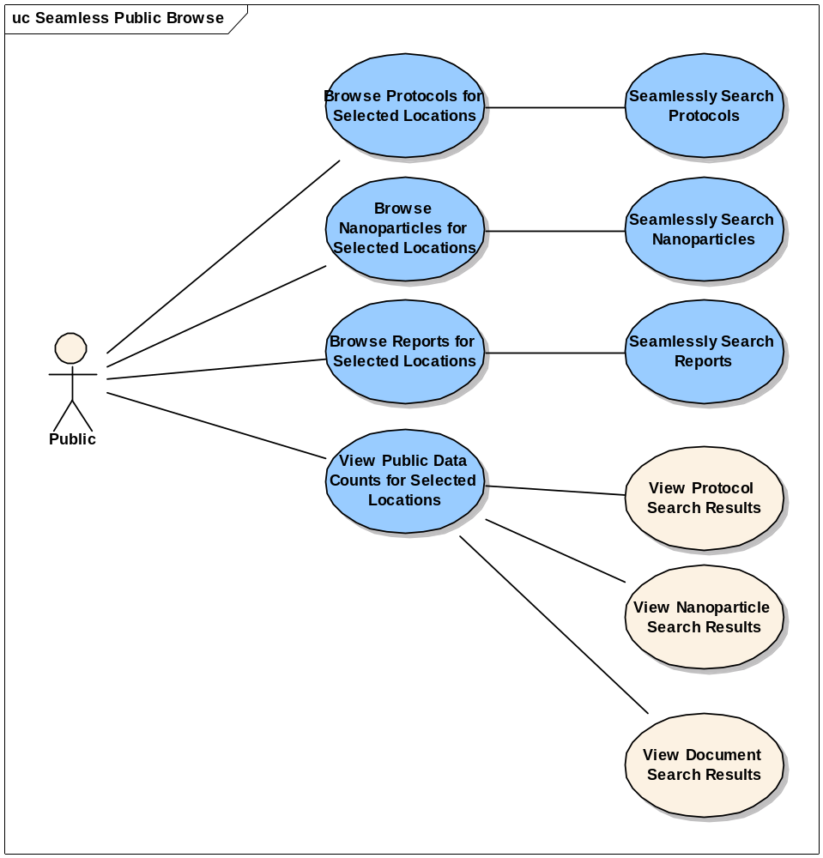
Figure 3-1 Public Seamless Browse High-Level Use Case Diagram

Browse documents for Selected Locations

Use Case Name | Browse Documents for Selected Location
Use Case ID | 10.1
Primary Actor | Public User
Brief Description | The Browse documents for Selected Locations use case allows the User to select one or more search locations to search for publicly available documents without logging in. The search locations include local system and all production caNanoLab grid services.
Trigger | The User desires to search for publicly available documents from one or more locations.
Pre-conditions | - The user navigates to the caNanoLab Web Site and click on the CLICKING HERE link on the disclaimer page.  - The system auto-discovers available caNanoLab grid services registered with production caGrid, stores the names of the caNanoLab grid services in the user session, populates the Location drop-down, and default the selection to Local.
Flow of Events | - The user selects one or more browse locations from the Location drop-down on the main page.  - The user clicks on the search link next to Documents in the Data Type column.  - The Search Documents form displays  - The user enters following optional search criteria:  - Document Type  - Document Title  - Publication Type  - PubMed ID  - Digital Object ID  - Journal  - Publication Status  - Research Area  - Year of Publication  - Authors  - Keyword  - Particle Composition Nanoparticle Entity Types  - Particle Composition Functionalizing Entity Types  - Particle Function Types  - Search locations. By default, the selected locations will be auto-highlighted  If no search criteria have been entered, a search will be performed for all documents.  - The user clicks the submit button to initiate the search  - A read-only list of publicly available documents that match the entered search criteria is listed on the search results page with the particle ID displayed as a link to obtain additional information about the document  - If selected search criteria results in no document matches, a message will be displayed on the top of the search page indicating that no documents exist for the submitted search criteria
Post Conditions | Success Condition: The user successfully searches the database and across the grid and obtains a list of all publicly available documents and that matches the search criteria  Alternate Condition:  AC1: User does not select any locations  AC2: Production caGrid is down  AC3: Any caNanoLab grid service is down after auto-discovery  AC4: User does not select search criteria  AC5: No result is found  Error Conditions:  EC1: System Error during Request Submission  EC2: Database Error during Document Retrieval
Alternative Flow | Alternate Condition:  AC1: User does not select search location  - The System assumes all locations are implied  AC2: Production caGrid is down  - The System displays only Local in the location drop-down and displays a message about not being able to auto-discover caNanoLab grid nodes  AC3: Any caNanoLab grid service is down after auto-discovery  - The System skips searching against the grid service and displays a message about the grid service not being available on the search result page  AC4: User does not select search criteria  1. The System displays a list of “all” publicly available reports  AC5: No result is found  1. A “No results found” message is displayed on the search form  Error Conditions:  EC1: System Error  - A system error has occurred which prevents processing of all related request  - The User contacts application help support  EC2: Database Error  - A database error has occurred which prevents processing of the protocol retrieval request  The System displays the error condition and application help contact information
Related Use Cases | Seamlessly Search Documents  View Documents Search Results

Seamlessly Search Documents

Use Case Name | Seamlessly Search Documents
Use Case ID | 10.2
Primary Actor | Public User
Brief Description | The Seamlessly Search Documents use case allows the User to search documents stored in the local system as well as the publicly available documents in the remote grid services in a seamless fashion
Trigger | The user desires to search for documents from local systems as well as public documents from caNanoLab grid services
Pre-conditions | - The user navigates to the caNanoLab Web Site and click on the CLICKING HERE link on the disclaimer page.  - The system auto-discovers available caNanoLab grid services registered with production caGrid, stores the names of the caNanoLab grid services in the user session, populates the Location drop-down, and default the selection to Local.  - The User is logged into the system
Flow of Events | - The user clicks on the Documents tab and clicks on Search Documents from the image map on the first page.  - The user enters following optional search criteria:  - Document Category  - Research Category  - Keywords  - Document Title  - PubMed ID  - Digital Object ID  - Publication Type  - Authors  - Particle Composition Nanoparticle Entity Types  - Particle Composition Functionalizing Entity Types  - Particle Function Types  If no search criteria have been entered, a search will be performed for all documents  - The user clicks the submit button to initiate the search  - A read-only list of publicly available documents as well as a list of local documents accessible to user that match the entered search criteria is listed on the search results page, with the particle ID displayed as a link to obtain additional information about the document  Depending on the user access privileges, the links on local documents either link to a read-only view of the document detail page or a read-write view of the document detail page. The links on remote documents link to a read-only view of the document detail page.  - If selected search criteria results in no document matches, a message will be displayed on the top of the search page indicating that no document sexist for the submitted search criteria
Post Conditions | Success Condition: The user successfully searches the database and across the grid and obtains a list of all publicly available documents as well as a list of local documents that matches the search criteria  Alternate Condition:  AC1: User does not log in  AC2: Production caGrid is down  AC3: Any caNanoLab grid service is down after auto-discovery  AC4: User does not select search criteria  AC5: No result is found  Error Conditions:  EC1: System Error during Request Submission  EC2: Database Error during Document Retrieval
Alternative Flow | Alternate Condition:  AC1: User does not log in  - The System follows use case 3.1  AC2: Production caGrid is down  - The System displays only Local in the location drop-down and displays a message about not being able to auto-discover caNanoLab grid nodes  AC3: Any caNanoLab grid service is down after auto-discovery  - The System skips searching against the grid service and displays a message about the grid service not being available on the search result page  AC4: User does not select search criteria  1. The System displays a list of “all” publicly available documents  AC5: No result is found  1. A “No results found” message is displayed on the search form  Error Conditions:  EC1: System Error  - A system error has occurred which prevents processing of all related request  - The User contacts application help support  EC2: Database Error  - A database error has occurred which prevents processing of the document retrieval request  The System displays the error condition and application help contact information
Related Use Cases | Browse Documents for Selected Locations  View Document Search Results

View Document Search Results

Use Case Name | View Document Search Results
Use Case ID | 10.3
Primary Actor | Public User
Brief Description | The View Document Search Results use case allows a Public User to view search results based on selected criteria as described in the <Seamless Search Documents> use case
Trigger | The User enters in search criteria as defined in the <Seamless Search Documents> use case and submits a request to search for documents
Pre-conditions | - The User is logged into the System  - The User has entered in Search Criteria on the Seamless Search Documents screen and has submitted the search request
Flow of Events | - The Public User views the search results in tabular form based on the requested criteria  - The search results table contains the: Document Category, Title, Publication Type, Document Link, Keywords, Research Category, Associated Particle Sample Names, Created Date and Location
Post Conditions | Success Condition:  The Public User successfully views the search results table.  Error Conditions:  EC1: System Error during Request Submission  EC2: Grid Node No Longer Available  EC3: Grid Node Remote Exception  EC4: Document Link Broken
Alternative Flow | Alternate Condition:  None  Error Conditions:  EC1: System Error  - A system error has occurred which prevents viewing additional details  - The User contacts application help support  EC2: Grid Node No Longer Available  - After the search request is submitted, a grid node becomes unavailable  - The System displays the search results including an indication that the grid node is no longer available for each node that is no longer available  EC3: Grid Node Remote Exception  - An exception is returned from a remote grid node  - The System displays the search results including an indication that a grid node has an exception  EC4: Document Link Broken  - The URL for the document is broken  - The System displays an error
Related Use Cases | Seamless Search Documents

3.2 Enhanced Document Submission
Figure 3-2 provides a high-level diagram of the caNanoLab 1.4.1 use cases associated with submitting a document. caNanoLab 1.4.1 use cases are highlighted in blue and leverage existing caNanoLab use cases for Submit Document.
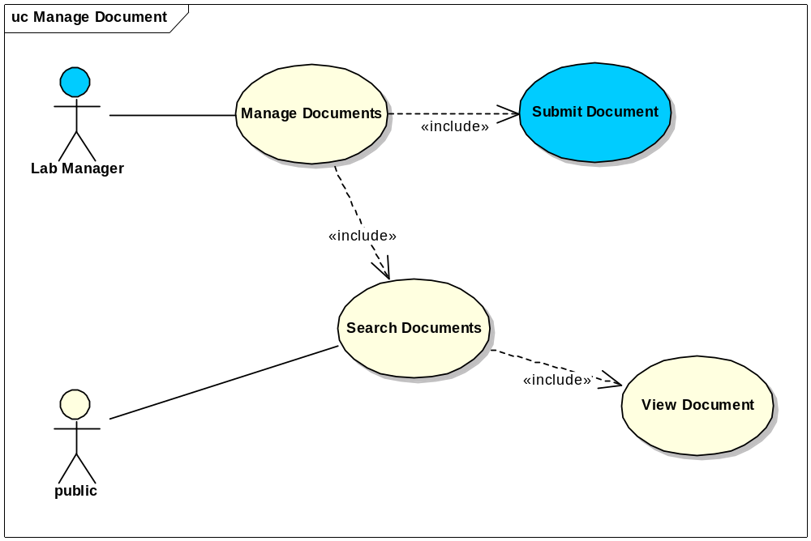
Figure 3-2 Document Submission High-Level Use Case Diagram
3.2.1 Submit New Document

Use Case Name | Submit Document (Publication)
Use Case ID | 11.1
Primary Actor | Data Curator
Brief Description | The Submit Document use case allows Data Curator to submit documents. Document type includes publication and report. Documents can be affiliated with one or multiple nanoparticles.
Trigger | The User desires to submit documents.
Pre-conditions | - The User is logged into the System and has the privilege to submit/update documents.  - Nanoparticles associated with the document have already been accessioned into the system
Flow of Events | - The User selects to Submit Documents  - The User selects ‘Publication’ as Document Type  - The User selects Publication Type  - The User selects Publication Status  - The User selects Publication Type  - The User Click to look up PubMed Identifier  - The User enters PubMed ID  - The User clicks on ‘Auto Populate Fields’ button to populate the following fields if available: Title, Journal, Authors, Year of Publication, Volume, Start Page, End Page  - The User selects Research Area  - The User enters Keywords  - The User enters Description  - The User selects document associated nanoparticle sample Name  - The User selects the visibility of the document  - The User submits the document into the system
Post Conditions | Success Condition: The User successfully submits the publication  Error Conditions:  EC1: System Error during Request Submission  EC2: Database Error during Retrieval
Alternative Flow | Alternate Conditions:  - The User selects a nanoparticle  - The User click on Document on the left side menu  - The User click on The ‘Add’ button under Document  - The User selects Document Type  - The User selects ‘Publication’ as Document Type  - The User selects Publication Type  - The User selects Publication Status  - The User selects Publication Type  - The User Click to look up PubMed Identifier  - The User enters PubMed ID  - The User clicks on Auto Populate Fields to populate the following fields if available: Title, Journal, Authors, Year of Publication, Volume, Start Page, End Page  - The User selects Research Area  - The User enters Keywords  - The User enters Description  - The User selects document associated nanoparticle sample Name  - The User selects the visibility of the document  - The User submits the document into the system  Error Conditions:  EC1: System Error  - A system error has occurred which prevents processing of the submission request  - The User contacts application help support  EC2: Database Error  - A database error has occurred which prevents processing of the search request  - The System displays the error condition and application help contact information
Related Use Cases | Seamlessly Search Documents
Issues/Notes | None

Use Case Name | Submit Document (Report)
Use Case ID | 11.2
Primary Actor | Data Curator
Brief Description | The Submit Document use case allows Data Curator to submit documents. Document type includes publication, report or other user entered type of documents. Documents can be affiliated with one or multiple nanoparticles.
Trigger | The User desires to submit documents.
Pre-conditions | - The User is logged into the System and has the privilege to submit/update documents.  - Nanoparticles associated with the document have already been accessioned into the system
Flow of Events | - The User selects to Submit Documents  - The User selects ‘Report’ as Document Type  - The User click on browse to upload report file or enters report URL  - The User enters Report Category  - The User enters Report Title  - The User selects report associated Nanoparticle Sample Names  - The User enters Report File Description  - The User enters Comments  - The User selects the visibility of the document  - The User submits the document into the system
Post Conditions | Success Condition: The User successfully submits the report  Error Conditions:  EC1: System Error during Request Submission  EC2: Database Error during Retrieval
Alternative Flow | Alternate Conditions:  - The User selects a nanoparticle  - The User click on Document on the left side menu  - The User click on The Add button under Document  - The User selects ‘Report’ as Document Type  - The User click on browse to upload report file or enters report URL  - The User enters Report Category  - The User enters Report Title  - The User selects report associated Nanoparticle Sample Names  - The User enters Report File Description  - The User enters Comments  - The User selects the visibility of the document  - The User submits the document into the system  Error Conditions:  EC1: System Error  - A system error has occurred which prevents processing of the submission request  - The User contacts application help support  EC2: Database Error  - A database error has occurred which prevents processing of the search request  - The System displays the error condition and application help contact information
Related Use Cases | Seamlessly Search Documents
Issues/Notes | None

4.Overall Requirements
The table below identifies the requirements for the caNanoLab 1.4.1 effort.

Prior-ity | Req # | Requirement | Use Case Name |  | Release #
 | 1.0 | The system shall allow Public Users to browse publicly available data without User login
 | 1.1.1 | The System shall allow users to seamlessly search locally stored documents as well as the publicly available documents stored in remote caNanoLab grid services. |  |  | 1.4.1
 | 2.0 | The system shall allow Authorized Users to submit Documents with User login |  |  | 1.4.1
 | 2.1.1 | The System shall allow user to auto populate publication field if PubMed ID is provided for publication type of document. |  |  | 1.4.1
 | 2.1.2 | The System shall allow user to upload files for report |  |  | 1.4.1

Sign Off

Approval

NCICBIIT Rep Print Name Date
NCL Rep Print Name Date
NCI OC Rep Print Name Date
SAIC Rep Print Name Date

