Software Requirements Specification

cancer Nanotechnology Laboratory (caNanoLab) 1.5.2

NCI CBIIT

DOCUMENT REVISION HISTORY

Version Number | Date | Description
1.0 | June 25, 2010 | Initial draft of caNanoLab Use Cases for release 1.5.2.

Background/Summary
The caNanoLab effort is collaboration between the NCI CBIIT, the Nanotechnology Characterization Laboratory (NCL), and the Cancer Centers of Nanotechnology Excellence (CCNE), facilitating the development of standards and an informatics platform supporting nanotechnology in medicine. The NCL performs and standardizes the characterization of nanomaterials intended for cancer therapeutics and diagnostics. One of the goals of the collaboration is the establishment of nanoparticle characterization standards and a structured repository (caNanoLab) in support of data sharing with the CCNEs and cancer Biomedical Informatics Grid (caBIG®) participants. Data sharing in a standards based fashion is facilitated via the caBIG grid (caGrid) platform, which enables data sharing across centers in a federated approach.
The caNanoLab 1.5.2 effort extends previous caNanoLab releases and provides support for build and deployment automation (BDA), curation account management and data availability metrics generation and viewing.

Table of Contents
Software Requirements Specification 1
cancer Nanotechnology Laboratory (caNanoLab) 1.5.2 1
Background/Summary 1
1. Introduction 3
1.1 Overview 3
1.2 Related Documents 3
2. Actors 4
3. Use Cases 5
3.1 Manage Collaboration Groups Use Cases 6
3.1.1. Create a Collaboration Group 6
3.1.2. Edit a Collaboration Group 7
3.1.3. Delete a Collaboration Group 8
3.1.4. Manage Users in a Collaboration Group 9
3.2 Manage Samples Use Cases 10
3.2.1. Assign User or Group Access to a Sample 11
3.2.2. Manage Data Availability Matrix 12
3.2.1.1 Generate Data Availability Matrix 13
3.2.1.2 Update Data Availability Matrix 14
3.2.1.3 Delete Data Availability Matrix 15
3.2.3. Manage Characterizations 15
3.2.3.1 Assign User or Group Access to a File 16
3.2.4. Manage Sample Publications Use Cases 18
3.3 Manage Protocols Use Cases 18
3.3.1. Assign User or Group to a Protocol 18
3.4 Manage Publications Use Cases 19
3.4.1. Assign User or Group Access to a Publication 20
3.5 Review Data and Assign to Public Use Cases 21
3.6 Search Samples Use Cases 22
3.6.1. View Data Availability Matrix 22
4. Overall Requirements 27
5. Sign Off 28
Approval 28

Introduction

Overview
The goals of the caNanoLab effort are to:
- Provide for the efficient storage and retrieval of nanomaterial characterizations to expedite and validate the use of nanotechnology in medicine
- Develop and support an initial standard for representing nanomaterial characterizations to facilitate data sharing in a semantically interoperable fashion in the spirit of the cancer Biomedical Informatics Grid (caBIG™)
- Implement a system that facilitates data sharing in the nanotechnology community in a secure fashion
- Provide informatics support to the Nanotechnology Characterization Laboratory (NCL)
The caNanoLab 1.5.2 effort expands upon previous caNanoLab releases (.50, 1.0, 1.1, 1.2, 1.2.1, 1.3, 1.4, 1.4.1, 1.5, 1.5.1). The major functionality in 1.5.2 includes:
- Support for BDA
- Support for curation account management.
- Support for data availability metrics against caNanoLab model and MINChar standards.
The purpose of this document is to identify and detail the use cases and requirements associated with the caNanoLab 1.5.2 Release.

Related Documents

Document Name | Version | Location
caNanoLab 1.5 Use Case Specification | 1.0 | https://ncisvn.nci.nih.gov/svn/cananolab/trunk/docs/usecase/
caNanoLab 1.4.1 Use Case Specification | 1.0 | https://ncisvn.nci.nih.gov/svn/cananolab/trunk/docs/usecase/
caNanoLab 1.4 Use Case Specification | 1.0 | https://ncisvn.nci.nih.gov/svn/cananolab/trunk/docs/usecase/
caNanoLab 1.3 Use Case Specification | 1.0 | https://ncisvn.nci.nih.gov/svn/cananolab/trunk/docs/usecase/
caNanoLab 1.2 Scope Document | 1.0 | https://ncisvn.nci.nih.gov/svn/cananolab/trunk/docs/usecase/
caNanoLab 1.2 Use Case Specification | 1.0 | https://ncisvn.nci.nih.gov/svn/cananolab/trunk/docs/usecase/
caNanoLab 1.0 Use Case Specification | 1.0 | https://ncisvn.nci.nih.gov/svn/cananolab/trunk/docs/usecase/
caNanoLab .50 Use Case Specification | 1.0 | https://ncisvn.nci.nih.gov/svn/cananolab/trunk/docs/usecase/

Actors
The table below describes the primary caNanoLab actors applicable to the caNanoLab Release 1.5.2 use cases as well as the intended authorization.

Actor | Description | Authorization
Curator | A Curator can manage and search all samples, publications, protocols, and collaboration groups in the caNanoLab system, and can assign any data to be visible to public. The curator is also responsible for reviewing private data and assigning them to be public. The Curator needs to log into the system. | Create, update, delete and read all samples, publications, protocols and collaboration groups.  Assign data to be public.
Researcher | A Researcher is responsible for managing samples, publications, protocols and collaboration groups assigned to be manageable by the Researcher. The Researcher is responsible for submitting private data to the Curator for review. The Researcher can search all public data and private data assigned searchable by the Researcher. The Researcher needs to log into the caNanoLab system. | Create, update, delete and read private samples, publications, protocols and collaboration groups that the Researcher has access to.  Read all public data.
Public | A Public actor doesn’t need to log into the caNanoLab system and can only search publicly available samples, publications and protocols. | Read public samples, publications and protocols.
Administrator | The Administrator, when logging into the UPT tool, is responsible for managing user accounts, user groups. When logging into the caNanoLab system, the Administrator is responsible for managing site preferences. | Submit, Access and Retrieve users and user groups and access privileges maintained in the NCI’s User Provisioning Tool (UPT).  Only when a user is assigned to be both a data curator and an administrator, the user can delete data from the System.

Use Cases
Figure 3-1 provides a high-level diagram of the caNanoLab 1.5.2 use cases. Pink colored ones are new use cases for release 1.5.2. Blue colored ones are use cases from previous releases but have modifications in release 1.5.2. Beige colored ones are uses cases from previous releases without any changes. Primary user activities related to release 1.5.2 include:
- Manage Collaboration Groups
- Manage Samples
- Manage Protocols
- Manage Publications
- Review Data and Assign to Public
- Search Samples
The sub-sections that follow provide detailed use cases associated with these activities.
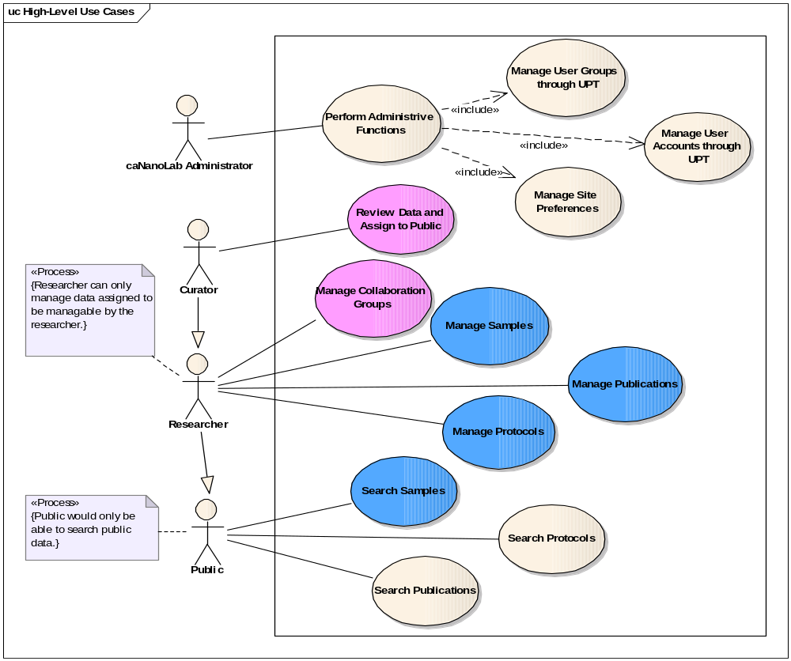
Figure 3-1 High-Level Use Cases

Manage Collaboration Groups Use Cases
Figure 3-2 provides a high-level diagram of the caNanoLab 1.5.2 use cases associated with managing Collaboration Groups.
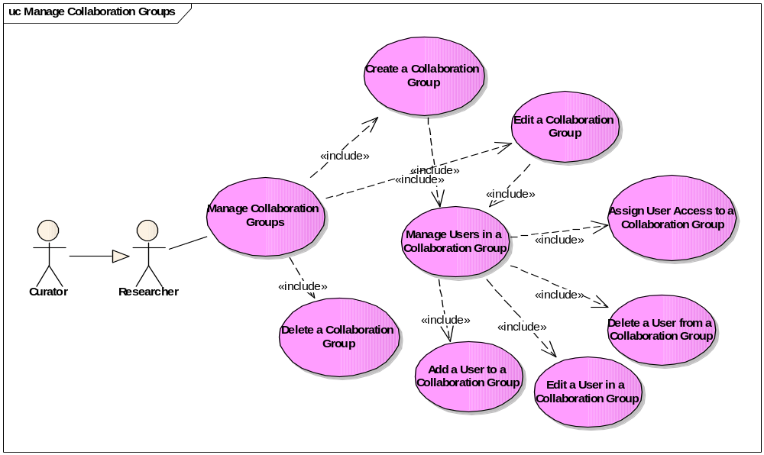
Figure 3-2 Manage Collaboration Groups Use Cases

Create a Collaboration Group

Use Case Name | Create a Collaboration Group
Use Case ID | 3.1.1
Primary Actor | Curator or Researcher
Brief Description | The Create a Collaboration Group use case allows the User to create new collaboration group and manage users in the collaboration group.
Trigger | The User desires to create a new collaboration group and assign users to the group.
Pre-conditions | - The User logs in the system.  - The User clicks on the COMMUNITY tab and clicks on the Manage Collaboration Groups Link.
Flow of Events | - The User clicks on the Add button to open the Collaboration Group Information form.  - The User submits the following information:  Group name  Group description  - The User clicks on the Add link next to User to open the User Information form and submits the user information. Please refer to the Manage Users in a Collaboration Group use case for details.  - The User clicks on the Save button in the Collaboration Group Information form to save the collaboration group.
Post Conditions | Success Condition: The collaboration group and its associated user are successfully submitted into the system, and the group information is shown as a row in the existing collaboration group table.  Error Conditions:  EC1: System Error during request submission  EC2: Database Error during request submission
Alternative Flow | Alternate Conditions:  None  Error Conditions:  EC1: System Error  - A system error has occurred which prevents the submission of the submission request  EC2: Database Error  - A database error has occurred which prevents the submission of the submission request  - The System displays the error condition and application help contact information
Related Use Cases | Manage Users in a Collaboration Group

Edit a Collaboration Group

Use Case Name | Edit a Collaboration Group
Use Case ID | 3.1.2
Primary Actor | Curator or Researcher
Brief Description | The Edit a Collaboration Group use case allows the User to edit an existing collaboration group and manage users in the collaboration group.
Trigger | The User desires to edit an existing collaboration group and manage users in the group.
Pre-conditions | - The User logs in the system.  - The User clicks on the COMMUNITY tab and clicks on the Manage Collaboration Groups Link.  - The System retrieves any existing collaboration groups assigned to be manageable by the USER. The Curator can manage all collaboration groups. The Researcher can only manage collaboration groups they have been assigned CURD role to.  - If there are existing collaboration groups in the system that can be managed by the user, the System presents a table of existing collaboration groups manageable by the USER, each with an Edit link for editing the existing collaboration group.
Flow of Events | - The User clicks on an Edit link in the existing collaboration group table to open the Collaboration Group Information form.  - The User edits the following information:  Group name  Group description  - The User clicks on the Add link next to User to open the User Information form to submit a new user or clicks on the Edit link in the existing user information table to edit an existing user. Please refer to Manage Users in a Collaboration Group for details.  - The User clicks on the Save button in the Collaboration Group Information form to save the collaboration group.
Post Conditions | Success Condition: The selected collaboration group and its associated user are successfully edited and resubmitted to the system, and the updated group information is shown as a row in the existing collaboration group table.  Error Conditions:  EC1: System Error during request submission  EC2: Database Error during request submission
Alternative Flow | Alternate Conditions:  None  Error Conditions:  EC1: System Error  - A system error has occurred which prevents the submission of the submission request  EC2: Database Error  - A database error has occurred which prevents the submission of the submission request  - The System displays the error condition and application help contact information
Related Use Cases | Manage Users in a Collaboration Group  Delete a Collaboration Group

Delete a Collaboration Group

Use Case Name | Delete a Collaboration Group
Use Case ID | 3.1.3
Primary Actor | Curator or Researcher
Brief Description | The Delete a Collaboration Group use case allows the User to delete an existing collaboration group and its user associations, as well as associated data accessibilities.
Trigger | The User desires to delete an existing collaboration group and it user associations.
Pre-conditions | - The User logs in the system.  - The User clicks on the COMMUNITY tab and clicks on the Manage Collaboration Groups Link.  - The System retrieves any existing collaboration groups assigned to be manageable by the USER. The Curator can manage all collaboration groups. The Researcher can only manage collaboration groups they have been assigned CURD role to.  - If there are existing collaboration groups in the system that can be managed by the user, the System presents a table of existing collaboration groups manageable by the USER, each with an Edit link for editing the existing collaboration group.
Flow of Events | - The User clicks on an Edit link in the existing collaboration group table to open the Collaboration Group Information form.  - The User clicks on the Delete button in the Collaboration Group Information form to remove the collaboration group.
Post Conditions | Success Condition: The selected collaboration group and its user associations are successfully deleted from the system, and the selected group information is removed as a row from the existing collaboration group table.  Error Conditions:  EC1: System Error during request submission  EC2: Database Error during request submission
Alternative Flow | Alternate Conditions:  None  Error Conditions:  EC1: System Error  - A system error has occurred which prevents the submission of the submission request  EC2: Database Error  - A database error has occurred which prevents the submission of the submission request  - The System displays the error condition and application help contact information
Related Use Cases | Edit a Collaboration Group

Manage Users in a Collaboration Group

Use Case Name | Manage Users in a Collaboration Group
Use Case ID | 3.1.4
Primary Actor | Curator or Researcher
Brief Description | The Manage Users in a Collaboration Group use case allows the User to add users to a collaboration group; remove users from the group; and edit user associations and user accessibilities to the group.
Trigger | The User desires to manage user in an existing collaboration group.
Pre-conditions | - The User logs in the system.  - The User clicks on the COMMUNITY tab and clicks on the Manage Collaboration Groups Link.  - The System retrieves any existing collaboration groups assigned to be manageable by the USER. The Curator can manage all collaboration groups. The Researcher can only manage collaboration groups they have been assigned CURD role to.  - If there are existing collaboration groups in the system that can be managed by the user, the System presents a table of existing collaboration groups manageable by the USER, each with an Edit link for editing the existing collaboration group.  - The User clicks on an Edit link in the existing collaboration group table to open the Collaboration Group Information form.
Flow of Events | - The User clicks on the Add link next to User to open the User Information form or clicks on the edit link in the existing user information table.  - The User submits/edits the following information:  - User login name (either by typing in the login name or clicking on the magnifying glass browse icon to select from an existing user list)  - Accessibility to the group (select one from the drop down list).  - The User clicks on the Save button in the User Information form to submit the user information.
Post Conditions | Success Condition: The user information is successfully submitted to the system, and the user information is shown as a row in the existing user information table.  Error Conditions:  EC1: System Error during request submission  EC2: Database Error during request submission
Alternative Flow | Alternate Conditions:  The User clicks on the Delete button in the User information form to remove the user association from the collaboration group.  Error Conditions:  EC1: System Error  - A system error has occurred which prevents the submission of the submission request  EC2: Database Error  - A database error has occurred which prevents the submission of the submission request  - The System displays the error condition and application help contact information
Related Use Cases | Create a Collaboration Group  Edit a Collaboration Group

Manage Samples Use Cases
Figure 3-3 provides a high-level diagram of the caNanoLab 1.5.2 use cases associated with managing samples. These use cases allow the User to submit new samples, copy samples, edit samples and remove samples, as well as manage compositions, characterizations and publications associated with samples.
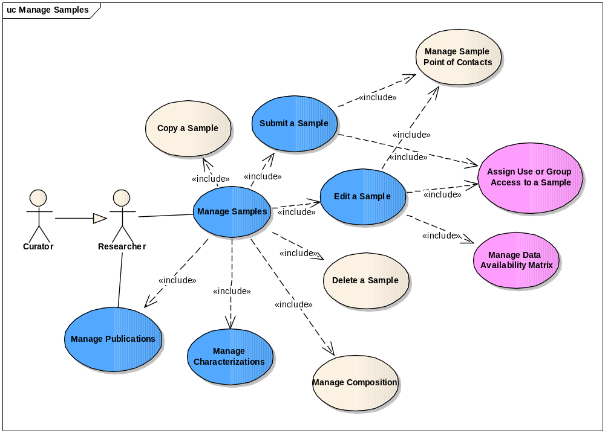
Figure 3-3 Manage Samples Use Cases
In this document, we focus on the two new uses cases for release 1.5.2: Assign User or Group Access to a Sample use case and Manage Data Availability Matrix use case, as well as two use cases that have modifications in release1.5.2: Manage Publications, Manage Characterizations.

Assign User or Group Access to a Sample

Use Case Name | Assign User or Group Access to a Sample
Use Case ID | 3.2.1
Primary Actor | Curator or Researcher
Brief Description | The Assign Group or User Access to a Sample use case allows the User to assign access privileges such as read only, read create update delete to a sample for individual users or collaboration groups.
Trigger | The User desires to assign user or group level access privileges to a sample.
Pre-conditions | - The User logs in the system.  - The User clicks on the SAMPLES tab.  - The User clicks on the Submit a New Sample link to open the Submit a New Sample form. Alternatively, the User clicks on the Search Existing Samples link to open the Search Sample Form or clicks on the Advanced Sample Search link to open the Advanced Sample Search Form; enters search criteria and clicks on the Search button to see a list of samples with Edit links. The user clicks on the Edit link next to the sample to open the Update Sample form.
Flow of Events | - The User clicks on the Add button next to “Access to the Sample” to open up the Access Information form.  - The User submits the following information:  Access by (selecting either Collaboration Group by User)  Collaboration Group Name (or User Name depending on the radio button selection above)  Access to the Sample (selecting from the drop down list)  - The User clicks on the Save button in the Access Information form to save the access information.
Post Conditions | Success Condition: The newly saved sample access information are saved as a row either in the existing Collaboration Group access table or the existing User access table depending on the Access By choice.  Error Conditions:  EC1: System Error during request submission  EC2: Database Error during request submission
Alternative Flow | Alternate Conditions:  The User decides to delete or update an existing sample access instead of adding a new access. The following flow of events happens:  - The User clicks on the Edit link in the existing Collaboration Group access table or the User access table to open up the Access Information form.  - The User either clicks on the Delete button to remove the access or clicks on the Save button to update the information in the form.  Error Conditions:  EC1: System Error  - A system error has occurred which prevents the submission of the submission request  EC2: Database Error  - A database error has occurred which prevents the submission of the submission request  - The System displays the error condition and application help contact information
Related Use Cases | Manage Users in a Collaboration Group

Manage Data Availability Matrix
Figure 3-4 provides a high-level diagram of the caNanoLab 1.5.2 use cases associated with managing data availability use cases.
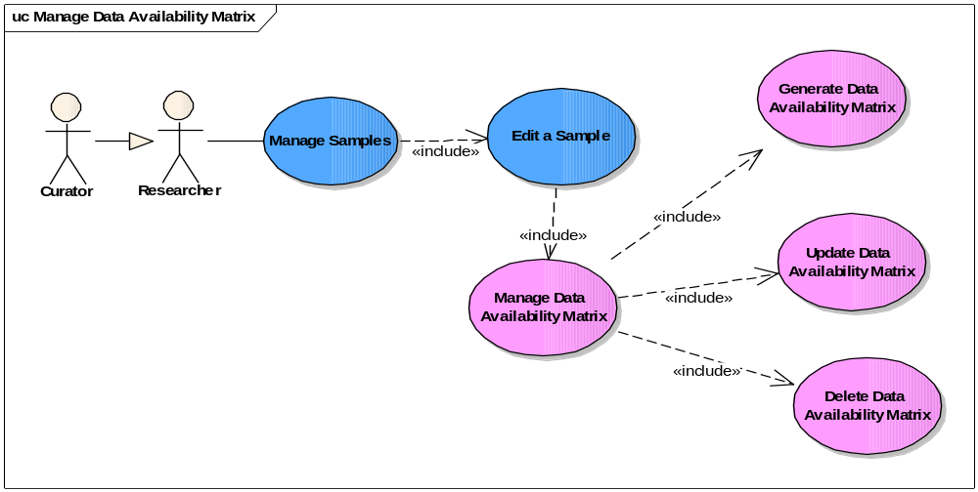
Figure 3-4 Manage Data Availability Use Cases

Use case details are provided below:

Use Case Name | Manage Data Availability Matrix
Use Case ID | 1.4
Primary Actor | Super Data Curator or Organization Data Curator
Brief Description | The Manage Data Availability Matrix use case allows the Actor to search and manage organization specific data components including samples, characterizations by setting the data to be available.
Trigger | The User desires to either search or submit a study
Pre-conditions | The User is authorized to access desired functionality
Flow of Events | The User selects to edit Sample via the <Edit Sample> use case  The User selects to generate Data Availability Matrix via the <Generate Data Availability Matrix> use case  The User selects to update data availability matrix via the <Update Data Availability Matrix> use case  The User selects to delete data availability matrix via the <Delete Data Availability Matrix> use case
Post Conditions | Success Condition: The appropriate page is displayed as identified in related Manage Data Availability use cases based on a user’s authorizations  Error Conditions:  EC1: System Error during request submission  EC2: Database Error during data retrieval
Alternative Flow | Error Conditions:  EC1: System Error  - A system error has occurred which prevents processing of all related request  - The User contacts application help support  EC2: Database Error  - A database error has occurred which prevents data retrieval  - The System displays the error condition and application help contact information
Related Use Cases | Search Sample  Edit Sample  Manage Organization Specific Data  Generate Data Availability Matrix  Update Data Availability Matrix  Delete Data Availability Matrix  View Data Availability Matrix

Use Case Name | Edit Sample
Use Case ID | 1.4.1
Primary Actor | Super Data Curator or organization data curator
Brief Description | The Edit Sample use case allows the Actor to update the sample data and generate, update or delete sample data availability.
Trigger | The User desires to edit sample information
Pre-conditions | The User is authorized to access desired functionality
Flow of Events | The User selects to search a sample via the <Search Sample> use case  The User selects to edit a sample from the search result via the <Edit Sample> use case  The User selects to generate data availability matrix via the <Generate Data Availability Matrix> use case  The User selects to update data availability matrix via the <Update Data Availability Matrix> use case  The User selects to delete data availability matrix via the <Delete Data Availability Matrix> use case
Post Conditions | Success Condition: The appropriate page is displayed as identified in related Edit Sample use cases based on a user’s authorizations  Error Conditions:  EC1: System Error during request submission  EC2: Database Error during data retrieval
Alternative Flow | Error Conditions:  EC1: System Error  - A system error has occurred which prevents processing of all related request  - The User contacts application help support  EC2: Database Error  - A database error has occurred which prevents data retrieval  - The System displays the error condition and application help contact information
Related Use Cases | Edit Sample  Manage Data Availability Matrix  Generate Data Availability Matrix  Update Data Availability Matrix  Delete Data Availability Matrix

Generate Data Availability Matrix

Use Case Name | Generate Data Availability Matrix
Use Case ID | 1.4.1
Primary Actor | Super Data Curator or Organization Data Curator
Brief Description | The Generate Data Availability Matrix use case allows the Actor to search for organization data and generate data availability matrix
Trigger | The User desires to either generate data availability matrix
Pre-conditions | The User is authorized to access desired functionality
Flow of Events | The User selects to generate data availability matrix for the sample
Post Conditions | Success Condition: The appropriate section is displayed as identified in related Generate Data Availability matrix use case based on a user’s authorizations  Error Conditions:  EC1: System Error during request submission  EC2: Database Error during data retrieval
Alternative Flow | Error Conditions:  EC1: System Error  - A system error has occurred which prevents processing of all related request  - The User contacts application help support  EC2: Database Error  - A database error has occurred which prevents data retrieval  - The System displays the error condition and application help contact information
Related Use Cases | Search Sample  Manage Organization Specific Data  Generate Data Availability Matrix  Update Data Availability Matrix  Delete Data Availability Matrix  View Data Availability Matrix

Update Data Availability Matrix

Use Case Name | Update Data Availability Matrix
Use Case ID | 1.4.1
Primary Actor | Super Data Curator or Organization Data Curator
Brief Description | The Update Data Availability Matrix use case allows the Actor to make a modification to the data availability matrix.
Trigger | The User desires to either search or submit a study
Pre-conditions | The User is authorized to access desired functionality
Flow of Events | The User select to update the Data Availability Matrix
Post Conditions | Success Condition: The appropriate section is displayed as identified in related Manage Data Availability Matrix use cases based on a user’s authorizations  Error Conditions:  EC1: System Error during request submission  EC2: Database Error during data retrieval
Alternative Flow | Error Conditions:  EC1: System Error  - A system error has occurred which prevents processing of all related request  - The User contacts application help support  EC2: Database Error  - A database error has occurred which prevents data retrieval  - The System displays the error condition and application help contact information
Related Use Cases | Search Sample  Manage Organization Specific Data  Generate Data Availability Matrix  Update Data Availability Matrix  Delete Data Availability Matrix  View Data Availability Matrix

Delete Data Availability Matrix

Use Case Name | Delete Data Availability Matrix
Use Case ID | 1.4.1
Primary Actor | Super Data Curator or Organization Data Curator
Brief Description | The Delete Data Availability Matrix use case allows the Actor to delete a generated data availability matrix.
Trigger | The User desires to either search or submit a study
Pre-conditions | The User is authorized to access desired functionality
Flow of Events | The User selects to delete the data availability matrix
Post Conditions | Success Condition: The appropriate page is displayed as identified in related Manage Study use cases based on a user’s authorizations  Error Conditions:  EC1: System Error during request submission  EC2: Database Error during data retrieval
Alternative Flow | Error Conditions:  EC1: System Error  - A system error has occurred which prevents processing of all related request  - The User contacts application help support  EC2: Database Error  - A database error has occurred which prevents data retrieval  - The System displays the error condition and application help contact information
Related Use Cases | Manage Organization Specific Data  Generate Data Availability Matrix  Update Data Availability Matrix  Delete Data Availability Matrix  View Data Availability Matrix

Manage Characterizations
Figure 3-5 provides a high-level diagram of the caNanoLab 1.5.2 use cases associated with manage characterization use cases.

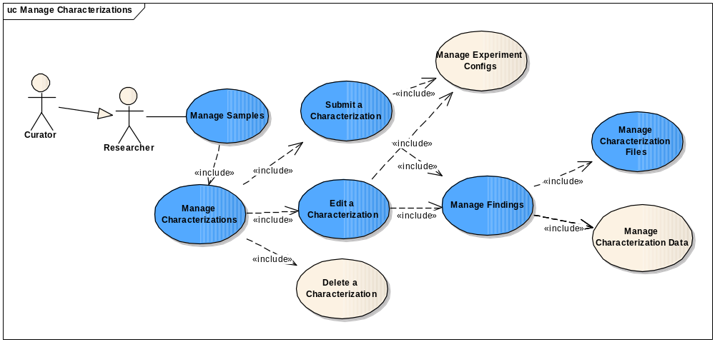
Figure 3-5 Manage Characterization Use Cases
In this document, we focus on the new use case Assign User or Group Access to a File use case under the Manage Characterization File use cases as shown in Figure 3-6.
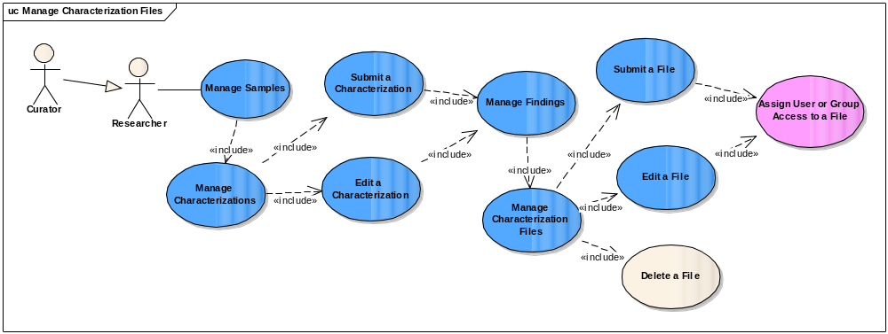
Figure 3-6 Manage Characterization Files Use Cases

Assign User or Group Access to a File

Use Case Name | Assign User or Group Access to a File
Use Case ID | 3.2.3.1
Primary Actor | Curator or Researcher
Brief Description | The Assign Group or User Access to a File use case allows the User to assign access privileges such as read only, read create update delete to a characterization file for individual users or collaboration groups.
Trigger | The User desires to assign user or group level access privileges to a characterization file.
Pre-conditions | - The User logs in the system.  - The User clicks on the SAMPLES tab.  - The User clicks on the Search Existing Samples link to open the Search Sample Form or clicks on the Advanced Sample Search link to open the Advanced Sample Search Form; enters search criteria and clicks on the Search button to see a list of samples with Edit links. The user clicks on the Edit link next to the sample to open the Update Sample form.  - The User clicks on the CHARACTERIZATION tab on the left to open the characterization summary view for the selected sample.  - The User either clicks on the Add button next to a characterization type to open the Submit a New Characterization form. Alternatively, the User clicks on the Edit link in the existing characterizations table to open up the Update Characterization form.
Flow of Events | - The User clicks on the Add button next to “Finding” or clicks on the Edit link in a row in the existing Finding table to open up the Finding Info form.  - The User clicks on the Add link next to “File” or clicks on the Edit link in a row in the existing File table to open the File submission form.  - The User clicks on the Add button next to “Access to the File” to open the Access Info form.  - The User submits the following information:  Access by (selecting either Collaboration Group by User)  Collaboration Group Name (or User Name depending on the radio button selection above)  Access to the (selecting from the drop down list)  - The User clicks on the Save button in the Access Information form to save the access information.
Post Conditions | Success Condition: The newly saved file access information are saved as a row either in the existing Collaboration Group access table or the existing User access table depending on the Access By choice.  Error Conditions:  EC1: System Error during request submission  EC2: Database Error during request submission
Alternative Flow | Alternate Conditions:  The User decides to delete or update an existing File access instead of adding new file access information. The following flow of events happens:  - The User clicks on an edit link in the existing Finding table to open the Finding info form.  - The User clicks on the Edit link in the existing File table to open up the File submission form.  - The User clicks on the Edit link in the existing Collaboration Group access table or the User access table to open up the Access Information form.  - The User either clicks on the Delete button to remove the access or clicks on the Save button to update the information in the form.  Error Conditions:  EC1: System Error  - A system error has occurred which prevents the submission of the submission request  EC2: Database Error  - A database error has occurred which prevents the submission of the submission request  - The System displays the error condition and application help contact information
Related Use Cases | Manage Users in a Collaboration Group

Manage Sample Publications Use Cases
The use cases for Manage Publications under Manage Samples in Figure 3-3 are the same as the Manage Publications use cases in Figure 3-8. Please refer to section 3.4 for details on Manage Publications use cases.

Manage Protocols Use Cases
Figure 3-6 provides a high-level diagram of the caNanoLab 1.5.2 use cases associated with managing protocols. These use cases allow the User to submit new protocols, edit protocols and remove protocols.
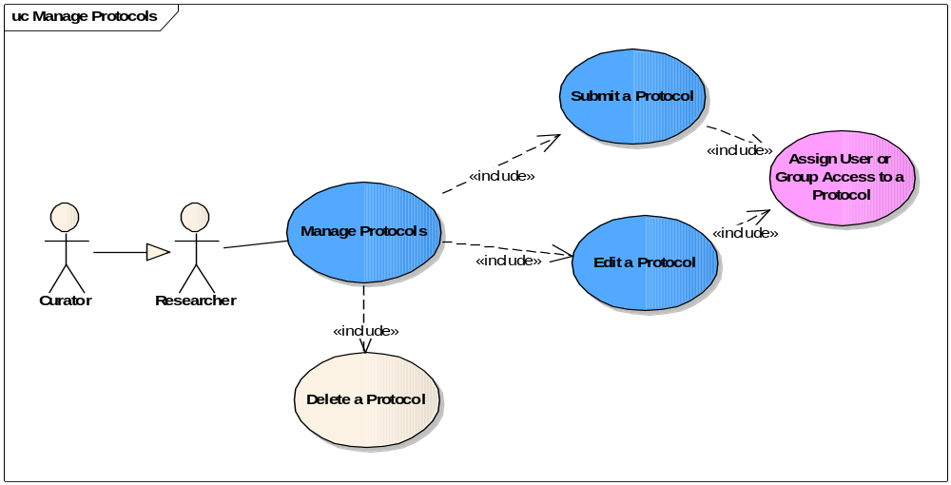
Figure 3-7 Manage Protocols Use Cases
In this document, we focus on the new uses case for release 1.5.2: Assign User or Group Access to a Protocol use case.

Assign User or Group Access to a Protocol

Use Case Name | Assign User or Group Access to a Protocol
Use Case ID | 3.3.1
Primary Actor | Curator or Researcher
Brief Description | The Assign Group or User Access to a Protocol use case allows the User to assign access privileges such as read only, read create update delete to a protocol for individual users or collaboration groups.
Trigger | The User desires to assign user or group level access privileges to a protocol.
Pre-conditions | - The User logs in the system.  - The User clicks on the PROTOCOLS tab.  - The User clicks on the Submit a New Protocol link to open the Submit a New Protocol form. Alternatively, the User clicks on the Search Existing Protocols link to open the Search Protocol Form; enters search criteria and clicks on the Search button to see a list of protocols with Edit links. The user clicks on the Edit link next to the protocol to open the Update Protocol form.
Flow of Events | - The User clicks on the Add button next to “Access to the Protocol” to open up the Access Information form.  - The User submits the following information:  Access by (selecting either Collaboration Group by User)  Collaboration Group Name (or User Name depending on the radio button selection above)  Access to the (selecting from the drop down list)  - The User clicks on the Save button in the Access Information form to save the access information.
Post Conditions | Success Condition: The newly saved protocol access information are saved as a row either in the existing Collaboration Group access table or the existing User access table depending on the Access By choice.  Error Conditions:  EC1: System Error during request submission  EC2: Database Error during request submission
Alternative Flow | Alternate Conditions:  The User decides to delete or update an existing protocol access instead of adding a new access. The following flow of events happens:  - The User clicks on the Edit link in the existing Collaboration Group access table or the User access table to open up the Access Information form.  - The User either clicks on the Delete button to remove the access or clicks on the Save button to update the information in the form.  Error Conditions:  EC1: System Error  - A system error has occurred which prevents the submission of the submission request  EC2: Database Error  - A database error has occurred which prevents the submission of the submission request  - The System displays the error condition and application help contact information
Related Use Cases | Manage Users in a Collaboration Group

Manage Publications Use Cases
Figure 3-7 provides a high-level diagram of the caNanoLab 1.5.2 use cases associated with managing publications. These use cases allow the User to submit new publications, edit publications and remove publications. As shown in Figure 3-3, the User can manage publications associated with a particular sample through managing samples or can manage publications outside the context of samples.
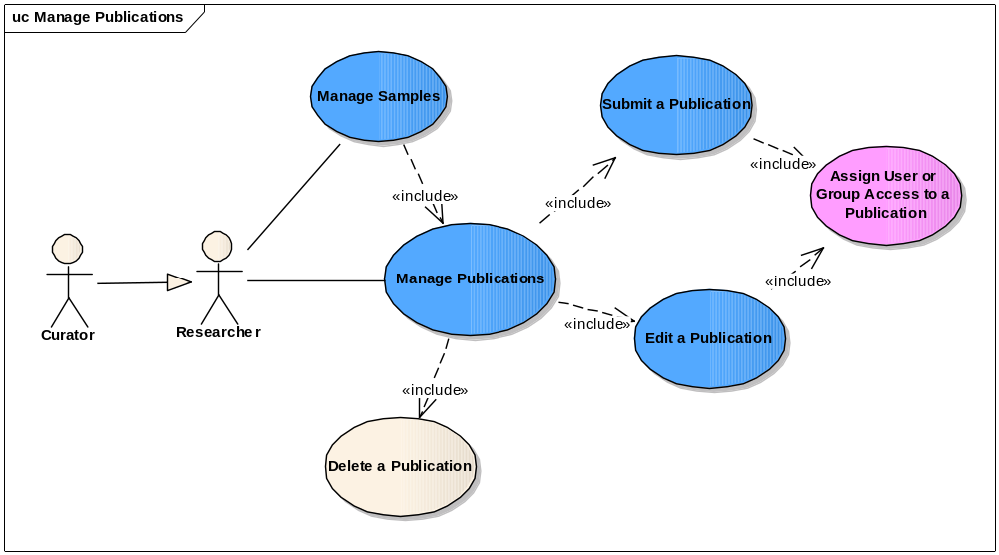
Figure 3-8 Manage Publications Use Cases
In this document, we focus on the new uses case for release 1.5.2: Assign Group or User Access to a Publication use case.

Assign User or Group Access to a Publication

Use Case Name | Assign User or Group Access to a Publication
Use Case ID | 3.4.1
Primary Actor | Curator or Researcher
Brief Description | The Assign Group or User Access to a Publication use case allows the User to assign access privileges such as read only, read create update delete to a publication for individual users or collaboration groups.
Trigger | The User desires to assign user or group level access privileges to a publication.
Pre-conditions | - The User logs in the system.  - The User clicks on the PUBLICATIONS tab.  - The User clicks on the Submit a New Publication link to open the Submit a New Publication form. Alternatively, the User clicks on the Search Existing Publications link to open the Search Publication Form; enters search criteria and clicks on the Search button to see a list of publications with Edit links. The user clicks on the Edit link next to the publication to open the Update Publication form.  Alternatively,  - The User logs in the system.  - The User clicks on the SAMPLES tab.  - The User clicks on the Search Existing Samples link to open the Search Sample Form or clicks on the Advanced Sample Search link to open the Advanced Sample Search Form; enters search criteria and clicks on the Search button to see a list of samples with Edit links. The user clicks on the Edit link next to the sample to open the Update Sample form.  - The User clicks on the PUBLICATION tab on the left to open the publication summary view for the selected sample.  - The User either clicks on the Add button next to a publication category to open the Submit a New Publication form. Alternatively, the User clicks on the Edit link in the existing publications table to open up the Update Publication form.
Flow of Events | - The User clicks on the Add button next to “Access to the Publication” to open up the Access Information form.  - The User submits the following information:  Access by (selecting either Collaboration Group by User)  Collaboration Group Name (or User Name depending on the radio button selection above)  Access to the (selecting from the drop down list)  - The User clicks on the Save button in the Access Information form to save the access information.
Post Conditions | Success Condition: The newly saved publication access information are saved as a row either in the existing Collaboration Group access table or the existing User access table depending on the Access By choice.  Error Conditions:  EC1: System Error during request submission  EC2: Database Error during request submission
Alternative Flow | Alternate Conditions:  The User decides to delete or update an existing publication access instead of adding a new access. The following flow of events happens:  - The User clicks on the Edit link in the existing Collaboration Group access table or the User access table to open up the Access Information form.  - The User either clicks on the Delete button to remove the access or clicks on the Save button to update the information in the form.  Error Conditions:  EC1: System Error  - A system error has occurred which prevents the submission of the submission request  EC2: Database Error  - A database error has occurred which prevents the submission of the submission request  - The System displays the error condition and application help contact information
Related Use Cases | Manage Users in a Collaboration Group  Manage Samples

Review Data and Assign to Public Use Cases
As shown in the high-level use case diagram in Figure 3-1, the Curator can review any private data submitted by researchers in the system and assign them to be visible to public.

Use Case Name | Review Data and Assign to Public
Use Case ID | 3.5
Primary Actor | Curator
Brief Description | The Review Data and Assign to Public use case allows the User to assign samples, publications and protocols to be read only to the public.
Trigger | The User desires to make private samples, publications and protocols publicly available.
Pre-conditions | - During the submission of private samples, publications and protocols, the researcher clicks on the Submit for Review button in the submission forms.  - The System saves these data pending for review in a database table.  - The User logs in the system.  - The User clicks on the CURATIONS tab.  - The System queries for all the data pending for review and presents these data in a table for the User to view. Each row in the table shows the data type and the data ID and an Edit link.
Flow of Events | - The User clicks on the Edit link in a row in the data pending for review table to open on the data submission form, e.g. Sample Submission form, Publication Submission form, and Protocol Submission form.  - The User clicks on the Submit for Public button.
Post Conditions | Success Condition: The marks the data as public and removes it from the database table that stores data pending for review.  Error Conditions:  EC1: System Error during request submission  EC2: Database Error during request submission
Alternative Flow | Alternate Conditions:  AC1:  The User decides to update an existing publication access instead of adding a new access. In this case, the User clicks on an edit link in the existing Collaboration Group access table or the User access table to open up the Access Information form. The User either clicks on the Delete button to remove the access or updates the information in the form.  Error Conditions:  EC1: System Error  - A system error has occurred which prevents the submission of the submission request  EC2: Database Error  - A database error has occurred which prevents the submission of the submission request  - The System displays the error condition and application help contact information
Related Use Cases | Manage Samples  Manage Publications  Manage Protocols

Search Samples Use Cases

View Data Availability Matrix
Figure 3-8 provides a high-level diagram of the caNanoLab 1.5.2 use cases associated with viewing data availability matrix.
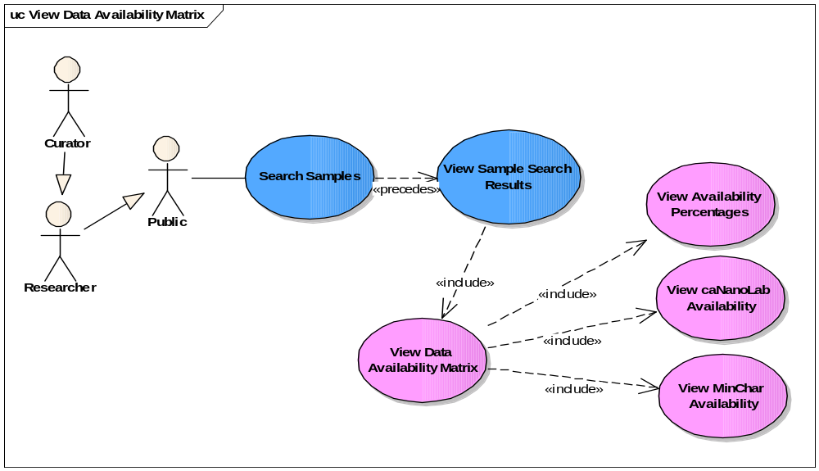
Figure 3-9 View Data Availability Use Cases
Use case details are provided below:

Use Case Name | View Data Availability Matrix
Use Case ID | 1.5
Primary Actor | Data Curator, Researcher, Public
Brief Description | The View Data Availability Matrix use case allows the Actor to search for sample and view data availability matrix for a sample.
Trigger | The User desires to either see data availability matrix
Pre-conditions | The User is authorized to access desired functionality and The User successfully found a list of available nanomaterial following use case <Search Sample>, or use case 8.4, <Seamlessly Search Nanoparticle>, in the use case document, caNanoLab 1.4 Use Cases.
Flow of Events | The User selects to search a sample via the <Search Sample> use case  The User clicks the link in Data Availability column from the nanomaterial search result list.  The Nanomaterial Data Availability Matrix page displays.
Post Conditions | Success Condition: The Data Availability Matrix page is displayed in tabular format with the following information:  - The score represented as percentage for the data availability (View Availability Percentage use case)  - List of the Data Type  - List of MINChar data availability (View MINChar Availability)  Error Conditions:  EC1: System Error during request submission  EC2: Database Error during data retrieval
Alternative Flow | Error Conditions:  EC1: System Error  - A system error has occurred which prevents processing of all related request  - The User contacts application help support  EC2: Database Error  - A database error has occurred which prevents data retrieval  - The System displays the error condition and application help contact information
Related Use Cases | Manage Organization Specific Data  Generate Data Availability Matrix  Update Data Availability Matrix  View Availability Percentage  View MINChar Availability

Use Case Name | View Availability caNanoLab Percentages
Use Case ID | 1.5
Primary Actor | Data Curator, Researcher
Brief Description | The View Availability Percentages use case allows the Actor to the data availability score as a percentage value. This use case is part of the View Data Availability Matrix use case.
Trigger | The User desires to view data availability matrix
Pre-conditions | The User is authorized to access desired functionality
Flow of Events | The User selects to search a sample via the <Search Sample> use case  The User clicks the link in Data Availability column from the nanomaterial search result list.  The system will generate the data availability score for the selected sample
Post Conditions | Success Condition: The appropriate page is displayed as identified in related View Data Availability Matrix use cases based on a user’s authorizations  Error Conditions:  EC1: System Error during request submission  EC2: Database Error during data retrieval
Alternative Flow | Error Conditions:  EC1: System Error  - A system error has occurred which prevents processing of all related request  - The User contacts application help support  EC2: Database Error  - A database error has occurred which prevents data retrieval  - The System displays the error condition and application help contact information
Related Use Cases | Manage Organization Specific Data  Generate Data Availability Matrix  Update Data Availability Matrix  View Data Availability Matrix  View MINChar Availability

Use Case Name | View Availability MINChar Percentages
Use Case ID | 1.5
Primary Actor | Data Curator, Researcher
Brief Description | The View Availability Percentages use case allows the Actor to the data availability score as a percentage value. This use case is part of the View Data Availability Matrix use case.
Trigger | The User desires to view data availability matrix
Pre-conditions | The User is authorized to access desired functionality
Flow of Events | The User selects to search a sample via the <Search Sample> use case  The User clicks the link in Data Availability column from the nanomaterial search result list.  The system will generate the data availability score for the selected sample
Post Conditions | Success Condition: The appropriate page is displayed as identified in related View Data Availability Matrix use cases based on a user’s authorizations  Error Conditions:  EC1: System Error during request submission  EC2: Database Error during data retrieval
Alternative Flow | Error Conditions:  EC1: System Error  - A system error has occurred which prevents processing of all related request  - The User contacts application help support  EC2: Database Error  - A database error has occurred which prevents data retrieval  - The System displays the error condition and application help contact information
Related Use Cases | Manage Organization Specific Data  Generate Data Availability Matrix  Update Data Availability Matrix  View Data Availability Matrix  View MINChar Availability

 | Use Case Name | View MINChar Availability
 | Use Case ID | 1.5
 | Primary Actor | Data Curator, Researcher
 | Brief Description | The View MINChar Availability use case allows the Actor to view MINChar Availability as part of the View Data Availability Matrix use case.
 | Trigger | The User desires to view data availability matrix
 | Pre-conditions | The User is authorized to access desired functionality.  The data has been set as available.
 | Flow of Events | The User selects to search a sample via the <Search Sample> use case  The User clicks the link in Data Availability column from the nanomaterial search result list.  The system will generate the MINChar availability for the selected sample and add a check mark for each of the data type.
 | Post Conditions | Success Condition: The appropriate page is displayed as identified in related Manage Study use cases based on a user’s authorizations  Error Conditions:  EC1: System Error during request submission  EC2: Database Error during data retrieval
 | Alternative Flow | Error Conditions:  EC1: System Error  - A system error has occurred which prevents processing of all related request  - The User contacts application help support  EC2: Database Error  - A database error has occurred which prevents data retrieval  - The System displays the error condition and application help contact information
 | Related Use Cases | Manage Organization Specific Data  Generate Data Availability Matrix  Update Data Availability Matrix  View Data Availability Matrix  View Availability Percentage

4. Overall Requirements
The table below identifies the requirements for the caNanoLab 1.5.2 effort:

Prior-ity | Req # | Requirement | Use Case Name |  | Release #
 | 1.1. | The System shall allow logged in users to create collaboration groups and assign users to the groups, and allow them to update and delete collaboration groups assigned manageable by them. |  |  | 1.5.2
 | 1.2 | The System shall allow logged in users to submit data (samples, protocols and publications), and allow them to update and delete data assigned manageable by them. |  |  | 1.5.2
 | 1.3 | The System shall allow logged in users to assign different data access roles (read only, create update read delete) to individual users or collaboration groups. |  |  | 1.5.2
 | 1.4 | The System shall allow logged in users to submit private data to the curator for review |  |  | 1.5.2
 | 1.5 | The System shall allow users in the Curator group to manage (create, update, delete, read) all data and publish data to be visible by public. |  |  | 1.5.2
 | 1.6 | The System shall allow logged in users to generate data availability metrics against the caNanoLab model and the MINChar standards on samples that are assigned manageable by them. |  |  | 1.5.2
 | 1.7 | The System shall allow public users to view the data availability metrics of public samples. |  |  | 1.5.2

Sign Off

Approval

NCI CBIIT Rep Print Name Date
NCL Rep Print Name Date
NCI OC Rep Print Name Date
SAIC Rep Print Name Date

