caTissue Writeable API Design Document

Version 0.0.1

Authors | Denis G Krylov
Reviewers | Joshua Phillips
Architecture Inception Team

DOCUMENT CHANGE HISTORY
Version Number | Date | Contributor | Description
0.0.1 | 12/15/2011 | Denis G Krylov | Initial version

Table of Contents
1 Introduction 4
1.1 Overview 4
2 Requirements 4

Introduction

Overview
caTissue provides Client API layer that allows invoking operations on caTissue domain objects remotely across networks. Examples of such operations include creation of institutions, users, and collection protocols. The Client API layer has been developed with caCORE framework; its main shortcoming is that it is not aligned with caGrid Integration effort having been undertaken by the caTissue development team. Specifically, the API is not compatible with grid API and does not utilize the grid security model.

The purpose of this effort is to grid-enable all operations that are currently available only through caCORE-based Client API.

Design

We have developed a caGrid 1.4 service that exposes caTissue Client API as a secure grid service. All operations available in the Client API are now expressed through a WSDL interface; caTissue business objects are exchanged as XML payloads. Furthermore, Writeable API service has been:
- Merged with caTissue Data Service to provide a single unified grid service,
- Enhanced to support operations on Dynamic Extension models.

The following diagram shows the high-level design of the grid service:
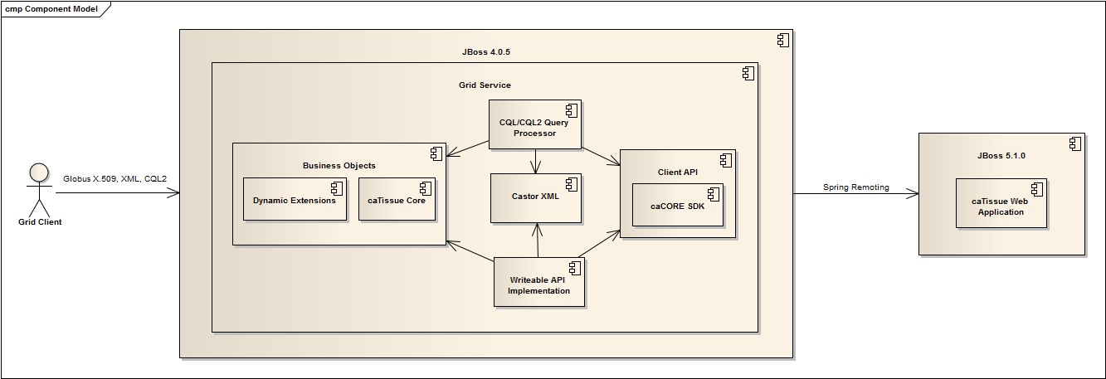
Grid client can submit either a dynamic CQL/CQL2 query or a strongly typed request for an operation of the Writeable API interface, e.g. registerParticipant. CQL/CQL2 queries are processed by the Query Processor that:
- Transforms CQL and CQL2 XML into Hibernate Query Language (HQL),
- Sends HQL to caTissue Web Application via Client API,
- Filters the results to enable security based on the grid client’s identity,
  - Results can include caTissue core business objects and dynamic extension objects.
- Converts the results back to XML using Castor,
- Sends XML back to the grid client.

Writeable API queries are handled by Writeable API implementation that:
- Transforms XML into corresponding object tree structure, which can include caTissue core business objects and dynamic extension objects,
- Delegates to appropriate Client API method,
- Converts the results back to XML using Castor,
- Sends XML back to the grid client.

