caTissue/PSC/C3PR Integration Design Document

Version 0.9
04/11/2011

Authors | Denis Krylov, SemanticBits LLC
Editor | Jithu Ramesh
Reviewers | Patrick McConnell, Kruttik Aggarwal, Joshua Phillips, SemanticBits LLC
DOCUMENT CHANGE HISTORY
Version Number | Date | Contributor | Description
0.1 | 12/10/10 | Denis G Krylov | Initial draft
0.2 | 12/13/10 | Denis G Krylov | Updated according to recent talk with Joshua.
0.3 | 12/14/10 | Denis G Krylov | Emphasized use of iHub and clarified CAS authentication as per Joshua’s comments.
0.4 | 12/15/10 | Denis G Krylov | Clarified C3PR’s approach to services (no grid services).
0.5 | 12/20/10 | Denis G Krylov | Updated after Rhett’s comments.
0.6 | 01/03/11 | Jithu Ramesh | Formatting update.
0.7 | 01/31/11 | Denis G Krylov | Addressed Joshua’s comments. Corrected a diagram.
0.8 | 03/17/11 | Denis G Krylov | Removed ESB from the design per NCI’s request. Added bi-directional communication with C3PR.
0.9 | 04/11/11 | Denis G Krylov | Removed Study Created/Updated event from C3PR integration scope.

Table of Contents
1. Introduction 5
2. Integration Design 5
2.1 Overview 5
2.2 Event Notifications 6
2.2.1 Overview 6
2.2.2 Message Format 6
2.2.3 Message Security 7
2.2.3.1 Authentication 7
2.2.3.2 Confidentiality 7
2.2.4 Message Reliability 7
2.3 Data Retrieval 7
2.3.1 Overview 7
2.3.2 C3PR 7
2.3.3 PSC 7
2.3.4 Security 7
2.3.4.1 Authentication 7
2.3.4.1.1 SAML 7
2.3.4.1.2 CAS 7
2.3.4.2 Confidentiality 8
2.3.5 Example 8
2.4 Registration Service 9

Table of Figures
Figure 1: Component View 6
Figure 2: C3PR Patient Registration Scenario 9

Introduction
caTissue needs to collaborate with C3PR and PSC in a number of different scenarios. caTissue needs to:
- Become aware of certain events initiated by C3PR and PSC,
- Obtain data related to the aforementioned events,
- Perform protocol registrations using a service interface.
All interoperability scenarios are summarized in the following table:
Application | Event | Data | Description
C3PR | Subject Created/Updated | Subject record. | caTissue needs to obtain subject data via Subject Management service.
C3PR | Subject Registration Created/Updated | StudySubject record. | caTissue needs to obtain study subject data via Subject Registration service.
PSC | Calendar for Subject Created | Calendar record | caTissue needs to obtain calendar data via Scheduled Calendar service.
PSC | Scheduled Activities Changed | Calendar record | caTissue needs to obtain calendar data via Scheduled Calendar service.
caTissue | Protocol Registration Created. | Collection Protocol Registration | caTissue needs to use a Registration service.
Detailed description of interoperability scenarios can be found in here and here.

Integration Design
  - Overview
The problem is threefold. First, C3PR and PSC need a way to broadcast event notifications to caTissue. Second, caTissue needs a way to retrieve data relevant to occurred events from C3PR and PSC. Third, caTissue needs to use a Registration web service to perform protocol registration.

The diagram below outlines the component view of the integration solution and is followed by a detailed description.
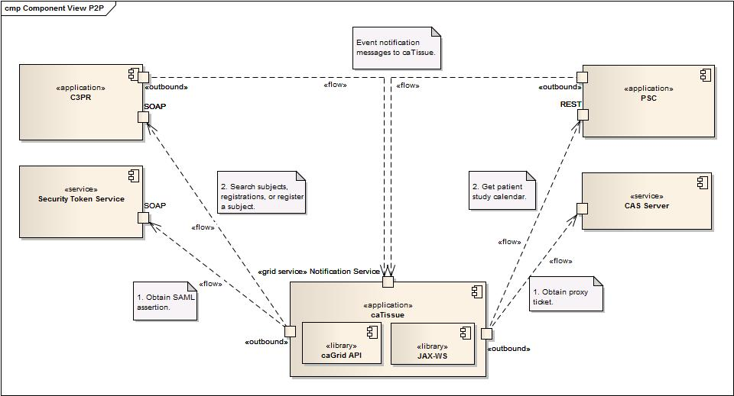
Figure 1: Component View
  - Event Notifications

Overview
Event notification broadcast will be implemented by as follows:
- caTissue will expose a secure grid service that will allow applications to publish event notifications,
- caTissue will store notification messages in an internal queue for processing,
- caTissue will invoke services to retrieve data pertaining to the received notifications.

Message Format
Notification messages will be XML messages conforming to a predefined XML Schema definition. Messages will include the following information:
- Event type
  - An enumeration of values
- Business object identifier
  - A synthetic identifier of the object pertaining to the event (study, subject, and so on)
- Optional originating application’s identifiers
  - An enumeration of values

Message Security

Authentication
All aspects of notification message delivery will be implemented via secure grid services; authentication will rely on grid security infrastructure.

Confidentiality
Confidentiality of the messages will be enforced by using transport layer security (TLS) on all ends.

Message Reliability
C3PR and PSC will be responsible for providing reliable message delivery in an ordered manner. However, caTissue will have to implement an internal queue for received notifications in order to ensure reliable processing. This is needed in order to cover situations in which caTissue fails to execute callback to a service and to retrieve data. Under these circumstances, notifications will need to be persisted and scheduled for another processing attempt. caTissue will consider using Quartz Scheduler for this purpose.

Data Retrieval

Overview
In order to retrieve data pertaining to events, caTissue will invoke NCI NES services exposed by other applications. caTissue will use a synthetic business object identifier, which was previously included in the event notification, to specify what data caTissue needs. C3PR and PSC will expose services to retrieve subjects, studies, registrations, and calendars.

C3PR
Currently, C3PR exposes its services as SOAP/HTTP web services that use WSDL to formally define service interfaces. caTissue will incorporate logic that will deal with specifics of invoking C3PR web services, including specifics of C3PR authentication described in 2.3.4.1.1. C3PR’s PSM specifications will be used to obtain information about the services’ contract.

PSC
PSC exposes its services as RESTful web services using XML as data format. caTissue will incorporate logic to execute RESTful web service requests. PSC’s PSM specifications will be used to obtain information about the services’ contract.

Security

Authentication

SAML
Currently, C3PR expects a SAML token of specific format containing authentication data to be provided as a part of a web service request. caTissue will implement logic to obtain a SAML token from a Secure Token Service, such as Authentication Service.

CAS
PSC relies on CAS-based authentication and expects a CAS security ticket to be provided as a part of web service request. caTissue will implement logic to obtain a CAS security ticket by contacting a CAS server and will present the ticket to PSC as a part of a request.
The need to obtain a security ticket from a CAS server places restrictions on configuration of authentication mechanisms in that server. For example, having only username and password authentication available in CAS server is not sufficient. CAS server will be configured to perform X.509 certificate authentication as well:
- caTissue will authenticate to CAS server using a X.509 certificate,
  - SSL client authentication
- CAS server will validate the certificate and issue a security token to caTissue
  - CAS server will have a trust relationship with caTissue.

Confidentiality
Confidentiality is enforced by TLS in cases of both C3PR and PSC.

Example
The diagram below provides a simple illustration of the scenario in which a new patient is registered on a study in C3PR, and caTissue retrieves the study subject.
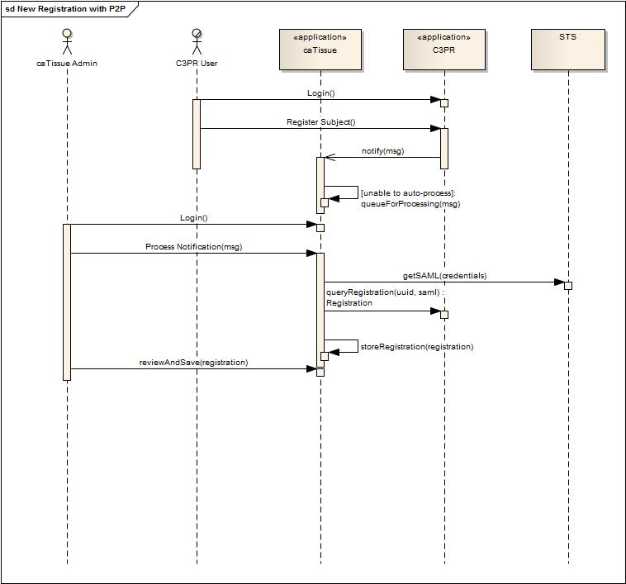
Figure 2: C3PR Patient Registration Scenario

  - Registration Service

Overview
A caTissue user must be able to perform protocol registrations in caTissue, and these registrations must be made available to other applications for consumption. In order to fulfill this requirement, caTissue needs to be refactored to use a Registration service for this purpose. Registrations made via the service will be accessible to other clients of the service.

