caTissue Integration with Grid Grouper
Design Document

Version 0.1
06/02/2011

Authors | Denis Krylov, SemanticBits LLC
Reviewers | Patrick McConnell, Srini Akkala, SemanticBits LLC

DOCUMENT CHANGE HISTORY
Version Number | Date | Contributor | Description
0.1 | 06/02/2011 | Denis G Krylov | Initial draft

Table of Contents
1. Introduction 5
2. Integration Design 5
2.1 Overview 5
2.2 Group Membership Retrieval 6
2.2.1 Group Privileges 7
2.2.2 Grid Grouper Authentication 7
2.3 Synchronization 7
2.4 Configuration 7

Table of Figures
Figure 1: Component View 6
Figure 2: Assigning permissions to grid groups 7

Introduction
Grid Grouper Integration is a part of the caGrid toolkit and enables federation of user identities and (potentially) roles, including caTissue users authorization across multiple institutions. In caTissue 2.0, the Grid Authentication component is implemented and covers both grid user authentication and local-to-grid user migration tasks. The main goal of Grid Grouper Integration is to allow centralized management of a caTissue user’s group membership information that can span more than a single institution or organization. Thus, for example, different authorization policies can be applied to a single user at different institutions running caTissue and without requiring separate user and role provisioning steps at each individual institution.
The best place to obtain detailed information about Grid Grouper is the caGrid website.

Integration Design
  - Overview
The diagram below provides a high-level component view of the Grid Grouper integration approach and is followed by a detailed description.
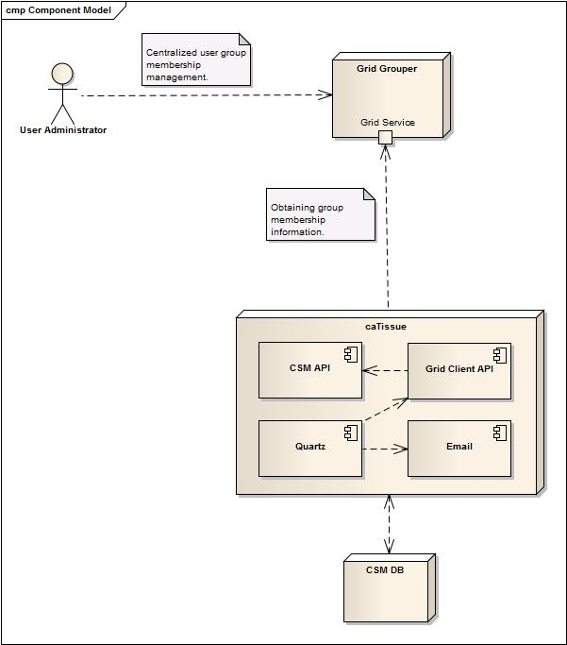
Figure 1: Component View
  - Group Membership Retrieval
Grid Grouper exposes a standard grid service that will be used to query for user group membership information. caTissue has incorporated a grid service client API for purposes of integration with CTRP and caGrid Authentication. This API will be re-used for Grid Grouper integration as well, requiring minimal additional libraries to caTissue. The Grid Grouper grid service client will be responsible for:
- Obtaining existing users’ membership information from Grid Grouper,
- Transform the information into a form suitable for the CSM component,
- Passing the information to the CSM component for storing in the CSM data store.

    - Group Privileges
caTissue will search for groups in Grid Grouper under one or more pre-configured stems

and will store found groups locally.
Every Grid Grouper group will be manually provisioned on one or more specific protocols with specific access permissions before users from that group can access any data in caTissue related to those protocols. A modification to the Collection Protocol Add/Edit screen will be made to accommodate new functionality: a section similar to the mockup below will be added to the Privileges tab:
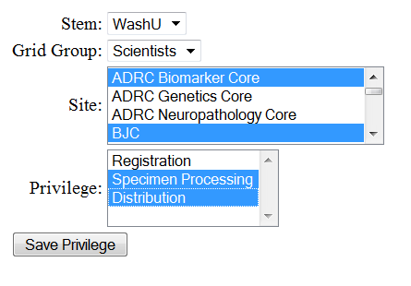
Figure 2: Assigning permissions to grid groups

    - Grid Grouper Authentication
The Grid Grouper grid service itself is a secure service. caTissue will need a valid X.509 host or user certificate to connect to Grid Grouper. Information needed to obtain a certificate will be specified in a configuration file.
  - Synchronization
To perform automated synchronization of CSM with Grid Grouper, Quartz Scheduler will be used to schedule and execute periodic jobs. Jobs will perform aforementioned membership retrieval and will produce email notification alerts warning about any problems that might have occurred during a synchronization attempt.
  - Configuration
The following new configuration options will be added to support the integration:
- Enabled/Disabled switch
- Credentials of the Grid Grouper system user or a path to host certificate
- Dorian URL
- Grid Grouper service URL
- Stem names, under which the groups are expected to be located

