caTissue Integration with Grid Grouper
SRS
Version 0.0.3

Authors | Denis G Krylov
Reviewers | Patrick McConnell
Architecture Inception Team

DOCUMENT CHANGE HISTORY
Version Number | Date | Contributor | Description
0.0.1 | 05/27/2011 | Denis G Krylov | Initial version
0.0.2 | 06/01/2011 | Denis G Krylov | Addressed comments.
0.0.3 | 06/07/2011 | Denis G Krylov | Addressed Rakesh’s comments.

Table of Contents
1 Introduction 4
1.1 Overview 4
1.2 Grid Grouper 4
1.3 Storyboard 4
2 Requirements 5

Introduction

Overview
Grid Grouper Integration is a part of a major development effort to enable federation of caTissue user authentication and authorization across multiple institutions. At this point, caTissue Grid Authentication component has already been implemented and covers both grid user authentication and local-to-grid user migration tasks. The main goal of Grid Grouper Integration is to allow centralized management of a caTissue user’s group membership information that can span more than a single institution or organization. Thus, for example, different authorization policies can be applied to a single user at different institutions running caTissue and without requiring separate provisioning steps at each individual institution.

Grid Grouper
The best place to obtain information about Grid Grouper is the caGrid website.

Storyboard
To see potential benefits of Grid Group Integration, let’s consider the following scenario.
Two instances of caTissue are deployed at Duke University Medical Center (DUMC) and at Wake Forest University Baptist Medical Center (WFUBMC). Both institutions are participating in a single clinical study with a collection protocol and thus are interested in collaborating with each other. Jane Doe is a supervisor of the study at DUMC and has unrestricted access to a local caTissue instance. Since the study is being conducted at two institutions, Jane Doe also needs to access tissue information at WFUBMC; however, her access to caTissue at WFUBMC needs to be limited, because she is not an employee at that institution.
The following steps can be followed to realize this use case:
- Jane gets a grid account to represent her identity.
- Jane receives a membership in Grid Grouper that assigns her to “Supervisors” group under “DUMC” stem and to “Scientists” group under “WFUBMC” stem.
- In each caTissue instance, both groups are given specific permissions on the study level.
- Jane registers in both instances of caTissue.
- Jane’s membership information is retrieved from Grid Grouper by caTissue instances, and her local caTissue accounts are assigned corresponding privileges automatically.
- Jane is now able to log into each caTissue instance using a single set of grid credentials, and her privileges in each instance correspond to her group membership in Grid Grouper.
- Jane gets her access restrictions at WFUMBC lifted. She gets re-assigned to “Supervisors” group under “WFUBMC” stem in Grid Grouper.
- Her new role change is reflected in caTissue instance at WFUBMC seamlessly and automatically. A wider set of access privileges is granted.

The following simplified diagram represents Jane’s group membership stored in Grid Grouper:
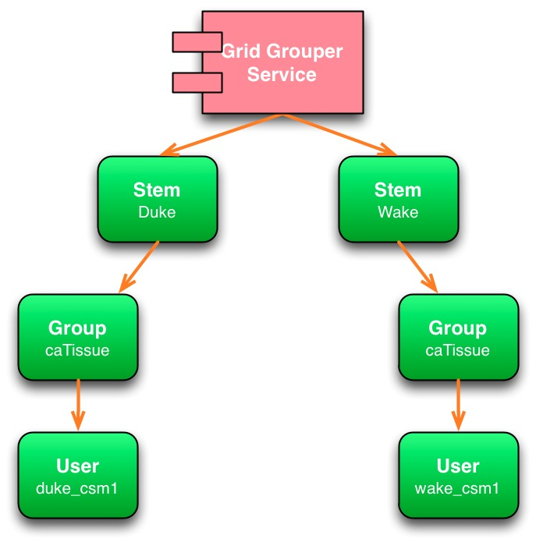

Requirements

Requirement ID | Requirement
caTissue-v20-100 | caTissue MUST retrieve group membership information from Grid Grouper for a) every newly provisioned user, whose target identify provider is on the grid (Dorian), b) every local user that has been migrated to the grid.
caTissue-v20-101 | caTissue SHOULD store group membership information obtained from Grid Grouper in a local CSM data store.
caTissue-v20-102 | caTissue MUST enforce authorization of grid users using their group membership information retrieved from or synced with Grid Grouper.
caTissue-v20-103 | caTissue SHOULD map Grid Grouper groups to local CSM groups.
caTissue-v20-104 | caTissue SHOULD automatically create a new CSM group for every Grid Grouper group for which a mapping is not found. Newly created group MUST not have any privileges assigned to it.
caTissue-v20-105 | caTissue MUST send a email notification to administrator when a new CSM group is created automatically.
caTissue-v20-106 | caTissue MUST sync its local CSM with Grid Grouper periodically to ensure that group and group membership information is up-to-date.
caTissue-v20-107 | caTissue MUST cancel all memberships in groups that have been found to have been deleted in Grid Grouper and send a email notification to administrator.
caTissue-v20-109 | caTissue SHOULD NOT attempt to propagate group membership changes made locally to Grid Grouper.
caTissue-v20-110 | caTissue MUST notify administrators of issues synchronizing.
caTissue-v20-111 | caTissue MUST notify administrators of synchronizing conflicts.
caTissue-v20-112 | caTissue MUST NOT assign privileges to users automatically from Grid Grouper unless explicitly configured to do so.
caTissue-v20-113 | Grid Grouper integration MUST be configurable, including whether the functionality is enabled, grid endpoints, and synchronization interval.
caTissue-v20-114 | Integration with Grid Grouper MUST NOT interfere with normal security provisioning within caTissue.
caTissue-v20-115 | caTissue MUST provide an interface to assign privileges to groups on protocol level.
caTissue-v20-116 | caTissue SHOULD NOT allow assigning permissions to groups on All-Protocol/All-Sites level.

