Test case automation framework
Junit provides a very traditional way to write test cases in which there is no option to give input data to the test case, all the required data is hard coded inside the test case.
This framework reads input from external source i.e from CSV file and makes the test case configurable. This test automation framework extends the junit struts test framework of java.

Design scope
Following are the brief requirements that are in the scope for the design of this framework:
- Ability to read the test case name and their corresponding data from the CSV file.
- Abitilty to run test case based on different roles.
- Ability to compare expected & actual test results.
- Ability to provide the output in the desired HTML format(some extra information like the test case id from the TMT).
- Ability to run the single test case with multiple input parameters.

Detailed design
Test automation framework accepts input from the csv file format, and provides a way to the developer to specify name of the test cases which they want to run and the required data in the CSV for these test cases.
Below is the structure diagram of the struts test automation framework: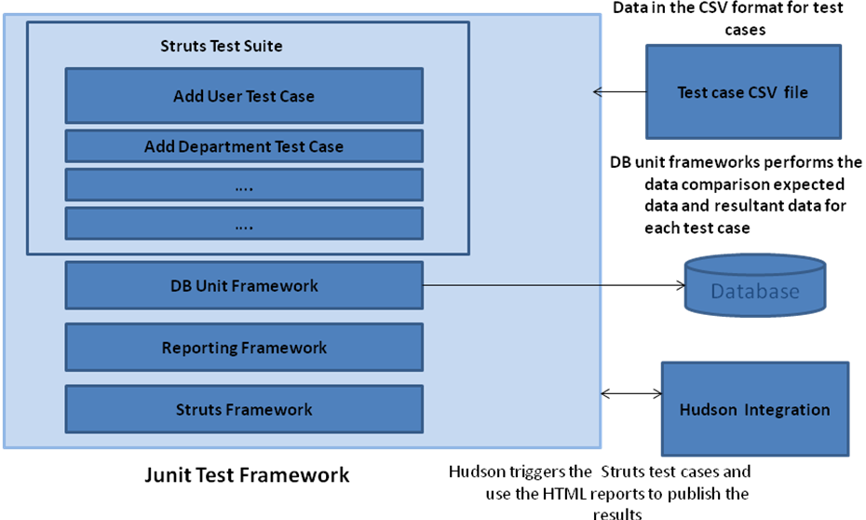
Figure 1: Structure diagram
In the structure diagram it is shown that this framework accepts the data in the form of CSV file and then run the test cases mentioned in the CSV file. After running each and every test case it compares the actual and expected data with the help of DB unit and then generates html rpeorts and publish them to the hudson.

Below is the class diagram of the test case automation framework:
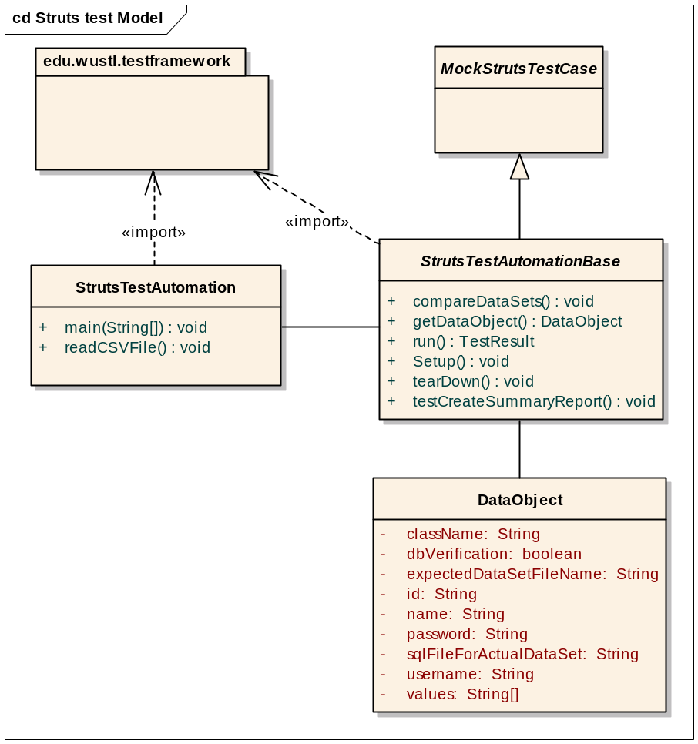
Figure 2: Class diagram

Description of classes:
- StrutsTestAutomationBase.java:
This class extends the MockStrutsTestCase class of the struts test case. To use this framework, the developer has to extend this class.
This class overrides the run() method provided by the junit, to create the custom report.
It also overrides the setup() and tearDown() methods of the junit for the setup of the environment required to run the test cases.
The operation testCreateSummaryReport() creates summary report of the test results.
This class also contains compareDataSets() which compares the expected data with the actual data.

- StrustTestAutomation.java:
This is the main class which will read the CSV file and will populate the DataObject from it. It creates the test suite and passes this data object to test case.
- DataObject.java: This is a simple wrapper object which holds the csv data information.
- DBUnitUtility.java: This class uses the DBUnit API’s to load the expected dataset and actual datasets for comparing data.
- DataSourceFinder.java: This class loads the database credentials from a configuration file.

Struts test automation framework flow:
The use case of this framework is to accept the data in the CSV file format, run the test cases and to return the report in html format after running the test cases mentioned in the CSV file.
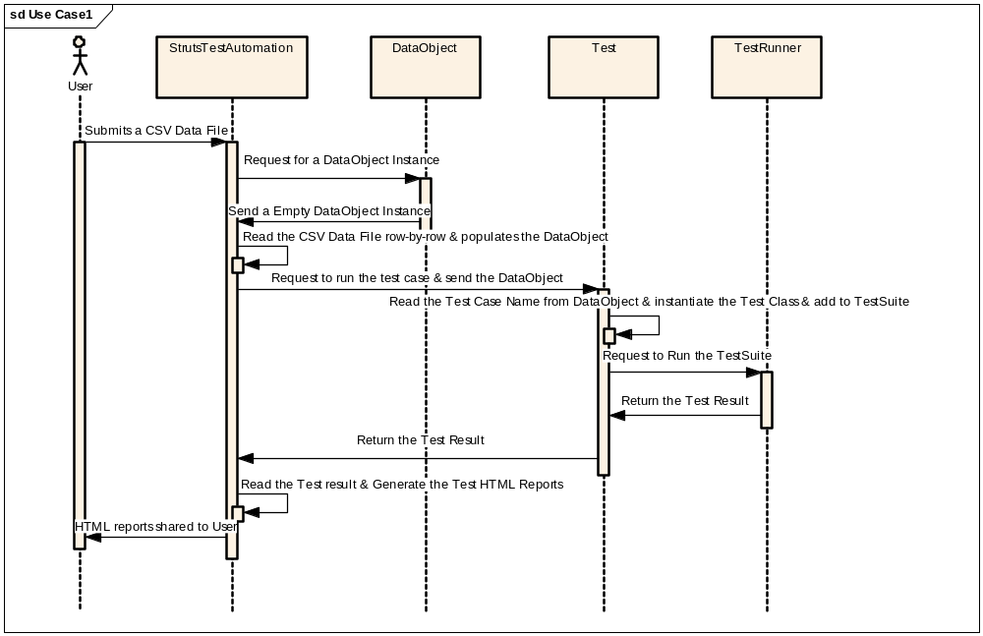
Figure 3: Sequence diagram
The above diagram depicts the complete workflow. i.e,
- User provides the input in the CSV format as shown in the following file:
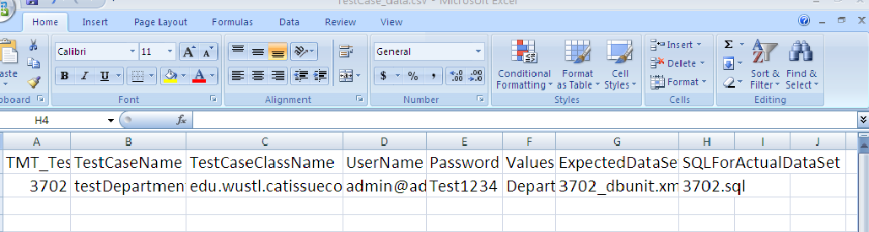
- StrutsTestAutomation class reads a row from the CSV input file and populates a instance of DataObject. Read the test case name from the dataObject, instantiate the corresponding test class and add it to test suite.
- Request to TestRunner class to run the test suite.
- TestRunner runs the test suite and returns the instance of testResult to the StrutsTestAutomation class.
- StrutsTestAutomation class reads the testResult and generates the reports and sends these reports to the user.

